## Legal basis and regulatory Landscape

**Legal basis**

As a globally active company, Siemens must comply with a large number of laws and other regulations in its markets. This is accompanied by just as many criminal and other liability risks and legal disadvantages for the company, its employees and its management at all levels of the company. Accordingly, the requirements for compliance at Siemens are complex. The aim is to provide reliable protection against these risks - and at the same time protect against damage to the reputation and business success of Siemens that could result from compliance violations within the company.

Initially, the legislation of the European Union, for example, on competition law, data protection or export controls, is decisive for compliance.

Important national laws such as the U.S. Foreign Corrupt Practices Act and the Bribery Act of the United Kingdom, for example, prohibit corruption and bribery. Both also affect business activities outside of both countries to a considerable extent. In addition, there are numerous other national laws around the world prohibiting corruption and bribery and on other topics such as the prohibition of money laundering and the financing of terrorism, violations of competition law, data protection and export controls, as well as official regulations, particularly on export controls.

These laws and regulations are subject to constant change, especially with regard to export controls. Overall, a tendency towards increased regulation can be observed. For example, in important markets of our company, the legal regulations, for example on the prohibition of corruption, have been tightened and there are also clear signs that state and international institutions are paying more attention to the enforcement of the relevant legal provisions. The guidelines and recommendations of national authorities - such as the U.S. Department of Justice, the French Agence Francaise Anticorruption (AFA) or the Serious Fraud Office (SFO) of the United Kingdom - play an important role in this regard, but at the same time they provide companies with essential guidance on how to adequately structure their compliance with regard to the fulfillment of legal due diligence requirements.

Finally, there are the agreements and recommendations of international organizations such as the UN Convention against Corruption and the OECD Convention on the Prohibition of Bribery of Foreign Public Officials, as well as international standards such as DIN ISO 37001 or DIN ISO 19600.

**Regulatory Landscape**

The [Compliance Organizatio](https://intranet.siemens.com/en/compliance/organization/index.htm)n (LC CO) has governance responsibility for the implementation of the Siemens Compliance System in the Company Units. It is responsible for the legal risk areas of anti- corruption, antitrust1, data privacy, anti-money laundering, export control and human rights2. These risks are covered by our Activity Fields including Collective Action and the approach of “Prevent, Detect and Respond”.

1 In conjunction with LC M&A CMP.

2 In conjunction with SU.

The Compliance System of the Company Units is based on a comprehensive set of rules and regulations. The following regulations contain “What” is expected of employees in the context of compliance obligations:

* The [Siemens Business Conduct Guidelines (BCG)](https://findit.compliance.siemens.com/content/10000101/Compliance/CL_CO/CL_CO_AT/findIT_CL_CO_AT_55.pdf) set forth the fundamental principles and rules governing how we act within the Company Units and in relation to our customers, external partners and the general public.
* The [Siemens Circular (SC 226)](https://srs.siemens.cloud/c/fs8o2k) sets forth the obligations for all employees of Siemens and respective controls to ensure the implementation of the Siemens Compliance System.

SC 226 is available in different languages: [German](https://soc.siemens.cloud/c/8j8nib) [Chinese](https://findit.compliance.siemens.com/content/10000103/Compliance/NorthEast%20Asia%20Cluster/RCo_China/findIT_RCo_China_1383.pdf)

[French](https://findit.compliance.siemens.com/content/10000102/Compliance/SouthWest%20Europe%20Cluster/RCo_Belgium/findIT_RCo_Belgium_2692.pdf) [Belgian / Dutch](https://findit.compliance.siemens.com/content/10000102/Compliance/SouthWest%20Europe%20Cluster/RCo_Belgium/findIT_RCo_Belgium_2692.pdf)

Spanish

The following regulations contain detailed guidance on “How” to perform the individual obligations anchored in the BCG and SC 226:

* The [Compliance Handbook](https://webbooks.siemens.com/public/LC/chen/index.htm?n=Compliance-Handbook) and the [Internal Control Program Export Control (ICP EX) set forth](http://intranet.siemens.com/ex/icp/en) [topic-specific working instructions with respect to compliance processes and tools as well as](http://intranet.siemens.com/ex/icp/en) [additional guidance and supporting information.](http://intranet.siemens.com/ex/icp/en)

The [Compliance Operating Model](https://srs.siemens.cloud/%23/c/ykgeor) contains binding guidelines for employees of the Compliance Organization of the Company Units. It defines the responsibilities within the Compliance Organization and how the Compliance System is organized.

Company Units may only issue specific or deviating compliance-related regulations that are within the scope of this Circular if they are required by law and/or are necessary to address or mitigate specific business risks. **Any such regulation must undergo the Compliance Portfolio Management process according to the** [**Compliance Operating Model.**](https://srs.siemens.cloud/%23/c/ykgeor) **As necessary, Legal and Compliance may issue guidance to implement the requirements set forth in this Circular.**

**Other regulations**

The Managing Board of Siemens AG and the CEOs / heads of the business units, supported by the General Counsels and Compliance Officers, have overall responsibility for Compliance and thus the corresponding organizational and supervisory duties. A summary of the basic principles of the organizational and supervisory duties for Germany can be found in the internal guidelines on [organizational and supervisory duties (White Book).](https://findit.compliance.siemens.com/content/10000101/Compliance/LC_CO/LC_CO_RG_PL/findIT_LC_CO_RG_PL_4387.pdf) In general, Siemens-internal regulations shall be published only on corporate level. It is also necessary to ensure that Siemens-internal regulations are binding for our Affiliated Companies according to [Siemens Circular 105](https://regulations-admin.siemens.com/content/SC/105/en) [“Implementation of Siemens-internal regulations in Affiliated Companies”.](https://regulations-admin.siemens.com/content/SC/105/en) Insofar, the [Siemens Conformance](https://wse04.siemens.com/content/P0003980/EN/SRR_Wiki/Conformance%20Process.aspx) [Process](https://wse04.siemens.com/content/P0003980/EN/SRR_Wiki/Conformance%20Process.aspx) applies.

Deviating local or business specific regulations are only permitted if required by laws or to address specific compliance risks and require corporate approval via the Compliance Portfolio Management Process according to the [Compliance Operating Model.](https://regulations-admin.siemens.com/content/SST/4/en)

## Definitions and Abbreviations

|  |  |
| --- | --- |
| **Additionally informed entity** | Siemens entity which is not directly affected by a compliance case but holds a stake (e.g. Division if a case is related to a Division business activity in a Regional Company). |
| **Affiliated Company** | Please refer to [Siemens Circular No. 105](https://regulations-admin.siemens.com/content/sc/105/en) |
| **AML** | Anti-Money Laundering *(*[*C.*](https://webbooks.siemens.com/public/LC/chen/index.htm?n=Part-1-Activity-Fields%2CC.-Anti-Money-Laundering)*)* |
| **ARE** | Accounting Unit within the Siemens group of companies (Abrechnungseinheit) |
| **AREA** | Antitrust Risk Exposure Assessment *(*[*B. Antitrust*](https://webbooks.siemens.com/public/LC/chen/index.htm?n=Part-1-Activity-Fields%2CB.-Antitrust)*)* |
| **BCG** | [Siemens Business Conduct Guidelines](https://findit.compliance.siemens.com/content/10000101/Compliance/CL_CO/CL_CO_AT/findIT_CL_CO_AT_55.pdf) |
| **BPC** | Business Partner Compliance *(*[*A 4. Business Partner*](https://webbooks.siemens.com/public/LC/chen/index.htm?n=Part-1-Activity-Fields%2CA.-Anti-Corruption%2C3.-Cooperation-with-Business-Partners)*)* |
| **Business Partner** | The English term “business partner” merely describes a commercial entity with which another commercial entity has business relations. However, the term “Business Partner” with capital letters in the Siemens compliance context only includes such business partners which are covered by SC 226 and therefore need to undergo a Compliance Due Diligence *(A 4. Business Partner)*. |
| **CCP** | Compliance Control Program |
| **CCO** | Chief Compliance Officer |
| **CDC** | Corporate Disciplinary Committee *(*[*L 4. Disciplinary Measures*](https://webbooks.siemens.com/public/LC/chen/index.htm?n=Part-3-Compliance-Internal-Tasks%2CL.-Case-Handling%2C-Discipline-and-Remediation%2C4.-Disciplinary-Measures)*)* |
| **CEA** | Corruption Exposure Assessment |
| **CDD** | Compliance Due Diligence(s) – Overview of CDD [H.2.8](https://webbooks.siemens.com/public/LC/chen/index.htm?n=Part-2-Business-Perspective%2CH.-Compliance-in-Business-Processes-and-Projects%2C8.-Compliance-Due-Diligences-and-Approvals) |
| **CF** | Controlling and Finance |
| **CF A** | Controlling and Finance Audit |
| **CF R 6** | Controlling and Finance - Accounting Reporting and Controlling - Shareholder Controlling |
| **CISS** | Corporate Information on Siemens Subsidiaries |
| **Clearance Case** | Investigation resulting in allegations against individuals not being able to be substantiated  *(*[*L 2.*](https://webbooks.siemens.com/public/LC/chen/index.htm?n=Part-3-Compliance-Internal-Tasks%2CL.-Case-Handling%2C-Discipline-and-Remediation%2C2.-Case-Handling) *Case Handling,* [*L 5.*](https://webbooks.siemens.com/public/LC/chen/index.htm?n=Part-3-Compliance-Internal-Tasks%2CL.-Case-Handling%2C-Discipline-and-Remediation%2C5.-Remediation) *Remediation)*. |
| **Clearance Case +** | Similar to Clearance Case. Nevertheless (process) deficiencies were observed. Remediation measures (e.g. training measures) are usually defined *(*[*L 2.*](https://webbooks.siemens.com/public/LC/chen/index.htm?n=Part-3-Compliance-Internal-Tasks%2CL.-Case-Handling%2C-Discipline-and-Remediation%2C2.-Case-Handling) *Case Handling,* [*L 5.*](https://webbooks.siemens.com/public/LC/chen/index.htm?n=Part-3-Compliance-Internal-Tasks%2CL.-Case-Handling%2C-Discipline-and-Remediation%2C5.-Remediation) *Remediation)*. |
| **Closure Case** | Investigation resulting in the investigated allegations not being able to be substantiated. In  contrast to a clearance case, there is no involvement of individual employees *(*[*L 2.*](https://webbooks.siemens.com/public/LC/chen/index.htm?n=Part-3-Compliance-Internal-Tasks%2CL.-Case-Handling%2C-Discipline-and-Remediation%2C2.-Case-Handling) *Case* |

|  |  |
| --- | --- |
|  | *Handling,* [*L 5.*](https://webbooks.siemens.com/public/LC/chen/index.htm?n=Part-3-Compliance-Internal-Tasks%2CL.-Case-Handling%2C-Discipline-and-Remediation%2C5.-Remediation) *Remediation)*. |
| **Closure Case +** | Similar to Closure Case. Nevertheless (process) deficiencies were observed. Remediation measures such as training are usually defined *(*[*L 2.*](https://webbooks.siemens.com/public/LC/chen/index.htm?n=Part-3-Compliance-Internal-Tasks%2CL.-Case-Handling%2C-Discipline-and-Remediation%2C2.-Case-Handling) *Case Handling,* [*L 5.*](https://webbooks.siemens.com/public/LC/chen/index.htm?n=Part-3-Compliance-Internal-Tasks%2CL.-Case-Handling%2C-Discipline-and-Remediation%2C5.-Remediation) *Remediation)*. |
| **CMC** | Compliance Management Council, see [Compliance Operating Model](https://regulations-admin.siemens.com/content/SST/4/en) |
| **CO** | Compliance Officer |
| **Compliance Case** | Plausible allegation regarding a possible violation of the Siemens Business Conduct Guidelines and/or the applicable law which could lead to criminal or administrative sanctions ([L.](https://webbooks.siemens.com/public/LC/chen/index.htm?n=Part-3-Compliance-Internal-Tasks%2CL.-Case-Handling%2C-Discipline-and-Remediation%2C2.-Case-Handling) Case Handling, Discipline and Remediation). |
| **Cooperation /**  **Consortium Partner** | See A 4.A.1.4. |
| **Counterpart** | Any third party including but not limited to customers, suppliers, as well as third parties such as intermediaries, resellers, distributors, agents, consultants, consortium partners, EPC contractors and joint venture partners.  *Relevant definition inter alia for chapters A 4.A.1. Compliance Due Diligence for Business Partners and* [*C. 2.*](https://webbooks.siemens.com/public/LC/chen/index.htm?n=Part-1-Activity-Fields%2CC.-Anti-Money-Laundering-(AML)%2C2.-AML-Due-Diligence) *AML Due Diligence.* |
| **CRA** | Compliance Risk Assessment *(*[*K 1.*](https://webbooks.siemens.com/public/LC/chen/index.htm?n=Part-3-Compliance-Internal-Tasks%2CK.-Compliance-Risk-Management-and-Reviews%2C1.-Compliance-Risk-Assessment)*)* |
| **CRB** | Compliance Review Board *(*[*K 2.*](https://webbooks.siemens.com/public/LC/chen/index.htm?n=Part-3-Compliance-Internal-Tasks%2CK.-Compliance-Risk-Management-and-Reviews%2C2.-Compliance-Review-Board)*)* |
| **Customs Agent** | Subtype of a Non-sales related Intermediary, see [A 4.A.1.2.](https://webbooks.siemens.com/public/LC/chen/index.htm?n=Part-1-Activity-Fields%2CA.-Anti-Corruption%2C4.-Cooperation-with-Business-Partners%2CA.-Relevance-for-Business%2CA.1.-Business-Partner-Types%2CA.1.2.-Non-sales-related-Intermediary) |
| **DI** | Degree of Implementation |
| **Distributor/other Reseller** | See A 4.A.1.3. |
| **Employee** | Members of the Managing Board, senior executives and any other persons working for Siemens AG and its affiliated companies worldwide. |
| **Engineering, Procurement and Construction Contractor (EPC)** | Example of a Value add Reseller, see A 4.A.1.3.2. |
| **ERM** | Enterprise Risk Management |
| **EY** | Ernst & Young – external auditors employed by Siemens. |
| **FRG** | [Financial Reporting Guidelines](https://webbooks.siemens.com/public/FRG/IGen/) |
| **Government Official** | The term “Government Official” includes anyone working at or on behalf of a government  entity (including a government-controlled company) or public international organization, as well as any candidate for political office, political party official or employee, or a political |

|  |  |
| --- | --- |
|  | party. A Government Official also includes an officer, director, or employee of a non- governmental institution whose employees are treated, because of their status or other reasons, as Government Officials under applicable local law, German law or U.S. law.  Examples of Government Officials are: police officers; members of the military; customs officials; officials of the World Health Organization, the European Council, the World Bank or the United Nations; candidates for the office of mayor; members of parliament; judges, public prosecutors or judicial staff; employees of public hospitals, public utilities or other public-sector companies.  *Relevant definition inter alia for chapters* [*A 1.3.*](https://webbooks.siemens.com/public/LC/chen/index.htm?n=Part-1-Activity-Fields%2CA.-Anti-Corruption%2C1.-Gifts-and-Hospitality%2C1.3.-SpoDoM-Approval-for-providing-benefits) *Gifts and Hospitality,* [*A 4.A.4.*](https://webbooks.siemens.com/public/LC/chen/index.htm?n=Part-1-Activity-Fields%2CA.-Anti-Corruption%2C4.-Cooperation-with-Business-Partners%2CA.-Relevance-for-Business%2CA.4.-Compliance-Due-Diligence-(CDD)) *Compliance Due Diligence for Business Partners, A 5.1.5 Conflict of Interest,* [*A 3.*](https://webbooks.siemens.com/public/LC/chen/index.htm?n=Part-1-Activity-Fields%2CA.-Anti-Corruption%2C3.-Facilitation-Payments) *Facilitation Payments. Please also see “****Politically Exposed Person*** *(PEP)” as a high ranking Government Official might also be a PEP.* |
| **Government Entity** | The term “Government Entity” is defined broadly to include national, state or local governments or government departments, bodies, agencies and other government entities, as well as “public international organizations” and political parties. “Public international organizations” include any organization with two or more governments as members. “Government entity” also includes “government- controlled enterprises,” meaning any entity, whether organized under public or private law, in which one or more government entities has a sufficient interest to give it control. Any entity that is at least 50% owned by any government entity would qualify as would any entity that is controlled in fact (e.g. via veto rights) by any government entity.  *Relevant definition inter alia for chapters A 1.3. Gifts and Hospitality and* [*A 4.A.4.*](https://webbooks.siemens.com/public/LC/chen/index.htm?n=Part-1-Activity-Fields%2CA.-Anti-Corruption%2C3.-Cooperation-with-Business-Partners%2C3.3.-Compliance-Due-Diligence-(CDD)) *Compliance Due Diligence for Business Partners.* |
| **HR** | Human Resources |
| **Intermediary** | See [A 4.A.1.2](https://webbooks.siemens.com/public/LC/chen/index.htm?n=Part-1-Activity-Fields%2CA.-Anti-Corruption%2C4.-Cooperation-with-Business-Partners%2CA.-Relevance-for-Business%2CA.1.-Business-Partner-Types%2CA.1.1.-Sales-related-Intermediary). and [A 4.A.1.2.](https://webbooks.siemens.com/public/LC/chen/index.htm?n=Part-1-Activity-Fields%2CA.-Anti-Corruption%2C4.-Cooperation-with-Business-Partners%2CA.-Relevance-for-Business%2CA.1.-Business-Partner-Types%2CA.1.2.-Non-sales-related-Intermediary) |
| **Investigation** | Activity designed to:   * determine whether a wrongful act has occurred * identify the persons responsible for the wrongful act * or clear the persons wrongfully accused of misconduct or rules violations. |
| **ICP EX** | [Internal Control Program Export Control](https://intranet.for.siemens.com/wll/0067/en/Pages/Default.aspx) |
| **JV** | Joint Venture |
| **KYC** | Know Your Counterpart / AML Due Diligence, see [C.2.](https://webbooks.siemens.com/public/LC/chen/index.htm?n=Part-1-Activity-Fields%2CC.-Anti-Money-Laundering-(AML)%2C2.-AML-Due-Diligence) |
| **LC** | Lead Country |
| **LC CO RFC RC** | Risk Management and Controls department |
| **Legal** | The legal representatives are all persons who are allowed by law to represent the  company (not to be confused with all persons having a contractual power of attorney to |

|  |  |
| --- | --- |
| **Representative** | sign on behalf of a company).  *Relevant definition inter alia for chapters* [*A 4.C.2.2.3.*](https://webbooks.siemens.com/public/LC/chen/index.htm?n=Part-1-Activity-Fields%2CA.-Anti-Corruption%2C4.-Cooperation-with-Business-Partners%2CC.-Relevance-only-for-Tool-Users-(Tool-description)%2CC.2.-Business-Partner-CDD-Process%2CC.2.2.-Business-Partner-Key-Data-%E2%80%93-How-to-create-a-Business-Partner%2CC.2.2.3.-Extended-Key-Data) *Compliance Due Diligence for Business Partners and* [*C 2.1*.](https://webbooks.siemens.com/public/LC/chen/index.htm?n=Part-1-Activity-Fields%2CC.-Anti-Money-Laundering-(AML)%2C2.-AML-Due-Diligence) *AML DD.* |
| **Lobbyist** | Subtype of a Non-sales related Intermediary, see [A 4.A.1.2](https://webbooks.siemens.com/public/LC/chen/index.htm?n=Part-1-Activity-Fields%2CA.-Anti-Corruption%2C4.-Cooperation-with-Business-Partners%2CA.-Relevance-for-Business%2CA.1.-Business-Partner-Types%2CA.1.2.-Non-sales-related-Intermediary) und A.5.1.5. und [A.5.2.](https://webbooks.siemens.com/public/LC/chen/index.htm?n=Part-1-Activity-Fields%2CA.-Anti-Corruption%2C5.-Conflict-of-interest%2C5.2.-Dos-and-Don%E2%80%99ts) |
| **Key Employee** | Any employee of the Signatory who will carry out work for Siemens and who will have direct contact with Siemens personnel (other than mere support activities, like assistants)  *(*[*A 4.C.2.2.3.*](https://webbooks.siemens.com/public/LC/chen/index.htm?n=Part-1-Activity-Fields%2CA.-Anti-Corruption%2C4.-Cooperation-with-Business-Partners%2CC.-Relevance-only-for-Tool-Users-(Tool-description)%2CC.2.-Business-Partner-CDD-Process%2CC.2.2.-Business-Partner-Key-Data-%E2%80%93-How-to-create-a-Business-Partner%2CC.2.2.3.-Extended-Key-Data)*) and (*[*I.1.3).*](https://webbooks.siemens.com/public/LC/chen/index.htm?n=Part-2-Business-Perspective%2CI.-Compliance-in-Mergers-and-Acquisitions%2C1.-Compliance-Due-Diligence%2C1.3.-Scope) |
| **Key Person** | Any individual who has a considerable influence on the Company’s business activities due to their position or their shareholding – this includes   * legal representatives (see separate definition), * directors, officers as well as * shareholders (see separate definition) with a significant amount of shares or voting power (more than 10%).   *(*[*A 4.C.2.2.3.*](https://webbooks.siemens.com/public/LC/chen/index.htm?n=Part-1-Activity-Fields%2CA.-Anti-Corruption%2C4.-Cooperation-with-Business-Partners%2CC.-Relevance-only-for-Tool-Users-(Tool-description)%2CC.2.-Business-Partner-CDD-Process%2CC.2.2.-Business-Partner-Key-Data-%E2%80%93-How-to-create-a-Business-Partner%2CC.2.2.3.-Extended-Key-Data)*) and (*[*I.1.3).*](https://webbooks.siemens.com/public/LC/chen/index.htm?n=Part-2-Business-Perspective%2CI.-Compliance-in-Mergers-and-Acquisitions%2C1.-Compliance-Due-Diligence%2C1.3.-Scope) |
| **M&A** | Mergers & Acquisitions *(I 1.)* |
| **MoM** | Minutes of Meeting |
| **“Need-to-know” principle** | General principle ruling the exchange of information relating to compliance investigations: Information is only shared with persons having a real need to know the respective details (e.g. in order to fulfill their managerial duties or to perform certain tasks during the remediation phase). |
| **Non-sales-related Intermediary** | See [A.4.A.1.2.](https://webbooks.siemens.com/public/LC/chen/index.htm?n=Part-1-Activity-Fields%2CA.-Anti-Corruption%2C4.-Cooperation-with-Business-Partners%2CA.-Relevance-for-Business%2CA.1.-Business-Partner-Types%2CA.1.2.-Non-sales-related-Intermediary) |
| **OR** | Operational Review |
| **Original Equipment Manufacturer (OEM)** | Example of a Value add Reseller, see A 4.A.1.3.2. |
| **PCMB** | Policy Control Master Book *(*[*K 3.*](https://webbooks.siemens.com/public/LC/chen/index.htm?n=Part-3-Compliance-Internal-Tasks%2CK.-Compliance-Risk-Management-and-Reviews%2C3.-Compliance-Control-Framework) *Compliance Control Program)* |
| **PE** | Permanent Establishment *(I 2.)* |
| ***Politically Exposed Person (PEP)*** | *While there is no global definition of a PEP, most countries including the EU* [*Anti-Money*](https://eur-lex.europa.eu/legal-content/EN/TXT/?uri=celex%3A32015L0849)[*Laundering Directive*](https://eur-lex.europa.eu/legal-content/EN/TXT/?uri=celex%3A32015L0849) *have based their definition on the* [*Financial Action Task Force on*](http://www.fatf-gafi.org/)[*Money Laundering*](http://www.fatf-gafi.org/) *(FATF) standard.*  ***FATF definition*:** Individuals who are or have been entrusted with prominent public functions by a foreign country, for example Heads of state or Heads of government, senior politicians, senior government, judicial or military officials, senior executives of state  owned corporations, important political party officials. Further, persons who are or have |

|  |  |
| --- | --- |
|  | been entrusted with a prominent function by a state owned enterprise or an international organization refers to members of senior management, i.e. directors, deputy directors and members of the board or equivalent functions.  Requirements for a PEP apply to family members or close associates, that is any individual publicly known, or known by the financial institution to be a close personal or professional associate. The definition of “Politically exposed Person” does not include middle-ranking or more junior individuals.  ***EU-AML Directive*:** Any individual who is entrusted with prominent public functions, including members of legislative bodies, government ministers, judges, high ranking members of the armed forces and senior officials of state-owned enterprises. This includes domestic citizens, as well as foreign ones. Family members or known close associates of a PEP must also be dealt with under PEP rules. This means applying enhanced due diligence. A family member of a PEP includes; a spouse or civil partner, children of the PEP and their spouses or civil partners, and parents of the PEP. A known close associate of a PEP means an individual known to have joint beneficial ownership of a legal entity or any other close business relationship, or an individual who has sole beneficial ownership of a legal entity known to have been set up for the benefit of the PEP.  *Relevant definition inter alia for chapter* [*C 1*.](https://webbooks.siemens.com/public/LC/chen/index.htm?n=Part-1-Activity-Fields%2CC.-Anti-Money-Laundering-(AML)%2C1.-AML-Red-Flags) *AML Red Flag. Please also see “****Government Official****” as most likely a PEP is also a Government Official and “****Related Parties****” as requirements for a PEP apply to family members or close associates.* |
| **R&D** | Research & Development |
| **Recommendation** | *In the case of Remediations (*[*L 5.*](https://webbooks.siemens.com/public/LC/chen/index.htm?n=Part-3-Compliance-Internal-Tasks%2CL.-Case-Handling%2C-Discipline-and-Remediation%2C5.-Remediation)*):* Recommended measure or set of measures defined to remedy a deficiency identified during a compliance investigation. The recommendations are defined during the investigation phase and are described in the investigation report. A recommendation may result in one or more remediation measures. |
| **Related Parties** | Close relatives (i.e. parents and their siblings, children including their spouses/life partners, siblings including their spouses or life partners and first nieces and nephews); spouses or life partners and close friends.  *Relevant definition inter alia for chapter* [*A 1.3.*](https://webbooks.siemens.com/public/LC/chen/index.htm?n=Part-1-Activity-Fields%2CA.-Anti-Corruption%2C1.-Gifts-and-Hospitality%2C1.3.-SpoDoM-Approval-for-providing-benefits) *Gifts and Hospitality.* |
| **Remediation** | “The act of setting back into proper condition” (Webster) The process of closing control or process gaps *(*[*L 5.*](https://webbooks.siemens.com/public/LC/chen/index.htm?n=Part-3-Compliance-Internal-Tasks%2CL.-Case-Handling%2C-Discipline-and-Remediation%2C5.-Remediation)*)*. |
| **Remediation Measure** | Structured set of tasks defined to close (remedy) a compliance violation *(*[*L 5.*](https://webbooks.siemens.com/public/LC/chen/index.htm?n=Part-3-Compliance-Internal-Tasks%2CL.-Case-Handling%2C-Discipline-and-Remediation%2C5.-Remediation)*)*. |
| **Red Flag** | Warning sign or concern that might trigger further measures, e.g. a Compliance Due Diligence for Resellers (A 4.A.1.3.1.) or an AML Due Diligence ([C 1.](https://webbooks.siemens.com/public/LC/chen/index.htm?n=Part-1-Activity-Fields%2CC.-Anti-Money-Laundering-(AML)%2C1.-AML-Red-Flags)). |
| **Remediation Team** | Project Team consisting of regular team members and additional team members *(L 5.)*. |

|  |  |
| --- | --- |
| **Reseller** | See A. 4.A.1.3. |
| **RIC** | Risk and Internal Controls *(*[*K 3.*](https://webbooks.siemens.com/public/LC/chen/index.htm?n=Part-3-Compliance-Internal-Tasks%2CK.-Compliance-Risk-Management-and-Reviews%2C3.-Compliance-Control-Framework) *Compliance Control Program)* |
| **RM** | Remediation Manager *(*[*L 5.*](https://webbooks.siemens.com/public/LC/chen/index.htm?n=Part-3-Compliance-Internal-Tasks%2CL.-Case-Handling%2C-Discipline-and-Remediation%2C5.-Remediation)*)* |
| **SCM** | Supply Chain Management |
| **Sales Agent** | Example of a Sales related Intermediary, see [A 4.A.1.1.](https://webbooks.siemens.com/public/LC/chen/index.htm?n=Part-1-Activity-Fields%2CA.-Anti-Corruption%2C4.-Cooperation-with-Business-Partners%2CA.-Relevance-for-Business%2CA.1.-Business-Partner-Types%2CA.1.1.-Sales-related-Intermediary) |
| **Sales related Business Consultant** | Example of a Sales related Intermediary, see [A 4.A.1.1.](https://webbooks.siemens.com/public/LC/chen/index.htm?n=Part-1-Activity-Fields%2CA.-Anti-Corruption%2C4.-Cooperation-with-Business-Partners%2CA.-Relevance-for-Business%2CA.1.-Business-Partner-Types%2CA.1.1.-Sales-related-Intermediary) |
| **Sales related Intermediary** | See [A 4.A.1.1.](https://webbooks.siemens.com/public/LC/chen/index.htm?n=Part-1-Activity-Fields%2CA.-Anti-Corruption%2C4.-Cooperation-with-Business-Partners%2CA.-Relevance-for-Business%2CA.1.-Business-Partner-Types%2CA.1.1.-Sales-related-Intermediary) |
| **SC 226** | [Siemens Circular No. 226 “Global Compliance”](https://circulars.siemens.com/documents/circulardownload.aspx?id=sc_226.pdf) |
| **Shareholder** | A shareholder is a natural or legal person who has an ownership share in a company. Depending on the legal form of the company in which the shareholder holds an investment, he may be referred to as a shareholder, partner or co-entrepreneur.  *Relevant definition inter alia for chapters* [*A 4.C.2.2.3.*](https://webbooks.siemens.com/public/LC/chen/index.htm?n=Part-1-Activity-Fields%2CA.-Anti-Corruption%2C4.-Cooperation-with-Business-Partners%2CC.-Relevance-only-for-Tool-Users-(Tool-description)%2CC.2.-Business-Partner-CDD-Process%2CC.2.2.-Business-Partner-Key-Data-%E2%80%93-How-to-create-a-Business-Partner%2CC.2.2.3.-Extended-Key-Data) *Compliance Due Diligence for Business Partners and* [*C 2*.](https://webbooks.siemens.com/public/LC/chen/index.htm?n=Part-1-Activity-Fields%2CC.-Anti-Money-Laundering-(AML)%2C2.-AML-Due-Diligence) *AML DD.* |
| **System Integrator (SI)** | Example of a Value add Reseller, see A 4.A.1.3.2. |
| **Task Force** | *In the case of Remediation (*[*L 5.*](https://webbooks.siemens.com/public/LC/chen/index.htm?n=Part-3-Compliance-Internal-Tasks%2CL.-Case-Handling%2C-Discipline-and-Remediation%2C5.-Remediation)*):* Specialist sub-set of the Case Remediation Team, consisting of management representatives from, for instance, the local organization, the Division or the Division and technical experts. It is formed when confidential or critical measures have to be implemented. |
| **TRACI** | Tracking of Compliance Cases Internationally *(L 2.3.)* |
| **Ultimate beneficial owner (UBO)** | An ultimate beneficial owner is any one or more natural person(s) who own or control the Counterpart, or on whose behalf the Counterpart acts. A person holding a participation of more than 25% of the company’s shares or having control over an equivalent amount of voting rights (even indirect) is legally defined as an example of an UBO.  Where no Ultimate Beneficial Owner (UBO) exists or where no UBO can be found the main legal representative of the Counterpart is legally deemed as UBO (“deemed” UBO).  *Relevant definition inter alia for chapters* [*A 4.C.2.2.3.*](https://webbooks.siemens.com/public/LC/chen/index.htm?n=Part-1-Activity-Fields%2CA.-Anti-Corruption%2C4.-Cooperation-with-Business-Partners%2CC.-Relevance-only-for-Tool-Users-(Tool-description)%2CC.2.-Business-Partner-CDD-Process%2CC.2.2.-Business-Partner-Key-Data-%E2%80%93-How-to-create-a-Business-Partner%2CC.2.2.3.-Extended-Key-Data) *Compliance Due Diligence for Business Partners and* [*C 2*.](https://webbooks.siemens.com/public/LC/chen/index.htm?n=Part-1-Activity-Fields%2CC.-Anti-Money-Laundering-(AML)%2C2.-AML-Due-Diligence) *AML DD.* |
| **Value-add Reseller** | See A 4.A.1.3.2. |

1. Change history and process

In the following chapters you will find an editorial history of changes that shows an overview of all chapters of the Compliance Web-Book that have been subject to significant changes. A detailed history of changes will be available in each chapter.

Chapter two contains overall information on the change process for all authors and spelling and notation remarks and the mandatory template for new Compliance Web-Book chapters.

## History of changes

|  |  |  |
| --- | --- | --- |
| **Date** | **Chapter** | **Major changes of binding content** |
| January 1,  2019 | Part 2, I. Mergers and Acquisitions; Permanent Establishments | First release through the Compliance Handbook.  Changes to former “Guidance for Compliance Officers in implementing the Compliance System in Permanent Establishments” (version 1.0) are: Process simplification, abolition of “ISA-I for PE’s” and Compliance Service Applicability Evaluation (SAE) and introduction of a Compliance Questionnaire. |
| April 1, 2019 |  | Adaption to new Company Structure |
| July 1,2019 | [Part 1, A. 3.3., Cooperation](https://webbooks.siemens.com/public/LC/chen/index.htm?n=Part-1-Activity-Fields%2CA.-Anti-Corruption%2C3.-Cooperation-with-Business-Partners) [with Businesss Partners-](https://webbooks.siemens.com/public/LC/chen/index.htm?n=Part-1-Activity-Fields%2CA.-Anti-Corruption%2C3.-Cooperation-with-Business-Partners) [CDD](https://webbooks.siemens.com/public/LC/chen/index.htm?n=Part-1-Activity-Fields%2CA.-Anti-Corruption%2C3.-Cooperation-with-Business-Partners) | Technical user handbook integrated in Chapter 3.3.1_CDD-Tool; general information and 3.3.2_CDD Process |
| Jan. 1, 2020 | [Part 1, A.1.2.5. Gifts and](https://webbooks.siemens.com/public/LC/chen/index.htm?n=Part-1-Activity-Fields%2CA.-Anti-Corruption%2C1.-Gifts-and-Hospitality%2C1.2.-Types-of-Benefits%2C1.2.5.-Non-economic-benefits) [Hospitality - Non-economic](https://webbooks.siemens.com/public/LC/chen/index.htm?n=Part-1-Activity-Fields%2CA.-Anti-Corruption%2C1.-Gifts-and-Hospitality%2C1.2.-Types-of-Benefits%2C1.2.5.-Non-economic-benefits) [benefits](https://webbooks.siemens.com/public/LC/chen/index.htm?n=Part-1-Activity-Fields%2CA.-Anti-Corruption%2C1.-Gifts-and-Hospitality%2C1.2.-Types-of-Benefits%2C1.2.5.-Non-economic-benefits) | More detailed instruction regarding „the dealing with principles“, compliance structure and links update, minor corrections. |

|  |  |  |
| --- | --- | --- |
|  | [Part 1, A.3.3. Cooperation](https://webbooks.siemens.com/public/LC/chen/index.htm?n=Part-1-Activity-Fields%2CA.-Anti-Corruption%2C3.-Cooperation-with-Business-Partners%2C3.3.-Compliance-Due-Diligence-(CDD)) [with Business Partners -](https://webbooks.siemens.com/public/LC/chen/index.htm?n=Part-1-Activity-Fields%2CA.-Anti-Corruption%2C3.-Cooperation-with-Business-Partners%2C3.3.-Compliance-Due-Diligence-(CDD)) [CDD](https://webbooks.siemens.com/public/LC/chen/index.htm?n=Part-1-Activity-Fields%2CA.-Anti-Corruption%2C3.-Cooperation-with-Business-Partners%2C3.3.-Compliance-Due-Diligence-(CDD)) | Update of Chapter 3.3.2.4.7 automatic SETIS Searches and Chapter 3.3.2.4.10 High Risk approvals of CMC member (or designated deputy) |
| [Part 3, L. 6. TreuInfo](https://webbooks.siemens.com/public/LC/chen/index.htm?n=Part-3-Compliance-Internal-Tasks%2CL.-Case-Handling%2C-Discipline-and-Remediation%2C6.-TreuInfo) | Update regarding responsibilities of recording of fiduciary cases (former TreuInfo cases). |
| April 1, 2020 | [Part 1, A.1 Gifts and](https://webbooks.siemens.com/public/LC/chen/index.htm?n=Part-1-Activity-Fields%2CA.-Anti-Corruption%2C1.-Gifts-and-Hospitality) [Hospitality](https://webbooks.siemens.com/public/LC/chen/index.htm?n=Part-1-Activity-Fields%2CA.-Anti-Corruption%2C1.-Gifts-and-Hospitality) | Chapter 1.2.4. and 1.3.4. Adaption of Risk Group of Contributions without Consideration |
| [Part1, A.3.3. Cooperation](https://webbooks.siemens.com/public/LC/chen/index.htm?n=Part-1-Activity-Fields%2CA.-Anti-Corruption%2C3.-Cooperation-with-Business-Partners%2C3.3.-Compliance-Due-Diligence-(CDD)) [with Business Partners -](https://webbooks.siemens.com/public/LC/chen/index.htm?n=Part-1-Activity-Fields%2CA.-Anti-Corruption%2C3.-Cooperation-with-Business-Partners%2C3.3.-Compliance-Due-Diligence-(CDD)) [CDD](https://webbooks.siemens.com/public/LC/chen/index.htm?n=Part-1-Activity-Fields%2CA.-Anti-Corruption%2C3.-Cooperation-with-Business-Partners%2C3.3.-Compliance-Due-Diligence-(CDD)) | Unpdate in Chapter 3.3.2.4.10. High risk approval only of CMC members, no designated deputy any more  Update in Chapters 3.3.2.4.10/3.3.1.1:  Chapter 3.3.2.4.10.1. Special CDD - approval requirements is deleted  Chapter 3.3.2.4.10.2. How to handle CDDs which require CMC Approval in the CDD-tool is deleted  Chapter 3.3.2.4.10.3 Management Approval becomes Chapter 3.3.2.4.10.1  Chapter 3.3.2.4.10.4 Withdrawal of a CDD becomes Chapter 3.3.2.4.10.2 Withdrawal of an Approval or Disapproval |
| [Part 1, A.6. Collective](https://webbooks.siemens.com/public/LC/chen/index.htm?n=Part-1-Activity-Fields%2CA.-Anti-Corruption%2C6.-Collective-Action-and-Siemens-Integrity-Initiative) [Action](https://webbooks.siemens.com/public/LC/chen/index.htm?n=Part-1-Activity-Fields%2CA.-Anti-Corruption%2C6.-Collective-Action-and-Siemens-Integrity-Initiative) | Chapter 6.4. Siemens Integrity Initiative - new facts regarding the Third Funding Round of the Siemens Integrity Initiative |

|  |  |  |
| --- | --- | --- |
|  | [Part 1, C. Anti-Money](https://webbooks.siemens.com/public/LC/chen/index.htm?n=Part-1-Activity-Fields%2CC.-Anti-Money-Laundering-(AML)) [Laundering](https://webbooks.siemens.com/public/LC/chen/index.htm?n=Part-1-Activity-Fields%2CC.-Anti-Money-Laundering-(AML)) | Redactional changes in chapter C. introduction,  C.1. and C.1.1.  Allocation of responsibilities C.3.  Chapter about AML Red Flags created C.1.  List of AML High Risk Countries included C.1.1.5.  Former separate binding documents for AML Red Flags and AML High Risk Countries abolished |
| [Part 2, H.2. Compliance in](https://webbooks.siemens.com/public/LC/chen/index.htm?n=Part-2-Business-Perspective%2CH.-Compliance-in-Business-Processes-and-Projects%2C2.-Compliance-in-Procurement) [Procurement](https://webbooks.siemens.com/public/LC/chen/index.htm?n=Part-2-Business-Perspective%2CH.-Compliance-in-Business-Processes-and-Projects%2C2.-Compliance-in-Procurement) | Chapter 2.1. Supplier Registration - Anti-Money- Laundering (AML) assessment in case of AML Red Flags |
| [Part 2, H.4. High risk](https://webbooks.siemens.com/public/LC/chen/index.htm?n=Part-2-Business-Perspective%2CH.-Compliance-in-Business-Processes-and-Projects%2C4.-High-Risk-Payments) [Payments](https://webbooks.siemens.com/public/LC/chen/index.htm?n=Part-2-Business-Perspective%2CH.-Compliance-in-Business-Processes-and-Projects%2C4.-High-Risk-Payments) | Deletion of CRB Q 3 references |
| [Part 2, H.5.](https://webbooks.siemens.com/public/LC/chen/index.htm?n=Part-2-Business-Perspective%2CH.-Compliance-in-Business-Processes-and-Projects%2C5.-Compliance%40Production-Facilities) [Compliance@production](https://webbooks.siemens.com/public/LC/chen/index.htm?n=Part-2-Business-Perspective%2CH.-Compliance-in-Business-Processes-and-Projects%2C5.-Compliance%40Production-Facilities) [facilities](https://webbooks.siemens.com/public/LC/chen/index.htm?n=Part-2-Business-Perspective%2CH.-Compliance-in-Business-Processes-and-Projects%2C5.-Compliance%40Production-Facilities) | Initial Version |
| [Part 2, H.6. Compliance In](https://webbooks.siemens.com/public/LC/chen/index.htm?n=Part-2-Business-Perspective%2CH.-Compliance-in-Business-Processes-and-Projects%2C6.-Compliance-in-Minorities) [Minorities](https://webbooks.siemens.com/public/LC/chen/index.htm?n=Part-2-Business-Perspective%2CH.-Compliance-in-Business-Processes-and-Projects%2C6.-Compliance-in-Minorities) | Initial Version |
| [Part 2, H.7. Compliance In](https://webbooks.siemens.com/public/LC/chen/index.htm?n=Part-2-Business-Perspective%2CH.-Compliance-in-Business-Processes-and-Projects%2C7.-Compliance-in-Permanent-Establishments) [Permanent Establishments](https://webbooks.siemens.com/public/LC/chen/index.htm?n=Part-2-Business-Perspective%2CH.-Compliance-in-Business-Processes-and-Projects%2C7.-Compliance-in-Permanent-Establishments) [(PEs)](https://webbooks.siemens.com/public/LC/chen/index.htm?n=Part-2-Business-Perspective%2CH.-Compliance-in-Business-Processes-and-Projects%2C7.-Compliance-in-Permanent-Establishments) | Structural switch from Capter I.2. to Chapter H.7. |
| [Part 3, J.1. Training](https://webbooks.siemens.com/public/LC/chen/index.htm?n=Part-3-Compliance-Internal-Tasks%2CJ.-Communication-and-Training%2C1.-Training) | Adaptation to CTCircle setup and processes |

|  |  |  |
| --- | --- | --- |
|  | [Part 3, J.3. Ambassador](https://webbooks.siemens.com/public/LC/chen/index.htm?n=Part-3-Compliance-Internal-Tasks%2CJ.-Communication-and-Training%2C3.-Ambassador-program) [Program](https://webbooks.siemens.com/public/LC/chen/index.htm?n=Part-3-Compliance-Internal-Tasks%2CJ.-Communication-and-Training%2C3.-Ambassador-program) | Chapter 3.6. Compliance Ambassador plus - Inclusion of the Mobility specific Compliance Ambassador plus program as Chapter 3.6. of this guidance |
| [Part 4, M.1. Mobility](https://webbooks.siemens.com/public/LC/chen/index.htm?n=Part-4-Company-specific-and-Regional-Regulations%2CM)-Company-specific-Regulations%2C1.-Mobility) | Chapter M.1. Mobility – Deletion of chapter, as there are no deviations to the ICP EX for Mobility anymore. |
| June 1, 2020 | [Part 1, A.3.3. Cooperation](https://webbooks.siemens.com/public/LC/chen/index.htm?n=Part-1-Activity-Fields%2CA.-Anti-Corruption%2C3.-Cooperation-with-Business-Partners%2C3.3.-Compliance-Due-Diligence-(CDD)) [with Business Partners -](https://webbooks.siemens.com/public/LC/chen/index.htm?n=Part-1-Activity-Fields%2CA.-Anti-Corruption%2C3.-Cooperation-with-Business-Partners%2C3.3.-Compliance-Due-Diligence-(CDD)) [CDD](https://webbooks.siemens.com/public/LC/chen/index.htm?n=Part-1-Activity-Fields%2CA.-Anti-Corruption%2C3.-Cooperation-with-Business-Partners%2C3.3.-Compliance-Due-Diligence-(CDD))  No historization of this version 1.5 V.2 in the online archive, because in V.1.6. (July 1, 2020) no  changes in this chapter | Chapter 3.3.1.1: Role description “Monitoring Responsible” deleted due to introduction of new CDD Update Process  Chapter 3.3.2.6: Revision due to the introduction of the CDD Update Process  Chapter 3.3.2.6.1: Revision due to the introduction of the CDD Update Process  Chapter 3.3.2.6.2: chapter deleted due to the introduction of the CDD Update Process |
| July 1, 2020 | [Part 3, L. 2. Case Handling](https://webbooks.siemens.com/public/LC/chen/index.htm?n=Part-3-Compliance-Internal-Tasks%2CL.-Case-Handling%2C-Discipline-and-Remediation%2C2.-Case-Handling) | Chapter 2.2.3 Other Cases  Update on handling of DP and EX cases in TRACI.  Update on HR Compliance cases categorization. |
| [Part 4, M. 1. Mobility](https://webbooks.siemens.com/public/LC/chen/index.htm?n=Part-4-Company-specific-and-Regional-Regulations%2CM)-Company-specific-Regulations%2C1.-Mobility) | Chapter 1.1.: Cooperation with Business Partners: Deviations for CDD Review und Approval introduced |

|  |  |  |
| --- | --- | --- |
| Oct. 1, 2020 | Structural amendments | Due to structural changes in the Compliance Handbook, the following chapters and/or sub- chapters within received new links.  [**A. 3** Facilitation Payments](https://webbooks.siemens.com/public/LC/chen/index.htm?n=Part-1-Activity-Fields%2CA.-Anti-Corruption%2C3.-Facilitation-Payments)  [**A. 4** Cooperation with Business Partners](https://webbooks.siemens.com/public/LC/chen/index.htm?n=Part-1-Activity-Fields%2CA.-Anti-Corruption%2C4.-Cooperation-with-Business-Partners)  [**A. 5** Conflict of Interest](https://webbooks.siemens.com/public/LC/chen/index.htm?n=Part-1-Activity-Fields%2CA.-Anti-Corruption%2C5.-Conflict-of-interest)  [**G.** Collective Action](https://webbooks.siemens.com/public/LC/chen/index.htm?n=Part-1-Activity-Fields%2CG.-Collective-Action%2CG.-Collective-Action-and-Siemens-Integrity-Initiative%2C3.-Guidance-on-Antitrust-in-Collective-Action)  [**H. 1** Compliance in Project Business](https://webbooks.siemens.com/public/LC/chen/index.htm?n=Part-2-Business-Perspective%2CH.-Compliance-in-Business-Processes-and-Projects%2C1.-Compliance-in-Project-Business)  [**H. 8** Compliance Due Diligences and Approvals](https://webbooks.siemens.com/public/LC/chen/index.htm?n=Part-2-Business-Perspective%2CH.-Compliance-in-Business-Processes-and-Projects%2C8.-Compliance-Due-Diligences-and-Approvals) |
| [Part 1 A.2. Sponsoring,](https://webbooks.siemens.com/public/LC/chen/index.htm?n=Part-1-Activity-Fields%2CA.-Anti-Corruption%2C2.-Sponsoring%2C-Donations%2C-Memberships) [Donations, Memberships](https://webbooks.siemens.com/public/LC/chen/index.htm?n=Part-1-Activity-Fields%2CA.-Anti-Corruption%2C2.-Sponsoring%2C-Donations%2C-Memberships) | Revision of Danger Sign questions Change of approval sequence  Responsibility of Compliance in the approval process |
| [Part 1, A.4. Cooperation](https://webbooks.siemens.com/public/LC/chen/index.htm?n=Part-1-Activity-Fields%2CA.-Anti-Corruption%2C4.-Cooperation-with-Business-Partners) [with Business Partners](https://webbooks.siemens.com/public/LC/chen/index.htm?n=Part-1-Activity-Fields%2CA.-Anti-Corruption%2C4.-Cooperation-with-Business-Partners) | Completely revised and restructured into three user-oriented parts  Chapter: A.1., A.1.3.: Definition of "Integrity Concern" among resellers has been rephrased.  Chapter A.1.2.: Various subgroups of Non-sales related Intermediaries removed from the scope of the NextGen tool  Chapter A.3.2.: New section with recommendation for dealing with value-add reseller  Chapter: B.3.: "Whitelisting process" for EPCs without Red Flags discontinued.  Chapter: C: Update of tool description Chapter C.6.: Data retention concept added |

|  |  |  |
| --- | --- | --- |
|  | [Part 1, C. AML](https://webbooks.siemens.com/public/LC/chen/index.htm?n=Part-1-Activity-Fields%2CC.-Anti-Money-Laundering-(AML)) | Chapter C.2. AML DD: Implementation of Fresh Eyes Project changes, Replacement of KYC-Tool process by AML DD process including direct access of Compliance Officers to ORBIS information and flexible factual clarification and assessment in absence of specific legal requirements. Handling of Red Flags in relation to German AREs by LC CO IR experts due to particular local law.  List of AML High Risk Countries C.1.1.5. adjusted: Added US Virgin Islands |
| [Part 2, H. 1. Compliance In](https://webbooks.siemens.com/public/LC/chen/index.htm?n=Part-2-Business-Perspective%2CH.-Compliance-in-Business-Processes-and-Projects%2C1.-Compliance-in-Project-Business) [Project Business](https://webbooks.siemens.com/public/LC/chen/index.htm?n=Part-2-Business-Perspective%2CH.-Compliance-in-Business-Processes-and-Projects%2C1.-Compliance-in-Project-Business) | Implementation of CMC decision (February 2020/August 2020) regarding Compliance in Project Execution (CiPE)  Discontinue the mandatory use of the [criteria](https://webbooks.siemens.com/public/LC/chen/index.htm?n=Part-2-Business-Perspective%2CH.-Compliance-in-Business-Processes-and-Projects%2C1.-Compliance-in-Project-Business%2C1.3.-Compliance-in-project-execution%2C1.3.1.-Projects-in-scope) [used to identify projects in scope of the](https://webbooks.siemens.com/public/LC/chen/index.htm?n=Part-2-Business-Perspective%2CH.-Compliance-in-Business-Processes-and-Projects%2C1.-Compliance-in-Project-Business%2C1.3.-Compliance-in-project-execution%2C1.3.1.-Projects-in-scope) [Compliance in Project Execution process.](https://webbooks.siemens.com/public/LC/chen/index.htm?n=Part-2-Business-Perspective%2CH.-Compliance-in-Business-Processes-and-Projects%2C1.-Compliance-in-Project-Business%2C1.3.-Compliance-in-project-execution%2C1.3.1.-Projects-in-scope)  Instead, the responsible Compliance Officer selects projects which are relevant for the project execution process as a mandatory risk mitigation measure during the PM070 sign-off or at any point during the project execution lifecycle. |
| [Part 2, H.4. Outgoing and](https://webbooks.siemens.com/public/LC/chen/index.htm?n=Part-2-Business-Perspective%2CH.-Compliance-in-Business-Processes-and-Projects%2C4.-Outgoing-and-Incoming-payments) [Incoming payments](https://webbooks.siemens.com/public/LC/chen/index.htm?n=Part-2-Business-Perspective%2CH.-Compliance-in-Business-Processes-and-Projects%2C4.-Outgoing-and-Incoming-payments) | New title of the Chapter (formerly high risk payment)  New Chapter structure with specific focus on involvement of Corporate Compliance and obligations resp. contribution of Compliance Officers |
| [Part 2, H.6. Compliance In](https://webbooks.siemens.com/public/LC/chen/index.htm?n=Part-2-Business-Perspective%2CH.-Compliance-in-Business-Processes-and-Projects%2C6.-Compliance-in-Minorities) [Minorities](https://webbooks.siemens.com/public/LC/chen/index.htm?n=Part-2-Business-Perspective%2CH.-Compliance-in-Business-Processes-and-Projects%2C6.-Compliance-in-Minorities) | Responsibilities clarified |

|  |  |  |
| --- | --- | --- |
|  | [Part 3, J.1. Training](https://webbooks.siemens.com/public/LC/chen/index.htm?n=Part-3-Compliance-Internal-Tasks%2CJ.-Communication-and-Training%2C1.-Training) | Adaptation to the structure of the CTCircle and addition of new processes, streamlining of the content   * Simplification of the training obligation (global/local mandatory, optional), section 1.2.2 * Reduction in CRB requirements, differentiation between Country CRB and Business CRB, section 1.2.4 * Requirements for regional training products, section 1.2.5.2 * Binding documentation in SABA, section 1.2.7.1 |
| [Part 3, K.2. CRB](https://webbooks.siemens.com/public/LC/chen/index.htm?n=Part-3-Compliance-Internal-Tasks%2CK.-Compliance-Risk-Management-and-Reviews%2C2.-Compliance-Review-Board) | Chapter 2.3. Update of mandatory content and frequency as defined in the Fresh Eyes Project |
|  | [Part 4, M.1. Mobility](https://webbooks.siemens.com/public/LC/chen/index.htm?n=Part-4-Company-specific-and-Regional-Regulations%2CM)-Company-specific-Regulations%2C1.-Mobility) | Chapter 1.2.: Export Control: Information on export control responsibilities added. |
|  | [Part 4, M.2. SRE](https://webbooks.siemens.com/public/LC/chen/index.htm?n=Part-4-Company-specific-and-Regional-Regulations%2CM)-Company-specific-Regulations%2C2.-Siemens-Real-Estate-(SRE)) | New Chapter 2,  Content comes from former SRE Intranetpage |
| Jan. 1, 2021 | [General Introduction](https://webbooks.siemens.com/public/LC/chen/index.htm?n=General-Introduction%2C1.-Legal-basis-and-regulatory-Landscape) | White Book added |
|  | [Part 1, A.4 Cooperation](https://webbooks.siemens.com/public/LC/chen/index.htm?n=Part-1-Activity-Fields%2CA.-Anti-Corruption%2C4.-Cooperation-with-Business-Partners) [with Business Partners](https://webbooks.siemens.com/public/LC/chen/index.htm?n=Part-1-Activity-Fields%2CA.-Anti-Corruption%2C4.-Cooperation-with-Business-Partners) | List of Global Business Partners added under A.4.3. |

|  |  |  |
| --- | --- | --- |
|  | [Part 1, C. AML](https://webbooks.siemens.com/public/LC/chen/index.htm?n=Part-1-Activity-Fields%2CC.-Anti-Money-Laundering-(AML)) | List of AML High Risk Countries C.1.1.5. adjusted (deleted: Iceland)  Legal requirements for Lawyers and other professionals in Germany only added in German Version |
|  | [Part 3, J.1. Training](https://webbooks.siemens.com/public/LC/chen/index.htm?n=Part-3-Compliance-Internal-Tasks%2CJ.-Communication-and-Training%2C1.-Training) | Consideration of EX Training Audit results:   * Invitation of new employees in CO- relevant functions to mandatory training within 3 months, * Use of alternative training formats in case of missing language versions of mandatory trainings * Annual review process Concretization of training processes: * Update of the list of training products * Connection of technically not integrated employees to SABA within 3 months * Inclusion of onboarding checklist and buddy concept for new CO employees |
|  | [Part 4, M.2. SRE](https://webbooks.siemens.com/public/LC/chen/index.htm?n=Part-4-Company-specific-and-Regional-Regulations%2CM)-Company-specific-Regulations%2C2.-Siemens-Real-Estate-(SRE)) | Revision of the texts and adaptation of the CRE description  Particularities for the prevention of money laundering (AML) in SRE |
|  | [Part 4, M.3. Siemens](https://webbooks.siemens.com/public/LC/chen/index.htm?n=Part-4-Company-specific-and-Regional-Regulations%2CM)-Company-specific-Regulations%2C3.-Siemens-Logistics-(SL)) [Logistics (SL)](https://webbooks.siemens.com/public/LC/chen/index.htm?n=Part-4-Company-specific-and-Regional-Regulations%2CM)-Company-specific-Regulations%2C3.-Siemens-Logistics-(SL)) | Initial Integration of SL specific instructions. |
| April 1, 2021 | [Part 1, A.4 Cooperation](https://webbooks.siemens.com/public/LC/chen/index.htm?n=Part-1-Activity-Fields%2CA.-Anti-Corruption%2C4.-Cooperation-with-Business-Partners) [with Business Partners](https://webbooks.siemens.com/public/LC/chen/index.htm?n=Part-1-Activity-Fields%2CA.-Anti-Corruption%2C4.-Cooperation-with-Business-Partners) | A.4.3. List of Global Business Partner updated |

|  |  |  |
| --- | --- | --- |
|  | [Part 1, C. AML](https://webbooks.siemens.com/public/LC/chen/index.htm?n=Part-1-Activity-Fields%2CC.-Anti-Money-Laundering-(AML)) | List of AML High Risk Countries C.1.1.5. adjusted (deleted: Mongolia) |
|  | [Part 3, L.8 Data deletion](https://webbooks.siemens.com/public/LC/chen/index.htm?n=Part-3-Compliance-Internal-Tasks%2CL.-Case-Handling%2C-Discipline-and-Remediation%2C8.-Data-deletion-and-retention) [and retention](https://webbooks.siemens.com/public/LC/chen/index.htm?n=Part-3-Compliance-Internal-Tasks%2CL.-Case-Handling%2C-Discipline-and-Remediation%2C8.-Data-deletion-and-retention) | New Chapter L.8: Transition and consolidation of key Compliance Case handling regulations from the "Data deletion and retention policy"; concurrently: repeal of this policy |

* 1. Instructions for authors

The Compliance Handbook includes all regulatory direction with view to our Siemens Compliance System.

Due to the changing environment and emerging risks, we need to update and adjust our regulations continuously to fit the new requirements and cover the risks.

A Change Management Process for adjustments in the regulations contained In the Compliance Handbook has been established. All content owners and authors are required to adhere to the instructions given in the following section.

* + 1. Change Management

All change requests and / or development proposals to Siemens Compliance System must undergo the [Compliance Portfolio Management process.](https://findit.compliance.siemens.com/content/10000101/Compliance/LC_CO/LC_CO_STR_SP/findIT_LC_CO_STR_SP_7355.pptx)

Certain change requests may be approved for release by the respective coordinator if they have a minor impact to the Siemens Compliance System, whereas significant3 changes must always be approved at the Decision Board Meeting by the Decision Board ([Decision Board Charter](https://findit.compliance.siemens.com/content/10000101/Compliance/LC_CO/LC_CO_STR_SP/findIT_LC_CO_STR_SP_5259.pdf)).

Upon decision of the Chief Compliance Officer, major development activities that are performed in a project structure do not have to undergo the Compliance Portfolio Management process.

3 Significant change means, but is not limited to:

1. Any new topic area or approach,
2. Change that has a major impact on the implementation of the Compliance System (and affects the operational work),
3. Change that affects several departments (e.g. a regulatory change affecting tools),
4. In case none of the above mentioned criteria is fulfilled and the change requires an investment of more than 30.000, 00 EUR.

In case of ambiguity whether a topic shall be approved by the Decision Board, final decision is made by the respective Coordinator. The Coordinator can also decide to escalate a minor topic to the Decision Board at its own discretion.

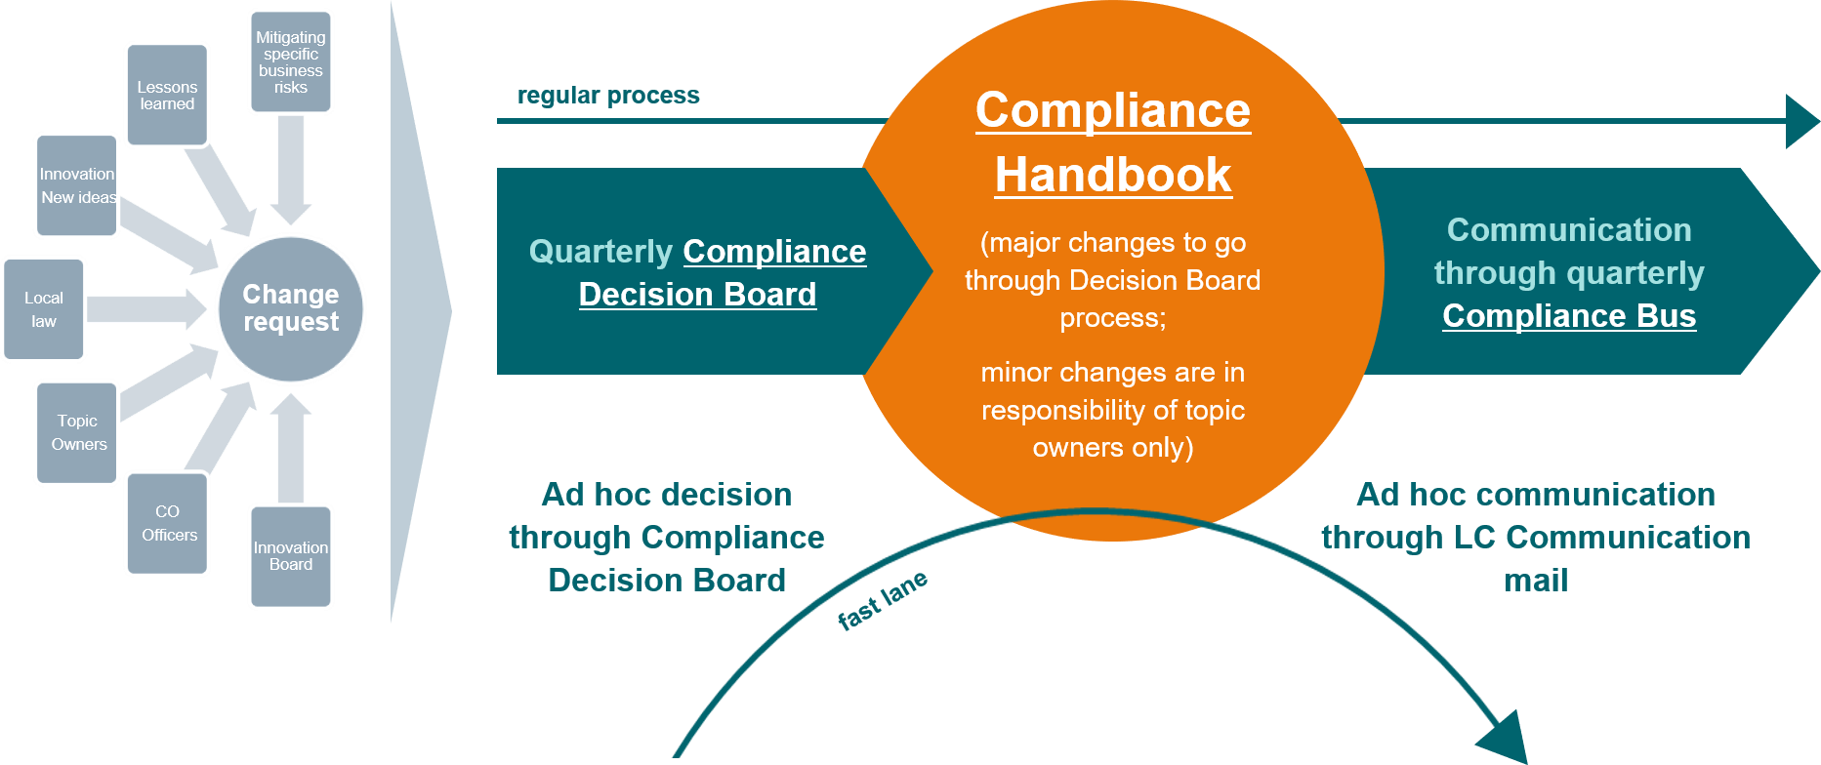

Changes that have been approved by the Compliance Decision Board or in the respective project structure through a Steering Committee or similar can be integrated into the Compliance Handbook.

* 1. The Changes have to be integrated into the respective chapter in the Word template uploaded In the [Compliance Handbook SharePoint.](https://workspace.c6.siemens.com/content/300000007/Compliance%20WebBook/Forms/AllItems.aspx) The “Track Changes” modus of Word must be used for the integration of changes. The changes will only be visible in the Compliance Handbook Preview Version after creation of a new Preview Version.4
  2. A short summary of the changes should be included in the section “History of Changes” of the respective Chapter.
  3. The Editor of the Compliance Handbook should be informed about the changes implemented. The Editor has the final approval authority and decides in close collaboration with the authors and topic owners about the release of the updated contents.
  4. For major changes in the Compliance Handbook we recommend a communication through the quarterly Compliance Bus. (Contact: Ines Zins, LC CO RFC CA, [ines.zins@siemens.com](mailto:ines.zins@siemens.com))

The Compliance Handbook will be updated on a quarterly basis. Updated Versions of the Compliance Handbook will be published by the editor in the so-called Web-book format and additionally as PDF version.

* + 1. Style Guide and Templates

In order to ensure that wording is consistent throughout the Web-Book and even more crucial, that the content is widely understood by employees, please use the following examples:

* + - 1. For **binding regulations**, please use expressions: ***must, is/are prohibited* and *is/are not permitted****. These are* probably most easily understood. Depending on the context, however, you can also use ***is/are binding, is/are mandatory, is/are to be complied with, is/are necessary****,* and *may not.*

4 [How to create an updated Preview Version](https://findit.compliance.siemens.com/content/10000101/Compliance/LC_CO/LC_CO_STR_SP/findIT_LC_CO_STR_SP_7963.ppt)

Constructions with *have to*, *shall*, *ought to* or *must not* should be avoided since they’re not really appropriate for regulations.

* + - 1. To express the idea that **exceptions** are possible, you can use, for example, *is* ***permitted if*, *is permitted provided that*** and ***is prohibited unless***.
      2. For **recommendations**, *should* is generally OK. But you can also use ***is/are recommended, is/are suggested* and *is/are advisable***.
      3. For **voluntary** actions, ***is permitted*** and ***may*** are often used. But you can also use simply ***is/are possible***.

The template that has to be used for the Compliance Handbook can be found here: [General Template for authors](https://findit.compliance.siemens.com/content/10000101/Compliance/LC_CO/LC_CO_STR_SP/findIT_LC_CO_STR_SP_7975.docx)

# Introduction to Anti-Corruption

The prevention of corruption requires procedures to avoid that financial means might be abused.

The elements of the first line of defense are internal processes to ensure that money is only given to Siemens employees or expenditures are reimbursed if there is a legitimate cause for it. Also, the mere impression of uncompliant behavior needs to be avoided. Therefore, Siemens has introduced rules for [Gifts and Hospitality](https://webbooks.siemens.com/public/LC/chen/index.htm?n=Part-1-Activity-Fields%2CA.-Anti-Corruption%2C1.-Gifts-and-Hospitality) as well as [Sponsoring, Donations and Memberships.](https://webbooks.siemens.com/public/LC/chen/index.htm?n=Part-1-Activity-Fields%2CA.-Anti-Corruption%2C2.-Sponsoring%2C-Donations%2C-Memberships)

On the other hand, it cannot be excluded that Siemens employees might encounter situations where they face a threat of death, injury or loss of personal liberty. Our rules on [Facilitation Payments](https://webbooks.siemens.com/public/LC/chen/index.htm?n=Part-1-Activity-Fields%2CA.-Anti-Corruption%2C3.-Facilitation-Payments) and payments under duress contain the relevant guidance for such incidents.

The elements of the second line of defense are processes avoiding the engagement of third parties to conceal bribes. For that reason, we have defined designated rules for [Business Partners.](https://webbooks.siemens.com/public/LC/chen/index.htm?n=Part-1-Activity-Fields%2CA.-Anti-Corruption%2C4.-Cooperation-with-Business-Partners%2CA.-Relevance-for-Business%2CA.1.-Business-Partner-Types%2CA.1.2.-Non-sales-related-Intermediary) Also, [Conflicts of Interest](https://webbooks.siemens.com/public/LC/chen/index.htm?n=Part-1-Activity-Fields%2CA.-Anti-Corruption%2C5.-Conflict-of-interest%2C5.2.-Dos-and-Don%E2%80%99ts) are covered as challenging situations that might lead to an undue influence on decisions.

# Gifts and Hospitality

“Gifts and Hospitality” includes all business-related benefits such as gifts, meals, entertainment, payment of travel and lodging expenses, trade fair tickets or other contributions without consideration. Under certain circumstances, providing or accepting Gifts and Hospitality could create the appearance of impropriety or even be considered as corruption. To minimize risks for [employees](https://webbooks.siemens.com/public/LC/chen/index.htm?n=General-Introduction%2C2.-Definitions-and-Abbreviations) and company related to benefits, every employee must comply with the following general principles and requirements when offering or accepting benefits:

**General principles** **–** Gifts and Hospitality must

▌ Be in accordance with applicable **laws and regulations** and mindful of **internal rules** that the recipient, especially [government officials,](https://webbooks.siemens.com/public/LC/chen/index.htm?n=General-Introduction%2C2.-Definitions-and-Abbreviations) might have.

▌ Be provided or received in a **transparent** manner and correctly recorded in the financial books and records.

▌ Be **appropriate** in terms of type, value, and frequency to the occasion and the position of the recipient.

▌ Not be offered, provided, demanded, or accepted with the **expectation** of any type of advantage.

▌ **Never give the** appearance **of dishonesty or inappropriateness.**

**In addition to our** **general principles**

▌ **A prior** **SpoDoM-Approval** **is required for offering or granting invitations to** **Entertainment****Events,** **reimbursement of** **Lodging or Non-Local Travel Costs****, or Other Contributions without Consideration of a value of EUR 20,000 or more**

* to **Government Officials** and their **Related Parties**, **Government Entities**, **Healthcare Providers,** members of a **purchasing department** or beneficiaries that are **involved in important business decisions** (**Risk Groups**),
* if no **exception** applies.

▌ No SpoDoM-Approval is required for offering or granting Gifts and Meals, reimbursement of Local Travel Costs, or for accepting Benefits.

▌ **Gifts of money** are prohibited unless a prior written **approval of the Compliance Officer** is granted.

### Guidance on general principles

Gifts and Hospitality must not be offered, provided, demanded, or accepted with the expectation of any type of advantage.

Employees must not provide or accept a gift or other benefit before checking it against our general principles. Already a promise or demand of Gifts and Hospitality with the expectation of an advantage (e.g. preferential treatment in competition with other companies) can be illegal.

Gifts and Hospitality must never give the appearance of dishonesty or inappropriateness.

Employees must refrain from any actions that could create an appearance of bad faith or inappropriateness, even if such actions are not illegal.

Gifts and Hospitality must be in accordance with applicable laws and regulations and mindful of internal rules that the recipient, especially government officials, might have.

The local rules of the country in which the benefit is provided is the starting point for evaluating compliance with applicable laws. If the recipient of the benefit does not live in this country, employees shall double-check the rules for the home country of the recipient as to whether any specific local rules apply, such as the prohibition of certain benefits or limits on the value of benefits. Most national laws require their nationals to adhere to the anti- corruption rules of their home country also when being abroad. National laws can vary considerably as to the prohibition of Gifts and Hospitality. In some countries, it may even be obligatory to comply with the internal rules of recipient`s organization, especially in the public sector (Government Officials and their Related Parties). Providing inappropriate gifts or hospitality to [Government Officials](https://webbooks.siemens.com/public/LC/chen/index.htm?n=General-Introduction%2C2.-Definitions-and-Abbreviations) and their [Related Parties](https://webbooks.siemens.com/public/LC/chen/index.htm?n=General-Introduction%2C2.-Definitions-and-Abbreviations) is prohibited and punishable by law.

* Information to / Authorization by the Superior of the Beneficiary

Local law or the internal rules, especially in the public sector, might also require that the superior of the beneficiary or a competent entity be informed or their authorization is needed. Depending on the circumstances and local standards, Siemens employees offering benefits should use appropriate, customized wording in their communication with the beneficiary, such as:

* + *“There might be special local regulations applicable to you in respect of the acceptance of these benefits. If you are unsure whether such regulations apply to you, please contact your local legal or compliance department or your superior and check if you are able to accept this offer.”*
  + *“Please do not forget to inform your superior and to obtain any authorization which might be required according to local laws and your organization’s internal rules before accepting this offer.”*
  + *“When accepting this invitation, we assume that your participation in this event is in compliance with local laws and internal rules applicable to you and that you have informed your superior, if so required.“*
  + *“When accepting this gift, we assume that the acceptance of this gift is in compliance with local laws and internal rules applicable to you and that you have received the authorization of the competent entity in your organization, if so required.“*
  + *“This offer of … is conditional upon your compliance with all legal and other requirements for acceptance, including but not limited to anti-corruption laws. By accepting this offer of …. you confirm that you have complied with all legal and other requirements applicable to you, in particular, but not limited to any approval requirement of any competent authority, entity or person.”*
  + *“This invitation is conditional upon the authorization by the competent entity in your organization.”*
  + *“When confirming your participation, we would like to ask you to affirm that you have received the authorization of your superior or any other competent entity in your organization for accepting this benefit.”*
  + *“Due to Public Sector regulations, we must ask you to provide us with a copy of the authorization of your superior for accepting this benefit.”*

Employees might also use an invitation and registration tool, if available, and insert appropriate compliance disclaimers. In the tool, the registration requirements can differentiate between private and public sector invitees by having the invitees certify that they belong to either sector, subsequently customizing the compliance disclaimer accordingly. For example, public sector invitees can be asked to certify actively that they have informed or received the authorization of their superior, whereas private sector invitees might just be hinted to the fact that Siemens assumes that the beneficiary complies with local laws and internal rules and has informed his superior.

If appropriate, the employee might disclose the value of the benefit in the invitation or offering. In addition, the employee might offer the beneficiary that he/she may choose to cover part of the costs, e.g. for accommodation and/or travelling to reduce the benefit to an amount which can be accepted by the beneficiary.

Gifts and Hospitality must be appropriate in terms of type, value, and frequency to the occasion and the position of the recipient.

The appropriateness of a benefit is judged based on all circumstances of the specific occasion, and in accordance with local law and standards. This encompasses the value of the benefit and the occasion on which it is offered, its frequency, the transparency with which it is processed and the position of the beneficiary, in particular whether the recipient will be responsible for making a business decision of significance to Siemens in the near future or has taken such decision in the recent past. The internal rules of the recipient’s organization may also provide assurance as to what is considered appropriate under local standards.

Gifts and Hospitality must be provided or received in a transparent manner and correctly recorded in the financial books and records.

Employees shall confer the benefit in such a way that it is obvious to the recipient's employer, line manager or colleagues, and that its nature and value can be verified. Conferring a benefit in secret creates the suspicion of an improper motive on the part of the giver. Employees shall therefore send gifts and invitations to the business address rather than the private address of the recipient, and shall use the company letterhead for the covering letter.

**Please note:** *“In case of benefits offered or granted jointly with third parties, the overall situation including the benefits offered or granted/financed by the third parties shall be assessed.”*

### Types of Benefits

**Benefits** are any economic and non-economic advantages which improve the recipients’/beneficiaries’ position.

**Economic benefits** are money or tangible non-monetary benefits

such as Gifts and Meals (A.1.2.1.), Entertainment Events (A.1.2.2.) or Travel and Lodging (A.1.2.3.) as well as Other Contributions without Consideration (A.1.2.4.).

**Non-economic benefits** are any other advantages. They may include, for example, a job or an internship for the recipient or the recipient's [Related Parties,](https://webbooks.siemens.com/public/LC/chen/index.htm?n=General-Introduction%2C2.-Definitions-and-Abbreviations) the granting of a permit or an introduction to

certain influential people (A.1.2.5.).

* + 1. Gifts and Meals

A **Gift** is a present or something that is given to an individual without payment. **Meals** include food and drinks.

Meals as Entertainment Events

If Meals are combined with additional benefits, they might be considered an Entertainment Event. In such case the Meal and any additional benefits must be handled in their entirety as an Entertainment Event.

Gifts of Money

Gifts of money encompass any benefit of a nature comparable to a monetary gift, for example, checks, shares, bonds or credit notes for a monetary amount, as well as vouchers for goods that can be redeemed in cash. Vouchers for goods that cannot be redeemed in cash, or fuel vouchers for a specific quantity of a specific type of gasoline are not considered monetary gifts.

Gifts of money generally create the appearance of bad faith or impropriety. Therefore, such gifts require the prior written **approval** of the responsible Compliance Officer even where they are permitted under local law.

Specific Principles

Besides the general principles and possibly country or industry specific requirements Siemens does not make gifts in illegally traded wildlife products, e.g. rhino horn, ivory and tiger, and does not accept such gifts from third parties.

SpoDoM-Approval

Providing Meals or Gifts to third parties does not require prior SpoDoM-Approval.

* + 1. Entertainment Events

An **Entertainment Event** comprises any event where the price is not

only paid for food and drinks but includes, for example, an (implicit) supplement for music or other entertainment. This encompasses folk festivals.

Specific Principles

Besides the general principles and possibly country or industry specific requirements, Entertainment Events shall comply with the following standards:

* + - * Wherever possible, the Entertainment Event shall be **part of a business program**;
      * Review and **approval by the manager** responsible according to applicable signature regulations must be **documented**. The manager shall review whether the intended activity is in line with Siemens rules as set out in these instructions;
      * Tickets must be acquired **via official sales offers**, not on the black market.

SpoDoM-Approval

Regarding a SpoDoM-Approval for providing Entertainment Events to Government Officials and their Related Parties, Healthcare Providers, members of a purchasing department or beneficiaries that are involved in important business decisions (Risk Groups) see Chapter A 1.3.

* + 1. Travel and Lodging Costs

**Travel and Lodging Costs** for third parties are e.g. costs for inspection tours, acceptance visits, training.

Exceptions

The reimbursement of travel costs for **job applicants** is not considered a benefit for the purposes of these instructions. The same applies for occasionally and spontaneously driving employees of customers or other third parties or giving these persons a lift in one’s own taxi. However, this exemption does not apply for arrangements to drive someone repeatedly.

The reimbursement of travel and lodging costs incurred by a **service provider** that are necessarily implied in providing a service ordered by and performed for Siemens does not constitute a benefit in the sense of these instructions. Costs shall however only be reimbursed if reimbursement has been agreed in advance, for example by means of a contract or a purchase order.

The same applies for **conference speakers** who have been invited to present a subject on behalf of Siemens on a conference or a congress. The reimbursement of these implied travel and lodging costs does not constitute a benefit in the sense of these instructions. However, specific regulations and reporting requirements may apply if the invited person works in the public sector or is a Healthcare Provider. In such cases, the applicable local and industry specific regulations must be checked or the responsible Compliance Officer shall be contacted.

Specific Principles

Besides the general principles and possibly country or industry specific requirements, reimbursing Travel and Lodging Costs for third parties shall comply with the following standards:

* The reimbursement itself (instead of a payment by the third party itself), the number and function of the persons (e.g. few or many, with or without spouses) as well as the standard of the travel (e.g. economy or business class) and lodging (e.g. three or four star hotel) and their duration must be justified by a **legitimate business purpose**.
* The costs need to be **proportional** compared to what is received in return (the standard of travel and lodging, the travelling duration, as well as number of travelling persons).
* Cost reimbursements may **not be made to private bank accounts** or to individual persons **or to third parties** (other than the employer of the beneficiary) for forwarding to the beneficiaries.
* Because **travel agencies** can be used to create slush funds, employees shall avoid reimbursement of costs for travelling or entertainment arranged by travel agencies for employees of the customer or other third party if Siemens has no sufficient control over the arrangements and their execution. In case the use of a travel agency is necessary, employees shall select agencies with high integrity and insist on an itemized, detailed proof of service and receipts of accommodation and travel providers.

Local vs. Non-Local Travel Cost

As local travel costs do not require a SpoDoM-Approval, it is important to distinguish between local and non-local travel costs.

Crossing a country border does not per se imply that the travel must be considered non-local. In case the nearest transportation stop to or from a Siemens facility is nearby but in another country, the travel may still be considered “local” provided it otherwise fits into the criteria for local travel. An approval in the SpoDoM tool thus is not required if the employee of the customer or supplier must be brought to the nearest transportation stop (e.g. a taxi to the airport or train station) which happens to be abroad due to the location of the Siemens facility.

Siemens regional companies may further define what falls under "local travel" for their respective country (for example with reference to a specific monetary threshold or a threshold regarding distance, means of transportation or otherwise). If there are various Siemens companies in the same country, the country specific definition shall be aligned among them. Country specific definitions of what is considered “local travel” shall be notified to the contact persons for gifts and hospitality at LC CO PT and LC CO RFC LF and shall be made available via the Compliance intranet.

SpoDoM-Approval

Regarding a SpoDoM-Approval for providing lodging or non-local travel to Government Officials and their Related Parties, Healthcare Providers, members of a purchasing department or beneficiaries that are involved in important business decisions (Risk Groups) see Chapter A 1.3.

* + - 1. Daily Allowances

 **Daily Allowances** are intended for reimbursement of daily travel and lodging costs.

Specific Principles

Besides the general principles and the specific principles for travel and lodging costs, Daily Allowances for third parties shall comply with the following standards:

* + - * + The occasion and the amount shall, where possible, be **specified in the customer contract or tender documents**. If a Daily Allowance is requested but not yet specified, occasion and amount shall be made transparent to the customer and aligned with an authorized representative of the customer and the supervisor of the beneficiary. Try to amend the contract. Have the customer guarantee if possible in the contract that the requested Daily Allowances are in line with local law;
        + In case the customer did **not determine the amount** of the Daily Allowance, use the travel reimbursement guidelines of the customer for the country the Daily Allowance is granted as a guideline for what is adequate. Should the customer not have such a guideline, use Siemens travel guidelines for the country the Daily Allowance is granted;
        + In case an authorized representative of the **customer requests** Siemens **to transfer the Daily Allowance to his employees directly** for legitimate reasons (e.g. money transfer or currency restrictions) indicating the account number(s), Daily Allowances may be paid to individual accounts, unless such transfer infringes applicable law or Siemens rules. The beneficiary must acknowledge the receipt. Customer’s request and beneficiary’s receipt must be documented. In all communications accompanying a payment or reimbursement, it must be clearly stated that it is being made to a recipient organization and not for the benefit of an individual person;
        + If payment of Daily Allowances to a **third party** for **forwarding to the beneficiaries** is absolutely necessary for legitimate reasons (e.g. money transfer or currency restrictions), confirm this with the customer and have the customer certify that this is in line with local law. Customer confirmation and receipt of the Daily Allowance by the beneficiaries shall be documented;
        + The beneficiary shall be reminded that the Daily Allowance might have to be **declared under local tax laws** and that Siemens does not take over the tax. The customer or the beneficiary must evaluate and implement any such requirement;
        + There are additional prerequisites for **handing out cash** as set forth in [Siemens Circular No. 208.](https://circulars.siemens.com/content/circulars/ca/_layouts/querplex/circularapplication/documents/CircularDownload.aspx?id=sc_208.pdf) Avoid handing out cash, see also Chapter C.
    1. Other Contributions without Consideration

**Other Contributions Without Consideration** include any voluntary contributions to entities (as opposed to individuals) in money or in kind without consideration that have a commercial background, such as an existing business relationship with the recipient, but that do not meet the prerequisites for a classification as a Sponsoring or a Donation / Charitable Contribution as set forth under [Siemens Circular No. 186”.](https://circulars.siemens.com/documents/CircularDownload.aspx?ID=SC_186.pdf)

Siemens provides Contributions with commercial background to existing or potential business partners or to other recipients to pursue legitimate business interests, such as building or nurturing contacts with customers and suppliers.

For example, a contribution to a customer’s or supplier’s company party would qualify as “Other Contribution without Consideration”. A contribution is still considered “without Consideration” if Siemens is offered a consideration in return that is of no or little value to Siemens.

Exceptions

The following expenditures do not qualify as Other Contribution without Consideration:

* + - * Mandatory charges pursuant to statutory obligations (for example, fees);
      * Additional contributions in connection with existing Memberships (these are to be registered in the SpoDoM tool in the category Memberships of [Siemens Circular No. 186](https://circulars.siemens.com/documents/CircularDownload.aspx?ID=SC_186.pdf));
      * Items from the Siemens advertising media catalogue;
      * Deliveries of products or services free of charge if they have been contractually agreed upon and they:
        + are required as samples for a specific, contractually defined business purpose and are appropriate and permitted under local law; or
        + have been agreed upon as a pricing tool in connection with a customer order (for example, free additional services or spare parts deliveries for a system supplied by Siemens); or
        + are implemented as part of a research partnership in accordance with [Siemens Circular No. 212,](https://circulars.siemens.com/documents/CircularDownload.aspx?ID=SC_212.pdf) in which Siemens has obtained defined considerations, such as rights to use the research results.
* Sponsoring Activities, Memberships, Donations and Charitable Contributions provided to third party corporations and other external entities are governed by [Siemens Circular No. 186](https://circulars.siemens.com/documents/CircularDownload.aspx?ID=SC_186.pdf) and the pertinent explanatory documents.

Specific Principles

Besides the general principles and possibly country or industry specific requirements, Other Contributions without Consideration shall comply with the following additional standards:

* + The identity of the recipient, the reason for and the planned use of the contribution must be **clear** and

plausible, legally justifiable and documented;

* + Contributions may **not be linked to sales transactions** or other business decisions in such a way that they themselves could be considered a reward for those transactions, or in such a way that the impression arises

that a relation of reciprocity exists (e.g. a contribution is made without plausible legitimate reason before or immediately after a business decision has been made);

* + Contributions may not be paid to private bank accounts or made to individual persons. In all communications accompanying a contribution, it must be clearly stated that the contribution is being made to a recipient organization and not for the benefit of an individual person;
  + Contributions may not be made to recipients whose **goals are incompatible** with Siemens’ company principles or would damage Siemens’ reputation;
  + Contributions may not be worth **less than €100.00** or the corresponding amount in local currency, since the administrative burden for handling such small contributions exceeds their value.

SpoDoM-Approval

In addition to the requirements above, a prior SpoDoM-Approval is mandatory for all Contributions without Consideration of a value of EUR 20,000 or more if the recipient organization is a Government [Entity](https://webbooks.siemens.com/public/LC/chen/index.htm?n=General-Introduction%2C2.-Definitions-and-Abbreviations) or Healthcare Provider or is involved in important business decisions, such as contract negotiations, the acceptance of a bid or a factory acceptance test.1

* + - 1. No political or religious contributions

Siemens is religiously and politically neutral. For this reason, the company’s contributions may not foster in a targeted manner either one religious group or one partisan political ideology vis-à-vis other persuasions or political viewpoints. Contributions without Consideration that benefit the activities of a religious denomination (for example, of a church or a clergy for missionary work or liturgical activities) or that support partisan political purposes or the representation of partisan political interests (for example, election events for political campaigns) are prohibited.

Consequently, it is also not permitted to hold memberships, as defined in the [Siemens Circular No. 186,](https://circulars.siemens.com/documents/CircularDownload.aspx?ID=SC_186.pdf) in political parties or religious organizations.

However, permissible are:

* + - * + Support for other activities of a religious organization or of a party-related organization that is non-partisan in accordance with its articles of association, as long as the Siemens strategic goals and the general requirements are complied with;
        + Contributions by Siemens employees in the U.S. to the Siemens Corporation Political Action Committee, since these are not contributions made by the company.
    1. Non-economic benefits

Non-economic benefits are any non-economic advantages. They may include, for example, a job or an internship for the recipient or the recipient's [Related Parties,](https://webbooks.siemens.com/public/LC/chen/index.htm?n=General-Introduction%2C2.-Definitions-and-Abbreviations) the granting of a permit or an introduction to certain influential people.

Awarding of Jobs (Dealing with Princelings)

The awarding of jobs – whether temporary, such as internships, or permanent – is exclusively to be made based on the personal and professional qualifications and suitability of the applicant ([BCG Chapter E](https://findit.compliance.siemens.com/content/10000101/Compliance/CL_CO/CL_CO_AT/findIT_CL_CO_AT_55.pdf)). This applies to the awarding of jobs to close relatives of actual or potential business partners, customers or policy makers **(,Princelings’)**, or to these themselves.

Recruitment of “princelings”, who are awarded internships or permanent positions in companies outside of the normal employment process, generally creates the appearance of bad faith or impropriety and can be considered corruption in most jurisdictions.

* + - * As a **manager**: Adhere to the principle of basing a decision to award a job solely on the individual’s personal and professional qualifications and suitability.
      * As an **employee**: If your manager wants to push through a job award, point out to him or her the proper process and why this important. If you feel uncomfortable, please turn to your compliance officer for help assessing the situation.
      * For **both**: If you become aware of a seemingly strange, quick or unexpected hiring, directly approach the hiring manager or turn to your compliance officer for support.

**Please note:** *“The awarding of jobs – whether temporary, such as internships, or permanent – is exclusively to be made based on the personal and professional qualifications and suitability of the applicant (*[*BCG Chapter E*](https://findit.compliance.siemens.com/content/10000101/Compliance/CL_CO/CL_CO_AT/findIT_CL_CO_AT_55.pdf)*).”*

### SpoDoM-Approval for providing benefits

**Please note:** *“Providing invitations to* *Entertainment Events* *and*

*the payment of Lodging or* *Non-Local Travel Costs* *must be approved in advance in the SpoDoM tool, if the beneficiary belongs to any of the*

*Risk Groups and the benefits are not stipulated in a contractual agreement as further specified below. Moreover, prior SpoDoM approval is always*

*mandatory for* *Other Contributions without Consideration* *of a value of EUR 20,000 or more to entities belonging to a Risk Group.2”*

Risk Groups

**“Risk Groups”** are [Government Officials](https://webbooks.siemens.com/public/LC/chen/index.htm?n=General-Introduction%2C2.-Definitions-and-Abbreviations) and their [Related Parties,](https://webbooks.siemens.com/public/LC/chen/index.htm?n=General-Introduction%2C2.-Definitions-and-Abbreviations) Government [Entities,](https://webbooks.siemens.com/public/LC/chen/index.htm?n=General-Introduction%2C2.-Definitions-and-Abbreviations) Healthcare Providers, members of a purchasing department, beneficiaries that are involved in important business decisions, such as contract negotiations, the acceptance of a bid or a factory acceptance test3. In case of doubt whether a person belongs to a purchasing organization or has the power to make an important business decision, this must be checked directly with the beneficiary4. An approval is required in the SpoDoM tool, if the beneficiary has alone or jointly with others the power to decide on a bid or to make any other important business decision for Siemens. To avoid any appearance of an improper influence, the approval requirement applies also when the important business decision has already been taken in the recent past.

Approval

The approval in the SpoDoM tool must be obtained **before the benefit is offered** or the invitation is made. It is recommended to start the SpoDoM process and to obtain the approval well in advance of the event date to have sufficient time to clarify all issues and to finalize the invitation after the approval.

National laws and internal rules of entities often take account of whether the beneficiary has informed his superior or received the authorization to accept a benefit. This applies in particular to the public sector but might also be applicable in the private sector. Thus, it should be checked if information to or authorization by the superior of the beneficiary is necessary and addressed appropriately, when providing a Benefit

The SpoDoM tool ensures the seamless and uniform documentation of the activities. The tool also offers a detailed checklist as to whether an approval in the SpoDoM tool is required. The result of this checklist can be printed and used for further documentation.

For an approval, the [SpoDoM tool](https://spodom.cf.siemens.de/dms) guides you through 6 steps: Identification, Authorization, Key Data Entry, Assessment, Approval and Execution. It is used to correctly categorize benefits. The tool also helps to find out if the beneficiary belongs to a Risk Group.

▌ Management

After having entered the required data in SpoDoM, the tool provides a list of one or more persons from the pertinent management group according to the applicable signature mandate rules who can be selected in the tool for approving the activity.

3 The following is, as a rule, considered an important business decision: The conclusion or termination of a frame contract; a settlement about material open claims; imposing material liquidated damages; the follow-up on material warranty costs; or the issuing of an acceptance certificate.

The following decisions are, as a rule, not as such considered an important business decision: Placing of purchase orders on the basis of an existing frame contract without further discounts or changes in the agreed terms; placing of regular orders based on standard terms and conditions; this may include discounts usual in the market; dealing with continuous business such as spare-part orders; or discussions during the pre-qualification phase of a tender, e.g. for clarification of technical issues without involvement of the final decision makers.

4 Examples of persons with relevant decision power are: Chief representatives of the potential customer (e.g. CEO, CFO); members of a committee deciding about the award of a tender.

Typically, the supervisor of the applicant (SpoDoM role: Originator) is responsible for the approval. Alternatively, the person who is going to authorize the payment for the activity may be selected. If the manager normally responsible for the authorization is himself/herself the host, as a rule, an additional manager must be involved.

▌ Compliance

The SpoDoM tool will provide a list of persons from the Compliance organization of the respective entity that is authorized to decide on the activity. One of these persons shall be selected by the originator.

▌ Communications/CM CUS

An approval by Communcations/CM CUS might be necessary for Sponsorships, Donations and Memberships as defined in [Siemens Circular No. 186.](https://circulars.siemens.com/documents/CircularDownload.aspx?ID=SC_186.pdf)

After the activity has been approved, the SpoDoM tool will generate an approval voucher. The voucher shall be attached to the documents for the relevant accounting unit when claiming payment of expenses related to a benefit.

* + 1. Approval Specifics for Entertainment Events

If any of the invitees to an Entertainment Event belongs to any of the Risk Groups, prior approval using the SpoDoM tool is required. It should also be checked if information to or authorization by the superior of the beneficiary is necessary and addressed appropriately.

The expenses for Entertainment Events shall be evaluated in their entirety. They may not be split separately into the meals, travel costs, lodging costs and the entertainment part. All costs for the entire event must be registered in the SpoDoM tool. In case a third party partly organizes and/or pays for an event together with Siemens, the complete agenda and expenses shall be included in the SpoDoM tool. For example, if a site visit organized and paid for by Siemens is tied to sight-seeing organized and paid for by a Siemens Business Partner, both site visit and sight-seeing must be registered in the SpoDoM tool for approval.

▌ Buying Tickets

In case of tickets purchase, the **SpoDoM-Approval** shall be obtained **before buying** tickets and the SpoDoM voucher shall be attached to the relevant accounting documents.

The intended purpose of the event and risk category of invitees should be **aligned** by the originator of the SpoDoM activity with the responsible person in the inviting business entity **before** purchasing tickets.

Evaluate whether the category and value of the intended event might hinder acceptance of the invitation by the intended invitees.

In case **the invitees cannot yet be determined**, the event shall be entered in the SpoDoM tool and evaluated on the basis of the anticipated category of invitees. The names of the invitees, the risk categorization and the evaluation must be adjusted to the actual invitees as soon as possible.

The approval in the SpoDoM tool must be obtained **before** the ticket is **offered**.

▌ Subsequent Approval in Exceptional Cases

If, in **exceptional** cases, the employee is for objective reasons not able to obtain the SpoDoM approval before the invitation (e.g. if the employee is travelling on business and has no access to the tool), the local

manager and the responsible Compliance Officer shall be contacted by other means, such as e-mail or telephone, in order to obtain their assessment of the intended activity.

The activity and the reason for the belated entry shall be **documented** in the SpoDoM Tool as soon as possible, at the latest within four weeks after the end date of the event. After this period, the employee must provide the Compliance Officer in writing with the reasons for the belated entry and the Compliance Officer can assist in making the entry in the SpoDoM tool.

▌ Spontaneous Guests

If an invitee brings along an uninvited guest, the rules of courtesy shall apply. If it were impolite to refuse inviting the unexpected guest in the specific situation, the host may **exceptionally** extent the invitation to that person. However, the participation of the spontaneous guest must be in line with the general and specific principles for Entertainment Events. The incident must be **documented** in the SpoDoM tool. In case of a recurring invitation the invitee shall be informed that Siemens expects him/her to announce an intention to bring along uninvited participants.

▌ Invitations of Siemens Employees’ Guests Please see Chapter 1.4..

* + 1. Exception: Siemens-Organized Events

Siemens-organized events are events that are organized or hosted by Siemens. These include, for instance, product presentations, media events or lecture series of Siemens panels. An external event cannot be classified as a Siemens-organized event even if it is financed entirely by Siemens.

Invitations to Siemens-organized or hosted events do not have to be approved in the SpoDoM tool if:

* + - * their purpose is to disseminate scientific or technical information of use to the invitees or to serve as a forum for the discussion of cultural or political topics and
      * at which any other benefits provided for invitees are appropriate in relation to the overall event.

Appropriate benefits, in the context of such an event organized by Siemens, are usually those that are directly related to the nature of the event, such as snacks or light meals, background music, a small souvenir of the location or related to the subject matter of the event, or a USB stick containing the presentation documents.

If therefore any other benefits provided to invitees could be considered inappropriate in relation to the overall event, an approval in the SpoDoM tool is required for Risk Groups. This can often occur with product presentations in particular, if – as is often the case - the presentation of the actual product is enhanced by the venue and ambiance of the event and by additional entertainment elements.

* + 1. Exception: Event/Travel/Lodging stipulated in a contract

An approval in the SpoDoM tool is not required for Entertainment Events, Lodging or Non-Local Travel for a member of a Risk Group where

* + - * the Lodging, Non-Local Travel or Entertainment Event has been contractually agreed upon (e.g. in a turn- key contract or a public offer of a reward); and
      * the respective contractual clauses have been reviewed by a member of the legal organization of the affected entity.

Nonetheless, the general and specific principles of Entertainment Events, or Travel and Lodging need to be observed.

The contract must have been checked and approved by the legal department of the affected entity before it is signed. The legal department may delegate this task to another person with a legal background, e.g. a contract manager of the respective business unit or Siemens entity or an external lawyer.

The content and extent of entertainment, lodging or non-local travel shall be stipulated in the contract in as much detail as possible in order to rule out subsequent disputes because of ambiguities in their interpretation. It should address at least the following items:

* + - * Scope and purpose of the travel activity;
      * Duration of the stay;
      * Number and – to the extent possible – function of the persons for which costs will be paid;
      * Specification of booking classes (or reference to applicable travel regulations such as the Siemens travel regulations) for transportation and accommodation;
      * Additional payments or benefits to be provided, if any (e.g. meals, incidentals, entertainment).

If the contract clause does not address a specific item which the customer requests to be reimbursed or if the customer asks for a modification of the contract, for example the participation of additional persons, an extended stay, five star instead of a four star hotel, the legal and compliance departments shall be involved to draft or review the proposed amendment of the contract.

Should an employee who shall process the reimbursement of the costs conclude that the contractual rules require amendments in order to ensure compliance with these instructions, he/she shall contact the responsible legal department and eventually the compliance department in order to define further steps.

**Please note:** *“A positive answer in the Limits of Authority (LoA) Tool in relation to ACRA question 3.2 (“Review of the terms of the contract by Legal or Contract Management”) does not automatically imply that a SpoDoM-Approval is not necessary. The above requirements as to the reimbursement must be stipulated in*

*the contract. If the contract only contains a very short clause without any details as to the scope and appropriateness of the costs to be reimbursed, a SpoDoM-Approval of the specific reimbursement is necessary.”*

* + 1. Approval of Other Contributions without Consideration*

Other Contributions without Consideration of a value of EUR 20,000 or more to a recipient organization that is a Government Entity, Healthcare Provider or that is involved in important business decisions, such as contract negotiations, the acceptance of a bid or a factory acceptance test, must always be registered and approved in the SpoDoM tool in advance of their offering or granting.5 The approval process is set forth in the applicable signature regulations and is implemented via the SpoDoM tool.

In case a contribution qualifies as Sponsoring or Donation / Charitable Contribution as defined under [Siemens](https://circulars.siemens.com/documents/CircularDownload.aspx?ID=SC_186.pdf) [Circular No. 186,](https://circulars.siemens.com/documents/CircularDownload.aspx?ID=SC_186.pdf) it must be evaluated in the SpoDoM tool under such category. It may not be entered in the SpoDoM tool under the category Other Contributions without Consideration. Otherwise, this would have the effect of circumventing the strategic restrictions set forth for Sponsoring or Donations / Charitable Contributions.

### Accepting Benefits as Siemens Employee

For accepting benefits, the general principles and possibly country or industry specific requirements apply. A SpoDoM-Approval is not required. However, where required by local law, the benefit has to be taxed e.g. as a wage component.

Benefits from External Parties

There is no formal approval process for the acceptance of Gifts and Hospitality by Siemens employees from an external party. If in doubt whether the gift or hospitality is in line with local law or Siemens rules, Employees should contact their responsible Compliance Officer. Employees must also check and comply with any tax implications and documentation needs under local law. For further information, the responsible human resources department can be contacted.

Of course, employees may accept occasional gifts of purely symbolic value. Employees may also accept meals or entertainment reasonable in value and consistent with local customs. A meal or entertainment is reasonable if the nature, value and frequency of the benefit are appropriate to the occasion on which it is given, to the position of the employee and all further circumstances. Any other meals, gifts or entertainment must be refused.

Internal Benefits offered by Siemens

Benefits offered by Siemens to employees of a Siemens company do not require an approval in the SpoDoM tool. Temporary employees, including student employees and interns, who have a valid contract are treated as internal staff for the purposes of these instructions. Nevertheless, such benefits must serve the Siemens interests, i.e. have a legitimate business purpose and be appropriate in relation thereto (for example employee motivation, improvement of team spirit, celebration of a success). The host or offeror and the recipient of the benefit have a duty to exercise due care in spending company funds and in general in the treatment of company assets.

Invitations to Siemens Employees’ Related Parties or guests

5 Exceptions can be found under Chapter A.1.5.1. Country Specific Requirements

In case an invitation to an Entertainment Event shall include Siemens [Employees' Related Parties](https://webbooks.siemens.com/public/LC/chen/index.htm?n=General-Introduction%2C2.-Definitions-and-Abbreviations) or other guests not connected with Siemens business activities, Siemens will assume such costs only in **exceptional** cases where this is in the business interest of Siemens (for example because the character of the event would require such participation, like in a family day organized for employee motivation). Whether such an exception exists will be decided by the responsible Compliance Officer through the approval process within the SpoDoM tool, if any of these persons belongs to a Risk Group. However, an approval in the SpoDoM tool is not required if these persons are invited to a Siemens-organized event (such as team events, Christmas parties or an “Open House” day).

### Specific Requirements

Depending on the country of the beneficiary or the country, where a benefit is offered, specific requirements may apply. Specific requirements also apply to Healthcare Business. The following list of requirements is not exhaustive. Employees shall verify together with their responsible Legal and Compliance organization, if further specific requirements apply to Gifts and Hospitality.

* + 1. Country Specific Requirements

For so-called Broad-Based Black Economic Empowerment (“**B-BBEE**”) (Supplier Development / Enterprise Development) contributions in South Africa, approval in SpoDoM is required for a value of EUR 100 or more.

Further country specific requirements may be found on the [“Siemens Compliance Map of Country-Specific Legal](https://intranet.legal-compliance.siemens.com/compliance/CountrySpecificLegalRequirements/) [Requirements (Gifts and Hospitality)”.](https://intranet.legal-compliance.siemens.com/compliance/CountrySpecificLegalRequirements/) Employees shall verify together with their responsible Legal and Compliance organization, if further specific requirements apply to Gifts and Hospitality.

* + 1. Specific Requirements for Healthcare Business

The healthcare system consists of people (Healthcare Professionals, „HCPs“)6, as well as of organizations and institutions (Healthcare Organizations, „HCOs“)7. HCPs and HCOs are subject to specific requirements regarding Gifts and Hospitality. HCPs and HCOs together are in these instructions referred to as Healthcare Providers. The following list of requirements is not exhaustive. Employees shall verify together with their responsible Legal and Compliance organization, if further specific requirements apply to benefits.

* + - 1. US Healthcare Sector

According to US law to all employees of Siemens Healthineers globally whose work involves any interaction with U.S.-licensed Healthcare Professionals (“HCPs“) and/or U.S.-based Healthcare Organizations (“HCOs“) a special regulation applies. For details please refer to Siemens Healthineers Compliance Web-Book: `Attachment 1: Disclosure Requirements USA`.

6 For definition of HCPs please refer to [Siemens Healthineers Compliance Web-Book: `Attachment 1: Disclosure](https://teamspace.healthcare.siemens.com/content/90000170/co/CommunicationsPublic/Compliance-Webbook.pdf) [Requirements USA` > `Definitions and Abbreviations`](https://teamspace.healthcare.siemens.com/content/90000170/co/CommunicationsPublic/Compliance-Webbook.pdf)

7 For definition of HCOs please refer to [Siemens Healthineers Compliance Web-Book: `Attachment 1: Disclosure](https://teamspace.healthcare.siemens.com/content/90000170/co/CommunicationsPublic/Compliance-Webbook.pdf) [Requirements USA` > `Definitions and Abbreviations`](https://teamspace.healthcare.siemens.com/content/90000170/co/CommunicationsPublic/Compliance-Webbook.pdf)

Furthermore, Siemens employees from other entities than the Siemens Healthineers entities worldwide or Siemens Regional Companies with Healthcare Business must register payments and other transfers of value in [ASTAR Web Portal](https://intranet.for.healthineers.siemens.com/wll/0034/Compliance/ASTAR/Pages/Default.aspx) when they participate in a tender jointly with the Siemens Healthineers entities or Siemens Regional Companies with Healthcare Business.

**Please note:** *“The registration in ASTAR is required regardless of any obligation to obtain internal approval for a benefit in the SpoDoM tool. Further information can be accessed on the* [*ASTAR webpage.*](https://intranet.for.healthineers.siemens.com/wll/0034/Compliance/ASTAR/Pages/Default.aspx)*”*

* + - 1. French Healthcare Sector

The following rules are valid for the Healthcare Business within the Siemens Regional Companies whose work involves any interaction with French Healthcare Professionals (“HCPs“) and/or French Healthcare Organizations (“HCOs”).

Any details can be found in the [Siemens Healthineers Compliance Web-Book: ` Attachment 2: Disclosure](https://teamspace.healthcare.siemens.com/content/90000170/co/CommunicationsPublic/Compliance-Webbook.pdf) [Requirements France`.](https://teamspace.healthcare.siemens.com/content/90000170/co/CommunicationsPublic/Compliance-Webbook.pdf)

**Please note:** *“All above cases must be entered in the SpoDoM tool, even if the French HCP is offered a Benefit normally not requiring registration in SpoDoM but in scope*

*of* [Siemens Healthineers Compliance Web-Book: ` Attachment 2: Disclosure Requirements](https://teamspace.healthcare.siemens.com/content/90000170/co/CommunicationsPublic/Compliance-Webbook.pdf) [France`](https://teamspace.healthcare.siemens.com/content/90000170/co/CommunicationsPublic/Compliance-Webbook.pdf)

*(for example business meals).”*

In case further information is needed, the French Healthineers Compliance Organization can be contacted.

* + - 1. Further Country-Specific Healthcare Requirements

For interactions with HCPs and/or with HCOs there are further country-specific requirements and disclosure obligations which can be found at the [Healthineers Compliance World Map of Country Specific Requirements.](https://intranet.app8.healthcare.siemens.com/HCOMap/)

### Further information

Further details, including the contact persons for gifts and hospitality at LC CO PT CO and LC CO RFC LF are available via the [Compliance intranet.](https://intranet.for.siemens.com/cms/059/en/processes/publications/Pages/compliance_gifts-hospitality.aspx) The Compliance Officers are also available for questions.

### Training and supporting material

Training & supporting material can be found on the [Gifts and Hospitality](https://intranet.for.siemens.com/cms/059/en/processes/publications/Pages/compliance_gifts-hospitality.aspx) intranet page, in the tab “Supporting Material”.

### History of changes

|  |  |  |
| --- | --- | --- |
| **Date** | **Author** | **Major changes of binding content** |
| January 1,  2019 | Panagiotis Chalioulias / Ulrike Desimoni / Soeren Kupich | Comprehensive revision of structure and format and text streamlining of the “Gifts and Hospitality – Binding Instructions” and integration into the Compliance Handbook. |
| October 15, 2019 | Panagiotis Chalioulias / Ulrike Desimoni / Soeren Kupich / Julia Wirth | More detailed instruction regarding „the dealing with principles“, compliance structure and links update, minor corrections. |
| April 1,  2020 | Ulrike Desimoni | Chapter 1.3.2. Content clarification regarding the exception: Siemens-Organized Events;  Chapter 1.2.4. and 1.3.4. Adaption of Risk Group of Contributions without Consideration |
| October 01, 2020 | Ulrike Desimoni / Soeren Kupich | Amendment of Chapter 1., 1.2.4., 1.3., 1.3.4.: Introduction of a threshold value of EUR 20,000 for Other Contributions without Consideration |
| April 1, | Ulrike Desimoni / | Amendment of Chapter 1.2.4, 1.3, 1.3.4, 1.5.1: |

|  |  |  |
| --- | --- | --- |
| 2021 | Soeren Kupich | introduction of mandatory SpoDoM approval for B- BBEE contributions in South-Africa as country- specific requirements |

* 1. Contacts

▌ Compliance Officer

The Compliance Officer responsible for your unit can be found through the following [link.](https://intranet.for.siemens.com/cms/059/en/about/org/Pages/compliance_organization.aspx)

▌ Corporate Governance Owner

Ulrike Desimoni (LC CO RFC LF) Yvonne Hamm-Düppe (LC CO RFC LF) Soeren Kupich (LC CO PT CO)

# Sponsoring, Donations, Memberships

Siemens supports organizations and activities around the world through Sponsoring Activities, Donations, Charitable Contributions and Memberships (“Contributions”). The support of certain groups, institutions, projects and activities is an essential part of our communications programs and initiatives to strengthen the Siemens brand, of our company’s social commitment as well as of its leadership in industry associations.

Communications (CM) has strategic responsibility (governance) for Sponsoring Activities, Donations and Charitable Contributions, and Memberships. Insofar, this chapter serves for information purposes only.

To bundle these activities in line with the relevant strategic objectives, to create transparency, to ensure compliance with all applicable statutory regulations and to strengthen control over the associated costs, Siemens has implemented the SpoDoM tool for registering and approving the activities. The Compliance Danger Sign questions to be answered in the SpoDoM tool in this context were fundamentally revised as of 01.10.2020.1 Compliance is now only included in the approval process for sponsorships and donations if the Danger Sign questions are answered positively.

The approval sequence in the SpoDoM tool for all ARE is as follows:

1. Communications
2. Compliance (in case of positively answered danger sign questions)
3. Management
4. CM CUS (only for donations > EUR 20,000 and sponsorships > EUR 50,000).

In agreement with the Siemens Business Conduct Guidelines, these Principles set out the mandatory requirements for the registration and approval of Contributions. They may not be circumvented either directly or through the use of third parties. The relevant managers are responsible for the appropriate, efficient and cost- conscious utilization of the company resources that have been allocated to such activities.

Additional information about Sponsorships, Donations and Memberships as well as Mandatory Contributions for social purposes can be found in the [Siemens Circular 186 “Principles for Sponsoring Activities, Donations,](https://circulars.siemens.com/documents/CircularDownload.aspx?ID=SC_186.pdf) [Charitable Contributions and Memberships”](https://circulars.siemens.com/documents/CircularDownload.aspx?ID=SC_186.pdf) and on the [“Sponsoring, Donations and Charitable Contributions,](https://intranet.for.siemens.com/cms/059/en/processes/publications/Pages/compliance_spodom.aspx) [Memberships, Other Contributions (SpoDoM)”](https://intranet.for.siemens.com/cms/059/en/processes/publications/Pages/compliance_spodom.aspx) intranet page.

### Training and supporting material

Training and supporting material can be found on the [SpoDoM](https://intranet.for.siemens.com/cms/059/en/processes/publications/Pages/compliance_spodom.aspx) intranet page, in the tab “Supporting Materials”.

1 The Compliance Danger Sign Questions implemented in SpoDoM, which are to be answered in the "Risk Assessment" section, have been fundamentally revised with the aim that the actual Compliance risks today are reflected in these questions and the number of questions are reduced as well as simplified.

### History of changes

|  |  |  |
| --- | --- | --- |
| **Date** | **Author** | **Major changes of binding content** |
| January 1,  2019 | Panagiotis Chalioulias / Ulrike Desimoni / Soeren Kupich | Revision of structure and format, text streamlining and integration into the Compliance Handbook. |
| Oct. 1,  2020 | Ulrike Desimoni/Soeren Kupich | Revision of Danger Sign questions Change of approval sequence  Responsibility of Compliance in the approval process |

### Contacts

▌ Compliance Officer

The Compliance Officer responsible for your unit can be found through the following [link.](https://intranet.for.siemens.com/cms/059/en/about/org/Pages/compliance_organization.aspx)

▌ Corporate Governance Owner

For these topics please contact Communications (CM). The responsible Governance Owners can be found on the [SpoDoM](https://intranet.for.siemens.com/cms/059/en/processes/publications/Pages/compliance_spodom.aspx) intranet page.

For Compliance questions in this context:

Ulrike Desimoni (LC CO RFC LF) Soeren Kupich (LC CO PT CO)

# Facilitation payments

The rules on the prohibition of corruption also apply without exception to so-called facilitation payments, as these are equally detrimental and usually pave the way for even more serious corruption issues. At the same time, Siemens has an obligation to ensure safe working conditions.

**General principles**

▌ Facilitation payments are prohibited.

▌ However, no employees are expected to risk life, limb or liberty in the course of performing their duties. Unjustified payments under duress will not be punished with disciplinary action.

▌ They must be reported in accordance with this section which also contains more detailed guidance.

Definitions:

A “*facilitation payment*” is the payment of a relatively small amount of money or the granting of any other benefit to usually low-ranking government officials, for their own personal benefit, with the aim of speeding up the performance of an official act to which the person making the payment/granting the benefit is entitled. This means that the government entity concerned would perform the official act in the same form and in any event, without payment to the government official (including, for example, granting approval where all preconditions are satisfied).

Both legally protected interests must therefore be considered when a situation of duress for Siemens employees arises. A “*situation of duress*” is a situation in which employees have no alternative but to make an unjustified payment in order to protect themselves or others against the threat of death, injury or loss of personal liberty. The “*threat*” must be tangible and manifest. A theoretical possibility does not qualify as duress1. “*Loss of personal liberty*” applies where there is a threat of imprisonment or comparable sanctions2.

### Prohibition of facilitation payments

Facilitation payments are prohibited by law in practically all countries as a form of corruption.

Legal exceptions in certain jurisdictions (such as Australia, South Korea and the USA) do not legalize facilitation payments as such, but merely exclude criminal prosecution, for example by the US authorities for facilitation payments effected outside the USA. Facilitation payments to government officials in the USA are forbidden and liable to criminal prosecution.

1 For example, if an armed government official is demanding payment without actually using his weapon to make a threat.

2 A mere delay in exit or onward travel procedures, caused for example by a refusal to perform customs clearance or objection to a visa in the context of passport control, is generally not sufficient to give rise to a situation of duress.

All Siemens employees are prohibited from offering, promising or making facilitation payments3. No such authorization will be granted. The same applies to payments or the granting of other benefits of comparable characteristics and with a comparable purpose to private commercial counterparties.

This prohibition may not be circumvented by making facilitation payments indirectly through third parties4. When working with third parties, employees must therefore look out for any indications, for example on invoices, that such third parties may have made or may be making facilitation payments in the context of their activities for Siemens.

### Exceptions

In many jurisdictions, a payment under duress is not deemed an act of corruption. In other countries, a situation of duress is at least recognized as justification or as grounds for exemption from punishment. Correspondingly, no Siemens employees are expected to risk life, limb or liberty in the course of performing their duties. Unjustified payments under duress will therefore not be punished with disciplinary action under the following conditions:

* Any employee should ask the person demanding the payment to explain the legal basis for the demand and inquire whether an official account or receipt will be issued for the payment5.
* If it becomes evident that the payment demanded most likely constitutes a facilitation payment, either because there is no plausible legal basis for such payment or because the government official refuses to issue an official invoice or receipt, the employee should oppose the demand as strongly as possible.
* If a situation of duress arises, it is permissible to yield to the request to make a facilitation payment. Expenditure in connection with facilitation payments is generally not reimbursed to employees or third parties acting for Siemens6.

Provided that

* the employee has complied in full with the applicable reporting and documentation obligations and
* there are no specific circumstances indicating that the employee is at fault in connection with the payment,

disciplinary action will generally be disproportionate because the employee will have allowed Siemens to meet its statutory documentation duties.

### Documentation and reporting

The request to make the payment must be reported to the [responsible Compliance Officer](https://intranet.for.siemens.com/cms/059/en/about/regions/Pages/compliance_regions-countries.aspx) without undue delay. The same applies if a third party acting for Siemens is suspected of having made facilitation payments or payments under duress in the context of its activities for Siemens.

3 Business Conduct Guidelines, section G1.

4 For example consultants, agents, intermediaries, other service providers or business partners.

5 The Regional Compliance Officer and the CSO Hotline +49 (89) 636 12345 can assist in clarifying whether or not the demand is justified in the case concerned.

6 For exceptions please see section 5.2. of this section below.

All facts7 must be recorded as soon as possible after the incident in a brief written report. This report must be submitted to the responsible Compliance Officer.

The Compliance Officer reports the incident in TRACI under the “Active Corruption” category, subcategory “Public Corruption Active”. To allow for easy identification, “FP” should be added in front of the case name8. In the case of a payment by a third party acting for Siemens, the report is produced by the responsible Compliance Officer in coordination with the third party concerned.

The Compliance Officer informs the management of the Regional Company and the General Counsel as soon as possible of every incident. The management of the Regional Company decides in consultation with the General Counsel and the responsible Compliance Officer whether the incident should be reported and, if so, to which local authority.

The management, together with the General Counsel and the Compliance Officer, decides on any further proceedings with the authority that requested the payment9. The responsible Compliance Officer advises the management of the Regional Company with regard to potential countermeasures for the future.

### Reimbursement of expenditure

Payments made under duress can be accounted for and reimbursed (for employees, this takes place within the framework of the travel expense reimbursement procedures), provided that

* + - the employee has properly documented a situation of duress and
    - the [responsible Compliance Officer](https://intranet.for.siemens.com/cms/059/en/about/regions/Pages/compliance_regions-countries.aspx) has confirmed the situation of duress.10

### Risk identification, monitoring and mitigation

The [responsible Compliance Officers](https://intranet.for.siemens.com/cms/059/en/about/regions/Pages/compliance_regions-countries.aspx) provide risk analyses concerning the occurrence of facilitation payments in their respective areas. They ensure that employees particularly exposed to risk receive appropriate training, with special regard to correct conduct in situations of duress.

All incidents must be reported immediately by the [responsible Compliance Officers](https://intranet.for.siemens.com/cms/059/en/about/regions/Pages/compliance_regions-countries.aspx) to Chief Compliance Officer and the Chief Counsel Compliance.

### Training and supporting material

Further information can be found on the [Facilitation Payments Intranet page.](https://intranet.for.siemens.com/cms/059/en/processes/publications/Pages/compliance_facilitation-payments.aspx)

7 The circumstances and subject matter of the demand, as well as the persons involved and their reaction to the refusal to pay.

8 The Compliance Officer reports the incident in TRACI under the “Active Corruption” category, subcategory “Public Corruption Active”. To allow for easy identification, “FP” should be added in front of the case name.

9 It is conceivable, for example, to issue a formal request to the authority that employs the recipient of the payment to provide an official invoice or receipt for the amount paid and/or to submit a claim for the recipient to return payment to the authority that employs the recipient of the payment or to a higher-level authority. 10 The [Compliance Officer](https://intranet.for.siemens.com/cms/059/en/about/regions/Pages/compliance_regions-countries.aspx) ensures that any reimbursement paid by the company is booked onto the account number 8311 Other Transfer of Class 8 "other income" to Class 6 and transfer of Class 6 "expenses" to Class 8.

▌ Quick guide “Do´s and Don’t´s”

The following quick guide summarizes the “[Do´s and Don’t´s](https://findit.compliance.siemens.com/content/10000101/Compliance/CL_CO/CL_CO_AT/findIT_CL_CO_AT_2272.pdf)” in terms of facilitation payments and shows which behavior is suggested in this context and which should be avoided if possible:

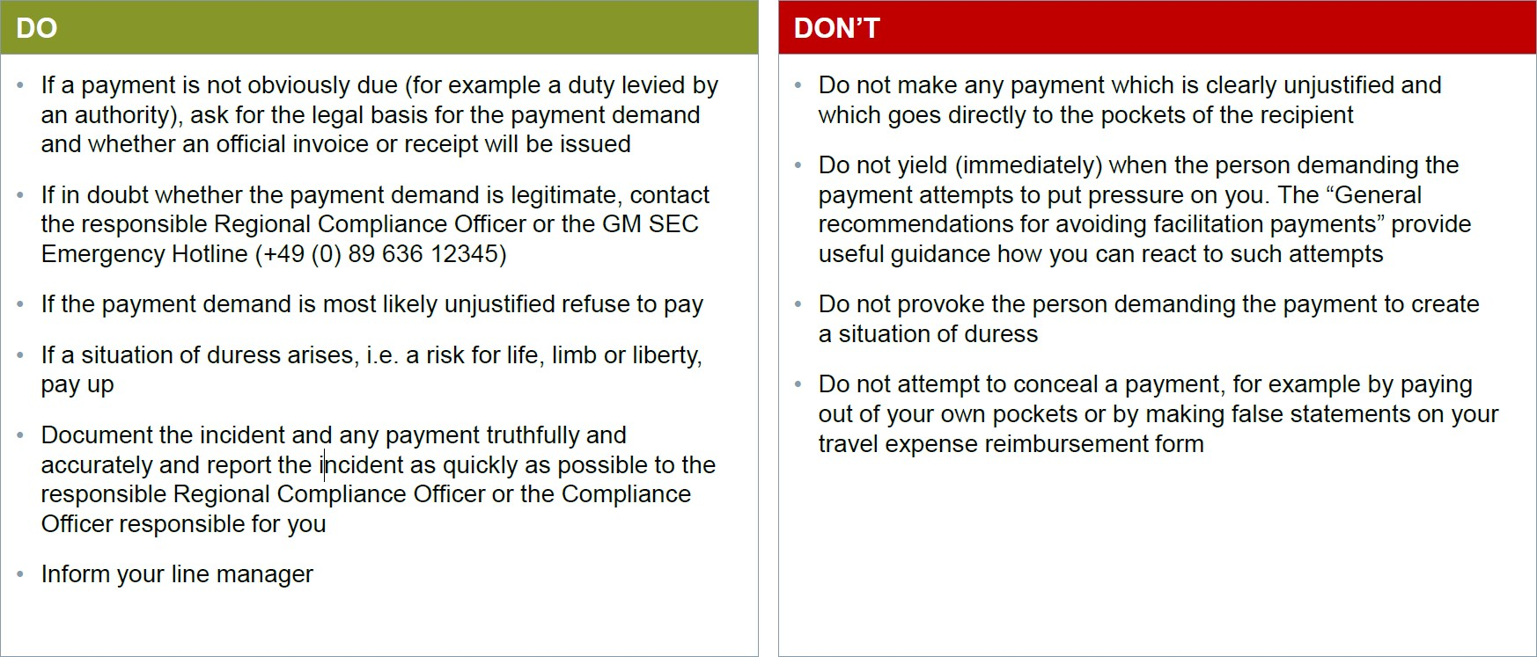

▌ General recommendations for avoiding facilitation payments

Furthermore the [“General recommendations for avoiding facilitation payments”](https://findit.compliance.siemens.com/content/10000101/Compliance/CL_CO/CL_CO_AT/findIT_CL_CO_AT_2269.pdf) can give more information in which general recommendations are given, on how to behave overseas in order to avoid a payment claim, how to react when faced with such a demand and how to proceed when the required payment cannot be avoided.

▌ Siemens Emergency Hotline (+49 89 636 12345)

Should a Siemens employee, during a business trip or business stay abroad, find himself in the situation of being asked to make a facilitation payment, he can obtain suitable 1st level support by calling the Siemens Emergency Hotline.

▌ Facilitation Payments as an awareness topic for Siemens

Additional information based on a concrete case study on the subject of facilitation payments as an awareness topic can be found in the presentation [“Awareness Topic Facilitation Payments”.](https://findit.compliance.siemens.com/content/10000101/Compliance/LC_CO/LC_CO_STR/findIT_LC_CO_STR_4880.pdf)

### History of changes

|  |  |  |
| --- | --- | --- |
| **Date** | **Author** | **Major changes of binding content** |

|  |  |  |
| --- | --- | --- |
| January 1, 2019 | Christina Wolfgramm Thomas Mark | First Release through the Compliance Handbook based on former Siemens Circular SC No. 226 “Global Compliance” Appendix 2. |
| January 1, 2020 | Yvonne Hamm-Düppe | Siemens Emergency Hotline added |

### Contacts

▌ Compliance Officer

The Compliance Officer responsible for your unit can be found through the following [link.](https://intranet.for.siemens.com/cms/059/en/about/org/Pages/compliance_organization.aspx)

▌ Content Owner

[Ralph Nohe (LC CO PT CO)](https://scd.siemens.com/luz/IdentitySearch?cn=nohe%2C%2Bralph&suchart=schnell) [Martin Felkl (LC CO RFC RC)](https://scd.siemens.com/luz/IdentitySearch?cn=felkl%2C%2Bmartin&suchart=schnell)

▌ Corporate Governance Owner

[Christina Wolfgramm](https://scd.siemens.com/luz/IdentitySearch?cn=WOLFGRAMM%2BCHRISTINA%2BZ002BPMD&tcgid=Z002BPMD&c=DE&o=SIEMENS&ou=LC&l=MCH%2BP&department=LC%2BCO%2BRFC%2BLF&&utI=I&utX=X&utT=T&rtH=H&rtS=S&rtZ=Z&rtO=O&rtAktiv=A) (LC CO RFC LF)

# Cooperation with Business Partners

## Relevance for Business

Under certain circumstances, Siemens may be held liable (B.1.) for the actions of certain third parties which we refer to as “[Business Partners](https://webbooks.siemens.com/public/LC/chen/index.htm?n=General-Introduction%2C2.-Definitions-and-Abbreviations)”.

Before starting a concrete relationship with certain third parties, Siemens must take steps to create transparency and ensure that the relationship is responsibly evaluated and managed. A **Compliance Due Diligence (CDD)** (A.4.) has to be initiated in the [CDD-Tool](https://compliance-tools.siemens.com/due-diligence/) and certain **contract provisions** (A.6.) need to be included in a contract with them.

After the approval of a CDD, an ongoing Business Partner relationship must be monitored by the respective Company Unit. The relevant CDD has to be kept up to date (A.4.2.).

Please find as follows an overview of our internal Business Partner landscape:

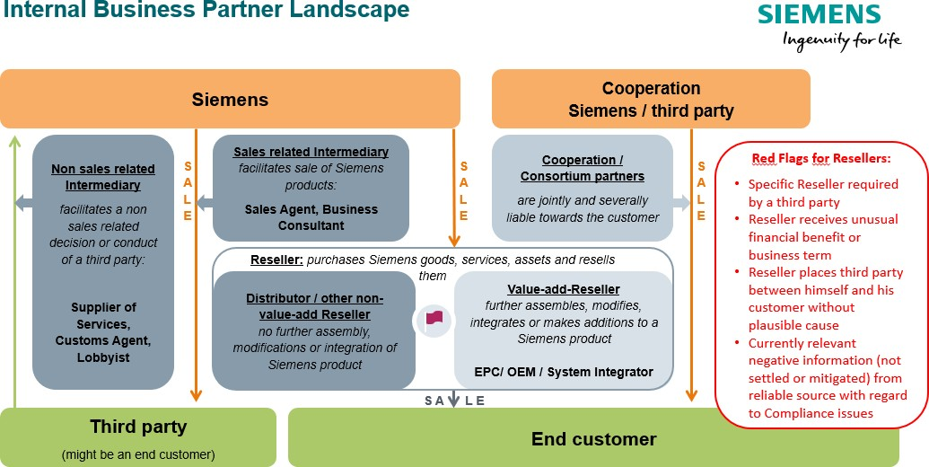

#### Business Partner Types

Certain business relationships require a Compliance Due Diligence (CDD) to be performed in the [CDD-Tool.](https://compliance-tools.siemens.com/due-diligence/) Generally, all Business Partners can be categorized as follows:

**Intermediaries**

* **Sales-related Intermediaries**, e.g. Sales Agents, Business Consultants (A.1.1.);
* **Non-sales related Intermediaries**, incl. Lobbyists and Customs Agents (A.1.2.).

**Resellers with Red Flags**

* **Value-add Reseller**, e.g. EPC, OEM / System Integrator (A.1.3.2.);
* **Distributor / other Reseller** (A.1.3.).

For these Resellers, a CDD and the use of certain contract provisions is only mandatory in case of one of the following **Red Flags**:

* + The use of the specific Reseller is required by a third party, e.g. an end customer (A.1.3.1.1.);
  + The Reseller receives an unusual financial benefit or business term from Siemens (A.1.3.1.2.);
  + The Reseller places another third party between himself and his customer without plausible cause (A.1.3.1.3.);
  + There is currently relevant negative compliance related information (not settled or mitigated) about the Reseller from reliable source (A.1.3.1.4.).

**Cooperation/Consortium Partners** (A.1.4.)

**Majority shareholdings** of Siemens (= affiliated companies) and **Siemens employees** are not in scope.

The identification of such Business Partners requiring a CDD is supported by the [Business Partner Checklist](https://compliance-tools.siemens.com/due-diligence/%23/ui/checklist) in the [CDD-Tool.](https://compliance-tools.siemens.com/due-diligence/)

* + 1. Sales related Intermediary

A **“Sales related Intermediary”** is a third party which

* facilitates1 the sale of Siemens goods, services2 and/or assets3

1 A Business Partner is in a position to **“facilitate”** decisions or the conduct of third parties to the benefit of Siemens when it may, actually or potentially, influence their conduct or decisions itself or through a third party. It is not relevant whether actually any improper influence is undertaken or intended. In contrast, if a Business Partner has no contact to any other party than Siemens or merely advises Siemens in its own decisions, generally he lacks the ability to influence decisions of a third party and is therefore out of scope of the Circular No. 226.

2 “**Siemens goods and services**” covers the entire Siemens portfolio, both physical and digital as well as financial.

* to another third party without purchasing4 them and
* receives a fee or other financial benefits5 (including price reductions)

from Siemens for such service6 (e.g. Sales related Business Consultants or Sales Agent)

* + - 1. Examples for sales related intermediaries
         * Sales related business consultant without sales rights

Third party commissioned to assist Siemens to **obtain sales or orders for defined specific business opportunities**, often larger projects. A sales related Business Consultant assists Siemens in generating revenue potential through direct contact with the customer (e.g. by promoting projects or supporting the pre-acquisition phase). He usually receives a fee that is not success related and works in an advisory

3 **“Assets”** such as real estate or those being part of a Merger & Acquisition (M&A) transaction are also considered to be “Siemens goods”. Insofar, real estate brokers or M&A advisors are also considered Sales related Intermediaries. But please note: If Siemens is for example interested e.g. to rent a new storage place, the real estate is not a Siemens asset. The real estate broker is then to be classified as non-sales related intermediary (for details please refer to [Overview with examples](https://findit.compliance.siemens.com/content/10000101/Compliance/LC_CO/LC_CO_DF/findIT_LC_CO_DF_9246.pdf) and A.1.2.)

4 If the Siemens goods, services and/or assets would be **purchased** by the Business Partner and then sold to another third party, the Business Partner does qualify as “Reseller”. In some cases Business Partners might also fulfill both criteria (e.g. in case of combined agency / distributorship agreements).

5 A **"financial benefit"** is every financial advantage, monetary or non-monetary. Examples for financial benefits are payments, transfers of tangible assets, granting of future business opportunities to the partner, a waiver of rights or titles by Siemens, price reductions, distribution rights, software licenses or simply any other valuable thing provided. “**Receiving**” from Siemens is not limited to a direct grant of the benefit by Siemens but covers also any indirect grant under the responsibility of Siemens, e.g. via third parties.

6 A business partner provides a "**service**" in the interest of Siemens when he is assigned by Siemens to influence decisions or the behavior of third parties in favor of Siemens. He does not act in the interest or on behalf of a Siemens entity if he pursues his own interests by influencing decisions or the behavior of third parties in his favor outside his work area and unmotivated by any advantages he may receive from Siemens. Examples: If a customer facilitates the purchase of Siemens products to be converted into components by its supplier, he is not acting in the interest of Siemens but in his own interest, even if he receives minor advantages from Siemens in return. The same applies to partners who (1) sell their own product and must additionally purchase Siemens by-products or services from Siemens or (2) sell their own product (e.g. a MindSphere App) for which the partner's customers must additionally purchase Siemens products or services (e.g. MindSphere operating system). The "supplementary" character of a Siemens product must be examined on a case-by-case basis; however, the Partner shall act in the interest of Siemens in any case if the purchase price of the Siemens product or the Siemens service is higher than 20% of the purchase price of the Partner's main product or service.

capacity without being accountable for the outcome of a consulting exercise (e.g. hired to facilitate introduction to customers or assist the sales function in other ways). A Consultant could also negotiate economical terms of a contract on behalf of Siemens. Purchasing contracts for the goods and services resulting from the consulting exercise are typically concluded between Siemens and the end customer directly.

* + - * + Sales agent

A Sales Agent is a person or company that **arranges sales transactions** as an **independent contractor** for an **undefined number of business opportunities**, on behalf of a Siemens entity as principal. Often in a defined territory or for a defined customer group, regarding contractually defined Siemens products or services (often also referred to as "commercial agent" or "commercial broker"). Sales Agents usually receive a commission from the principal for the business deal arranged and for projects based on separate agreed commission agreements. Sales Agents do not purchase and resell Siemens products and services (as opposed to Resellers) but represent the company in a certain region or towards certain customers. The purchasing contracts for the goods and services are typically concluded between Siemens and the end customer directly (also see [SC 140 Regional sales activities - Representation rights](https://regulations-admin.siemens.com/content/SC/140/en) [and sales rights](https://regulations-admin.siemens.com/content/SC/140/en)).

Please keep in mind that Strategy (ST TO) is responsible for the preparation and conclusion of contracts between sales agents / distributors and Siemens AG allocating representation rights / sales rights to third parties to ensure that sales rights granted to the Business Partner do not overlap with those granted to other sales agents.

* + - 1. Exceptions

Introducer are Business Partner of Siemens Financial Services (SFS) to which [SFS Implementing Rule](https://circulars.siemens.com/content/circulars/ca/CircularAttachmentsCorporate/SR_226_SFS.pdf) (only accessible for SFS employees) applies. Please refer to A.8.

* + 1. Non-sales related Intermediary

A regular **“Non-sales related Intermediary”** is a third party which

* facilitates7 a **non-sales related** decision or conduct (e.g. the issuance or award of an approval, permit, license or visa, a technical certification, or the payment of a debt)8
* of another **third party** to the **benefit of Siemens**9 and

7 A Business Partner is able to **“facilitate”** decisions or the conduct of third parties to the benefit of Siemens when it may, actually or potentially, influence their conduct or decisions itself or through a third party. It is not relevant whether actually any improper influence is undertaken or intended. However, if a Business Partner has no contact to any other party than Siemens or merely advises Siemens in its own decisions, generally he lacks the ability to influence decisions and is therefore out of scope of the Circular No. 226.

8 Other “**non-sales related decision or conduct**” would be e.g. the issuance or award of an acceptance, permission, a registration or liquidation, a confirmation or recognition, a technical certification.

* receives a **fee or other financial benefits**10 (including price reductions) from Siemens for such service11.

9 “**To the benefit of Siemens**”: In general, those decisions or conducts are covered, where the realistic danger of corruption, facilitation payments or other illegal conduct e.g. towards a third party exists, of which Siemens could benefit. However, an external engineer who is responsible for controlling the construction works of external contractors for a Siemens power plant would not be in scope. In that constellation, the engineer might technically have the possibility facilitate a “non-sales related decision or conduct” of such contractors. On the other hand, it is an unlikely scenario, that an engineer bribes a construction company - that is a contractor of Siemens - for the benefit of Siemens. However, if the same engineer has contact to authorities in relation to permits etc. needed for the final operation of the power plant, the situation is different as Siemens might benefit from it.

10 A **"financial benefit"** is every financial advantage, monetary or non-monetary. Examples for financial benefits are payments, transfers of tangible assets, granting of future business opportunities to the partner, a waiver of rights or titles by Siemens, price reductions, distribution rights, software licenses or simply any other valuable thing provided. **“Receiving from Siemens”** is not limited to a direct grant of the benefit by Siemens but covers also any indirect grant under the responsibility of Siemens, e.g. via third parties.

11 A Business Partner is performing a **“service”**, if he acts in the interest or on behalf of a Siemens unit. This is the case when he is tasked by Siemens to influence decisions or the conduct of third parties for the benefit of Siemens. Insofar, a Business Partner is not acting in the interest or on behalf of a Siemens unit if he pursues his own interests by influencing decisions or the conduct of third parties to his benefit outside of his scope of work and unmotivated by any benefits he might receive from Siemens.

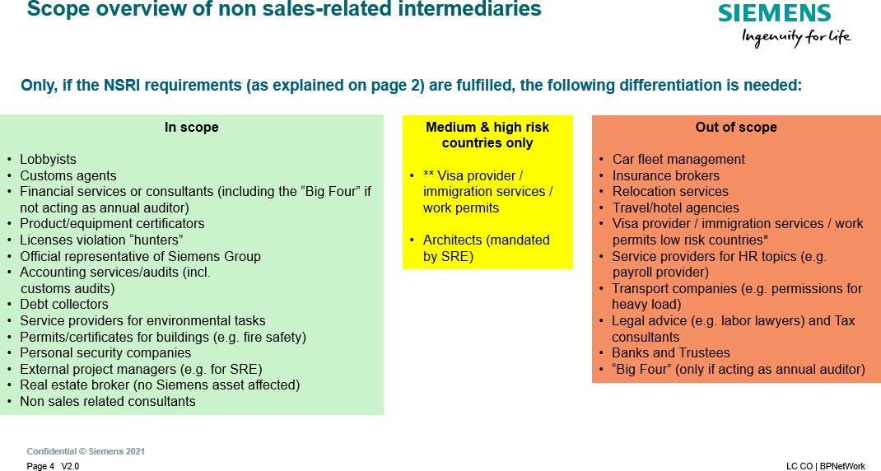

The respective definitions with examples, specific approval requirements etc. can be found [here.](https://findit.compliance.siemens.com/content/10000101/Compliance/LC_CO/LC_CO_DF/findIT_LC_CO_DF_9246.pdf)

Customs Agents

**Customs Agents conduct** customs clearing in the name and on behalf of Siemens as his sole service or part of other services.

For additional requirements regarding **Customs Agents** please refer to the [Broker Processing and Clearance](https://intranet.for.siemens.com/wll/0087/en/cu-org/ext/brpc/Pages/tab.aspx) [process of CF T.](https://intranet.for.siemens.com/wll/0087/en/cu-org/ext/brpc/Pages/tab.aspx) This process needs to be followed **prior** to conducting a CDD.

Lobbyists

“**Lobbyist**” who represents Siemens’ interests in the political domain (e.g. in relation to governments) regarding non-sales related decisions or measures including regulation or legislation.

Details can be found [here.](https://findit.compliance.siemens.com/content/10000101/Compliance/LC_CO/LC_CO_DF/findIT_LC_CO_DF_9246.pdf)

If a **mandatory lobbyist register** exists in the country, a lobbyist can only be contracted if he is listed in the register. If he is not listed, the reasons for that need to be clarified.

Besides the regular CDD-Process, a Lobbyist must be approved by the local GA department and by GM GA.

This applies to all new agreements with lobbyists and to all amendments to and renewals or extensions of existing agreements.

Further information and contacts of GA can be found [here.](https://intranet.for.siemens.com/cms/056/en/about/org/Pages/gm-ga-org.aspx)

* + 1. Reseller / Distributors

A **Reseller** is a third-party who is planned to be contracted to purchase goods, services and/or other assets from Siemens and to resell or lease them to other third-parties on its own account.

A **Distributor** is a Reseller who resells Siemens products, services and/or other assets via his/her sales channels, or directly to multiple end customers without further assembly, technical modifications or additions.

Resellers and distributors are only in scope under certain conditions:

* + - 1. Reseller / Distributors with Red Flag

Reseller and Distributors are only in scope if they have at least one “**Red Flag”**. Value-add-resellers are only in scope if they have at least one red flag and involvement of recognizable Siemens product (Details can be found in section A.1.3.2.)

“**Red Flags**” are any circumstances that may indicate a risk regarding the Business Partner’s integrity. Any commercial, financial, legal or ethical irregularity can be a “Red Flag.” The existence of a “Red Flag” does not preclude business but makes it necessary to review the Business Partner via a CDD.

If Resellers **additionally** fulfill criteria of a Sales related Intermediary or Cooperation/Consortium Partner (e.g. in case of combined agency / distributorship agreements), they are automatically in scope notwithstanding any red flags.

In unclear cases, please contact your [Compliance Officer.](https://intranet.siemens.com/en/compliance/contacts.htm) The results of such consultation and decision shall be documented accordingly.

Please also keep in mind to check the need for an AML Due Diligence and that certain competition law requirements must be met in [dual distribution](https://lkb.siemens.com/content/00000008/LegalKnowledgeBase/y5t2v021dbqp/LKB006654.pdf)12 situations (more details can be found in the [LC intranet](https://intranet.for.siemens.com/org/lc/en/legal/orga/cmp/Pages/cmp.aspx?tabcardname=single%20topic%20guidance)).

**Examples for “Red Flags”**

* The use of the specific Reseller13 is required14 by a third party15, e.g. an end customer (A. 1.3.1.1.);
* The Reseller receives an unusual16 financial benefit17 or business term18 from Siemens

12 **“Dual distribution”** describes the situation of being a manufacturer on the one hand and a competitor to our own distributor vis-à-vis (end) customers on the other hand.

13 A **“specific Reseller”** is a Reseller (e.g. an EPC, Distributor) individually identified by the third party and explicitly required by it to become the direct contractual customer of Siemens instead of the end customer. Please be aware, that a company, which belongs to the same group of companies as the end customer is not considered to be a Reseller.

14 **“Required”** means any demand or request either in written or verbal form to use a specific Reseller. A Reseller is not deemed to be “required” by a third party if it is requested in the framework of a public or private tender, in a transparent manner in the tender documents and this requirement applies equally to all bidders.

15 A **“third party”** is any company or individual outside Siemens.

(A.1.3.1.2.);

* The Reseller places19 another third party between himself and his customer without plausible cause20 (A.1.3.1.3.);
* There is currently relevant negative compliance related information (not settled or mitigated) about the Reseller from reliable source21 (A.1.3.1.4.).
  + - * 1. Required by a third party

A third party (e.g. end customer) might require a Reseller in bad faith for fostering problematic purposes on behalf or to the benefit of the third party or persons within the third party and/or the Reseller. This Reseller might create a pool of money (e.g. by overcharging) colluding with the third party or its employees which could be misused for problematic purposes, e.g. for bribery or kickbacks. In most cases the third party is a representative of the end customer or another decision-making authority involved in the business case.

The required specific Reseller could be critical if:

The reasons for requiring a Reseller are not plausible and/or transparent because of missing commercial, technical or legal justification;

Indications are available that key persons or key employees within the required Reseller have close personal ties to the decision maker or end customer or are even the same persons represented in both companies;

16 **“Unusual”**: In general, it is not uncommon that Siemens supports Resellers to promote Siemens' products. Insofar, only “unusual” financial benefits should get into our focus. See chapter A.3.2.3.2.2. for details.

17 “**Financial benefits”** include any actual or promised payments of any sum of money as well as other benefits with a monetary value. Examples are “rebates”, “discounts”, “bonuses”, “special prices”, easily achieved penalties for project deadlines or guarantees or warranted characteristics as well as reimbursement of marketing, advertising or warehousing expenses, acceptance of unjustified claims or unjustified change orders.

18 **“Business term”** means every clause, condition or other stipulation, either in written or verbal form, which defines a part of the business relationship, e.g. contract provisions, general terms and conditions or any other mutual agreement via email, telephone or in meetings.

19 **“Placed”** means that our contractual Reseller establishes a further business relationship between himself and an additional third party to conduct his business with the end-customer.

20 **“Without plausible cause”** means a non-comprehensible involvement of the further third party. This is e.g. the case when the further third party does not create any added (or only minor) value for the envisaged business case.

21 **“Source”** could be any source of information, e.g. news, internet including social media or personal contacts. **“Reliable”** means that the source is competent in the field of interest, without any biases or conflicts of interest. Examples are established journals, reputable magazines, authors with credits and affiliation, governmental information.

The required Reseller has no obvious references, track record or experience in the respective field or country of activities;

A Reseller who has not been mentioned in ongoing contract negotiations between Siemens and the end customer is suddenly introduced by the third party (e.g. the end customer) as the required new contractual partner.

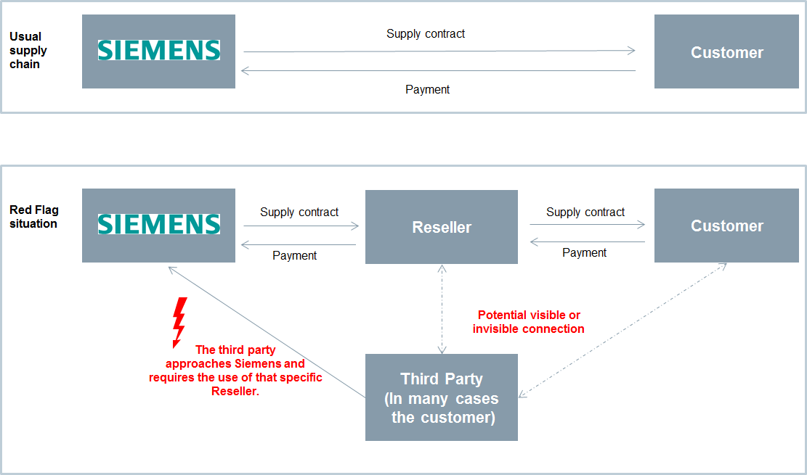

* + - * 1. Unusual financial benefit or business term

It is not uncommon that Siemens supports Resellers to promote Siemens' products and services by targeted sales and marketing activities. In addition, sometimes Siemens might reimburse warehousing expenses to its Resellers to ensure adequate stock level for the indirect channel or might give a start-up financing reimbursing costs for promotion and merchandizing. In many cases, these reimbursements are part of an established “partner program”. Instead of an actual reimbursement, special investments by the Reseller (in e.g. marketing activities, sales competency, stock excellency) might also be measured based on predefined targets and then financially rewarded in form of an incentive scheme, all of which is documented in a “partner agreement”.

On the other hand, it can be a danger sign for corruption if “unusual” financial benefits or unusual business terms are agreed with a Reseller. The Reseller might create a pool of money e.g. claiming inflated contractual penalties or passing on financial benefits which could be misused for problematic purposes, e.g. for bribery.

To identify an “unusual” nature it is important to assess first what “usual” means. This could be done by using examples from similar constellations in the relevant market or country. Also, the Siemens price lists and standard business terms should be considered. Then a comparison with the actual business case is needed to identify gaps (and possible tolerable reasons for these). The pure facts, that a payment was made or a business term was used for several times, does not automatically imply an “usual” character of that payment or business term.

Unfortunately, no fixed rules can be provided regarding the result of the comparison between a “usual” and the constellation of the concrete business case to find out if it is still “usual” or already “unusual”. Therefore, a case by case evaluation is necessary.

**Examples** regarding the “usual” or “unusual” character of a “financial benefit”:

A financial benefit may be “usual” if it is a part of a partner program or one-time marketing activity and if it is transparently calculated, accessible to many partners, openly communicated and part of a written agreement;

A financial benefit may be “unusual” if it is requested from Siemens by the Reseller to receive such benefits exclusively and without a transparent target setting. And of course, the amount is of essence.

“Unusual business terms” differ often clearly from Siemens` general terms and conditions:

Extended or uncommon contractual penalties;

Extended warranties;

Very high discounts without product strategic rationale;

Actual scope and adequacy of prices of services (e.g. assembly, maintenance) cannot be determined;

Low or no down payments in project business;

Very long or unwarranted payment terms.

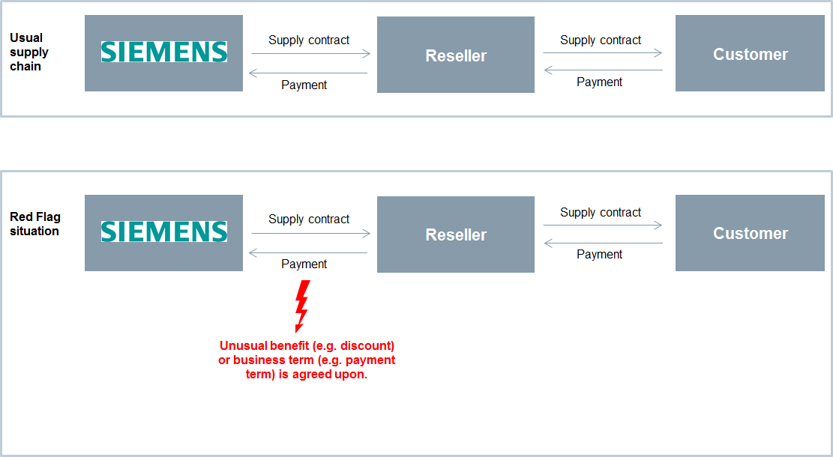

* + - * 1. Another third party between the Reseller and his customer

The involvement of an additional third party (e.g. an additional reseller or an intermediary) between our contractual Reseller and the end customer without a comprehensible reason is a danger sign. This constellation decreases transparency and might be misused for problematic purposes. The additional third party might create a

pool of money e.g. by a collusive overcharging which could be misused for problematic purposes, e.g. for bribery or kickbacks.

The following examples indicate a missing plausible cause:

Circumvention of tax or foreign exchange regulations: Our Reseller might involve a further third party to circumvent potentially the tax or foreign exchange regulations. Often jurisdictions with the character of a tax haven are involved.

Disguised identity of the additional third party: Our Reseller might use an additional third party with the intention to camouflage the identity of the person or company potentially critically profiting of the business activity (e.g. via the additional third party acting as a straw man or a dummy). It might also be the case that the unknown person or company uses the money he gains for critical purposes, e.g. bribery or kick back.

Price inflation: The final price charged to the end-customer gets unnaturally inflated using additional third party, which increases the risk that money is channeled out of the value chain for critical purposes.

Money laundering: The payment contractually owed to Siemens by our Reseller is announced to be transferred from the additional third party.

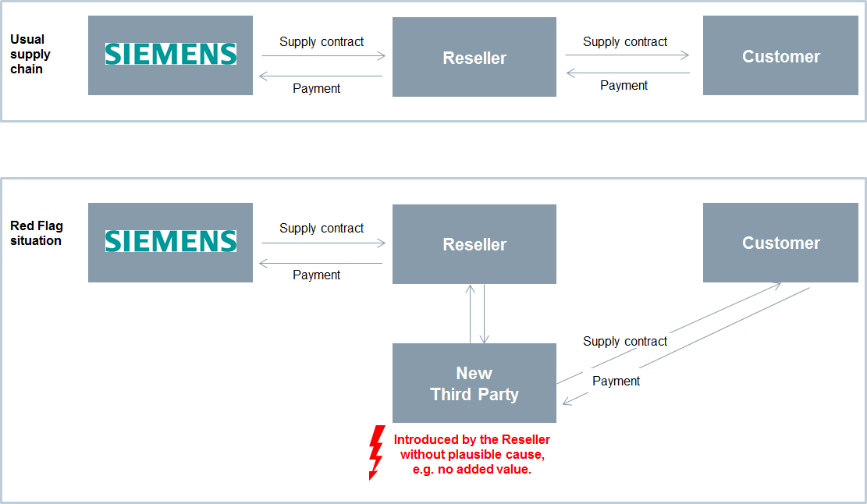

* + - * 1. Currently relevant negative compliance related information

There might be currently negative Compliance related information about the Reseller itself or its key employees, for example:

Current accusations or criminal proceedings (not settled or mitigated);

Unsolved or ongoing compliance cases;

Close ties to a decision maker at the (end)customer;

Payments from a third country;

“Management Judgment”, i.e. a request from Business Management or responsible Compliance Officer to perform a Due Diligence on this Reseller, e.g. based on suspicions on potential problematic activities or lack of integrity of the Reseller;

Other currently relevant negative Compliance related information (not settled or mitigated) about the Business Partner from reliable source .

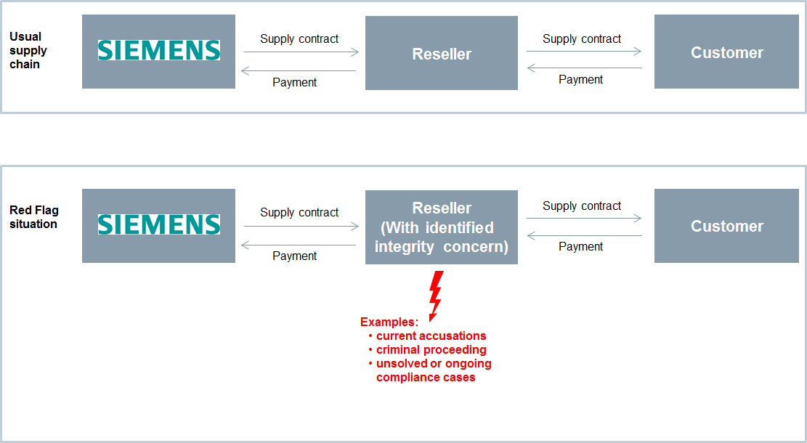

* + - 1. Value-Add Reseller

A **Value-Add Reseller** (e.g. EPC / OEM / System Integrator) is a Reseller who further assembles, technically modifies or makes additions to a Siemens product. A Value-Add Reseller is only in scope if the Siemens product remains “recognizable” as such, that means that it forms a **major part** of the newly created product of the Reseller (e.g. a large Siemens turbine in a power plant).

This will usually be the case when:

1. The value of the Siemens product in relation to the total volume is greater than 20%.
2. The decision of the end customer to purchase the product is essentially based on the fact that a Siemens product is included.

A Value-Add Reseller is not in scope if the Siemens product only forms a **minor part** (e.g. a Siemens fire detection system in a building).

Please note:

In case an Value-Add Reseller shows **massive negative information**, it is **strongly recommended**, also regardless of the above mentioned requirements, to create a CDD to be able to monitor the Value-Add Reseller

during the business relationship. The responsible Compliance officer should consult with the colleagues from LC CO RFC LF / PT in each individual case.

* + - 1. Exceptions
         * Leasing company

An End Customer request to use a leasing company is no Red Flag since it is normal business conduct that end customer decides to lease instead of purchasing a product.

* + - * + Group of companies / purchasing companies

A Reseller belonging to the same group of companies as the end customer is not considered as Business Partner. This also applies to state-controlled companies which are reselling to an end customer also controlled by that state. However, other purchasing companies remain in scope.

* + 1. Cooperation/Consortium Partners

A **“Cooperation/Consortium Partner” is a third party with whom Siemens**

* plans to collaborate to achieve a sales related22 common goal and
* is jointly and severally liable towards the customer for the scope of the contract

(e.g. a partner in a Consortium, Arbeitsgemeinschaft or “ARGE”, Unión Temporal de Empresas or “UTE”, Groupement Momentané d’Entreprises or “GME”)

A Cooperation/Consortium is usually based on an arrangement in which several firms (from the same or different industry sectors or countries) to pool their technical, financial and human resources.

* + - 1. Examples
         * In an **open consortium** all members of the consortium, i.e. Siemens and its consortium partner(s) enter into a contract with the customer and all consortium members are jointly and severally liable towards the customer for the performance of the contract. In case Siemens enters into an open consortium a CDD must be conducted for all consortium partner(s). The same applies for all other agreements with joint and several liabilities irrespective of the title of the agreement (e.g. “Teaming Agreements”, “Three Party Agreements” etc.).
         * In a **silent consortium** the contract with the customer is only concluded between the customer and one of the companies and only that company is liable towards the customer for the performance of the contract. For silent consortium partners, generally no CDD is required. This is only necessary if they also

22 Collaboration in the framework of a research and development (R&D) cooperation/consortium is not sales related.

fall into another category (e.g. as resellers, non-sales related intermediaries, suppliers etc.). In such cases, the respective processes must be followed.

However, please note that not only the contractual agreement is decisive, but all actual circumstances must be considered.

* + - 1. Exceptions

The following constellations of cooperation/consortia are **excluded** from the scope:

* + - * + Consortium partners (including the consortium leader) which participate in a **bank lending consortium** together with a Siemens finance company as well as any bank or other third party which perform typical functions in a financing provided by a lenders’ consortium (e.g. Facility Agent, Security Trustee, Paying Agent, Technical Agent) are out of scope.
        + **Silent Consortium Partners** do not require a CDD if they do not perform additionally a task which is in scope of Circular No. 226, e.g. as a sales agent (see above A.1.1.1.).
        + **Joint Venture Partners** are subject to Circular No. 222: “Application for and approval of capital investments and divestments”. If, however, they perform additionally a task, e.g. as a sales agent, they are in scope.

#### Business Partner Strategy

For the company units Digital Industries (DI), Smart Infrastructure (SI) and Siemens Mobility (SMO), a Business Partner Strategy must be defined by the respective management based on a mandatory Business Partner portfolio and strategy statement. The selection of Business Partners must be in line with this strategy. On an annual basis the Business Partner portfolio and strategy review is reviewed by the responsible CEO of the Siemens unit, supported by Compliance. Details can be found in the document “[Business Partner Strategy”.](https://findit.compliance.siemens.com/content/10000101/Compliance/CL_CO/L_CO_OM/findIT_L_CO_OM_4992.pdf)

Further details on Business Partner portfolio and strategy review can be found in Chapter B.2.

#### Subcontractors of Business Partners

The use of subcontractors or further resellers is subject to the condition that the Business Partner obliges the subcontractor/further reseller to comply with compliance provisions equivalent to those in the contract between Siemens and the Business Partner.

It is not required that the Business Partner includes exactly or even similar clauses to the Binding Contract Provisions since Siemens’ influence on the concrete terms of a contractual agreement between third parties is limited.

However, as a minimum, the Business Partner must oblige its subcontractors or further resellers to comply with all applicable laws and regulations, in particular to any laws and regulations relating to anti-corruption, anti-money laundering and antitrust.

For specific Business Partner types, please note the following:

**Intermediaries:** Where an Intermediary intends to use a subcontractor for the services agreed with Siemens, an approval by Siemens is required, provided that such subcontractor would be in scope of [Circular No. 226](https://circulars.siemens.com/content/circulars/ca/_layouts/querplex/circularapplication/documents/CircularDownload.aspx?id=sc_226.pdf) if he would be retained by Siemens directly.

**Reseller**: A Reseller must notify Siemens if he intends to resell the goods to a party other than the end customer.

If the Company Unit is notified by the Business Partner after the conclusion of the contract that it intends to use a new or other subcontractor or further reseller, for medium and high risk CDDs the CDD Responsible has to update the CDD.

Where a red flag is identified in relation to any subcontractor/further reseller of a Business Partner, the same action must be taken as if the red flag had occurred regarding the Business Partner himself.

#### Compliance Due Diligence (CDD)

A valid and approved CDD is a prerequisite for cooperating with Business Partners. Only the [CDD-Tool](https://compliance-tools.siemens.com/due-diligence/) may be used for this. Details are explained in **Chapter C** “Relevance only for Tool User (Tool description)”.

* + 1. CDD Process (Overview)

The Compliance Due Diligence process (**CDD Process**) supports conducting a risk- based integrity check of Business Partners. The aim is to ensure that all Business Partner engagements are based upon a transparent overview of the planned relationship and that this relationship is continuously and effectively monitored.

The Siemens Company Unit who would like to engage a Business Partner is responsible for starting a CDD in the [CDD-Tool.](https://compliance-tools.siemens.com/due-diligence/)

The steps of a CDD are as follows:

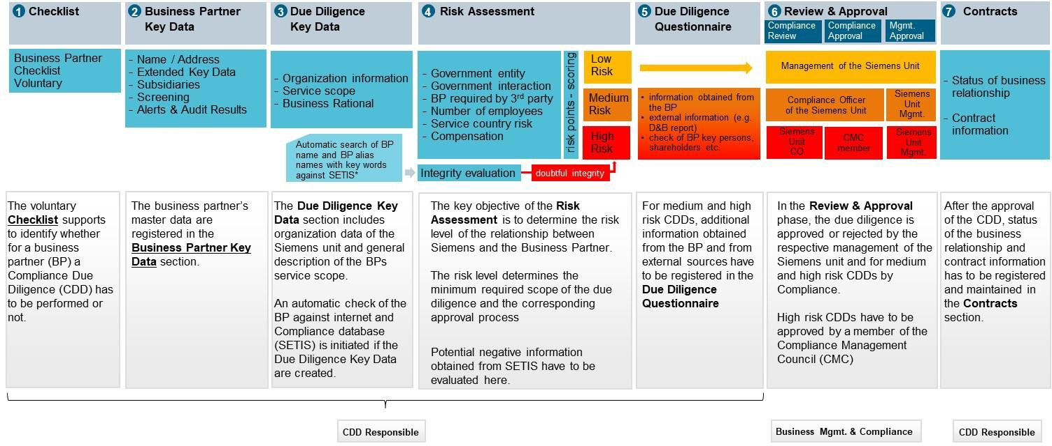

Specific Approval

Contracts with business partners assigned to the risk category “**high risk**”, have to be approved by the CEO / Head of a Business Company23, Regional Company or Corporate Function prior to the contract signature.24 Responsible for informing are both the CDD Responsible and the approving manager.

Please note:

If a CDD serves for more than one “Division” or Business Unit, the "**biggest user principle**" applies. The Division (or Business Unit) must be selected that is having or is planned to have the biggest business volume with the Business Partner. This principle avoids that CDDs are assigned to “- performed on ARE level -“ or “- performed on division level -“ which causes intransparency. If you are unsure about the correct assignment, please contact your Compliance Officer.

**For further details of the CDD process, please see chapter** **C.1.**

* + 1. Monitoring / Update

Approval of the CDD does not mean that all corruption risks can be excluded. Accordingly, once the CDD has been approved the Siemens unit dealing with the Business Partner must stay in close contact with the Business Partner and be alert and vigilant to any danger signs pointing to a risk of corruption which may appear in the course of the business relationship.

The Update Process in combination with the existing Business Partner portfolio reviews of CDDs in Compliance Review Boards and management meetings supports the ongoing monitoring of Business Partner relationships.

* + - 1. Principles

Business awareness

The business unit is aware of its responsibility for its Business Partners. This awareness can for example be expressed by clear tone from the top message by the CEO to the respective entities, or simply by the fact that relationships to Business Partners are regularly discussed in business meetings, Compliance Review Boards or corresponding meetings.

Regular assessments

The need for the relationship and the performance in consideration of the compensation is reassessed on a regular basis. Especially if the engaging Siemens entity is not located in the country but another Siemens entity is, there must be clear and transparent evidence why the relevant services cannot be provided by the Siemens organization.

23 A CEO may also delegate the approval-role in alignment with the respective Compliance Officer to a member of the CEO`s Top or Senior Management.

24 In the case that essential topics will be negotiated and signed later than the (main) contract (e.g. a commission rate) the highest management has to be involved upfront also.

If a Business Partner acts as a “door opener”, for example due to his unique technical experience or market knowledge, the engagement should only be temporary until the targets of the engagement are fulfilled or “until the door is open” and the knowledge about a market or a technology has been built up in Siemens.

Especially for Distributors and Sales related Intermediaries, it is recommended to visit them before the engagement is started. An assessment on a regular basis whether the Business Partner provides the services and that the compensation, rebates or any other benefits (in line with local law) are in proportion to these services is part of any common business behavior.

Warning signs are taken seriously

Potential warning signs in the relationship need to be taken seriously and properly addressed. “Red flags" can, for example, be:

* A suspicion of a breach of the compliance provisions in the contract with the Business Partner e.g.: chapter compensation and expense reimbursement (e.g. the partner insists on being paid in cash in departure from the contractual agreements or issues false invoices or other false documentation, or makes suspicious statements in conversations which may be indicative of corrupt activities, e.g. that he needs financial or other support for accommodating the demands of a “friend” employed at the end customer).
* Credible information about the Business Partner which indicates non-compliance with laws, contract regulations or other rules and procedures regarding the integrity of the Business Partner.
* A merger or acquisition which has influence on the Business Partner directly or indirectly, if there is a justified suspicion about Compliance issues at the acquired company.
* A change in management which creates doubts about the integrity of the Business Partner, e.g. if a close government connection or a reputation for corruption of the new management are known.

Measures to be taken

The Siemens unit must take appropriate steps – in cooperation with the General Counsel and the Compliance Officer – to eliminate corruption risks, for example:

* to update the CDD;
* to seek clarification from the Business Partner;
* to decide to conduct an audit in consultation with Legal, Controlling and Finance Audit (CF A) and the Compliance Officer;
* to adjust the contract conditions (if this would constitute a viable remedy to a risk identified);
* to terminate the business relationship (i.e. if there is no other way of remedying the corruption risk identified);
* to disapprove the CDD. It is possible to centrally disapprove a CDD or the Business Partner by the Compliance Officer (see chapter C.5.1.3);
* to restrict the CDD approval, e.g. to a particular payment.

Regular discussion of high-risk relationships

Relationships with the highest risk are discussed regularly e.g. in the Compliance Review Board meetings. The risk level determined in the [CDD-Tool](https://compliance-tools.siemens.com/due-diligence/) should not be decisive, but one indication.

Further criteria, either solely or combined, should be considered to focus on business relationships with highest risk, like

* sales related higher risk due diligences for natural persons;
* due diligences for Business Partners located or performing services in countries with a high corruption index;
* Business Partners located or providing services in a country outside of the country of the respective Siemens entity or in a country where Siemens is not represented;
* due diligences with adverse but not proven information (e.g. negative press reports);
* business relationships where different third parties are involved in the value chain, e.g. sub-distributors, subcontractors especially where the customer is located in a country with a high corruption risk;
* Business Partners that receive a considerable compensation for their services, especially if the compensation is a success fee;
* sales related business relationships where the Business Partner is engaged in the tender phase with a governmental customer especially in countries with a high corruption risk.

The [Business Partner Dashboard](https://dashboard.compliance.siemens.com/dashboard/client/risk.html) can be used by Compliance Officers to identify such CDDs.

* + - 1. Update of CDDs

A Regular (mandatory) update of a CDD will be due every three years. A limited number of questions have to be re-answered and are marked in the [CDD-Tool:](https://compliance-tools.siemens.com/due-diligence/)

* + - * + Low risk: updated integrity search;
        + Medium risk: as low risk plus a new version of the independent background report (Dun & Bradstreet) to be obtained and reviewed;
        + High risk: as for low/medium plus update of organizational setup (Extended Key Data and group structure) and integrity checks (SETIS/internet and Involvement of Key Persons in litigations)

The CDD Responsible will be automatically informed by an email notification to start an Update of a CDD and the approval process is based on the significance of changes.

No significant changes: only sign-off by the CDD Responsible, with the Management Approver and CO Reviewer informed of the changes via email. They may raise questions and request further information if deemed necessary.

Significant changes: a new Management Approval and CO Review is required with the CO Reviewer responsible to involve further stakeholders like CO or CMC if deemed necessary. Only an increase of the risk level requires a Compliance approval.

The [CDD-Tool](https://compliance-tools.siemens.com/due-diligence/) will automatically determine the relevant approval process. For further details, please refer to chapter C.3.

* + 1. Global Business Partners

Specific Business Partners with global focus and a number of subsidiaries are “Global Business Partners”.

* The following Logistic service providers (including listed subsidiaries) performing customs clearance

|  |  |  |  |
| --- | --- | --- | --- |
| **CDD ID** | **BP Name (Headquarter)** | **Contact** | **List of subsidiaries** |
| 0081227 | Agility GIL Services AG | LC CO Corp. | [Download PDF](https://findit.compliance.siemens.com/content/10000101/Compliance/Sectors_CU_XSBS/Sector_CU/findIT_Sector_CU_6773.pdf) |
| 0082242 | Deutsche Post AG / DHL | LC CO Corp. | [Download PDF](https://findit.compliance.siemens.com/content/10000101/Compliance/Sectors_CU_XSBS/Sector_CU/findIT_Sector_CU_3798.pdf) |
| 0083789 | Karl Heinz Dietrich GmbH & Co. KG | LC CO Corp. | [Download PDF](https://findit.compliance.siemens.com/content/10000101/Compliance/Sectors_CU_XSBS/Sector_CU/findIT_Sector_CU_4088.pdf) |
| 0066215 | Kuehne + Nagel | LC CO Corp. | [Download PDF](https://findit.compliance.siemens.com/content/10000101/Compliance/Sectors_CU_XSBS/Sector_CU/findIT_Sector_CU_9812.pdf) |
| 0075756 | Schenker AG | LC CO Corp. | [Download PDF](https://findit.compliance.siemens.com/content/10000101/Compliance/Sectors_CU_XSBS/Sector_CU/findIT_Sector_CU_3766.pdf) |
| 0082411 | Bollore | LC CO Corp. | [Download PDF](https://findit.compliance.siemens.com/content/10000101/Compliance/Sectors_CU_XSBS/Sector_CU/findIT_Sector_CU_3884.pdf) |
| 0066200 | Fracht AG | LC CO Corp. | [Download PDF](https://findit.compliance.siemens.com/content/10000101/Compliance/Sectors_CU_XSBS/Sector_CU/findIT_Sector_CU_6541.pdf) |
| 0084828 | United Parcel Service Inc. | LC CO Corp. | [Download PDF](https://findit.compliance.siemens.com/content/10000101/Compliance/Sectors_CU_XSBS/Sector_CU/findIT_Sector_CU_6976.PDF) |
| 0084827 | FEDEX CORP (incl. TNT) | LC CO Corp. | [Download PDF](https://findit.compliance.siemens.com/content/10000101/Compliance/Sectors_CU_XSBS/Sector_CU/findIT_Sector_CU_7302.pdf) |
| 0300383 | Geodis | LC CO Corp. | [Download PDF](https://findit.compliance.siemens.com/content/10000101/Compliance/Sectors_CU_XSBS/Sector_CU/findIT_Sector_CU_7720.pdf) |
| 0302284 | Senator | LC CO Corp. | [Download PDF](https://findit.compliance.siemens.com/content/10000101/Compliance/LC_CO/LC_CO_STR_RM/findIT_LC_CO_STR_RM_8682.pdf) |

* The following Engineering, Procurement and Construction companies (EPCs) and their subsidiaries

|  |  |  |  |
| --- | --- | --- | --- |
| **CDD ID** | **Name (Parent Company)** | **Responsible country** | **List of subsidiaries** |
| 0073534 | DURO FELGUERA, S.A. | Spain | [Link](https://findit.compliance.siemens.com/content/10000101/Compliance/Sectors_CU_XSBS/Sector_CU/findIT_Sector_CU_6158.xlsx) |
| 0070706 | SNC Lavalin Inc. | Canada | [Link](https://findit.compliance.siemens.com/content/10000101/Compliance/Sectors_CU_XSBS/Sector_CU/findIT_Sector_CU_7315.pdf) |
| 0078166 | TECNICAS REUNIDAS, S.A. | Spain | [Link](https://findit.compliance.siemens.com/content/10000101/Compliance/Sectors_CU_XSBS/Sector_CU/findIT_Sector_CU_5974.xlsx) |
| 0080241 | Hyundai Engineering & Construction Co Ltd | South Korea | [Link](https://findit.compliance.siemens.com/content/10000101/Compliance/LC_CO/LC_CO_STR_RM/findIT_LC_CO_STR_RM_8163.xlsx) |

* Siemens Shareholders in UAE/Saudi Arabia as below

|  |  |  |
| --- | --- | --- |
| **CDD ID** | **BP Name (Headquarter)** | **Contact** |
| 0057814 | Scientechnic (Br of Easa Saleh Al Gurg Group LLC) | LC CO UAE |
| 0055655 | Electro Mechanical Company LLC | LC CO UAE |
| 0070619 | E.A. Juffali & Brothers | LC CO UAE |

* Other Global Business Partners as below (including listed subsidiaries)

|  |  |  |  |
| --- | --- | --- | --- |
| **CDD ID** | **Name (Parent Company)** | **Contact** | **List of subsidiaries** |
| 0304709 | Siemens Energy AG | LC CO RFC LF | [Download PDF](https://findit.compliance.siemens.com/content/10000101/Compliance/LC_CO/LC_CO_STR_RM/findIT_LC_CO_STR_RM_9716.pdf) |

CDDs for Global Business Partners (flagged with a globe in the [CDD Tool](https://compliance-tools.siemens.com/due-diligence/)) can be used by all Company Units**. No local CDD is needed for the same scope of work**. Local contracts with the Global Business Partners and its listed subsidiaries will not require the inclusion of binding contract provisions if a reference to the central frame contract made.

Details of the process can be found in section B.3.

#### Training of Business Partners

An efficient Compliance Program also includes training of Business Partners.

Siemens Compliance training is **mandatory** for all Business Partners with **high risk CDDs** and has to be documented in the [CDD Tool](https://compliance-tools.siemens.com/due-diligence/). Training of Business Partners with medium and low risk CDDs is **optional**.

In the mandatory training, at least all **key persons** must participate. The Business Partner has the possibility to invite further employees.

Even if the Business Partner has a comprehensive Compliance program in place, the training must be conducted because it informs the Business Partner about Siemens’ requirements and procedures.

There are several possibilities how to conduct the training:

* The **standard external web-based training** for Business Partner can be initiated [here](https://bpcdd.compliance.siemens.com/bpext/nui/train)
* **Use of the available documents** ([Business Partners Flyer,](https://findit.compliance.siemens.com/content/10000101/Compliance/CL_CO/CL_CO_AT/findIT_CL_CO_AT_1764.pdf) [Business Partner Presentation](https://findit.compliance.siemens.com/content/10000101/Compliance/CL_CO/CL_CO_AT/findIT_CL_CO_AT_2829.pptx) and [Speaker](https://findit.compliance.siemens.com/content/10000101/Compliance/CL_CO/CL_CO_AT/findIT_CL_CO_AT_2242.pdf) [Notes.](https://findit.compliance.siemens.com/content/10000101/Compliance/CL_CO/CL_CO_AT/findIT_CL_CO_AT_2242.pdf) It can be sufficient to hand over the flyer to the Business Partner and clarify questions over the phone.
* **In-person trainings**. Ideally in the frame of existing business events and not on a separate basis.

#### Contract provisions

The Company Unit is responsible for its contracts.

Contracts with business partners must contain the binding contractual provisions depending on the CDD risk level (low/medium/high). In addition, the Code of Conduct for Siemens Suppliers and Third-Party Intermediary Partners must be attached to all contracts. For specific business partner types (e.g. Consortium Partner, EPC etc.), specific contract provisions exist. Details can be found in Section B.5.

For deviations of contract provisions please follow the respective approval process (B.5.5.).

#### Payments

Payments to a Business Partner require an approved CDD. They must be made directly to the partner and supported by evidence of services and/or goods received.

The Siemens unit is responsible for reviewing Business Partners’ invoices to determine if the contractual requirements for payment have been met.

Payments must be done as ERP system-based payments to the bank account identified in the CDD. "ERP- System-Based Payment" means any payment based on an instruction generated by an ERP-System and contained in a batch payment file, where the batch payment file is sent either to finavigate® or a Bank of the Entity.

#### Specifics for certain Siemens units

SFS

The following exceptions for **Intermediaries** apply exclusively to the SFS Commercial Finance (SFS COF) Business Unit of the Service Company Siemens Financial Services (SFS):

“**Introducers**” within the leasing and receivables purchase business and “**Remarketing Partners”** are only in scope of the Business Partner Regulations, if the preliminary review during business initiation or during the annual review show **compliance relevant "Red Flags"** e.g. corruption, money laundry etc. and the Introducer/ Remarketing Partner is contractually entitled to compensation which exceeds 1.000 EUR annually.

Introducers (Product category Brokerage of financing)

According to SFS COF’s I[ntroducer Assessments and Review Guideline](https://workspace-secure.sfs.siemens.com/content/10001100/rm/Guidelines/O.Introducer%20Assessment/COF%20Introducer%20Guideline.docx) an “**Introducer**” is a third party business partner of the SFS Business Unit COF who is introducing a finance transaction as “**Vendor**“ or “**Broker**”.

* **“Vendors”** are typically the equipment suppliers whose products are financed by SFS COF. There are two subtypes: “**Manufacturers”** and “**Resellers incl. Distributors**”.

The additional requirement of a Red Flag / Threshold is based on the comparably lower compliance risk of the financing of the sale of products which is merely an annex to the main business activity of the Vendor. The vendor's goal is to sell its own product to an end customer, whereby SFS COF only provides the financing to facilitate the Vendor`s customers use of the asset.

* **Brokers** typically facilitate business opportunities of SFS COF by introducing SFS financing to third party equipment suppliers or their customers. There are three subtypes: “**Traditional Brokers”, “Assignors”** and “**Other Brokers”**.

The additional requirement of a Red Flag / Threshold is based on the comparably lower compliance risk of the broker market versus the product market. In the broker market the business success of a broker is based exclusively on the good financing conditions he can offer his customer. As the financing rate / interest is the key factor in the customer`s considerations, the risk of bribes to the customer to accepts SFS financing over another financing with better condition is low.

Remarketing Partners (Product category remarketing of used Siemens owned assets)

**“Remarketing Partners** act as brokers on behalf of SFS in sale of used leasing assets owned by SFS or other used assets that SFS can claim title to in event of customer default during a finance contract. Remarketing Partner will seek and introducer buyers to SFS with the aim of achieving the best possible outcome for SFS and will receive compensation for their service

The additional requirement of Red Flag / Threshold is based on the comparably lower compliance risk of the resale of used goods of usually smaller value or a relatively low amount of commission.

#### Contacts

For questions please contact your [**Compliance Officer.**](https://intranet.for.siemens.com/cms/059/en/about/org/Pages/compliance_organization.aspx)

**Technical questions concerning** [**CDD-Tool**](https://compliance-tools.siemens.com/due-diligence/) can be answered by IT Hotline, generally available from 9 a.m. to 5

p.m. CET (Monday – Friday) except public holidays in Germany / Bavaria). Supported languages: German and English. **E-mail:** [**bpc-tool.cit@siemens.com**,](mailto:bpc-tool.cit@siemens.com) Phone: +49 (89) 636-31436, Fax: +49 (89) 636-35893.

## Relevance only for Legal and Compliance

#### Siemens` liability for Business Partners

Siemens may be held accountable for the actions of a Business Partner from a legal and a reputational point of view. Working with a potentially corrupt Business Partner, therefore, creates a significant risk for Siemens. The OECD-Report on “[the liability of legal Persons for foreign bribery](https://www.oecd.org/daf/anti-bribery/Liability-Legal-Persons-Foreign-Bribery-Stocktaking.pdf)” identifies multiple jurisdictions in which a company can be held liable for the actions of its Business Partners (see [chapter 2.6.2 p. 91 et seq.](https://www.oecd.org/daf/anti-bribery/Liability-Legal-Persons-Foreign-Bribery-Stocktaking.pdf)) and outlines possible consequences for companies, such as debarment from public tenders (see [chapter 2.10 p. 129 et seq.](https://www.oecd.org/daf/anti-bribery/Liability-Legal-Persons-Foreign-Bribery-Stocktaking.pdf)). On the other hand, the OECD Report also shows that the existence of an effective compliance system not only has a preventive function, but it also serves to mitigate sanctions in some jurisdictions (see [chapter 2.11 p. 148 et](https://www.oecd.org/daf/anti-bribery/Liability-Legal-Persons-Foreign-Bribery-Stocktaking.pdf) [seq.](https://www.oecd.org/daf/anti-bribery/Liability-Legal-Persons-Foreign-Bribery-Stocktaking.pdf)). In general, the legal risk depends on the legal landscape of the respective jurisdiction. However, there are jurisdictions where very limited or no connection to the country is needed to have local consequences for the acts of a corrupt Business Partner (see [chapter 2.8 p. 110 et seq.](https://www.oecd.org/daf/anti-bribery/Liability-Legal-Persons-Foreign-Bribery-Stocktaking.pdf)).

* + 1. German Criminal Code (StGB)

German law distinguishes between offences affecting public officials (e.g. Sec. 331-334 StGB - [German Criminal](https://www.gesetze-im-internet.de/englisch_stgb/) [Code](https://www.gesetze-im-internet.de/englisch_stgb/)) and those which affect fair competition (e.g. Sec. 298, 299 StGB). Sec. 11 StGB determines who is a “public official” (if necessary, in conjunction with Sec. 335a StGB).

In the sense of Sec. 331 et seq. StGB corruption can be committed:

* In active form (demand, offer and promise of a benefit, granting of an (undue) advantage, bribery, kickback payments)
* In passive form (accepting of an (undue) advantage, bribability)

In the case of accepting an advantage (Sec. 331 StGB) the public official accepts an advantage for which he has no legal claim as an equivalent for his or her duties. The official act does not have to be illegal. The granting of such an advantage is punishable by Sec. 333 StGB.

Bribability and bribery within the meaning of Sec. 332 and 334 StGB are always accompanied by a breach of duty, therefore an official act contrary to his or her duty.

Pursuant to Sec. 299 StGB it is a criminal offence for an employee or representative of a business company to demand, promise or accept an (undue) advantage in business transactions, so that in return he or she will get an unfair advantage in the competition of purchasing goods or commercial services.

A criminal responsibility in relation to the actions of third parties may arise due to the legal concepts of direct and indirect perpetrator (Täter / mittelbarer Täter) or co-perpetrator (Mittäter) (Sec. 25 StGB) as well as accessory (Teilnehmer) consisting of instigation (Anstiftung, Sec. 26 StGB) and assistance (Beihilfe, Sec. 27 StGB).

* + 1. UK Bribery Act 2010

According to [Section 7](http://www.legislation.gov.uk/ukpga/2010/23/section/7) and [Section 8](http://www.legislation.gov.uk/ukpga/2010/23/section/8) of the UK Bribery Act of 2010 (UKBA), a company may be responsible for offences of so called “associated persons” if they bribe with the intent to obtain or retain business or a business advantage. An “associated person” of a company is defined as someone who performs services for or on behalf of a company. For example, an agent of a company qualifies as an associated person. Whether a third party “performs services for or on behalf of” a company is determined by a review of all relevant circumstances, and not merely the nature of the relationship between the third party and the company. The official [Guidance to the](https://www.justice.gov.uk/downloads/legislation/bribery-act-2010-guidance.pdf) [Bribery Act](https://www.justice.gov.uk/downloads/legislation/bribery-act-2010-guidance.pdf) further explains (p. 16) that a person who “performs services for or on behalf of” a company includes anyone connected to the company who might be capable of committing bribery on its behalf. This broad scope means that contractors and resellers could be “associated” persons. It is also noteworthy that [Section 7](http://www.legislation.gov.uk/ukpga/2010/23/section/7) of the UKBA provides a defense for companies that have in place adequate procedures designed to prevent “associated persons” from undertaking illegal conduct.

* + 1. US Foreign Corrupt Practices Act

According to Sections 78dd-1, 78dd-2, 78dd-3, 78m, 78ff of the US [Foreign Corrupt Practices Act of 1977](https://www.justice.gov/criminal-fraud/statutes-regulations) (FCPA), a company is liable for its agents and stockholders acting on its behalf if they behave corruptly towards any foreign official or provide financial benefits to any person while knowing that all or a portion of such will be used to corruptly influence or induce a foreign official to obtain or retain business or secure an improper advantage for the company. According to the official [Guidance,](https://www.justice.gov/criminal-fraud/fcpa-guidance) the FCPA expressly prohibits corrupt payments made through third parties or intermediaries. Specifically, this covers payments made to “any person, while knowing that all or a portion of such money or thing of value will be offered, given, or promised, directly or indirectly” to a foreign official. Because the US Congress anticipated the use of third-party agents in bribery schemes and to avoid the related “head-in-the-sand” problem, it defined the “knowing” element as being aware of a high probability of a bribery payment. In so doing, the FCPA holds companies liable for a “conscious disregard,” “willful blindness” or “deliberate ignorance” of a bribery scheme committed by third-party agents ([FCPA Guidance](https://www.justice.gov/criminal-fraud/fcpa-guidance) [p. 21](https://www.justice.gov/criminal-fraud/fcpa-guidance)). The FCPA Guidance also specifically identifies the pool of third parties to include agents, consultants, and distributors. At the same time, the FCPA also makes clear that risk-based due diligence is particularly important for the use of third-parties and such due diligence will be considered by the DOJ and the SEC in assessing the effectiveness of a company’s compliance program ([FCPA Guidance p. 60](https://www.justice.gov/criminal-fraud/fcpa-guidance)).

* + 1. DOJ Settlement 2008

The 2008 Settlement Agreement with the Department of Justice (DoJ) requires that all Siemens subsidiaries and affiliates indefinitely maintain an anti-corruption internal control system and corporate compliance program with specifically defined elements. This includes e.g. due diligence requirements (e.g. for Business Partners), a corporate official with overall responsibility for the implementation and oversight of the Siemens Compliance System globally, an effective reporting system and disciplinary procedures. The DOJ requirements have since become the framework of the Siemens Compliance System. Today, Siemens AG must ensure that all independently operating entities fully implement the core elements of the Siemens Compliance System. Failure to do so by any independently operating Siemens-owned entity would constitute a breach of the Settlement Agreement by Siemens AG, potentially resulting in the rescission of the Settlement Agreement.

#### Business Partner Portfolio and Strategy review

Business Partner portfolio and strategy review is mandatory for Digital Industries (DI), Smart Infrastructure (SI) and Siemens Mobility (SMO) on an annual basis. For other units, it must be decided by the respective management and the Compliance Officer.

Business and Compliance jointly identify and analyze the business strategies involving the cooperation with Business Partners to develop a strategic business statement of the responsible CEO. The key objectives of the Business Partner Portfolio and Strategy Review are to help ensure:

* a strategic focus to Business Partner engagements;
* an alignment with general business strategy;
* improved management awareness.

The review should challenge the use of Business Partners reflecting the current set-up and taking the business strategies (e.g. go-to-market approach, sales channels, partner management, etc.) into consideration. The individual strategy is binding for the respective business.

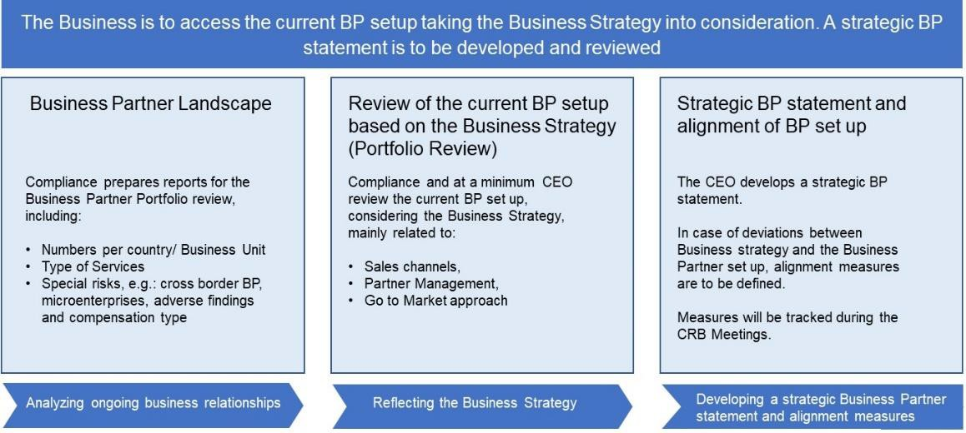

* + 1. Current Business Partner landscape

To facilitate the discussions, comprehensive information on all Business Partners should be obtained and include:

* number of Business Partners, risk profile, type of services, service country, special risks e.g. cross border business, microenterprise, compensation type, adverse findings.
* For specific high-risk partners: generated business versus commissions paid.
  + 1. Future Business Strategy

The future business strategy must be obtained by the Compliance Officer from the responsible CEO / Strategy Team / Business Development and would typically include details on:

* actual and potential new markets / portfolio;
* impact of changes in country specific political/economic outlook;
* particular customers, product line, geographical area, niche market, etc.;
* business areas most likely to require Business Partner support based on sales channel / go to market strategy.

**Example questions that Compliance may ask the Business:**

Does the current Sales Agent set-up reflect the sales channel strategy overall and/or in the respective countries?

Does the Business Partner portfolio support the go to market approach related to Markets, Regions, Business Segments?

Do you see future changes in the business model that might impact the Business Partner portfolio, for example:

* new markets to be tapped using support from a Business Partner,
* termination of non-performing businesses in certain countries,
* decisions to change from an internal to an external sales force;
* M&A activities?
  + 1. Strategic statement

The key deliverable of the Portfolio Review is the Strategic Business Partner statement of the CEO.

The actual strategic statements of the Siemens entities can be found here: [Business Partner Portfolio & Strategy](https://findit.compliance.siemens.com/content/10000101/Compliance/CL_CO/L_CO_OM/findIT_L_CO_OM_4992.pdf) [Review.](https://findit.compliance.siemens.com/content/10000101/Compliance/CL_CO/L_CO_OM/findIT_L_CO_OM_4992.pdf) The result of the respective workshop / statement is to be shared with the assigned countries and respective BUs.

#### Global Business Partners

For certain Business Partners including their subsidiaries a **centralized CDD** is valid for all Siemens entities (“Global Business Partners”). For the work scope covered in a due diligence for a Global Business Partner and its subsidiaries, **no local CDDs needs to be performed**.

**Local contracts** with the Global Business Partner and its listed subsidiaries will not require binding contract provisions if a central frame contract including binding contract provisions exists and reference to this frame contract is made.

**CDDs** for Global Business Partners are flagged with a special symbol (a globe) in the [CDD-Tool](https://compliance-tools.siemens.com/due-diligence/) and can be used by all Siemens entities.

A new Global Business Partner can be nominated to LC CO RFC by the respective department and must be confirmed by Head of LC CO RFC.

In detail:

Compliance Due Diligence

For the Global Business Partner **Parent Company**, the respective Siemens entity must perform a high risk CDD. No separate questionnaires exist in the [CDD Tool](https://compliance-tools.siemens.com/due-diligence/). However specific guidance (C.2.2.4.) has to be followed.

A Compliance expert session with the Business Partner has to be conducted by the Compliance Officer to exchange and obtain more information in relation to its corporate direction and past activities to ensure there is no historic, legal or compliance issues and a sound basis for the integrity of its business activities in its headquarters and subsidiaries.

The Global Business Partner incl. all listed subsidiaries must be checked against SETIS. The approval follows the standard approval process except the Compliance Approval, which always must be done by the Head of LC CO RFC CU.

Contracts

Mandatory binding contracts provisions must be accepted and form part of a contract with the contracting party, either

* as part of a **global framework agreement** and a reference to it in the local engagement letter or
* as part of each **individual contract** if no global framework exists.

For any deviations the standard escalation process has to be followed (B.5.5.). The global framework agreement needs to be registered in the [CDD Tool](https://compliance-tools.siemens.com/due-diligence/). All individual contracts must be registered by the respective business responsible under the CDD for the Global Business Partner. Compliance Officers shall monitor the conclusions of individual contracts e.g. via the [LoA process](https://webbooks.siemens.com/public/LC/chen/index.htm?n=Part-2-Business-Perspective%2CH.-Compliance-in-Business-Processes-and-Projects%2C1.-Compliance-in-Project-Business) to assure correct registration in time.

New or modified subsidiaries

To add further subsidiaries, the Compliance Officer responsible for the CDD, must be contacted. The Questionnaire for new or modified subsidiaries (according to the type, see following chapters) must be filled and necessary documents, information and confirmations relating to the new / changed subsidiary must be gathered.

The list of Global Business Partners including subsidiaries has to be adjusted and forwarded to LC CO PT CO or publication on the [CDD Homepage.](https://intranet.siemens.com/en/compliance/topics-tools/business-partner.htm)

Update

The Update of a CDD must cover the worldwide Siemens business of all subsidiaries of the Global Business Partner.

Information Letter / Consent Form of subsidiaries

The Information Letter / Consent Form requirements (C.5.2.2.) need to be considered according to the rules of the country of a subsidiary, if personal data (e.g. information about material litigation) is obtained from Key Persons or Key Employees.

Further information is available in the following supporting documents:

* [“Discussion Guide” for Compliance Expert Session](https://findit.compliance.siemens.com/content/10000101/Compliance/LC_CO/LC_CO_STR_RM/findIT_LC_CO_STR_RM_5173.doc)
* [“Company List”](https://findit.compliance.siemens.com/content/10000101/Compliance/LC_CO/LC_CO_STR_RM/findIT_LC_CO_STR_RM_5174.xlsx)
* [“Guideline on Interpretation” of the Due Diligence Questionnaire for Global Business Partners](https://findit.compliance.siemens.com/content/10000101/Compliance/LC_CO/LC_CO_STR_RM/findIT_LC_CO_STR_RM_5175.xlsx)
* [“CDD-Questionnaire” for new/additional subsidiaries](https://findit.compliance.siemens.com/content/10000101/Compliance/LC_CO/LC_CO_STR_RM/findIT_LC_CO_STR_RM_5176.xlsx)
* Release documents [for Global Logistics Service Providers](https://findit.compliance.siemens.com/content/10000101/Compliance/LC_CO/LC_CO_STR_RM/findIT_LC_CO_STR_RM_5172.doc)

**Please note**: The so-called “whitelisting process” for EPCs without Red Flags (formerly described in section 3.3.3.4.) was discontinued as of 1 October 2020, as the whitelisted EPCs were Business Partners mainly of Siemens Energy business. It was not necessary to maintain the process for Siemens AG.

#### Compliance onsite check

A compliance onsite check is an **onsite review** at the premises of the Business Partner to identify potential compliance risks. It includes a face to face discussion with the Business Partner, ideally at their offices/premises. supporting an assessment and judgment of the appropriateness and suitability of the Business Partner to work with Siemens.

There are **two types** of Compliance checks:

* Initial check of a proposed Business Partner

The initial compliance onsite check is a mandatory preventive measure in the Business Partner Due Diligence process. It must be performed prior to the approval of the CDD and formalization of the relationship with the Business Partner.

Based on the following criteria the [CDD-Tool](https://compliance-tools.siemens.com/due-diligence/) will after the risk assessment automatically determine, the requirement for a mandatory initial onsite check for Sales related Intermediaries (A.1.1.) with a high risk CDD:

* The Business Partner is located in a **medium or high-risk country** outside the country of the contracting Siemens entity and/or
* The Business Partner country is **not the country where the services are provided** (but only if at least one of the countries is a high-risk country

This onsite check is a onetime event (regardless of the number of active CDDs for the Business Partner).

* Ad hoc check of an existing Business Partner

The ad hoc compliance onsite check is a voluntary detective measure (e.g. as result of monitoring observations) on an existing Business Partner to identify and mitigate potential compliance risks arising from the existing relationship.

* + 1. **Roles and Responsibilities**

The Compliance Officer of the Siemens entity who wants to engage the Business Partner is responsible that the check is undertaken. The compliance onsite check is performed by the Compliance organization that is responsible for the country where the Business Partner is located.

For exceptional cases (e.g. the Business Partner is located in a country with no Siemens presence) the compliance check and/or due diligence can be outsourced to external service providers.

The Siemens business representative is responsible to provide all the relevant available information for the preparation of the compliance check and for the communication with the Business Partner.

The Siemens business representative will be invited to join the onsite check. His or her participation on the onsite review is recommended, not mandatory.

* + 1. Process

The Compliance onsite check consists of three steps: preparation, execution and reporting.

* + - 1. Preparation

The person from the Compliance organization who performs the check (**Compliance Check Performer)** gathers all relevant information concerning the Business Partner from the [CDD-Tool,](https://compliance-tools.siemens.com/due-diligence/) including the CDD (or CDDs if more than one active) and use the [Excel-Template Preparation Tool.](https://findit.compliance.siemens.com/content/10000101/Compliance/CL_CO/CL_CO_P/findIT_CL_CO_P_4166.xlsx)

The Compliance Check Performer organizes an initial discussion for preparation of the Compliance Check with the Siemens Business representative.

Important topics for discussion with the Business representative:

* + - * + business rationale to hire the Business Partner;
        + size of the Business Partner organization (including number of employees and other resources)
        + scope of service;
        + contractual conditions (including remuneration) and performance;
        + potential representatives from the Business Partner side who should attend the onsite visit25;
        + Possible compliance risks (e.g. resulting from media information or connected to the future business).

For checks on existing Business Partners, there might be several CDDs involving different Siemens AREs. An internal alignment with all relevant AREs (respective Business representatives) must be performed by the Compliance Check Performer to identify the most appropriate person from business that should coordinate the communication and potentially join the onsite review.

Align with the Business representative the preparation and execution, including participants, timing, communication protocol with the Business Partner and the agenda for the meeting with the Business Partner.

25 The purpose is to identify the relevant people within the Business Partner organization who are or will be managing Siemens business and who could be more exposed to inappropriate behavior due to their function and interactions with government officials or other relevant third parties.

A sample Announcement Letter [template](https://findit.compliance.siemens.com/content/10000101/Compliance/CL_CO/CL_CO_P/findIT_CL_CO_P_4164.docx) is available to assist in the communication of the request for a compliance check to the Business Partner - its use is not mandatory. Not all the topic considered in the Preparation Tool would be applicable or appropriate considering the Business Partner size and nature. It shall be used as guidance only for a customized discussion. Additional topics can be considered.

* + - 1. Execution

There is no requirement concerning the duration or format but shall be decided based on what would be appropriate under the circumstances26. The Onsite Check should be used for the Business Partner training.

* + - 1. Reporting

A report in English (or a reliable translation) has to be prepared by the Compliance Check performer.

The report must be prepared using the Executive Summary template as well as the Appendix 1 – Detailed Report template provided in the Compliance Check Performance Tool Excel file. The Appendix 1 template is available in both [Excel](https://findit.compliance.siemens.com/content/10000101/Compliance/CL_CO/CL_CO_P/findIT_CL_CO_P_4166.xlsx) and [Word.](https://findit.compliance.siemens.com/content/10000101/Compliance/CL_CO/CL_CO_P/findIT_CL_CO_P_4167.docx)

The content of the report and the result of the compliance check need to be aligned with the involved Compliance stakeholders. There should be no disparity of opinion about the result of the Compliance Check between the relevant Compliance stakeholders.

The final version of the report should be distributed to the Compliance stakeholders and uploaded in the [CDD-](https://compliance-tools.siemens.com/due-diligence/) [Tool](https://compliance-tools.siemens.com/due-diligence/) as audit result (Alerts & Audit Results in the Business Partner key data section).

The report should not be shared with the Business Partner.

* + - 1. Results

The result of the Compliance Check can be:

* + - * + **Positive** → No concerns identified.
        + **Positive with Reservations** → ‘Reservations’ are concerns that are not substantial to our decision to continue working with the Business Partner. Those reservations are not material or are easily remediated (i.e., potential shortcomings on their books and records or minor concerns about Business Partner internal processes). Such ‘Reservations’ do not affect the positive nature of our assessment and we consider the Business Partner suitable to continue working with Siemens.

In case reservations are noted, required follow-up actions may be defined by the responsible Compliance Officer and documented in the Executive Summary and in Appendix 1 – Detailed report.

* + - * + **Negative** → Material, compliance related concerns were detected that may require withdrawal from the proposed relationship or termination of contractual relationship.

26 For example, consider the difference in performing a Compliance Check on individual sales agent compared with a company with 200 employees, 10 of which might be involved in Siemens related business activities. The duration and format of the meeting would obviously differ.

For cases with a negative result the Compliance communicate the results of the check to the Siemens business counterparts. Disagreements should be escalated to the Chief Compliance Officer for decision.

* + - 1. Supporting documents

[Word-Template Exemplar Announcement Letter](https://findit.compliance.siemens.com/content/10000101/Compliance/CL_CO/CL_CO_P/findIT_CL_CO_P_4164.docx) [Excel-Template Preparation Tool](https://findit.compliance.siemens.com/content/10000101/Compliance/CL_CO/CL_CO_P/findIT_CL_CO_P_4166.xlsx)

[Word-Template Reporting](https://findit.compliance.siemens.com/content/10000101/Compliance/CL_CO/CL_CO_P/findIT_CL_CO_P_4167.docx)27

#### Contract Provisions

The aim of the Binding Contract Provisions is to:

* obligate the Business Partner to adhere to the applicable laws and regulations in the area of anti- corruption, antitrust and other regulations related to “white-collar crime”,
* allow Siemens the right to terminate the agreement – and, if possible, other agreements with the same Business Partner – in the event of a violation of these provisions,
* prevent cash payments and other potentially insecure methods of payment which may serve to transfer funds for illicit purposes, and
* allow Siemens (in high and medium risk cases) to perform audits in the event that Siemens has reason to believe that a breach of the Compliance provisions by the Business Partner has occurred, or in case internal assessments indicate a potential corruption risk that Siemens would need to address.

The provisions must be included into the agreement in accordance with the relevant risk level of the CDD.

There are different versions of the Binding Contract Provisions for different types of Business Partner as well as different risk levels (low/medium/high):

* **Standard Contract Provisions for Intermediaries and Resellers with Red Flags** (click here for [English (May 2018),](https://findit.compliance.siemens.com/content/10000101/Compliance/LC_CO/LC_CO_RG_PL/findIT_LC_CO_RG_PL_3729.docx) other languages see B.5.1.)
* Contract Provisions for **Value-add Resellers / EPC with Red Flags** (B.5.2.);
* Contract Provisions for **Cooperation/Consortium Partners** (B.5.3.);
* Compliance Declaration for **Custom Agents** without a written contractual agreement (B.5.4.).

The Company Unit concerned is responsible for its contracts with Business Partners and must involve the legal department. Contracts must include the Binding Contract Provisions. Any deviations of contract provisions must be approved by Legal (B.5.5).

27 The Appendix 1 template can be located in the *Preparation Tool* Excel file and on the *Appendix 1: Detailed Report* Word file. The template is the same, so feel free to use whichever format (Excel or Word) you feel more comfortable with for the Appendix.

Please note:

In the case of renegotiation of a contract, the most updated compliance provisions must be used. If the provisions used in the contract are stricter than the latest version of Compliance provisions, there is no need to renegotiate. The protection of Siemens is ensured.

In case of doubts, please contact your Compliance Officer or Legal Counsel.

* + 1. **Standard Contract Provisions**

The **Standard Contract Provisions** for all **Intermediaries** and those **Resellers who have Red Flags** (Version May 2018) can be found here:

|  |  |  |
| --- | --- | --- |
| [**English (May 2018)**](https://findit.compliance.siemens.com/content/10000101/Compliance/LC_CO/LC_CO_RG_PL/findIT_LC_CO_RG_PL_3729.docx) | [**German (May 2018)**](https://findit.compliance.siemens.com/content/10000101/Compliance/LC_CO/LC_CO_RG_PL/findIT_LC_CO_RG_PL_3738.docx) |  |
| [**Arabic (May 2018)**](https://findit.compliance.siemens.com/content/10000101/Compliance/LC_CO/LC_CO_RG_PL/findIT_LC_CO_RG_PL_3730.odt) | [**Bosnian (May 2018)**](https://findit.compliance.siemens.com/content/10000101/Compliance/LC_CO/LC_CO_RG_PL/findIT_LC_CO_RG_PL_3733.docx) | [**Brazil**](https://findit.compliance.siemens.com/content/10000101/Compliance/LC_CO/LC_CO_RG_PL/findIT_LC_CO_RG_PL_3732.docx)**ian (May 2018)** |
| [**Bulgaria**](https://findit.compliance.siemens.com/content/10000101/Compliance/LC_CO/LC_CO_RG_PL/findIT_LC_CO_RG_PL_3734.docx)**n (May 2018)** | [**Chinese**](https://findit.compliance.siemens.com/content/10000101/Compliance/LC_CO/LC_CO_RG_PL/findIT_LC_CO_RG_PL_4185.zip) **(May 2018)** | [**Croatia**](https://findit.compliance.siemens.com/content/10000101/Compliance/LC_CO/LC_CO_RG_PL/findIT_LC_CO_RG_PL_3735.docx)**n (May 2018)** |
| [**Czech (May 2018)**](https://findit.compliance.siemens.com/content/10000101/Compliance/LC_CO/LC_CO_RG_PL/findIT_LC_CO_RG_PL_7656.docx) | [**Dutch (May 2018)**](https://findit.compliance.siemens.com/content/10000101/Compliance/LC_CO/LC_CO_RG_PL/findIT_LC_CO_RG_PL_8393.docx) | [**French (May 2018)**](https://findit.compliance.siemens.com/content/10000101/Compliance/LC_CO/LC_CO_RG_PL/findIT_LC_CO_RG_PL_3753.docx) |
| [**Gree**](https://findit.compliance.siemens.com/content/10000101/Compliance/LC_CO/LC_CO_RG_PL/findIT_LC_CO_RG_PL_3739.docx)**k (May 2018)** | [**Hungarian**](https://findit.compliance.siemens.com/content/10000101/Compliance/LC_CO/LC_CO_RG_PL/findIT_LC_CO_RG_PL_3740.docx) **(2018)** | [**Italian (May 2018)**](https://findit.compliance.siemens.com/content/10000101/Compliance/LC_CO/LC_CO_RG_PL/findIT_LC_CO_RG_PL_7448.docx) |
| [**Polish (2018)**](https://findit.compliance.siemens.com/content/10000101/Compliance/LC_CO/LC_CO_RG_PL/findIT_LC_CO_RG_PL_8392.docx) | [**Romanian (May 2018)**](https://findit.compliance.siemens.com/content/10000101/Compliance/LC_CO/LC_CO_RG_PL/findIT_LC_CO_RG_PL_3746.docx) | [**Russian (May 2018)**](https://findit.compliance.siemens.com/content/10000101/Compliance/LC_CO/LC_CO_RG_PL/findIT_LC_CO_RG_PL_8755.doc) |
| [**Serbian (May 2018)**](https://findit.compliance.siemens.com/content/10000101/Compliance/LC_CO/LC_CO_RG_PL/findIT_LC_CO_RG_PL_3747.docx) | [**Spanish (May**](https://findit.compliance.siemens.com/content/10000101/Compliance/LC_CO/LC_CO_RG_PL/findIT_LC_CO_RG_PL_3750.docx) **2018)** | [**Slovakia**](https://findit.compliance.siemens.com/content/10000101/Compliance/LC_CO/LC_CO_RG_PL/findIT_LC_CO_RG_PL_3748.docx)**n (May 2018)** |
| [**Slovenian (May 2018)**](https://findit.compliance.siemens.com/content/10000101/Compliance/LC_CO/LC_CO_RG_PL/findIT_LC_CO_RG_PL_3749.docx)  [**Ukrainian (May 2018)**](https://findit.compliance.siemens.com/content/10000101/Compliance/LC_CO/LC_CO_RG_PL/findIT_LC_CO_RG_PL_3751.doc) | [**Swiss**](https://findit.compliance.siemens.com/content/10000101/Compliance/LC_CO/LC_CO_RG_PL/findIT_LC_CO_RG_PL_3759.zip) **(May 2018)** | [**Turkish (May 2018)**](https://findit.compliance.siemens.com/content/10000101/Compliance/LC_CO/LC_CO_RG_PL/findIT_LC_CO_RG_PL_7836.pdf) |

The above listed adoptions are only translations of the English version into local language, for detailed information please consult with the respective General Counsel.

* + 1. Value-add Resellers with Red Flags

Contracts with Value-add Resellers (e.g. EPC, OEM, System Integrators”) should at least include sections **1.1, 1.2**

and **6.1** of the Global Binding Contract Provisions of the applicable language version as mutual obligation.

Based on the concrete business relationship, additional contractual safeguards (e.g. additional clauses of the Standard Contract Provisions, (B.5.1.) shall be considered and aligned between the responsible Legal Counsel and Compliance Officer.

If there is disagreement or the contracting party refuses to include certain compliance clauses, Compliance should involve the responsible Legal colleague for further alignment.

If it is not possible to amend the contract or to propose a Compliance provision at the time of the offer (for example in case of a public tender), a **wording of the general content** as described below shall be included with the offer.

*“Integrity is part of the values of both of our companies. For this very reason we shall have comprehensive clauses covering compliance aspects in our contract. For us this is a condition precedent for the validity of our offer and we are looking forward agreeing with you on this.”*

During contract negotiations, the responsible Siemens entity shall then strive to include a Compliance provision as proposed above.

* + 1. Cooperation / Consortium Partner

[Compliance Provisions for Consortium Agreements](https://findit.compliance.siemens.com/content/10000101/Compliance/CL_CO/L_CO_OM/findIT_L_CO_OM_4840.docx) (English/German) [Compliance Provisions for Consortium Agreements (Czech)](https://findit.compliance.siemens.com/content/10000101/Compliance/LC_CO/LC_CO_RG_PL/findIT_LC_CO_RG_PL_7331.docx)

The provisions are already integrated in the relevant model agreements provided on the Legal homepage: [Consortium Agreements](https://intranet.for.siemens.com/org/lc/en/legal/templates/cooperation/Pages/cooperation_consortium.aspx)

* + 1. Customs Agents

If no contractual agreement with a customs agent exists, the respective “Compliance Declaration by Customs Agent” must be signed by the Business Partner.

[Customs Agents declaration with respect to Siemens Business Partner](https://findit.compliance.siemens.com/content/10000101/Compliance/LC_CO/LC_CO_RG_PL/findIT_LC_CO_RG_PL_4072.docx) (English) ([German](https://findit.compliance.siemens.com/content/10000101/Compliance/LC_CO/LC_CO_RG_PL/findIT_LC_CO_RG_PL_4069.docx)) [(Italian)](https://findit.compliance.siemens.com/content/10000101/Compliance/LC_CO/LC_CO_RG_PL/findIT_LC_CO_RG_PL_8360.docx) [(Czech)](https://findit.compliance.siemens.com/content/10000101/Compliance/LC_CO/LC_CO_RG_PL/findIT_LC_CO_RG_PL_7333.docx) Please refer also to the [Broker Processing and Clearance process of CF T.](https://intranet.for.siemens.com/wll/0087/en/cu-org/ext/brpc/Pages/tab.aspx)

* + 1. Deviation process

Deviations of the Binding Contract Provisions require the approvals as described below. In general, two situations are treated differently, deviations

* in model contracts which are designed for multiple use by Siemens and such
* in individual contracts where the Binding Contract Provisions as provided here or the compliance provisions of a Siemens model contract are planned to be adjusted for a specific contractual relationship.
  + - 1. Deviations in model contracts

Binding Contract Provisions need to be included into every model contract intended for the use in Business Partner relationships. In general, no deviations of the model clauses shall be made. However, if legal requirements of a certain jurisdiction require adaptations e.g. in local model contracts (for individual contracts see B.5.5.2.) adaptions are possible. If changes to the contract provisions are considered material changes by the Legal Counsel, the following approval process applies:

Low and medium risk clauses

For “low risk” and “medium risk” model contracts, changes to the [Binding Contract Provisions](https://findit.compliance.siemens.com/content/10000101/Compliance/LC_CO/LC_CO_RG_PL/findIT_LC_CO_RG_PL_3729.docx) need to be approved by LC CO RFC LF. Therefore, the General Counsel as well as the Compliance Officer need to prepare a track changes document comparing the English version of the global “[Binding Contract Provisions](https://intranet.siemens.com/en/compliance/topics-tools/supporting-documentation.htm)” with an English version of the Binding Contract Provision of the respective country indicating the proposed changes and explaining the adaptation including a reference to the exact paragraph of the law requiring the adaptation (if any).

High risk clauses

For all changes in “high risk” model contracts, proposed changes of the “[Binding Contract Provisions](https://findit.compliance.siemens.com/content/10000101/Compliance/LC_CO/LC_CO_RG_PL/findIT_LC_CO_RG_PL_3729.docx)” need to be additionally approved by the superior to the General Counsel as well as the Compliance Officer (e.g. on Corporate / Lead Country level) prior to submitting the request to LC CO RFC LF.

For changes of audit rights in local “high risk” model contracts, LC CO RFC LF needs further approval by the Chief Compliance Officer.

* + - 1. Deviations in individual contracts

For any deviation to the Binding Contract Provisions or approved deviating model clauses (according to the deviation process in B.5.5.1.) that the negotiating Legal Counsel intends, the following approval processes apply:

Low and medium risk clauses

For “low risk” and “medium risk” contracts, the negotiating Legal Counsel himself is responsible for approving changes.

High risk clauses

For all deviations in “high risk” contracts, except for only editorial changes, the negotiating Legal Counsel has to obtain an approval of the responsible Business/Lead Country General Counsel, or the Head of the Corporate Legal Department after alignment with the Compliance Officer.

The Compliance Officer and the Legal Counsel must prepare a template to document and explain the changes. The Compliance Officer will be able to download this template from the [CDD Tool](https://compliance-tools.siemens.com/due-diligence/).

For changes of audit rights in “high risk” contracts, a further approval of the Chief Compliance Officer is to be obtained by the approving General Counsel by forwarding the aforementioned template (with additional

remarks if necessary) to the following e-mail-address for approval: [businesspartner_consultation.legal-](mailto:businesspartner_consultation.legal-compliance@siemens.com) [compliance@siemens.com.](mailto:businesspartner_consultation.legal-compliance@siemens.com)

The approval needs to be uploaded in the [CDD Tool](https://compliance-tools.siemens.com/due-diligence/) by the Compliance Officer.

* + 1. Code of Conduct

For every risk level, the [Code of Conduct for Siemens Suppliers and Third Party Intermediaries](https://findit.compliance.siemens.com/content/10000101/Compliance/LC_CO/LC_CO_STR_RM/findIT_LC_CO_STR_RM_8757.pdf) has to be attached to the contract.

For more information please see [Procurement Standards - Download center](https://intranet.for.siemens.com/cms/050/en/processes/jobrole/Pages/downloadcenter.aspx) or [SCM Homepage.](https://new.siemens.com/global/en/company/about/corporate-functions/supply-chain-management.html)

#### Additional mitigation measures

* + 1. Under Observation

Every Compliance Officer is entitled to flag a Business Partner with the “under observation” alert in the Business Partner Key Section.

Flagging as “under observation” means that a Business Partner could have valid CDDs, but additional measures are necessary to control and/or monitor a risk. It is of particular importance to describe the reasons for the flag very clearly and fully detailed.

The Compliance Officer, who enters the alert is responsible to keep the entry updated. The responsibility also includes the organization that all CDDs for this Business Partner consider the alert and align on a harmonized handling.

Further details are explained in this [guidance.](https://findit.compliance.siemens.com/content/10000101/Compliance/LC_CO/LC_CO_DF/findIT_LC_CO_DF_10076.pdf)

How to set the "under observation” alert in the tool is explained under C.2.2.6.

* + 1. Disapproval / Alert & Audit

In the worst case, a Business Partner could also be “**Centrally disapproved**” (see chapter C.2.2.6. and C.5.1.3.). For specific Business Partners mandatory or voluntary audits may have been performed. Results of audits should be taken into consideration for the evaluation.

* + 1. Information sharing

When taking his or her position, the head of a Siemens unit shall discuss high risk Business Partners in the Compliance Review Boards or any corresponding meeting. The outcome shall be documented in the minutes. The Compliance Officer shall actively assist the head of the Siemens unit in such review.

* + 1. Breaches of Siemens Group Code of Conduct for Suppliers and Third Party Intermediaries

Further information can be found on the respective [SCM homepage.](https://intranet.for.siemens.com/cms/059/en/processes/publications/Pages/compliance_procurement.aspx?tabcardno=1-1)

#### Specifics for certain Siemens units

Due to its specific risk structure, certain Siemens units require a tailored approach. Such **specific regulations**

must be **approved** by the management and the Compliance Management Council (CMC).

It is the **responsibility** of the respective Management to align specific requirements with other units to cross- check whether or not similar requirements exist and to conduct an impact analysis (e.g. how many additional Business Partners will be in scope due to the specific regulation) before the approval.

An overview of the current specifics can be found in section A.8.

#### Business Partner Dashboard

The [Business Partner Dashboard](https://dashboard.compliance.siemens.com/) is available only for Compliance employees. It combines data analytics together with data visualization to identify potential risks and quality issues and to support reporting.

#### Supporting material

Compliance Country Ratings

Transparency International publishes the [Corruption Perception Index](https://www.transparency.org/research/cpi/overview) (TI/CPI) regularly. Based on these ratings and a risk evaluation by LC CO, the Compliance Country Ratings (low/medium/high) are determined and shown in this [country list with risk ratings.](https://findit.compliance.siemens.com/content/10000101/Compliance/LC_CO/LC_CO_STR_RM/findIT_LC_CO_STR_RM_8266.pdf)

The threshold values are:

* High-risk countries are countries with a rating ≤ 42
* Medium-risk countries are countries with a rating ≥ 43 and ≤ 66
* Low-risk countries are countries with a rating ≥ 67

Company registers

To properly identify Business Partners and get certain basic information about them, a lot of countries offer online company registers.

European [Business Register](http://www.ebr.org/index.php/information-distributors/) Germany - [Unternehmensregister](https://www.unternehmensregister.de/ureg/) UK [Companies House](https://www.gov.uk/government/organisations/companies-house)

Please feel free to suggest other useful official registers or public sources to be displayed here.

U.S. Securities and Exchange Commission

The [SEC internet page](https://www.sec.gov/litigation.shtml) provides information on SEC enforcement actions, opinions issued by the Commission, briefs filed by SEC staff, trading suspensions, and notices concerning the creation of investors claims funds in specific cases.

Micro-enterprises

A short supporting document who to handle micro-enterprises could be found [here.](https://findit.compliance.siemens.com/content/10000101/Compliance/LC_CO/LC_CO_DF/findIT_LC_CO_DF_10074.pdf)

#### Business Partner Network

The Business Partner Network is a global team of individuals with varying degrees of Compliance Business Partner expertise who have a real interest and passion for the topic and can work collaboratively for the benefit of the entire organization. The general goal is to support the Compliance Community in all aspects related to Business Partner’s topics.

The BP Network consists of several workstreams:

|  |  |  |  |  |  |
| --- | --- | --- | --- | --- | --- |
| **Workstream** |  | **Organized by** |  | | |
| Procedures enhancement |  | [Christina Wolfgramm](https://scd.siemens.com/luz/IdentitySearch?tcgid=Z002BPMD) and [Helge Seefeld](https://scd.siemens.com/luz/IdentitySearch?tcgid=ZZZZZOPZ) |  |  | [more](https://intranet.for.siemens.com/cms/059/en/processes/publications/Pages/compliance_bp_network.aspx?tabcardno=1&openPortlet=2) |
| Communication |  | [Sascha Bader](https://scd.siemens.com/luz/IdentitySearch?tcgid=Z000NEUS) |  |  | [more](https://intranet.for.siemens.com/cms/059/en/processes/publications/Pages/compliance_bp_network.aspx?tabcardno=1&openPortlet=3) |
| Knowledge development |  | [John Garred](https://scd.siemens.com/luz/IdentitySearch?tcgid=Z000SJTH) |  |  | [more](https://intranet.for.siemens.com/cms/059/en/processes/publications/Pages/compliance_bp_network.aspx?tabcardno=1&openPortlet=4) |
| Operational activities |  | [Peter Lohse](https://scd.siemens.com/luz/IdentitySearch?tcgid=Z00079UT) |  |  | [more](https://intranet.for.siemens.com/cms/059/en/processes/publications/Pages/compliance_bp_network.aspx?tabcardno=1&openPortlet=5) |
| Reporting |  | [Sascha Bader](https://scd.siemens.com/luz/IdentitySearch?tcgid=Z000NEUS) |  |  | [more](https://intranet.for.siemens.com/cms/059/en/processes/publications/Pages/compliance_bp_network.aspx?tabcardno=1&openPortlet=6) |
| Quality |  | [John Garred](https://scd.siemens.com/luz/IdentitySearch?tcgid=Z000SJTH) |  |  | [more](https://intranet.for.siemens.com/cms/059/en/processes/publications/Pages/compliance_bp_network.aspx?tabcardno=1&openPortlet=7) |
| Consultation |  | [Peter Lohse](https://scd.siemens.com/luz/IdentitySearch?tcgid=Z00079UT) |  |  | [more](https://intranet.for.siemens.com/cms/059/en/processes/publications/Pages/compliance_bp_network.aspx?tabcardno=1&openPortlet=8) |

Sponsors are Sandra Scherm (LC CO DI) and Carla Dalrymple (LC CO PT). Details can be found [here.](https://intranet.for.siemens.com/cms/059/de/processes/publications/PublishingImages/Compliance/click_auf_die_Rakete.pdf)

#### Contacts

Questions regarding the **CDD process** and legal aspects as well as process improvements can also be discussed directly with the responsible persons in the **HQ**:

* Helge Seefeld, LC CO PT CO; E-Mail: [helge.seefeld@siemens.com](mailto:helge.seefeld@siemens.com)
* Christina Wolfgramm, LC CO RFC LF; E-Mail: [christina.wolfgramm@siemens.com](mailto:helge.seefeld@siemens.com)

**Technical questions concerning** [**CDD-Tool**](https://compliance-tools.siemens.com/due-diligence/) can be answered by **IT Hotline,** generally available from 9 a.m. to 5 p.m. CET (Monday – Friday) except public holidays in Germany / Bavaria). Supported languages: German and English. **E-mail:** [**bpc-tool.cit@siemens.com,**](mailto:bpc-tool.cit@siemens.com) Phone: +49 (89) 636-31436, Fax: +49 (89) 636-35893.

* 1. **History of changes**

|  |  |  |
| --- | --- | --- |
| **Version / Date** | **Author** | **Major changes** |
| Business Partner Web- | Laszlo Nagy | **1.2** Business Partner categories updated and redefined, new categories of Intermediaries |

|  |  |  |
| --- | --- | --- |
| Book Version 2.0  May 28, 2018 | Henning Tabbert | and Resellers, scope of Value-add Resellers consolidated;  **1.3** Due Diligence chapter and roles and responsibilities adjusted according to new Due Diligence Tool process;  **1.3.4** Information Letter / Consent form requirements updated;  **1.4.1** Standard Contract Provisions updated;  **1.5** Monitoring chapter and roles and responsibilities adjusted according to new Due Diligence Tool process;  **1.5.5** Additional language versions of Audit and Books & Records Flyer;  For details, please also see [Redline Version](https://findit.compliance.siemens.com/content/10000101/Compliance/LC_CO/LC_CO_RG_PL/findIT_LC_CO_RG_PL_7266.pdf) of the former Business Partner Webbook (2017- 12) compared to Version 2.0 (2018-05-28). |
| Business Partner Web- Book Version 2.0  July 4, 2018 | Laszlo Nagy Henning Tabbert | No material changes, merely added information, translations and clarifications:  **1.2.1.3** Information on DOJ Settlement added   * + 1. SETIS / Internet Search clarified     2. Countries requiring Consent Forms added   **1.3.8.1** Clarification regarding approval of Sales related Intermediaries with success related compensation  **1.4.1.1** French, Chinese and Czech Version of Contract Provisions added  **1.3.7** Clarifications regarding monitoring process  **2.** Information on data migration from Intranet site also added to Webbook |

|  |  |  |
| --- | --- | --- |
| January 1, 2019 | Laszlo Nagy Henning Tabbert | Integration of former Business Partner Webbook in new Compliance Handbook |
| April 1, 2019 | Laszlo Nagy Henning Tabbert | Implementation of new Company Structure  Preparations for the integration of CDD-Tool user manual in chapters 3.3.1. and 3.3.2 |
| June 4, 2019 | Laszlo Nagy Henning Tabbert | Update of Chapter 3.3.1_CDD-Tool; general information and 3.3.2_CDD Process |
| July 1,2019 | Laszlo Nagy Henning Tabbert Laura Göller  Isadora Burgard- Torres | Technical user handbook integrated in Chapter 3.3.1_CDD-Tool; general information and 3.3.2_CDD Process |
| October 1, 2019 | Henning Tabbert  Laura Göller  Isadora Burgard- Torres | Update due to organizational changes  Update Chapter 3.3.2.6. Monitoring and Monitoring Principles (interim monitoring process) |
| January 1, 2020 | Laura Göller  Isadora Burgard- Torres | Update of Chapter 3.3.2.4.7 automatic SETIS Searches and Chapter 3.3.2.4.10 High Risk approvals of CMC member (or designated deputy) |

|  |  |  |
| --- | --- | --- |
| March 1, 2020 | Koen Miezenbeek  Henning Tabbert, Sedat Tuna | Italy removed from countries that require Consent form (3.3.2.3.10)  Update in Chapter 3.2.6.1. Current Company specific scope: SFS COF. Specific guidelines for Intermediaries of SFS COF. |
| April 1, 2020 | Christina Wolfgramm,  Helge Seefeld,  Yvonne Hamm- Düppe | Update in Chapters 3.3.2.4.10/3.3.1.1:  Chapter 3.3.2.4.10 High risk approval only of CMC members, no designated deputy any more  Chapter 3.3.2.4.10.1. Special CDD - approval requirements (Letterbox companies, High risk Microenterprises with significant Government interaction, Lobbyists, Sales-related Intermediaries with success related compensation) is deleted  Chapter 3.3.2.4.10.2. How to handle CDDs which require CMC Approval in the CDD-Tool is deleted  Chapter 3.3.2.4.10.3 Management Approval becomes Chapter 3.3.2.4.10.1  Chapter 3.3.2.4.10.4 Withdrawal of a CDD becomes Chapter 3.3.2.4.10.2 Withdrawal of an Approval or Disapproval |
| June 1, 2020 | Helge Seefeld, Soeren Kupich Koen Miezenbeek | Chapter 3.3.1.1: Role description “Monitoring Responsible” deleted due to introduction of new CDD Update Process  Chapter 3.3.1.5: Adjustments due to introduction of new CDD Update Process  Chapter 3.3.1.6: Adjustments due to introduction of new CDD Update Process  Chapter 3.3.2.6: Revision due to the |

|  |  |  |
| --- | --- | --- |
|  |  | introduction of the CDD Update Process  Chapter 3.3.2.6.1: Revision due to the introduction of the CDD Update Process  Chapter 3.3.2.6.2: chapter deleted due to the introduction of the CDD Update Process Siemens Real Estate changed to “Real Estate Unit” to include carved out units real estate units.  Chapter 3.5. CO Review Guidance added |
| October 1, 2020 | Christina Wolfgramm,  Helge Seefeld, | 1. All chapters:   **Organizational changes**   1. All chapters:   The Business Partner chapter has been **completely revised and restructured**. Now, the three **user-oriented** parts focus on   * 1. Business users,   2. Legal & Compliance users,   3. Tool users.   They provide a short and concise documentation that covers specific areas of interest.  Many sections have been massively **shortened**, **simplified, and supplemented with explanations.**   1. Chapter: A.1., A.1.3.   Chapter The **definition of "Integrity Concern**" among resellers has been rephrased. With this change, we reimplemented the old approach.   1. Chapter A.1.2.   As a result of the Fresh Eyes project, various **subgroups of Non-sales related Intermediaries** were removed from the |

|  |  |  |
| --- | --- | --- |
|  |  | scope of the NextGen tool. A comprehensive [overview with definitions](https://findit.compliance.siemens.com/content/10000101/Compliance/LC_CO/LC_CO_DF/findIT_LC_CO_DF_9246.pdf) [and examples](https://findit.compliance.siemens.com/content/10000101/Compliance/LC_CO/LC_CO_DF/findIT_LC_CO_DF_9246.pdf) will be available in the corresponding chapter.   1. Chapter A.4.1.   Additional Section **“Biggest user principle"**   1. Chapter A.3.2.   New section with **recommendation for dealing with value-add reseller** that are out of scope but show massive red flags   1. Chapter: B.3.   The so-called "**whitelisting process**" for EPCs without Red Flags will be discontinued.   1. Chapter: C   **Update of tool description**  Data retention concept added |
| Jan 1, 2021 | Ch. Wolfgramm LC CO RFC LF, H.  Seefeld LC CO PT CO | 1. List of Global Business Partners added under A.4.3. 2. Business Partner Dashboard information included in B.8. 3. Business Partner Network Information included in B.10. |
| Feb 2021 | Ch. Wolfgramm LC CO RFC LF, H.  Seefeld LC CO PT CO | 1. A. 4.3. Global Business Partner: Hyundai Engineering Co Ltd taken out 2. C. Several instruction videos added |
| April 1, 2021 | Isadora Burgard- Torres LC CO RFC | I. A.4.3. Global Business Partner were revoked: |

|  |  |  |
| --- | --- | --- |
|  | CU  P. Lohse LC CO DI | 1. DSV Air & Sea Holding A/S” (DSV   - BP ID 054477| CDD 0072178)  and   1. F.H. Bertling International GmbH” (Bertling - BP ID 054558 | CDD 0084829)   II. B.6.1. (Under Observation) adapted and B.6.2. New Chapter: Disapproval/Alert & Audit; accordingly former B.6.2 (Information Sharing) became B.6.3. and former B.6.3. (Breaches of CoC) became B.6.4. |

## Relevance only for Tool Users (Tool description)

#### Compliance Due Diligence (“CDD”) Tool information

* + 1. Roles and Responsibilities

Management is fully responsible for proper selection and monitoring of Business Partners on an ongoing basis and "owns" the Business Partner relationship.

The Siemens unit concerned with the retention and / or contractual relationship with a Business Partner is responsible for the creation of the CDD and to maintain the contractual relationship.

If more than one Siemens entity is a contractual party in one specific agreement (either Consortium or other three- party agreements), only one CDD is required. Responsible for performing the CDD is the Siemens unit (ARE) in the leading role.

The following roles and responsibilities apply:

▌ Business Roles

|  |  |
| --- | --- |
| **CDD Responsible** | **Performs** a **complete** and **accurate** Compliance **Due Diligence** for a relationship so that management and Compliance can make an informed review and approval decision.  Ad hoc update of a CDD in case of due diligence relevant changes of the business relationship and for a regular CDD updates every three years. |
| **Management Approver** | R**eviews all information** provided in the Compliance Due Diligence and CO Review and performs an **approval decision.** |
| **CDD Viewer** | S**ees all information/ data of a CDD** (same rights as ARE Viewer, but on CDD level) |

▌ **Compliance Roles:**

|  |  |
| --- | --- |
| **Compliance Reviewer** | **Performs a structured and documented CDD review**. |
| **Compliance Approver** | Checks **the conclusions of the Compliance Reviewer and performs a**  Compliance approval for high risk CDDs.  A Compliance Approver must be member of the **Compliance Management** |

|  |  |
| --- | --- |
|  | **Council (CMC)** |

▌ Other Roles:

|  |  |
| --- | --- |
| **ARE Viewer** | Can **view** the content of all CDDs of a specific ARE. |

Business roles are maintained in the respective CDD see C.5.1.1.

Compliance roles and other roles are maintained by Compliance in the roles management tool (SCROM).

* + 1. How to access the [CDD-Tool](https://compliance-tools.siemens.com/due-diligence/)

The [CDD-Tool](https://compliance-tools.siemens.com/due-diligence/) can be accessed from the [Compliance intranet page from the section Business Partners](https://intranet.for.siemens.com/cms/059/en/processes/publications/Pages/compliance_business-partner.aspx) or via:

▌ CDD-Tool (Live System):

[**https://compliance-tools.siemens.com/due-diligence/**](https://compliance-tools.siemens.com/due-diligence/)

If you want to get familiar with the tool and test creating a Business Partner or CDD, a testing system is available:

▌ CDD-Tool Training System:

<https://cl-tools-dev.compliance.siemens.com/BPC-QA/>

Please use the Google Chrome browser for the use of the [CDD-Tool.](https://compliance-tools.siemens.com/due-diligence/) Information entered into the [CDD-Tool](https://compliance-tools.siemens.com/due-diligence/) must either be provided in English or German. If Business Partner outside Germany are involved, only English is to be used (e.g. if a HQ Operating company engages a Business Partner located outside Germany).

* + 1. CDD-Tool homepage and navigation menu

When opening the [CDD-Tool,](https://compliance-tools.siemens.com/due-diligence/) you will start with “My Dashboard”.

The navigation menu can be found in the upper part of the tool and is divided into: *My Dashboard* / *Search* /

*Checklist* / *Administration* (only visible for System Administrator.) and *My Settings*.

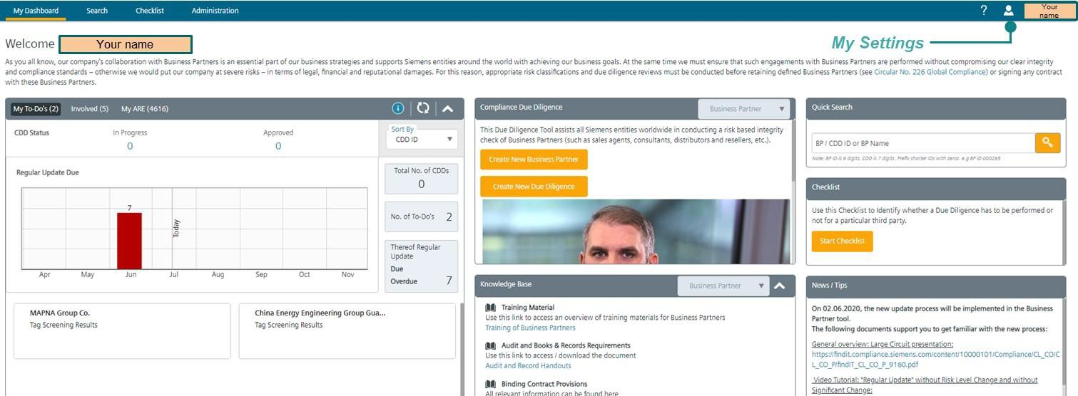

From ***My Dashboard*** (personalized Dashboard per User) you can access all the functions, e.g. open To Do's, create of Business Partners and CDDs, quick search, checklist to prove if a CDD is required as well as additional material. There are links to relevant materials, e.g. internal regulations, supporting documents, "how to" video tutorials and information on how to get help.

* + 1. My Settings

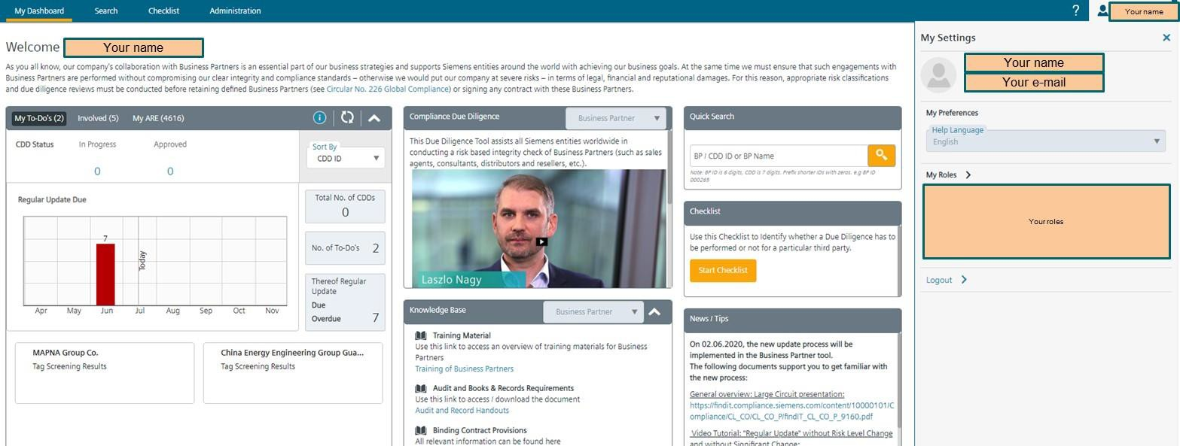

By clicking on **your** name in the top right corner you will find the roles you currently have in the [CDD-Tool,](https://compliance-tools.siemens.com/due-diligence/) e.g. ARE viewer, CO Reviewer, etc. and the AREs the roles are applicable for.

* + 1. My Dashboard

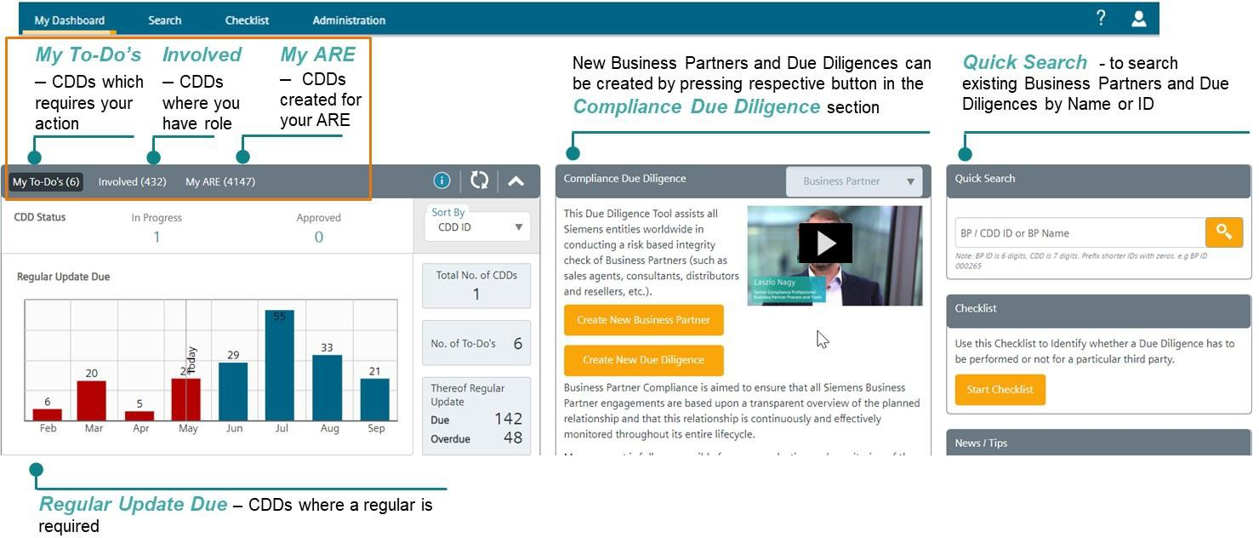

In “My Dashboard” on the top left the following information is available:

* “My To-Do`s”: gives a quick overview of all CDDs requiring your attention.
* "Involved": gives an overview of CDDs you have a role in
* "My AREs": you can see all CDDs created for **Your** AREs. The "update symbol" allows you to update the status box. 

The "info symbol " will open a box on the right with additional information. 

A graph “Regular Update Due” shows CDDs where a regular update is required. Below the graph, your “To Do’s” are displayed as CDD cards.

* + 1. Searching for existing Business Partners or CDDs

The first step is to search for a matching Business Partner entry to avoid double entries. There are different ways to search for existing Business Partners and/or CDDs, either using the Navigation Menu or the functionalities in My Dashboard:

* **Quick Search -** to find Business Partner/ CDD by Name or Identification Number (ID) (available in *„****My Dashboard“*** or ***„Search“*** section of the Navigation Menu)
* **Map Search -** to find Business Partners which are located in a particular country
* **Advanced Search** - to search by various criteria, e.g. risk level, Business Partner type, CDD status etc.

If the Business Partner cannot be found, a **new Business Partner** must be created.

Quick search

You can enter either an Identification Number (ID) for a CDD or Business Partner or enter the Business Partner name. The [CDD-Tool](https://compliance-tools.siemens.com/due-diligence/) will automatically display options after entering three digits.

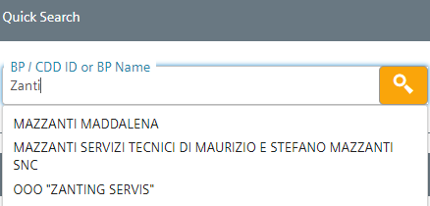

Please note: BP ID is 6 digits, CDD is 7 digits. Prefix shorter IDs with zeros. e.g. BP ID 000265

Map search

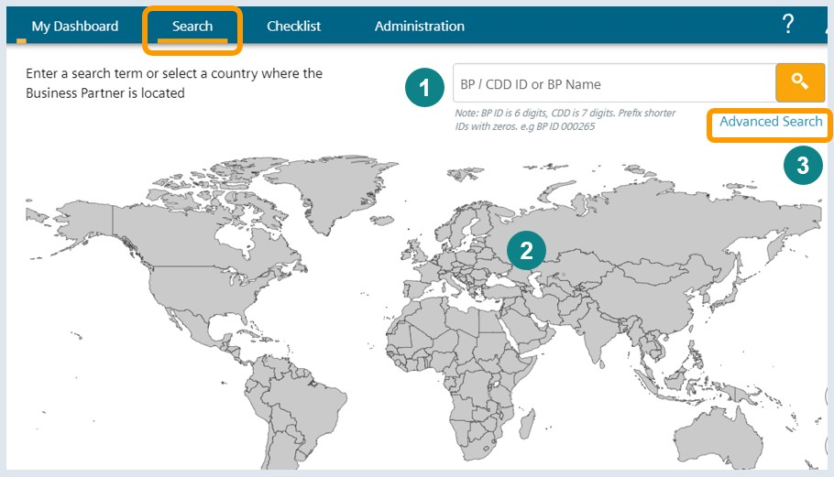

In this section you can either use (1) a BP ID / BP name or (2) select the country where the Business Partner is located using the map.

Advanced Search

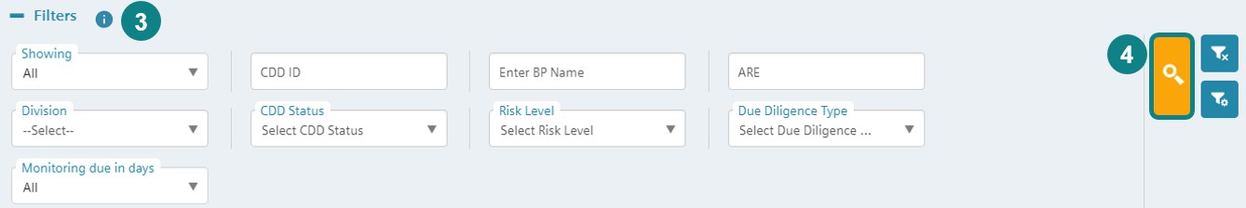

To perform an Advanced Search (3) click *“Advanced search”* and enter the search criteria (e.g. CDD ID, Business Partner name, ARE number, Company units (e.g. BUs, former Divisions, OpCos, CDD Status, Risk Level, etc.) and (4) start by clicking the search button.

Per default the shown search criteria are displayed. Additional filters (Regular Update Due etc.) can be selected

by clicking (configure filters). The settings are saved per user.



#### Business Partner CDD Process



* + 1. Business Partner Checklist - Determining if a CDD is required

A "[Business Partner Checklist](https://compliance-tools.siemens.com/due-diligence/%23/ui/checklist)" in the [CDD-Tool](https://compliance-tools.siemens.com/due-diligence/) can help determining whether a partner is in scope.

The Checklist can be accessed via My Dashboard or the **Business Partner Checklist section**.

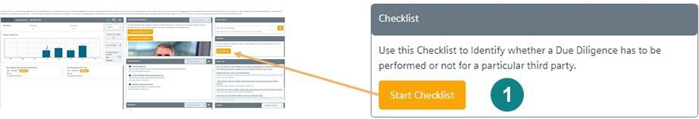

1. Start Checklist

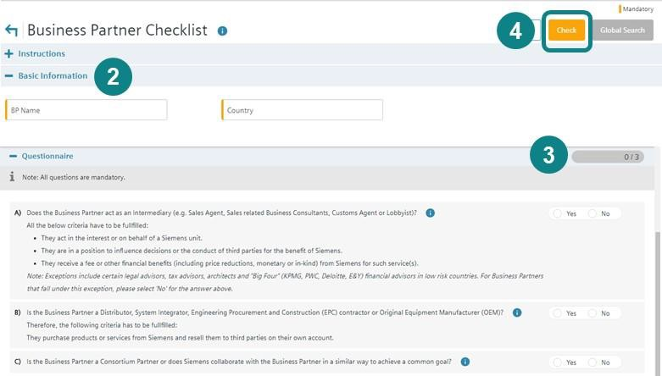

1. Enter Business Partner Name **and** Business Partner Country
2. Answer all questions
3. Click the “Check”

The questions are based on the relevant types of Business Partners (e.g. intermediaries, resellers, consortium partners). For matters of simplification, there is no differentiation between Sales related Intermediaries and Non- sales related Intermediaries, since a CDD is mandatory for both. Further details on the definitions and types can be found in chapter A.1.

* Depending on the answers, sub-questions will automatically pop-up if necessary.
* All questions must be answered with “yes” or “no"
* The “  ” symbol provides more detailed explanations to the questions.

After the Check (4), the [CDD-Tool](https://compliance-tools.siemens.com/due-diligence/) determines whether a CDD is necessary. A report of the results can be printed out. If a CDD is necessary, click the Global Search button in the top right corner (next to the Check button), which will redirect you to the search page where you can creation of a new Business Partner entry.

This [video](https://myid.siemens.com/idp/SSO.saml2?SAMLRequest=fVLBbgIhFPyVDffdRYwaiGtiNU1NbDWu7aGXBtlnJVlgy2Nt%2Ffuy2iZ68cDlMTNvZmCM0tSNmLbhYDfw1QKG5MfUFsX5oiCtt8JJ1CisNIAiKFFOn5eCZVQ03gWnXE2uKPcZEhF80M6SZDEvyAfsK7VnXO7iAT4aSMaAVopyUJzt%2BmxIh2xYjeiAk%2BQNPEZmQaJQpCO2sLAYpA1xRBlNKU8Z31Iuen0x6L2TZB7TaCvDmXUIoUGR5%2Bakqww1GLCYKWdyXTV5Wa6yzj0jyfTf4sxZbA34EvxRK3jdLK9FjroCd6PTRl4uY5Fgg1YyAEnWfwU9aFtp%2B3m%2Fm90FhOJpu12n61W5JZNxZ0qcs%2FrJneXj%2FBo4vjzqS1yxmK9drdUpeXTeyHDfQTfRVbo%2FQ0XT9Y0hpoml1LX7nnmIqQoSfAskn1x23v6dyS8%3D&RelayState=https%3A%2F%2Fmyvideo.siemens.com%2Fembed%2Fsecure%2Fiframe%2FentryId%2F1_jxvscz55%2FuiConfId%2F35060351) provides assistance on how to check if a Business Partner is in scope.

* + 1. Business Partner Key Data – How to create a Business Partner
       1. **Creating a new Business Partner**

First search for the Business Partner in the [CDD-Tool,](https://compliance-tools.siemens.com/due-diligence/) to ensure that it has not already been created.

One or more CDDs can be registered for Business Partner (please see detail for the **re-use** of an existing CDD in C.4.).

The creation of a Business Partner can be initiated directly from the Business Partner Checklist or via My Dashboard”.

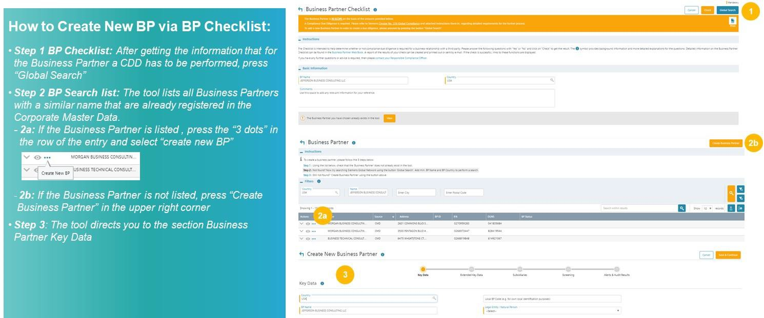

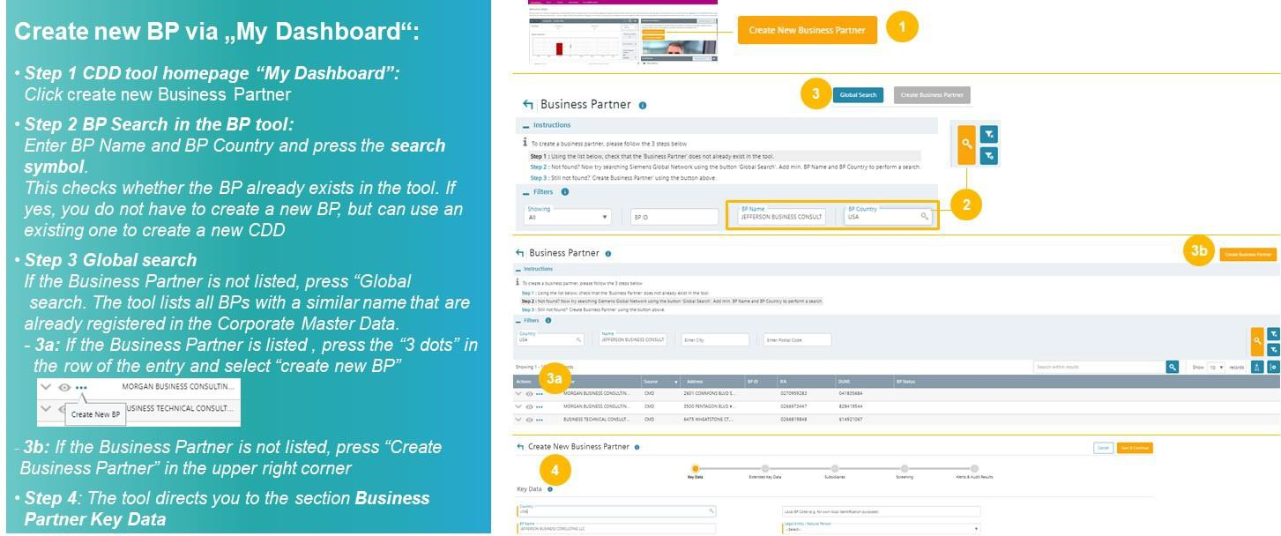

This [video](https://myid.siemens.com/idp/SSO.saml2?SAMLRequest=fVLLboMwEPwV5DuPWiUhFiCliapGShsUaA%2B9VA4sjSWwqdekzd%2FXkFZKLhy9npmdGTtG3jYdW%2FbmKPfw1QMa56dtJLLxIiG9lkxxFMgkbwGZKVm%2BfN4y6gWs08qoUjXkijLN4IigjVCSOJt1Qj74XTSjlM%2FCmsNdNA8AIKzD%2BX1dBYtZHUY15Qdqz1FFnDfQaJkJsUKWjtjDRqLh0thRQAM3WLg0LIKQhSGj9J04a5tGSG5G1tGYDpnvt2dReSigBYleqVpfVJ2f5ztvcE%2BJs%2Fy3uFIS%2BxZ0DvokSnjdb69FTqICdaPTW57PbZEgjSi5AeJkfwU9CFkJ%2BTndzeECQvZUFJmb7fKCpPFgio1ZdTqxPPavgfHlUV%2Fsis06U40oz86j0i030w6GiajceoSybugbjU1jS2ka9b3SYFMlxOgeiJ9edt7%2BnfQX&RelayState=%2Fmedia%2F1_0o4wucxd) provides additional assistance on how to create a new Business Partner.

* + - 1. Business Partner Key Data

The Key Data page is the first page when creating a Business Partner. The progress bar shows the different chapters where information about the Business Partner can be registered. The orange circle shows where in the process you currently are.

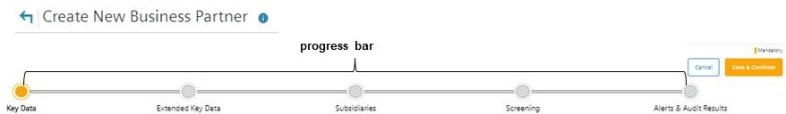

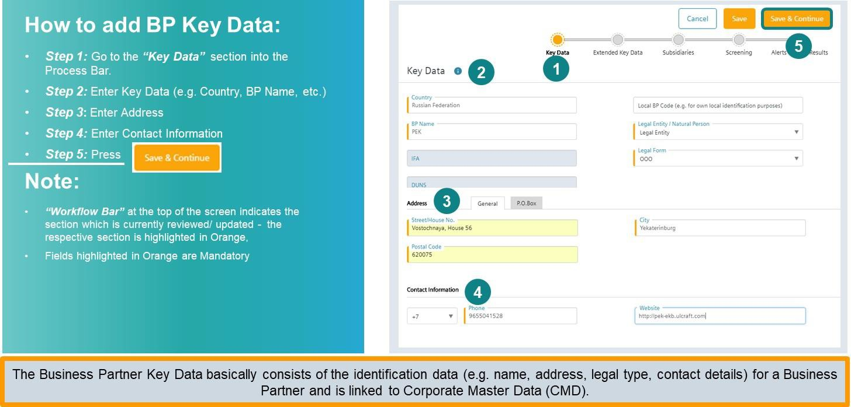

In the Key Data enter address and contact information of the Business Partner. All mandatory fields are marked with an orange bar.

Legal entity/natural person: If the Business Partner is a company, select “legal entity” and chose the legal form. If the Business Partner is an individual, select “natural person”

* + - 1. Extended Key Data

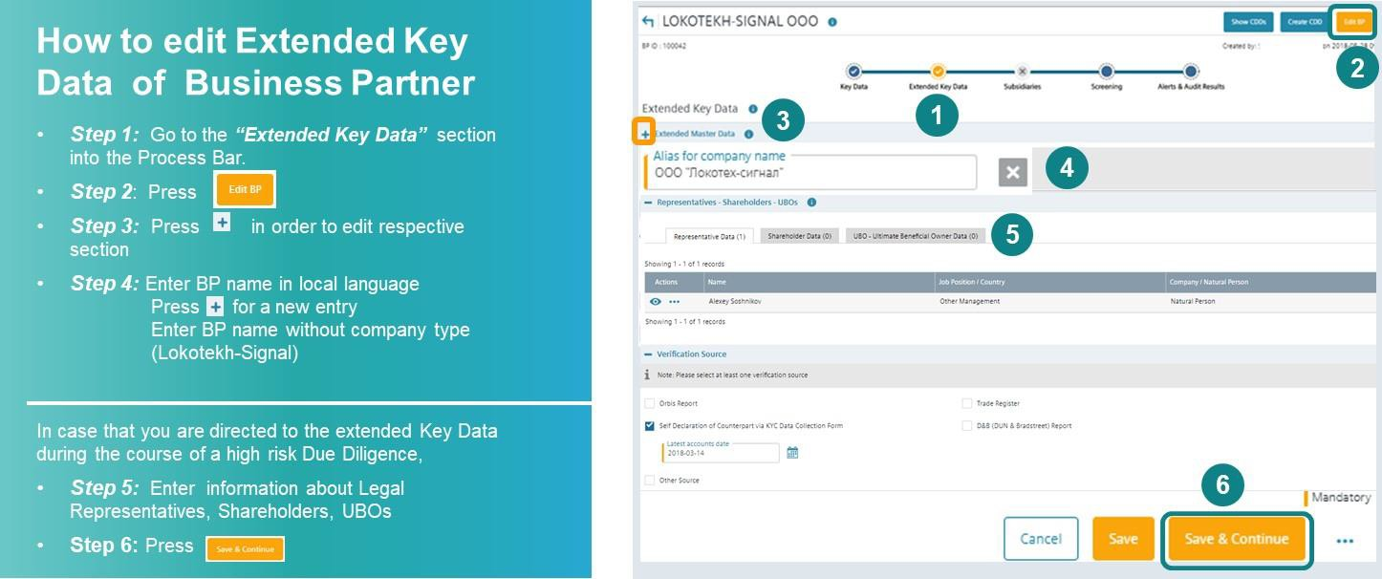

In the extended key data section, register alias names of a Business Partner (step 1-step 4). An alias name can be a for example a pseudonym of the Business Partner but also the name in local characters. Alias names are also automatically checked against SETIS (Internet and World Compliance database and DAMEX-SPS, i.e.

Sanctioned Party Screening) during the CDD.

**Example**: If you have registered a company with the Business Partner name “Lokotekh-Signal OOO” in Russia, you should register the Alias “LOKOTEKH-SIGNAL” (without OOO) plus this name in **local characters**.

This increases the accuracy of SETIS searches.

Registration of legal representatives, shareholders, ultimate beneficial owners (UBO's) (only for high risk CDDs)

For high risk CDDs, additional Business Partner key data related information to Legal Representatives, Shareholders and Ultimate Beneficial Owners (UBOs) is required. The risk level is determined by the CDD Risk Assessment at a later stage. The [CDD-Tool](https://compliance-tools.siemens.com/due-diligence/) directs you from the high risk CDD Questionnaire directly to this section.

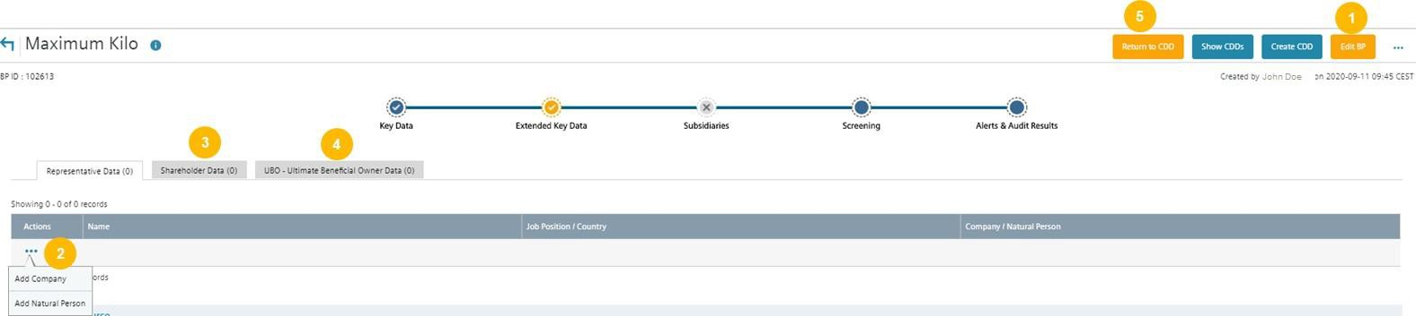

* **Step 1:** Press “Edit” to add relevant information in the chapter “Representatives, Shareholders and UBOs”.
* **Step 2:** Press the three dots to enter the name (Surname and Name) and position of the requested person or the company name. Press “Save” to save the entered information.
* **Step 3:** Register shareholder with >= 25% shares
* **Step 4:** Register the Ultimate Beneficial Owner (UBO)
* **Step 5:** After pressing save return to the CDD Questionnaire of the high risk CDD and complete the questionnaire

Further explanations on Key Persons and Key / Acting Employees Legal Representatives, Shareholders, UBOs can be found in the chapter on [Definitions and Abbreviations](https://webbooks.siemens.com/public/LC/chen/index.htm?n=General-Introduction%2C2.-Definitions-and-Abbreviations) of the General Introduction of the Compliance Handbook.

This [video](https://myid.siemens.com/idp/SSO.saml2?SAMLRequest=fVJPT8IwFP8qS%2B9js4MhzViCECMJysLQgxdT24c02drZ16F%2Be7uhCVx2fX2%2Fv68Z8rpq2KJ1R72DzxbQBd91pZH1D3PSWs0MR4VM8xqQOcHKxeOG0VHMGmucEaYiF5BhBEcE65TRJFiv5uRNCpGk9JBOU5Hw6WEC8UTEkkqZCJ5SyuWYzmYpTJNbEryARY%2BcE0%2Fk4YgtrDU6rp0fxTQO41lIJ%2FubhI1TNhm%2FkmDl0yjNXY86Otcgi6L6R8kRKqhB40iYOlKyicpyO%2BrcUxIs%2Fi0ujca2BluCPSkBz7vNJclJSTBXPK3HRdwXCdopwR2QoPgr6E5pqfTHcDfv5yVkD%2Ft9ERbbck%2FyrDPF%2Bqw2HxDPosvF7HzUJy%2BxXhWmUuInuDe25m7YQTdRMjz0q6zp%2Bkbn0%2FhSqsp8LS34VHPibAskys%2Ba138n%2FwU%3D&RelayState=https%3A%2F%2Fmyvideo.siemens.com%2Fembed%2Fsecure%2Fiframe%2FentryId%2F1_lzahxvmd%2FuiConfId%2F35060351) provides further assistance on how to regarding Extend Key Data.

* + - 1. Subsidiaries

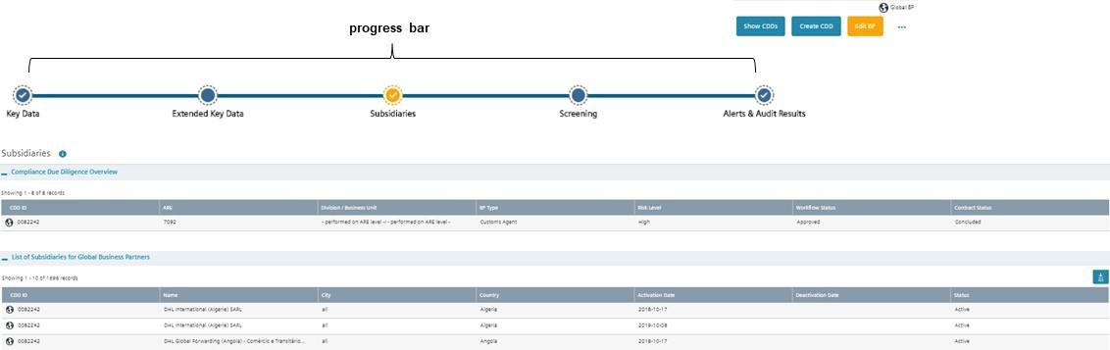

Subsidiary section is relevant only for Global Business Partners. It will be only available after the Business Partner is marked as global in CDD data.

* + - 1. Screening

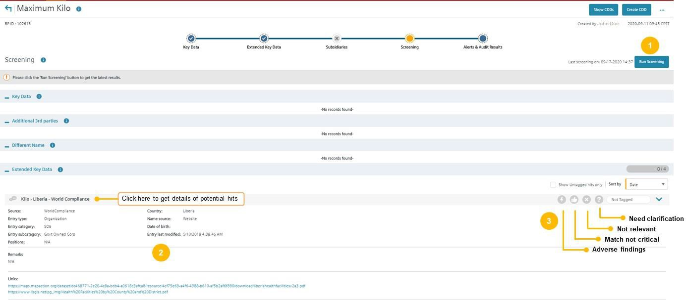

In the "**Screening"** results of screenings against the listings from World Compliance and DAMEX using the tool SETIS are displayed.

This [video](https://myid.siemens.com/idp/SSO.saml2?SAMLRequest=fVLLboMwEPwV5DuPWiUhFiCliapGShsUaA%2B9VA4sjSWwqdekzd%2FXkFZKLhy9npmdGTtG3jYdW%2FbmKPfw1QMa56dtJLLxIiG9lkxxFMgkbwGZKVm%2BfN4y6gWs08qoUjXkijLN4IigjVCSOJt1Qj74XTSjlM%2FCmsNdNA8AIKzD%2BX1dBYtZHUY15Qdqz1FFnDfQaJkJsUKWjtjDRqLh0thRQAM3WLg0LIKQhSGj9J04a5tGSG5G1tGYDpnvt2dReSigBYleqVpfVJ2f5ztvcE%2BJs%2Fy3uFIS%2BxZ0DvokSnjdb69FTqICdaPTW57PbZEgjSi5AeJkfwU9CFkJ%2BTndzeECQvZUFJmb7fKCpPFgio1ZdTqxPPavgfHlUV%2Fsis06U40oz86j0i030w6GiajceoSybugbjU1jS2ka9b3SYFMlxOgeiJ9edt7%2BnfQX&RelayState=%2Fmedia%2F1_nxu0lvvp) provides assistance on how to use SETIS for internet checks.

Note:

The Screening starts automatically if a new CDD is created or if a Regular Update of a CDD is performed. It is repeated automatically every 6 months.

To perform a Screening manually

* ***Step 1:*** Press **“Run Screening”** to get latest results, and
* ***Step 2:*** Review identified hints (if any)
* ***Step 3:*** Tag the hits

Hits identified during a CDD have to be analyzed and tagged by the CDD Responsible. New hits resulting from a screening that is automatically repeated every 6 months have to be analyzed and tagged by a Lead CO Reviewer (Compliance) of CDDs performed for this Business Partner.

Explanations regarding potential hits in DAMEX can be found in the [DAMEX Sanctions Matrix.](https://findit.compliance.siemens.com/content/10000101/Compliance/LC_CO/LC_CO_EX_GOV/findIT_LC_CO_EX_GOV_6348.xlsx) This [video](https://myid.siemens.com/idp/SSO.saml2?SAMLRequest=fVJbb4IwFP4rpO%2Fcg0oDJE6zzMRNImwPe1kqHGYTaFlPcfPfr%2BKW6Auvp%2Be7nibIurany0EfxR6%2BBkBt%2FXStQDo%2BpGRQgkqGHKlgHSDVFS2Wz1saOB7tldSyki25gUwjGCIozaUg1madko9q4R%2B8hs0iCIMmnMOsqasFgB%2FGdex5fhwBa8KZX%2FsRsd5AoUGmxBAZOOIAG4GaCW1GXuDZXmwHUen7NJxTb%2F5OrLVJwwXTI%2BqodY%2FUdbszrx3k0IFAp5Kdy%2BveLYqdc3EfEGv5b3ElBQ4dqALUiVfwut%2Fekpx4DfKOZzA4l5kiQWheMQ3Eyv8KeuCi5uJzupvDdQnpU1nmdr4rSpIlF1N0zKqyCfHEvV1Mrkd9MRKbdS5bXp2tR6k6pqcdXCa8tptxlfaXvlGbNKaUtpXfKwUmVUq0GoC42VXz%2Fu9kvw%3D%3D&RelayState=%2Fmedia%2F1_d7uqgbhz) provides assistance on handling of new Integrity Search Results.

* + - 1. Alerts & Audit Results

The Alerts and Audit Results section can be only edited by a Compliance Officer, for standard users this section is read only.

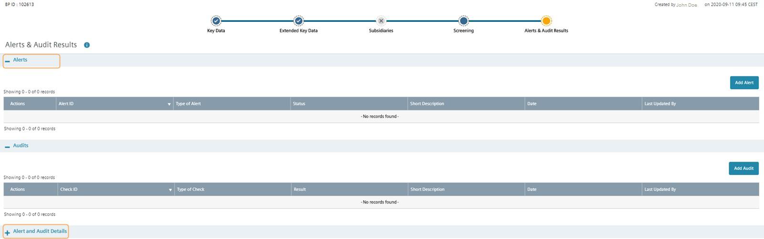

Alerts

In this section a Business Partner can be e.g. flagged as “under observation” or centrally disapproved by a Compliance Officer see also C.5.1.3. Centrally Disapproval / Business Partner under observation.



* 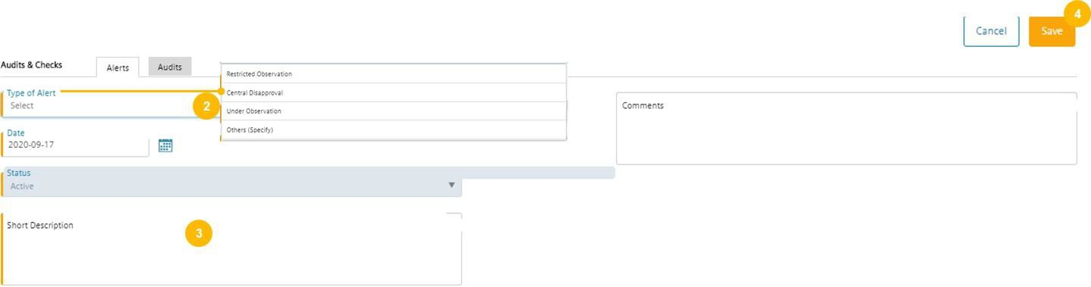***Step 1:*** Press “Add Alert”
* ***Step 2:*** Select the type of the alert
* ***Step 3:*** Enter a short description (text will be included in the e-mail to involved persons)
* ***Step 4:*** Press Save

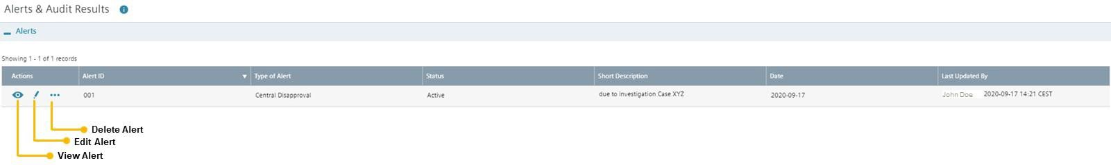

Clicking the symbols, you can view, edit (e.g. deactivate) or delete an alert.

Audits

The results of a Business Partner audit performed by CF A or of a Compliance Onsite Check (B.4. Compliance onsite check) can be registered. The process to add an audit is similar to the alerts process.

This [video](https://myid.siemens.com/idp/SSO.saml2?SAMLRequest=fVJPT4MwFP8qpPcBFqbYAMncYlwyHRnowYtp4emaQIt9Zeq3t2yabBeur%2B%2F39zVF3rU9Wwx2r3bwOQBa77trFbLjQ0YGo5jmKJEp3gEyW7Ny8bhh1A9Zb7TVtW7JGWQawRHBWKkV8darjLyJOElEw%2BNIRDymV4kIKadCUCooT66TEBpIwnh%2BIyjxXsCgQ2bEETk44gBrhZYr60YhDWfh7YzOq3DO5hGj0SvxVi6NVNweUXtre2RB0P3IxkcJHSj0a90FsumDstz6o3sns%2Fi3uNQKhw5MCeYga3jebc5JDrIBfcEzOFzAXZGgrKy5BeIVfwXdSdVI9THdjTgtIXuoqmJWbMuK5Oloih2zmnxCPA3OF9PTUZ%2BcxHpV6FbWP969Nh230w7GiWxm78dV1o99o3VpXCltq7%2BWBlyqjFgzAAnyk%2Bbl38l%2FAQ%3D%3D&RelayState=https%3A%2F%2Fmyvideo.siemens.com%2Fembed%2Fsecure%2Fiframe%2FentryId%2F1_d1gxq9w7%2FuiConfId%2F35060351) provides assistance for the Alerts & Audit Results section.

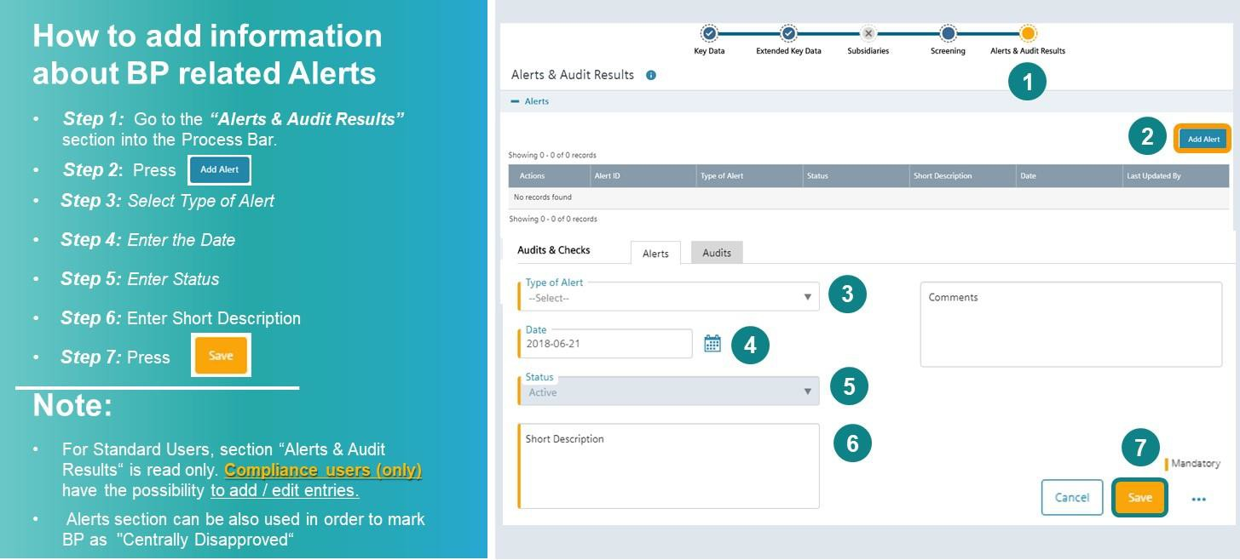

* + 1. Due Diligence Key Data – How to create a CDD
       1. **Creating a CDD**

One or more CDDs can be registered for the same Business Partner. This [video](https://myid.siemens.com/idp/SSO.saml2?SAMLRequest=fVLLboMwEPwV5DuPWiUhFiCliapGShsUaA%2B9VA4sjSWwqdekzd%2FXkFZKLhy9npmdGTtG3jYdW%2FbmKPfw1QMa56dtJLLxIiG9lkxxFMgkbwGZKVm%2BfN4y6gWs08qoUjXkijLN4IigjVCSOJt1Qj74XTSjlM%2FCmsNdNA8AIKzD%2BX1dBYtZHUY15Qdqz1FFnDfQaJkJsUKWjtjDRqLh0thRQAM3WLg0LIKQhSGj9J04a5tGSG5G1tGYDpnvt2dReSigBYleqVpfVJ2f5ztvcE%2BJs%2Fy3uFIS%2BxZ0DvokSnjdb69FTqICdaPTW57PbZEgjSi5AeJkfwU9CFkJ%2BTndzeECQvZUFJmb7fKCpPFgio1ZdTqxPPavgfHlUV%2Fsis06U40oz86j0i030w6GiajceoSybugbjU1jS2ka9b3SYFMlxOgeiJ9edt7%2BnfQX&RelayState=%2Fmedia%2F1_jqs236zu) provides additional assistance on how to create a new due diligence.

There are two options to create a CDD:

1. Business Partner Key Data are already available and you are creating a first CDD for this BP:

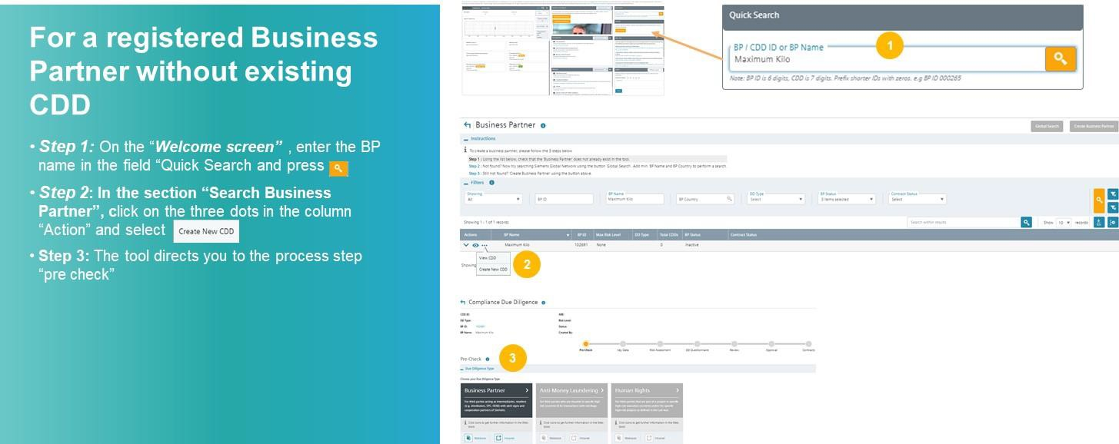

1. Business Partner Key Data are created and other CDD(s) exist(s):

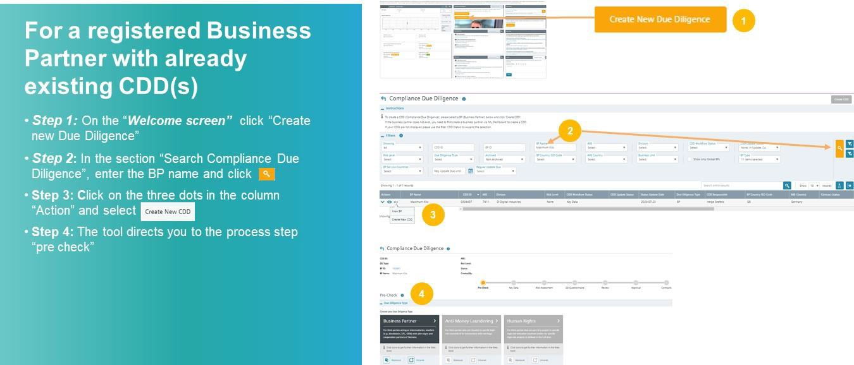

* + - 1. Pre-Check

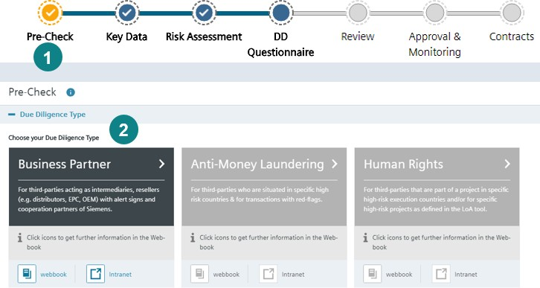

**Once you have started creating a new CDD,** click on Business Partner in the Pre-Check.

* + - 1. CDD Key Data

In the CDD Key Data key elements of the business relationship must be described.

If CDD Key Data is newly created or a Regular Update is started, an automatic screening of Business Partner name and alias name(s) against SETIS is initiated. The evaluation of potential hits must be performed as part of the risk assessment of the CDD.

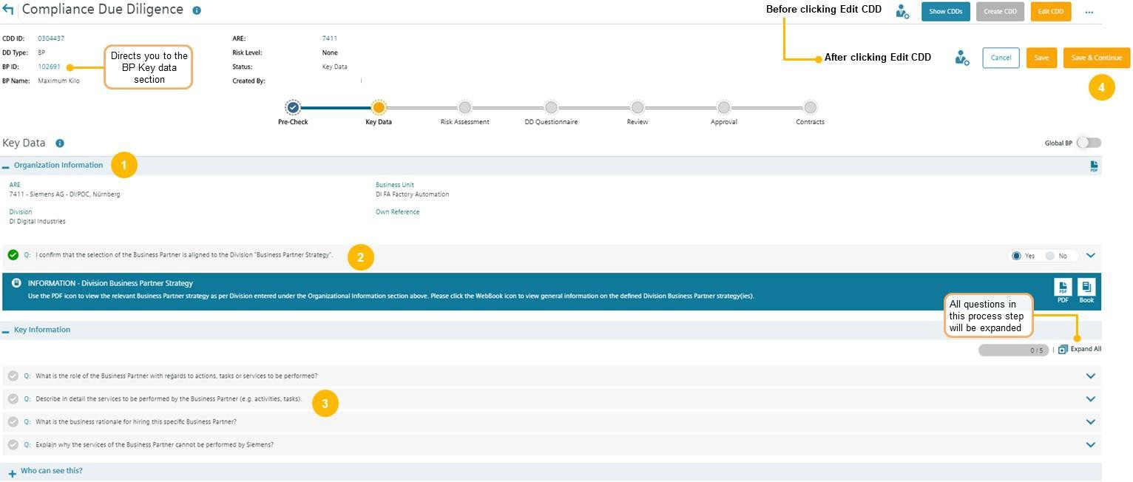

CDD Key Data consists of

1. Organizational Information
2. Key Information
3. Who can see this? (maintenance of CDD roles => see C.5.1.1.) To edit information, click "Edit CDD".

* ***Step 1:*** Enter details of the Siemens entity engaging the Business Partner (ARE number, Business).
* ***Step 2:*** Depending on the organization data, confirm that the engagement is in line with the Business Partner Strategy (available in the [CDD-Tool](https://compliance-tools.siemens.com/due-diligence/))
* ***Step 3:*** Enter requested details of the business relationship
* ***Step 4:*** Press "Save and Continue"

This [video](https://myid.siemens.com/idp/SSO.saml2?SAMLRequest=fVLLboMwEPwV5DuPWiUhFiCliapGShsUaA%2B9VA4sjSWwqdekzd%2FXkFZKLhy9npmdGTtG3jYdW%2FbmKPfw1QMa56dtJLLxIiG9lkxxFMgkbwGZKVm%2BfN4y6gWs08qoUjXkijLN4IigjVCSOJt1Qj74XTSjlM%2FCmsNdNA8AIKzD%2BX1dBYtZHUY15Qdqz1FFnDfQaJkJsUKWjtjDRqLh0thRQAM3WLg0LIKQhSGj9J04a5tGSG5G1tGYDpnvt2dReSigBYleqVpfVJ2f5ztvcE%2BJs%2Fy3uFIS%2BxZ0DvokSnjdb69FTqICdaPTW57PbZEgjSi5AeJkfwU9CFkJ%2BTndzeECQvZUFJmb7fKCpPFgio1ZdTqxPPavgfHlUV%2Fsis06U40oz86j0i030w6GiajceoSybugbjU1jS2ka9b3SYFMlxOgeiJ9edt7%2BnfQX&RelayState=%2Fmedia%2F1_5fy0qxyl) provides additional assistance on how to complete the CDD Key Data.

Explanation of some questions asked in the chapter CDD Key Data. Role of the Business Partner



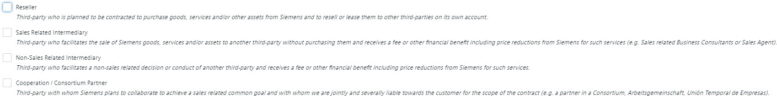

* + Detailed information about Business Partner types (=roles) are available in A.1.
  + If the Business Partner acts in several roles e.g. as Reseller and Sales Agent, more than one role can be selected.
  + Depending on the Business Partner type additional specific questions must be answered during the course of the due diligence.

Service description Business Partner

Ensure that information about the relationship is complete and transparently described in a way that it is understood by an objective independent person. The description should explain:

* 1. How consistent the scope compared to the Business Partners normal operations is and
  2. Whether the Business Partner has sufficient resources and qualifications.

Press “Save and Continue” to finalize the CDD Key Data and move to the Risk Assessment.

[Best practice examples of neutral service descriptions](https://findit.compliance.siemens.com/content/10000101/Compliance/LC_CO/LC_CO_RG_PL/findIT_LC_CO_RG_PL_9576.pdf) (e.g. for Sales Agent, EPC, non-sales related intermediary provide further assistance.

* + 1. Risk Assessment

After completing the Key Data, you are forwarded to the Risk Assessment.

The risk level of the **relationship** (low, medium or high) is determined by the Business Partner type in the Key Data and by risk relevant questions to be answered in the risk assessment.

In addition, the evaluation of potential SETIS hits influences the risk level of the CDD.

The risk level will determine the subsequent questionnaires, the necessity for a Compliance onsite check, whether the Business Partner must receive a training, approval requirements and mandatory contract provisions.

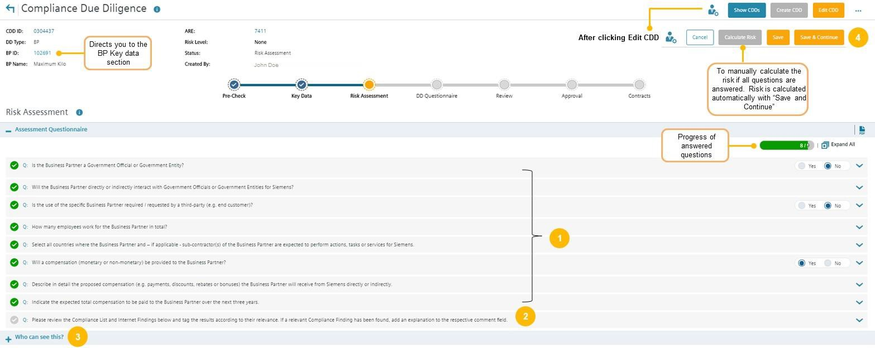

* ***Step 1:*** Answer all questions (except the last one about results of the Internet check)
* ***Step 2:*** Evaluate SETIS / Internet Search see **C.2.4.2.**
* ***Step 3:*** Maintain Approver roles see **C.5.1.1**.
* ***Step 4:*** Press Save & Continue

This [video](https://myid.siemens.com/idp/SSO.saml2?SAMLRequest=fVJPT8IwFP8qS%2B%2BwUZBBw5YgxEiCsjD04MV07UOabO3s61C%2Fvd3QBC67vr7f39cF8qqs2bJxJ72HzwbQBd9VqZF1DwlprGaGo0KmeQXInGD58mnL6DBitTXOCFOSK0g%2FgiOCdcpoEmzWCXmP4xGlEwnjYiqiCZd0PpOFmApZjOJxAVMRz45HOqXFhASvYNEjE%2BKJPByxgY1Gx7Xzo4hGg2g%2BoHeH0YiN52wcv5Fg7dMozV2HOjlXIwvD6kfJISqoQONQmCpUsg7zfDds3VMSLP8trozGpgKbgz0rAS%2F77TXJWUkwNzyNx4XcFwnaKcEdkCD7K%2Bheaan0R383xWUJ2ePhkA2yXX4g6aI1xbqsNu0RX4TXi4vLUZ%2B9xGadmVKJn%2BDB2Iq7fgftRMnBsVtldds3Op%2FGl1KW5mtlwadKiLMNkDC9aN7%2BnfQX&RelayState=%2Fmedia%2F1_5seveyds) provides additional assistance on how to complete the Risk Assessment.

If the Risk Assessment determines a low risk CDD, confirm that the CDD is complete, includes accurate information and select whether the Business Partner raises Compliance concerns or not. After that you can submit the CDD for Management Approval

In case of a medium or high risk CDD, continue with the DD Questionnaire (C.2.5.)

* + - 1. **Explanation of some questions in the Risk Assessment**

**Interaction with government officials**

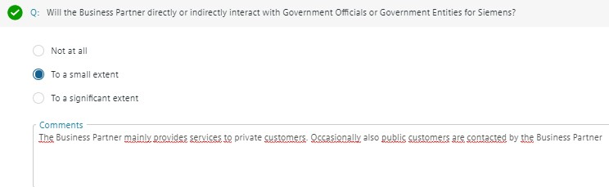

If there is any kind of interaction with governmental officials or entities, detailed information regarding the kind of interaction with Government Officials must be provided in the comment box.

The Business Partner does not interact with government officials or entities to **a significant extent** if the interaction is only on an occasional or random basis (e.g. a business partner occasionally delivers equipment to public schools, but the main customer basis are private enterprises).

You can find the definition of governmental officials [here.](https://webbooks.siemens.com/public/LC/chen/index.htm?n=General-Introduction%2C2.-Definitions-and-Abbreviations)

##### Compensation details

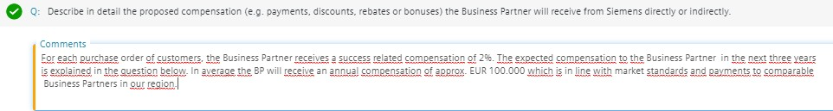

The question must be answered that an independent reader understands, what the Business Partner will receive and whether the compensation is in line with market practice. It must be plausible that the compensation is in a reasonable proportion to the services the Business Partner provides.

* + - 1. Internet checks and Sanctioned Party/World Compliance checks

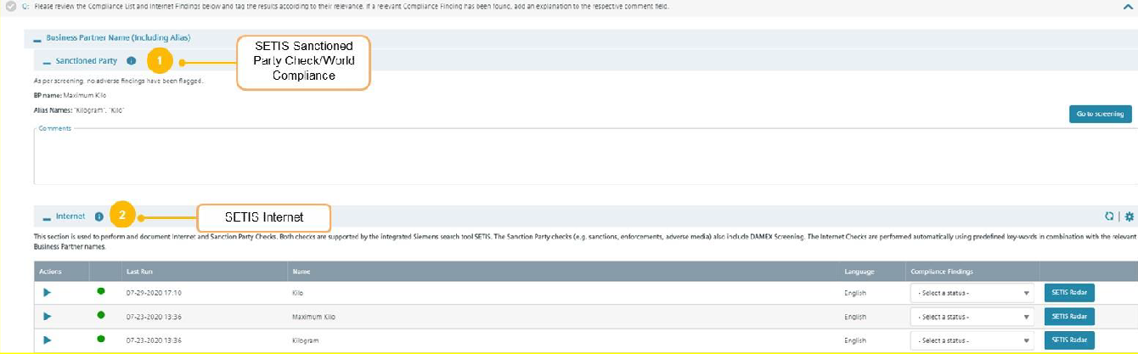

Potential hits of SETIS of Business Partner names and alias names must be evaluated.

* + - 1. Sanctioned Party/World Compliance

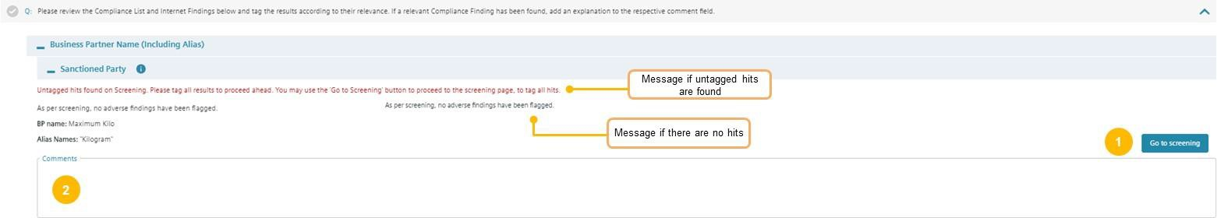

If “As per screening, no adverse findings have been flagged” skip the section and continue with the Internet check.

If hits in the Sanctioned Party lists or the World Compliance Database are found, a message is displayed: “Untagged hits found on Screening. Please tag all results to proceed ahead”. Hits are displayed and have to be tagged in the Business Partner Screening section, see C.2.2.5.

* ***Step 1:*** If untagged hits were found “Go to Screening”, evaluate and tag the hits in the Business Partner Screening
* ***Step 2:*** Comment results of your evaluation in the comment box and continue with section SETIS Internet Check

Explanations regarding potential hits in DAMEX can be found in the [DAMEX Sanctions Matrix.](https://findit.compliance.siemens.com/content/10000101/Compliance/LC_CO/LC_CO_EX_GOV/findIT_LC_CO_EX_GOV_6348.xlsx)

* + - 1. Internet

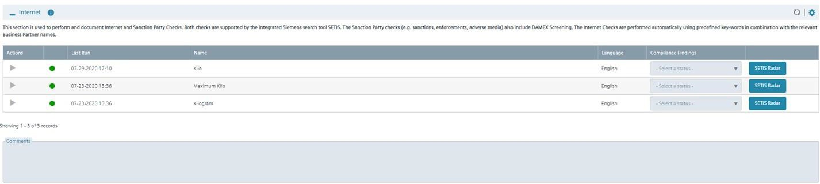

This [video](https://myid.siemens.com/idp/SSO.saml2?SAMLRequest=fVLLboMwEPwV5DuPWiUhFiCliapGShsUaA%2B9VA4sjSWwqdekzd%2FXkFZKLhy9npmdGTtG3jYdW%2FbmKPfw1QMa56dtJLLxIiG9lkxxFMgkbwGZKVm%2BfN4y6gWs08qoUjXkijLN4IigjVCSOJt1Qj74XTSjlM%2FCmsNdNA8AIKzD%2BX1dBYtZHUY15Qdqz1FFnDfQaJkJsUKWjtjDRqLh0thRQAM3WLg0LIKQhSGj9J04a5tGSG5G1tGYDpnvt2dReSigBYleqVpfVJ2f5ztvcE%2BJs%2Fy3uFIS%2BxZ0DvokSnjdb69FTqICdaPTW57PbZEgjSi5AeJkfwU9CFkJ%2BTndzeECQvZUFJmb7fKCpPFgio1ZdTqxPPavgfHlUV%2Fsis06U40oz86j0i030w6GiajceoSybugbjU1jS2ka9b3SYFMlxOgeiJ9edt7%2BnfQX&RelayState=%2Fmedia%2F1_nxu0lvvp) provides additional assistance on how to use SETIS for Internet checks.

In this section potential hits of an automatic internet search (Google or Bing) are displayed. The status of the search is marked with a colored bubble:

Green bubble: SETIS-search completed Orange bubble: SETIS-search in progress Red bubble: Radar has failed

You can only proceed if bubbles are green. If the bubble is orange or red, save the CDD and return after a while to check whether the problem has been solved. In urgent cases send a message to bpc- [tool.cit@siemens.com](mailto:tool.cit@siemens.com)

The searches are automatically performed with Compliance relevant keywords (e.g. corruption, bribery) in English and in the language of the Business Partner country.

You can manually add up to three languages that are supported by SETIS:

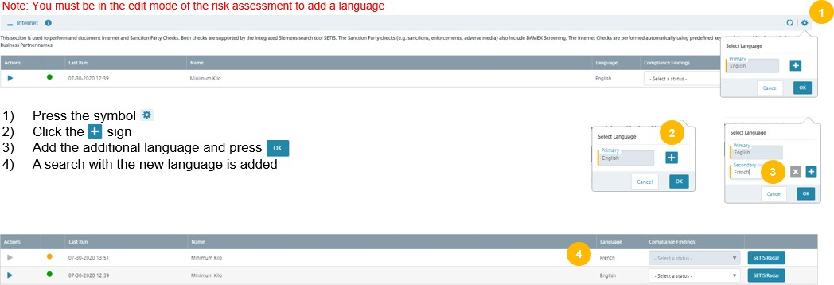

Evaluation of SETIS internet searches



After searches are completed press the respective SETIS Radar button to go to SETIS and to view the content of the results.

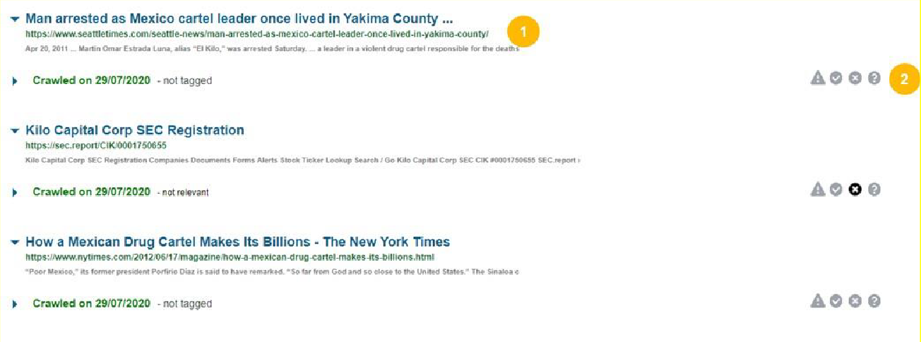

* ***Step 1:*** In SETIS, check all hits. To get more info about a hit, click the respective link
* 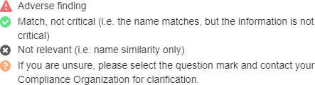***Step 2:*** In SETIS tag all hits with the respective symbols:
* ***Step 3:*** Go back to Risk Assessment in the [CDD-Tool](https://compliance-tools.siemens.com/due-diligence/)

Hints for the evaluation of SETIS hits

The following guidance is a collection of ideas and does not have a binding character:

* + - * + Identify false positive hits due to same or similar names or due to different writing or spelling.
        + Evaluate **credibility of source** of hit (credibility decreasing):

DAMEX

Official authority websites

World Compliance Database

Press or blog articles

* + - * + Check regional, temporal, company, business and individual proximity of hit:

Regional: does the hit concern the countries where the business is planned?

Temporal: does the hit cover recent (less than five years) or historical events?

Company: does the hit concern the exact legal entity with which business is intended or another entity of a group of companies?

Business: does the hit concern the area of business that is relevant for the intended business relationship

Individuals: Does the hit concern individuals which are key persons or key employees for the intended business?

* + - * + Check severity of (alleged) infringement:

Does the hit concern allegations or proven convictions?

Does the hit concern a serious crime or a misdemeanor (*“Ordnungswidrigkeit” – e.g. minor wrongdoing*)?

Does the hit concern the management, a larger number of employees or does it have an isolated character (systematic or one-time failure)?

* + - * + Evaluate remediation measures of business partner:

Did the business partner take appropriate measures after the infringement mentioned in the hit?

Note: If you get a hit in a language you do not understand, contact a colleague who understands it or your Compliance Officer.

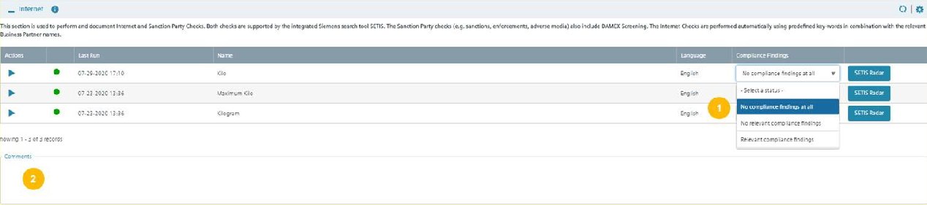

* ***Step 1:*** For each search select whether there are “no Compliance findings at all”, “no relevant Compliance findings” or “relevant Compliance findings”
* ***Step 2:*** Write a short summary of the results of your evaluation in the comment box

If a language is not supported by SETIS, you get a hint:



In this exceptional case perform a manual internet search as per the guidance below in the language of the country the Business Partner is located. If you are not familiar with the language, please contact a colleague who understands or your Compliance Officer.

Manual internet search

Publicly and locally available search engines should be used:

* + - * + Search for name as well as close variations. Searches should seek to identify press release / press information that may call into question the compliance of the Business Partner.
        + If you encounter a large number of hits when searching for a particular name refine your search by using a combination of terms such as “bribe” and “corrupt” (e.g. “[Name of Business Partner]” + “corrupt”, “[Name of Business Partner]” + “bribe”).
        + If available, review the top 20 hits. Be curious and check whether public information is available that might cause you to suspect the Business Partners reputation or integrity. If you get findings obviously solved by the Business Partner (remember the Siemens case), discuss with your Compliance Officer.
        + Depending on the result, use the respective answer in question RA 14 (no compliance findings at all; no relevant compliance findings; relevant compliance findings).
        + Upload a screenshot or PDF document of the search in the CDD Key Data of the [CDD-Tool](https://compliance-tools.siemens.com/due-diligence/) (supporting documents).
        + Document the results of your search in the comment field for Internet searches in the Risk Assessment.
    1. DD Questionnaire

For medium and high risk CDDs, the CDD Responsible is asked to provide more information. To get a complete and neutral picture, the CDD questionnaires include internal information obtained from the Business Partner as well as external information from independent sources. For high risk CDDs, for example shareholders, Ultimate Beneficial Owner (UBO) and other key persons have to be checked and the Business Partner has to be trained (e.g. via web-based training).

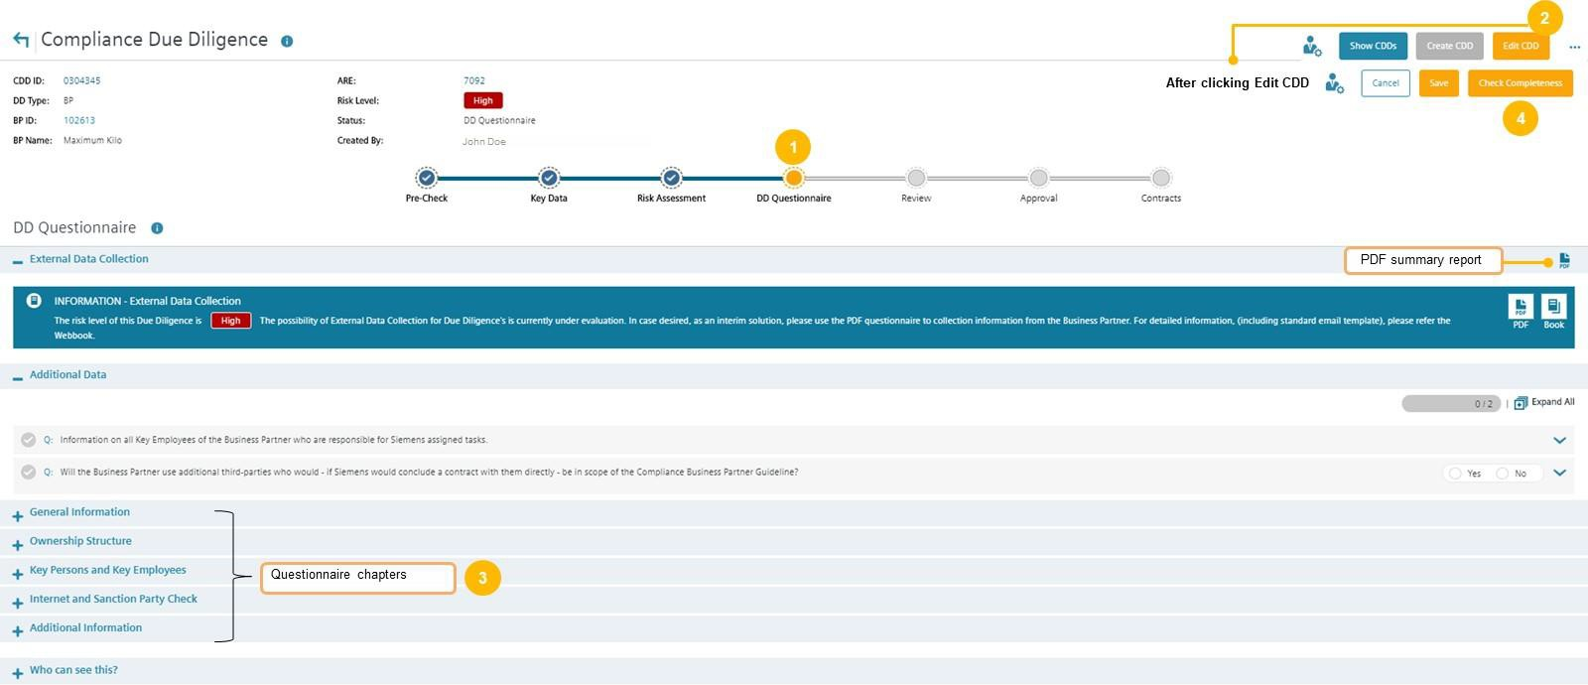

How to complete the DD Questionnaire:

* ***Step 1:*** Go to the ***“DD Questionnaire***”
* ***Step 2:*** Press Edit
* ***Step 3:*** Answer all questions
* ***Step 4: Submit CDD for Compliance Review by*** pressing “Check Completeness” This [video](https://myid.siemens.com/idp/SSO.saml2?SAMLRequest=fVJPT8IwFP8qS%2B%2BwrjCBhi1BiJEEhbDpwYsp7UOabO3s61C%2FvWVoAheur%2B%2F393WKoq4aPmv9wWzhswX00XddGeTdQ0ZaZ7gVqJEbUQNyL3kxe1px1qe8cdZbaStyAbmNEIjgvLaGRMtFRt6ZGggxYWrM0lSlAkaTwU7QCRvskoTK4d1oLweM7pMhI9ErOAzIjASiAEdsYWnQC%2BPDiDLao5MeS0ua8jThdPxGokVIo43wHergfYM8jusfrfqooQaDfWnrWKsmLop1%2F%2BQ%2ByMz%2BLc6twbYGV4A7agkv29UlyVErsFc8bcDFIhQJxmspPJBo81fQvTZKm4%2Fb3ezOS8gfy3LT26yLkuTTkyneZXX5DfFpfLk4PR%2F1OUgsFxtbafkTPVhXC3%2FbwWmiVW%2FfrfLm1Df6kCaUUlX2a%2B4gpMqIdy2QOD9rXv%2Bd%2FBc%3D&RelayState=%2Fmedia%2F1_8tzn98h9) provides further assistance on how to complete a due diligence.

Explanation of some questions in the DD Questionnaire External Data Collection

The Siemens unit may also ask the Business Partner to directly provide answers to a major part of the due diligence questions. A blue box will appear, which contain a link to the External Data Collection questionnaire to collect information from the Business Partner directly via PDF document.

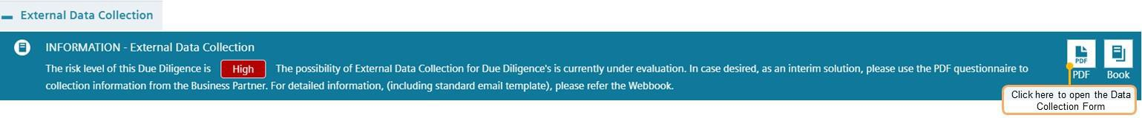

##### Information of Key employees of the Business Partner (only high risk CDD)

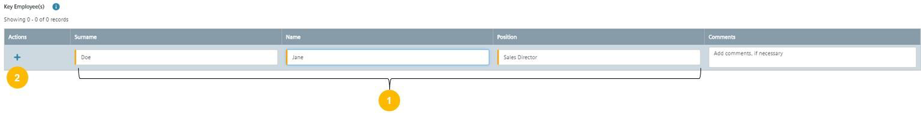Key employee(s) of the Business Partner who will carry out work for Siemens and who will have direct contact with Siemens personnel (other than mere support activities, like assistants)

* ***Step 1:*** Enter Surname, Name and Position of the Key Employee
* ***Step 2:*** Press “+” to save the entry (and to add further key employees if applicable)

##### Additional third parties used by the Business Partner (subcontractors)

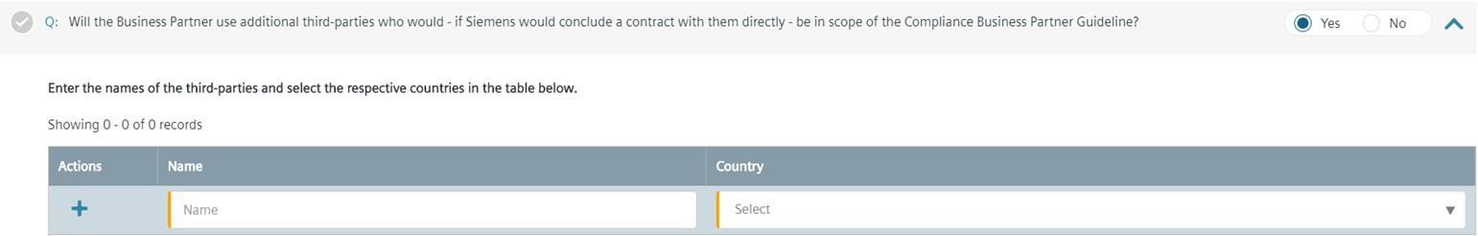

Please refer to chapter A.3. Subcontractors of Business Partners

##### Information Letter / Consent Form

To ensure that the background screening for a medium or high risk CDD on the integrity of the Business Partner is in line with the data privacy regulations at least an Information Letter needs to be sent to the Business Partner.

In some countries, data privacy regulations might require an explicit consent of the Business Partner and or the respective individuals.

The [CDD-Tool](https://compliance-tools.siemens.com/due-diligence/) contains a list of all countries requiring a Consent Form and will show the respective advice based on the country of the Business Partner or the Siemens entity.

For more information, please refer to chapter C.5.2.3.

Audit rights and Books & Records

Information about Siemens Audit and Books & Records requirements must be sent to Business Partners with medium or high risk CDDs. The Business Partners must understand the scope of such audits and the expectations of transparent Books & Records.

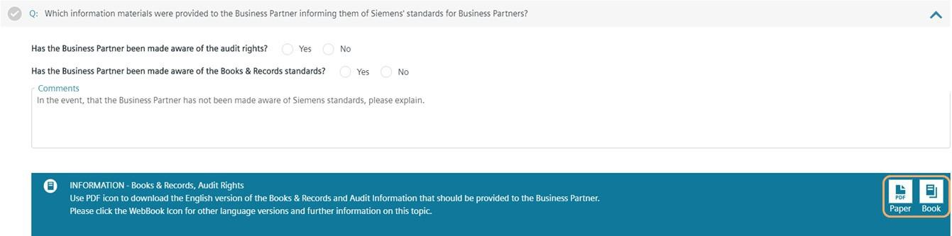

For more information, please refer to chapter C.5.2.2.

Training of Business Partners

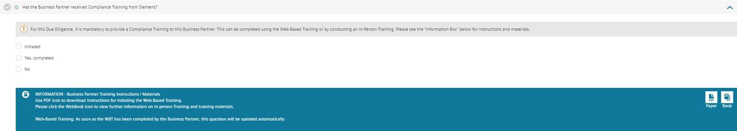

Business Partner training is mandatory for all high risk CDDs and has to be documented in the [CDD-Tool.](https://compliance-tools.siemens.com/due-diligence/) For more information, please refer to chapter A.5.

Business licenses / authorization

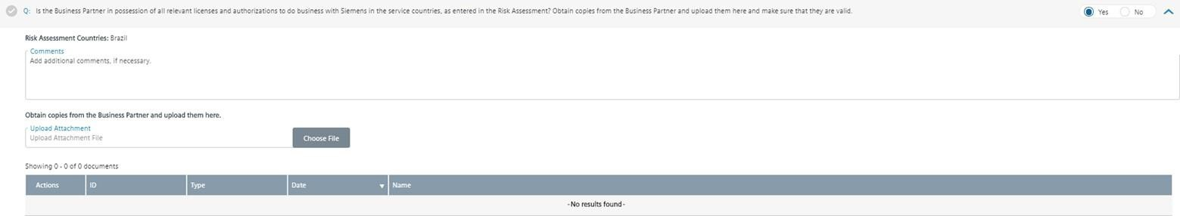

Business licenses are permits issued by government agencies that allow individuals or companies to conduct business within the government's geographical jurisdiction. A single jurisdiction often requires multiple licenses that are issued by multiple government departments and agencies. Business licenses vary between countries, states, and local municipalities. There are often many licenses, registrations and certifications required to conduct a business in a single location.

Typically, a company's business activity and physical location (address) determines which licenses are required to operate lawfully. Other determining factors may include the number of employees and the form of business ownership, such as sole proprietor or corporation.

Also, in many jurisdictions a business must notify the responsible authority and register in official registers to perform business. If the business is entered in the trade or commercial registry, this entry also determines the correct and full company name. Often, also the address and legal representatives as well as additional date are shown in the commercial register.

A list of company registers can also be found on [Wikipedia.](https://en.wikipedia.org/wiki/List_of_company_registers)

Independent background report (e.g. Dun & Bradstreet report, Creditreform, Sinotrust, Spark)

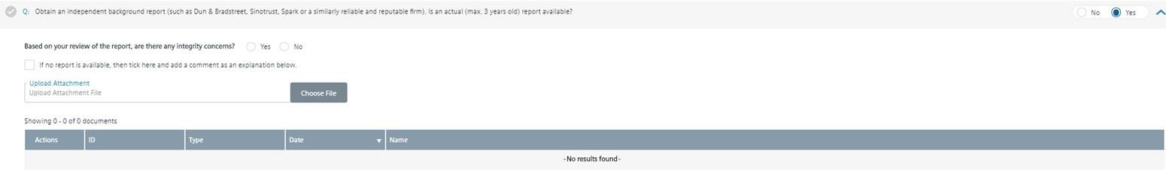

An independent background report should contain information relevant to check the information provided by the Business Partner regarding:

* Integrity of Business Partner
* Business Partners ties (personal or business) to government or a government official
* The names of all directors, officers, managing partners, owners, beneficial owners, majority shareholder, key employees
* Civil or criminal judgements against the business partner.

If there are any differences between the information in the report and the information provided by business partner, point this out to the Business Partner, obtain the business partners explanation and provide details.

Credit Reports such as Dun & Bradstreet and Creditreform can be ordered via Siemens Global Information Sphere: <https://sgi.siemens.com/home?f=credit&a=Resultlist!sm>

However, it is recommended that you contact your Compliance Officer to get information about local sources for such background report.

Extended Key Data (Legal Representatives, Shareholders and Ultimate Beneficial Owners)

For high risk CDDs, additional Business Partners key data related information to legal representatives, shareholders and Ultimate Beneficial Owners (UBOs) is required.

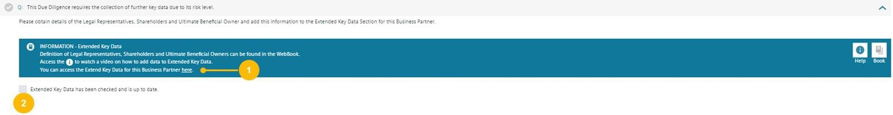

* + **Step 1:** Click to access the Extended Key Data for this Business Partner. The tool automatically redirects you to the Business Partners Extended Key Data page.
  + **Step 2:** After the Extended Key Data is completed tick the box. You can find more information how to enter Extended Key Data here **Internet and Sanction Party Check**

This [video](https://myid.siemens.com/idp/SSO.saml2?SAMLRequest=fVLLboMwEPwV5DuPWiUhFiCliapGShsUaA%2B9VA4sjSWwqdekzd%2FXkFZKLhy9npmdGTtG3jYdW%2FbmKPfw1QMa56dtJLLxIiG9lkxxFMgkbwGZKVm%2BfN4y6gWs08qoUjXkijLN4IigjVCSOJt1Qj74XTSjlM%2FCmsNdNA8AIKzD%2BX1dBYtZHUY15Qdqz1FFnDfQaJkJsUKWjtjDRqLh0thRQAM3WLg0LIKQhSGj9J04a5tGSG5G1tGYDpnvt2dReSigBYleqVpfVJ2f5ztvcE%2BJs%2Fy3uFIS%2BxZ0DvokSnjdb69FTqICdaPTW57PbZEgjSi5AeJkfwU9CFkJ%2BTndzeECQvZUFJmb7fKCpPFgio1ZdTqxPPavgfHlUV%2Fsis06U40oz86j0i030w6GiajceoSybugbjU1jS2ka9b3SYFMlxOgeiJ9edt7%2BnfQX&RelayState=%2Fmedia%2F1_nxu0lvvp) provides additional assistance on how to use SETIS for Internet checks.

For Business Partner with key persons, representatives, shareholder and UBOs an further internet and sanction party checks need to be evaluated. Check the representative names against the Sanctioned Party List result and Internet search result in SETIS. Review anything that might cause you to suspect the company’s reputation or integrity.

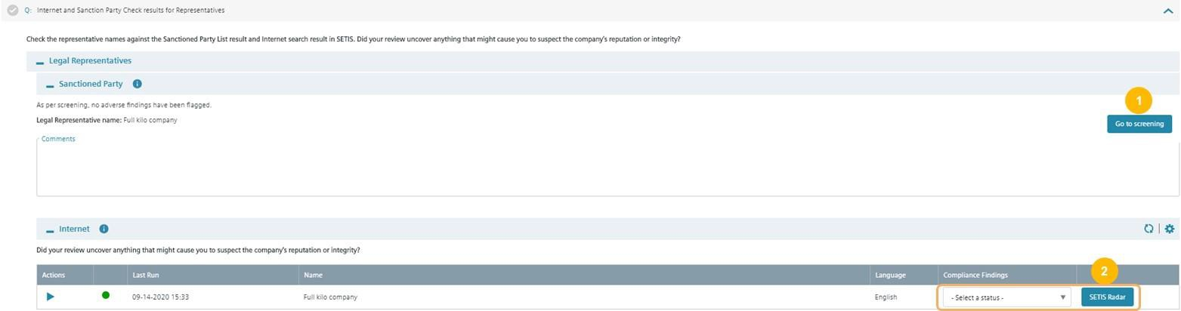

* **Step 1:** In case of adverse findings, press “Go to Screening” to evaluate results from sanction parties list. The [CDD-Tool](https://compliance-tools.siemens.com/due-diligence/) redirects you to the Business Partners Screening page (C.2.2.5. Screening) to tag potential hits. Afterwards return to the DD Questionnaire to finalize the CDD question.
* **Step 2:** Review internet results from SETIS. Press “SETIS Radar” Button to show relevant results from Intranet. The [CDD-Tool](https://compliance-tools.siemens.com/due-diligence/) redirects you in an second window to the SETIS Internet Results page to tag relevant Internet hits. Afterwards select the overall rating of the Compliance findings.

If key employees, shareholder and ultimate beneficial owner subcontractor exist, further checks need to be reviewed in these chapter.

* + 1. **Review & Approval**

An approval decision for a CDD must be documented in the [CDD-Tool.](https://compliance-tools.siemens.com/due-diligence/) Contracts for high risk CDDs require an additional approval (outside of the [CDD-Tool](https://compliance-tools.siemens.com/due-diligence/)).

Where integrity concerns exist, the Siemens unit must take appropriate steps – in cooperation with the relevant General Counsel and Compliance Officer – to mitigate the risk of corruption.

Approval requirements depend on the CDD risk level. Approval steps are **automatically set** in the [CDD-Tool.](https://compliance-tools.siemens.com/due-diligence/)

Low risk CDD

* **Management approval of CDD and contract:** Management function of the respective Siemens unit according to the signature mandate of this unit.

Medium risk CDD

* **Compliance review of CDD:** Compliance Reviewer as defined in roles management tool (SCROM)
* **Management approval of CDD and contract:** Management function of the respective Siemens unit according to the signature mandate of this unit or specific OpCo / Business Unit.

High risk CDD

* **Compliance review of CDD:** Compliance Reviewer as defined in roles management tool (SCROM)
* **Compliance approval of CDD:** All high risk CDDs are to be approved by the responsible CMC Member. Further information can be found [here.](https://findit.compliance.siemens.com/content/10000101/Compliance/LC_CO/LC_CO_RG_PL/findIT_LC_CO_RG_PL_9045.pdf)
* **Management approval of CDD**: Management function of the respective Siemens unit according to the signature mandate of this unit or specific OpCo / Business Unit regulations (see Business Partner strategy of corresponding unit).
* **Management approval of contract:** Relevant CEO / Head of a Business Company28, Regional Company or Corporate Function.

For the avoidance of doubt, further approvals for the contracts or alignment with dedicated departments within Siemens may be required to finalize a contract with the Business Partner. For example, Strategy ST TO is responsible for the preparation and conclusion of contracts between sales agents / distributors and Siemens AG allocating representation rights / sales rights to third parties to ensure that sales rights granted to the Business Partner do not overlap with those granted to other sales agents. Nevertheless, the Siemens unit concerned must make sure that the agency agreement contains the relevant compliance model clauses (see [SC 140 “Regional](https://regulations-admin.siemens.com/content/SC/140/en) [sales activities - Representation rights and sales rights](https://regulations-admin.siemens.com/content/SC/140/en)” for details).

* + - 1. Compliance Review

For medium and high risk CDDs, the responsible Compliance Reviewer (Compliance Officer) must perform a Compliance Review and submit the CDD. The [CDD-Tool](https://compliance-tools.siemens.com/due-diligence/) determines the responsible Compliance Reviewer

28 A CEO may also delegate the approval-role in alignment with the respective Compliance Officer to a member of the CEO`s Top or Senior Management.

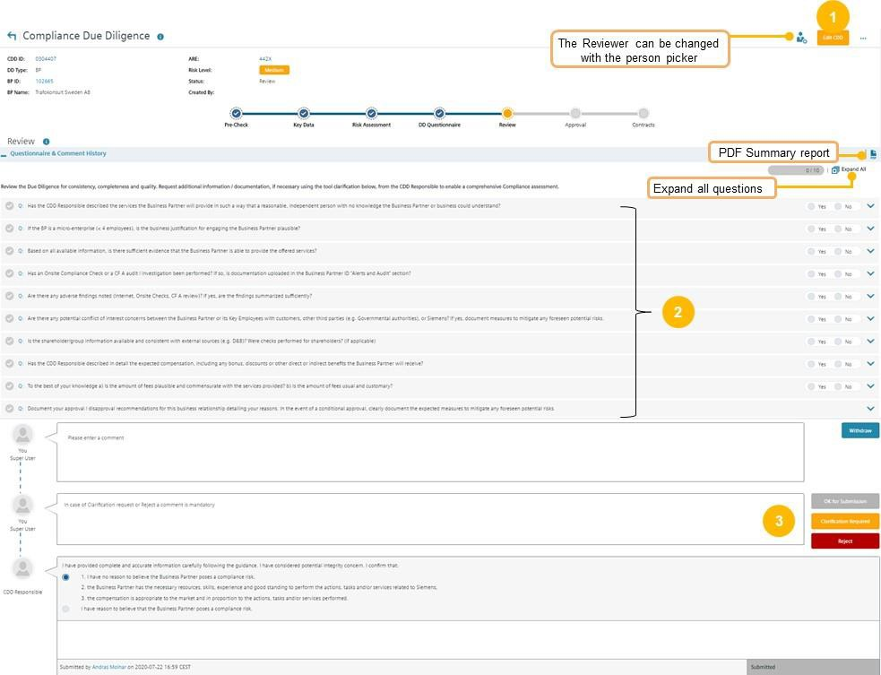automatically based on the ARE.

* + - * + **Step 1:** Press “Edit CDD”
        + **Step 2:** Answer all questions. Click on the blue arrow to expand the sections
        + **Step 3:** Based on your review either submit for the next approval step(s) (OK for submission) or submit the CDD back to the CDD Responsible (Reject)

If based on a review, the CDD shall be disapproved, you must submit the CDD to the next approver to do the disapproval in the approval section.

Note:

In the EDIT mode, you cannot switch to other process steps like DD Questionnaire. If you want to review the CDD information (Key Data, Risk Assessment or DD Questionnaire) just press “Cancel” to leave the EDIT mode in the Review section.

This [CO Review guidance](https://findit.compliance.siemens.com/content/10000101/Compliance/LC_CO/LC_CO_DF/findIT_LC_CO_DF_9224.pdf) is aimed for the CO Reviewer and useful for CO Approvers and other Compliance colleagues to understand the main aspects of the CO Review and analysis of all the information in a CDD.

* + - 1. Compliance Approval

All high risk CDDs must be approved by the responsible CMC Member. Further information can be found [here.](https://findit.compliance.siemens.com/content/10000101/Compliance/LC_CO/LC_CO_RG_PL/findIT_LC_CO_RG_PL_9045.pdf)

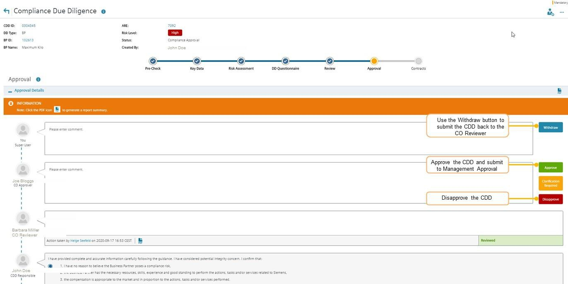

**Step 1:** Go to **“Approval”** section

**Step 2:** Select one of the decision options

**Note:** With the clarification request button, you can communicate with persons involved In the CDD in a chat function. The clarification request button has no influence on the workflow status - it remains in “Compliance Approval”. To submit the CDD back to the CO Reviewer to adapt the CO Review, use the Withdraw button.

* + - 1. Management Approval

Once the CDD is submitted for approval the respective **Management Approver** receives a notification for an approval decision.

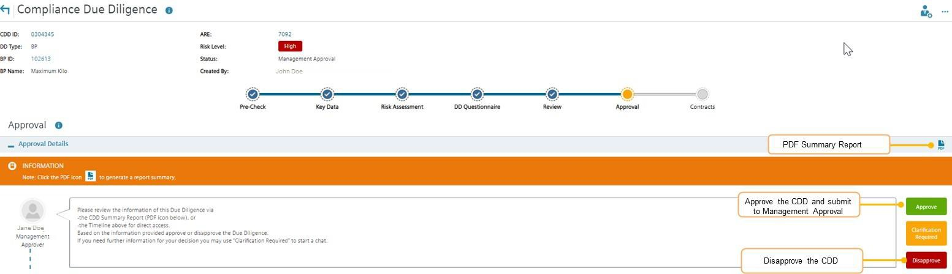

**Step 1:** Go to **“Approval”** section

**Step 2:** Select one of the decision options

For definition and change of Management Approvers please refer to C.5.1.1.

* + - 1. Withdrawal of Approval or Disapproval

The approval of a CDD can be withdrawn by Management or Compliance if compliance concerns have been identified and the approval decision must be changed.

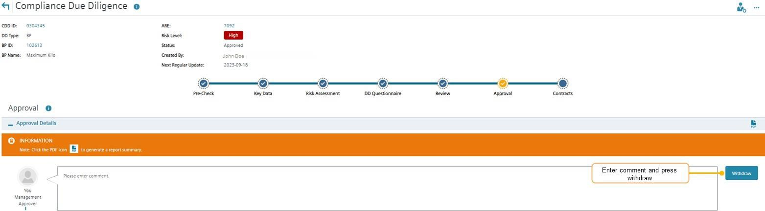

***Step 1:*** *Go to* ***“Approval”*** *section*

***Step 2:*** *Press “Withdraw”*

**Note:** After Withdrawal, the workflow status changes to “In Update – Key Data”.

* + 1. Contracts

The status of contracts with Business Partners must be registered in the [CDD Tool](https://compliance-tools.siemens.com/due-diligence/). The details must be updated in case of subsequent alterations, amendments, or extensions.

For details regarding mandatory contract provisions and other issues regarding the contractual relationship see chapter A.6.

After approval of the CDD, the “contracts” section becomes available. The status must be entered and regularly updated.

How to register contract information

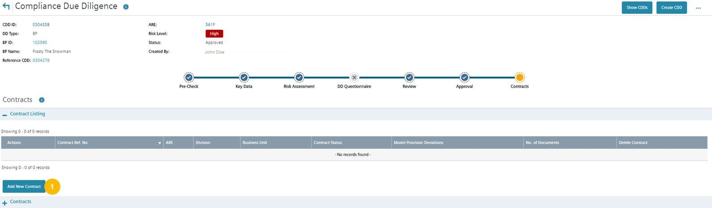

**Step 1:** Go to **“Contracts”** and press “Add New Contract”

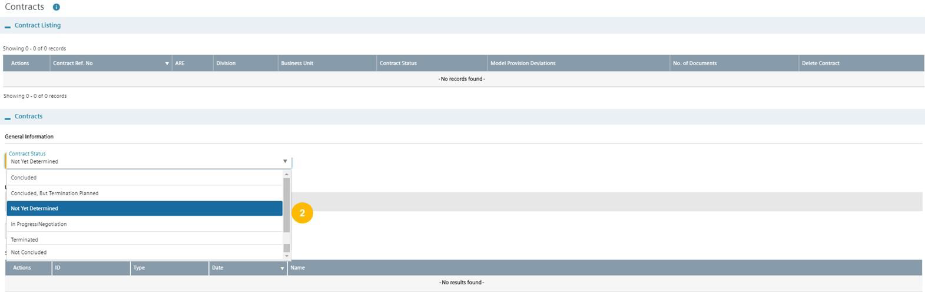

**Step 2:** Select the contract status (e.g. concluded)

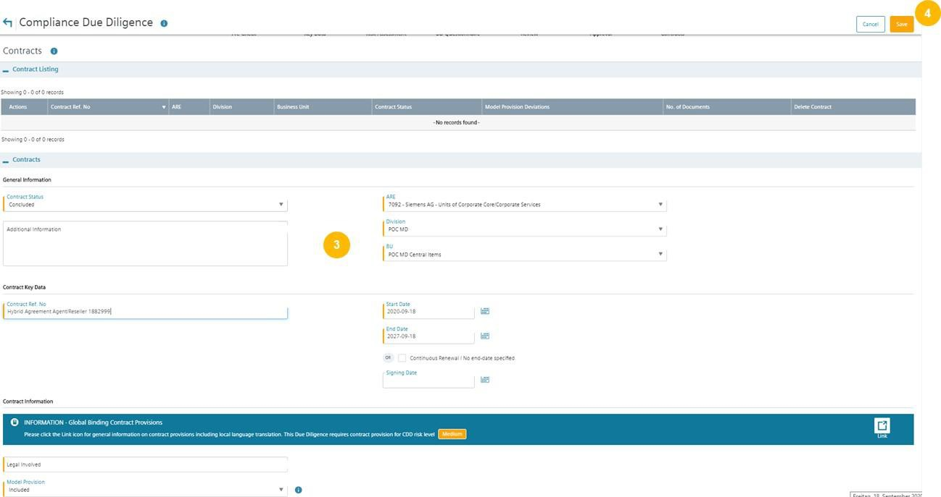

**Step 3:** Add information about the contract (fields in orange are mandatory)

**Step 4:** Press “Save”

#### Update of CDDs

Overview of Update Process (Regular and Ad hoc)

The Update Process in combination with the existing Business Partner portfolio reviews of CDDs in Compliance Review Boards, the automatic SETIS screening of a Business Partner every 6 months and regular discussions in Management meetings support the ongoing monitoring of Business Partner relationships.

Regular Updates:

A Regular (mandatory) update of a CDD is due every three years from the last approval date. Only a limited number of questions must be re-answered. However, the CDD Responsible must check the CDD and must ensure that the **content of the complete CDD is up to date and reflects the current relationship** with the Business Partner.

The following information must be newly answered:

* + - Low risk: updated integrity search;
    - Medium risk: as low risk plus a new version of the independent background report (Dun & Bradstreet) to be obtained and reviewed;
    - High risk: as for low/medium plus update of organizational setup (Extended Key Data and group structure) and integrity checks (SETIS/internet and Involvement of Key Persons in litigations).

The CDD Responsible gets an email notification to start an Update of a CDD and the approval process is streamlined depending on the significance of any changes as follows:

* + - No significant changes: only sign-off by the CDD Responsible is required, with the Management Approver and CO Reviewer informed of the changes made via email. They may still raise questions and request further information if deemed necessary.
    - Significant changes: a re-approval by the Management and a repeat of the review by CO Reviewer responsible. An involvement of further stakeholders like CO Approver or CMC may be necessary. Only an increase of the risk level to high risk requires a documented Compliance approval.

The [CDD-Tool](https://compliance-tools.siemens.com/due-diligence/) automatically determines the relevant approval process.

Change of Regular Update Date:

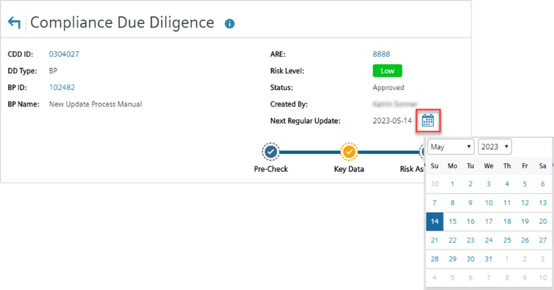Compliance Officers can change the due date for a Regular Update. In order not to run the risk that the information in the CDD is not kept up to date, the date should be chosen sensibly. The new due date must not be in the past and max. 1 year later than the current due date.

Ad hoc Updates:

Between the three-year Regular Updates, the CDD Responsible is still obliged to keep the CDD up to date by starting an Ad Hoc Update. Any Update that constitutes a significant change will result in a reapproval as under the Regular Update.

To further limit risk, every six months the Business Partner name and Aliases will be automatically screened via SETIS against our integrity database. In case of new hits Compliance Reviewers will be informed via email, asked to evaluate the hits and to initiate further actions if deemed necessary.

The Regular and Ad hoc Update process is illustrated on the following picture:

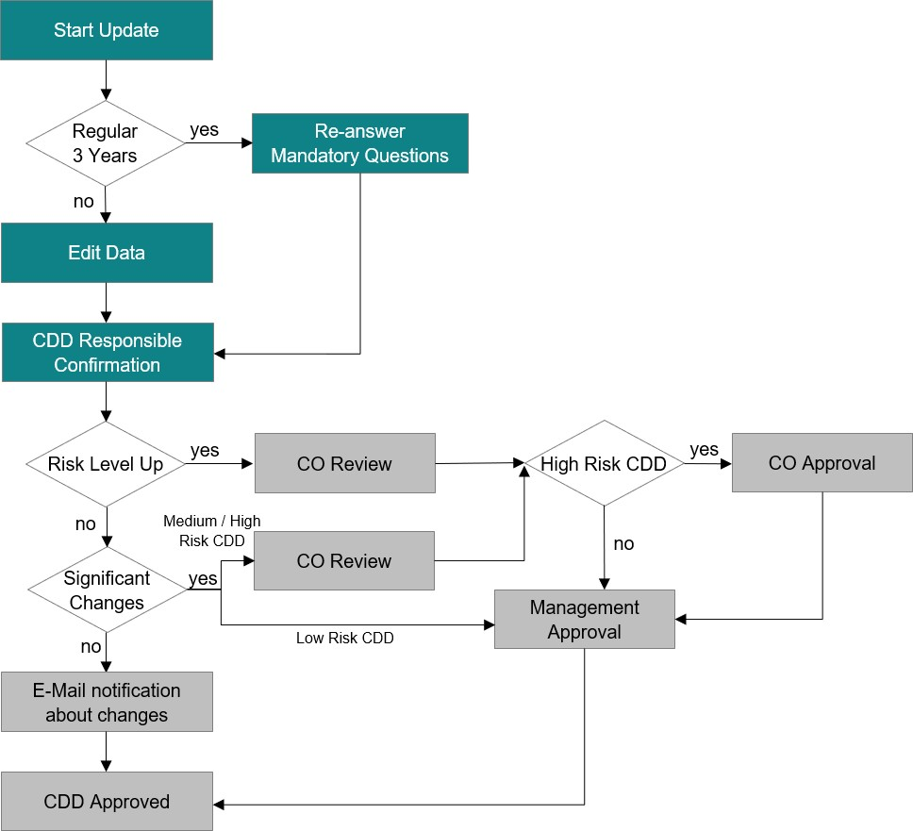

Regular Update and Ad Hoc Update

The process of Regular and Ad hoc Updates is basically the same, but the Regular Update Process will reset answers to essential questions. These must be answered again by the CDD Responsible.

Regular Update

The request to update a CDD is made in 2 ways. One is by receiving an e-mail notification and the other is via “My Dashboard” in the [CDD-Tool](https://compliance-tools.siemens.com/due-diligence/) itself.

Ad Hoc Update Hint

Once the Update Process has started, it can no longer be stopped and must be run through to the end. If no changes are made, the Update Process is completed without a management approval.

Before you start the update, please check in the Person Picker if the correct Management Approver has been selected.

If the Approver needs to be changed, the new responsible persons can be added in the WCST (“Who can see this?”) section and then selected in the Person Picker.

The following cases are considered below:

* Case a: **Update without re-approval** (No increase of Risk Level and no Significant Changes)
  + Example: Low Risk CDD
* Case b: **Update with re-approval** (No increase of Risk Level and Significant Changes)
  + Example: Medium Risk CDD

1. **Update without re-approval** (No increase of Risk Level and no Significant Changes)

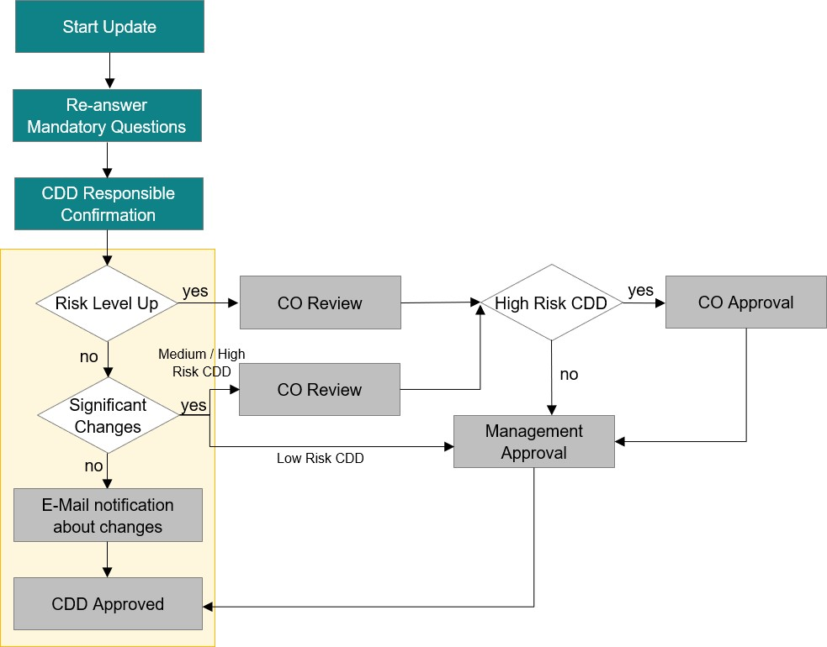

(a1) Start Update – CDD Responsible

My Dashboard: CDD Responsible starts update in “My Dashboard”

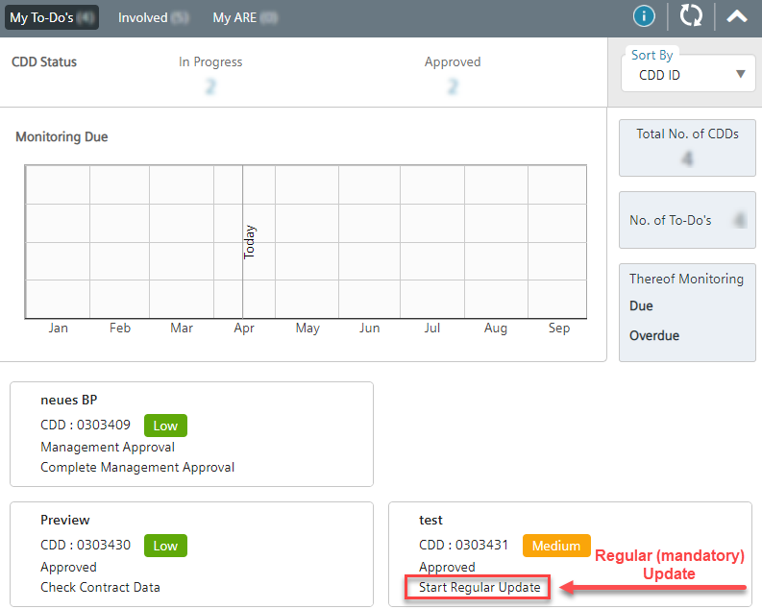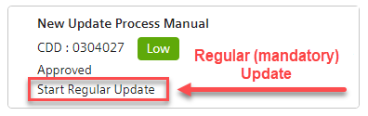

Open CDD and ***Start Update*** process:



(a2) Key Data – CDD Responsible

The Status of the CDD will change into ***in Update – Key Data***.

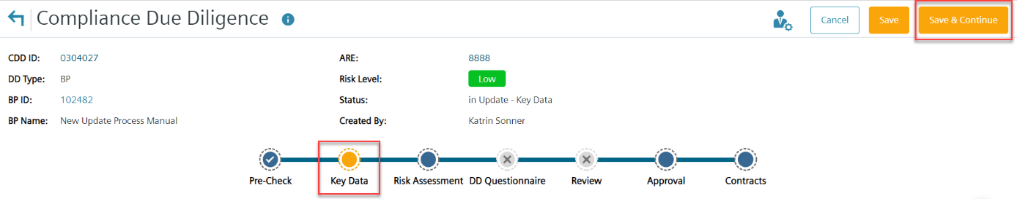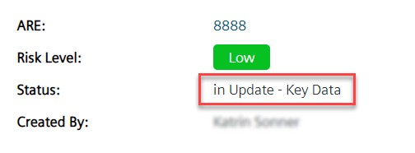

In this example, no changes in the **Key Data** section are required. Press ***Save & Continue***.

(a3) Risk Assessment – CDD Responsible

Tag the search results for SETIS, go back to [CDD-Tool](https://compliance-tools.siemens.com/due-diligence/) ***and Select a status*** in the Compliance Findings in the **Risk Assessment** section. In this example, the status is the same as before the update: **No relevant Compliance findings**.

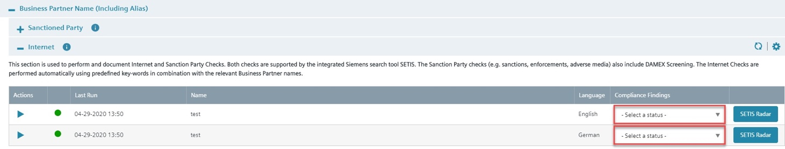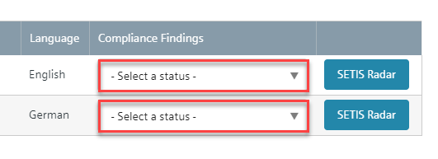

… and press ***Save & Continue***.

With the confirmation that the guidance has been followed, information is provided and integrity concerns are considered, the Update can be completed. Press “***Complete Update”***.

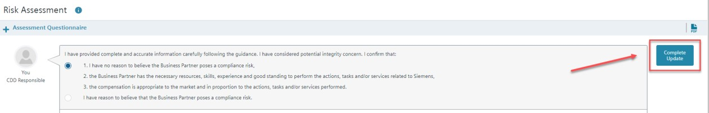

An E-Mail notification will be sent to the selected Management Approver and the selected CO Reviewer (Medium / High Risk CDDs).

Update is now completed.

1. **Update with re-approval** (No increase of Risk Level and Significant Changes)

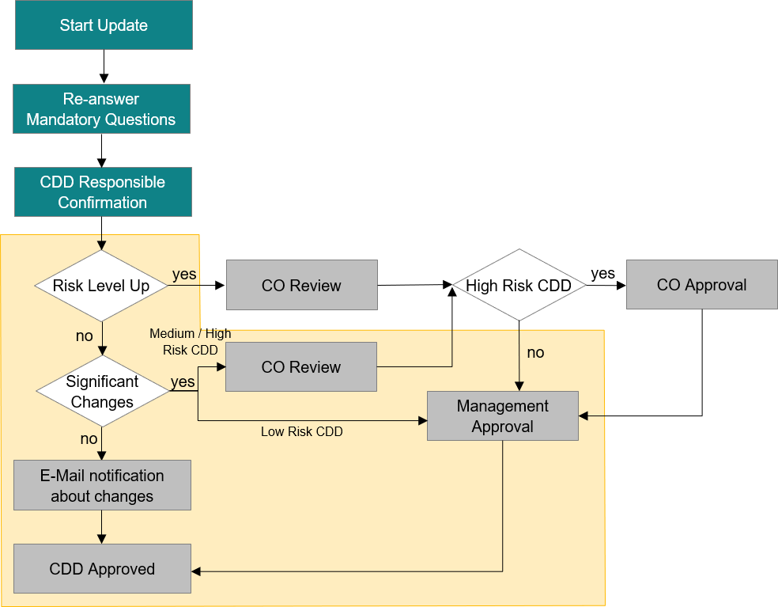

**Low Risk CDDs** with significant changes need to be approved by the Management.

**Medium Risk CDDs** with significant changes need to be reviewed by Compliance and then approved by the Management.

**High Risk CDDs** with significant changes need additionally a Compliance Approval after the Compliance Review and before the Management Approval.

(b1) Start Regular Update – CDD Responsible

My Dashboard: CDD Responsible starts update in “My Dashboard”



Open CDD and ***Start Update*** process:



(b2) Key Data – CDD Responsible

The Status of the CDD will change into ***in Update – Key Data***.

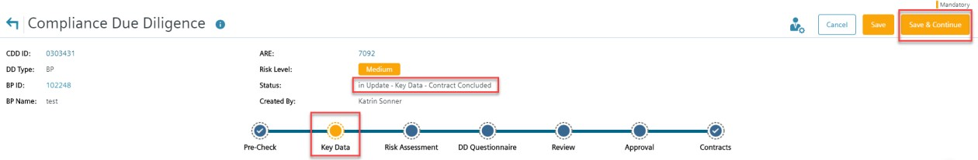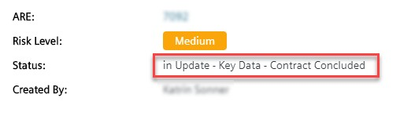

If there is no need to update the **Key Data** section, press ***Save & Continue***.

(b3) Risk Assessment and SETIS Screening – CDD Responsible

The [CDD-Tool](https://compliance-tools.siemens.com/due-diligence/) switches to **Risk Assessment** …

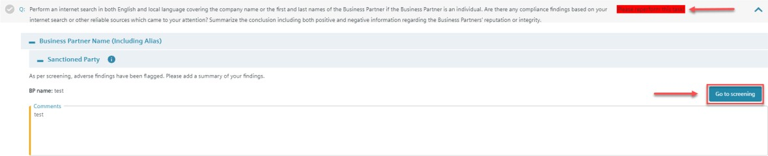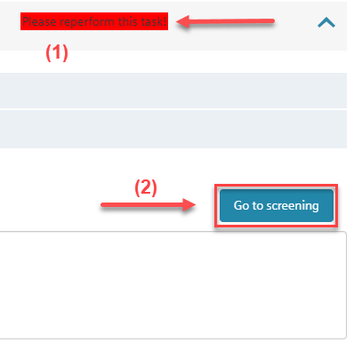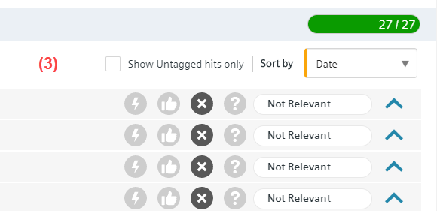

… and ask you to perform mandatory tasks (1), to do a SETIS screening (2) and tag all search results (3) according to their relevance.

After finishing the screening in SETIS, press ***Return to CDD***.

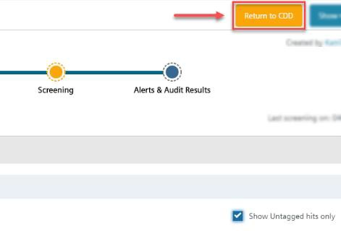

***Select a status*** in the Compliance Findings in the **Risk Assessment** …

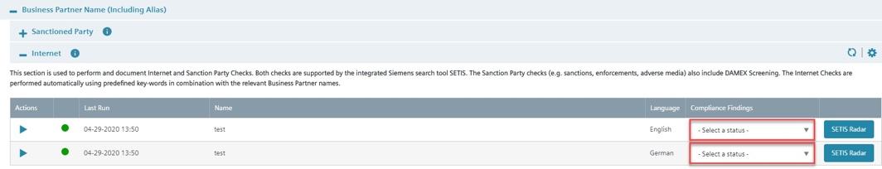

… and press ***Save & Continue***.

(b4) DD Questionnaire – CDD Responsible

The CDD jumps to **DD Questionnaire** and asks to reperform the mandatory tasks.

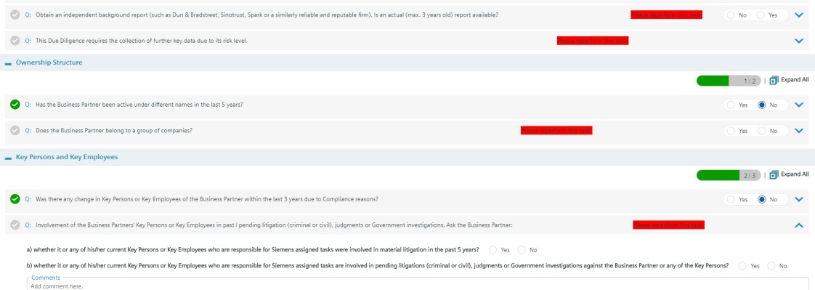

Press ***Check Completeness*** to ensure that all questions are answered.

(b5) Submit for Review – CDD Responsible

If the completeness check was successful, the CDD must send to the CO Reviewer with ***Submit for Review***.

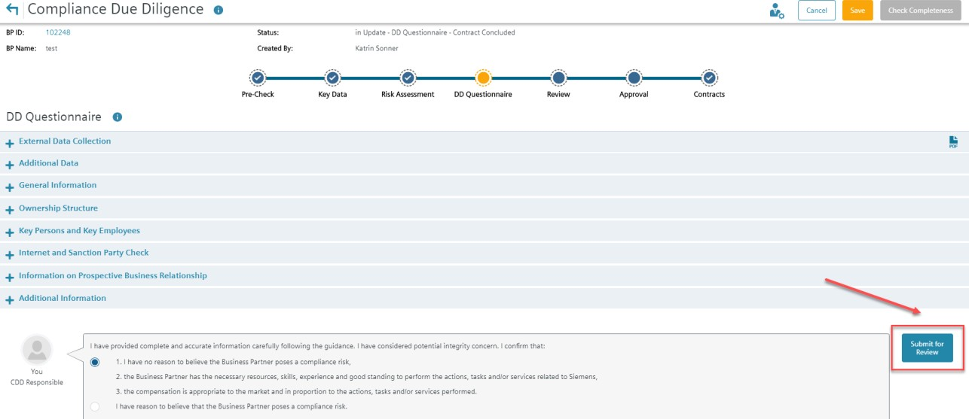

(b6) Complete Compliance Review – CO Reviewer

My Dashboard: CO Reviewer starts review in “My Dashboard”

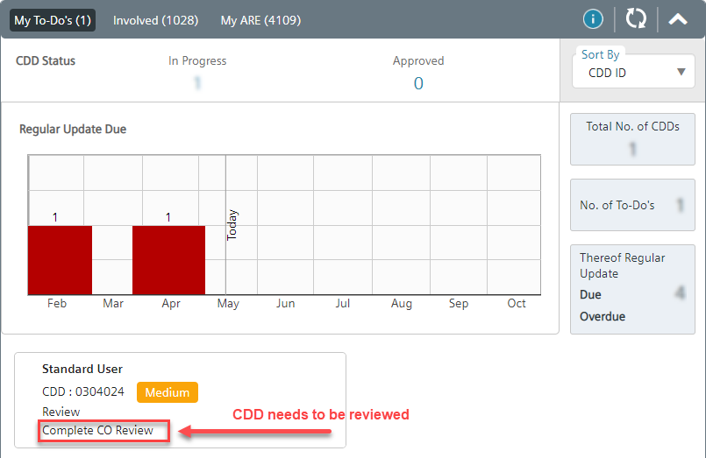

Open CDD and ***Edit CDD*** to start review:

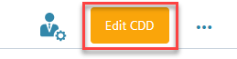

Answer the questions and press ***Save & Continue***.

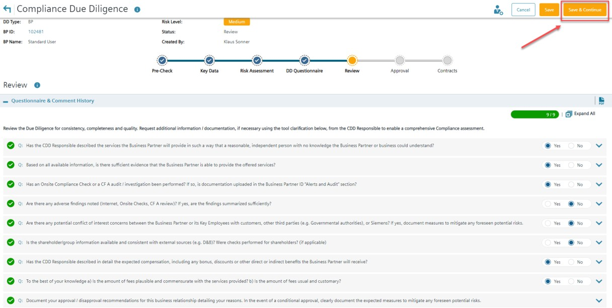

To complete the review, press ***OK for Submission***.

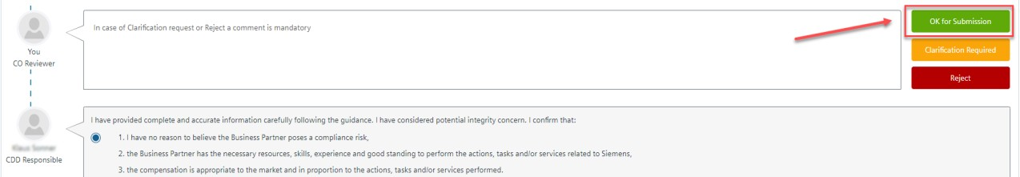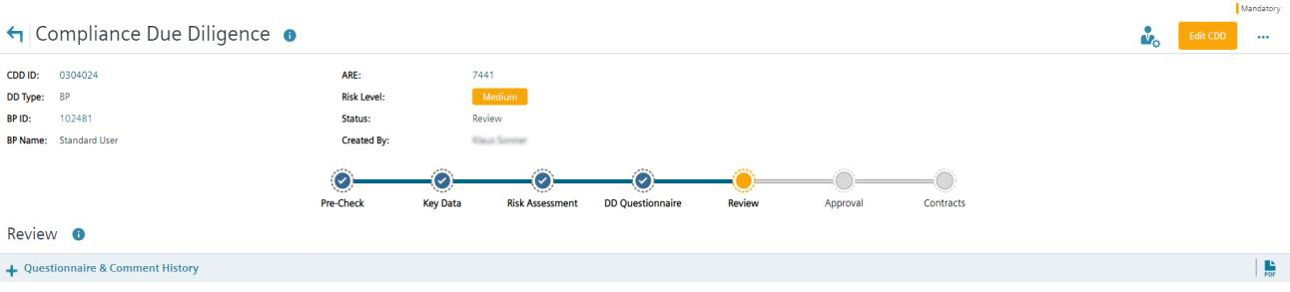

(b7) Complete Approval – Management Approver

My Dashboard: Management Approver starts approval in “My Dashboard”

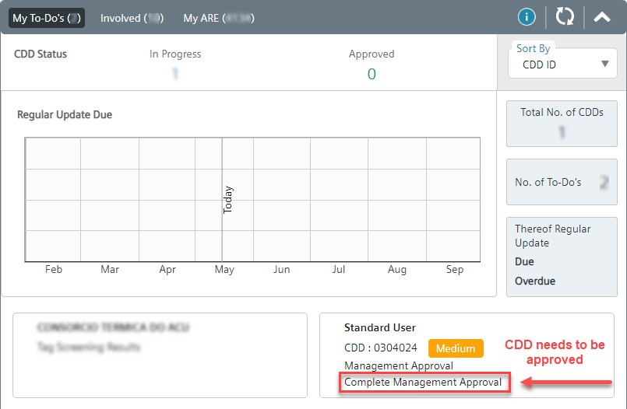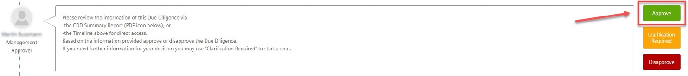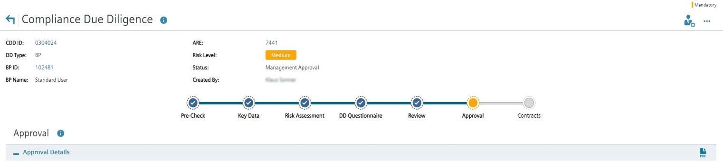

Update is completed.

Further information and guidance material is available:

* [Video Tutorial: "Handling of new Integrity Search Results - Instructions for Compliance Reviewer"](https://myvideo.siemens.com/media/1_d7uqgbhz)
* [Video Tutorial: "Regular Update" without Risk Level Change and without Significant Changes](https://myvideo.siemens.com/media/1_v0uszm7h)
* [Video Tutorial: "Adhoc Update" without Risk Level Change and with a Significant Change](https://myvideo.siemens.com/media/1_82s9bain)
* [Questions & Answers - New Update Process](https://findit.compliance.siemens.com/content/10000101/Compliance/CL_CO/CL_CO_P/findIT_CL_CO_P_9172.pdf)
* [Instructions for CDD Responsibles on how to update the CDDs](https://findit.compliance.siemens.com/content/10000101/Compliance/CL_CO/CL_CO_P/findIT_CL_CO_P_9096.pdf)
* [Instructions for Management Approver on how to complete the Management approval](https://findit.compliance.siemens.com/content/10000101/Compliance/CL_CO/CL_CO_P/findIT_CL_CO_P_9116.pdf)
* [Video: How to monitor regular updates in the CDD Tool and in the BP Dashboard (06:18 min)](https://web.microsoftstream.com/video/72cf02f6-ec81-48c3-9723-7386dd9b48b0?list=studio)

#### Reuse of existing CDDs (reference CDD)

If a Business Partner is retained more than once, an approved and valid CDD may already exist. If this CDD was performed by the same Siemens unit (ARE) and covers all aspects of the new engagement e.g. Business Partner type, scope of work, country, proposed remuneration and payment terms, this CDD can be used and no additional CDD is required. However, the new contract must be maintained in the contract section of this CDD.

If the CDD was performed by a different ARE a new CDD must be performed even if all aspects of the business relationship are identical. Further, if the Business Partner is retained for a different scope of work, or if other circumstances of the CDD which may influence the approval decision are different from those which have already been approved in the existing CDD, a new CDD is necessary.

The results of an existing CDD (parent) can be reused in certain cases to avoid double work using the Reference function for medium and high risk CDDs.

For Global Business Partners refer to chapter A.4.3..

How to create a Reference

* + - ***Step 1: Start*** new CDD and complete the Risk Assessment.
    - ***Step 2:*** If Reference is possible (Key Data and Risk Assessment of both CDDs are generally the same), select relevant CDD at the end of ***“Risk Assessment”*** and provide a comment.
    - ***Step 3***: Press “Request Reference”

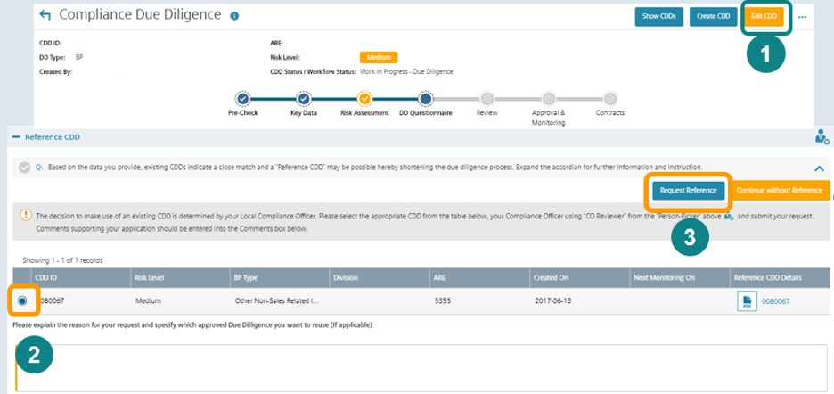

The request for Reference must be confirmed by Compliance and approved by Management

How to confirm a Reference by Compliance

* + - ***Step 1:*** Go to **“Review”** section
    - ***Step 2***: Press “OK for Manager Approval”

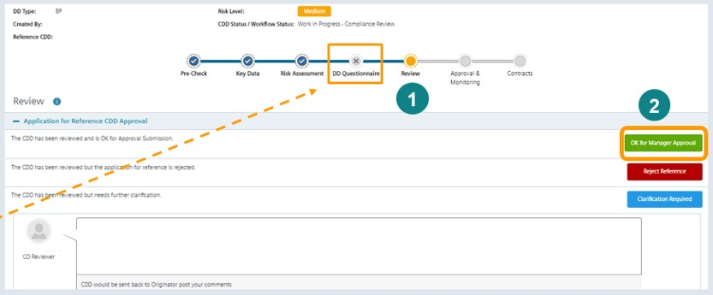

Note:

* “DD Questionnaire” is not applicable for References.
* After confirmation by Compliance the Management Approver is informed via email to “Approve” the Reference CDD. (Ensure that *Management Approver* is maintained in “Who can see this?”)
* Approval of a Reference does not mean that no separate contract is required to be signed / registered. Every Siemens unit must ensure that a valid contract with the Business Partner is existing and contract details are maintained in the CDDs “Contracts” section.
* If the parent CDD becomes invalid, the existing Reference CDD must be changed to a standard CDD via the Update process. (Compliance Officers may use the Business Partner Dashboard to figure out References with invalid parent CDDs.)

#### Supporting functions and documents

* + 1. Supporting functions
       1. **How to manage CDD roles**

**Note**: CDD roles can be managed in the View mode of a CDD. There is no need to edit the CDD or to start an update of a CDD to change roles.

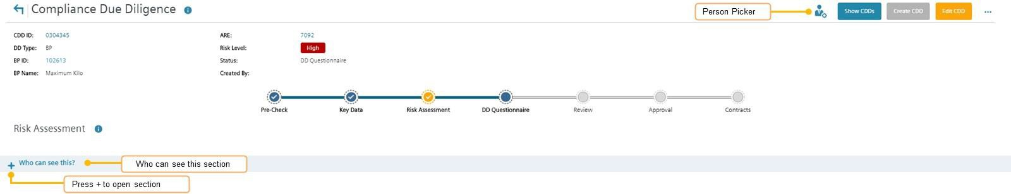

In the “**Who can see this?**” section roles for CDD Responsible, Management Approver and CDD Viewer can be added or deleted. Management Approvers **should be added manually in all cases**.

Compliance Officer roles (CO Reviewer, CO Approver) are maintained in the Compliance role Management system SCROM and cannot be manually added in this section.

With the **“person picker”** in the right upper corner **–** the lead roles for the CDD (Lead CDD Responsible, Lead Management Approver, Lead CO Reviewer, Lead CO Approver) can be defined/changed. You can define for example two or more CDD Responsibles for a CDD in the “Who can see this?” section (who can edit a CDD and receive relevant e-mail notifications). But only the CDD Responsible in the “person picker” is the Lead CDD Responsible who can, for example, submit a CDD for Management Approval or for CO Review.

How to enter Roles in the “Who can see this?” section

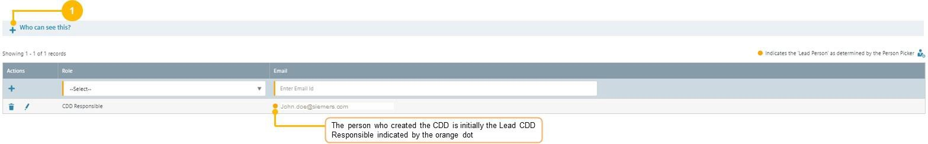

***Step 1:*** Press "+" at “**Who can see this**” at the very bottom.

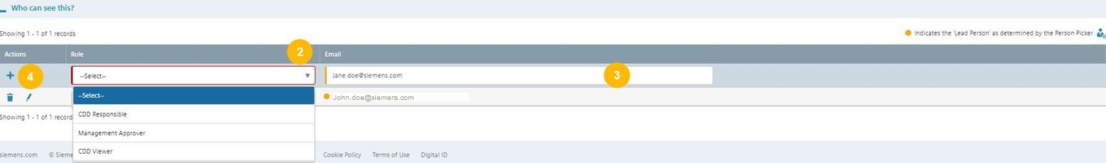***Step 2:*** Select the role that you want to add

(CDD Responsible, Management Approver, CDD Viewer).

***Step 3:*** Enter the e-mail address of the person you want to add.

***Step 4:*** Press “+” to save.



How to change Lead Roles with the Person picker

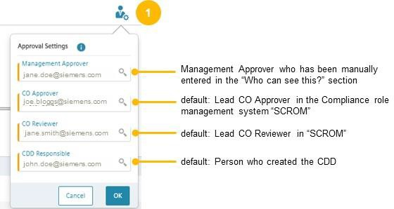

***Step 1:*** Click on the “person picker” button next to the “Show CDDs” button in the upper right corner.

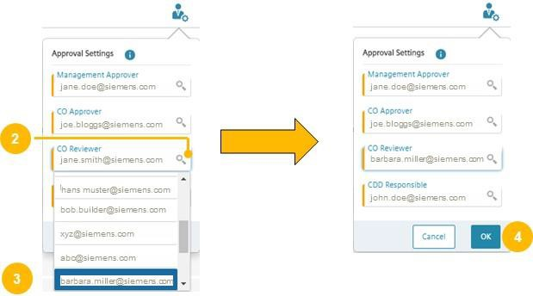

***Step 2:*** Select the lead role that you want to change (e.g. CO Reviewer) and click the magnifying glass.

***Step 3:*** Select the person that should get the new lead role.

**Step 4:** Confirm with OK

Scenario:

A CDD Responsible (john.doe@siemens.com) should be replaced by another person (james.young@siemens.com)

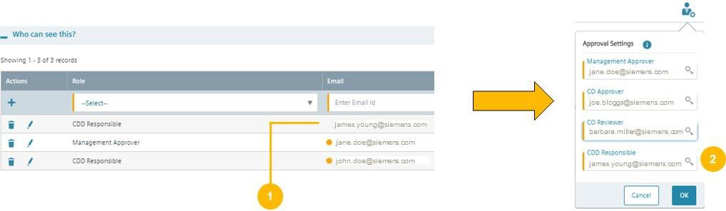

***Step 1:*** Add the new CDD responsible (james.young@siemens.com) in the “Who can see this?” section

***Step 2:*** Change the lead CDD responsible with the person picker from [john.doe@siemens.com](mailto:john.doe@siemens.com) to james.young@siemens.com)

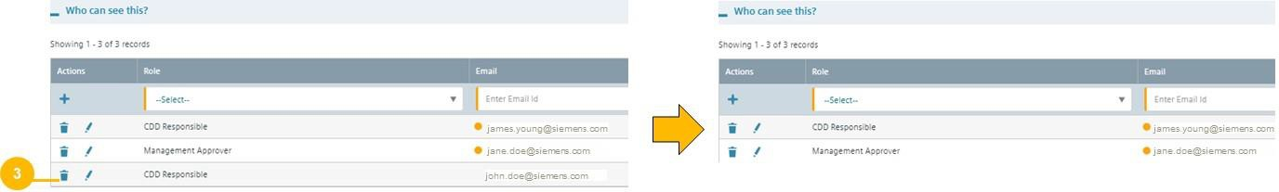

***Step 3:*** Delete the old CDD responsible [john.doe@siemens.com](mailto:john.doe@siemens.com) with the paper bin.

* + - 1. Closing/Cancellation/Reactivation of CDDs

A CDD in work in progress (e.g. in status “key data”, “risk assessment”, or in an approval stage) can be **cancelled**

by a CDD Responsible or a Compliance Officer.

An approved or disapproved CDD can be **closed** by a Compliance Officer only. A CDD should be closed if the CDD is no longer needed (not even as a parent CDD for a Reference CDD). If the contract status of a CDD is “not concluded” or “terminated” for one year, the CDD will be automatically closed (in accordance with the data deletion concept).

Closing and cancellation are done with the same process steps.

How to cancel a CDD

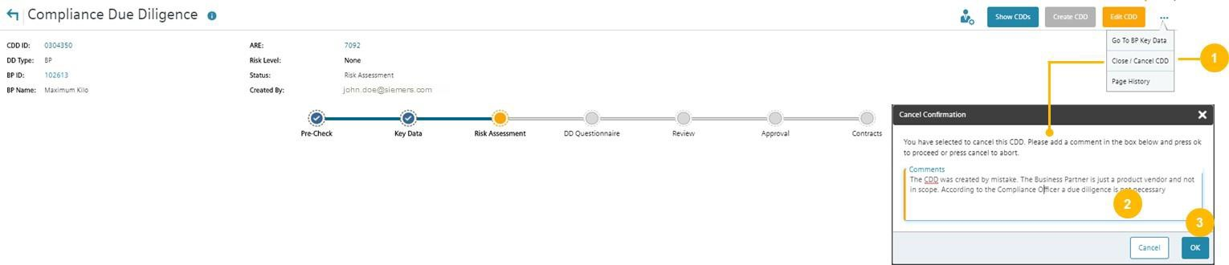

***Step 1:*** In the view mode of a CDD (not in the edit mode) press the three dots to open the menu bar. Press “Close / Cancel CDD”

***Step 2:*** In the pop-up window, enter a comprehensive comment why the CDD should be cancelled.

***Step 3***: Press OK

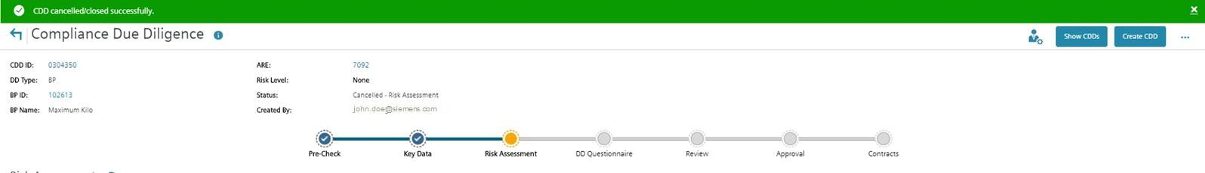

Note: A cancelled CDD gets a cancellation flag and the status “cancelled” but is not immediately physically deleted (according to data deletion concept).

How to reactivate a CDD

A cancelled or closed CDD can be reactivated by a Compliance Officer

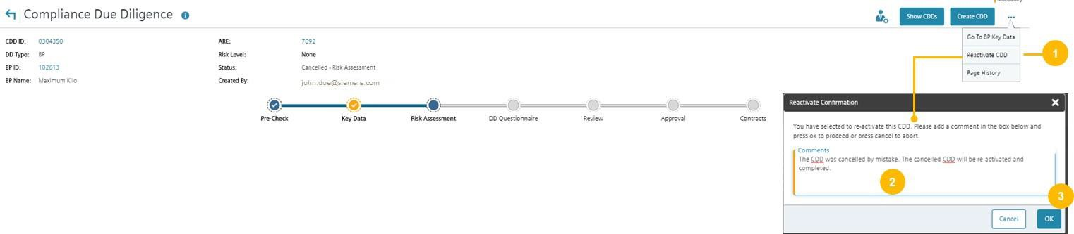

***Step 1:*** In the view mode of a CDD (not in the edit mode) press the three dots to open the menu bar. Press “Reactivate CDD”.

***Step 2:*** In the pop-up window, enter a comprehensive comment why the CDD should be reactivated.

***Step 3***: Press OK.

* + - 1. Centrally Disapproval / Business Partner under observation

Compliance Officer can flag a Business Partner as “under observation” or as "centrally disapproved" In the Alerts & Audits Result section.

A Centrally Disapproval should be performed e.g. in case of a negative result of a CF A audit or an internal investigation (if it is aligned with the investigation team). If a Business Partner is centrally disapproved no further CDD can be performed.

A Business Partner should be flagged as under observation e.g. in case of negative information that requires further monitoring.

If a Business Partner is flagged as under observation or as centrally disapproved, all persons involved in CDDs for the Business Partner get an e-mail notification.

To flag a Business Partner as "centrally disapproved" or as "under observation", please refer to C.2.2.6.

* + 1. Supporting documents
       1. **External Data Collection**

The documents can be sent to the Business Partner for the collection of Information needed for the DD questionnaire:

[Medium risk due diligence](https://findit.compliance.siemens.com/content/10000101/Compliance/LC_CO/LC_CO_STR_RM/findIT_LC_CO_STR_RM_7208.pdf) [High risk due diligence](https://findit.compliance.siemens.com/content/10000101/Compliance/LC_CO/LC_CO_STR_RM/findIT_LC_CO_STR_RM_7207.pdf)

* + - 1. Audit and Books & Records Requirements

Information about Siemens Audit and Books & Records requirements must be sent to medium and high-risk Business Partners. The Business Partner must understand the scope of such audits and the expectations of transparent Books & Records.

Based on the binding contract provisions for medium and high risk due diligences (A.6.), Siemens has the right to perform audits in the event that

* + - * + there is a reason to believe that there is a breach of Compliance provisions by the Business Partner or
        + internal assessments indicate a potential corruption risk for Siemens.

The “On-site Audits Purpose and Approach” should be provided to the Business Partner.

[**English**](https://findit.compliance.siemens.com/content/10000101/Compliance/LC_CO/LC_CO_STR_RM/findIT_LC_CO_STR_RM_7205.pdf)[**Chinese**](https://findit.compliance.siemens.com/content/10000101/Compliance/LC_CO/LC_CO_STR_RM/findIT_LC_CO_STR_RM_5971.pdf)[**French**](https://findit.compliance.siemens.com/content/10000101/Compliance/LC_CO/LC_CO_STR_RM/findIT_LC_CO_STR_RM_5240.pdf)

[**Canadian French**](https://findit.compliance.siemens.com/content/10000101/Compliance/LC_CO/LC_CO_STR_RM/findIT_LC_CO_STR_RM_5523.pdf)[**German**](https://findit.compliance.siemens.com/content/10000101/Compliance/LC_CO/LC_CO_STR_RM/findIT_LC_CO_STR_RM_5869.pdf)[**Italian**](https://findit.compliance.siemens.com/content/10000101/Compliance/LC_CO/LC_CO_STR_RM/findIT_LC_CO_STR_RM_5439.pdf)

[**Portuguese**](https://findit.compliance.siemens.com/content/10000101/Compliance/LC_CO/LC_CO_STR_RM/findIT_LC_CO_STR_RM_5622.pdf)[**Brazilian Portuguese**](https://findit.compliance.siemens.com/content/10000101/Compliance/LC_CO/LC_CO_STR_RM/findIT_LC_CO_STR_RM_5621.pdf)[**Spanish**](https://findit.compliance.siemens.com/content/10000101/Compliance/LC_CO/LC_CO_STR_RM/findIT_LC_CO_STR_RM_5383.pdf)

[**Russian**](https://findit.compliance.siemens.com/content/10000101/Compliance/LC_CO/LC_CO_STR_RM/findIT_LC_CO_STR_RM_5873.pdf)

Siemens requires an appropriate documentation from its Business Partners for the compliant use of the funds received from Siemens. A misuse can have consequences up to a termination of the contract.

“Siemens’ Books and Records Requirements” should be provided to the BP.

[**English**](https://findit.compliance.siemens.com/content/10000101/Compliance/LC_CO/LC_CO_STR_RM/findIT_LC_CO_STR_RM_7205.pdf)[**Chinese**](https://findit.compliance.siemens.com/content/10000101/Compliance/LC_CO/LC_CO_STR_RM/findIT_LC_CO_STR_RM_6804.pdf)[**Portuguese**](https://findit.compliance.siemens.com/content/10000101/Compliance/LC_CO/LC_CO_STR_RM/findIT_LC_CO_STR_RM_6193.pdf)

[**Brazilian Portuguese**](https://findit.compliance.siemens.com/content/10000101/Compliance/LC_CO/LC_CO_STR_RM/findIT_LC_CO_STR_RM_6192.pdf)[**Russian**](https://findit.compliance.siemens.com/content/10000101/Compliance/LC_CO/LC_CO_STR_RM/findIT_LC_CO_STR_RM_6195.PDF)[**Spanish**](https://findit.compliance.siemens.com/content/10000101/Compliance/LC_CO/LC_CO_STR_RM/findIT_LC_CO_STR_RM_6120.pdf)

[**French**](https://findit.compliance.siemens.com/content/10000102/Compliance/SouthWest%20Europe%20Cluster/RCo_Belgium/findIT_RCo_Belgium_2691.pdf)

A combined version of the flyer in English can be found [here.](https://findit.compliance.siemens.com/content/10000101/Compliance/LC_CO/LC_CO_STR_RM/findIT_LC_CO_STR_RM_7205.pdf)

* + - 1. Information Letter / Consent Form

To ensure that the background screening for a medium or high risk CDD on the integrity of the Business Partner is in line with the data privacy regulations at least the following Information Letter/E-Mail ([English](https://findit.compliance.siemens.com/content/10000101/Compliance/LC_CO/LC_CO_STR_RM/findIT_LC_CO_STR_RM_7200.docx) and local adoptions: [Italian](https://findit.compliance.siemens.com/content/10000101/Compliance/LC_CO/LC_CO_STR_RM/findIT_LC_CO_STR_RM_7482.docx) and [Chinese](https://findit.compliance.siemens.com/content/10000101/Compliance/LC_CO/LC_CO_STR_RM/findIT_LC_CO_STR_RM_7483.DOCX)) with a reference to the Siemens “Business Partner Privacy Notice” (available [here](https://new.siemens.com/global/en/general/privacy-notice.html)) needs to be send to the Business Partner.

In some countries, data privacy regulations might require an explicit consent of the Business Partner and or the respective individuals. A draft of such Consent Form for local adoption can be found here in [English.](https://findit.compliance.siemens.com/content/10000101/Compliance/LC_CO/LC_CO_STR_RM/findIT_LC_CO_STR_RM_7199.docx) The [CDD-](https://compliance-tools.siemens.com/due-diligence/)

[Tool](https://compliance-tools.siemens.com/due-diligence/) contains a list of all countries requiring a Consent Form29 and will show the respective advice based on the country of the Business Partner or the Siemens entity.

* + - 1. Compliance Country Rating

Compliance Country Ratings Transparency International publishes the [Corruption Perception Index (TI/CPI)](https://eur01.safelinks.protection.outlook.com/?url=https%3A%2F%2Fwww.transparency.org%2Fresearch%2Fcpi%2Foverview&data=02%7C01%7Cchristina.wolfgramm%40siemens.com%7Cbc09d0edce084d353e0b08d865213e25%7C38ae3bcd95794fd4addab42e1495d55a%7C1%7C0%7C637370540727961504&sdata=XWlxmAyOE22n7Chubitt9Cd1voamzPqzkkPLGiC5VsE%3D&reserved=0) regularly. Based on these ratings and a risk evaluation by LC CO, the Compliance Country Ratings (low/medium/high) are determined and shown in this [country list with risk ratings.](https://findit.compliance.siemens.com/content/10000101/Compliance/LC_CO/LC_CO_STR_RM/findIT_LC_CO_STR_RM_8266.pdf)

The threshold values are:

High-risk countries are countries with a rating ≤ 42

Medium-risk countries are countries with a rating ≥ 43 and ≤ 66 Low-risk countries are countries with a rating ≥ 67

* + - 1. Legend of icons / symbols

Different symbols that you will find in the [CDD-Tool.](https://compliance-tools.siemens.com/due-diligence/)

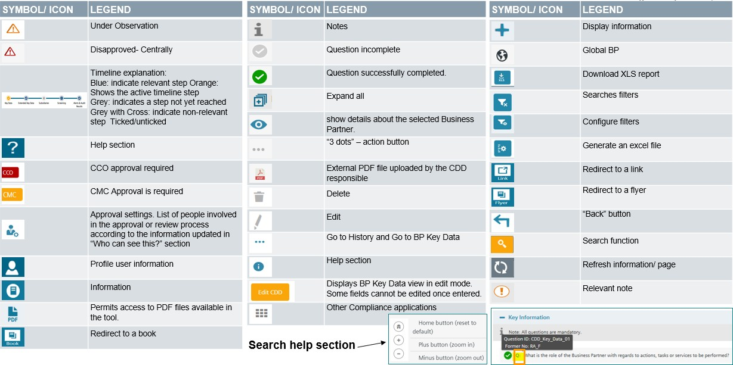

* + 1. [**CDD-Tool**](https://compliance-tools.siemens.com/due-diligence/) **Support**

If you have technical questions with the [CDD-Tool](https://compliance-tools.siemens.com/due-diligence/) please contact [bpc-tool.cit@siemens.com](mailto:bpc-tool.cit@siemens.com) A web based training is available in the [financeTraining Desk.](https://financetraining.siemens.com/lms/?StoryID=741&fcourseid=666&tile=1&websiteLang=en)

29 Currently, according to our information the following countries require a Consent Form: Argentina, Belarus, Colombia, France, India, Indonesia , Kazakhstan, Mauritius, Peru, Portugal, Russia, Slovakia, Turkey and Uruguay.

#### Data Retention Concept

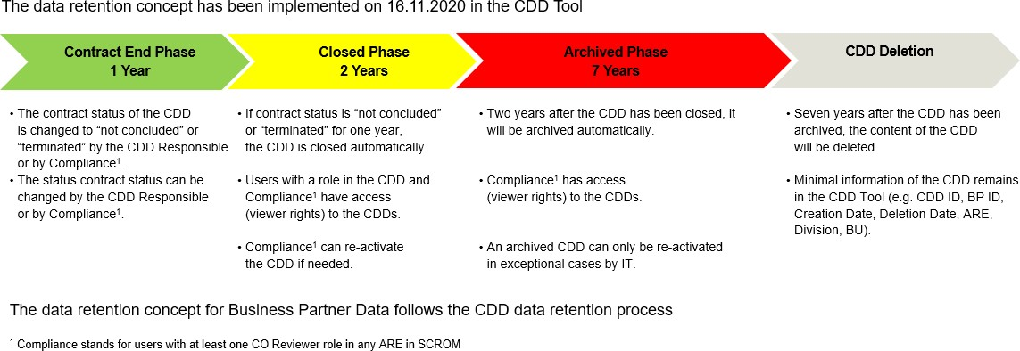

The data retention process starts with the closing of a CDD. A CDD can be closed manually see C.5.1.2. or a CDD is closed automatically if the status of all contracts of a CDD have been actively set as “not concluded” or “terminated” see C.2.7. and this has not been changed for one year.

A closed CDD can be re-activated by a Compliance Officer (role CO Reviewer or CO Approver as per SCROM) see C.5.1.2.

If a CDD is in CDD Update Status “Closed” for a time period of two years, the status of the CDD changes automatically from “Closed” to “Closed Archived”. Only Compliance Officers and Superusers have still access to archived CDDs with viewer rights.

Seven years after the CDD has been archived, the content of the CDD will be deleted. Only minimal information remains in the CDD tool (e.g. CDD ID, BP ID, ARE Division, BU, creation and deletion date).

# Conflict of interest

Conflicts of interest can arise in a variety of constellations, when the interests of an individual or of his/her close personal relations diverge from those of the company or organization to which the individual belongs or belonged to.

Conflicts of interest can hinder the success of a company, lead to economic damages and also tarnish the company’s reputation if they become public, for instance, if the conflict of interest leads to uneconomical decisions, if customers get lost because they lose confidence in the integrity of the company or if confidential information is disclosed as a result. In some cases, conflicts of interest might also bear anti-corruption or antitrust risks.

To minimize risks related to conflicts of interest, every employee must comply with the following general principles:

**General Principles:**

▌ Business decisions always have to be made **in the best interest of the company** and not on the basis of personal interests.

▌ Situations, in which the appearance of a conflict of interest may arise, have to be anticipated and **avoided**. Avoiding a conflict of interest can also mean to abstain from decisions that could be affected by the conflict of interest.

▌ Situations, in which the appearance of a conflict of interest may arise, have to be **disclosed1** to our managers.

### Typical constellations

There are typical constellations, in which a conflict of interest may potentially arise. In particular, such a conflict can be caused by:

* Direct relationships of Siemens employees or external Business Partners2,

i.e. Siemens employees or external Business Partners themselves, personally have:

* + Personal relations (A.5.1.1.).
  + Secondary/prior/subsequent employment in third party3 companies (A.5.1.4.), including job rotation between the public and the private sector (A.5.1.5.).
  + Competitive interest and/or investment in third party companies (A.5.1.2. und A.5.1.3.).
* Indirect relationships of Siemens employees or external Business Partners,

i.e. friends and/or family of Siemens employees or external Business Partners have:

* + Personal relations (A.5.1.1.).

1 To do so, please use the [Declaration form: Conflict of Interest.](https://findit.compliance.siemens.com/content/10000101/Compliance/LC_CO/LC_CO_RG/findIT_LC_CO_RG_7994.docx)

2 External Business Partner: see [A.](https://workspace.c6.siemens.com/content/300000007/Compliance%20WebBook/Part%201%20Activity%20Fields/A)%20Anti-corruption/4.%20Business%20Partners.docx)4.

3 Third-party: Customer (e.g. public sector), Supplier, Competitor.

* + Employment in third party companies (A.5.1.4).
  + Competitive interest and/or investment in third party companies (A.5.1.2. und A.5.1.3.).

By its nature, a conflict of interest may potentially arise not only to the detriment of Siemens but also for the benefit of Siemens. In both cases, the same rules apply.

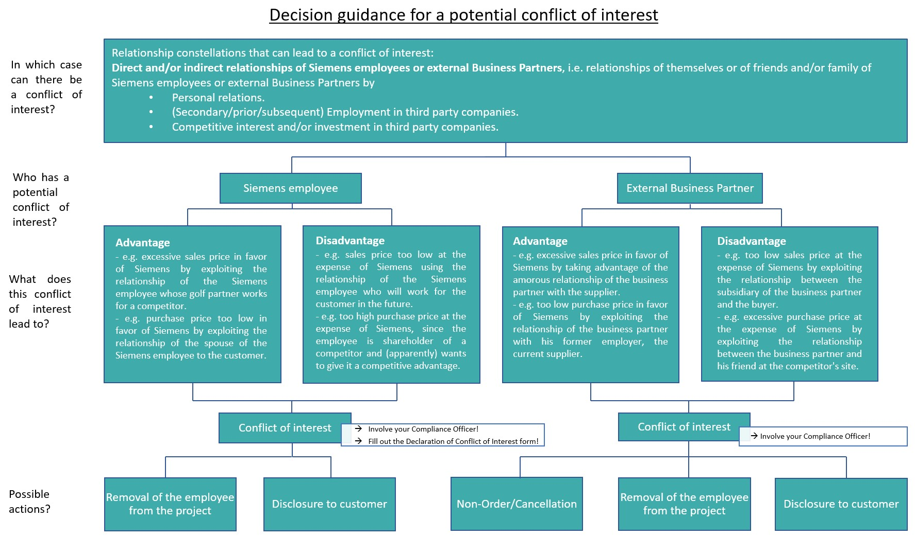In any case, especially if in doubt, please involve Compliance as early as possible.

4

* + 1. **Personal relations**

Close relations can lead to a conflict of interest, if business decisions are made on the basis of personal interests as a result.

Typical examples:

* There is an intimate relationship between an employee and a manager and the manager grants an undue advantage to the employee due to the personal relationship. In this case, the manager is obliged to disclose the conflict of interest at an early stage and to eliminate it by e.g. changing the reporting relationships.

4 The Declaration of Conflict of Interest form can be found [here.](https://findit.compliance.siemens.com/content/10000101/Compliance/LC_CO/LC_CO_RG/findIT_LC_CO_RG_7994.docx)

* There is a recommendation of a good friend for a job at Siemens or that the Siemens employee concludes a contract with a specific supplier, in whose company a close relative or good friend of the Siemens employee works.

Both of the examples and similar situations can be solved by creating transparency. We must adhere to the following:

* We have to inform the HR department and follow the regular processes without offering exceptions what so ever.
  + 1. Relations to third-party companies: Competition with Siemens

A conflict of interest may also arise in business relationships with or through investments in a competitor or customer of Siemens. See also A.5.1.3. and A.5.1.4.

Typical examples:

* The employee also works for or advises a competitor of Siemens.
* The employee himself competes directly with Siemens (by offering products that Siemens sells).
* There are personal or family ties to competitors.

We must adhere to the following:

* We do not operate or work for a company that competes with Siemens.
* We do not engage in any activity that competes with Siemens.
  + 1. Relations to third-party companies: Investment

Conflicts of interest can also arise in the case of direct or indirect investments in third-party companies or other forms of influence on a company.

For **Business partners** of Siemens that only applies if Siemens is engaged in business with the respective company or has a mandate there. In the case of investments in publicly traded companies, this only applies if the investment exceeds three percent of the total capital.

For **competitors** the above applies if the management of the competitor can be influenced through the investment. This can be assumed if the interest exceeds three percent of the total capital of this company.

A conflict of interest may also arise in business relationships with or through investments in a competitor or customer of Siemens.

Typical examples:

* The employee also works for or advises a competitor of Siemens.
* The employee himself offers products that Siemens sells.
* There are personal or family ties to competitors.
* the offer of a seat on the supervisory board of another organization. The third-party company might be a Business Partner or a competitor of Siemens. These activities require Siemens’ approval.

We must adhere to the following:

* We inform the Human Resources department in writing of any direct or indirect investment in companies:
  + That are business partners of Siemens if We are engaged in business with the company or have a board or management role in the company. With respect to publicly traded companies, this only applies if the investment exceeds three percent of the total capital.
  + That compete with our company if We can influence the management of the competitor through this investment. This is presumed if the interest exceeds three percent of the total capital of the company.
    1. Employment: Secondary, prior or subsequent employment

A conflict may arise in the performance of secondary activities or employment, which prevent the employee from properly performing his duties at Siemens.

Secondary employment can only be prohibited, and previously granted permission only be revoked, if it leads to an impairment of the employee’s work performance, interferes with his or her duties within the company, or if there is a risk of a conflict of interest. Occasional writing, lecturing, and similar activities, and temporary seasonal or clerical work are not regarded as secondary employment.

Typical examples:

* The employee could have an accident at work due to being overtired and exhausted by his secondary employment. Therefore, such a secondary employment must be approved by Siemens.

But: Only occasional writing activities, lectures, and similar occasional activities as well as temporary work are not regarded as secondary employment.

* A prior or subsequent employment on the other hand can for example lead to the disclosure of confidential information or business secrets, if the employee does not handle the situation with care.

We must adhere to the following:

* Before we engage in paid secondary employment, we consult with our managers.
* We inform the HR department in writing that we would like to take up paid secondary employment and will only do so after obtaining written consent.
  + 1. Employment: Job rotation public/private sector

A conflict of interest can also arise if employees of a company switch to the public sector or vice versa. The fast or repeated change between the public service (politics/ ministries) and the private sector may in particular lead to conflicts of interest, e.g. to influence on the legislation through the use of insider knowledge and acquired contacts.

"Waiting periods", i.e. a waiting period between the change of positions, are intended to remedy this situation. In this context, the so-called Karenzzeitengesetz (“waiting period act”) has been introduced in Germany in 2015, but other countries also have corresponding laws and regulations.

For Siemens employees but also for Siemens itself, different risks may arise in connection with the change of public servants to the private sector and vice versa. Thereby it makes no difference whether Siemens employees move to the public sector or vice versa or whether they do so temporarily as part of exchange programs or for an indefinite period of time.

We must adhere to the following:

* Thorough subject and environment check (previous activity - planned position) especially of former or current contacts to Siemens (e.g. in the context of award procedures) in order to avoid conflicts of interest.
* Transparent selection process.
* Clear and transparent documentation of the secondment.
* Examination and maintenance of legal requirements (e.g. Sec. 105 Federal Civil Servants Act (Bundesbeamtengesetz), laws on waiting periods, etc.); in this respect, if necessary, also obtain a confirmation that the hiring does not conflict with statutory, contractual or other legal obstacles and waiting period regulations from the previous function.

The following measures should be taken:

* If necessary, implementation of further internal security measures (e.g. circular).
* Limitation of secondment time (generally up to six months; in justified individual cases prolongation possible).
* No assignment to drafting bills, to executive functions or to those with final decision-making authority, to the awarding of public contracts and to functions whose exercise directly affects the specific business interests of the sending office.
* For inquiries on lobbying topics, the Siemens communication principles must be observed.

Therefore, always involve GM and CM, respectively, and please coordinate potential reactions with GM GA EU and LC C GF.

In case of doubt please refer to your Compliance Officer or to Compliance Legal (LC CO RFC LF).

* + - 1. Specific legislation – Germany Karenzzeitengesetz:
* Waiting period for retiring members of the Federal Government as well as for parliament state secretaries to prevent conflicts of interest between the public service contract and employment after office.
* Obligation to notify the Federal Government or its responsible member in the event of the intention to take up employment outside the public sector within the first 18 months after leaving office.
* Possibility of prohibiting intended employment in case of possible interference with public interests.
* Limitation of the prohibition period to 12 to a maximum of 18 months, Sec. 6a of the Federal Ministerial Act (Bundesministergesetz “BMinG”)
* In addition, partly own waiting period regulations at Federal State level.

Further regulations

* Obligation to maintain confidentiality on matters that have become known in office, e.g. in accordance with Sec. 6 of the Federal Ministerial Act (Bundesministergesetz “BMinG”).
* Duty to disclose a new lobbying activity for up to five years after leaving office for civil servants (judges, etc.), if the new activity is related to the previous activity. The administrative authority can then prohibit the new activity. Anyone who disregards this prohibition loses his pension rights, Sec. 105 Federal Civil Servants Act (Bundesbeamtengesetz “BBG”).
* In the extreme case, possibly criminal acceptance of benefits (Sec. 331 German Criminal Code).
* Even if the legally required waiting periods are adhered to, Sec. 331 et seq. of the German Criminal Code and the Siemens BCGs are to be observed.

Important: An employment may not be offered or granted "in return" for the performance of the service. Already the appearance of dishonesty is to be avoided.

* + - 1. Specific legislation - others European Union
         * Members of the European Commission must notify the Commission of any intended professional activity which is to commence within 18 months after leaving the office.
         * Lobbying in former departments is completely prohibited during this time.
         * Furthermore, the Commissioners are subject to a non-competition clause: if there could be conflicts of interest with the former area of responsibility, an ethics committee decides on compatibility.
         * For other employees in EU-Institutions, a similar waiting period of up to three years applies.

Czech Republic

* + - * + The permission to take up a position in the public service must be granted by the employer; the employment must not be terminated. However, there is no entitlement to remuneration during the exercise of the public office.
        + After giving up/ leaving the public office, the employee has the right to continue working in a position of equal rank. The only exception would be the removal of the position in the meantime. If the employee is employed at a lower position, he would have to be fully compensated.
        + Confidential information obtained during affiliation with the company or the public employer may not be taken into account at the other office.

USA

* + - * + Waiting periods for mandate holders and staff members of the executive range from one year to up to a lifelong ban on certain activities.
        + For the legislative, a different waiting period of one up to two years applies.

### Dos and Don’ts

To protect ourselves and our company, we pay close attention to possible conflicts of interest. The following questions help us to assess whether this is the case:

* Is the decision I make for Siemens influenced by personal interests?
* What impression does the situation leave on external third parties, such as customers, authorities, and investors?
* How would the public react to my business decision?

We must adhere to the following:

1. In case of **competition** with Siemens (For details please refer to A.5.1.2.):
   * We do not operate or work for a company that competes with Siemens.
   * We do not engage in any activity that competes with Siemens.
2. In case of **secondary, prior or subsequent employment** (For details please refer to A.5.1.4.)
   * Before we engage in paid secondary employment, we consult with our managers.
   * We inform the Human Resources department in writing that we would like to take up paid secondary employment and will only do so after obtaining written consent.
3. In case of **investment in third-party companies** (For details please refer to A.5.1.3.):
   * We inform the Human Resources department in writing of any direct or indirect investment in companies:
     + That are business partners of Siemens if We are engaged in business with the company or have a board or management role in the company. With respect to publicly traded companies, this only applies if the investment exceeds three percent of the total capital.
     + That compete with our company if We can influence the management of the competitor through this investment. This is presumed if the interest exceeds three percent of the total capital of the company.
4. In case of **close relations** (For details please refer to A.5.1.1.)
   * We have to inform the HR department and follow the regular processes without offering exceptions what so ever.
5. In case of **job rotation public/private sector** (For details please refer to A.5.1.5.)
   * Thorough subject and environment check (previous activity - planned position) especially of former or current contacts to Siemens (e.g. in the context of award procedures) in order to avoid conflicts of interest.
   * Transparent selection process.
   * Clear and transparent documentation of the secondment.
   * Examination and maintenance of legal requirements (e.g. Sec. 105 Federal Civil Servants Act (Bundesbeamtengesetz), laws on waiting periods, etc.); in this respect, if necessary, also obtain a confirmation that the hiring does not conflict with statutory, contractual or other legal obstacles and waiting period regulations from the previous function.

The following regulations should be taken:

* + If necessary, implementation of further internal security measures (e.g. circular).
  + Limitation of secondment time (generally up to six months; in justified individual cases prolongation possible).
  + No assignment to drafting bills, to executive functions or to those with final decision-making authority, to the awarding of public contracts and to functions whose exercise directly affects the specific business interests of the sending office.
  + For inquiries on lobbying topics, the Siemens communication principles must be observed.

### Training and supporting material

Detailed public information can also be found here:

* [ICC Guidelines on Conflict of Interest in Enterprises](https://icc-estonia.ee/wp-content/uploads/2018/06/ICC-Guidelines-on-CoI-and-Dilemmas-final-4-5-18.pdf)
* [OECD Guidelines for Managing Conflict of Interest in the Public Service](http://www.oecd.org/gov/ethics/oecdguidelinesformanagingconflictofinterestinthepublicservice.htm) Siemens internal information can be found here:
* Presentation: [“Siemens and the public sector - The change of employees between the public service](https://findit.compliance.siemens.com/content/10000101/Compliance/LC_CO/LC_CO_RG_PL/findIT_LC_CO_RG_PL_7244.pdf) [and the private sector”](https://findit.compliance.siemens.com/content/10000101/Compliance/LC_CO/LC_CO_RG_PL/findIT_LC_CO_RG_PL_7244.pdf)
* Article in the news center: “[What is allowed, what is prohibited](https://newscenter.siemens.com/siemens-news/index.php?webcode=50076487&rwlogin=1)?”
* [Intranet Page BT HQ Switzerland „Sideline Work“](https://intranet.for.siemens.com/cms/080/en/processes/collaboration/Pages/hr-experts.aspx)
* [Conflict of interest BCG short film](https://myvideo.siemens.com/media/1_cadb24vv)
* Potential sample for declaration form: [Conflict of Interest](https://findit.compliance.siemens.com/content/10000101/Compliance/LC_CO/LC_CO_RG/findIT_LC_CO_RG_7994.docx)

### History of changes

|  |  |  |
| --- | --- | --- |
| **Date** | **Author** | **Major changes of binding content** |
| January 1, 2019 | Christina Wolfgramm | Wording and structure in line with the new Business Conduct Guidelines. First release through the Compliance Handbook. |
| January 1, 2020 | Koen Miezenbeek | Update due to organizational changes |

* 1. Contacts

▌ Compliance Officer

The Compliance Officer responsible for your unit can be found through the following [link.](https://intranet.for.siemens.com/cms/059/en/about/org/Pages/compliance_organization.aspx)

▌ Corporate Governance Owner

The contact persons for conflicts of interest are: Christina Wolfgramm (LC CO RFC LF)

Ulrike Desimoni (LC CO RFC LF)

1. Antitrust

Compliance with Antitrust law is of highest importance for Siemens.

Infringements of Antitrust law result in very significant risks: they range from very large fines and Siemens’ exclusion from public tenders to prison sentences for Siemens employees. In addition, the risks of private damages actions being pursued on the basis of Antitrust law infringements continue to increase. The internationalization of Antitrust enforcement has multiplied these risks – significantly more than 100 countries have now introduced Antitrust laws. For an internationally active company such as Siemens, it is therefore all the more important to conduct its worldwide business operation in compliance with Antitrust law.

**Antitrust principles**

▌ Employees must comply with all applicable Antitrust laws in accordance with their obligations under such laws and with their obligations under Circular 226 and [Chapter G2 of the Business Conduct](https://intranet.legal-compliance.siemens.com/docs/2019_SAG_BCG_English_FINAL.pdf) [Guidelines (“Fair competition and anti-trust laws”)](https://intranet.legal-compliance.siemens.com/docs/2019_SAG_BCG_English_FINAL.pdf) and this chapter.

▌ The basic principles of Antitrust law are clear and simple: competitors must not enter into anti- competitive agreements with each other, in particular if they concern hard core conduct such as price fixing or market sharing.

▌ All (possible) breaches of Antitrust law must be reported without delay. Employees can use any of the following reporting options: Line managers, Legal and Compliance, “Tell us” or the Siemens- Ombudsman.

### Siemens Antitrust Compliance Program

Senior management and line managers must ensure that, in accordance with their statutory organizational and supervisory obligations, no infringements of Antitrust law are committed and that the company and its employees are protected.

Siemens management does not tolerate any violations of Antitrust law and will take rigorous action against persons guilty of intentional infringement. All employees must be aware of Antitrust-related risks, comply with applicable Antitrust rules and consult the experts in Legal and Compliance if in any doubt in any particular case.

The Siemens Antitrust Compliance Program is based on the following principles:

* + clear communication from management regarding the necessity of Antitrust Compliance;
  + targeted identification of Antitrust-related risks by way of a regular “Antitrust Risk Exposure Assessment” (“AREA”) and monitoring of new developments and lessons learned;
  + professional and comprehensive Antitrust advice and [Antitrust training programs;](https://intranet.for.siemens.com/cms/059/en/about/org/Pages/legal_cmp.aspx)
  + rigorous investigation of, and the imposition of disciplinary sanctions for, infringements of Antitrust law and
  + regular review and further development of the Antitrust Program.

### Training and supporting material

Basic information and supporting material on Antitrust and Trade Secrets law and the relevant Compliance requirements are available on the [Homepage of LC M&A CMP.](https://intranet.for.siemens.com/cms/059/en/about/org/Pages/legal_cmp.aspx) There, employees may find general guidance documents as well as papers and presentations dedicated to specific topics like trade association meetings or competitive intelligence.

In case of questions, direct contact to the legal experts of LC M&A CMP should be sought.

### History of changes

|  |  |  |
| --- | --- | --- |
| **Date** | **Author** | **Major changes of binding content** |
| January 1,  2019 | Gordon Christian Felix Gloeckner | First release through the Compliance Handbook based on Siemens Circular SC No. 226 “Global Compliance”, Appendix 1. |
| July 1, 2020 | Julia Wirth | Addition of links to supporting material |
| October 1,  2020 | Georg Böttcher, Hubert Klinger | Shortening and streamlining of whole chapter in accordance with changes to Circular 226 |

1. Contacts

▌ Compliance Officer

The Compliance Officer responsible for your unit can be found through the following [link.](https://intranet.for.siemens.com/cms/059/de/about/org/Pages/compliance_organization.aspx)

▌ Corporate Governance Owner

The contact person for Antitrust is:

[Georg Boettcher](https://scd.siemens.com/luz/IdentitySearch?cn=BOETTCHER%2BFRIEDRICH%2BGEORG%2BZ001PJ1T&tcgid=Z001PJ1T&c=CO&o=SIEMENS&ou=EM&l=TEJ%2BB&department=LC%2BLAM%2BRC-CO&&utI=I&utX=X&utT=T&rtH=H&rtS=S&rtZ=Z&rtO=O&rtAktiv=A) (Chief Counsel Competition)

The contact persons for the Compliance Handbook content Antitrust are: [Annette Kraus (LC CO IR)](https://scd.siemens.com/luz/IdentitySearch?cn=KRAUS%2BANNETTE%2BZ002K99S&tcgid=Z002K99S&c=DE&o=SIEMENS&ou=LC&l=MCH%2BP&department=LC%2BCO%2BIR&&utI=I&utX=X&utT=T&rtH=H&rtS=S&rtZ=Z&rtO=O&rtAktiv=A)

[Georg Boettcher (LC M&A CMP)](https://scd.siemens.com/luz/IdentitySearch?cn=BOETTCHER%2BGEORG%2BZ001PJ1T&tcgid=Z001PJ1T&c=DE&o=SIEMENS&ou=LC&l=MCH%2BP&department=LC%2BM%26A%2BCMP&&utI=I&utX=X&utT=T&rtH=H&rtS=S&rtZ=Z&rtO=O&rtAktiv=A)

## Anti-Money Laundering (AML)

Delivery and supply activities entail the risk of being abused for money laundering or terrorist financing. Siemens strives to maintain business relationships only with reputable customers, partners, and companies whose business activities comply with legal requirements and whose financial resources are not of illegitimate origin.

The global Siemens Anti-Money Laundering (AML) System focusses on the Siemens goods trading business and aims at combating money laundering and terrorism financing by creating the necessary transparency in business conducted with **Counterparts**1. It consists of the following obligations, unless stricter local / sector specific legal requirements must be complied with:

Fundamental Principles and Rules of our BCG - H3: This is what we do:

* + We use a risk-based approach to verify the identity and economic background of customers, business partners, and other third parties, and the origin of payments to ensure they come from legitimate sources.
  + We immediately inform Legal and Compliance or our manager in the event of suspicious activity. When necessary, Siemens reports suspicious activity to law enforcement authorities.

In addition to the fundamental principles and rules of our BCG, the following applies:

* + In case of an **indication of money laundering or terrorism financing** (“**AML Red Flag**”, [**Chapter C.1.**](https://webbooks.siemens.com/public/LC/chen/index.htm?n=Part-1-Activity-Fields%2CC.-Anti-Money-Laundering-(AML)%2C1.-AML-Red-Flags)) in relation to a Counterpart, its Business Model, the Transaction / Financing e.g.
    - Unusual or implausible business activities or
    - Indications for **disguising the source of funds and/or involved persons**

or even a **concrete suspicion** of money laundering or terrorism financing, the responsible Compliance Officer must be informed2 and an **AML-specific Due Diligence (AML DD)** must be performed ([**Chapter C. 2**.](https://webbooks.siemens.com/public/LC/chen/index.htm?n=Part-1-Activity-Fields%2CC.-Anti-Money-Laundering-(AML)%2C2.-AML-Due-Diligence)) before entering into, or continuing with a business relationship or performing any transaction with a Counterpart.

* + Where required by **local / sector specific AML regulations**, additional or deviating measures might have to be taken (**Chapter C.3.**).
  + If an AML DD required by law cannot be performed, performing transactions and

1 **Counterparts** are defined in detail here. Generally, Counterparts involved in business with a **customer** are in the focus of activities fighting money laundering. Payments to suppliers are subject to DAMEX checks aiming at preventing terrorism financing.

2 via this [e-mail template.](https://findit.compliance.siemens.com/content/10000101/Compliance/LC_CO/LC_CO_CORP_AML/findIT_LC_CO_CORP_AML_9110.msg)

entering into or continuing a business relationship are generally prohibited. The same applies when the Compliance Organization issues a respective instruction ([**Chapter C.**](https://webbooks.siemens.com/public/LC/chen/index.htm?n=Part-1-Activity-Fields%2CC.-Anti-Money-Laundering-(AML)%2C4.--Prohibited-transactions-or-business-relationships)[**4**](https://webbooks.siemens.com/public/LC/chen/index.htm?n=Part-1-Activity-Fields%2CC.-Anti-Money-Laundering-(AML)%2C4.--Prohibited-transactions-or-business-relationships)).

* The cash handling rules for incoming and outgoing cash payments according to **Siemens Circular 208 “Treasury Transactions in the Company“** must be adhered to (as a general rule prohibited at or above 10,000 EUR; further details see [**Chapter C.5.**](https://webbooks.siemens.com/public/LC/chen/index.htm?n=Part-1-Activity-Fields%2CC.-Anti-Money-Laundering-(AML)%2C5.-Cash-Handling-Rules)).

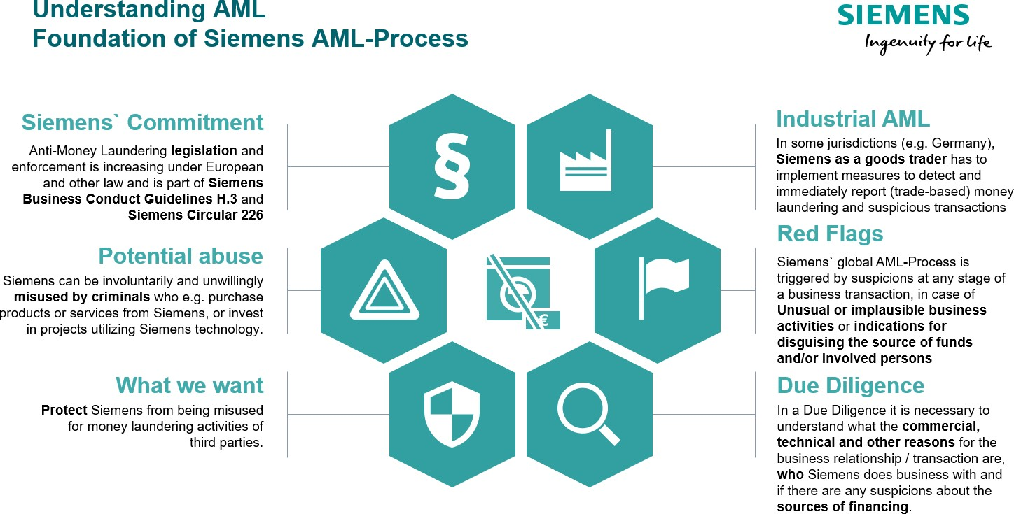

## AML Red Flags

Unless stricter local / sector specific legal requirements must be complied with (Chapter C.3.), the existence of an AML Red Flag requires contacting the responsible Compliance Officer so he or she can start a AML Due Diligence with the support of the business ([Chapter C. 2](https://webbooks.siemens.com/public/LC/chen/index.htm?n=Part-1-Activity-Fields%2CC.-Anti-Money-Laundering%2C2.-AML-Due-Diligence)).

AML Red Flags describe circumstances that could be seen as indication of money laundering or terrorism financing such as

▌ AML Red Flag: Unusual or implausible business activities

▌ **AML Red Flag: Indications for disguising the source of funds and/or involved persons**

Above AML Red Flags may relate to the

* + **Counterpart:** The Counterpart3 itself, its representatives and ultimate beneficial owners and their conduct.
  + **Business Model:** The business relationship and its commercial, technical and other parameters.
  + **Transaction / Financing:** The financial transactions and payments (e.g. source of funds, payment methods, e.g. cash, and financing) as well as the involvement of third parties.

As the existence of an AML Red Flags does not automatically hint to criminal activity it needs to be assessed, whether such indication leads to a concrete AML suspicion in the situation in question. Therefore, the Compliance Officer must be contacted for further clarification of circumstances by an AML DD, if AML Red Flags are identified.

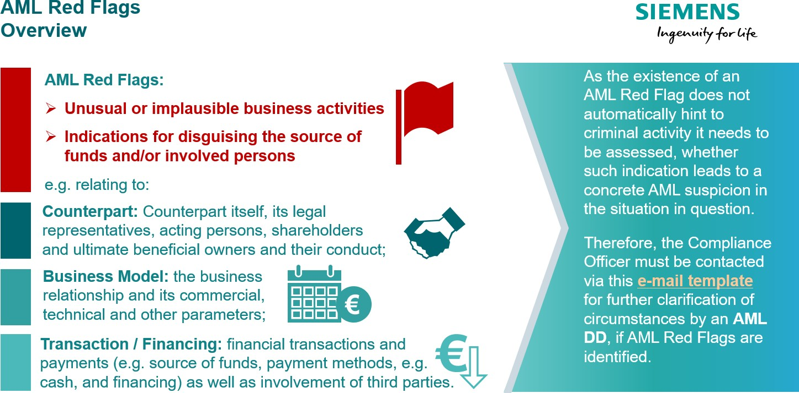

* 1. AML Red Flag Examples

▌ AML Red Flag: Unusual or implausible business activities, e.g.:

* + - **Counterpart:**
      * Counterpart **founded only recently, lacks expertise** in his claimed field of business;
      * Location of office or bank account has **no relation to residence or place of business** of Counterpart;

3 **Counterparts** are defined in detail here. Generally, Counterparts involved in business with a **customer** are in the focus of activities fighting money laundering. Payments to suppliers are subject to DAMEX checks aiming at preventing terrorism financing.

* + - * Counterpart has **questionable reputation / integrity** or even **known criminal records**;
      * **Politically Exposed Person (PEP)4** involved without plausible legitimate explanation;
    - Business Model:
      * Planned business not consistent with **Counterparts` regular field of business**.
      * It “**lacks economic sense**”, e.g. unusually high margin, high upfront payments, other unusual terms to the benefit of Siemens or business is questionable from a technical, logistic or other perspective;
      * Counterpart has low sensitivity and interest to commercial / technical details with no apparent reason (such as an urgent spare delivery).
    - Transaction / Financing
      * Planned business **not consistent** with Counterparts` financial situation
      * **Cash payments / deposit** onto Siemens’ account **above Siemens thresholds5;**

▌ AML Red Flag: Indications for disguising the source of funds and/or involved persons, e.g.:

* + - **Counterpart:**
      * Counterpart is a letter box company**6** (shell company) and / or has a complex and in-transparent

company structure,

* + - * **role / function of acting persons** is unclear; **legal representatives7** seem to avoid personal contacts**;**
      * Usual information **not provided, provided data vague, difficult to verify or not in line** with other sources;
    - Business Model:
      * Business structure is **unnecessarily complex**, e.g. it involves several companies or suppliers through several countries, where a direct business would be feasible and easier;
      * Counterpart requests a service / supplies from Siemens, which he **could have easily sourced locally,** without a plausible explanation.
    - Transaction / Financing
      * Transaction **unusually complex**, the source of funds is **in-transparent**;

4 PEPs are defined in detail here.

5 See Chapter C.5.

6 See Chapter C.1.3.

7 Legal representatives are defined in detail here

* + - * Transaction via **AML High Risk Country8** without plausible legitimate reason;
      * Payments9 proposed / made **through third party** / **letterbox company10** without plausible legitimate reason or **split and / or from multiple sources**;
      * Transaction or financing **changed unexpectedly** and without plausible explanation;
      * Payment **exceeds amounts due / are unrequested**, followed by request for reimbursement, sometimes also to different country / account.
      * Payments using **informal banking systems** ([Hawala Banking](https://en.wikipedia.org/wiki/Hawala));

### Letterbox company

A letter box company often shows at least some of the following indicators:

* + - no or no **sufficient personnel, office resources or financial background** for business transaction;
    - a business address that is **shared by numerous other companies**, avoids to reveal address;
    - **lacks expertise** in his claimed field of business, has **no visible (lawful) business activity or income**;
    - legal representatives **exercise similar functions** in many other companies;
    - administered by a law firm or other firm **known to be administrating letter box companies**;
    - located in an **AML High Risk Country11**.

### AML High Risk Countries

The involvement of an AML High Risk Country is only considered an AML Red Flag if there is no plausible legitimate explanation.

|  |  |  |  |  |  |
| --- | --- | --- | --- | --- | --- |
| **Afghanistan** | AML HRC (EU) | **Grenada** | OFC (EU) | **Niue** | OFC (EU) |
| **Albania** | AML HRC (FATF) | **Guernsey** | OFC (EU) | **Pakistan** | AML HRC (EU / FATF) |
| **Andorra** | OFC (EU) | **Hong Kong** | OFC (EU) | **Panama** | AML HRC (EU / FATF), OFC (EU) |
| **Anguilla** | OFC (EU) | **Iran** | AML HRC (EU / FATF) | **Philippines** | OFC (EU) |
| **Antigua and Barbuda** | OFC (EU) | **Iraq** | AML HRC (EU) | **Saint Lucia** | OFC (EU) |

8 See Chapter C.1.3.

9 **Payment:** an amount of money paid, or the act of paying.

10 See Chapter C.1.2.

11 See Chapter C.1.3.

|  |  |  |  |  |  |
| --- | --- | --- | --- | --- | --- |
| **Aruba** | OFC (EU) | **Isle of Man** | OFC (EU) | **Seychelles** | OFC (EU) |
| **Bahamas** | AML HRC (EU); OFC (EU) | **Jamaica** | AML HRC (EU / FATF) | **Singapore** | OFC (EU) |
| **Bahrain** | OFC (EU) | **Jersey** | OFC (EU) | **Sint Maarten** | OFC (EU) |
| **Barbados** | AML HRC (EU / FATF), OFC (EU) | **Korea, North** | AML HRC (EU / FATF) | **St. Kitts and Nevis** | OFC (EU) |
| **Belize** | OFC (EU) | **Lebanon** | OFC (EU) | **Syria** | AML HRC (EU / FATF) |
| **Bermuda** | OFC (EU) | **Liberia** | OFC (EU) | **Trinidad and Tobago** | AML HRC (EU) |
| **Botswana** | AML HRC (EU / FATF) | **Liechtenstein** | OFC (EU) | **Turks and Caicos Islands** | OFC (EU) |
| **British Virgin Islands** | OFC (EU) | **Marshall Islands** | OFC (EU) | **Uganda** | AML HRC (EU / FATF) |
| **Cambodia** | AML HRC (EU / FATF) | **Mauritius** | AML HRC (EU / FATF), OFC (EU) | **US Virgin Islands** | OFC (EU) |
| **Cayman Islands** | OFC (EU) | **Montserrat** | OFC (EU) | **Vanuatu** | AML HRC (EU), OFC (EU) |
| **Cook Islands** | OFC (EU) | **Myanmar** | AML HRC (EU / FATF) | **Yemen** | AML HRC (EU / FATF) |
| **Curacao** | OFC (EU) | **Nauru** | OFC (EU) | **Zimbabwe** | AML HRC (EU / FATF) |
| **Dominica** | OFC (EU) | **Nicaragua** | AML HRC (EU / FATF) |  |  |
| **Ghana** | AML HRC (EU / FATF) | **Saint Vincent and the Grenadines** | OFC (EU) |  |  |
| **Gibraltar** | OFC (EU) | **Samoa** | OFC (EU) |  |  |

The internal Siemens list of AML High Risk Countries is based on the following three official sources. As Siemens for its core business as an industrial company (“goods trading”) is generally not obliged to strictly apply those lists (in contrast e.g. to the financial sector), the updates of the consolidated Siemens might deviate slightly from official enactments by the referenced institutions.

1. AML HRC = AML High Risk Country
   1. EU: [Commission Delegated Regulation (EU) 2020/855 of 7 May 2020](https://eur-lex.europa.eu/eli/reg_del/2020/855/oj) amending [Delegated](http://data.europa.eu/eli/reg_del/2016/1675/2018-10-22) [Regulation (EU) 2016/1675 of 14 July 2016](http://data.europa.eu/eli/reg_del/2016/1675/2018-10-22)
   2. FATF: [Call for action](http://www.fatf-gafi.org/countries/#high-risk) and [other monitored jurisdictions](http://www.fatf-gafi.org/countries/#other-monitored-jurisdictions)
2. OFC (EU) = Offshore Financial Center according to [EU statistical office Eurostat](https://ec.europa.eu/eurostat/statistics-explained/index.php?title=Glossary%3AList_of_offshore_financial_centres)

Status: 1 April 2021

Changes relating to last version (1 January 2021) of consolidated list:

* **Deleted:** Mongolia

## AML Due Diligence

Unless stricter local / sector specific legal requirements must be complied with (Chapter C.3.), the existence of an AML Red Flag ([Chapter C.1.](https://webbooks.siemens.com/public/LC/chen/index.htm?n=Part-1-Activity-Fields%2CC.-Anti-Money-Laundering%2C1.-AML-Red-Flags)) requires contacting the responsible Compliance Officer so he or she can start a AML Due Diligence with the support of the business.

AML Red Flags describe typical situations, that bear a higher AML risk. The goal of the AML DD is to assess, whether an AML Red Flag - meaning a factual constellation that **typically** indicates a high AML risk - also means that the **concrete situation** bears a high AML risk. Therefore, it needs to be checked whether the concrete situation that triggered an AML Red Flag

* + leads to a concrete AML suspicion or
  + **we can be reasonably confident (after mitigation measures) that counterparts` funds are not related to criminal activities**

Following this goal, the completion of an AML DD comprises of the following steps:

▌ Step 1: Clarify Circumstances to

* Know and transparently understand the **commercial, technical and other reasons** for the business relationship / transaction and its form.
* Know and transparently understand **who Siemens does business with** and who represents, owns and ultimately benefits from this business.
* Plausibly understand the sources of **financing of the Counterpart** and their **financial transactions** with Siemens.
* Find out if there are indications for a **criminal origin of the funds**.

▌ Step 2: Take action to

* **Mitigate the risk** of Siemens being abused for money laundering and
* Fulfill possible **legal requirements.**

▌ Step 3: Monitoring to observe if changes require further actions.

The AML Due Diligence (AML DD) must be performed **before** entering into or continuing with a business relationship or performing any transaction with a Counterpart. The AML DD must be started immediately when the AML risk occurs/becomes known.

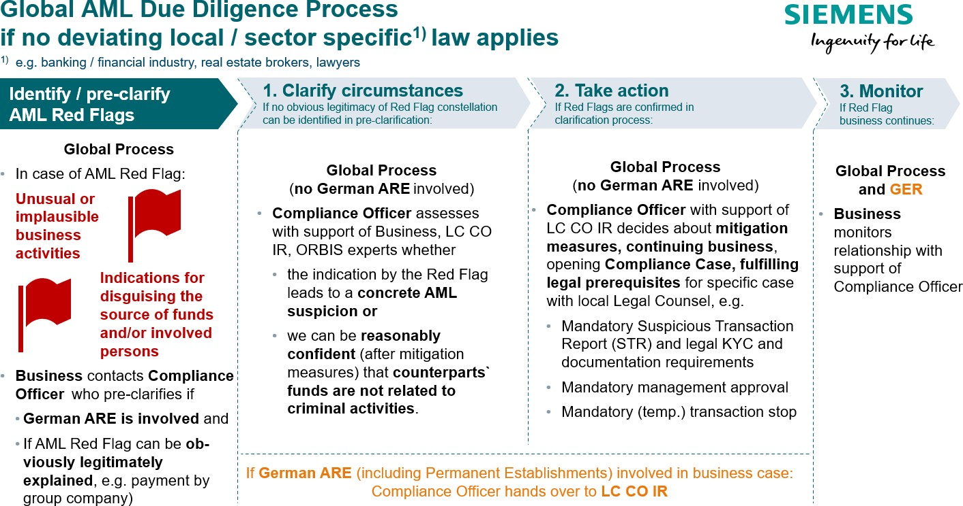

* 1. Clarify circumstances

The clarification of circumstances is comprised of two steps, the

* + - confirmation of the AML Red Flag by the Compliance Officer as a kind of pre-check on the basis of the information provided by the business (Chapter C.2.1.1.) and
    - the actual collection and assessment of further facts (Chapter 2.1.2.).
    1. Confirmation by the Compliance Officer

The Compliance Officer performs a first check, if

* + - * the concrete situation indeed shows all **factual** elements as described in the AML Red Flag or if the AML Red Flag situation is given but may be **obviously plausibly and legitimately** explained, e.g. if from his perspective
        + the company structure is also complex / in-transparent or if the setup had been previously reviewed and approved also from a Compliance perspective;
        + the business models lacks economic sense or it is an obviously legitimate business model (as opposed to formally legal only);
        + it is a third party through which a payment was made or

errors in name spellings led someone to believe, that there was a third party paying or

it is a third-party payment but it is obviously legitimately made by a group company of the customer.

* A **German ARE** is involved in the business case.

This decision must be taken without delay and on the basis of the information available to the Compliance Officer at the time; there is no need for internal reviews, audits or investigative measures at this point.

There is no need for further clarification or actions where it is – contrary to the first assessment of the business – obvious from the perspective of a Compliance Officer that no AML Red Flag exists.

If the existence of the AML Red Flag can be confirmed by the Compliance Officer, it is necessary to further clarify the circumstances (see next subchapter). In all cases where a **German ARE** is involved, the Compliance Officer reports the confirmed AML Red Flag-situation to LC CO IR. For the reporting of the AML Red Flag-situation the Compliance Officer may use the suggested [e-mail notification.](https://findit.compliance.siemens.com/content/10000101/Compliance/LC_CO/LC_CO_CORP_AML/findIT_LC_CO_CORP_AML_9110.msg)

* + 1. Collection and assessment of facts

In any case where an AML Red Flag is confirmed by the Compliance Officer, a further clarification is needed. This clarification is needed to assess, whether the AML Red Flag-Situation that typically indicates a high AML risk also means that the **concrete situation** bears a high AML risk.

The responsibility for collection and assessment depends on the fact if a German ARE (e.g. the legal entity Siemens AG itself or any of its German subsidiaries) is involved in the business case or transaction where the AML Red Flag has been identified.

▌ No German ARE involved: Compliance Officer

In all cases where no German ARE is involved, the Compliance Officer will assess whether the AML Red Flag-situation that typically indicates a high AML risk also means that the **concrete situation** bears a high AML risk. Therefore, it is necessary to assess the

* + - * plausibility of business activity
      * **integrity of involved parties and legitimacy of source of funds**

Depending on the circumstances the clarification may require, in particular, but not limited to some or all of the following:

* + - * + Internal information about **the business relationship / case**, e.g. an overview of the involved parties and the contractual and financial setup as well as business judgement about the economic and technical adequacy
        + Plausibility check of **legal nature / source of funds** of the Counterpart
        + name and registered business address of the **Counterpart**
        + the Counterpart`s **ownership and control structure(s) to see** whether an AML Red Flag is indicated in **ORBIS** (see chapter C.2.1.3.), e.g. because one of the individuals raises integrity concerns

to see if there are any **indications for illegitimate sources of the funds of the Counterparts** or any of the persons identified is involved in illegitimate business.

▌ German ARE involved: LC CO IR

In all cases where a German ARE is involved, the Compliance Officer reports the confirmed AML Red Flag- situation to LC CO IR. For the reporting of the AML Red Flag-situation the Compliance Officer may use the suggested [e-mail notification.](https://findit.compliance.siemens.com/content/10000101/Compliance/LC_CO/LC_CO_CORP_AML/findIT_LC_CO_CORP_AML_9110.msg)

The Business supports this by giving the necessary information. Also, third party information can be accessed e.g. via **ORBIS**.

Generally, the AML risk evaluation refers to the Siemens Counterpart. In circumstances where Third Parties make payments to Siemens (transactions), the AML Due Diligence should be performed for those Third Parties.

On the basis of the collected information, it can be assessed whether a high AML risk exists in the concrete situation. Therefore, it has to be assessed if a situation or conduct of the Counterpart is unusual compared to the standards in the relevant industry and no sufficiently plausible explanation exists based on currently available information.

LC CO IR will support, upon request, with the assessment whether a high AML risk exists. To get support from LC CO IR the Compliance Officer may use the suggested [e-mail notification.](https://findit.compliance.siemens.com/content/10000101/Compliance/LC_CO/LC_CO_CORP_AML/findIT_LC_CO_CORP_AML_9110.msg)

The relevant business relationship should - wherever possible - be suspended and no further transactions be performed until the clarification is finished and – if needed – further actions according to the next subchapter have been defined.

If the assessment confirms a high AML risk or even leads to positive knowledge of AML infringements in the concrete situation, further actions have to be taken.

* + 1. ORBIS access

▌ Check plausibility of business activity

Besides information from the business, ORBIS information especially from the categories “Financials”, local registry documents” Industry & activities” as well as “Geographic footprint” might be helpful (fields marked with an orange frame on the screenshots below)

▌ Check for ORBIS Flags

ORBIS shows orange Flags in the overview category “Key Information” as well as relating to individuals and companies in the categories “Beneficial Owners”, Controlling shareholders”, “Current directors & managers” as well as “Ownership structure” (fields marked with an green frame on the screenshots below).

The orange flags may relate to the [LexisNexis / WorldCompliance-categories](https://findit.compliance.siemens.com/content/10000101/Compliance/LC_CO/LC_CO_CORP_AML/findIT_LC_CO_CORP_AML_7463.pdf) “Enforcement”, “Adverse Media”, “Sanction List”, “PEP”, “Associated Entity”, or “Registrations”. Only “**Enforcement**” and “**Adverse Media**” should be screened for relevant findings hinting at an illegal source of our Counterparts funds.

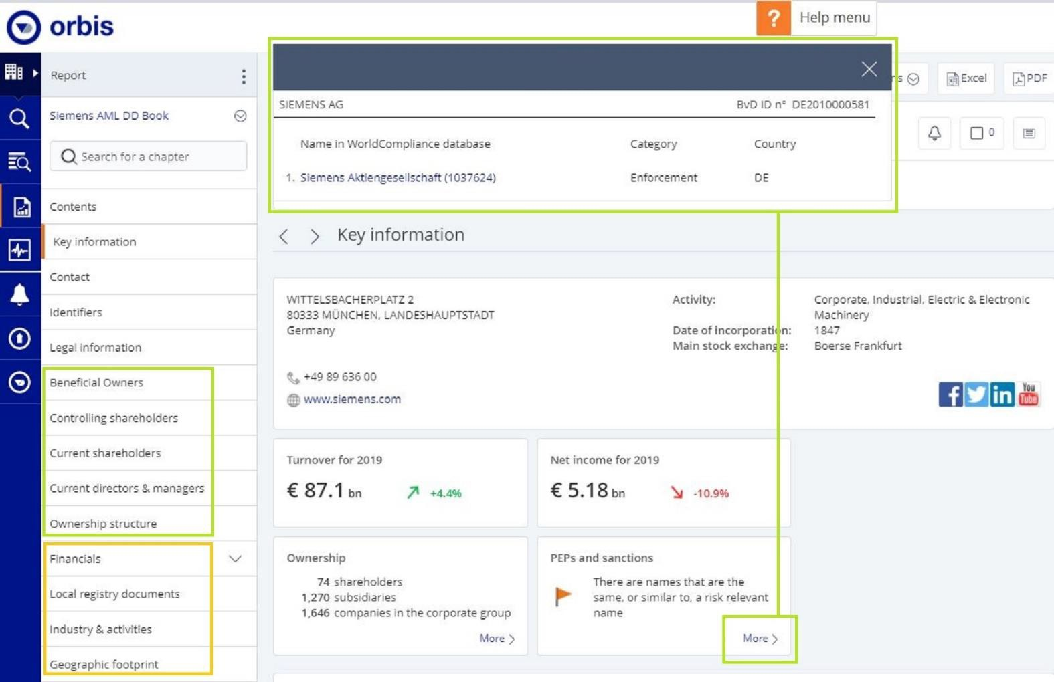

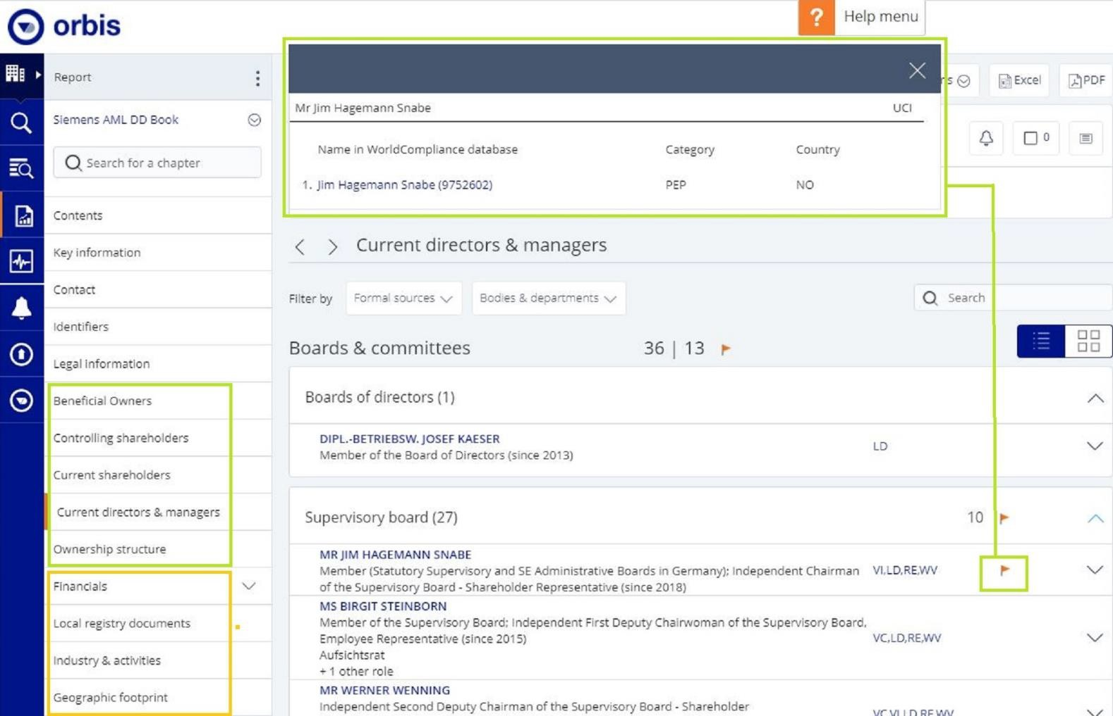

▌ Hit evaluation

The guidance on hit evaluation of SETIS hits applies accordingly, see [chapter A.4.C.2.4.4.](https://webbooks.siemens.com/public/LC/chen/index.htm?n=Part-1-Activity-Fields%2CA.-Anti-Corruption%2C4.-Cooperation-with-Business-Partners%2CC.-Relevance-only-for-Tool-Users-(Tool-description)%2CC.2.-Business-Partner-CDD-Process%2CC.2.4.-Risk-Assessment%2CC.2.4.4.-Internet)

▌ Access to ORBIS

As Compliance Officer, please refer to your responsible regional, Business or Service & Governance Head of Compliance / Department Head. Accesses to ORBIS have be allocated to the Compliance office of the following Siemens units:

|  |  |  |
| --- | --- | --- |
| **Assignment of Access to Countries** | | **Assignment of Access to Businesses** |
| **Country** | **Shared with** | DI |
| USA | Netherlands | SI |
| Brazil | Turkey | MO |
| France | Canada | CD |
| Austria | Japan | SFS |
| Switzerland | |  |
| Portugal | Australia | **Assignment of Access to Service & Governance** |

|  |  |  |
| --- | --- | --- |
| Spain | Argentinia | IR |
| Italy |  | PT |
| Indien | Sweden | EX |
| Singapore | UK | RFC |
| South Africa |  |  |
| UAE | Mexico |  |

▌ Access Rights

The Access Right-Holders can also found on this [list.](https://findit.compliance.siemens.com/content/10000101/Compliance/LC_CO/LC_CO_CORP_AML/findIT_LC_CO_CORP_AML_9601.xlsx)

▌ User Manual

An ORBIS **user manual** is available [here.](https://findit.compliance.siemens.com/content/10000101/Compliance/LC_CO/LC_CO_CORP_AML/findIT_LC_CO_CORP_AML_9549.pdf)

▌ Important Restrictions:

* Due to export control regulations and the fact that Orbis is owned by Bureau van Dijk (owned by Moody's) Russia and China need to receive the reports from other countries. Recommendation: China to receive reports from Singapore or via Business (DI, SI, MO, CD); Russia to receive reports from Austria or via Business (DI, SI, MO, CD) same applies for Iran - obtain report over UAE or Business and all other embargoed countries.
* Each account can have more than one user by sharing the user name and password. *Please keep* [*Ute*](https://scd.siemens.com/luz/IdentitySearch?cn=ute%2Bstach&suchart=schnell&utI=I&utX=X&utT=T&rtH=H&rtS=S&rtZ=Z&rtO=O&rtAktiv=A)[*Stach*](https://scd.siemens.com/luz/IdentitySearch?cn=ute%2Bstach&suchart=schnell&utI=I&utX=X&utT=T&rtH=H&rtS=S&rtZ=Z&rtO=O&rtAktiv=A)*, LC CO PT CO informed about any active users within your organization. Rec*ommendation: Within your time zone max. two user per account - otherwise the account is not accessible if another user is already logged in.
* DO NOT set the value to "always logged in”
* Note: the annual amount of ORBIS reports is limited. Please do not request reports without necessity.

▌ Technical Questions

For any technical question in relation to ORBIS, please refer to [Ute Stach,](https://scd.siemens.com/luz/IdentitySearch?cn=ute%2Bstach&suchart=schnell&utI=I&utX=X&utT=T&rtH=H&rtS=S&rtZ=Z&rtO=O&rtAktiv=A) LC CO PT CO

### Take action

The responsibility for further actions depends again on the fact if a German ARE is involved in the business case or transaction where the AML Red Flag has been identified.

▌ No German ARE involved

In all case where no German ARE is involved, the Compliance Officer will decide on further measures. LC CO IR will support upon request. A decision has to be taken about

* + - continuing business,
    - **mitigation measures** which would reduce the AML risk to a level where the business can be continued, e.g, agreeing on a direct payment by the customer instead of a third party payment
    - opening a **Compliance Case** and
    - **legal prerequisites** for specific case (see chapter C.3.)

LC CO IR will support, upon request, with the assessment of possible actions. To get support from LC CO IR the Compliance Officer may use the suggested [e-mail notification.](https://findit.compliance.siemens.com/content/10000101/Compliance/LC_CO/LC_CO_CORP_AML/findIT_LC_CO_CORP_AML_9110.msg)

▌ German ARE involved

LC CO IR continues handling the issue.

### Monitoring

The AML DD requires appropriate follow up and monitoring procedures concerning the Counterpart, the business model and or any transactions with the Counterpart. Such follow-up and monitoring may vary from case to case; its frequency, scope and depths shall be defined jointly with the mitigation measures.

The overall responsibility for the completion of the follow up and monitoring lies with the Business. The Compliance Officer supports the monitoring of the business relationship.

The same applies, if any Siemens colleague becomes aware of new information or data about a Counterpart that deviates from information or data obtained previously or any new doubts with regards to the potential involvement of the Counterpart in money laundering or terrorism financing occur.

If any AML risk was identified in the course of the AML DD an enhanced monitoring is needed based on the defined mitigation measures.

The integrity information ([chapter C.2.1.](https://webbooks.siemens.com/public/LC/chen/index.htm?n=Part-1-Activity-Fields%2CC.-Anti-Money-Laundering-(AML)%2C2.-AML-Due-Diligence%2C2.1.-Clarify-circumstances)) should be monitored on a regular basis or at any time e.g. in case of

* + - new information or data about a Counterpart that deviates from information or data obtained previously, or
    - any new doubts with regards to the potential involvement of the Counterpart in money laundering or terrorism financing.

## Local / sector specific AML requirements

The global Siemens Anti-Money Laundering (AML) System has been designed with a focus on Siemens` industrial / goods trading business. It is applicable, as far as no deviating local / sector specific law, e.g. for banking / financial industry, real estate brokers or lawyers, applies. The global Siemens Anti-Money Laundering (AML) System is administered by LC CO RFC / LC CO PT CO. SFS issues are handled by LC CO SFS.

The responsible Compliance Officer is obliged to check (e.g. as part of the assessment of the regulatory risk in the CRA) if his or her local or sector specific requirements are fulfilled by the global Siemens Anti-Money Laundering (AML) System or if additional measures need to be taken. In that case, further measures are to be aligned with LC CO RFC / LC CO PT CO respectively LC CO SFS for SFS.

### Germany

The German AML Law (Geldwäschegesetz, GwG) contains duties for several types of “obliged parties”:

* + - **German Siemens entities selling Siemens products, services and projects** are an obliged party as “Goods Trader” (Güterhändler, Sec. 2 para. 1 No. 16 GwG). The global AML DD Process is designed to identify critical situations in accordance with the applicable law. In case of involvement of German AREs, those AML Red Flag situations will be handled by the experts for German AML law at LC CO IR.
    - **Financial industry activities** lead to the status of an obliged party (Sec. 2 para. 1 Nos. 1-9 GwG). For AML of the financial industry, please contact [SFS Compliance.](https://intranet.for.siemens.com/cms/059/en/about/org/Pages/compliance_organization.aspx) For Next47 as “Financial company”, please contact the [Compliance Officer for Next47.](https://intranet.for.siemens.com/cms/059/en/about/org/Pages/compliance_organization.aspx)
    - **Real Estate Brokers** are obliged parties (Sec. 2 para. 1 No. 14 GwG). For real estate matters, please contact the [Compliance Officer for SRE.](https://intranet.for.siemens.com/cms/059/en/about/org/Pages/compliance_organization.aspx)
    - For the **Transparency Register** (Sec. 18 GwG), please contact the [Compliance Officer for CF R.](https://intranet.for.siemens.com/cms/059/en/about/org/Pages/compliance_organization.aspx)
    - **Lawyers and other professionals** are obliged parties (Sec. 2 para. 1 Nos. 10-12 GwG). For lawyers and other professionals, please contact the [Compliance Officer for LC](https://intranet.for.siemens.com/cms/059/en/about/org/Pages/compliance_organization.aspx) or [Jürgen Krais,](https://scd.siemens.com/luz/IdentitySearch?cn=j%C3%BCrgen%2Bkrais&maxanz=50&suchart=schnell&tab=tabs-1) LC CO IR and see Chapter C.3. of the German version of this Handbook.

## Prohibited transactions or business relationships

Where an AML Due Diligence (AML DD) that is obligatory by law cannot be performed, for example because the Counterpart does not provide the information relevant for such AML DD, it is prohibited to do business with the Counterpart. An existing business relationship must be terminated. In particular, no transaction or payment must be performed or received from the Counterpart.

The same applies where LC CO RFC LF or LC CO IR issue a corresponding instruction in the course of an AML DD with view to the risk of money laundering or terrorism financing.

Following a suspicious activity report (`SAR`) or a suspicious transaction report (`STR`) the relevant business relationship, transaction or payment must remain suspended for at least three full working days or longer, where the local law requires.

## Cash Handling Rules

For incoming and outgoing cash payments in any currency the conditions of the [Siemens Circular 208 (Treasury](https://regulations.siemens.com/content/sc/208/en) [Transactions in the Company)](https://regulations.siemens.com/content/sc/208/en) apply (Sec. 4.10.1 and 5.4):

*“Payments with Cash are specifically regulated in many jurisdictions according to money laundering or other laws. The governance for Anti-Money Laundering lies with Legal & Compliance (LC CO RFC / LC CO SFS) and supports the BizCos by appropriate processes.*

* *If there are no stricter requirements under local law, Cash transactions (whether incoming or outgoing) at or above*
  + *€ 2,000 or equivalent for transaction of precious metals (e.g. gold, silver, platinum and others for use in Siemens products or for sale as scrap metals) are prohibited.*
  + *€ 10,000 or equivalent for any other transaction are prohibited.*
* *Splitting of Cash payments into smaller amounts which in total exceed the above thresholds to circumvent those thresholds is prohibited.*
* *It is also prohibited to circumvent the thresholds by making or receiving Cash transactions via third parties.*
* *For transactions exceeding the above thresholds, Non-Cash payment methods (e.g. electronic funds transfer, check, etc.) are to be used.*

*Exemptions from these rules are not permitted for payments by or in the name of or for any German ARE (e.g. by a local Siemens ARE afterwards internally invoicing the German ARE).*

*For all Non-German AREs, the ARE-CFO jointly with the responsible ARE Compliance Officer, may grant exemptions for payments exceeding the above thresholds, provided that*

* *the payment method used is in accordance with local legal requirements*12*,*
* *no German is directly or indirectly involved in the transaction and*
* *it does not constitute a Cash payment for the purpose of the German Anti-Money Laundering Act (GwG).*

*The responsible ARE Compliance Officer needs to inform LC CO RFC LF of all exemptions granted.”*

▌ Approvals of deviations for non-Germen ARE

The Compliance Officer at ARE level may grant such deviation if the above prerequisites are met and

* no cashless solution is available and
* the Counterpart (originator of a payment to Siemens or recipient of a cash payment from Siemens) has undergone a complete AML Due Diligence (including Know Your Counterpart (KYC) and AML Assessment) in line with Siemens’ internal AML requirements (see Chapter C. 2.).
* Additionally, in case of incoming payments (to Siemens), Siemens must ensure the Counterpart can reasonably demonstrate that the cash money is from a legal source/ has been obtained through legal activities.

The competent ARE Compliance Officer must inform LC CO RFC LF of any such exception granted.

▌ Examples for Cash Payments

Typical situations where cash payments may occur and that are impacted by the regulations above include, but are not limited to:

* Paying of **stamp duties**,
* Selling of **scrap material**,
* Purchasing of **material on a construction site**,
* Paying of **contractually agreed Daily Allowances**,
* Payments **into or out of cash boxes approved** under [Siemens Circular 208 `Treasury Transactions](https://regulations.siemens.com/content/sc/208/en) [in the Company`.](https://regulations.siemens.com/content/sc/208/en)

The following scenarios are not affected by the regulations above.:

* The creation and existence of a **cash box in accordance with** [Siemens Circular 208 `Treasury](https://regulations.siemens.com/content/sc/208/en) [Transactions in the Company`,](https://regulations.siemens.com/content/sc/208/en) even if the cash amount contained in such cash box exceeds the

10.000 EUR threshold; however payments by third parties into, or to third parties out of such cash boxes are fully subject to the regulation in Chapter C.1.1.;

* The **(physical) transport of cash by Siemens employees** as long as there is no payment involved (for example, a cash withdrawal of 10.000 EUR from the bank).

## Training and supporting material

Basic AML information for Business and Compliance

* [AML Homepage](https://intranet.for.siemens.com/cms/059/en/processes/publications/Pages/compliance_aml.aspx)
* [AML Information Package](https://findit.compliance.siemens.com/content/10000101/Compliance/LC_CO/LC_CO_CORP_AML/findIT_LC_CO_CORP_AML_9650.pptx)
* [AML Scribble Video](https://findit.compliance.siemens.com/content/10000101/Compliance/CL_CO/CL_CO_AT/findIT_CL_CO_AT_4551.wmv)

Further AML awareness and training for Compliance

* [AML Awareness Package FY 2021 - House of Risks](https://findit.compliance.siemens.com/content/10000101/Compliance/LC_CO/LC_CO_CORP_AML/findIT_LC_CO_CORP_AML_9651.pptx)
* [Integrity Moment FY 2020](https://findit.compliance.siemens.com/content/10000101/Compliance/CL_CO/L_GF/findIT_L_GF_8581.pptx)
* [AML Game: “Too good to be true” (2018)](https://findit.compliance.siemens.com/content/10000101/Compliance/LC_CO/LC_CO_CORP_AML/findIT_LC_CO_CORP_AML_6173.pptx)

AML awareness and training for specific local / sector requirements

* Please see Chapter C. 3.

## History of changes

|  |  |  |
| --- | --- | --- |
| **Date** | **Author** | **Major changes of binding content** |
| 01.10.2017 | Y. Hamm- Dueppe/U. Stach | Initial Version of KYC Guidance (V.1.0) and AML Assessment Guidance (V.1.0) |
| 24.11.2017 | A. Schieffer | Modifications to Cash-Handling and Accounting Controls: Prohibition of cash payments of >= 10.000 Euros; only for Non-German AREs exceptions are permissible, if unavoidable;  Corresponding [Siemens Circular 208 (Treasury](https://regulations.siemens.com/content/sc/208/en) [Transactions in the Company)](https://regulations.siemens.com/content/sc/208/en) came into effect on Dec. 15, 2017 |
| 08.01.2018 | Y. Hamm-Dueppe | Former KYC Guidance (V.1.1):   * Exceptions for end-user/end-customer * Description of necessity of deemed UBO * Guidance for evaluation of PEP Hits |
| 09.04.2018 | Y. Hamm- Dueppe/U. Stach | Former KYC Guidance (V.1.2):   * New EX trigger: end-customer in Russia * Disapproved Counterparts to be transferred into Business Partner Tool (today: NextGen) * Definition of relevant shareholder   Former AML Assessment Guidance (V.2.0):   * Exceptions in case of EX trigger: no need for AML Assessment * Particularities in case of real estate agency business * LoA – Limits of Authority particularities * Additional requirements:   + Management approval   + for cash payments |

|  |  |  |
| --- | --- | --- |
| 01.07.2018 | Y. Hamm-Dueppe/  U. Stach | Former KYC Guidance (V.1.3):   * Deletion of risk trigger: “whitelisted EPCs” * Data collection of five legal representatives instead of four * No screening in exceptional cases   Former AML Assessment Guidance (V.2.2):   * Additional Requirements extended to Tunisia, Trinidad & Tobago, Sri Lanka |
| 01.01.2019 | Y. Hamm- Dueppe/U. Stach | * Re-definition of risk trigger `corresponding AML law requirements` into `corresponding AML requirements` * Deletion of EX risk trigger within KYC process; corresponding changes regarding especially Shareholder structure and UBO definition:   + 1st level > 25 % shares   + 2nd and following level > 50 % shares * New chap. 2.4.3.1. Documentation of completion: Need of documentation of `disapproval` and   `completion under conditions` of KYCs within the KYC Tool   * Specification of list categories * Additional Requirements extended to Guyana and Pakistan*. *According to DELEGATED COMMISSION REGULATION (EU) 2018/1467 of 27 July 2018 amending the Delegate Regulation (EU) 2016/1675 supplementing Directive (EU) 2015/849 of the European Parliament and of the Council as regards the inclusion of Pakistan in the table in point I of the Annex (AML very high risk countries) |
| 01.10.2019 | Henning Tabbert | * Revised Approach (Red Flag oriented) * Elimination of country risk due as diligence/KYC trigger (Introduction of chapter C., 2.1., 2.3.3.; 2.3.4.1) |

|  |  |  |
| --- | --- | --- |
| 01.01.2020 | Henning Tabbert | * Cash requirements C.1.1. according to GWG changes |
| 01.04.2020 | Henning Tabbert | * Redactional changes in chapter C. introduction, C.1. and C.1.1. * Allocation of responsibilities C.3. * Chapter about AML Red Flags created C.1. * List of AML High Risk Countries included C.1.1.5. * Former separate binding documents for AML Red Flags and AML High Risk Countries abolished |
| 01.07.2020 | Henning Tabbert | * List of AML High Risk Countries C.1.1.5. adjusted:   + **Added:** Albania, Jamaica, Myanmar, Nicaragua, Uganda   + **Deleted:** American Samoa, Ethiopia, Guam, Libya, Nigeria, Puerto Rico, Saudi Arabia, Sri Lanka, Tunisia, US Virgin Islands. |
| 01.10.2020 | Henning Tabbert | * Chapter C.2. AML DD: Implementation of Fresh Eyes Project changes, Replacement of KYC-Tool process by AML DD process including direct access of Compliance Officers to ORBIS information and flexible factual clarification and assessment in absence of specific legal requirements. Handling of AML Red Flags in relation to German AREs by LC CO IR experts due to particular local law. * List of AML High Risk Countries C.1.1.5. adjusted: * **Added:** US Virgin Islands |
| 01.01.2021 | Henning Tabbert | * List of AML High Risk Countries C.1.1.5. adjusted:   **Deleted:** Iceland   * Legal requirements for Lawyers and other professionals in Germany only added in German Version |
| 01.04.2021 | Koen Miezenbeek | * List of AML High Risk Countries C.1.1.5. adjusted:   **Deleted:** Mongolia |

1. Contacts

▌ Compliance Officer

The Compliance Officer responsible for your unit can be found through the following [link.](https://intranet.for.siemens.com/cms/059/en/about/org/Pages/compliance_organization.aspx)

▌ LC CO IR

[Jürgen Krais,](https://scd.siemens.com/luz/IdentitySearch?cn=j%C3%BCrgen%2Bkrais&maxanz=50&suchart=schnell&tab=tabs-1) LC CO IR

▌ AML Legal Frame

[Koen](https://scd.siemens.com/luz/IdentitySearch?cn=henning%2Btabbert&suchart=schnell&utI=I&utX=X&utT=T&rtH=H&rtS=S&rtZ=Z&rtO=O&rtAktiv=A) [Miezenbeek,](https://scd.siemens.com/luz/IdentitySearch?cn=MIEZENBEEK%2BKOEN%2BFRANCISCUS%2BPETRUS%2BZ0041FAX&tcgid=Z0041FAX&c=DE&o=SIEMENS&ou=LC&l=ERL%2BM%2BWVS67&department=LC%2BCO%2BRFC%2BLF) LC CO RFC LF

▌ AML Processes & Tools / ORBIS

[Ute Stach,](https://scd.siemens.com/luz/IdentitySearch?cn=ute%2Bstach&suchart=schnell&utI=I&utX=X&utT=T&rtH=H&rtS=S&rtZ=Z&rtO=O&rtAktiv=A) LC CO PT CO

▌ AML Risk Management

[Martin Felkl,](https://scd.siemens.com/luz/IdentitySearch?cn=martin%2Bfelkl&maxanz=50&suchart=schnell&utI=I&utX=X&utT=T&rtH=H&rtS=S&rtZ=Z&rtO=O&rtAktiv=A) LC CO RFC RC

▌ **SFS**

For AML of the financial industry, please contact [SFS Compliance.](https://intranet.for.siemens.com/cms/059/en/about/org/Pages/compliance_organization.aspx)

▌ **Germany**

For contacts regarding the different obliged parties according to German AML law (GwG) please see Chapter C. 3.

## Data Privacy

Data privacy laws are being introduced for the first time or else are being tightened up, not only in the EU in the form of the directly applicable General Data Protection Regulation adopted on April 14, 2016, but also in many other countries. At the same time, supervisory authorities are being put in place and given more rights than ever. This is accompanied by greater media coverage and an increase in the number of public tenders which request data privacy solutions. This change has a tangible impact for Siemens AG and Siemens Affiliated Companies located within or outside the EU and requires adapting Siemens’ data privacy related processes to the applicable legal framework.

**Data Privacy in a nutshell**

▌ Personal data means any information that relates to an identified or identifiable natural person.

▌ Processing of personal data requires a legitimate legal basis. Examples of legal bases include contractual relationships, legitimate interests of the company or consent by the data subject.

▌ Any employee who becomes aware of a data breach must take immediate action and inform the [Data](https://findit.compliance.siemens.com/content/10000101/Compliance/CL_CO/CL_CF_DP/findIT_CL_CF_DP_3529.pdf) [Privacy Organization](https://findit.compliance.siemens.com/content/10000101/Compliance/CL_CO/CL_CF_DP/findIT_CL_CF_DP_3529.pdf) as described in the [Data Privacy Incident Management Process.](https://intranet.for.siemens.com/cms/059/en/processes/publications/Pages/compliance_data-privacy_program.aspx?tabcardno=1-6)

▌ Applicable data privacy laws often require companies to maintain a detailed record of all processing activities of personal information. Any processing of personal information in an application or system must be documented within the Siemens CDP Center by the respective process owner with the support of IT.

▌ Data Privacy laws require appropriate data processing agreements that contain requirements for service providers which provide data processing services (such as hosting or similar solutions).

More Information on our Data Privacy Management System are available [here](https://intranet.for.siemens.com/cms/059/en/processes/publications/Pages/compliance_data-privacy_management_system.aspx).

## Responsibility

The first key principle - Data privacy compliance as the responsibility of each Siemens employee

Complying with the law is a fundamental principle for Siemens. All Siemens employees are required to perform their daily tasks in accordance with applicable laws and regulations, including laws and regulations on data privacy (for example sections H7 of the [Business Conduct Guidelines](https://findit.compliance.siemens.com/content/10000101/Compliance/CL_CO/CL_CO_AT/findIT_CL_CO_AT_55.pdf)). This chapter therefore provides support to help employees from the respective target groups to comply with this principle in their daily work. Further directives are included in the “[Binding Corporate Rules (BCR) for the Protection of](https://findit.compliance.siemens.com/content/10000101/Compliance/CL_CO/CL_CF_DP/findIT_CL_CF_DP_9541.pdf) [Personal Data](https://findit.compliance.siemens.com/content/10000101/Compliance/CL_CO/CL_CF_DP/findIT_CL_CF_DP_9541.pdf)”.

The second key principle - Collaboration between the stakeholders identified and the Data Privacy Organization

Data privacy compliance falls under the responsibility of the Controller1 and the Processor2. Collaboration between Siemens entities is a key driver in Siemens’ compliance with applicable laws and regulations. In addition, the Siemens Data Privacy Organization3 supports stakeholders in the implementation of their respective tasks defined herein and acts as an intermediary between the stakeholders and external parties (e.g. supervisory authorities, data subjects, service providers and third parties).

An overview of the Siemens Data Privacy Organization including data privacy contacts in Siemens entities can be found in the [Intranet.](https://intranet.for.siemens.com/cms/059/en/processes/publications/Pages/compliance_data-privacy_organization_NEW.aspx?tabcardno=1-1)

## Tasks – Action Items

### Incident Handling / Data Breaches

Any breach of security leading to the accidental or unlawful destruction, loss, alteration, unauthorized disclosure of, or access to personal data may trigger notification requirements to authorities and data subjects.

For this purpose, any employee who becomes aware of such a breach must take immediate action in line with the [Data Privacy Incident Management Guidance](https://findit.compliance.siemens.com/content/10000101/Compliance/CL_CO/CL_CO_P/findIT_CL_CO_P_2957.pdf) and inform the Data Privacy Organization, if possible by using [the data breach report form.](https://findit.compliance.siemens.com/content/10000101/Compliance/LC_CO/LC_C_DP/findIT_LC_C_DP_6356.docx) Any communication with supervisory authorities and data subjects concerned needs to be coordinated with the Data Privacy Organization.

### Register of processing activities

Applicable data privacy laws (such as the EU data protection regulation) often require companies to maintain a detailed record of all processing activities and to conduct a privacy impact assessment for certain processing operations. Such processing activities shall be documented within the [Siemens CDP](https://intranet.for.siemens.com/cms/059/en/processes/publications/Pages/compliance_data-privacy_cdp.aspx) [Center](https://intranet.for.siemens.com/cms/059/en/processes/publications/Pages/compliance_data-privacy_cdp.aspx)4 by the respective Process Owner5 with the support of the IT (responsible for describing the technical and organizational measures and the possible engagement of further sub-processors).

Documentation in the CDP Center is mandatory if:

* + - the Controller is situated in a country in which an application register is required by law, or

1 Means the company which, alone or jointly with others, determines the purposes and means of the processing of personal data; e.g. the employer regularly acts as Controller for the personal data of its employees.

2 Means a legal person which processes Personal Data on behalf of a Controller. A company regularly qualifies as Processor if it acts as external or internal IT service provider (such as the hosting of applications or the provision of IT support services).

3 A local contact within the Data Privacy Organization can be identified [here.](https://findit.compliance.siemens.com/content/10000101/Compliance/CL_CO/CL_CF_DP/findIT_CL_CF_DP_3529.pdf) The responsibilities within the Siemens Data Privacy Organization are described in [Roles & Responsibilities document.](https://findit.compliance.siemens.com/content/10000101/Compliance/CL_CO/CL_CF_DP/findIT_CL_CF_DP_3142.pdf)

4 Means the electronic application register of Siemens, available [here.](https://intranet.for.siemens.com/cms/059/en/processes/publications/Pages/compliance_data-privacy.aspx)

5 Means the organizational unit at Siemens AG or an Affiliated Company that has the business responsibility for a data processing activity, such as an IT application or service.

* + - a Siemens entity acts as Processor for a Controller located in a country with this type of documentation requirement.

Even in other cases, a notification in the CDP Center is highly recommended in order to obtain a comprehensive overview of data privacy risks within Siemens.

### Data processing agreements

EU and other data privacy laws impose contractual requirements for the provision of processing services (such as SaaS, hosting or similar solutions). These requirements apply in particular to Sales, Procurement, LC and IT.

Such requirements include the obligation to

* + - carefully select a provider, taking into account the adequacy of the technical and organizational measures implemented and
    - agree on certain contract terms for the data processing agreement (by including data processing terms with certain mandatory content).

Siemens AG or an Affiliated Company is directly bound by the statutory requirement to enter into such data processing terms even if it only acts as provider (i.e. a [Processor](https://intranet.for.siemens.com/cms/059/en/processes/publications/Pages/compliance_data-privacy_gdpr.aspx)) for customers. In regard to external

customer / provider facing agreements there are sample data processing terms for “[Siemens acting as](https://findit.compliance.siemens.com/content/10000101/Compliance/LC_CO/LC_CO_DP/findIT_LC_CO_DP_4584.docx) [Customer](https://findit.compliance.siemens.com/content/10000101/Compliance/LC_CO/LC_CO_DP/findIT_LC_CO_DP_4584.docx)” and “[Siemens acting as Provider](https://findit.compliance.siemens.com/content/10000101/Compliance/LC_CO/LC_CO_DP/findIT_LC_CO_DP_4583.doc)” available on the intranet.

Furthermore there is an existing [internal data processing agreement](https://intranet.for.siemens.com/cms/059/en/processes/publications/Pages/compliance_data-privacy_program.aspx?tabcardno=1-8) between all Siemens Group Companies(“Intercompany Agreement”).

### Data privacy audits of service providers

If the provision of processing services (such as SaaS, hosting or similar solutions) involves personal data and such services are purchased from an external IT service provider, the technical and organizational measures implemented by this service provider must be audited on a regular basis by the respective Process Owner. Additional stakeholders are IT.

The intervals of such audits depend on the criticality of the personal data processed; in the case of IT applications and services containing sensitive HR data, audits should be conducted every two years. For this purpose, it is recommended that the Process Owner requests applicable and current audit reports and certifications from the service provider and retains a copy thereof for documentation purposes. For low risk applications the audit may be based on [self-assessments.](https://intranet.for.siemens.com/cms/059/en/processes/publications/Pages/compliance_data-privacy.aspx)

### Rights of data subjects (information rights)

Data privacy laws often [grant information and access rights](https://intranet.for.siemens.com/cms/059/en/processes/publications/Pages/compliance_data-privacy_gdpr.aspx) to individuals. The stakeholder involved is the Process Owner. Information on processing personal data shall be provided at the time when personal data is obtained (e.g. through a privacy notice in the application).

Access rights to personal data processed (including a copy thereof) shall also be considered, depending on the applicable laws. The [Siemens HR Privacy Notice](https://findit.compliance.siemens.com/content/10000101/Compliance/LC_CO/LC_C_DP/findIT_LC_C_DP_5592.pdf) describes the processing of personal data of the Siemens employees.

### Privacy in the product business

In the development of Siemens products, solutions and services the principles of “data privacy by design” (and by default) shall be taken into account throughout the development process. Concerned stakeholder are Cybersecurity, R&D, Quality managers and CT.

The [Circular No. 23](https://srs.siemens.cloud/%23/c/zpus5k)6 “Cybersecurity” requires that Siemens complies with data privacy laws, e.g. the General Data Protection Regulation, including the privacy by design and by default principle. These principles require Siemens to consider data privacy during the whole lifecycle of a product, solution and service in order to

* + - implement measures and product components which meet the data protection principles within products, solutions and services (Privacy by Design), and
    - apply privacy friendly settings automatically, without requiring the user to make manual changes to the privacy settings (“Privacy by Default”).

For further details, the Privacy by Design Checklist for Product Business and other material (including for customer requests), please refer to the [Intranet.](https://intranet.for.siemens.com/cms/059/en/processes/publications/Pages/compliance_data-privacy.aspx)

## Training and supporting material

* [Data Privacy Management System](https://intranet.for.siemens.com/cms/059/en/processes/publications/Pages/compliance_data-privacy_management_system.aspx)
* [Siemens CDP Center](https://intranet.for.siemens.com/cms/059/en/processes/publications/Pages/compliance_data-privacy_cdp.aspx)
* [Siemens Circular No. 236](https://srs.siemens.cloud/%23/c/zpus5k)
* [Data Privacy WBT (mandatory for specific job families)](https://training.siemens.com/lms/participant/)
* [Interactive subway plan for the General Data Protection Regulation (GDPR)](https://intranet.legal-compliance.siemens.com/dp-subway-map)
* [Scribble Video](https://myvideo.siemens.com/media/SIEMENS%2Bbetrieblicher%2BDatenschutz_EN%2B-%2Bby%2Bexplainity/1_wvyhuhwn)

## History of changes

|  |  |  |
| --- | --- | --- |
| **Date** | **Author** | **Major changes of binding content** |
| January 1,  2019 | Achim Köhler Axel Kessler | First release through the Compliance Handbook based on Siemens Circular SC No. 226 “Global Compliance”, Appendix 14. |
| October 1,  2020 | Axel Kessler | Adaptions according to deletion of Siemens Circular 216 “Binding Corporate Rules (BCR) and Intercompany Agreement (ICA) for the Protection of Personal Data” and integration into Circular 226 |
| April 1, 2021 | Axel Kessler  Yvonne Hamm- Düppe | Reference to LC CO Data Deletion and Retention Policy applicable for the LC Organization deleted due to new Chapter Part 3 .L.8. |

1. Contacts

▌ Compliance Officer

The Compliance Officer responsible for your unit can be found through the following [link.](https://intranet.for.siemens.com/cms/059/en/about/org/Pages/compliance_organization.aspx)

▌ Corporate Governance Owner

The contact persons for data privacy are:

[Axel Kessler](https://scd.siemens.com/luz/IdentitySearch?tcgid=Z000SFCC) (Data Protection Officer Siemens AG)

# Human Rights

Siemens considers respect for human rights to be an integral part of our responsibility as a global business. For us, this responsibility is a core element of responsible business conduct and we are committed to ensuring respect for human rights within Siemens’ sphere of influence.

Our commitment to this principle is firmly anchored in the Siemens Business Conduct Guidelines1 which set out the fundamental principles and rules governing the way we act within our company and in relation to our partners and the general public.

Accordingly, involvement of the company in any infringements of human rights or other adverse human rights impacts must be avoided. Compliance with applicable laws and regulations is essential but beyond that Siemens employees are expected to be aware of these issues, and both to avoid infringing on the human rights of others and to address adverse human rights impacts in activities and circumstances with which Siemens is involved.

**General principles of respecting human rights**

▌ Involvement of the company in any infringements of human rights or other adverse human rights impacts must be avoided.

▌ Be in accordance with applicable laws and regulations.

▌ Be aware of human rights issues beyond legal compliance.

▌ Avoid infringing on the human rights of others and address adverse human rights impacts in activities and circumstances with which Siemens is involved.

The following is intended to provide an overview of the Siemens human rights policy contained in the Siemens Business Conduct Guidelines (“BCG”). This also requires a brief outline of several important conventions and recommendations by international organizations which are endorsed by Siemens, and the principles of which are reflected in our Business Conduct Guidelines.2

Other existing company regulations – namely other Siemens circulars – and related governance are not affected by the content of this chapter.

1 Business Conduct Guidelines, section K.

2 Further information is available on the [Compliance Intranet.](https://intranet.for.siemens.com/cms/059/en/about/org/Pages/compliance.aspx) See also <http://siemens.com/global/en/company/sustainability/humanrights>

### Siemens human rights policy

The overall commitment of Siemens to respect human rights is contained in the [BCG section B](https://findit.compliance.siemens.com/content/10000101/Compliance/CL_CO/CL_CO_AT/findIT_CL_CO_AT_55.pdf) – “We respect the personal dignity, privacy, and personal rights of each individual.” – is elaborated further throughout the BCG, especially in [section K.](https://findit.compliance.siemens.com/content/10000101/Compliance/CL_CO/CL_CO_AT/findIT_CL_CO_AT_55.pdf)

Siemens is committed to embracing and supporting, within its sphere of influence, the set of core values in the areas of human rights, labor standards, the environment, and anti-corruption included in the [United Nations](https://www.unglobalcompact.org/what-is-gc/mission/principles) [Global Compact](https://www.unglobalcompact.org/what-is-gc/mission/principles)3 (“UNGC”) as an integral part of its business strategy and operations. Siemens has been a participant in the Global Compact since 2003.

Siemens considers the ten principles of the UNGC4 as binding for Siemens AG and its Affiliated Companies worldwide.

Siemens accordingly requires its business units and employees to always act in accordance with the UNGC principles, including, without limitation:

**Principle 1:** That business should support and respect the protection of internationally proclaimed human rights.

**Principle 2:** That business should make sure that they are not complicit in human rights abuses.5

**Principles 3 to 6:** Which define fundamental responsibilities for businesses regarding labor.

As set out in the BCG section K, Siemens also expects its employees, suppliers and business partners around the globe to recognize and apply the standards of certain international organizations as specified in the appendix.6

Respecting human rights is a key element of the integrity with which Siemens expects all employees to act.7

As stated [in Siemens Circular No. 226: chapter 3, section 5,](https://regulations-admin.siemens.com/content/sc/226/en) all Siemens employees are required to avoid any involvement of Siemens in any infringements of human rights or other adverse impacts on human rights.

Moreover they are also expected:

* to avoid causing or contributing to adverse human rights impacts through their or the company’s own activities, and address such impacts when they occur, and

3 As well as the rules laid down in the framework agreement of the International Metalworkers´ Federation (IMF) 4 As well as the rules laid down in the framework agreement of the International Metalworkers´ Federation (IMF) 5 See the [Compliance Intranet](https://intranet.for.siemens.com/cms/059/en/about/org/Pages/compliance.aspx) for further information.

6 Most of these international conventions and recommendations refer to human rights; see the [Compliance](https://intranet.for.siemens.com/cms/059/en/about/org/Pages/compliance.aspx) [Intranet](https://intranet.for.siemens.com/cms/059/en/about/org/Pages/compliance.aspx) for further information. Related links are also provided at <https://new.siemens.com/global/en/company/sustainability/humanrights.html>. Binding requirements towards Siemens suppliers and third party intermediaries are contained in the [Code of Conduct for Siemens Suppliers and](https://intranet.for.siemens.com/cms/050/en/processes/jobrole/Documents/Procurement_Standards/Download-Center/CoC/CoC_Brochure_en.pdf) [Third Party Intermediaries](https://intranet.for.siemens.com/cms/050/en/processes/jobrole/Documents/Procurement_Standards/Download-Center/CoC/CoC_Brochure_en.pdf) (see also [section J of the BCG](https://findit.compliance.siemens.com/content/10000101/Compliance/CL_CO/CL_CO_AT/findIT_CL_CO_AT_55.pdf)).

7 See [section B of the BCG,](https://findit.compliance.siemens.com/content/10000101/Compliance/CL_CO/CL_CO_AT/findIT_CL_CO_AT_55.pdf) see also [section E of the BCG](https://findit.compliance.siemens.com/content/10000101/Compliance/CL_CO/CL_CO_AT/findIT_CL_CO_AT_55.pdf) for related management responsibilities

* to seek to prevent or mitigate adverse human rights impacts that are directly linked to Siemens operations, products or services by the company’s business relationships, even if Siemens has not contributed to those impacts.

### United Nations Guiding Principles

States have the duty to protect and maintain human rights (in particular through legislation and effective enforcement of the law). For this reason our corporate responsibility to respect human rights first of all requires compliance with the law.8

In addition, human rights due diligence should be undertaken – as per the [United Nations Guiding Principles on](http://www.ohchr.org/Documents/Publications/GuidingPrinciplesBusinessHR_EN.pdf) [Business and Human Rights](http://www.ohchr.org/Documents/Publications/GuidingPrinciplesBusinessHR_EN.pdf)9 (“UNGP”) understood as an ongoing process to identify, prevent and mitigate adverse human rights impacts which a company may cause or contribute to through its own activities or which may be directly linked to its products, operations or services by a business relationship and account for how they address these impacts. Thus human rights due diligence goes beyond a company’s own operations and direct contractual partners; it covers a company’s entire value chain.10

Siemens supports the [UNGP.](http://www.ohchr.org/Documents/Publications/GuidingPrinciplesBusinessHR_EN.pdf) They provide important guidance for the further operationalization of our company’s responsibility to respect human rights.

### External developments

Human rights due diligence and related disclosure are increasingly required by legislation., affecting Siemens or parts of Siemens either directly or indirectly.11 Furthermore, several states have already published national action plans to disseminate and implement the UNGP, others are in the process of developing such plans or have committed to doing so.12

8 See [section A of the BCG,](https://findit.compliance.siemens.com/content/10000101/Compliance/CL_CO/CL_CO_AT/findIT_CL_CO_AT_55.pdf) see also [Compliance Intranet.](https://intranet.for.siemens.com/cms/059/en/about/org/Pages/compliance.aspx)

9 See the [Compliance Intranet](https://intranet.for.siemens.com/cms/059/en/about/org/Pages/compliance.aspx) for further details on the UNGP, the elements of human rights due diligence and related resources. The 2011 update of the OECD Guidelines for Multinational Enterprises also draws on and is aligned with the UNGP.

10 The comprehensive coverage of the value chain is also increasingly required by legislation and regulation. See the [Compliance Intranet](https://intranet.for.siemens.com/cms/059/en/about/org/Pages/compliance.aspx) for further information and resources (also containing practical examples of impacts and action taken).

11 See the [Compliance Intranet](https://intranet.for.siemens.com/cms/059/en/about/org/Pages/compliance.aspx) for further information and examples, including international developments such as in the European Union.

12 See the [Compliance Intranet](https://intranet.for.siemens.com/cms/059/en/about/org/Pages/compliance.aspx) for further information, including national action plans already published.

### Implementation at Siemens

Respecting human rights is integrated into the Siemens Compliance System with its pillars “Prevent, “Detect” and “Respond” – and is covered there, among others, as follows:

* + Human rights due diligence as a module of the assessment of compliance risks within the LoA process13
  + Human rights risks as a mandatory element of the Compliance Risk Assessment (CRA)14
  + Human rights as an optional topic of Compliance Review Boards (CRB)15; if required, the Chief Compliance Officer reports on the topic of human rights to the Managing Board and the Compliance Committee of the Supervisory Board of Siemens AG within the CRB
  + Reporting and further handling of human rights-related incidents as compliance cases16

The Heads of CD SU and LC CO report to the Siemens Sustainability Board (SSB) on the topic of human rights if required.17

Since fiscal 2017, the company’s annual Sustainability Information contains a separate chapter on human rights.

Siemens will continue to improve the integration of human rights aspects into the Siemens global compliance system, and aims to improve support for Siemens employees in their daily work in this regard.

### Human Rights Project Due Diligence

Human rights due diligence constitutes a key component of the UN Guiding Principles – understood as the continuous process of identifying and addressing the human rights impact of a company across its operations and products, and throughout its supplier and business partner networks.

In case Human Rights PDD is required for your project, you will be requested in the LoA tool to initiate it (‘early warning” in key data section and request in the human rights module of the Compliance Risk Evaluation).

The following chapter contains all instructions and resources to guide project managers with the performance of the Human Rights Project Due Diligence (PDD).

IMPORTANT:

13 See [Circular No. 226:](https://regulations-admin.siemens.com/content/sc/226/en) annex, chapter 3.1.7

14 See [Circular No. 226:](https://regulations-admin.siemens.com/content/sc/226/en) annex, chapter 3.10

15 See [Circular No. 226: annex, chapter 4.6](https://regulations-admin.siemens.com/content/sc/226/en) and [Compliance Review Board](https://webbooks.siemens.com/public/LC/chen/index.htm?n=Part-3-Compliance-Internal-Tasks%2CK.-Compliance-Risk-Management-and-Reviews%2C2.-Compliance-Review-Board) (Part 3, K. 2.)

16 See [Circular No. 226: annex, chapters 4.1, 4.3, 5](https://regulations-admin.siemens.com/content/sc/226/en) and [Case Handling, Discipline and Remediation](https://webbooks.siemens.com/public/LC/chde/index.htm?n=Teil-3-Compliance-Interne-Aufgaben%2CL.-Fallbearbeitung%2C-Disziplinar--und-Abhilfema%C3%9Fnahmen) (Part 3 L.)

17 The SSB has tasked CD SU and LC CO to work together on developing human rights management further at Siemens.

The Human Rights PDD does not substitute due diligences or similar procedures required for a project by applicable local law or other regulation or e.g. by export credit agencies or financing institutions. Related activities should be considered for the Human Rights PDD and vice versa in order to avoid redundant work and inconsistent results.

The Human Rights PDD does not substitute or modify specific due diligences or other assessments or similar procedures required by internal regulation.

The Human Rights PDD does neither constitute nor does it replace legal evaluation or advice.

* 1. Start of the Project Due Diligence

Please download and complete the [initial questionnaire.](https://findit.compliance.siemens.com/content/10000101/Compliance/LC_CO/LC_CO_STR/findIT_LC_CO_STR_6393.docx)

* + - Please complete the initial questionnaire to the best of your knowledge. You are not expected to spend much time on clarifying details you do not know yet. Filling the initial questionnaire should not take more than a few minutes.
    - If you have any specific concerns about possible human rights issues related to the project, please also include them in the questionnaire.
    - The initial questionnaire form will be updated. Please make sure to always use the latest version by downloading it from the [intranet](https://intranet.for.siemens.com/cms/059/en/processes/publications/Pages/compliance_humanrightspdd.aspx) or the Compliance Handbook.

Please send the filled initial questionnaire to the Authorized Compliance Officer (ACO) for the project via email to initiate the Human Rights PDD.

Please initiate the Human Rights PDD as early as possible as this will help avoiding or minimizing the risk of delays, especially in case of further clarification or determination of a mitigation plan.

What’s next?

Compliance will assess the project for human rights risks. You could be asked for further details in some cases. This will usually just take a few days, and you will receive follow up information on the results and on further proceeding from the ACO.

The assessment may have the following results:

1. No indications for specific human rights risks identified and no mitigation needed: See tab ‘Completion’.
2. Specific human rights risk(s) cannot be excluded, further clarification required: See tab ‘Clarification’.
3. Specific human rights risk(s) identified requiring mitigation: See tab ‘Mitigation’.
4. Specific human rights risk(s) identified which could not be mitigated (will apply in exceptional cases only!): ACO will contact you prior to issuing the related statement to discuss further proceeding – usually further clarification will be performed if the assessment so far would result in the identification of risks that could not be mitigated. See tab ‘Clarification”.

Assessment findings and results will be documented by the ACO.

* 1. Clarification

The ACO will inform you within a few days after receiving the initial questionnaire that further clarification is needed.

You will be contacted by the ACO for further clarification in the following situations:

* + - There are indications of specific human rights risk(s), but the completion of assessment requires further fact finding, usually to allow for an in depth evaluation of a specific issue.
    - The assessment performed so far would result in the identification of specific human rights risks that could not be mitigated. Such assessment result – as a general rule – will be always based on the results of further clarification.
    - Specific human rights risk(s) have been identified which should be mitigated, but further clarification is needed or seems the best option for preparing the mitigation plan.

The ACO will align clarification and further evaluation activities with you.

There is no exhaustive list of clarification measures. Examples include (without being limited to) extended research, involvement of colleagues (internal experts), contacting customer, supplier, consortium partner or other third parties, obtaining information from local authorities, obtaining external experts’ advice/evaluation or consultations on the ground.

Clarification measures will always be aligned between PM and ACO individually, also to minimize risks of delays while at the same time ensuring required clarification.

Sometimes clarifying facts and exploring mitigation possibilities should best go hand in hand (e.g. in case of a consultation with consortium partner about responding to risks in the area of the joint (end-)customer).

Please participate in and support further clarification activities, especially if they require contacting the customer or other third parties or involving colleagues. This will play an important role for completing further clarification as fast as possible.

**Clarification or/and further evaluation activities will then be performed as agreed.**

What’s next?

Clarification will have one of the following results, you will be informed by the ACO accordingly together with instructions for further proceeding:

1. DD statement ‘specific indications for human rights risks not confirmed and no mitigation needed”: See tab ‘Completion”.
2. Specific human rights risk(s) confirmed requiring mitigation: See tab ‘Mitigation”.
3. DD statement ‘specific human rights risk(s) confirmed which cannot be mitigated” (will apply in exceptional cases only!): See chapter 5.5. “Completion”

Clarification results will be documented by the ACO.

* 1. Recommendations

As a result of a [Human Rights Compliance Project Due Diligence (PDD),](https://intranet.for.siemens.com/cms/059/en/processes/publications/Pages/compliance_humanrightspdd.aspx) ‘Recommendations’ may be provided in case further clarification is required or if no specific indications of key human rights risks relevant for the project have been found (see also next chapter ‘Mitigation’), but project structure and operational environment could lead to such risks especially during project execution.

As PDDs are conducted rather early during the sales phase (i.e. prior to PM040) when specific human rights related risks might not yet possibly be confirmed, ‘Recommendations’ provide the means to address potential issues where mitigating measures are not required or adequate at that point in time. However, if at a later stage in the process such risks become more tangible, ‘Recommendations’ can be a basis for mitigating measures.

‘Recommendations’ provided by LC CO RFC LF as a result of a PDD should be considered and aligned by the ACO together with the APM of the respective project.

Please see Chapter 6 ‘Toolbox’ for an overview of possible ‘Recommendations’ / Mitigating Measures.

* 1. Mitigation

If specific human rights risks have been identified or – in case of clarification – confirmed and require mitigation, the ACO will contact you for the mitigation plan.

The ACO will propose possible mitigation measures for discussion with you. Please also think about what could be done to respond to the risk(s).

Together with the ACO you then determine the mitigation plan including responsibilities and timelines.

There is neither an exhaustive list of mitigation measures nor one ‘standard’ mitigation measure in response to a specific human rights risk, mainly due to the broad range of potential human rights issues and further project specific circumstances. Of course, there are best or proven practices which will have to be considered.

The way Siemens could become involved with human rights issues is another decisive criterion for determining mitigation actions:

* + - If Siemens could cause or contribute to human rights issues, mitigation means effective prevention.
    - If Siemens through its participation in the project could only be linked to issues caused or contributed to by third parties, mitigation means trying to influence these third parties to take the necessary steps – in other words: ‘Do something reasonable in good faith to influence others to prevent or improve the situation.’

Mitigation Activities

Sometimes mitigation activities could also be performed jointly with other parties – such as consortium partners – which besides efficiency gains could also help to increase influence (‘leverage’) on other parties (see above).

In many situations, established company processes and operational practices may offer opportunities for mitigation of human rights risks without major additional effort or adjustments.

Some examples of mitigation measures (not exhaustive!):

* + - Adding related provisions to a consortium, supplier or customer contract
    - Adding related provisions or at least language to a compliance/integrity pact already planned for other reasons)
    - Making the topic a permanent agenda item for project meetings, workshops or other meetings on project site
    - Including the topic in staff training sessions (also jointly performed with other parties) or proposing such training measures to third parties
    - Agreeing with SCM to initiate sustainability audit (before or during execution phase) e. g. for third party manpower provider or sub-contractor
    - Including the topic in site inspections or similar monitoring activities
    - Implementing grievance mechanisms at project site jointly with other parties involved

Results of a previous consultation with consortium partner or another third party on (joint) mitigation measures should be considered here as well.

Even if the Human Rights PDD does not result in the need for risk mitigation, the ACO may make some recommendations for increasing awareness of specific issues in the further sales or for the execution phase.

Please see Chapter 6 ‘Toolbox’ for an overview of possible ”Recommendations” / Mitigating Measures.

What’s next?

The agreed mitigation plan will be documented by the ACO.

**The ACO will provide you the agreed mitigation plan together with the DD statement (incl. DD results) and instructions for further proceeding. See** chapter 5.5. “Completion”.

* 1. Completion

For each DD you will receive a DD statement from the ACO – which concludes the DD if there are no updates, see below – together with instructions for next steps in the LoA tool.

You will receive one of the following DD statements:

1. DD statement ‘specific human rights risks not identified/not confirmed and no mitigation needed’
2. DD statement ‘specific human rights risk(s) identified/confirmed requiring mitigation’ together with DD results and agreed mitigation plan
3. DD statement ‘specific human rights risk(s) confirmed which cannot be mitigated’ together with DD results (will apply in exceptional cases only!)

What’s next?

**You may then complete the LoA CRE human rights module in the LoA tool by selecting the relevant confirmation** (and entering mitigation plan details if applicable).

* + - Please note in case of mitigation plan: If you complete the LoA CRE human rights module after starting the implementation of the mitigation plan, you may choose the ‘green’ confirmation. Otherwise you would have to select the ‘yellow’ confirmation.
    - For further details about the confirmations in the LoA CRE human rights module see the related explanations in the light bulbs in the LoA tool.

Please file the DD statement provided by the ACO (if applicable incl. DD results and mitigation plan) in the project documentation.

Update of DD needed?

The facts assessed in the DD must still be valid (= not affected by relevant changes) when you are going to complete the LoA CRE human rights module.

Examples for relevant changes include (without being limited to) new consortium partner or new major vendor or media reports on allegations of potential human rights violations against customer or another third party involved in the project or other relevant changes in the project set up or political developments.

Relevant changes could also ‘improve’ DD results. Examples:

* + - Confirmation of less or even no risk(s)
    - Reduction of scope of mitigation plan
    - Confirmation of risk(s) allowing for mitigation instead of risk(s) without mitigation possibility

If you are aware of relevant change(s), the DD should be updated. Please contact the ACO, and provide the details of the change(s).

Update of the DD follows the same process as the initial DD (with the exception of the initial questionnaire).

In case of relevant changes, see tab ‘Update’ for details regarding handling of the LoA CRE human rights module confirmation.

* 1. Update

If you are aware of relevant change(s), the DD should be updated. Please contact the ACO, also providing the details of the relevant change(s).

**For examples of relevant changes see** chapter 5.5. “Completion”**.**

**Update of the DD follows the same process as the initial DD** (with the exception of the initial questionnaire which is not required again).

**To complete the LoA CRE human rights module** in case of required update of the DD, **there are the following ways to proceed:**

1. Postpone completing this module until the DD has been updated.
   * You may choose this way if the DD and status of mitigation (if applicable) would have justified selecting the ‘green’ or the ‘yellow’ confirmation in this module.
   * You will have to proceed this way if specific risks have been confirmed by the initial DD which cannot be mitigated. Perhaps the DD update will have a different result.

**General**

1. **In case of time pressure you may also select the ‘yellow’ confirmation in this module** (‘Human Rights PDD has not been completed so far’) allowing you to complete the entire LoA CRE before the DD has been updated.
   * You may choose this way if you have already informed the ACO about the relevant changes and if there are no indications for risks which – if they were confirmed – could not be mitigated and if the initial DD and status of mitigation (if applicable) would have led to selecting the ‘green’ or the ‘yellow’ confirmation in this module.
   * Otherwise this way may not be chosen. Please then postpone the confirmation until the DD has been updated (see above).

### Toolbox

The following table provides an overview of possible mitigating measures for potential Human Rights related risks in project business (as identified e.g. during a Human Rights Compliance project due diligence 'PDD').

Information on how to respond to Human Rights related incidents / observations is provided in Chapter 'Response to incidents/observations'.

Adverse Due Diligence

Findings

(e.g. regarding involved parties, project, etc)

X

X

X

X

X

X

X

X

X

X

X X X X

X

X X X X

X

X X X X

X

X X X X

X

X X X X X X X

X

X

X

X

X

X

X

X X X X X X X X

X

X X

X X

X

X

X

X X

X

X

X X

X

X X

X

X

X

X X

X

X

X

X

X

* PACT Workshop / Kick-off Meeting
* Site visits / inspections
* Training for suppliers / Sustainability Toolbox External - SCM Detection Modules / incident driven inspection

Focus - GM SEC Project Security (Siemens Standard No. 6)

* Operational / site level grievance mechanism

Focus

Internal - Mark project for compliance in project execution

* Supplement to CRSA
* Awareness of PM Execution Phase
* Awareness of Site Manager

Focus

External - Contractual safeguards - Non standard

* Audits
* Try to influence 3rd parties

External - Request information from 3rd parties Focus - Project specific Integrity Pacts, etc

* EHS process within PM@Siemens

Internal - Consult CC: Evaluation of reputational risk Focus - Consult with local colleagues

* Contractual safeguards - Standard

Focus

Internal - Involvement of specific project team members

- Media monitoring

**Security Forces Security Forces**

engaged by engaged by 3rd

Siemens Parties

Issues related to other 3rd Parties

Issues related to Consortium Partners

Issues related to Subcontractors

Specific

(e.g. impacts on cultural

/ religious heritage; often specific law s)

Human Rights Issues related to

Security Forces

(e.g. abusive / excessive use of violence, security forces involved in violent / armed conflict in country of project execution, etc)

Indigenous People

Community Impacts

(e.g. expropriation, forced resettlements;

impacts on livelihoods, health, w ater, etc)

Labor Issues and OHS

(e.g. child labour, decent w ages and w orking time, forced labour,

freedom of association, collective bargaining, human trafficking, migrant w orkers, modern slavery, etc)

**Risk Factors (in combination with findings / ratings)**

**Measures**

For details click on measures or use navigation on left side

**Risk Factors / Risk Areas**

For details click on risk factors / risk areas or use navigation on left side

Additionally, specific mitigating measures are provided for special topics as follows:

**Measures**

**Exucution Phase**

**Sales Phase**

* + Disputed Territories, e.g. Palestinian territories (Gaza, West Bank or East Jerusalem), Golan Heights, Western Sahara, Crimea (Crimean Peninsula)
  + An Export Credit Agency, Multilateral Development Bank or Multilateral Finance Institution is involved in the project
  + Technical Nexus, i.e. the project is technically related to another project / facility (such as e.g. a sub- station is related to the power plant feeding the power grid)

**Purpose and target groups**

* + The toolbox is intended to support Project Managers and other project team members as well as Compliance Officers involved in project business with responding to human rights challenges during project sales and project execution phases.
  + Response to human rights challenges covers the mitigation of identified human rights risks as well as other activities in consideration of potential human rights issues not being formally classified as human rights risk.
  + The toolbox also offers guidance on dealing with human rights related incidents or allegations.

Priority for smart use of existing procedures

* + Project management at Siemens and other related procedures within the governance of support functions contain broad potential for use in response to human rights challenges. Therefore and to minimize additional complexity and operational burden for colleagues, priority is given to the use of these standard procedures also in the context of response to human rights challenges.
  + Measures beyond that have mostly not been included in this first version of the toolbox but will be added during the ongoing extension of the toolbox.

Understanding the toolbox

* + Human rights issues are diverse, and the specific situations posing human rights risks are even more diverse by type of issue, contract structure, regional environment and many other factors. Also, for this reason the toolbox cannot provide an exhaustive enumeration of all possible measures.
  + Furthermore, many measures may be suitable to respond to various human rights challenges or issues – which may also be helpful in case there are more than just one topic to address.
  + Please also be aware that measures included in the toolbox are not described in a ‘plug and play’ mode; in many situations they will have to be further detailed and adapted to the specific circumstances of the respective project.
  + Measures suggested in the toolbox may often be considered together with other measures. Experience shows that designing a set of orchestrated measures will usually allow for better outcomes.

Boundaries

* + Please carefully observe other relevant procedures which might apply or be affected by any planned/intended measure and involve relevant function as required (e. g. EHS, GM SEC, HR, SCM and of course CO, esp. incidents of non-conformance (human rights violations) – This toolbox should always be understood and used that way.
  + When it comes to collaboration with external third parties, always make sure to comply with tender terms and conditions, contractual obligations and applicable laws – e. g. re. Antitrust.

Support by LC CO RFC LF

* + Project Managers may always consult with the Authorized Compliance Officer for their project – regardless whether the project has been marked for compliance in project execution – on selection and customizing of measures in response to human rights issues. Furthermore, ACOs may always involve LC CO RFC LF for specific intended/planned measures.

The [Human Rights pages on the Compliance Intranet](https://intranet.for.siemens.com/cms/059/en/processes/publications/Pages/compliance_humanrights.aspx) provide further information and external references.

Regarding Project Business and the LoA Process, guidance for the performance of the Human Rights Project Due Diligence is provided

* 1. General measures

This section includes suggested measures which might be chosen at any point in time during project sales as well as during project execution phases. This also applies to changes of the situation following to the performance of the human rights project due diligence or to the review of the compliance risk landscape for the project at PM 100.

* + 1. Media monitoring Overview / References

Ongoing monitoring of public media may play an important role to **become aware of potential human rights**

**issues or related controversies or protest** regarding a customer or end-customer project Siemens could become involved with via project business. Media monitoring may also help to become aware of actual human rights related incidents which might require specific response.

* + - * Media monitoring may be implemented in **various ways**, ranging from creating Google alerts to requesting the communications function of your entity to commission such monitoring to an external service provider.
      * Effective media monitoring requires – among other factors – that **local language** is covered and that a

**broad base of media sources** is in scope, especially including local media without any exclusions.

* + - * Terms such as ‘human rights’ or similar expressions should not be included in the search terms, as they often will not occur in media reports. Instead it is suggested to **use search terms taken from ‘daily’ language** describing what may happen – e. g. ‘protest’ – in a way media would likely report these incidents.
      * For more important or specifically exposed (‘critical’) projects likely to generate broader media attention and coverage, in addition LC CO RFC LF may be asked to create such alerts within the database used for risk screening as part of human rights project due diligence (may be created for companies, governmental authorities or projects; monitoring is performed in around 16 languages covering approx.

100.000 sources globally).

Applicability

* + - * Media monitoring aiming at identifying potential human rights issues at an early stage should **predominantly be considered in case of possible community or other public issues / potential controversies**. Potential involvement of indigenous **communities** could also occur in such scenarios.
      * Expected resettlements or other material impacts on larger groups of rights holders on community levels should always raise the question whether to initiate media monitoring.
      * The key question to answer considering media monitoring is: Would the local or regional public care about related incidents? Besides the potential adverse impact, this could also depend on the overall context of dealing with the respective or comparable projects or the overall protection status of indigenous communities and their human rights.
      * Consider media monitoring in case of **greenfield projects** if human rights issues could possibly occur in planning stage – e. g. in the course of public license or permits proceedings.
      * Media monitoring could also be suitable for **brownfield projects**, e. g. if the existing customer site or another customer site or (similar) third party project in the respective area is exposed to allegations of human rights violations.
      * Beyond these potential issues, media monitoring should also be considered re. other issues such as labor related if repeatedly dealt with in the public or in media: Migrant work related issues in the Gulf States are a good example of that.
      * Media monitoring should predominantly be considered in case of **potential reputational risk for Siemens**, but also to support becoming aware of upcoming or actual issues at an early stage.
    1. Involvement of specific project team members Overview / References

When addressing certain human rights related issues, the project roles and team structure as defined in the

[PM@Siemens Guide](https://intranet.for.siemens.com/wll/0103/en/Pages/pbe-pm-guide.aspx) can be used in order to obtain expert knowledge and support on specific topics within the existing set-up for a specific project.

Among others, the following project core team functions can be of particular value in regards to certain human rights related matters:

* + - * **Site Manager** (see also chapter ‘Awareness of Site Manager’)
      * **Project Procurement Manager** (see also chapters ‘Training for suppliers / Sustainability Toolbox’ and ‘SCM Detection Modules / incident driven inspection’)
      * **EHS Manager in Projects** (‘EHSMiP’, see also chapter ‘EHS process within PM@Siemens)

In addition to involving these functions individually, it is always advisable to communicate any known potential human rights risk for a specific project during the project kick-off meeting / PACT meeting (with the support of the ACO), so that the mentioned functions are being made aware at an early stage (see also chapter ‘PACT Workshop / Kick-off Meeting’).

Example

The following was detected during the [Human Rights Compliance Project Due Diligence (PDD)](https://intranet.for.siemens.com/cms/059/en/processes/publications/Pages/compliance_humanrightspdd.aspx) for a project as part of the LoA process:

* + - * The sub-contractor planned to be engaged as a major vendor by Siemens for civil works (in scope of Siemens as per customer contract) had a number of safety incidents in the recent past, all of which led to injured workers of the sub-contractor, and
      * The country risk rating for OHS in the project execution country is high.

In this case, the EHSMiP and the Project Procurement Manager were involved to determine the most adequate measures towards this sub-contractor to avoid safety incidents in the Siemens project (e.g. in form of contractual stipulations requiring certain safety equipment to be provided to workers of the sub-contractor including proper instructions on its usage, unannounced inspections by Siemens during the project execution phase, etc.).

* + 1. Audits

**Overview / References**

In exceptional cases – and when other measures listed in this toolbox are already exhausted and/or deemed insufficient to deal a with potential or actual issue at hand – it may be considered to conduct a project audit focusing on human rights related issues.

This should always be discussed and aligned with LC CO RFC LF beforehand and is not considered a standard measure. The (potential) severities of the issues and their consequences to Siemens have to be considered.

If issues are related to sub-contractors, please see also chapter ‘SCM Detection Modules / incident driven inspections’ as an alternative way to address them.

* + 1. Try to influence 3rd parties Overview / References

Especially in case of concerns of possible human rights violations which could be caused or contributed to by

others such as customers or end-customers while Siemens would be involved with such adverse impacts the question arises how Siemens could execute existing – or try to build – leverage aiming to influence the behavior of such third parties to make them act responsibly, i.e. to avoid causing or contributing to human rights violations or to terminate actual violations which may have already occurred.

* + - * In several situations, potential human rights issues potentially relate to other than just human rights risks at the same time, such as potential protest by local communities which could **impact access to project site, project execution timelines or staff security at the same time**.
      * Please therefore **consider addressing human rights issues indirectly** by stating a legitimate contractual context/motivation such as project timelines/risk of disruption of project execution, security assessment issues etc. – there is **no need to act as human rights activists/defenders** to address such issues towards third parties.
      * Use of leverage may occur in a **pro-active/preventive mode, but** it could **also** be required **in response to actual issues** you may have observed or detected.
      * **Use of leverage goes beyond execution of contractual or legal rights**. Use of leverage **may also be considered as an offer of support to a third party** (and not via a sanctions approach).
      * Please also keep in mind that third parties will not always be against addressing such issues, they may often face similar challenges – so strive for trustful exchange and collaboration.
      * In many cases it will be quite **difficult to use leverage in the project sales phase towards the customer**. Tender proceeding terms and conditions as well as applicable laws will restrict the feasibility of such efforts. But as outlined above, **to some extent such issues may be addressed implicitly**, e.g. re. project timelines or customer’s expectations re. timely completion of required license or permit proceedings as a prerequisite for the commencement of the respective project.
      * If this is considered being impossible at a certain point in time, there might be better opportunities later – or you might consider different tactics or other business relationships to address.

Applicability

* + - * The use of leverage may be required **towards contractual counterparts** – such as consortium partners or sub-contractors, **but also beyond**, e. g. vs. end-customers or other state or non-state actors involved in a project.
      * Use of leverage may be considered regarding **various possible human rights issues**, ranging from community and indigenous community issues connected to relocation, resettlement or expropriation to all kinds of recruiting, employment or labor issues. As well issues potentially resulting from collaboration with state or private security forces may be addressed via leverage.

Examples / Case Studies

* + - * **Consortium partner**: The consortium partner has civil and construction works in scope and will have to recruit a larger number of workers for the project, mainly from abroad. Potential human rights risks include migrant work, forced labor, human trafficking, child labor, also during collaboration with labor brokers themselves involving local recruiting agents in the sourcing countries. Leverage may be used by supporting the consortium partner with training of his recruiting staff, selection of labor brokers, checks during recruiting etc.
      * This example is also applicable for **sub-contractors**.
      * **Customer**: There are concerns re. the appropriate consultations with affected communities during an infrastructure project. There have been community protests re. similar projects in the region over the last years, partly resulting in violence and involvement of police and armed forces by the government. Let’s assume that Siemens has established solid relationships with the public authorities handling the community consultations. What about offering to the customer to support him with his negotiations or contacts with the public authorities trying to influence them to execute consultations in a timely but at the same time correct manner which would help to avoid delays or even disruption of the project execution?
    1. Request information from 3rd parties Overview / References

Request for information may serve to further clarify project details not known when the human rights project due

diligence has been performed. Such requests may be directed to contractual counterparts – consortium partners, sub-contractors or customers – and to other third parties (e.g. end-customers or public authorities).

* + - * Submitting a request for information **doesn’t** necessarily **require formal entitlement** e.g. by contracts or applicable laws.
      * Justified expectations of the other party regarding **confidential handling of such information** should be respected to the extent possible.
      * In many cases requests for information should be considered **prior to decision making about attempts to use leverage** (though in some cases such a request may be understood as a first means of such leverage as well).

Applicability

Requests for information in general may relate to all kinds of possible human rights issues.

* + - * In case of **ECA/MDB/IFI involvement** on the part of other counterparts or third parties, requests for information may help to figure out to which extent required due diligence – e.g. as per the [OECD](http://www.oecd.org/tad/xcred/oecd-recommendations.htm) [Common Approaches](http://www.oecd.org/tad/xcred/oecd-recommendations.htm) in case of ECA involvement or according to the [IFC Performance Standards](https://www.ifc.org/wps/wcm/connect/Topics_Ext_Content/IFC_External_Corporate_Site/Sustainability-At-IFC/Policies-Standards/Performance-Standards) or [World Bank Safeguards](https://www.worldbank.org/en/projects-operations/environmental-and-social-policies) – has already been performed and to obtain information on results.
      * Requesting information will be **important for understanding base line of potential issue areas** or to track performance of relevant procedures vs. defined standards/applicable regulation (= whether project specific standards are in line with international requirements/standards and defined project specific requirements have been/are duly implemented).

Examples / Case Studies

* + - * **Consortium partner**: See example in previous section. Prior to offering support during recruiting, you could consider asking the potential sub-contractor to provide detailed information about the planned recruiting program covering training of staff, due diligence on labor brokers, but also for accommodation planning at project site. This example is also applicable for sub-contractors.
      * **Customer**: Ask the customer for further details re. technical nexus [see there] or further relevant details of end-customer operation or project.
      * **Customer**: There are concerns re. the appropriate consultations with affected communities during an infrastructure project. There have been community protests re. similar projects in the region over the last years, partly resulting in violence and involvement of police and armed forces by the government. Ask the customer about his evaluation of related risks and preventive measures undertaken or planned with that regard (please note: staff security and risk of disruption of project execution by blockades or strike could serve as argument why such clarification is asked for).
    1. Project specific Integrity Pacts etc.

**Overview / References**

In case project specific integrity pacts to mitigate corruption risks are going to be concluded for a project, such pacts **could also be used to address potential human rights risk** at the same time.

* + - * This could **especially** be considered **if an integrity pact is** not just **concluded** for the project sales phase (e.g. tender procedure), but **also or mainly for project execution phase**. Beyond creating contractual liabilities for the parties concluding the pact, such agreements state **practical obligations for all parties re. handling of certain matters or for joint preventive measures** such as periodic risk workshops. Human rights issues or risks may be easily added hereto if found suitable.
      * Depending on the circumstances, **human rights issues may be included or addressed in integrity pacts in a rather general way** – e.g. just stating overall obligations to ensure respect of human rights – **or they may be addressed specifically**, e.g. by referring to certain community issues already foreseen or listing relevant kinds of labor related human rights issues, e.g. dealing with migrant workers, their recruiting, employment, working and/or accommodation conditions. This will usually require that the integrity pact will also cover the project execution phase, as labor related issue will rarely occur already or only during project sales phase.
      * Beyond supplementing integrity pacts to be concluded for other reasons, you may also **consider integrity pacts solely for human rights issues** in certain cases. Regarding relationships to direct contractual counterparts such as consortium partners or sub-contractors, potential safeguards or provisions should predominantly be included in the respective contractual agreements.
      * Please **always involve the responsible Legal expert and LC CO RG CL** for further advice and drafting of Integrity Pacts.

Applicability

Integrity pacts may be used to address **various types of human rights issues if all involved parties have a stake in the issues** to be covered by the intended agreement.

Examples / Case Studies

* + - * **Customer and end-customer**: Addition of general requirement to ensure respect of human rights in a large infrastructure project to an integrity pact mainly concluded for ant-corruption purposes
    1. EHS process within PM@Siemens Overview / References

Human rights related issues in the areas of labor and OHS can arise in the course of a project, especially if civil

works are being performed in countries with high / extreme country risk ratings for the indicators ‘Labor Rights and Protection’ and ‘OHS’ (see also chapter ‘Labor Issues and OHS’).

For projects requiring a [Human Rights Compliance Project Due Diligence (PDD),](https://intranet.for.siemens.com/cms/059/en/processes/publications/Pages/compliance_humanrightspdd.aspx) such circumstances will typically be identified during the risk screening.

As the [PM@Siemens Guide](https://intranet.for.siemens.com/wll/0103/en/Pages/pbe-pm-guide.aspx) includes a well-established EHS process, this existing process can be used in certain cases to address potential labor and OHS issues. This should always be discussed with the nominated EHS Manager in Projects (EHSMiP as a project core team member) for the respective project. Further details can be found on the HR EHS Intranet site under [‘EHS in Projects / EHS in PM@Siemens’.](https://intranet.for.siemens.com/wll/0034/en/ehs-regulations/Pages/ehs_projects.aspx)

The [PM@Siemens Guide](https://intranet.for.siemens.com/wll/0103/en/Pages/pbe-pm-guide.aspx) includes EHS already at PM020 (‘Identify EHS requirements’) and defines specific activities for each project milestone.

Example

In a project in a country with a high risk rating for ‘Labor Rights and Protection’ and ‘OHS’, Siemens is involved in the installation of equipment together with a local sub-contractor of Siemens, who is in addition also performing certain civil works, which are in Siemens’ scope as per customer contract.

During the [Human Rights Compliance Project Due Diligence (PDD)](https://intranet.for.siemens.com/cms/059/en/processes/publications/Pages/compliance_humanrightspdd.aspx) before PM040 it was identified that the sub- contractor has had several safety incidents in other projects (i.e. non-Siemens projects) in the past.

The matter was discussed by the PM and the ACO with the EHSMiP and the Country EHS Officer, and included in the EHS plan at PM100. Measures were e.g. the inclusion of EHS-related clauses in the contract with the sub- contractor, and site inspections by the Country EHS Officer (see also chapter ‘Site visits / inspections’).

* 1. Measures in sales phase

The measures in this section should mainly be considered for project sales phase, but may also be feasible already during pre-sales and/or project execution phase (in case of relevant concerns or indications mainly).

* Please note that human rights risks mostly occur during execution of (end-) customer project including related license permit proceedings, therefor usually there will be no mitigation need for Siemens during sales phase. Of course, certain measures may be suitable or recommended in sales phase already.
  + 1. Consult CC: Evaluation of reputational risk Overview / References

Human rights due diligence firstly relates to risks for rights holders, and not to risks to Siemens. However,

involvement with human rights issues and especially human rights violations will often also pose risks to our company.

* + - * **Certain projects may specifically pose reputational risk** for Siemens. In such situations it is recommended to **consider** asking your communications function for a **dedicated evaluation of reputational risk** for Siemens which could be associated with the project.
      * Please note: The human rights project due diligence does not cover evaluation which requires specific communication expertise.
      * In some cases, **further functions might have to be involved** by the communications function such as

e.g. GM GA (Government Affairs).

Applicability

Evaluation of reputational risk should be considered in case of planned community relocation or resettlements of larger group of rights holders, specific exposure may exist in case indigenous communities could become affected or in case similar projects in the region or country have already resulted in related controversies or even allegations against Siemens.

* + - * Such evaluation could also result in **identifying the need to prepare for (further) public allegations** (e.

g. by preparing a holding statement), sometimes also involving the communications department at Lead Country, or in the development of a **comprehensive communication strategy and tactics**.

* + - * Please note that such communication measures will usually not mitigate risks to rights holders, but instead mainly risks for Siemens.
      * Upon request **LC CO RFC LF may support such evaluation** by check of databases for similar/comparable projects/cases or for NGOs already engaged/involved in relevant campaigns for similar projects (same/neighboring country/sector/type of project).

Examples / Case Studies

* + - * Project in sales phase: supply of equipment for greenfield hydropower plant project in country in South America
      * Project in sales phase: supply and installation of equipment in copper mine of private sector customer; massive community protest resulting in involvement of state security forces, some community protesters were killed; massive NGO campaigning against customer and large multi-national companies involved in mining project a couple of years ago
    1. Consult with local colleagues Overview / References

In some cases, the **knowledge, insights and perception of colleagues** close to the project site will provide

valuable additional information or support with the evaluation of potential human rights issues or their likelihood.

* + - * This may relate to **public perception of a certain project** (or similar ones) **or to the reputation of a third party** involved in the project or to experiences with the handling of license/permit proceedings by public authorities.
      * Expertise and insights of local colleagues may significantly **help to evaluate desk top findings** or data base hits of PDD.
      * Local colleagues are also capable of the **local language**.
      * Whom to involve: Consider involving the ACO, colleagues from respective division etc., further to be identified per topic (e. g. CC, SCM or EHS), also via local/country CO.

Applicability

Consultation with local colleagues is relevant **mainly for HQ projects or cross border projects/projects** to be executed (= project site located) in other than involved ARE country.

* + - * Such consultation should also be considered to **obtain a clearer and more detailed picture of the attitude of local public/communities** towards a planned project.
    1. Contractual safeguards – Standard Overview / References

Certain risks may be already – at least partly and rather high level – mitigated by **ensuring that standard**

**contract clauses are included** in the respective relationships, this will mainly apply to

* Suppliers, esp. sub-contractors
* Consortium partners

regarding their contractual commitment to abide by the Code of Conduct for Siemens Suppliers and Third Party Intermediaries incl. related Siemens rights re. audits, corrective measures or termination of contract.

* + - * Usually the **contract with a consortium partner** will include the obligation to abide by the Code of Conduct for Siemens Suppliers and Third Party Intermediaries (as the consortium partner is also in scope of BP CDD). This – at least for human rights related clauses of the CoC – should be ensured anyhow regardless of the risk classification of the consortium contract regarding other compliance risk areas.
      * In such situations it **sometimes may be enough to ensure that related standard provisions are duly included** in the respective contractual agreements/documents.
      * Besides contract clauses, you might **consider other options in addition**. Examples: Document related discussions in MoM, agree on regular/periodic review/coverage of issue in regular on-site inspections or jour fixes (see also Chapter ‘Site visits / inspections’).
      * In case of **specific issues/risk exposure** it may be considered appropriate to **include more specific contractual obligations/clauses** (see also next chapter). This will also apply re. contracts with customers following to tender procedure.

Applicability

Use of standard clauses will mainly be suitable to cover potential human rights issues if the respective contractual counterpart of Siemens has a certain proximity or direct relationship to such issues allowing him to ensure by his own actions to effectively mitigate human rights issues pro-actively.

* + - * This will usually relate to **labor-related human rights issues** for civil and construction works in scope of the counterpart.
      * This **may also include further issues re. community impact**, especially in case of turnkey projects, depending on the specific scope.
    1. Contractual safeguards – Non-standard Overview / References

Supplementing or specifying standard clauses/provisions – including the introduction of additional contract topics

into contracts with counterparts not based on Siemens standard contract clauses – should be **considered if Siemens standard contracts / contract clauses may be insufficient to address specific human rights issues**, also with the **aim to explicitly address such issues in a contract** (beyond its coverage in the more general contract provisions).

* + - * Non-standard contract clauses **could also be required in case there will not be any contractual agreement between Siemens and such counterpart** by default (e. g. end-customer, project consulting/managing company commissioned by customer/end-customer -> see also sec. Integrity Pacts).
      * Contract clauses should **not** be understood as **the only means to address issues in contractual relationship**; other options (to be considered in addition) include: Document related discussions in MoM or similar document, agree in contract on regular/periodic review/coverage of issue in regular on-site inspections planned or agreed on anyhow etc. [-> see also section site visits/inspections]

Applicability

* + - * Non-standard contract clauses may be considered re. **most potential human rights issues**.
      * They may especially be used to **focus attention of contracting parties** on a specific issue or to introduce contractual obligations beyond applicable local laws or to agree on certain due diligence regarding third parties involved by a counterpart, such as labor brokers, or re. dealing with certain potential incidents beyond/besides the terms and conditions of licenses and permits.

Examples / Case Studies

* + - * Supplementing standard contract clauses with **sub-contractor or consortium partner** (civil works in scope): e. g. working with **labor brokers**
      * Supplementing standard contract clauses with sub-contractor or consortium partner (civil works in scope): Agreed **standards of worker accommodation** of sub-contractor / consortium partner work force in labor camp (additional requirements beyond CoC and extension of Siemens audit rights)
      * Non-standard contracts, e. g. customer**: Basic principles of selection of/collaboration with state or private security forces** (maybe also re. relocation) – of course within realistic boundaries! Especially if the customer is in a similar overall position as Siemens, the customer could possibly share our concerns and could be willing to take up matter vs. the end-customer.
    1. Supplement to CRSA Overview / References

The Corporate Responsibility Self-Assessment by a supplier (CRSA) is standard process step in supplier

qualification (see the [SCM intranet](https://intranet.for.siemens.com/cms/050/en/processes/jobrole/Pages/procurement-standards.aspx) for details)

* + - * In case of specific indications of human rights risks you might consider suggesting to/agree with Project procurement function to **add further requests for confirmation/information to this regular assessment** process in order to ensure that potential suppliers/sub-contractors are made aware of such requirements (and related contractual requirements, see previous section) from the beginning. This may also help to consider such aspects in further supplier selection.

Applicability

This measure will **mainly** be used re. **labor related human rights** issues as the sub-contractor will usually not be actively involved in community related procedures.

Examples / Case Studies

* + - * Recruiting of workers for project specific employment
      * Recruiting procedures incl. verification of job applicants’ age
      * Accommodation of workers
      * OHS civil works incl. provision of drinking water at project site etc.
  1. Measures in execution phase

The following measures should mainly be considered for/during project execution phase besides the general measures dealt with in section 1.6.1.

* In some cases, measures contained in the previous section could be considered in addition, especially in case related incidents occur during project execution.
  + 1. Awareness of PM Execution Phase Overview / References

Making the PM Execution Phase aware of potential human rights risks which might occur in a project during

execution phase constitutes a **basic measure**; **most further measures will require it as prerequisite**.

* + - * This will also help ensuring that the PM pays appropriate attention to any related observations or incidents and that the PM will take care of drawing the attention of other project team members to such potential issues. [see also next section on Site Manager]
      * Awareness of PM Execution Phase should **usually be considered in conjunction with ongoing monitoring measures** for relevant human rights issue areas.
      * If required, the PM should be provided with a **briefing on relevant human rights issue areas** (LC CO RFC LF may support with related information upon request).

•

Applicability

This measure **mainly** applies **in case of potential human rights risks without specific indications** e. g. due to country context or project type/background or track record of counterparts.

* + - * In many cases the human rights project due diligence will have already identified some potential human rights issues which the PM should pay specific attention to.
      * It may occur that the focused awareness of PM may be enough as measure to ensure that attention is paid to such issues without e.g. the need for the ACO to additionally mark the project for compliance in project execution (considered next escalation level, see respective section below).
      * This measure may be considered a **means to support preventive efforts for most potential human rights issues** or at least help identifying specific indications of related actual human rights issues. This won’t really work if human rights concerns mainly or solely refer to issues rooted in international humanitarian law which will not occur/disappear or change in any other way during project execution (which mainly could be the case when it comes to human rights issues re. so-called disputed territories. See -> related section below).
    1. Awareness of Site Manager Overview / References

Situation and background are same as before. In case measure 1.6.3.1 is selected and there is a Site Manager

for the project, it is recommended as a general rule to also choose this measure in addition.

* + - * This measure could be **applied to field team lead/similar functions/roles and to entire project team**

likely being on site.

Applicability

* + - * See section Awareness of PM Execution Phase above.
      * Awareness of Site Manager should **mainly be considered in case of potential human rights issues likely becoming visible at project site during project execution**. See examples below.
      * This measure should not be considered an effective measure for human rights issues where related action may have occurred early before Site Manager arrives at project site or if taking place at different location). Usually PM should then also make sure to become informed/involved in case of any relevant incident or related observation/indications.
      * PM Execution Phase should also consider requesting/agreeing with Site Manager to **ensure ongoing monitoring during project execution** to the extent feasible with a special focus on the potential human rights issues identified before.

Examples / Case Studies

* + - * Observations of possible human rights issues re. **working conditions of sub-contractor workforce** such as OHS (e.g. inappropriate provision of drinking water) or working time (continuation of work despite hot temperatures and without provision of sun protection devices; refusal to reschedule daily working time due to weather conditions which could also be required by local laws)
      * Employment related issues usually cannot be observed at project site, but Site Manager may become aware of such issues rather accidentally through complaints heard or received); for example: **overtime work**, **withholding of IDs or questionable pay roll deductions** for recruiting cost/fees workers complain/discuss among each other during work on project site
      * Observations or reports of **community protest connected to protest around project site** (not: inappropriate community involvement at an early stage of end-customer project); observations of questionable response by **security forces** to such protest using violence without evident justification
    1. Mark project for compliance in project execution Overview / References
       - As described in the chapter ['Compliance in project pre-sales, sales and execution',](https://webbooks.siemens.com/public/LC/chen/index.htm?n=Part-2-Business-Perspective%2CH.-Compliance-in-Business-Processes-and-Projects%2C1.-Compliance-in-Project-Business) projects are identified

and designated for 'Compliance in Project Execution' based on the relevant Compliance risks

* + - * The review of compliance the risk landscape at PM100 should include a comprehensive evaluation of the potential human rights issues identified (e.g. during the Human Rights Project Due Diligence (PDD) and determination of possible mitigation measures found necessary
      * One of the main benefits of applying this method is that the identified measures will be followed up as part of the PM@Siemens milestone systematic (see [PM@Siemens Guide](https://intranet.for.siemens.com/wll/0103/en/Pages/pbe-pm-guide.aspx))
      * LC CO RFC LF may assist in the preparation of the compliance risk analysis at PM 100 or its performance upon request by responsible Compliance Officer (ACO).

Applicability

This measure may be applied to address, for example, the following risks:

* + - * In case of **civil works performed by a subcontractor / consortium partner / other 3rd party** without a contractual relationship to Siemens, to address e.g. issues related to labor & OHS
      * In case **communities / indigenous people are affected**, to address issues related to resettlement, pollution, etc.
      * In case **security forces are involved** - engaged by Siemens or a 3rd party - to address issues related to possible excessive violence
      * In case there were **adverse findings related to involved 3rd parties** during the Human Rights project due diligence (PDD), in order to address the issues detected earlier

Examples / Case Studies

During a [Human Rights Compliance Project Due Diligence (PDD)](https://intranet.for.siemens.com/cms/059/en/processes/publications/Pages/compliance_humanrightspdd.aspx) performed as part of the LoA process, it was recommended to designate a project for 'Compliance in Project Execution' due to the fact that:

* + - * The customer will **engage a subcontractor (company name not known at the time of the PDD, no contractual relationship to Siemens) to perform civil works**, and the human rights country risk rating for the country of project execution for **labor rights and protection is EXTREME** (information provided by LC CO RFC LF as part of the PDD). Siemens could become involved with related adverse impacts even without causing or contributing to them through its participation in the project (linkage with the company’s business operations through business relationships).
      * Siemens will work with private **security forces** (company name not known at the time of the PDD) regarding security of project site and accommodation facilities for project staff. The country of project execution is **affected by armed conflict, human rights country risk ratings for arbitrary arrest and extrajudicial killings are EXTREME**. Same applies to security forces related country risk rating. Especially in case (state or non-state) security forces will be hired that are involved in such conflict, there might be a risk of excessive use of violence (especially as security forces involved with project site security). **Human rights issues could potentially result from abusive use of violence by security forces**. As above, Siemens could become involved with related adverse impacts even without causing or contributing to them through its participation in the project.

These risks were reviewed by the respective Compliance Officer together with the Project Manager at PM100 and the relevant project team members.

As a result, the following **measures were defined and were included in the PM@Siemens process** for follow- up:

* + - * As the company names of the subcontractor of the customer and the security company were meanwhile known, a background check was performed on them.
      * It turned out that the subcontractor allegedly had previously issues with forced labor and OHS in similar projects in the country. It was decided that the PM together with the CO will address this in the next meeting with the customer in order to create awareness for this matter. It was agreed that the site manager does 'visual inspections' to detect related warning signs on an ongoing basis.
      * The due diligence did not turn out any adverse findings regarding the security company. However, it was decided to discuss the concerns with the contact person from the security company and - as the contract

was being negotiated - to include additional contract clauses. Also here, it was agreed with the site manager to monitor the security company closely.

* + 1. PACT Workshop / Kick-off Meeting Overview / References

The [Project Acceleration by Coaching and Teamwork (PACT) Workshop](https://intranet.for.siemens.com/wll/0103/en/Pages/pbe-pact.aspx) as defined in the [PM@Siemens Guide](https://intranet.for.siemens.com/wll/0103/en/Pages/pbe-pm-guide.aspx)

helps project teams in the bidding and execution phase to organize their projects efficiently and bring the participating persons together more quickly.

PACT Workshops are mandatory for A/B projects. For other projects, PACT Workshop can be conducted on a voluntary basis. If no (voluntary) PACT workshop is performed for a specific project, also the project kick-off meeting can be used as a platform / opportunity to address certain human rights related matters.

The PACT workshop / project kick-off meeting can be of particular value for projects where a [Human Rights](https://intranet.for.siemens.com/cms/059/en/processes/publications/Pages/compliance_humanrightspdd.aspx) [Compliance Project Due Diligence (PDD)](https://intranet.for.siemens.com/cms/059/en/processes/publications/Pages/compliance_humanrightspdd.aspx) has been performed and recommendations / mitigation measures are defined. In such cases, the whole project team can be made aware of the potential issues / measures and details can be explained. It is recommended to invite the ACO of the project to address these matters.

Example

Siemens has won a large infrastructure project (project category B) in a country with a high country risk rating for human rights, and specifically also for the indicator regarding ‘Land, Property and Housing Rights’.

Before the start of the Siemens scope of the project (including equipment delivery, installation, commissioning and field testing, as well as a separate service contract), the governmental customer relocated two small communities which lived and worked on the area of land now being used for the project.

Even though the resettlement has been concluded, there are still protests against the project by local activists, as well as a pending court case related to allegations that the resettlement has not been done in line with the respective local laws and regulations, and that the compensation to the families previously owning the land was not adequate.

Details of the issues and potential risks were identified during the [Human Rights Compliance Project Due](https://intranet.for.siemens.com/cms/059/en/processes/publications/Pages/compliance_humanrightspdd.aspx) [Diligence (PDD)](https://intranet.for.siemens.com/cms/059/en/processes/publications/Pages/compliance_humanrightspdd.aspx) prior to PM040.

The PM invited the ACO to the PACT workshop and provided a timeslot where the ACO could explain the details of the issues to the project team, many of which will be on site on a daily basis. The ACO pointed out that Siemens could become involved with related adverse impacts even without causing or contributing to them (as Siemens was not involved in the relocations) just through its participation in the project (linkage with the company’s business operations through business relationships).

All team members were asked to notify the PM and the ACO in case they would make any related observations during their work on site, so that issues potentially affecting Siemens could be addressed as early as possible.

* + 1. Site visits / inspections

**Overview / References**

On site visits or inspections performed by Siemens potentially provide various benefits: As a preventive measure they will demonstrate to other parties involved that Siemens is paying substantial attention to the respective matters. Site visits/inspections at the same time may also help to detect actual human rights issues at the project site.

* + - * The overall recommendation is to mainly **utilize inspections/site visits planned or scheduled anyhow and for other reasons also for human rights related purposes**.
      * Accordingly, such activities should **usually be performed by project staff being on/visiting project site anyhow**.
      * This may be done **either explicitly**, e.g. as agreed with the other parties before or by making such issues standing items for the site visit/inspection agenda. But it could also be considered to cover human rights issues **implicitly**, i.e. by just paying attention to related activities at the project site during performance of a site inspection.
      * Discussion of findings could then as well **be included in review or follow up meetings** where the outcomes of previous site visits/inspections will be discussed or analyzed together with the **determination of action items**.
      * In case this might not be enough to address potential human rights risks appropriately, it could be considered in addition or instead to agree on **dedicated inspection activities** either on a regular or on a case by case basis.
      * For all such inspection activities it should be **clarified in advance whether and for which specific matters further experts** – either from the project team or from the Regional Company – should be **involved**. Examples include dedicated site visits e. g. by CO, Security Manager, OHS MiP, Project Procurement Manager.
      * In exceptional cases, the **participation of external experts or public authorities** could be considered or even required. This should be **clarified in advance, also by involving the responsible Legal expert** especially re. involvement of public authorities.
      * Involved colleagues should seek to **familiarize themselves with relevant issues and possible danger/warning signs in advance** (-> section on issues, see also section on awareness of Site Manager and on PACT).
      * See also section on audits.
      * Covering human rights issues implicitly in standard site visit/inspection procedures and/or by referring to other legitimate contractual context/motivation such as project timelines/risk of disruption of project execution, staff security issues etc. could be considered here as well under certain circumstances – as stated above, there is no need to act as human rights activists/defenders to address such issues.

Applicability

This measure mainly should be considered to address human rights topics suitable for obtaining clarification or observations at project site (i. e. mainly labor/working conditions incl. OHS, security and conflict/protest close to project site and related issues).

This measure may also be chosen for clarifying observations/alleged human rights issues reported by others before

* + 1. Training for suppliers / Sustainability Toolbox

The Code of Conduct for Siemens Suppliers and Business Partners defines Siemens sustainability standards and principles for Siemens Suppliers, who are obliged to comply with its provisions, several of which are related to human rights, e.g.

* + - * Respect for the basic human rights of employees
      * Prohibition of child labor
      * Health and safety of employees
      * Environmental protection

However, in some cases there is a lack of knowledge on the side of the suppliers, which can be addressed by the know-how transfer and capability building concept:

It is believed that the Siemens sustainability principles are most effective when they are applied voluntarily on the basis of personal conviction. The key elements here are broadening the suppliers’ capability and intensifying the transfer of knowledge about sustainability. As a standard concept, Siemens supports its suppliers e.g. through individual meetings and by providing information.

In the context of suppliers / sub-contractors engaged for projects, knowledge / awareness / training may also include specific human rights related issues affecting the project at hand – in a similar way as these topics can be addressed to the Siemens project team (see chapter ‘PACT Workshop / Kick-off Meeting’).

Please contact the Project Procurement Manager and the ACO if such activities are considered. Compliance Officers can contact LC CO RFC LF in case further support is required.

Further information:

* + - * [Siemens Sustainability / Supply Chain Internet site](https://www.siemens.com/global/en/home/company/sustainability/sustainablesupplychain.html)
      * [Siemens Sustainability Intranet site](https://intranet.for.siemens.com/cms/099/en/about/org/Pages/st-su-org.aspx)
      * [Sustainability in the Supply Chain Intranet](https://intranet.for.siemens.com/cms/050/en/about/initiatives/Pages/sustainability-in-scm.aspx)
    1. SCM Detection Modules / incident driven inspection

The Code of Conduct for Siemens Suppliers and Business Partners defines Siemens sustainability standards and principles for Siemens Suppliers, who are obliged to comply with its provisions, several of which are related to human rights, e.g.

* + - * Respect for the basic human rights of employees
      * Prohibition of child labor
      * Health and safety of employees
      * Environmental protection

Siemens checks compliance with the duties and principles of the Code of Conduct with the aid of a number of detection modules. In the context of human rights related matters in regards to suppliers / sub-contractors engaged for projects, the following modules may be considered:

* + - * Incident-Driven Inspections:

In case of identified breaches to the Code of Conduct for Siemens suppliers, Incident Driven Inspections are initiated to minimize risks in the supply chain

* + - * External Sustainability Audits:

Such audits are conducted by one of Siemens’ external audit partners, and are used as control mechanisms for high-risk suppliers.

Further information:

* + - * [Sustainability in the Supply Chain Internet site](https://w5.siemens.com/cms/supply-chain-management/en/sustainability/detection/Pages/detection.aspx)
      * [Corporate Responsibility Detection Modules Intranet site](https://intranet.for.siemens.com/cms/050/en/about/initiatives/Pages/detection_modules.aspx)

Please note that deployment of these detection modules due to human rights related issues should always be discussed beforehand with the ACO and – in any case – with the Project Procurement Function (activities are commissioned by SCM).

Especially in case of activities based on an actual human rights / compliance related incident, the **ACO must always be involved immediately**. It may occur that such incidents could also constitute a compliance violation subject to a compliance investigation. Any activities regarding such an incident would then have to be **closely aligned with LC CO RG CH in advance**!

Depending on the urgency and severity of the matter, it should be considered to staff inspection teams with employees of the local Siemens entity if possible.

In case of site / staff security related matters, activities should be aligned with [GM SEC](https://intranet.for.siemens.com/cms/056/en/about/org/Pages/gm-sec-org.aspx) in advance (see also chapter ‘GM SEC Project Security‘). Similarly, the EHSMiP should be involved if matters are related to EHS.

Please note that these detection modules are to be differentiated from CF A Audits (see chapter ‘CF A Audits upon special request’).

* + 1. GM SEC Project Security (Siemens Standard No. 6)

The [PM@Siemens Guide](https://intranet.for.siemens.com/wll/0103/en/Pages/pbe-pm-guide.aspx) establishes requirements which have to be met in regards to the security of projects, and the [Siemens Standard No. 6 ‘Project Security](https://intranet.for.siemens.com/cms/056/en/processes/security/Pages/project-security.aspx) details these requirements, as well as the tasks and expected collaboration between the responsible Bid / Project Managers and GM SEC.

Whenever potential or actual human rights related issues involving security forces appear in a project, GM SEC should be involved in addition to the ACO.

For a general overview regarding the relevance of security forces matters for human rights, please see chapter ‘Human Rights Issues related to Security Forces’.

GM SEC Project Security can provide support, for example, in the following areas:

* + - * Advice on security
      * Support with Bid Security Concepts (Sales Phase) and Project Security Concepts (Execution Phase)
      * Advice on risk management
      * Support in selection of qualified service providers
      * Security Advice during all phases of project execution
      * Site Security Reviews Further information:
      * [GM SEC Project Security](https://intranet.for.siemens.com/cms/056/en/processes/security/Pages/project-security.aspx)
      * [Siemens Standard No. 6 ‘Project Security](https://intranet.for.siemens.com/cms/056/en/processes/security/Pages/project-security.aspx)
    1. Operational / site level grievance mechanism

With [“Tell Us” and the Siemens Ombudsman,](https://www.siemens.com/global/en/home/company/sustainability/compliance/reporting-channels.html) **Siemens provides protected channels for reporting of possible compliance violations accessible also to external parties and rights holders**. These channels may also be used **to report alleged human rights violations involving Siemens or Siemens employees**. Plausible allegations will be handled as compliance cases if not dealt with by another expert function within the company.

* + - * However, due to various reasons, these reporting channels will not always be known to individuals or communities affected by projects with Siemens involvement. Besides missing knowledge about these channels, also lack of technical access (internet, phone) or (perceived) lack of privacy for filing a report or insufficient confidence and trust into such ‘remote’ procedures usually play a role here.

For these and several other reasons, increasingly so-called operational or site-level grievance mechanisms have been implemented. This basically means to develop complaint mechanisms on or close to project sites/accommodation facilities in consideration of the aspects mentioned above **targeting workers at project sites**. Similarly, related mechanisms have been developed **for members of the communities** surrounding project sites – of course with different specifications.

Such operational /site-based grievance mechanisms **have proven their worth** – **for both detecting human rights violations** allowing for appropriate handling and response, but **also as a powerful contribution to the prevention** of related adverse impacts.

As the design and implementation of such mechanisms is quite complex and procedures for handling of incoming complaints need to be fully in line with contractual and legal requirements (not only based upon local laws!), **besides the ACO always the responsible Legal expert and LC CO RG as well as LC CO RFC LF should be involved** from the very beginning.

See also section below on dealing with incidents.

Applicability

Operational / site level grievance mechanisms could or even should be considered in connection with larger customer or end-customer projects and with the project execution country having high or even extreme human rights risk, also specifically re. the relevant issues and/or in case there are specific indications of heightened risk of likelihood of related adverse impacts,

* + - * especially in case Siemens could become involved with labor-related human rights issues via a consortium partner for or sub-contracting of civil or construction works, and where our external partner will likely have to recruit and employ a larger group of workers, possible to be sourced from abroad (which could create/increase risks also re. human trafficking, child labor or other issues re. migrant work) or
      * e.g. in case of a turn key project potentially involving Siemens with land acquisition/use issues such as expropriation, resettlements even if Siemens would not be directly participating in the related proceedings.
  1. Measures for special topics

Specific measures are available for special human rights related topics, e.g. if the project site is located in a disputed territories (e.g. Gaza, West Bank or East Jerusalem, Golan Heights, Western Sahara, Crimea), involvement of an Export Credit Agency / Multilateral Development Bank / Multilateral Finance Institution in the project, or if there is a technical nexus to another project / facility with potential or actual human rights issues.

* + 1. Disputed territories Overview / References

Certain territories are subject to dispute among the international community re. the legitimacy of state control

executed over these territories. These disputes touch upon mostly complex questions and issues in the areas of politics and international law.

Involvement in a customer or end-customer project affecting such disputed territory as a rule will result in various issues re. international humanitarian law, significant potential reputational risk for Siemens at the same time potentially putting Siemens into a dilemma considering existing or expected future customer relationships. This situation may even occur if the project site is not or not entirely located in such disputed territory or in case the project has only a seemingly indirect nexus with such territory. In many instances, such nexus is far out of Siemens scope or Siemens control (such as e.g. the question of the use of electrical energy generated by a Siemens project).

There is no recommended standard measure in response to such a situation. It is **crucial to involve the responsible Legal expert. Please also involve LC CO RFC LF**. Most likely such projects will have to be carefully assessed legally and from the human rights perspective.

Applicability

*Relevant territories are*

* Gaza, West Bank or East Jerusalem, or to Golan Heights
* Western Sahara
* Crimea
  + 1. Export Credit Agency, Multilateral Development Bank or Multilateral Finance Institution is involved in the project

The fact that an Export Credit Agency, Multilateral Development Bank or Multilateral Finance Institution is involved in a project does by itself not alter / increase the inherent human rights related risks of that project.

However, such institutions often stipulate human rights related due diligence requirements for projects they are supporting. These requirements are sometimes passed on by the customer to its suppliers (e.g. Siemens) as part

of the tender documents / contract. However, they should be known to Siemens anyhow in all cases to avoid, for example, becoming a target of potential sanctions by the respective institution.

Please be aware that this could also apply if Siemens itself is not directly involved in funding / financing transaction and related application / negotiation procedures.

For these reasons, also the PM@Siemens LoA Tool displays a warning message under the Project Key Data tab:

* + - * ‘For all projects with involvement of the World Bank, or any other Multilateral Development Bank or Multilateral Financial Institution: Advice of the respective Legal department is to be obtained to ensure that all relevant regulations are known and adhered to (…)”
      * Additionally, a contact person is named there to discuss special considerations related to MDB T&Cs during the tender process and for special support.

Any human rights related requirements of an involved institution should be considered in the review of the compliance risk landscape as part of compliance in project execution (which is a recommended measure for such projects in most of the cases) or at an earlier stage.

The following are examples for requirements by specific institutions:

* + - * ECA Euler Hermes: [OECD Common Approaches](http://www.oecd.org/tad/xcred/oecd-recommendations.htm)
      * World Bank Group: [WB Group Safeguards](https://www.worldbank.org/en/projects-operations/environmental-and-social-policies) and [IFC Performance Standards](https://www.ifc.org/wps/wcm/connect/Topics_Ext_Content/IFC_External_Corporate_Site/Sustainability-At-IFC/Policies-Standards/Performance-Standards)
    1. Technical Nexus

A Siemens project might be technically connected to one or more other projects or facilities that have potential or actual human rights issues. When evaluating the human rights related risks of such a Siemens project, this has to be considered independent of whether or not the Siemens project itself is directly exposed to human rights issues

* and it is also independent of who owns or operates the projects / facilities with issues.

For example, a Siemens transmission project (e.g. delivery and installation of sub-stations) is technically connected to one or more power plants (e.g. hydro power plants or coal fired power plants that generate electrical power which goes into the transmission project) which have significant exposure to human rights issues.

For projects requiring a [Human Rights Compliance Project Due Diligence (PDD),](https://intranet.for.siemens.com/cms/059/en/processes/publications/Pages/compliance_humanrightspdd.aspx) such circumstances will typically be identified during the risk screening.

It is important to understand that such a technical nexus could involve Siemens with related adverse impacts even without causing or contributing to them, i.e. just through its participation in the project (linkage with the company’s business operations through business relationships).

Accordingly, the human rights related risks of the related or connected projects / facilities must generally be considered when evaluating the overall human rights risk of the Siemens project. Referring to the example above, these risks must also be considered in case Siemens has never had any project directly related to the power plants in question, and also if the customer / end-customers of the Siemens project is different from the owner / operator of the power plants.

Please note that a comprehensive understanding of the entire (customer / end-customer) project including all associated facilities (e.g. newly built access roads) is crucial for obtaining a reliable and complete picture and understanding of possible human rights related risks. A human rights risk assessment should never be limited to the Siemens scope of a project only or, limited by judging what could be within Siemens responsibility in respect to human rights – this is another, subsequent question. This approach for human rights risk assessments applies to all aspects of Siemens projects, e.g. the (technical) project scope, to the site location and proximity to the facility having issues, as well as to the time frame (e. g. if a service project is done for a facility that is already in operation and, for example, issues regarding construction of that customer project occurred in the past).

* 1. Response to incidents/observations

All observations/reported allegations/complaints should be dealt with carefully; involve CO (regardless of compliance in project execution!) unless an issue may be resolved immediately, exhaustively, easily and on site! – Example: insufficient provision of drinking water at project site – or rescheduling of certain works due to weather conditions in line with applicable local law in alignment with all parties involved etc.

For all other observations, reports on alleged human rights issues received, always the ACO should be involved immediately/in due course. ACOs will ensure that such reports will be dealt with in accordance with applicable law and company regulation.

* 1. Risk factors/areas

This section introduces the key human rights risk areas associated with Siemens project business. Accordingly, this section is not exhaustive. There are further human rights related risk areas which may be added to this section over time. If you have concerns regarding a human rights related risk not included in this section, please as the APM contact the ACO. ACOs may contact LC CO RFC LF for further advice and support.

* + 1. Labor Issues and OHS

This sub-section focuses on those labor related human rights issues – including Occupational Health and Safety (OHS) – specifically exposing companies to human rights related risks in connection with project business and beyond their own operations and own workforce. This sub-section contains further information about issues listed below.

The following labor issues are not covered to date: Discrimination in the Workplace, Freedom of Association and Collective Bargaining, Young Workers.

Why do we focus on civil and construction work?

Workers for civil and construction works are frequently recruited for the project on a temporary basis. Depending on the availability of workers around the project site(s) or in the project execution country, workers may be recruited far away from the project site or from abroad. These workers could be migrant workers, and many – if not most – workers recruited for civil and construction works have either low or any professional education, and the recruiting in their home countries will often be performed by recruiting agencies (labor brokers) some of which

may force the workers to pay them recruitment fees in addition to the payments by their customers (future employers). Illiteracy is quite common among the workers which increases the risks of employment related human rights issues and as well e.g. for OHS.

All these factors make such workers quite vulnerable for labor related human rights violation. In addition, national legislation in some countries creates further risks or even adverse impacts, such as the sponsorship system in some states in the Gulf region (which does not permit workers to leave the country without formal permission by their employer).

* + - 1. Child labor

The employment of children by state and non-state actors may violate international law. Violations of the prohibition of child labor impose obstacles for children to exercise their right to education, childhood, development, play and health by being economically exploited. Siemens can be directly implicated or can be deemed complicit in violations of the prohibition of child labor, particularly when operating in developing economies.

Definition of the Issue

Child labor is defined by the International Labor Organization's (ILO) Convention on the Minimum Age (No. 138) as employment that limits or damages the physical, mental, moral, social or psychological development of children. It sets the **minimum age for work at 15**.

In some countries, an exception is made on grounds of the country's economic development, poverty or lack of educational resources and the minimum age for work is lowered to 14 years.

The ILO Convention on Worst Forms of Child Labor (No. 182) prohibits hazardous work for persons below the age of 18. All children are also prohibited from working the same number of hours as adults and at night.

**Please note that as a general rule children below the age of 18 may not be employed for work at project sites, especially not for civil and construction work.** In practice it will be **difficult for recruiting staff e.g. of a consortium partner or sub-contractor to verify the correct age of job applicants**, especially those of those from abroad. IDs or other documents stating the age of a job applicant may not always be relied upon (they may be falsified or just not stating the correct age for various other reasons – or these documents simply relate to another person than the job applicant). Related **challenges are likely to increase further if many workers must be recruited by a rather small or mid-size company** within a short period of time e.g. due to tough project timelines.

**Convention No. 182 also prohibits other worst forms of child labor** such as slavery, trafficking, prostitution, etc. Despite strong protections in legal instruments, according to the ILO there are 168 million children working throughout the world, many full-time. Of these, more than half (85 million) are exposed to hazardous forms of child labor. Many children worldwide do not have access to basic primary education.

Implications for business

Governments have the primary duty to protect human rights, while companies have the responsibility to respect human rights. Effective access to remedies should be available to those whose human rights have been violated.

Companies can be found or deemed to be complicit in human rights violations committed by others where they knowingly assist to or benefit from such violations. The standard for knowledge could be either an actual cognizance of the violation or what a company ‘should have known’ in the circumstances.

**Business can be directly implicated or can be deemed complicit in violations of the prohibition of child labor**. Issues associated with child labor include denial of access to education, health risks and the restriction of the child’s liberty.

The types of **challenges that business is likely to face** in relation to this issue include:

* Inadequate enforcement of labor laws by authorities;
* A legal minimum age that does not meet international standards;
* Inadequate age verification mechanisms;
* High time pressure for recruiting;
* Recruiting of workers from abroad;
* Insufficient due diligence prior to engagement of labor brokers / success fee agreements with such recruiting agencies

o High levels of poverty requiring children to contribute to the household income (also in home countries of migrant workers);

* Cultural or social acceptance of child labor (‘common practices’)
  + - 1. Decent Wages

Violations of the payment of decent wages through the practices of state and non-state actors limiting the right of a person to fair remuneration may expose Siemens to several operational, financial, legal and reputational risks. In project business **specific attention should be paid to this topic when working with sub-contractors or consortium partners having civil and construction works in their scope**.

As well, specific attention should be paid to this issue if the **customer contractually requires Siemens to ensure adherence to related international standards or applicable legislation into its supply chain**; failure to do so might lead to contractual liability or black listing for future business.

Definition of the Issue

The right to fair remuneration is enshrined in Article 7 of the International Covenant on Economic, Social and Cultural Rights (ICESCR). Specifically, **workers are entitled to fair wages and equal pay for work of equal value without discrimination**. Remuneration must also be enough to provide workers with a decent living for themselves and their families.

Numerous conventions from the ILO provide for more detailed provisions on fair remuneration laid down in the ICESCR. For example, ILO convention 131 prescribes that minimum wages should be established at a rate that is sufficient to cover, as a minimum, the cost of living and the needs of workers and their families.

Despite strong legal protection provided in numerous instruments, the ILO's Global wage report 2014/15 suggests that there are still significant wage gaps between men and women, as well as between national and migrant workers.

Implications for business

Governments have the primary duty to protect human rights, while companies have the responsibility to respect human rights. Effective access to remedies should be available to those whose human rights have been violated. Companies can be found or deemed to be complicit in human rights violations committed by others where they knowingly assist to or benefit from such violations. The standard for knowledge could be either an actual cognizance of the violation or what a company ‘should have known’ in the circumstances.

Businesses operating in countries in which oversight mechanisms and safeguards against such conditions are inadequate also face risks associated with deteriorating industrial relations. These include potential disruptions to operations caused by strikes or sit-ins, low workforce morale (with implications for productivity and staff retention), as well as lawsuits. In this way, deteriorating industrial relations may prompt workers to resort to the practice of working-to-rule.

The types of **challenge that business is likely to face** in relation to the payment of decent wages include:

* National legislation governing minimum wages that does not meet international standards;
* Poor enforcement of domestic labor laws and inadequate implementation of international labor standards;
* Excessive demands on partners to reduce costs and to meet tight deadlines;
* Inadequate pay roll deductions for recruiting cost, accommodation or safety devices, overcharging for food supply
* Indirect payment of wages (to labor brokers or other third party instead of directly to workers)
* Lack of union representation, undermining the capacity of workers to bargain collectively for higher wages;
* Relaxed labor regulation within export processing zones.
  + - 1. Decent Working Time

Violations of working time through the practices of state and non-state actors my limit the right of a person to decent working hours. Siemens may face several operational, financial, legal and reputational risks where these standards aren’t met. **Specific risks may arise from potential violations of working hours regulations project business on the part of suppliers, subcontractors or other businesses involved in the project**.

Definition of the Issue

The right to decent working time is enshrined in Article 7 of the International Covenant on Economic, Social and Cultural Rights (ICESCR). Specifically, **workers are entitled to the right to rest, leisure, reasonable limitation of working hours and adequate holiday allowances with pay**. These conditions are linked to basic human rights including the right to an adequate standard of living (including adequate food, clothing and housing), the right to physical and mental health and the right to life.

Numerous ILO conventions provide for more detailed provisions on decent working hours laid down in the ICESCR. ILO convention 1 stipulates that generally **working time should not exceed 48 hours per week, or eight hours a day, with at least one day off in every seven**. ILO convention 30 states **a working day cannot exceed ten hours**. Furthermore, ILO convention 1 also states that where overtime work is allowed and required, the **maximum number of additional hours must be fixed**, and **overtime must be compensated at a rate of no less than 25% above the normal rate of pay**.

Implications for business

Governments have the primary duty to protect human rights, while companies have the responsibility to respect human rights. Effective access to remedies should be available to those whose human rights have been violated. Companies can be found or deemed to be complicit in human rights violations committed by others where they knowingly assist to or benefit from such violations. The standard for knowledge could be either an actual cognizance of the violation or what a company ‘should have known’ in the circumstances.

Businesses operating in countries in which oversight mechanisms and safeguards against excessive working hours are inadequate also face **risks** associated with issues such as potential **disruptions to operations caused by strikes or sit-ins, increased likelihood of safety incidents (especially fatalities which could cause disruptions of work on project site as well, e.g. due to investigations by public authorities) as well as lawsuits**.

The types of **challenge that business is likely to face** in relation to excessive working time include:

* National legislation governing working time that does not meet international standards;
* Poor enforcement of domestic labor laws and inadequate implementation of international labor standards;
* Excessive demands on sub-contractors or suppliers to reduce costs and to meet tight deadlines;
* Lack of union representation, undermining the capacity of workers to bargain collectively for lower working hours;
* Relaxed labor regulation within export processing zones.
  + - 1. Forced Labor

Further risk to business may occur in the course of the association with practices of the extraction of work or services from an individual under the menace of any penalty and without consent. Businesses face reputational and associated financial risks if allegations of complicity in the use of forced labor practices occur in its direct operations as well as in the supply chain. In addition, business can face legal and financial risks as a result of criminalization of forced and bonded labor practices under national legal systems.

Definition of the Issue

The prohibition of forced labor is enshrined in the International Bill of Human Rights, namely in **Article 8 of the International Covenant on Civil and Political Rights (ICCPR)** and stems from the prohibition of slavery as provided for in Article 4 of the Universal Declaration of Human Rights (UDHR) and Article 8 ICCPR. Article 5 of the 1926 Slavery Convention prohibits forced labor. It also obliges states to progressively end the practice.

However, where the practice still exists, workers must receive adequate compensation for their work. Slavery under the Slavery Convention is defined as "the status or condition of a person over whom any or all of the powers attaching to the right of ownership are exercised". Where an individual is enslaved, he or she may be subject to forced labor because of slavery.

The prohibition of forced labor forms part of the ILO Eight Core Conventions on Fundamental Human Rights, including ILO Convention No. 29 on Forced Labor (1930) and ILO Convention No. 105, on the Abolition of Forced Labor (1957). **According to Article 2 of ILO Convention No. 29, forced labor is defined as "all work or service which is exacted from any person under the menace of any penalty and for which the said person**

has not offered himself voluntarily". The "menace of any penalty" does not have to be physical punishment or constraint; it can take other forms, such as the loss of rights or privileges.

**Forced labor can take a number of forms**. It can be direct, for example by exacting work from an individual without remunerating him or her and without his or her consent. It can also be indirect, which includes bonded labor or indentured labor. According to Article 1 of the UN Supplementary Convention on the Abolition of Slavery, bonded labor or debt bondage means "the status or condition arising from a pledge by a debtor of his personal services or of those of a person under his control as security for a debt, if the value of those services as reasonably assessed is not applied towards the liquidation of the debt or the length and nature of those services are not respectively limited and defined". It **may also involve the use of physical force to prevent freedom of movement or the retention of identity documents, particularly where migrant or illegal workers are involved**. **The frequency of payment of wages** should also be considered here (e.g. one-time payment at the end of employment period). In general, monthly payment of wages will be a uncritical solution.

Other forms of forced labor include prison labor. Prison labor is the practice where detained individuals are forced to undertake certain labor projects or work for private enterprise for no or substandard compensation, which may include prisoners of conscience.

The UN Protocol to Prevent, Suppress and Punish Trafficking in Persons, especially Women and Children defines trafficking as the act of "recruitment, transportation, transfer, harboring or receipt" of persons by force, threat, coercion, abduction, fraud or deception for the purposes of "exploitation" (Article 3). Such exploitation includes forced labor, as well as forced sexual exploitation.

In addition, the International Convention on the Protection of the Rights of All Migrant Workers and Members of Their Families (adopted by General Assembly resolution 45/158 of 18 December 1990) provides that no migrant be subject to forced labor. Often, **where migrant workers are employed, employers hold identity papers or wages, creating a situation where workers cannot leave**. In many instances, victims of trafficking are afraid of the consequences of approaching authorities due to their immigration status and/or threats and misinformation conveyed by the traffickers.

The ILO estimates that 21 million people are victims of forced labor worldwide.

Because forced labor is generally rooted in poverty, discrimination and cultural acceptance of the practice businesses are advised to assess socio-economic situation, such as levels of unemployment and job scarcity as motivating factors making individuals vulnerable to exploitation when operating in countries with a poor human rights record.

Implications for business

Governments have the primary duty to protect human rights, while companies have the responsibility to respect human rights. Effective access to remedies should be available to those whose human rights have been violated. Companies can be found or deemed to be complicit in human rights violations committed by others where they knowingly assist to or benefit from such violations. The standard for knowledge could be either an actual cognizance of the violation or what a company ‘should have known’ in the circumstances.

Businesses face the risk of allegations of complicity in the use of forced labor. Most allegations arise in the context of companies being complicit in the use of such labor by suppliers, subcontractors and other partners. This may include complicity in practices of forced labor by recruitment agencies. For example, the **most frequent**

**accusations involve violations relating to indebtedness as a result of the high burden of recruitment fees or wage deductions for board and lodgings, where no adequate policies and monitoring systems exist**. In addition, forced labor is criminalized under most countries’ domestic laws (e.g. UK Modern Slavery Act). As a result, businesses should be aware of the forms and causes of forced labor, as well as how it might occur in different industries.

The types of **challenges that business is likely to face** in relation to this issue include:

* Economic processing zones which are often exempt from national labor laws, and often cannot be inspected by labor officials to detect labor abuses;
* Weak supply chain management significantly increases the risk of complicity of forced labor;
* Socio-economic causes, such as high unemployment and job scarcity as motivating factors making individuals vulnerable to exploitation;
* Embedded cultural practices may create an environment where forced labor is prevalent;
* Unethical and exploitative recruitment practices may increase the risk to business of becoming complicit in forced labor;
* Inadequate national enforcement of labor laws;
* Public corruption, especially within labor inspectorates and police forces, may be conducive to forced labor;
* Poor workforce health and productivity and ineffective workplace safety standards;
* A high prevalence and reliance on migrant labor may create an environment prone to forced labor.
  + - 1. Migrant Workers

Specific risks will occur in case of labor migrants who entered a country for the explicit purpose of employment (foreign, non-national, regular or irregular migrants) either by allegations of complicity or direct involvement in violations of the rights of migrant workers, who might be **characterized by a greater degree of vulnerability** as compared to national workers with regards to the equality and non-discrimination in the workplace, freedom from forced labor, child labor and trafficking, occupational health and safety, working and living conditions (working time, wages), freedom of association and collective bargaining, access to remedies and other labor related social and civil rights.

Definition of the Issue

**A migrant is a person who moves from one place to another to live (and usually work) either temporarily or permanently**. The International Convention on the Protection of the Rights of All Migrant Workers and Members of their Families defines a migrant worker as “a person who is to be engaged, is engaged or has been engaged in a remunerated activity in a State of which he or she is not a national”. Estimates from the International Labor Organization (ILO) suggest that there are **150 million migrants in the global workforce**.

**Migrant workers can be particularly susceptible to labor and human rights abuses**. They are often unaware of the labor laws in force in their new country of residence, meaning that they are less likely to know when their labor and human rights are being infringed. Often migrant workers are unfamiliar with the native languages of the country in which they are living and working, which inhibits communication and access to potentially important information about their rights.

Migrant workers are **often faced with discrimination due to their status**. Different forms of **discriminatory treatment include low pay, long working hours and dangerous working environments**. In many cases, employers are known to hold workers' identity cards, travel documents and other important personal papers in order to compel them to work for the employer involuntarily, restrict their ability to apply to other jobs, restrict their ability to move freely during non-working hours or to prevent them from leaving the country.

Migrant workers, who are likely to belong to a minority group within the country they are living and working in, are also vulnerable to exploitation and societal discrimination which translates into disadvantages in other areas based on their race, culture, religion or other characteristics. Additionally, migrant workers with an irregular immigration status are typically preferred by employers in the informal sector of economies (by definition being unregulated), exposing workers in this economic area to lower pay, less job security, and an increased level of occupational hazards. Despite the severity of these issues, weaknesses found within the national systems designed to ensure workers' rights are enforced typically result in abuses not being reported, or properly addressed.

Implications for business

Governments have the primary duty to protect human rights, while companies have the responsibility to respect human rights. Effective access to remedies should be available to those whose human rights have been violated. Companies can be found or deemed to be complicit in human rights violations committed by others where they knowingly assist to or benefit from such violations. The standard for knowledge could be either an actual cognizance of the violation or what a company ‘should have known’ in the circumstances.

Although migrant workers are vulnerable to exploitation in many situations, businesses are most likely to be associated with violations of their rights in their supply chains or other business relationships including consortia due to limited control over the employment practices of their partners. In countries where labor legislation and workplace cultures explicitly provide for preferential treatment and higher payment for national workers than for migrants, businesses are likely to face heightened risk and challenges.

The types of **challenges that business is likely to face** in relation to this issue include:

* Inadequate and restrictive provisions in and enforcement of domestic labor laws;
* Domestic legislation that is contrary to international standards and company policies;
* Violations of relevant internationally recognized labor rights in export processing zones and in certain sectors (e.g. domestic work);
* Discrimination against and prohibition of unionization of migrant workers.
  + - 1. Modern Slavery

Companies could become associated with or exposed to practices of slavery, servitude, trafficking in persons and forced labor by state and non-state actors within their supply chain or other business relationships. This topic is included in the web book as a separate issue despite overlaps to other issues such as human trafficking because it is used by legislation and may also be frequently found in discourse.

Definition of the Issue

The term ‘modern slavery’ is not defined under international law. Rhetoric concerning slavery and enslavement is consistently intertwined with human trafficking and their concepts, along with many other exploitative practices, which are often collectively labelled as ‘modern slavery’ or some variation thereof.

To allow for a clear distinction, **modern slavery is understood as an umbrella term for slavery, servitude, trafficking in persons and forced or compulsory labor (hereinafter modern slavery)**.There are various definitions of slavery, servitude, forced or compulsory labor, and trafficking in persons, but reference is here made to the definitions made by institutions charged with addressing these issues, such as the UN and ILO.

The prohibition of slavery is enshrined in Article 4 of the Universal Declaration of Human Rights (UDHR) and Article 8 of the International Covenant on Civil and Political Rights (ICCPR). Article 2 and 5 of the 1926 Slavery Convention prohibits the slave trade and forced labor. It also obliges states to end the practice “progressively and as soon as possible.”

The prohibition of forced labor is enshrined in the International Bill of Human Rights, namely in Article 8 of the ICCPR, and stems from the prohibition of slavery.

The ILO’s Eight Core Conventions on Fundamental Human Rights, including ILO Convention No. 29 on Forced Labor (1930) and ILO Convention No.105 on the Abolition of Forced Labor (1957), also prohibit forced labor along with many other exploitative practices.

In turn, the UN Protocol to Prevent, Suppress and Punish Trafficking in Persons, is the first global legally binding instrument that prohibits the trade of human beings for the purpose of exploitation, and includes “exploitation of the prostitution of others or other forms of sexual exploitation, forced labor or services, slavery or practices similar to slavery, [and] servitude.”

As a response to ‘modern slavery’ **some states have introduced new legislation to address the problem. Such an example is the UK Modern Slavery Act 2015** (which requires businesses with a global turnover in excess of £36m and trading in the UK to report on their actions to address slavery, servitude, forced or compulsory labor and human trafficking each financial year).

Implications for business

Governments have the primary duty to protect human rights, while companies have the responsibility to respect human rights. Effective access to remedies should be available to those whose human rights have been violated. Companies can be found or deemed to be complicit in human rights violations committed by others where they knowingly assist or benefit from such violations. The standard for knowledge could be either an actual cognizance of the violation or what a company ‘should have known’ in the circumstances.

Businesses face the risk of allegations of complicity in the use of modern slavery. Most allegations arise in the context of companies being complicit in the use of modern slavery by suppliers, subcontractors and other partners. This may include complicity in practices of modern slavery by services sector used by many companies, recruitment agencies and processes or **labor-intensive low skilled sectors with rapid turnover rates**. For example, the most frequent accusations involve violations relating to indebtedness as a result of the **high burden of recruitment fees or wage deductions for board and lodgings, where no adequate policies and monitoring systems exist**. In other cases, poor and vulnerable individuals may fall into trafficking chains by deception and are then sold by criminal groups into forced labor or other forms of exploitation. In addition, modern

slavery is criminalized under most countries’ domestic laws (e.g. UK Modern Slavery Act). As a result, businesses should be aware of the forms and causes of modern slavery, as well as how it might occur in different industries.

The types of **challenges that business is likely to face** in relation to this issue include:

* Informal economies which often cannot be inspected by labor officials to detect labor abuses;
* Weak supply chain management significantly increases the risk of complicity in modern slavery;
* Socio-economic causes, such as high unemployment, poverty and job scarcity as motivating factors making individuals vulnerable to exploitation;
* Embedded cultural practices, such as discrimination against women, children, ethnic minorities or refugees, may create an environment where modern slavery is prevalent;
* Unethical and exploitative recruitment practices may increase the risk to business of becoming complicit in modern slavery;
* Inadequate national enforcement of labor laws;
* Public corruption, especially within labor inspectorates and police forces, may be conducive to modern slavery;
* A high prevalence and reliance on migrant labor or other vulnerable groups may create an environment prone to modern slavery.
  + - 1. Occupational Health and Safety

Companies like Siemens could become associated with violations of health and safety standards by state and non-state actors. In accordance with the OHS Convention No.155 of the International Labor Organization (ILO), "health", for the purpose of this index, encompasses "the physical and mental elements affecting health" in the workplace. This includes risk associated from the potential existence of poor health and safety standards in global value chains. Specific risk exists re**. sub-contractors or consortium partners having civil and construction works in scope which might even increase in case of recruiting of low or unskilled workers** (often migrant workers not familiar with the local language at project site or the English language, illiteracy could pose risk in addition, if not duly considered in the design and implementation of preventive OHS programs).

Violations of the right to safe and healthy working conditions include the **failure to provide effective protective equipment where necessary as well as adequate OHS training** to raise employees' awareness and to prevent injuries.

Definition of the Issue

The **right to safe and healthy working conditions is enshrined in Article 7 of the Covenant on Economic, Social and Cultural Rights (ICESCR)**. Numerous conventions of ILO provide for more detailed provisions on the occupational health and safety conditions laid down in the ICESCR.

Despite strong legal protection provided in numerous instruments, ILO estimates that 2.3 million people die annually from occupational accidents and diseases, while work-related accidents occur at a rate of 153 workers every 15 seconds. Indeed, in August 2004, ILO Director-General Guy Ryder stated that “**work claims more victims around the globe than war does**”.

The cost of occupational accidents and diseases amounts to approximately 4% of the world's GDP. This reflects expenditure on sick pay, early retirement, accident compensation, elevated insurance premiums and replacing

skilled workers. The associated reputational damage caused by a major accident can also be extremely costly for affected companies.

In addition to compliance with adequate regulations, **health and safety risks are affected by violations of other working conditions**. For example, excessive working hours or unpaid sick leave can increase the risk of accidents through the presence of fatigued employees in the workplace. Such factors also increase the risk of health complaints leading to losses in productivity.

Implications for business

Governments have the primary duty to protect human rights, while companies have the responsibility to respect human rights. Effective access to remedies should be available to those whose human rights have been violated. Companies can be found or deemed to be complicit in human rights violations committed by others where they knowingly assist to or benefit from such violations. The standard for knowledge could be either an actual cognizance of the violation or what a company ‘should have known’ in the circumstances.

Although the state is responsible for the protection of the right to work in a safe and healthy environment by ensuring that the right is observed in practice, it is incumbent on companies to discharge their duties to respect this right by promoting a safe and healthy working environment in all their operations. Decent working conditions can also increase productivity, decrease absenteeism and turnover of labor.

Businesses face operational and associated financial, legal and reputational risks where they fail to meet these standards, either in their own operations, or in those of their suppliers, subcontractors or partners. For example, businesses may be confronted with interruptions to production or government-mandated workplace closures, as well as costs associated with compensation claims and sick pay where excessive working hours and poor OHS standards result in occupational accidents, injuries and disease.

Moreover, businesses operating in, or sourcing from, countries in which oversight mechanisms and safeguards against such conditions are inadequate or weak face heightened risks associated with deteriorating industrial relations. These include potential disruptions to operations caused by strikes or sit-ins, low workforce morale (with implications for productivity and staff retention), as well as lawsuits.

The types of **challenge that business is likely to face** in relation to occupational health and safety include:

* National legislation governing occupational health and safety that does not meet international standards;
* Poor enforcement of domestic labor laws and inadequate implementation of international labor standards;
* Excessive demands on suppliers to reduce costs and to meet tight deadlines;
* Sectors with high levels of latent health and safety risk (e.g. mining, heavy machinery, construction);
* The extension of value chains into informal sectors, where occupational health and safety is not regulated by government institutions;
* Lack of union representation, undermining the capacity of workers to bargain collectively for improved working conditions;
* Relaxed regulation of working conditions, including health and safety standards within export processing zones.
  + - 1. Trafficking in Persons

Companies may also be exposed to risk through the possible association with practices of state and non-state actors engaged in the illegal trade of human beings for the purpose of exploitation. **This is a risk a company may face in any region of the world and at all stages of operation, supply and distribution**. In view of the global extent of the phenomenon, no individual company can conclude that it is safe from the risk of complicity in human trafficking, whether by the nature of the sector in which it operates or the context in which it is established.

Aside from the financial risks associated with any legal action taken against companies prosecuted for trafficking offences, **alleged involvement in the crime may deter potential clients or prompt existing clients to cancel contracts**. The long-term profitability and growth prospects of businesses may also be jeopardized by a diminished capacity to attract new business opportunities and partners. Companies may also be stripped of export licenses and denied access to international markets in response to allegations or convictions.

Definition of the Issue

The UN Protocol to Prevent, Suppress and Punish Trafficking in Persons, the first global legally binding instrument, provides an internationally agreed definition of human trafficking. Under Article 3, **trafficking in persons is defined as:**

"the recruitment, transportation, transfer, harboring or receipt of persons, by means of the threat or use of force or other forms of coercion, of abduction, of fraud, of deception, of the abuse of power or of a position of vulnerability or of the giving or receiving of payments or benefits to achieve the consent of a person having control over another person, for the purpose of exploitation. Exploitation shall include, at a minimum, the exploitation of the prostitution of others or other forms of sexual exploitation, forced labor or services, slavery or practices similar to slavery, servitude or the removal of organs".

**Trafficking is commonly associated with sexual exploitation, especially of women and children**, and according to a 2014 report by the UN Office on Drugs and Crime (UNODC) accounts for 53% of all recorded human trafficking cases. However, the trafficking for forced labor is also a serious issue. It accounts for 40% of cases, constituting the second most common form of trafficking, especially of illegal economic migrants. These estimates may not provide an accurate representation, however, given that instances of trafficking for forced labor go undetected and unreported more often than cases of trafficking for commercial sexual exploitation.

Human trafficking gives rise to violations of a number of human rights, such as the right to liberty guaranteeing against arbitrary detention, the right to security of person, freedom of movement and freedom from torture and other cruel, inhuman or degrading treatment. Attendant violations include those related to labor rights. Additional rights may be affected subject to a person being trafficked.

Implications for business

Governments have the primary duty to protect human rights, while companies have the responsibility to respect human rights. Effective access to remedies should be available to those whose human rights have been violated. Companies can be found or deemed to be complicit in human rights violations committed by others where they knowingly assist to or benefit from such violations. The standard for knowledge could be either an actual cognizance of the violation or what a company ‘should have known’ in the circumstances.

Businesses face substantial legal risk when they fail to implement human rights due diligence to ensure that business operations and activities at all levels of the value chain do not contribute to human trafficking. Human trafficking is criminalized under most countries’ domestic laws (e.g. UK Modern Slavery Act). Accordingly, risks posed to business by trafficking – whether they are directly involved or implicated through their chains of production or supply – include the violation of national legal requirements resulting in potential criminal or civil liability.

It goes without saying that companies may be found complicit in trafficking for forced labor if they employ victims of trafficking. The risk of complicity is highly likely in case of complex value chains involving numerous suppliers, subcontractors and partners.

Where individuals in companies provide hospitality to business partners that involve the provision of the services of trafficked sex workers, companies may be also seen assisting trafficking.

The risk of involvement in human trafficking in connection with sexual exploitation will significantly increase of **project sites being located in remote areas and requiring the temporary employment of larger numbers of workers**. Likely prostitution will establish around the project site or the accommodation facilities which often goes together with human trafficking, forced labor or child labor in its worst forms (see related sub-sections).

Brand and company reputation are also likely to suffer as a result of allegations of complicity in human trafficking. Aside from the financial risks associated with any legal action taken against companies prosecuted for trafficking offences, alleged involvement in the crime may deter potential clients or prompt existing clients to cancel contracts. The long-term profitability and growth prospects of businesses may also be jeopardized by a diminished capacity to attract new business opportunities and partners. Companies may also be stripped of export licenses and denied access to international markets in response to allegations or convictions.

The types of **challenges that business is likely to face** in relation to this issue include:

* Allegations of complicity in human trafficking;
* Complicity of state authorities in human trafficking;
* An absence of laws that prevent trafficking in persons or their poor enforcement;
* Low conviction rates for perpetrators of trafficking;
* Weak monitoring of recruitment practices (e.g. of migrant workers) in the supply chain;
* Poor enforcement of labor standards and local labor laws.
  + 1. Community Impacts

Communities and/or its members may be adversely impacted by projects in manifold ways – ranging from relocation or other land use related activities to toxic emissions into the air or water or endangering their access to drinking water.

Among the key issues repeatedly connected with projects especially around public infrastructure or larger scale projects in the private sector are land, property and housing.

In connection with projects, state and non-state actors may adversely impact rights holders in the enjoyment of the right to immovable property, including land and housing. There are different ways in which state and non-state

actors can contribute to violation of property, land and housing rights of individuals. For instance, businesses depending on natural resources such as land have the potential to destabilize the environment because they can increase demand for the resource that may already be in short supply and which is crucial for local communities’ livelihoods or the survival of indigenous peoples. In a post-conflict environment the lack of an effective property and land restitution process for displaced persons and ethnic community members, as well as outstanding claims on damaged and illegally occupied properties, mean that businesses securing plots of land or other immovable property for their operations are at risk of contributing to existing property disputes. In addition, the allocation of land and other immovable property by the state for different business projects may disproportionately affect the land, housing and property rights of certain groups and can cause tension or fuel conflict.

Definition of the Issue

Land, property and housing are one of the most complex and sensitive human rights areas because it serves as a foundation for a wide range of cultural and social identities; it is a cornerstone of economic activity and regularly serves as the basis for institutional development; it is the underpinning for markets and businesses (e.g. credit, real estate, labor, rental contracts, agriculture production), and it is almost impossible to separate it from natural resource management. **The following elements of property, land and housing rights are covered**:

* **Land rights** (whether defined under statutory or under customary law) are the rights that individuals and groups hold with respect to land and related resources (e.g. minerals, pasture, water). Land tenure rules define the ways in which property rights to land are allocated, transferred, used, or managed in a particular society.
* **Property rights** in the context of the index are associated with the ‘immoveable’ property. Property rights are a bundle of rights to use, control, and transfer assets, including land and houses. Property rights include the rights to own occupy, enjoy, and use; to realize financial benefits; and to access services in association with it. There is an intrinsic link between the right to property, the right to adequate housing and land rights.
* **Adequate housing** is interpreted in a broad sense and is seen as the right to an adequate standard of living, to live somewhere in security, peace and dignity. While adequacy is determined in part by social, economic, cultural, climatic, ecological and other factors, it is possible to determine a consistent set of factors for the purposes of constructing this index. Housing is not adequate if its occupants do not have the following as a minimum:
* **Security of tenure**: a degree of tenure security which guarantees legal protection against forced evictions, harassment and other threats.
* **Availability of services, materials, facilities and infrastructure**: sustainable access to natural and common resources, safe drinking water, energy for cooking, heating and lighting, sanitation and washing facilities, means of food storage, refuse disposal, site drainage and emergency services.
* **Affordability**: a level of living when basic needs are not threatened or compromised due to unreasonable rent levels or rent increases.
* **Habitability**: adequate space to protect from cold, damp, heat, rain wind or other threats to health, structural hazards, and disease vectors.
* **Accessibility**: full and sustainable access to adequate housing resources by disadvantaged groups as the elderly, children, the physically disabled, the terminally ill, and victims of conflicts.
* **Location**: access to employment opportunities, health-care services, schools, childcare centers and other social facilities, or a location in a clean environment far from polluted or dangerous areas.
* **Cultural adequacy**: respecting and taking into account the expression of cultural identity.

**The right to property, land and housing has been enshrined as a human right in international law – both conventional and customary – through universal and regional treaties and national constitutions**. The right to property recognizes everyone’s right to peacefully enjoy their property, be it composed of existing possessions or assets acquired by law or claims which raise a legitimate expectation of obtaining effective enjoyment. The right protects individual property, as well as communal property as in the case with some systems. Limitations of the right are permissible, provided that they respect the principle of legality and proportionality and that they are directed towards assuring or advancing the public or general interest. States have positive and negative obligations related to the right to property, land and housing.

**Property, land and housing is essential for the protection of human life and dignity of the right holder** as it contributes to the realization of economic and social rights, including the right to food and to social security. For instance, the protection of security of tenure, in particular from forced evictions, is part of the right to property and this link requires little explanation.

The **link between land and food** is also obvious as land is a means to realize the right to food. For instance, large-scale land acquisitions and leases may jeopardize the right to food.

**Property rights and its link with land and housing rights have been extensively defined in the international instruments and case-law**. The right to property is enshrined in Article 17 of the Universal Declaration of Human Rights (UDHR) and Articles 13, 18, 19, 29 and 30 of the International Convention relating to the Status of Refugees. Article 5 (v) of the 1965 International Convention on the Elimination of All Forms of Racial Discrimination guarantees “the right to own property alone or in association with others”.

Several other core human rights treaties, such as the International Convention on the Elimination of All Forms of Discrimination against Women, the International Convention on the Protection of the Rights of Migrant Workers and Members of Their Families, the Convention on the Rights of Persons with Disabilities and the ILO Convention No.169 concerning Indigenous and Tribal peoples recognize the rights of ownership and possession of the vulnerable groups over the land and property and guarantee effective protection of their rights of ownership and possession of land, housing and property.

Implications for business

Governments have the primary duty to protect human rights, while companies have the responsibility to respect human rights. Effective access to remedies should be available to those whose human rights have been violated. Companies can be found or deemed to be complicit in human rights violations committed by others where they knowingly assist or benefit from such violations. The standard for knowledge could be either an actual cognizance of the violation or what a company ‘should have known’ in the circumstances.

Businesses face the risk of allegations of complicity in the violation of property, land and housing rights. Allegations of direct responsibility can occur if the company itself arbitrarily interferes with the enjoyment of the right – e.g. forcibly evicts individuals from their property, land and houses for securing plots for their operations. However (and this is the more likely scenario for Siemens), allegations also arise in the **context of companies being complicit in violations by suppliers, subcontractors and other partners such as customers or end- customers**. For instance, businesses may be associated with violations of right to property, land and adequate housing if they knowingly assist or benefit from state expropriation done without legal basis or not in the public

interest – e.g. serious human rights violations associated with forced evictions, including arrests, detentions and killings of people who resist government relocation efforts that are linked to the leasing of large plots of land for commercial agriculture businesses.

On the other hand, businesses are also expected to respect property and adequate housing rights of individuals by **protecting them from pollution and dangerous areas**, **scarcity of water resources** caused by their operations, against expulsion from or destruction of their property, or delimitation and demarcation of the communal land of indigenous people during implementation of business projects, which, if not observed could amount to a violation of the right to property, land and adequate housing.

Together with the states, businesses are expected to undertake positive measures to create an enabling environment to enjoy property rights. For example, in a country characterized by extreme inequalities in access to property, failure of the state to take corrective actions could represent a violation of the obligation to fulfil the right to property and consequently may increase the risk to businesses in association with those violations.

Businesses should be aware of the types and causes of violations of right to land, property and adequate housing, as well as how it might occur in different industries and link with other social, economic and cultural rights.

The types of **challenges that business is likely to face** in relation to this issue include:

* Public corruption, especially within land management institutions and law enforcement personnel, may be conducive to violations of the right to land, property and adequate housing;
* Lost records of land titles as a result of conflicts leading to unclear status of lands;
* Unclear tenure rights because of a conflict between customary and statutory laws;
* Discriminatory property, land and housing laws, especially targeting women, indigenous peoples and migrants;
* Large scale leasing of land for various business projects associated with human rights violations.
  + 1. Indigenous People Specific

Obstacles indigenous communities within a country may face in exercising their traditional rights may pose significant risk to companies. These rights are the rights to land, territories and natural resources, the right to decide their own distinct identities and procedures of belonging, as well as to have their identities recognized, the rights to self-government and self-determination, including to be asked for their free, prior and informed consent in decisions that may affect them.

Definition of the Issue

The protection of the rights of indigenous peoples stems from the right to self-determination as enshrined in the International Bill of Human Rights, namely in Article 2 of the ICCPR, and the principle of non-discrimination. The rights of indigenous peoples are specifically protected in the UN Declaration on the Rights of Indigenous Peoples, the ILO Convention No. 169 on the Rights of Indigenous and Tribal Peoples in Independent Countries.

There has been **no singular definition of indigenous peoples** adopted at the international level. Rather, self- identification has been deemed to be the key criterion. The prevailing view among various stakeholders working

on indigenous issues is that a specific definition is not necessary to safeguard the recognition and protection of their rights.

ILO Convention 169 on Indigenous and Tribal Persons uses the following language in describing the peoples it aims to protect: "Peoples in independent countries who are regarded as indigenous on account of their descent from the populations which inhabited the country, or a geographical region to which the country belongs, at the time of conquest or colonization or the establishment of present state boundaries and who, irrespective of their legal status, retain some or all of their own social, economic, cultural and political institutions".

According to international human rights law, **this assortment of rights is considered the minimum standard for the cultural survival of indigenous groups**. Article 33 of the United Nations Declaration on the Rights of Indigenous Peoples (UNDRIP) refers to the right to decide their own identities and procedures of belonging.

However, **indigenous peoples are often not afforded the same rights as other groups**, including property rights, cultural rights and the right to dispose of their land’s wealth and resources. This can be largely due to discrimination by the authorities. Other obstacles faced by indigenous groups include a lack of access to basic services, as well as to legal assistance and remedies for human rights violations**. Indigenous peoples and activists are also vulnerable to attack by groups with competing interests**.

Implications for business

Governments have the primary duty to protect human rights, while companies have the responsibility to respect human rights. Effective access to remedies should be available to those whose human rights have been violated. Companies can be found or deemed to be complicit in human rights violations committed by others where they knowingly assist or benefit from such violations. The standard for knowledge could be either an actual cognizance of the violation or what a company ‘should have known’ in the circumstances.

**Extractive, construction and utility companies operating in areas with indigenous populations are at particular risk** due to the magnitude of land use. Issues associated with appropriation of indigenous land include infringements on cultural and religious freedoms, such as denial of access to or destruction of religious sites, as well as restrictions on their ability to worship through ceremonial and traditional means that may be directly linked to their land. Business activities may also impose restrictions on the movement of indigenous peoples on or around their land, thus hindering their ability to ensure their livelihood through traditional activities such as hunting and fishing. Pollution and environmental destruction of indigenous habitats are other risks posed by company operations.

The types of **challenges that business is likely to face** in relation to this issue include:

* Absence of laws that protect indigenous groups or an implementation deficit of relevant laws;
* Discrimination by the authorities;
* Impact assessments that do not include consultation with indigenous groups and determination of their free, prior and informed consent to all decisions that might directly and indirectly affect them;
* Pollution and environmental destruction affecting the livelihoods of indigenous communities;
* Harassment and violence against indigenous activists based on their distinct identity;

State organized forced displacement of indigenous communities and expropriation of their lands.

* + 1. Security Forces

Complicity in human rights violations committed by public and/or private security forces poses another risk to companies. **Violations of the human rights by security forces include arbitrary arrests and detentions, extrajudicial killings, enforced disappearances, and torture or other ill-treatment of individuals**.

Definition of the Issue

The definition of ‘security forces’ includes, besides public security services and private security contractors, all officers of the law, whether appointed or elected, who exercise police functions, especially the powers of arrest or detention; and armed forces (military), whether public or private.

**Public security providers** include international armed forces (e.g. UN forces); national armed forces; national security services (e.g. internal intelligence agencies); national and local paramilitary forces; and local, citizen- based security groups (e.g. town guards, militias, self-defense groups). The role of public security forces is to provide effective protection to the civilian population against human rights violations, while acting within the law and under the control of the civil authority.

**Private security contractors** are also used by companies at times for the protection of their assets and employees in high risk countries and regions. However, their duties are limited as compared to those of state security providers as they cannot exercise the power of administration of justice. For instance, where private security guards are allowed to apprehend those invading a company’s property, they need to hand them over to police which is responsible for the enforcement of law applicable to such cases.

**In certain circumstances, security forces are allowed to use force in the course of their duties**. However, in accordance with Basic Principles on the Use of Force and Firearms by Law Enforcement Officials, they may do so only “when strictly necessary and to the extent required for the performance of their duty”.

Implications for business

Governments have the primary duty to protect human rights, which entails ensuring that security forces do not commit human rights violations. Governments must ensure that in the training of their forces, a special attention is given to alternatives to the use of forces, including methods of mediation and negotiation, as well as alternatives to the use of firearms. Under the UN framework, it is incumbent on companies to respect human rights and to therefore ensure that contracted security forces comply with international human rights law.

In addition, effective access to remedies should be available to those whose human rights have been violated by security forces. Such remedies should be provided for at both the state and the corporate levels. Companies can be found or deemed to be complicit in human rights violations committed by others where they knowingly assist in or benefit from such violations. The standard for knowledge could be either an actual cognizance of the violation or what a company ‘should have known’ in the circumstances. **Businesses are at risk of complicity if they employ state or private security forces that perpetrate violations, especially where prior training and monitoring of such forces is lacking**.

Companies operating in emerging economies are often faced with **significant security challenges**, particularly in countries rich in natural resources. Such challenges regularly arise in countries where security forces,

paramilitaries and private security companies have a history of committing human rights violations. For example, **challenges in relation to security forces could arise as a result of ongoing or past armed conflict, corruption, a lack of discipline among security personnel, or significant governance gaps**.

Companies have a clear interest in protecting their employees and assets while maintaining respect for human rights. However, there is a risk that **companies employing, co-operating with, or benefiting from the protection of state or private security forces may become (knowingly or unknowingly) complicit in human rights violations**. **Accusations of complicity may intensify if violations appear to facilitate certain business activities**. For example, such violations may include violent crackdowns on trade union activists or anti- business protesters.

Private security contractors are sometimes hired to supplement or fulfil security needs in environments where state resources are lacking or weak, but their actions are often unregulated. In cases where security is supplemented in this way, companies may contribute to or reimburse the cost of such provisions. While this security is expected to be consistent with national laws, international human rights law and international humanitarian law, human rights violations may occur during the protection of company property and personnel. There are numerous **examples of companies who have been held legally accountable for the actions of state or private security forces**, whether employed directly by the company or otherwise.

**Even where allegations of complicity do not result in legal action, companies can still face a range of non- legal risks**. These can be of a short-term nature (e.g. operational disruptions as a result of community unrest aimed at public security forces and/or the company) or of a long-term nature (e.g. sustained consumer campaigns that ultimately require a change in company strategy or policy with respect to the country in question).

The types of **challenges that business is likely to face** in relation to this issue include:

* Unstable investment climates in countries with histories of widespread human rights violations by security forces that often go unpunished;
* Inadequate training of security forces in protecting and respecting human rights;
* Low and unfair wages among security personnel;
* Corrupt practices among security personnel;
* Weak regulation of private security forces;
* Inadequate risk assessments, human rights impact assessments and broader human rights due diligence;
* Inadequate communication of company policy on security forces and human rights;
* Inadequate monitoring of or consultation with security forces.
  + 1. Adverse Due Diligence Findings

The human rights project due diligence may result in the confirmation of human rights risks requiring mitigation measures – already in project sales or in execution phase – or in indications of potential human rights risks usually together with recommendations for response.

* + - * Please note that human rights risks for a project will not be confirmed just based upon the country risk rated high or extreme for the respective issue in the project execution country. In general there must be further specific indications either concerning a third party involved in the project or the customer or end-

customer project or for this project as such. In some cases such additional indications may also relate to similar projects in the country.

o There is one **exception to this general rule** being **projects connected to so-called disputed territories** (see related section in this web book).

* + - * Adverse due diligence findings usually are based upon media reports and other publicly available sources covered by the external risk screening database and tool used for the PDD. Reports generated in this database and tool may include confirmed human rights violations – e.g. indictment of a company or its managers by court decision or cancellation of a permit by a state authority due to such issues. Many reports contain allegations of human rights violations raised e.g. by affected rights holders or NGOs. The **due diligence cannot make a judgement about the correctness or justification** of such allegations.
      * However, such adverse findings together with the other criteria may result in the confirmation of a human rights risk requiring mitigation or at least will trigger some recommendations for preventive response.
      * The more specific the adverse diligence findings, the more specific mitigation or response measures will have to look like. As APM, please always involve the ACO for further discussion and determination of measures. ACOs may also contact LC CO RFC LF for advice and support. Depending on the type of issue, please also involve relevant other project team members, support or expert functions (see related section).
      * Usually a mix of measures should also be considered, re. possible issues on the part of a sub-contractor

e. g. including additional contractual provisions, training of sub-contractor staff on site, monitoring et al.

### Training and supporting material

The [Human Rights pages on the Compliance Intranet](https://intranet.for.siemens.com/cms/059/en/processes/publications/Pages/compliance_humanrights.aspx) provide further information and external references.

Regarding **Project Business and the LoA Process**, guidance for the performance of the Human Rights Project Due Diligence is provided on the [Human Rights Project Due Diligence pages of the Compliance Intranet.](https://intranet.for.siemens.com/cms/059/en/processes/publications/Pages/compliance_humanrightspdd.aspx) It is also addressed in the [Guidance “Compliance in project pre-sales, sales and execution”.](https://findit.compliance.siemens.com/content/10000101/Compliance/LC_CO/LC_CO_STR_RM/findIT_LC_CO_STR_RM_7093.pdf)

Supporting information for Compliance Officers is available on the [Compliance in Projects pages of the](https://intranet.for.siemens.com/cms/059/en/processes/publications/Pages/compliance_project-management.aspx) [Compliance Intranet under Supporting Material.](https://intranet.for.siemens.com/cms/059/en/processes/publications/Pages/compliance_project-management.aspx)

The Siemens commitment to human rights is also addressed on the [Siemens Internet.](https://www.siemens.com/global/en/home/company/sustainability/humanrights.html)

### History of changes

|  |  |  |
| --- | --- | --- |
| **Date** | **Author** | **Major changes of binding content** |
| January 1,  2019 | Daniel Kronen (LC CO GR HRC) | First release through Compliance Handbook based on Siemens Circular SC No. 226 “Global Compliance” |

|  |  |  |
| --- | --- | --- |
|  |  | Appendix 16. |
| January 1,  2020 | Koen Miezenbeek (LF CO RFC LF) | Update due to organizational changes. |

1. Contacts

▌ Authorized Compliance Officer

For matters related to [Human Rights Compliance Project Due Diligences (PDD):](https://intranet.for.siemens.com/cms/059/en/processes/publications/Pages/compliance_humanrightspdd.aspx) the Authorized Compliance Officer (ACO) as listed under the ‘Authorization’ tab in the PM@Siemens LoA Tool of the respective project.

▌ Compliance Officer

The Compliance responsible for your unit can be found through the following [link.](https://intranet.for.siemens.com/cms/059/en/about/org/Pages/compliance_organization.aspx)

▌ Corporate Governance Owner

[Daniel Kronen (LC CO RFC LF)](https://scd.siemens.com/luz/IdentitySearch?cn=KRONEN%2BDANIEL%2BZ001WTVF&tcgid=Z001WTVF&c=DE&o=SIEMENS&ou=LC&l=MCH%2BP&department=LC%2BCO%2BRFC%2BLF&&utI=I&utX=X&utT=T&rtH=H&rtS=S&rtZ=Z&rtO=O&rtAktiv=A)18

18 shared responsibility with CD SU

1. Export Control

Siemens is obliged to comply company-wide with the legal requirements for Export Control and to ensure their proper and efficient implementation. For the internal implementation of the statutory provisions the binding principles apply as set out in this chapter.

▌ The [**“Internal Control Program Export Control Compliance”**](http://intranet.siemens.com/ex/icp/en) **(ICP EX)** is binding for all Siemens units providing detailed instructions for

* + Export Control in Business processes
  + **End-use and product related Export Control regulations**
  + Export Control regulations for technology transfer and technical support
  + **Embargos**
  + Export authorizations.

▌ **All employees** are obliged to comply with the applicable statutory provisions and internal guidelines. Employees who are deemed to be **"U.S. persons"** must also comply with the US sanctions provisions which additionally apply to them.

▌ To prevent the unauthorized use of our products and services by third parties, the **ultimate destination and end use of goods and services** must always be checked in accordance with the guidelines for export control (ICP EX).

▌ All **goods intended for exports must be classified** according to the relevant export list and have to be checked for product-specific license requirements and prohibitions**.**

▌ Business transactions are not to be entered into if there are **indications of any illegal use** of our goods and services, especially if use for the purposes of proliferation cannot be excluded. LC CO EX must be contacted in cases of doubt.

▌ Key export control and customs processes are supported by uniform company-wide IT solutions. The implementation of these **company-wide IT solutions is mandatory**.

The Export Control Business Partners also have the authority to prohibit individual business transactions and to issue directives and implement the regulations of LC CO EX, in particular the ICP EX, within their area of responsibility. The national applicable law and regulations must be observed.

Executive Export Control provisions which change the content of the Siemens Circular 226, and the binding ICP EX instructions are not permitted, unless the deviation is mandatory for legal reasons. Insofar, the Portfolio Management Process has to be complied with according to Chapter 3.2 of the [Compliance Operating Model.](https://regulations-admin.siemens.com/content/sst/4/en)

The Company Unit and country-specific working instructions are available on the intranet of the particular unit and

- as existent - generally linked within the ICP EX.

## Export Control obligations and tools

Export Control Obligation for all employees

All employees are obliged to comply with the applicable legal requirements and internal regulations for Export Control. In addition, all employees who are designated a “U.S. person” must comply with the US sanction regulations applicable to them. These rules apply not only to employees who are directly and indirectly involved in the delivery of goods and services. Regardless of the sanctions that could be imposed by law, infringements of the legal requirements can lead to disciplinary measures.

The legal requirements and the Siemens-internal regulations regarding Export Control must be observed. In essence, these Export Control regulations are contained in the [ICP EX](http://intranet.siemens.com/ex/icp/en) providing detailed instructions for

* Export Control in Business processes
* End-use and product related Export Control regulations
* Export Control regulations for technology transfer and technical support
* Embargos
* Export authorizations.

Export Control Tools

The standard processes published in the ICP EX are supported by uniform corporate IT solutions. The use of the corporate IT solutions and their standardized integration in the ERP systems of the company is mandatory: The use of [DAMEX](https://damex.siemens.com/damex-auskunft-web/?language=en) (Data Automated Export Control System) Tool for SAP R/3 systems and of the AEB tool for SAP S4 systems is mandatory. Moreover, further corporate IT solutions such as [LACOS](https://intranet.siemens.com/lacos) (License Administration and Control System) and [GLORIA](https://hrs.siemens.com/gloria) (Global Risk Assessment) are mandatory within their scope of application.

Furthermore, the designated reporting tool has to be used, currently [MONA](https://intranet.eccprod.cit.siemens.com/RSAarcher) (Monitoring Application). The development and implementation of the Corporate IT solutions is carried out by LC CO PT EX in coordination with LC CO EX.

## Export Control responsibilities

Responsibilities for Export Control within a company are associated with executive management positions and a designated export control organization.

If necessary, the German affiliated companies appoint their own ECO within their management board or ECC in coordination with LC CO. The regulations regarding ECO and ECC apply accordingly.

### Export Compliance Officer and LC CO

Export Compliance Officer

In accordance with administrative regulations a member of the Management Board of Siemens AG is appointed as “Export Compliance Officer” (ECO) of Siemens AG. The ECO has the necessary rights to carry out the dele- gated tasks, in particular unlimited authority to issue directives in the area of Export Control for all Siemens units. The ECO has tasked LC CO with the implementation of the tasks connected therewith.

In due consideration of the regulatory framework of corporate law the ECO receives direct access to all business units and the specific legal position for the area of Export Control. He is responsible for imposing binding regulations regarding organization, business processes, employee selection and training in Export Control as well as monitoring the fulfillment of such regulations using appropriate measures.

Within this framework the ECO is authorized to prohibit individual business transactions. The “Legal and Compliance Export Control” department (LC CO EX) is assigned to the ECO for the execution of his tasks.

Export Control Commissioner and LC CO EX

The head of the department LC CO EX is also the “Export Control Commissioner” (ECC). He reports to the ECO and the CCO (Chief Compliance Officer) and has unlimited access to both. The ECC has unlimited authority in all matters concerning Export Control at all Siemens units and is also authorized to prohibit individual business transactions.

LC CO EX has the worldwide authority to issue binding instructions on Export Control and sets out regulations concerning the organization. This includes in particular

* developing, implementing, enforcing, monitoring and controlling the ICP EX and other relevant Siemens internal regulations and processes in force, including the associated Corporate IT solutions
* employee selection and training, information obligations to the ECO concerning Export Control activities to the appropriate extent.

Compliance Officers and EX Business Partners

The respective Compliance Officers of the Company Units must designate a person with responsibility for “Export Control” in their LC CO unit. They also appoint the “[Export Control Business Partner”](https://intranet.legal-compliance.siemens.com/compliance/icp/#icpContacts) of the respective CEO.

In exceptional cases and in conjunction with LC CO EX the Export Control tasks of the Compliance Officer may be delegated to other Siemens units.

### CEOs with LC CO support

Compliance with the applicable legal requirements for Export Control and the corresponding internal Siemens regulations must be ensured by the LC CO unit and by the CEOs of the Siemens Businesses, Corporate Functions, Business Units, Countries and Regional Units within their business responsibility according to Chapter

4.1 of the Compliance Operating Model. According to this, CEOs are obliged to implement internal Siemens regulations, in particular the ICP EX, in close cooperation with the respective LC CO unit and to integrate them into the operative business activities and processes (e.g. Sales, Logistics, and Research and Development).

## Tasks of the Export Control Organization

The export control organization fulfills various tasks that support an internal control system that satisfies the requirements of regulatory authorities. Some of these tasks are coordinated with other departments of the legal compliance organization.

Employee selection and training

To ensure sufficient and qualified personnel resources for the Export Control function, specific regulations for the employee selection and training exist. These must be taken into consideration both in personnel and development planning, and when filling positions.

Further information can be found on the [Compliance Training Intranet site.](https://intranet.for.siemens.com/cms/059/de/processes/publications/Pages/compliance_trainings.aspx)

Monitoring

LC CO is authorized to conduct regular checks on the proper implementation of the ICP EX and other Siemens- internal regulations concerning Export Control in all affected Siemens units. In addition, ad-hoc checks can be made at the direction of the ECO, ECC or CCO. The LC CO units perform internal checks for their area of responsibility as defined in the [ICP EX](https://webbooks.siemens.com/public/lccoex/icpexen/index.htm?n=01-Export-Control---Guidance-Topics%2CI.-Monitoring-and-Audits) as well as the Compliance Operating Model.

Reporting

To ensure the necessary flow of information, the Compliance Officers inform the relevant responsible CEOs or heads of Corporate Functions in the course of the CRB or on an ad hoc basis. These reports must be sent to LC CO EX at the same time.

Furthermore, all audit reports and verification orders relating to Export Control, as well as the corresponding official reports, investigations and other official measures, must immediately be communicated to LC CO EX to enable them to fulfill the control obligations.

Detailed information can be found in the [ICP EX](https://webbooks.siemens.com/public/lccoex/icpexen/index.htm?n=04-Regulatory-ICP-Essentials%2CF.-Monitoring-and-Reporting-and-Corrective-Actions%2CReporting) as well as the [Compliance Operating Model.](https://regulations-admin.siemens.com/content/sst/4/en)

## Training and supporting material

Training material for export control can be found in the ICP EX section [“Training”](https://webbooks.siemens.com/public/lccoex/icpexen/index.htm?n=01-Export-Control---Guidance-Topics%2CJ.-Training) and the [Compliance Training](https://l-collaboration.siemens.com/content/10002000/workspaces/cotrma/SitePages/Export%20Control.aspx) [Marketplace Export Control.](https://l-collaboration.siemens.com/content/10002000/workspaces/cotrma/SitePages/Export%20Control.aspx)

Information about export control terms can be found in the [ICP EX Glossary.](https://intranet.legal-compliance.siemens.com/compliance/icp/)

## History of changes

|  |  |  |
| --- | --- | --- |
| **Date** | **Author** | **Major changes of binding content** |
| January 1,  2019 | Hartmut Schwirner Silke Biermann | First Release through the Compliance Handbook based on Siemens Circular SC No. 226 “Global Compliance” Appendix 15 |
| April 1, 2019 | Hartmut Schwirner | Reference to Mobility deviations in chapter M. 1. of this Compliance Handbook |
| October 1,  2019 | Hartmut Schwirner | Removal of references to LC CO OA, Org-Code change for LC CO GR RM, updates to embedded links due to ICP EX Re-Design |
| April 1, 2020 | Marina Hausen | Removal of references to the Mobility ICP EX. |
| Oktober 1,  2020 | Marina Hausen | Update naming of company units to reflect the organizational changes for Oct 1, 2020. |
| April 1, 2021 | Marina Hausen | Addition of information about usage of the AEB tool as a corporate export control application for SAP S4 systems. |

1. Contacts

▌ Compliance Officer

The Compliance Officer responsible for your unit can be found through the following [link.](https://intranet.for.siemens.com/cms/059/en/about/org/Pages/compliance_organization.aspx)

▌ Export Control Business Partner

The EX Business Partner responsible for your unit can be found [here.](https://intranet.legal-compliance.siemens.com/compliance/icp/#icpContacts)

▌ Corporate Governance Owner

[LC CO EX](https://intranet.for.siemens.com/cms/059/en/about/org/Pages/compliance_export-control.aspx)

# Collective Action and Siemens Integrity Initiative

The Legal and Compliance Collective Action & External Affairs Team (LC CO RFC CA, Collective Action Team) coordinates the Collective Action activities at Siemens. Collective Action was started in 2008 and is an activity field of the Siemens Compliance System and described in the [Siemens Circular 226,](https://regulations.siemens.com/content/sc/226/en) Chapter 3 “Prevent”, Article 12 “Collective Action” as well as in the [Compliance Operating Model](https://regulations-admin.siemens.com/content/sst/4/en) Chapter 2.2 “Prevent” and its Appendix “Summary of mandatory items”.

Collective Action, which involves building alliances against corruption in order to level the playing field, is an integral part of the Siemens Compliance System and one of the priority focus topics.

**All Siemens units planning Collective Action activities:**

▌ should involve their respective Compliance Officer and the Compliance Collective Action team.

▌ must follow the [Antitrust Guidance](https://lkb.siemens.com/content/00000008/LegalKnowledgeBase/y5t2v021dbqp/LKB000764.pdf) for Collective Action ([Compliance Handbook, G.3.](https://webbooks.siemens.com/public/LC/chen/index.htm?n=Part-1-Activity-Fields%2CG.-Collective-Action%2CG.-Collective-Action-and-Siemens-Integrity-Initiative%2C3.-Guidance-on-Antitrust-in-Collective-Action)).

Siemens actively drives the implementation of Collective Action and aims to set up projects with partners in

industry, the public sector, non-governmental organizations, international organizations and civil society.

In addition, Siemens has started the Siemens Integrity Initiative with a budget of more than US$ 100m as part of the settlement agreed with the World Bank in July 2009 and the European Investment Bank (EIB) in March 2013. The initiative funds organizations, projects and training activities worldwide in the fight against corruption.

More information can be found at: [www.siemens.com/collective-action](http://www.siemens.com/collective-action) and [www.siemens.com/integrity-initiative.](http://www.siemens.com/integrity-initiative)

### Collective Action in a nutshell

Over recent years, Siemens has successfully introduced and implemented a comprehensive global Collective Action program and the Siemens Integrity Initiative to jointly fight corruption and promote integrity in business transactions.

The ultimate goal is to establish fair and sustainable market conditions in collaboration with other companies, governments and non-governmental organizations for the benefit of all market participants.

* + Corruption is theft from a country and its citizens. It cripples democratic and economic development and distorts fair competition.
  + Money flowing into dark channels is absorbed and is therefore unavailable for investments in infrastructure. This limits the prosperity of an economy.
  + Experience has shown that, without an adequate anticorruption culture based on Long-Term Initiatives, Integrity Pacts and Compliance Pacts are difficult to implement or do not result in sustainable change.

### We have therefore concentrated our focus on further expanding Long-Term Initiatives, which are also supported by the 3. Guidance on Antitrust in Collective Action

Over recent years, Siemens has successfully introduced and implemented a comprehensive global Collective Action Program to jointly fight corruption and promote integrity in business transactions. The ultimate goal is to establish fair and sustainable market conditions in collaboration with other companies, governments and non- governmental organizations for the benefit of all market participants. Therefore, Collective Action promotes a level playing field in which a transparent process based exclusively on the attractiveness of companies’ product or service offerings (such as quality, price, innovation and customer service) ensures that the contract is awarded to the best bidder. Collective Action prevents competition from being distorted and destroyed by corruption and ensures that companies acting honestly and morally are not disadvantaged.

As Siemens’ Collective Action activities include collaboration with other (possibly competing) companies, care must be taken to avoid any conflict of such contacts or discussions with antitrust rules.

Within the framework of the Collective Action Program, discussions with other companies on the coordination of anti-corruption initiatives in compliance **with the limits set by LC M&A CMP** below are entirely legitimate.

Accordingly, care must be taken to ensure that when discussing such issues, competitors do not use the opportunity to enter into anticompetitive agreements or give each other insight into confidential information that ought not to be shared.

* 1. Key Principle

The key principle is that all Siemens employees who have contact with other (possibly competing) companies in the context of Collective Action activities must bear in mind that antitrust law requires every company to compete autonomously, on its own merits. This is the case regardless of how laudable the purpose of the cooperation is. In other words, the fact that companies work together to root out corruption and other illicit business practices does not mean that antitrust law is applied any less strictly to such cooperation.

* 1. Prohibition of agreeing, implementing or enforcing anticompetitive agreements

Contacts or discussions between companies in the context of Collective Action activities must not be used to agree, implement or enforce any kind of anti-competitive agreement, e.g. related to price fixing, market sharing, bid rigging or collusive tendering, agreements on production / capacities / investments, supplier / customer boycotts.

In addition, Collective Action activities must not be used by competitors to jointly agree on terms of trade to be used with customers. For example, it would not be permissible for competitors to agree that they will no longer agree to unlimited liability clauses in their contracts with customers. Similarly, it may raise antitrust issues to agree not to purchase products or services in specified countries (e.g. due to high corruption risks or low human rights standards) or to agree on certain payment terms with the aim of avoiding terms that would enable the concealment of kickback payments (e.g. cash payments, payment by cheque).

Care must also be taken not to agree on minimum standards in relation to certain areas where, in the absence of mandatory regulation, companies would be competing against each other. For example, it is legitimate for companies to agree to all comply with a particular country’s minimum wage legislation. However, it may be problematic to agree on minimum wage standards that exceed mandatory standards.

* 1. Prohibition of exchanging competitively relevant information

In addition, competitively relevant information that can enable competitors to coordinate their conduct on the market must not be exchanged, e.g.:

* + - prices, price components, rebates and other factors influencing price, production, marketing and other costs;
    - supply/customer relationships (names of suppliers/customers);
    - market strategy, product launches, R&D projects;
    - investments, withdrawal from business areas or
    - other competitively relevant business and trade secrets.
  1. Conduct at meetings

When organizing Collective Action activities and meeting representatives of other (possibly competing) companies at Collective Action gatherings, please bear in mind the following key points:

* + - It is preferable that Collective Action meetings in which competitors are involved are organized by, and carried out under the auspices of, neutral facilitators such as NGOs or international organizations;
    - All interested parties should be able to participate freely in the Collective Action activities, both in the deliberations about new Collective Action measures, as well as in the measures finally agreed;
    - Any decision to implement a particular measure should be made in an open and transparent process;
    - There should be an agenda for any Collective Action meeting, and the discussions should not stray from the agenda without good reason;
    - No competitively relevant information should be discussed;
    - If problematic issues are discussed, leave the meeting immediately and contact Legal and Compliance;
    - You should be particularly careful during the social side of such meetings (meals, hotel bar, etc.).
  1. Direct contact with competitors

In the context of Collective Action, there may be occasions when Siemens employees contact employees working for competitors or vice-versa. For example, there may be occasions when employees of competing companies discuss whether a particular tender should be supported by an integrity pact. Alternatively, a company may initiate discussions about entering into a compliance pact for a particular business area or transaction.

In the context of Collective Action, direct contact with competitors is generally acceptable as long as the discussions relate purely to the putting in place of appropriate Collective Action arrangements, and do not lead to either anticompetitive agreements or illegal information exchange.

However, the basic rule remains that Siemens employees must not speak to competitors unless they have a compelling business reason to do so and that they can be sure that no antitrust issues arise. As the dividing line between appropriate and inappropriate actions is particularly fine when direct contacts between Siemens and its competitors occur, Siemens employees are encouraged to contact the experts at LC M&A CMP if they have any questions about antitrust rules as they relate to Collective Action.

Further information can be found on our Legal Competition (LC M&A CMP) website:

https://intranet.for.siemens.com/cms/059/en/about/org/Pages/legal_cmp.aspx and https://lkb.siemens.com/content/00000008/LegalKnowledgeBase/y5t2v021dbqp/LKB000764.pdf

* 4. Siemens Integrity Initiative.
* We are continuously driving our strategy: from fighting corruption to market development through business-minded Collective Action activities

**The benefits:** Lower levels of corruption help to develop markets and reduce risks.

More public spending will be available; financial and socio-economic stability is fostered; investors are attracted; civil society is encouraged; peace and security dialog is supported.

**The result:** Increased market volumes with higher addressable market shares for suppliers based on fair competition, which ultimately drives innovation and prosperity for all stakeholders.

Collective Action enables corruption to be fought collectively, with various interest groups working together and building an alliance against corruption so that the problem can be approached and resolved from multiple angles. It calls for cooperation on the part of participants from the worlds of politics, business and society at large.

The ultimate goal of Collective Action is to create fair and equitable market conditions and thus establish a “level playing field” for all marketplace participants, eliminating the temptation of corruption for all those concerned.

Collective Action is therefore part of the Siemens Compliance Priority “Foster Integrity”.

All in all, Collective Action and the Siemens Integrity Initiative are a key element to ensure clean business and to mitigate risk.

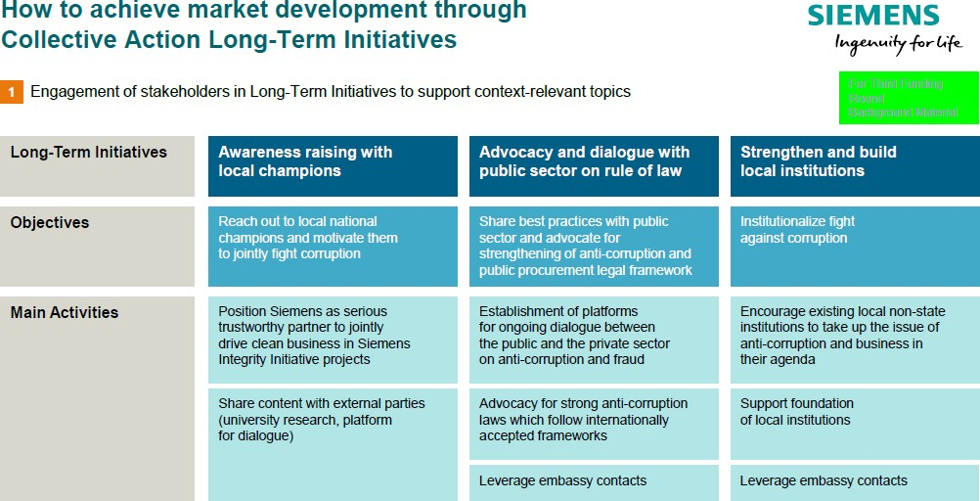

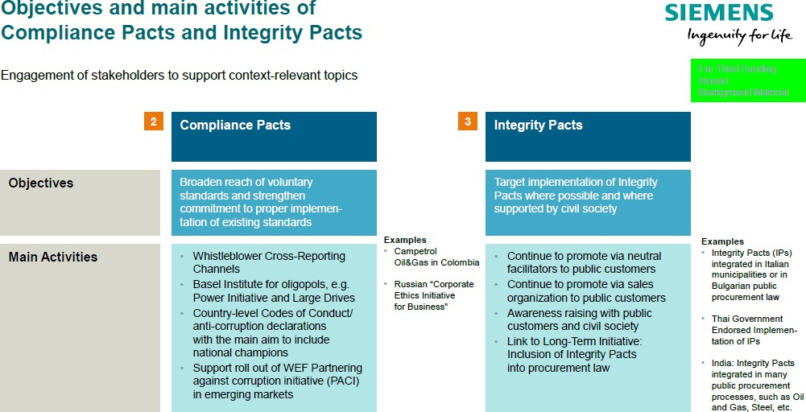

### How to create a level playing field through Collective Action

In the face of the widespread and deep-rooted corruption problem that affects society in general, governments and their procuring entities and the private sector in equal measure, it seems highly unlikely that individual activities alone will be sufficient to bring about significant ethical changes and improve the transparency of business processes.

**This is precisely where Collective Action methods come into their own.**

* 1. **Starting point and background**

Collective Action methods make it possible for us to fight corruption collectively, working together with the various interest groups to build an alliance against corruption and to approach and resolve the problem from multiple angles. The ultimate aim of these joint efforts is to create fair and equal market conditions – a "level playing field"

* for all market players and eliminate the temptations of corruption for all.

Collective Action promotes a fair competitive situation in which a transparent process based exclusively on market economic criteria (such as quality, price, innovation and service) ensures that the contract is awarded to the best bidder. It prevents competition from being distorted and destroyed by corruption and ensures that companies acting honestly and morally are not disadvantaged.

The success of the initiative hinges to a great extent on the trust and commitment of the parties at the highest management level, as well as a general consensus regarding the consequences and sanctions to be applied if the agreed processes and rules are breached. It is important for each participant to demonstrate the credibility of its intentions by implementing its own compliance program to a recognized standard.

The available methods range from Integrity Pacts for individual procurement transactions right through to industry- specific Codes of Conduct and Compliance Pacts, as well as joint measures implemented as part of a long-term initiative to raise a country's public awareness and tighten up its regulatory system and procurement guidelines.

Ideally, such action should involve competitors, authorities, non-governmental organizations (NGOs) and other interest groups working jointly for the common good. It is also crucial to examine the antitrust aspects in each individual case.

Siemens is engaged in a variety of cooperative projects with NGOs (non-governmental organizations) and IOs (international organizations) committed to fighting corruption and establishing and maintaining freedom of competition. We have, for example, been very actively involved in the Collective Action working group of the World Bank Institute. We are also a permanent member of the working group for the tenth principle (anti- corruption) of the UN Global Compact and of the Commission on Anti-Corruption of the International Chamber of Commerce (ICC), as well as a long-standing Sherpa in the G20/20 process since 2011.

Through our cooperation with NGOs and IOs such as the World Bank, we are continuously working to improve our established Compliance Program in dialogue with our partners and assume a leading role in the field of compliance and transparency.

With the clear objective of becoming a respected international partner in the fight against corruption, we are striving to extend this commitment even further in the future.

* 1. “The House of Collective Action”

As described in the previous chapter**,** Collective Action enables corruption to be fought collectively, with various interest groups working together and building an alliance against corruption so that the problem can be approached and resolved from multiple angles.

The advantages of Collective Action:

* + - Collective Action combines various methods of combating corruption. It involves acting collectively and forming alliances against corruption.
    - Collective Action calls for cooperation on the part of participants from the worlds of politics, business and society at large.
    - Its ultimate goal is to create fair and equitable market conditions and thus establish a “level playing field” for **all** marketplace participants, eliminating the temptation of corruption for all those concerned.
    - Collective Action helps to set up the conditions for fair competition within a corrupt environment.
    - Collective Action promotes innovation, as bidders are selected solely on the basis of their price, quality and capacity to innovate.
    - Observance of antitrust law when collaborating with other companies must be ensured by a neutral monitor (for example in the form of a non-governmental organization).
    - Collective Action can, if necessary, cover gaps in legislation or replace or augment inadequate local law.

At Siemens, the Collective Action methods encompass project-specific, sector-wide and long-term initiatives. All activities, global and local, are driven through complementary channels.

This is partly illustrated in the “House of Collective Action” and its individual parts are described below:

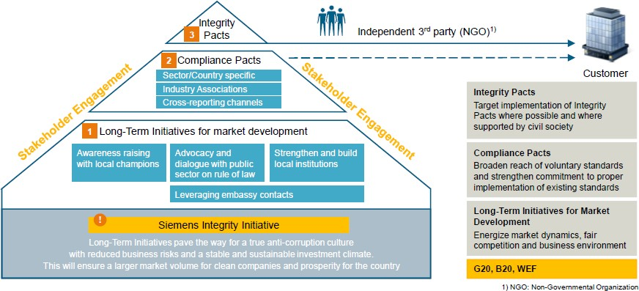

* + 1. Project-specific methods – Integrity Pacts

Integrity Pacts help to ensure that the procedure for awarding orders in public-sector contracts is free from corruption.

These methods were developed by the non-governmental organization “Transparency International”. They are intended to guarantee transparency in the order-awarding process and to rule out bribery in the awarding of public-sector contracts.

Following an invitation to tender from a public-sector customer, the bidding companies sign legally binding contracts, and commit themselves to behaving with integrity from the start of the tender process until the end of the project. If the contract is breached, sanctions are imposed, which can be as severe as the exclusion of the company from further invitations to tender.

An independent monitor supervises the contract-awarding process and observance of the Integrity Pact.

Integrity Pacts help to ensure that bidders are selected on the basis of fair criteria and serve all the stakeholders as a means of protecting the integrity of the project.

Please refer to Integrity Pact Templates at the [Collective Action Download Center.](https://intranet.for.siemens.com/cms/059/de/processes/publications/Pages/compliance_collective-action-download-center.aspx) (Under category Collective Action Legal Center of Competence)

**For support with the templates, please contact Christina Wolfgramm or Ulrike Desimoni (LC CO RFC LF).**

* + 1. Sector-wide codes of conduct / Compliance Pacts

Companies from the same sector get together and draw up a code of ethics or code of conduct.

These can take various forms, ranging from principles-based provisions to legally binding agreements. In the latter case, companies that violate the anticorruption code are penalized with sanctions.

However the principles-based codes also have a high degree of effectiveness, as especially the public commitment to anticorruption and transparency exerts increased pressure on the participating companies not to breach the agreement. This type of Collective Action is particularly suitable in oligopolistic markets.

The uncompromising support of senior management within the companies concerned is critical to the success of the initiative. In order to avoid breaches of antitrust law, it is vital to enlist the services of an external, independent monitor.

Please refer to Integrity Pact Templates here in our [Collective Action Download Center.](https://intranet.for.siemens.com/cms/059/de/processes/publications/Pages/compliance_collective-action-download-center.aspx) (Under category Collective Action Legal Center of Competence)

**For support with the templates, please contact Christina Wolfgramm or Ulrike Desimoni (LC CO RFC LF).**

**Please also refer to the** [**Collective Action Antitrust Guidance.**](https://lkb.siemens.com/content/00000008/LegalKnowledgeBase/y5t2v021dbqp/LKB000764.pdf) **For more information, please contact the** [**Legal and Compliance Competition Team.**](https://intranet.for.siemens.com/cms/059/en/about/org/Pages/legal_cmp.aspx)

* + 1. Long-Term Initiatives for market development

Long-Term Initiatives are particularly effective in states rated as being prone to corruption, as they are essential to pave the way to the establishment of a true anti-corruption culture. Collaboration between government,

commercial companies and society in the fight against corruption helps to raise awareness among politicians and the general public.

The acknowledgment that bribery and corrupt behavior damage the entire economy of a state brings long-term benefits for all stakeholders. Long-Term Initiatives set out the fundamental conditions that will enable project- specific Integrity Pacts and industry-specific Compliance Pacts to come to fruition and achieve general acceptance.

Their success contributes to a world free from corruption and helps to direct the investment of many millions of euros and other resources toward their intended destination. In addition, and as an important element of our Long Term Initiatives, Siemens is deeply engaged in the B20 Task Forces on Improving Transparency and Anti- Corruption. Since 2011 we have been able to present our positions in the global consultation process at the G20/B20 summits in France, Mexico, Russia, Australia, Turkey, China, Germany, Argentina, Japan, and currently in Saudi Arabia.

As described in the background, our many engagements in e.g. the New York-based United Nations Global Compact (10th Principle), our work with the Commission on Corporate Responsibility and Anti-corruption of the International Chamber of Commerce in Paris, our representation of Siemens in the World Economic Forum’s Pact Against Corruption Initiative (PACI) in Switzerland, and other C-Level support contribute to our Long-Term Initiatives.

* + 1. Collective Action Stakeholder Mapping

In April 2011, we started Phase II of the “Collective Action Country Strategy & Stakeholder Mapping Process” and have implemented an ongoing process since then.

Please find our latest Stakeholder Mapping Analysis, dated April 2018 [here.](https://findit.compliance.siemens.com/content/10000101/Compliance/LC_CO/LC_CO_CA/findIT_LC_CO_CA_7418.pdf)

Collective Action Stakeholder Mapping

* + - * ensures a thorough analysis of the specific country situation and permits a structured approach to potential anticorruption stakeholders in the individual country
      * helps the responsible Compliance Officer to identify suitable Collective Action partners in the Siemens countries
      * supports the establishment of strong relations with our Collective Action stakeholders
      * fosters a climate of confidence, which in turn facilitates dialog
      * enables stakeholders to share their expertise and engage collectively in anticorruption
      * will help to enable a better understanding of specific stakeholder expectations and the concerns of various players and helps to develop a strong anticorruption community and network in all Siemens countries.

Knowing your stakeholders is:

* + - * the prerequisite for selecting partners for Collective Action against corruption
      * the successful implementation of Long-Term Initiatives and partnerships, the latter of which provide the basis for facilitating Integrity Pacts and Compliance Pacts in your country by strengthening the anti-corruption mindset
      * active stakeholder engagement in the longer term (even if you do not engage in successful cooperation with a certain stakeholder now, it is worthwhile to stay in contact and to look for opportunities for Collective Action in the future)
      * the development of future Collective Action opportunities and the positioning of Siemens as an anticorruption leader

### Guidance on Antitrust in Collective Action

Over recent years, Siemens has successfully introduced and implemented a comprehensive global Collective Action Program to jointly fight corruption and promote integrity in business transactions. The ultimate goal is to establish fair and sustainable market conditions in collaboration with other companies, governments and non- governmental organizations for the benefit of all market participants. Therefore, Collective Action promotes a level playing field in which a transparent process based exclusively on the attractiveness of companies’ product or service offerings (such as quality, price, innovation and customer service) ensures that the contract is awarded to the best bidder. Collective Action prevents competition from being distorted and destroyed by corruption and ensures that companies acting honestly and morally are not disadvantaged.

As Siemens’ Collective Action activities include collaboration with other (possibly competing) companies, care must be taken to avoid any conflict of such contacts or discussions with antitrust rules.

Within the framework of the Collective Action Program, discussions with other companies on the coordination of anti-corruption initiatives in compliance **with the limits set by LC M&A CMP** below are entirely legitimate.

Accordingly, care must be taken to ensure that when discussing such issues, competitors do not use the opportunity to enter into anticompetitive agreements or give each other insight into confidential information that ought not to be shared.

* 1. Key Principle

The key principle is that all Siemens employees who have contact with other (possibly competing) companies in the context of Collective Action activities must bear in mind that antitrust law requires every company to compete autonomously, on its own merits. This is the case regardless of how laudable the purpose of the cooperation is. In other words, the fact that companies work together to root out corruption and other illicit business practices does not mean that antitrust law is applied any less strictly to such cooperation.

* 1. Prohibition of agreeing, implementing or enforcing anticompetitive agreements

Contacts or discussions between companies in the context of Collective Action activities must not be used to agree, implement or enforce any kind of anti-competitive agreement, e.g. related to price fixing, market sharing, bid rigging or collusive tendering, agreements on production / capacities / investments, supplier / customer boycotts.

In addition, Collective Action activities must not be used by competitors to jointly agree on terms of trade to be used with customers. For example, it would not be permissible for competitors to agree that they will no longer agree to unlimited liability clauses in their contracts with customers. Similarly, it may raise antitrust issues to agree not to purchase products or services in specified countries (e.g. due to high corruption risks or low human rights standards) or to agree on certain payment terms with the aim of avoiding terms that would enable the concealment of kickback payments (e.g. cash payments, payment by cheque).

Care must also be taken not to agree on minimum standards in relation to certain areas where, in the absence of mandatory regulation, companies would be competing against each other. For example, it is legitimate for companies to agree to all comply with a particular country’s minimum wage legislation. However, it may be problematic to agree on minimum wage standards that exceed mandatory standards.

* 1. Prohibition of exchanging competitively relevant information

In addition, competitively relevant information that can enable competitors to coordinate their conduct on the market must not be exchanged, e.g.:

* + - prices, price components, rebates and other factors influencing price, production, marketing and other costs;
    - supply/customer relationships (names of suppliers/customers);
    - market strategy, product launches, R&D projects;
    - investments, withdrawal from business areas or
    - other competitively relevant business and trade secrets.
  1. Conduct at meetings

When organizing Collective Action activities and meeting representatives of other (possibly competing) companies at Collective Action gatherings, please bear in mind the following key points:

* + - It is preferable that Collective Action meetings in which competitors are involved are organized by, and carried out under the auspices of, neutral facilitators such as NGOs or international organizations;
    - All interested parties should be able to participate freely in the Collective Action activities, both in the deliberations about new Collective Action measures, as well as in the measures finally agreed;
    - Any decision to implement a particular measure should be made in an open and transparent process;
    - There should be an agenda for any Collective Action meeting, and the discussions should not stray from the agenda without good reason;
    - No competitively relevant information should be discussed;
    - If problematic issues are discussed, leave the meeting immediately and contact Legal and Compliance;
    - You should be particularly careful during the social side of such meetings (meals, hotel bar, etc.).
  1. Direct contact with competitors

In the context of Collective Action, there may be occasions when Siemens employees contact employees working for competitors or vice-versa. For example, there may be occasions when employees of competing companies discuss whether a particular tender should be supported by an integrity pact. Alternatively, a company may initiate discussions about entering into a compliance pact for a particular business area or transaction.

In the context of Collective Action, direct contact with competitors is generally acceptable as long as the discussions relate purely to the putting in place of appropriate Collective Action arrangements, and do not lead to either anticompetitive agreements or illegal information exchange.

However, the basic rule remains that Siemens employees must not speak to competitors unless they have a compelling business reason to do so and that they can be sure that no antitrust issues arise. As the dividing line between appropriate and inappropriate actions is particularly fine when direct contacts between Siemens and its competitors occur, Siemens employees are encouraged to contact the experts at LC M&A CMP if they have any questions about antitrust rules as they relate to Collective Action.

Further information can be found on our Legal Competition (LC M&A CMP) website:

<https://intranet.for.siemens.com/cms/059/en/about/org/Pages/legal_cmp.aspx>and <https://lkb.siemens.com/content/00000008/LegalKnowledgeBase/y5t2v021dbqp/LKB000764.pdf>

### Siemens Integrity Initiative

Since 2009, LC CO RFC CA has conceptualized and headed the Siemens Integrity Initiative, which is based on Siemens’ agreements with the World Bank dated July 2, 2009 and the European Investment Bank, dated March 15, 2013.

With total funding of more than US$ 100 million, the initiative supports organizations and projects that fight corruption and fraud through Collective Action, education and training.

The initial First Funding Round, which disbursed a sum of around US$ 40 million, was launched in December 2009, with projects being announced beginning in December 2010. Under the Second Funding Round, which started in 2013, selected projects are to receive approximately US$ 35,554 million of funding over a period of three to five years.

The Third Funding Round was launched on March 13, 2018 (see [Press Release](https://www.siemens.com/content/dam/internet/siemens-com/global/company/sustainability/compliance/collective-action/pdf/pr2018030198coen-siemens-integrity-initiative.pdf)) and offered a funding volume of up to US$ 30 million for up to 25 projects.

In order to achieve an overall geographically balanced portfolio of projects in the Third Funding Round, preference was given to projects with activities in the following countries:

Adriatic Region, Angola, Argentina, Brazil, China, Colombia, Egypt, India, Indonesia, Iran, Iraq, Ivory Coast, Kenya, Korea, Libya, Morocco, Mozambique, Myanmar, Nigeria, Pakistan, Russia, Saudi Arabia, Spain, South Africa, Syria, Tunisia, Turkey, United Arab Emirates, Ukraine.

Following the announcement of the application modalities, we received applications for the Third Funding Round from some 140 organizations from more than 50 countries with a requested funding volume of more than USD 280 million.

From this large number, we have committed funding to 22 projects for a total of USD 25.2 million for the most innovative and promising project proposals. The projects meet our eligibility and selection criteria as described in our "Green Booklet".

Under the leadership of LC CO RFC CA, a global interdisciplinary team (Compliance, Legal, Tax, Finance, Regional Compliance Officers) has conducted a thorough due diligence of the applications before the final selection. The selection of projects takes into account both the range of topics and the regional distribution of funding.

As part of the Siemens-World Bank settlement agreement, the World Bank has audit rights over the use of funds (US$ 100 million over a period of 15 years beginning in 2009) and veto rights over the selection of projects by

Siemens. The agreement between Siemens and the European Investment Bank (€ 13.64 million over five years) gives the EIB the right to reject the projects proposed.

As of March 2020, we have supported 77 projects with a committed funding of USD 98.5 million. Overall, our projects are making good progress, and we report on them publicly every year (see, for example, the [Siemens](http://www.siemens.com/integrity-initiative/Report2019) [Integrity Initiative Annual Report 2019](http://www.siemens.com/integrity-initiative/Report2019)).

The projects backed in the first rounds of funding have made a tangible difference locally, in regions and sectors, and we are particularly pleased to see more and more committed and well-connected supporters rallying to the Collective Action banner and joining our common effort to fight corruption.

At the request of the World Bank, all 55 projects of the first two funding rounds have in 2017 undergone an

external evaluation by the Universalia Management Group, who conclude that “the overall findings of the Mid-term Review are positive”. Please refer to our [**Siemens Integrity Initiative Annual Report 2017**,](http://www.siemens.com/integrity-initiative/Report2017) which includes the summary of the Mid-term Review.

Main observations of the Mid-term Review are:

* The Siemens Integrity Initiative has **positively pushed ahead the agendas** on Collective Action
* Since its establishment in 2009, the Integrity Initiative **has gained the respect of many anti-corruption actors** around the world.
* It has **highlighted the role of the private sector** in fighting corruption and fraud and **demonstrates the business case** for investing in Collective Action.
* It has contributed to **strengthening the organizational capacities** of several Integrity Partners.
* It has made some contributions to **fostering the generation and exchange of knowledge** among anti-corruption actors.
* Siemens’ **management approach** made effective use of the company’s global presence and ensured

**high levels of accountability**, which allowed the Integrity Initiative to trace every dollar spent.

### Training and supporting material

All material about Collective Action and the Siemens Integrity Initiative can be found here:

* + Siemens Collective Action Internet page: [www.siemens.com/collective-action](http://www.siemens.com/collective-action)
  + Siemens Integrity Initiative Internet page: [www.siemens.com/integrity-initiative](http://www.siemens.com/integrity-initiative)
  + [Collective Action Intranet Page](https://intranet.for.siemens.com/cms/059/en/processes/publications/Pages/compliance_collective-action.aspx)
  + [Collective Action Internal Download Center,](https://intranet.for.siemens.com/cms/059/en/processes/publications/Pages/compliance_collective-action-download-center.aspx) which also provides templates in the “Legal Center of Competence”.

### History of changes

|  |  |  |
| --- | --- | --- |
| **Date** | **Author** | **Major changes of binding content** |
| January 1, 2019 | Sabine Zindera (LC CO GR CAS) | First release through the Compliance Handbook. |
| August 19, 2019 | Sabine Zindera | Second release in light of organizational changes from Oct 1, 2019 (then: LC CO RFC LF) |
| April 1,  2020 | Sabine Zindera LC CO RFC CA | Third release, which essentially describes the new facts regarding the Third Funding Round of the Siemens Integrity Initiative |
| October 1, 2020 | Sabine Zindera LC CO RFC CA | Fourth release, which includes minor refinements |

1. Contact

▌ Compliance Officer

The Compliance Officer responsible for your unit can be found through the following [link.](https://intranet.for.siemens.com/cms/059/en/about/org/Pages/compliance_organization.aspx)

▌ Corporate Governance Owner

Sabine Zindera (LC CO RFC CA)

1. Introduction to Business Processes and Projects

Siemens business is often closely connected to processes which support procurement, sale of products or to projects which handle the major undertakings.

Both business types show characteristic challenges and risk areas. Siemens manages these factors via the creation of a respective awareness and, if adequate, further trainings and support tools.

This chapter takes the perspective of the business and intends to provide access to the different risks and activity fields (chapters A. – G.) by explaining them in the context of Compliance in Business Processes.

The different fields considered are:

* + Compliance in project business (H.1.)
  + Compliance in procurement (H.2.)
  + Requirements of third parties (e.g. in tenders) (H.3.)
  + High Risk Payments (H.4.)
  + [Compliance@Production Facilities](https://webbooks.siemens.com/public/LC/chen/index.htm?n=Part-2-Business-Perspective%2CH.-Compliance-in-Business-Processes-and-Projects%2C5.-Compliance%40Production-Facilities) (H.5.)
  + [Compliance in Minorities](https://webbooks.siemens.com/public/LC/chen/index.htm?n=Part-2-Business-Perspective%2CH.-Compliance-in-Business-Processes-and-Projects%2C6.-Compliance-in-Minorities%2C6.2.-Training---supporting-documents) (H.6.)
  + [Compliance in Permanent Establishments](https://webbooks.siemens.com/public/LC/chen/index.htm?n=Part-2-Business-Perspective%2CH.-Compliance-in-Business-Processes-and-Projects%2C7.-Compliance-in-Permanent-Establishments) (H.7.)

As a kind of summary you will find an Overview of all relevant Compliance Due Diligences and Approvals in Chapter H.8.

# Compliance in Project Business

The [Project Business Excellence with the PM@Siemens methodology](https://intranet.for.siemens.com/wll/0103/en/Pages/pbe-pm-guide.aspx) is the company-wide standard for project management developed in coordination with the Organizational Units. It defines the tasks, responsibilities and fundamental processes in project management and for project business.

It addresses all important areas of Siemens’ project management and describes the expectations for excellent project business across the entire life cycle, including the mandatory minimum requirements that must be met during acquisition and execution.

The [Limits of Authority (LoA)](https://intranet.for.siemens.com/wll/0103/en/Pages/pbe-loa.aspx) process is part of the PM@Siemens methodology. It defines when and at what level management decisions are required. It improves the quality of decision-making in the bidding phase (bid/no-bid) for each individual project.

Compliance in Project (CiP) mainly addresses Limits of Authority (LoA) project types [Solution Business (LoA); Service Business (LoA)] with Compliance specific risks especially regarding [Anti-Corruption,](https://webbooks.siemens.com/public/LC/chen/index.htm?n=Part-1-Activity-Fields%2CA.-Anti-Corruption) [Anti-Money](https://webbooks.siemens.com/public/LC/chen/index.htm?n=Part-1-Activity-Fields%2CC.-Anti-Money-Laundering-(AML)) [Laundering](https://webbooks.siemens.com/public/LC/chen/index.htm?n=Part-1-Activity-Fields%2CC.-Anti-Money-Laundering-(AML)) and [Human Rights](https://webbooks.siemens.com/public/LC/chen/index.htm?n=Part-1-Activity-Fields%2CE.-Human-Rights)

The Compliance in Projects (CiP) handbook chapter aims to ensure appropriate identification of risks during the pre-sales, sales and execution phase and adequate mitigation of these risks.

**General principles:**

▌ **Projects** must comply with the Siemens-internal regulations as well as the applicable local laws during the:

▌ **Pre-sales phase**

* For an early identification and mitigation of Compliance risks in the pre-sales phase, it is recommended to establish a regular dialogue between sales personnel and the Compliance Officer (CO) where potential Compliance risks are assessed and mitigated as early in the process as possible (pre-sales risk assessment)

▌ **Sales phase**

* A LoA Compliance Risk Evaluation (LoA CRE) is the core element of Compliance in the sales phase. A LoA CRE is part of the [PM@Siemens LoA Tool](https://loa.cf.siemens.de/loa/faces/jsf/home.xhtml) which supports the identification of Compliance risks.

▌ **Execution phase**

* The identification of Compliance risks and mitigation during the project execution phase lies within the overall responsibility of the Project Manager of the execution phase (PM execution)

with support from the responsible Compliance Officer.

▌ The **Siemens Project Manager1** is overall responsible ensuring appropriate identification and mitigation of Compliance risks throughout the entire project lifecycle.

▌ The responsible **Compliance Officer** will support the Project Manager whenever needed**2.** He has to be involved according to [PM Guide](https://intranet.for.siemens.com/wll/0103/en/Pages/pbe-pm-guide.aspx)**3**

▌ Any Compliance concern arising throughout the project lifecycle must be communicated immediately to the responsible sales or project manager4 and the Compliance Officer (CO)5.

▌ Export control related risks are covered by the existing export control processes.

1. Bid manager, authorized project manager (sales phase) and execution project manager. 2 According to [circular No. 182 “Limits of Authority (LoA) Process and Project Approvals”](https://circulars.siemens.com/content/circulars/ca/_layouts/querplex/circularapplication/documents/CircularDownload.aspx?ID=SC_182.pdf&page=4) 3 In line with the latest version
2. The Authorized Project Manager should inform the responsible Business Manager if applicable.
3. The Compliance Officer should be the Compliance Officer for the respective Business (e.g. unit), for example the ACO (Authorized Compliance Officer as defined in the PM@Siemens LoA Tool), the mandated Compliance Officer (e.g. operational Compliance Officer) or the Country Compliance Officer or a nominated representative.

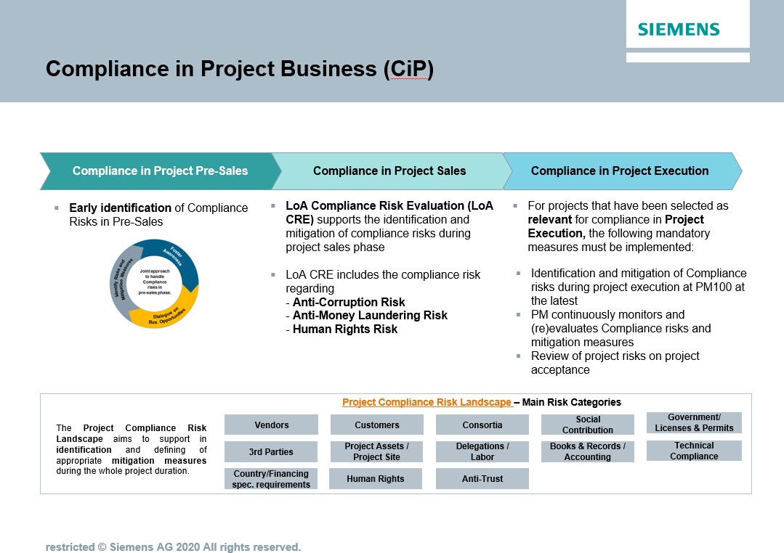

### Compliance in pre-sales

Already while developing a business opportunity (pre-sales), it is possible that un-identified or un-mitigated Compliance risks may lead to violations of applicable law.

Potential violations may also occur prior to entering the Limits of Authority (LoA) process.

**General principles:**

▌ For an early identification and mitigation of Compliance risks in the pre-sales phase, it is recommended to establish a **regular dialogue** between sales personnel and the CO where potential Compliance risks are assessed and mitigated as early in the process as possible **(pre-sales risk assessment)**

▌ This concept can be adapted in a risk-oriented manner by the Businesses/Countries.

▌ It is very important that a risk which may occur in pre-sales is identified, and appropriately mitigated.

▌ Further guidance on risk identification in the pre-sales phase is available [here.](https://intranet.for.siemens.com/cms/059/en/processes/publications/Pages/compliance_project-management.aspx)

A **pre-sales risk assessment** for business opportunities with an expected bid-volume exceeding €2,500,000 should focus on the following (examples but not limited to), if these risk areas exist

* + - Legally binding commitments without a step-out clause
    - Involvement of 3rd parties to influence a project
    - Projects that raise the potential for a competition or antitrust risk situation (e.g. consortium with a competitor or a parallel bid by Siemens)
    - Risks associated to consortiums
    - Projects with [AML Red Flags (chapter C 1)](https://webbooks.siemens.com/public/LC/chen/index.htm?n=Part-1-Activity-Fields%2CC.-Anti-Money-Laundering-(AML)%2C1.-AML-Red-Flags)
    - Risks related to human rights violations
    - Financing projects
    - Projects with partners located in countries with increased export control risks
    - Cost sharing with partners
    - Highly complex business cases

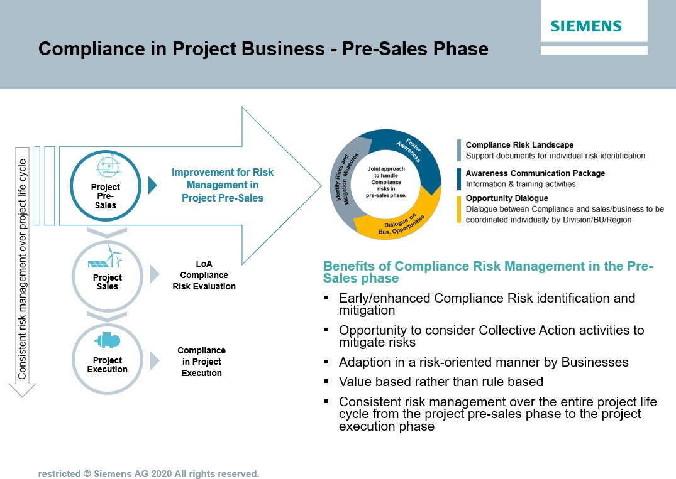

### Compliance in project sales

Many Compliance risks occur during the sales phase. Also, Compliance matters that occur during project execution often originate from the sales phase.

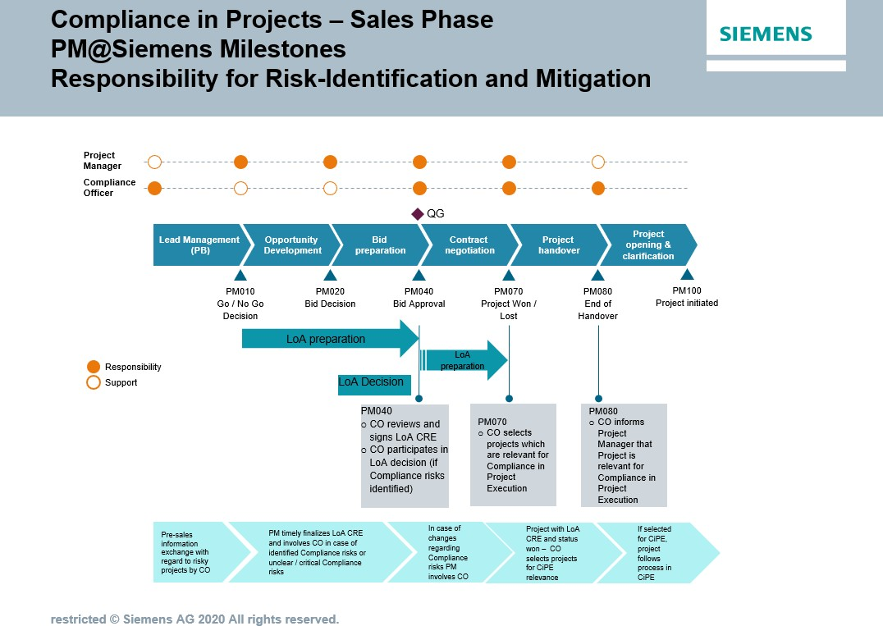

**General principles:**

▌ A LoA Compliance Risk Evaluation (LoA CRE) is the core element of Compliance in the sales phase. The LoA CRE is part of the PM@Siemens [LoA Tool](https://loa.cf.siemens.de/loa) which supports the identification of Compliance risks.

▌ Further guidance on risk identification is available in the [Project Compliance risk landscape**.**](https://findit.compliance.siemens.com/content/10000102/Compliance/LC_CO/LC_CO_PT_CO_CiP/findIT_LC_CO_PT_CO_CiP_2654.pdf)

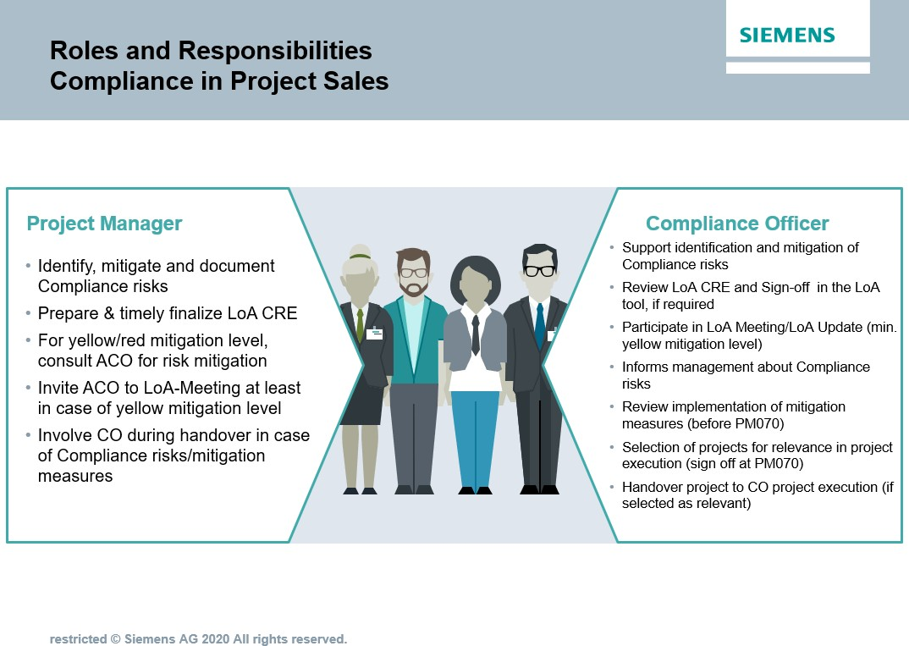

* + 1. Projects in scope for LoA CRE

A risk-based LoA CRE is required for all projects (and sub-projects) that are subject to the LoA (Limits of Authority) process with a total order volume (planned revenue) of more than € 2,500,000 and that fulfill **at least one of the following criteria**:

* + - * Project category A/B or
      * Business Partner involvement (according to [Compliance Handbook, A 3 Cooperation with Business](https://webbooks.siemens.com/public/LC/chen/index.htm?n=Part-1-Activity-Fields%2CA.-Anti-Corruption%2C3.-Cooperation-with-Business-Partners) [Partners](https://webbooks.siemens.com/public/LC/chen/index.htm?n=Part-1-Activity-Fields%2CA.-Anti-Corruption%2C3.-Cooperation-with-Business-Partners)) or
      * Customer / execution country is a [TI/CPI high risk country](https://findit.compliance.siemens.com/content/10000101/Compliance/LC_CO/LC_CO_STR_RM/findIT_LC_CO_STR_RM_8266.pdf)6 which is different from the country of the Siemens entity7 (ARE country) or
      * Projects backed by a "national export credit guarantee" or financed wholly or partly by multilateral development banks or multilateral financial institutions8 or

6 Anti-Corruption High-risk countries are stored in the PM@Siemens LoA Tool. Transparency International publishes the Corruption Perception Index (TI/CPI). Based on these ratings (average over the past two years) and a risk evaluation by LC CO, the Compliance Country Ratings (low/medium/high) have been prepared.

7 Siemens entity that signs the contract with the customer. In the PM@Siemens LoA Tool this is indicated as the “ARE country” (ARE = Abrechnungseinheit).

8 Only the institutions listed in the PM@Siemens LoA Process Tool (Section Key Data) need to be considered.

* + - * Nominated major vendor involved9 or
      * Project execution country is a

1. [Human Rights extreme risk country](https://findit.compliance.siemens.com/content/10000101/Compliance/LC_CO/LC_CO_STR/findIT_LC_CO_STR_6394.xlsx) and the project category is A/B/C; or
2. [Human Rights high risk country](https://findit.compliance.siemens.com/content/10000101/Compliance/LC_CO/LC_CO_STR/findIT_LC_CO_STR_6394.xlsx) and at least one of the following criteria is fulfilled:
   * + - * Project category A/B or
         * the project category is C and as consortium partner or major vendor is involved or
3. [Human Rights extreme or high risk country](https://findit.compliance.siemens.com/content/10000101/Compliance/LC_CO/LC_CO_STR/findIT_LC_CO_STR_6394.xlsx) and the project involves an Export credit guarantee, Multilateral Development Bank or Multilateral Financial Institutions involved.

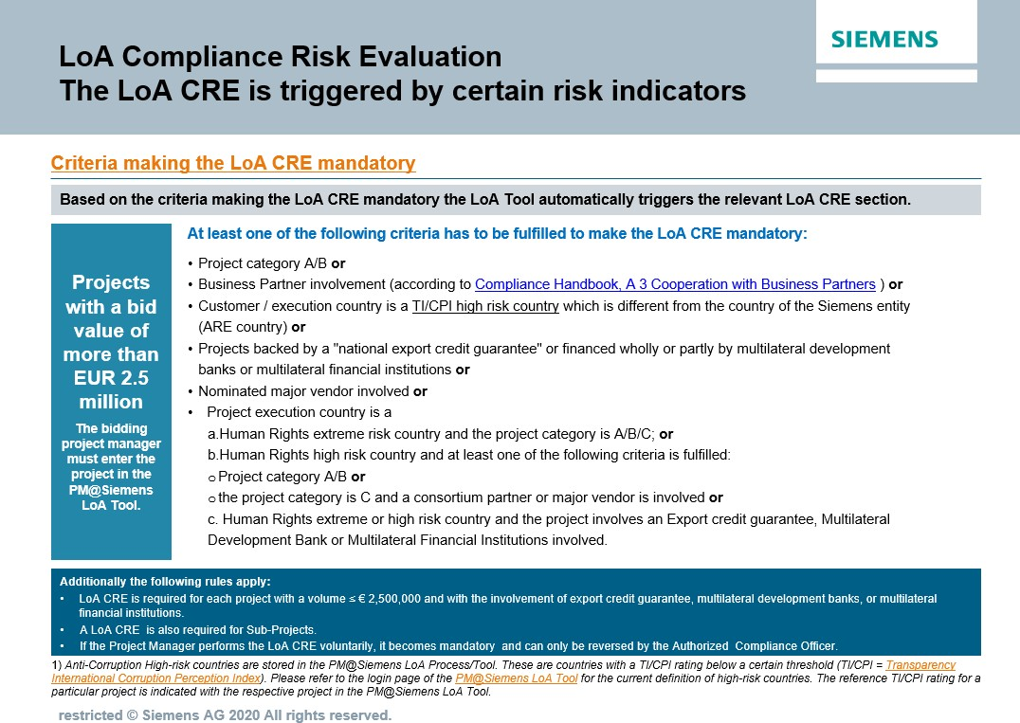Furthermore this applies also for every project with a volume ≤ € 2,500,000 with the involvement of export credit guarantee, multilateral development banks, or multilateral financial institutions.

* + 1. Identification & mitigation of Compliance risks

9 A Nominated major vendor is any external company/firm that supplies goods, carries out work, performs services or supports Siemens in any other way (including all kind of subcontractors, sub suppliers and suppliers/manufacturers etc.) which is mandatorily required by the customer or any third party without choice or technically understandable reason for single sourcing in regard to a certain LoA, if the Businesses specific threshold for share of volume and value of order apply.

The LoA CRE’s purpose is to identify and document Compliance relevant risks and to define corresponding mitigation measures during the Siemens sales process up to PM040/PM070. Compliance risks are determined during the LoA CRE, approved and signed by the CO at PM040/PM070 and are included in the LoA risk report and Compliance risk summary for the LoA decision.

The authorized project manager (sales phase) with support from the CO is responsible for the identification and mitigation of applicable Compliance risks. A LoA CRE is mandatory for all projects meeting the criteria in chapter [H 1.2.1.](https://webbooks.siemens.com/public/LC/chen/index.htm?n=Part-2-Business-Perspective%2CH.-Compliance-in-Business-Processes-and-Projects%2C1.-Compliance-in-Project-Business%2C1.2.-Compliance-in-project-sales%2C1.2.1.-Projects-in-scope-for-LoA-CRE) of this document and with final review performed by the Authorized Compliance Officer (ACO) before the final LoA decision.

The “Compliance Summary10” provides a comprehensive overview on Compliance relevant information and will be archived in the PM@Siemens.

* + 1. LoA CRE preparation by APM

Depending on the data provided in the “key data” section of the LoA, additional information may be required from the authorized project manager (APM). This documentation/evidence (e.g. results of internet searches, company information with regard to third parties, vendors, consortium partners, confirmations received by legal, contract management, and/or project commercial) must be included with the project documentation and made available to the CO. A Compliance risk class is automatically defined.

The CO must have access to any Compliance related information in any project within his area of responsibility and participates in the decision process as defined in [circular No. 182 “Limits of Authority (LoA) Process and](https://circulars.siemens.com/content/circulars/ca/_layouts/querplex/circularapplication/documents/CircularDownload.aspx?ID=SC_182.pdf&page=4) [Project Approvals”.](https://circulars.siemens.com/content/circulars/ca/_layouts/querplex/circularapplication/documents/CircularDownload.aspx?ID=SC_182.pdf&page=4)

* + 1. LoA CRE – review and sign-off by ACO

The APM initiates the LoA sign-off workflow, which triggers an automated email to notify the ACO. The ACO then reviews and clarifies the provided information and involves the CO of the respective escalation level11 (e.g. in cross border projects) to ensure comprehensive coverage of all Compliance risks.

Mitigation measures12 are documented by the APM and ACO in the LoA CRE and are part of the LoA risk report. This includes identifying risks, mitigation steps; persons assigned the implementation measures and timelines/due dates. During the sign-off the ACO may comment on Compliance relevant topics and add potential conditions for approval and measures to mitigate Compliance risks.

Ideally, the agreed upon mitigation efforts should be implanted no later than the PM070 stage by the APM. Nevertheless, any measures and action items not completed shall be handed over and be dealt with during project execution phase.

Note: If any identified risk has a status of RED before the LoA decision, PM040 bid approval will not be possible

10 Compliance Risk Summary provides an overview of project relevant information, compliance relevant risks and defined mitigation measures.

1. Escalation level according to [circular No. 182 “Limits of Authority (LoA) Process and Project Approvals”](https://circulars.siemens.com/content/circulars/ca/_layouts/querplex/circularapplication/documents/CircularDownload.aspx?ID=SC_182.pdf&page=4)
2. The mitigation measures could also include appropriate Collective Action activities such as Compliance and Integrity Pacts in Consortia.
   * 1. LoA decision / LoA update

If any identified risks have a status of YELLOW before the LoA decision, the ACO must participate in the LoA decision.

Management is informed about Compliance risks and proposed mitigation measures before LoA decision. An adequate level of Compliance risk clarification and mitigation has to be achieved by the involved parties. This ensures a sound basis for management decision.

The LoA Update is performed according to [circular No. 182 “Limits of Authority (LoA) Process and Project](https://circulars.siemens.com/content/circulars/ca/_layouts/querplex/circularapplication/documents/CircularDownload.aspx?ID=SC_182.pdf&page=4) [Approvals”](https://circulars.siemens.com/content/circulars/ca/_layouts/querplex/circularapplication/documents/CircularDownload.aspx?ID=SC_182.pdf&page=4) and the CO participates if required.

* + 1. Handover to project execution

If more than one Compliance Officer is involved in the project (e.g. for cross border projects) they should discuss the comprehensive risks identified for the project and align on further cooperation during the project execution phase starting with PM080.

### Compliance in project execution

**General principles:**

▌ Compliance in the project execution phase (CiPE) applies to all projects selected by the Authorized Compliance Officer (ACO) as relevant to the project execution phase. The relevance selection by the ACO must be documented in the LoA tool during the sign-off process at the milestone PM070 for all projects with LoA CRE and won status.

▌ If the ACO decides that a project is relevant for CiPE, then the resulting steps and activities are mandatory for the PM responsible during execution phase.

▌ The CiPE process starts with PM100.

▌ Irrespective whether a project is subject to the CiPE process or not, the identification of Compliance risks and mitigation during the project execution phase lies within the overall responsibility of the PM execution with support from the responsible CO.

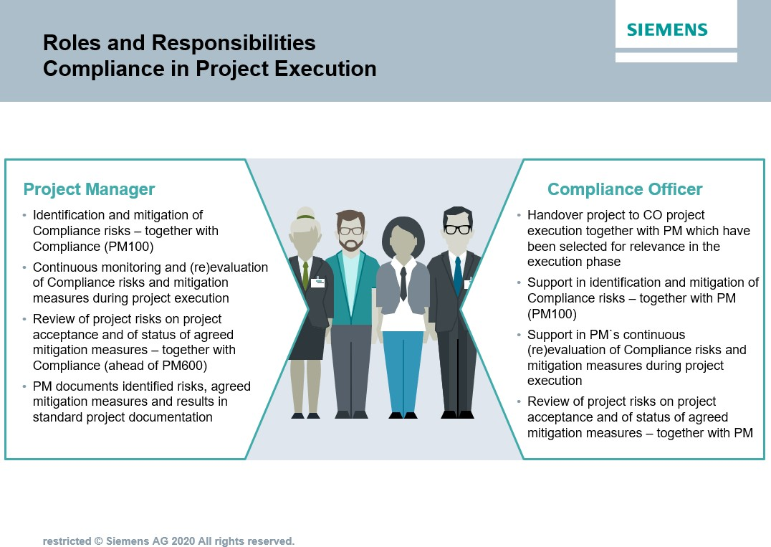

* + 1. Selection of projects for CiPE

For any Siemens project with LoA CRE and status won the ACO decides about the CiPE relevance of the project as a mandatory risk mitigation measure.

The selection of CiPE relevant projects is a mandatory process step at the sign off process at milestone PM070 in the PM@Siemens LoA tool.

If the ACO decides that a project is relevant for CiPE, then the resulting steps and activities are mandatory for the PM responsible during execution phase.

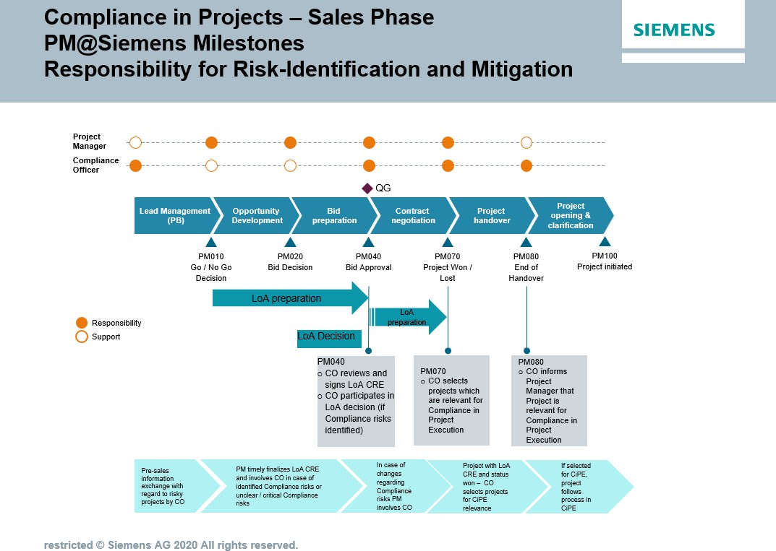

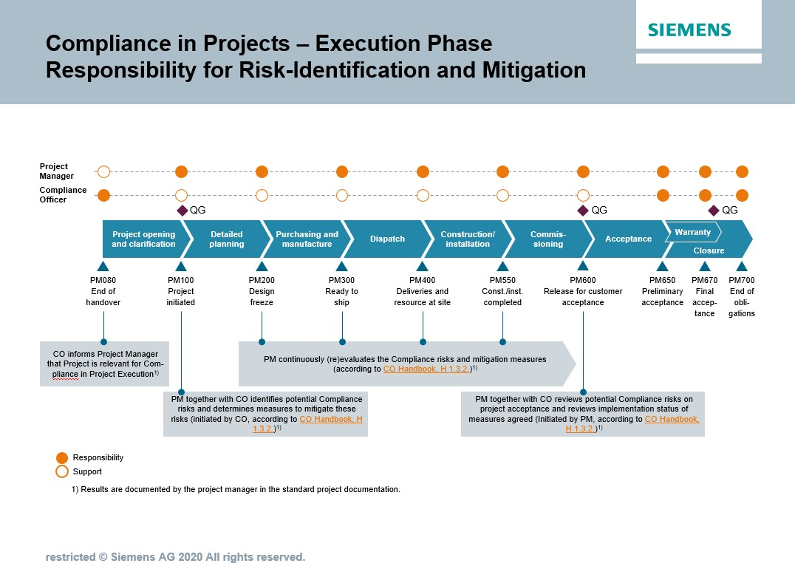

The PM should involve the ACO at any time during the project’s execution phase for matters related to risk analysis and mitigation. During the project execution phase a project can be selected at any time as relevant for Compliance in project execution. It is in the discretion of the Compliance Officer to decide whether a project is relevant for the execution phase or not.

If the selection is made after PM100, the meeting specified in H 1.3.2.1.must be held without delay. The meeting minutes should include the result of the review and must be included in the standard project documentation by the PM.

Potential reasons which could lead to select a project as relevant for CiPE (after PM080) as a mandatory mitigation measure during the project execution phase can be for example:

* Compliance concerns made by the PM/CEO/CFO/Responsible Business Manager during project execution
* Business Partner13 shows increased risks (high-risk BP, BP "under observation", etc.)
* Customer demands the involvement of a specific subcontractor or intermediary without plausible justification
* Risks or concerns raised as a result of an internal or external audit

1. according to [Compliance Handbook A 3](https://webbooks.siemens.com/public/LC/chen/index.htm?n=Part-1-Activity-Fields%2CA.-Anti-Corruption%2C3.-Cooperation-with-Business-Partners%2C3.2.-Business-Partner-Categorization)
   * Compliance investigation mandate related to the project
   * AML Red Flags ([chapter C 1](https://webbooks.siemens.com/public/LC/chen/index.htm?n=Part-1-Activity-Fields%2CC.-Anti-Money-Laundering-(AML)%2C1.-AML-Red-Flags)) arises
     1. Measures for the identification and mitigation of Compliance risks

For projects selected as relevant for Compliance in project execution according to this handbook chapter, the following measures are mandatory.

* + - 1. Measures and process at the start of the project execution phase (PM100)

Compliance risks and agreed upon measures for mitigation are documented in the project documentation according to PM@Siemens.

Compliance Meeting

The responsible CO initiates a meeting14 with the PM at the start of the project execution. (If the project is designated after PM100, this meeting must be held without delay).

The Compliance meeting should occur as follows:

14 The meeting can also take the form of a Live Meeting, telephone conference or similar virtual conferencing.

* + - * + Compliance relevant risks during the project execution phase should be identified and if applicable, it should be started to define measures to mitigate these risks. (These measures may include collective action activities such as Compliance and integrity pacts in consortia or special purpose vehicles).
        + The [Project Compliance Risk Landscape](https://findit.compliance.siemens.com/content/10000102/Compliance/LC_CO/LC_CO_PT_CO_CiP/findIT_LC_CO_PT_CO_CiP_2654.pdf) can be used to support the risk analysis.
        + To ensure the project adheres to local country Compliance requirements, the local CO of the project`s location should also be involved.

Results/Monitoring

The PM will include the results (e.g. risk mitigation measures, names of responsible persons, and timelines/due dates) of this meeting in the project documentation

* + - 1. Continuous monitoring and revaluation by PM

The PM regularly monitors whether the Compliance risks identified at the start of the project execution phase still exist or whether they have changed. This is done both ad-hoc and in line with the regular risk management cycle for projects.

If a new Compliance related risk arises or an existing risk changes (or no longer applies), the PM notifies the CO and responsible business manager for agreement on adequate mitigation measures.

The PM also regularly checks that the agreed upon mitigation measures are effective or still adequate and adjusts the measures accordingly if required.

Results/Monitoring

The PM provides evidence of the completed Compliance measures in the project documentation. The PM also provides the results of the evaluation in the standard “Q-Gate” documentation and informs the responsible CO.

* + - 1. Review of project risks on project acceptance (PM600)

Prior to the PM600, the PM initiates a mandatory discussion with the responsible CO. The purpose of this meeting is to review the risk analysis H 1.3.2.1. with regard to the upcoming project’s acceptance and define additional mitigation measures when necessary. Particularly emphasis should be on the acceptance tests and decision- making process within the customer acceptance framework.

At least the following topics15 should be covered:

* + - * + Is there any indication that an employee of the customer will demand an unjust advantage (e.g. cash payment or other benefit) in exchange for signing the customer acceptance documents?
        + Is there any indication that an employee of the customer will demand and unjust advantage for proceeding with the customer acceptance even though the technical specifications or test results do not yet fulfill Siemens’ contractual obligations?
        + Is there any indication that an employee of the customer is deliberately delaying the acceptance preparations for no valid reason and is demanding an unjust advantage in exchange for ending the delays?
        + Is there any scrap or excess material left over that could be misused to create slush funds or otherwise used inappropriately?

1. For further examples, red flags and sample measures to avoid Compliance risks see [Project Compliance Risk Landscape.](https://findit.compliance.siemens.com/content/10000102/Compliance/LC_CO/LC_CO_PT_CO_CiP/findIT_LC_CO_PT_CO_CiP_2654.pdf)

In addition, the PM and responsible CO will perform a final check with regard to the implementation of previously defined mitigation measures.

Result/Monitoring

The PM will include the result of the review in the meeting minutes and the final evidence of the Compliance measures in the project documentation at PM650.

* + - 1. Further measures

At any time during the project execution, the PM and responsible CO can define further joint measures in the addition to the activities in sections H 1.3.2..

### Factors for the selection of projects for CiPE

|  |  |  |
| --- | --- | --- |
|  | Criteria | Explanation |
| 1. | Projects with project category “A” | *The project categorization is determined in the PM@Siemens LoA Tool.* |
| 2. | Projects with anti-corruption risk class 1 or 2 | *The anti-corruption risk class is determined in the PM@Siemens LoA Tool.* |
| 3. | Projects in high-risk countries outside the entity's own country | *Siemens Compliance country ratings (TI/CPI) is ≤ 42 and minimum one of the execution countries differs from the ARE country of the responsible Siemens entity (signing party). The Siemens Compliance Corruption country rating (TI/CPI) is stored in the PM@Siemens LoA Tool16".* |
| 4. | Projects with Anti-Money Laundering  Red Flags (AML Red Flags) | *AML Red Flags are described in* [*chapter C1*](https://webbooks.siemens.com/public/LC/chen/index.htm?n=Part-1-Activity-Fields%2CC.-Anti-Money-Laundering-(AML)%2C1.-AML-Red-Flags) |
| 5. | Projects backed by a "national export credit guarantee" or financed wholly or partly by multilateral development banks or multilateral financial  institutions | *A definition of the relevant financial institutions is given in the PM@Siemens LoA Tool. The applicability is also determined there.* |
| 6. | Business Partners with red flags and BP CDDs17 "under observation" | *The project involves a Business Partner that is currently designated as "under observation" in the NextGen BPC-Tool (Business Partner Compliance tool) or to which red flags have been assigned.* |

1. [Siemens Compliance Corruption Country Rating](https://findit.compliance.siemens.com/content/10000101/Compliance/LC_CO/LC_CO_STR_RM/findIT_LC_CO_STR_RM_8266.pdf)
2. Business Partner Compliance Due Diligence

|  |  |  |
| --- | --- | --- |
|  |  | *The current categorization of the Business Partner is stored in the NextGen BPC-Tool (Business Partner Compliance tool).* |
| 7. | Suspicious behavior of the customer in the selection of a subcontractor or intermediary | *The customer issued an instruction for a subcontractor or intermediary (distributor or system integrator, for example) to be involved in the project*  *without plausible justification.* |
| 8. | Projects attracting a high level of public attention18 | *Circumstances under which designation can be required in individual cases include for example:*   * *Infrastructure project with interregional importance* * *"Construction progress pressure" due to public attention (e.g. Berlin airport, Metro Ryad)* * *Complex projects/megaprojects* * *High level of media attention.* |
| 9. | External consortium (open and silent consortium) | *Siemens is involved as a consortium partner in an open or silent consortium.* |
| 10. | Projects for which unusual/unclear contractual agreements have been made with the customer regarding travel, FAT, accommodation, daily allowances, social responsibility | * *Unusual agreements relate, for example, to daily allowances that are inadequate, e.g. that differ significantly from the amounts agreed in comparable cases / exceed adequate usual local travel costs.* * *Unclear agreements are contractual terms that are ambiguous regarding the purpose of such trips or that grant the customer an extensive right to determine the justification for such trips, which customer employees should take part, or the class of air tickets/hotels to be reserved or other reimbursements without a legitimate business purpose.* * *Siemens involvement in "social responsibility" measures (sponsoring and donations or other*   *contributions).* |
| 11. | No Compliance organization in the country of project execution19 | * *There is no local Siemens Compliance organization in the country where the project is being implemented.* * *Compliance activities are controlled or implemented from the Business and/or from*   *regional Compliance organizations in other countries.* |
| 12. | Compliance "preconditions" for project execution are already defined in the sales phase (e.g. LoA decision). | * *Compliance risks were identified during the LoA Compliance Risk Evaluation, and corresponding mitigation measures defined (LoA Tool Risk Report).* * *The agreed mitigation measures have either not been implemented or are scheduled for* |

1. *„*Normally this includes governmental projects but there might be reasons not to include them due to low risks”

19 The place of activity/normal place of employment of the Authorized Compliance Officer responsible for the country is decisive

|  |  |  |
| --- | --- | --- |
|  |  | *implementation during the project execution*  *phase.* |
| 13 | Projects with Human Right risks | * *Projects with ECA/IFI involvement* * *Projects with indications/evidence of protest or controversies (especially in case of allegations of human rights violations raised through protesters)* * *Projects in conflict affected project execution countries (incl. pre- and post-conflicts)* * *Projects requiring more than small scale land acquisition or relocation of (members of) communities e.g. by customer or end-customer* * *Projects with indications/evidence of impacts on indigenous communities/peoples* * *Projects with major civil or construction work in scope of Siemens or a Siemens consortium partner* * *Projects with a project execution country having an extreme human rights risk country rating* |

### Training and supporting material

**▌** [**Compliance in Project Business Intranet**](https://intranet.for.siemens.com/cms/059/en/processes/publications/Pages/compliance_project-management.aspx)

**▌** [**Collaboration in innovation projects one-pager**](https://findit.compliance.siemens.com/content/10000101/Compliance/LC_CO/LC_CO_DF/findIT_LC_CO_DF_9125.pdf)

**▌** [**Collaboration in innovation projects Compliance checklist**](https://findit.compliance.siemens.com/content/10000101/Compliance/LC_CO/LC_CO_DF/findIT_LC_CO_DF_9127.xlsx)

**▌** [**Compliance in innovation projects training slides**](https://findit.compliance.siemens.com/content/10000101/Compliance/LC_CO/LC_CO_DF/findIT_LC_CO_DF_9124.pdf)

### History of changes

|  |  |  |
| --- | --- | --- |
| **Date** | **Author** | **Major changes of binding content** |

|  |  |  |
| --- | --- | --- |
| May 8, 2013 | Wolfgang Raschka (CT CSG PM PE)  Martin Felkl (CL CO-O BE) | * First Version Guidance Compliance in Project Execution |
| April 1, 2017 | Uwe Breitenstein (LC CO GR RM) | Project Execution   * Update criteria for identification of relevant projects * Implementation new process * Definition of roles and responsibilities |
| November 1,  2017 | Uwe Breitenstein (LC CO GR RM) | Project Sales   * First Version “Guidance Compliance in Project Sales” |
| May 1, 2018 | Uwe Breitenstein (LC CO GR RM) | * Consolidation of the existing guidances “sales” and “execution” into one directive “Compliance in Projects” * Implementation “Pre-Sales” |
| October 1,  2020 | Ute Stach  (LC CO PT CO) | * Implementation of CMC decision (February 2020/August 2020) regarding Compliance in Project Execution (CiPE) * Discontinue the mandatory use of the [criteria used](https://webbooks.siemens.com/public/LC/chen/index.htm?n=Part-2-Business-Perspective%2CH.-Compliance-in-Business-Processes-and-Projects%2C1.-Compliance-in-Project-Business%2C1.3.-Compliance-in-project-execution%2C1.3.1.-Projects-in-scope) [to identify projects in scope of the Compliance in](https://webbooks.siemens.com/public/LC/chen/index.htm?n=Part-2-Business-Perspective%2CH.-Compliance-in-Business-Processes-and-Projects%2C1.-Compliance-in-Project-Business%2C1.3.-Compliance-in-project-execution%2C1.3.1.-Projects-in-scope) [Project Execution process.](https://webbooks.siemens.com/public/LC/chen/index.htm?n=Part-2-Business-Perspective%2CH.-Compliance-in-Business-Processes-and-Projects%2C1.-Compliance-in-Project-Business%2C1.3.-Compliance-in-project-execution%2C1.3.1.-Projects-in-scope) * Instead, the responsible Compliance Officer selects projects which are relevant for the project execution process as a mandatory risk mitigation measure during the PM070 sign-off or at any point during the project execution lifecycle. |
| April 1, 2021 | Peter Lohse  (LC CO DI) | * New supporting documents for “Collaboration in innovation projects” |

* 1. Contacts

▌ Compliance Officer

The Compliance Officer responsible for your unit can be found through the following [link.](https://intranet.for.siemens.com/cms/059/en/about/org/Pages/compliance_organization.aspx)

▌ Corporate Governance Owner

[Ralph Nohe (LC CO PT CO)](https://soc.siemens.cloud/profile/Z000FA6G)

# Compliance in Procurement

Siemens can act in the value chain as a purchaser, i.e. as a customer itself, or as a supplier ([Chapter H.3](https://webbooks.siemens.com/public/LC/chen/index.htm?n=Part-2-Business-Perspective%2CH.-Compliance-in-Business-Processes-and-Projects%2C3.-Requirements-of-third-parties-e.g.-in-tenders).). In both constellations, Compliance related risks must be considered and minimized.

This Chapter describes the measures for Siemens Procurement to minimize Compliance related risks, especially in sourcing and purchasing activities. Supply Chain Management (SCM) has a central meaning for Siemens and is a major contributing factor to the sustainable company success. In the corresponding processes, Siemens would also like to ensure that all involved employees and business partners comply with the applicable rules and regulations. We extend this responsibility to our suppliers, too, and strive to ensure and promote sustainability within our supply chain.

**Following procurement processes require the involvement of the Compliance organization:**

▌ the supplier registration

▌ changes/deletions to our Code of Conduct for Siemens Suppliers and Third-Party Intermediaries

▌ insufficient assessment/audit results of the Corporate Responsibility Detection Modules

▌ Vendor Dashboard

▌ P2P Process

in order to support the business and purchasing departments directly in exercising its business responsibility.

### Supplier registration

The incorporated compliance check in the supplier registration of SCM STAR/PEGA SMDM on global layer level consists of the Business Partner (BP) check and in case that an [AML Red Flag](https://webbooks.siemens.com/public/LC/chen/index.htm?n=Part-1-Activity-Fields%2CC.-Anti-Money-Laundering-(AML)%2C1.-AML-Red-Flags) occurs, of an [Anti-Money-Laundering](https://webbooks.siemens.com/public/LC/chen/index.htm?n=Part-1-Activity-Fields%2CC.-Anti-Money-Laundering-(AML)%2C1.-AML-Red-Flags) [(AML) Due Diligence.](https://webbooks.siemens.com/public/LC/chen/index.htm?n=Part-1-Activity-Fields%2CC.-Anti-Money-Laundering-(AML)%2C1.-AML-Red-Flags)

In case that a newly registered supplier is acting as a [Business Partner a BP Compliance Due Diligence](https://intranet.for.siemens.com/cms/059/en/processes/publications/Pages/compliance_business-partner.aspx) has to be executed in the BPC Tool and the respective BP ID has to be entered therein.

### Code of Conduct

The "[Code of Conduct for Siemens Suppliers and Third Party Intermediaries](https://intranet.for.siemens.com/cms/050/en/about/initiatives/Pages/coc.aspx)" (CoC) is based to a great extent on the principles of the UN Global Compact relating to human rights, labor standards, environmental protection and

anticorruption initiatives. These principles are derived from the Universal Declaration of Human Rights, the Declaration on Fundamental Principles and Rights at Work of the International Labor Organization (ILO) and the principles of the Rio Declaration on Environment and Development.

Siemens expects all suppliers to demonstrate their commitment towards the standards and principles of the Code of Conduct for Siemens Suppliers and Third-Party Intermediaries.

* + 1. **Different ways of submitting to CoC**

Suppliers can commit to the CoC in various ways:

* via electronical submittal during supplier registration process in SCM STAR / PEGA or via signed Corporate Responsibility Declaration in written form. Both options have an unlimited validity.
* via acceptance of the Corporate Responsibility Contract Clause, which has to be a mandatory element of all new and extended procurement contracts. This commitment is valid during the validity of the respective contract. For the definition of procurement contracts please see: [Definition of relevant Procurement Contracts](https://intranet.for.siemens.com/cms/050/en/about/initiatives/Documents/Procurement_Standards/CoC/Definition_Procurement_Contract.pdf)
* via acceptance of Siemens' Conditions of Purchase in which the CoC has to be included by the local responsible procurement units. This commitment is valid only Purchase Order based.
  + 1. Deviations from CoC: Escalation process

In case a supplier insists on changes/deletions to the Corporate Responsibility contract clause/declaration or to the Code of Conduct, exceptions can be granted according to the Escalation Process. The Compliance Officer is part of the approval process for exceptions according to the [Escalation Process.](https://intranet.for.siemens.com/cms/050/en/about/initiatives/Pages/coc.aspx)

### Detection Modules and CWM Process

CWM = Central Warning Message

**Corporate Responsibility Detection Modules**

Corporate Responsibility [Detection Modules](https://intranet.for.siemens.com/cms/050/en/about/initiatives/Pages/detection_modules.aspx) monitor the adherence with the requirements and principles of the CoC for Siemens Suppliers.

Based on a Risk Based Approach the following Detection Modules exist:

* Corporate Responsibility Self Assessment
* Supplier Quality Audits
* External Sustainability Audits
* Incident Driven Inspections

Supply Chain Management/Procurement will involve the responsible/operational Compliance Officer in case of insufficient assessment/audit results of the compliance requirements therein, based on the decision of Supply Chain Management/Procurement.

Central Warning Message Process (CWM)

In case of a massive breach of a CoC requirement and if supplier did not respond, refused or failed to correct measures in the expected time frame a Central Warning Message (CWM) process can be initiated.

The CWM process ensures that appropriate measures will be defined to react regarding supplier's breaches of CoC. This may include a message to the local master data responsible to block the suppliers in the respective systems.

SCM FE has possibilities to address the local responsible via individual message or via "CAP Monitor" of Corporate Master Data (CMD).

If a CWM process is needed, please contact SCM FE to define appropriate measures.

Please note: All Siemens employees and employees of affiliated companies should report suppliers’ massive breach of CoC to SCM FE.

### Vendor Dashboard

Siemens places a high priority on the complete, worldwide transparency, effective execution and control of Supply Chain Management and Procurement processes to safeguard the company’s business success and to protect it against associated compliance risks. In the spirit of the Siemens Ownership Culture each of us is responsible for adhering to Supply Chain Management and Procurement related circulars and policies in order to ensure compliance - company-wide.

Supply Chain Management and Procurement activities are to be monitored on a regular basis. Based on defined criteria certain vendors will be identified for further analysis regarding their adhering to compliance requirements. The [Vendor Dashboard](https://intranet.for.siemens.com/cms/050/en/processes/jobrole/vendor-dashboard/Pages/Default.aspx) is an IT-based application in that all vendor data of relevant ARE´s are uploaded and quarterly updated. Target of the SCM Vendor Dashboard is to proactively enable the local SCM organization by provision of these identified vendors to foster compliant P2P processes by analysis of systematic process deficiencies and detection of possible fraud cases.

A close collaboration between Supply Chain Management/Procurement and the Compliance Organization thereby ensures an effective assessment approach and results.

Role of local compliance organization:

* Pre-alignment of Top supplier selection. Verify about already existing investigations/clarifications.
* Support of transaction deep dive in case of possible fraud incidents.
* Receive possible fraud cases or other violations of Siemens Circular 226 and drive further compliance internal investigation/clarification.
* Approve final assessment conclusions e.g. in cross-functional P2P review board. More information is included in the [Introduction and Assessment Guide.](https://wse04.siemens.com/content/P0003122/Vendor%20Dashboard/Support_Trainings_official/SCM%20Vendor%20Dashboard_Intro_and_Assessment_Guide.pdf)

### Purchase to Pay

Siemens places a high priority on the complete worldwide transparency and effective control of the purchasing processes, in order to protect against the associated compliance risks. The rules applicable to the purchasing process, which are binding on the affected company entities, have been documented in the [P2P Purchasing](https://intranet.for.siemens.com/cms/050/en/processes/jobrole/Pages/purchase-to-pay.aspx) [Control Framework.](https://intranet.for.siemens.com/cms/050/en/processes/jobrole/Pages/purchase-to-pay.aspx)

In order to protect against key compliance risks and to sustainably implement an internal control system in the P2P process, IT-supported, preventative and detective rules and controls have been instituted.

### Training and supporting material

▌ [**SCM Procurement Compendium**](https://intranet.for.siemens.com/cms/050/en/processes/jobrole/Pages/procurement-standards.aspx)

The objective of the Supply Chain Management Procurement Compendium is to provide an insight into procurement key topics. It addresses procurement employees and interface partners - for example in projects or product development - as well as all interested Siemens' employees.

The SCM Procurement Compendium

* provides details about specific procurement topics and links to further information
* presents an overview of the SCM functions and procurement levers
* explains key principles, processes, methods, applications and services.

[**Web Based Training "Correct Purchasing"**](https://intranet.learning-campus.siemens.com/E-LEARNING/en/catalog/DBAAAFQ/chapter/DBAARQU/index.do?hash=f8d29da498fa13606e483e0230f6896f)

In the Web based Training "Correct Purchasing" you will see how the involvement of the Supply Chain Management mitigates risks and how procurement creates value for our company. SCM employees or SCM cross-functional partners will get to know the principles of correct purchasing, the so-called mandatory elements, as the basis of compliant and successful procurement for Siemens and will learn how important it is to follow the rules of correct purchasing.

▌ [**Siemens Circular No. 213**](https://regulations-admin.siemens.com/content/sc/213/en)

Procurement principles at Siemens are defined in the [Siemens Circular No. 213.](https://circulars.siemens.com/documents/circulardownload.aspx?id=sc_213.pdf)

▌ [**SCM Functional Excellence - Procurement Standards**](https://intranet.for.siemens.com/cms/050/en/processes/jobrole/Pages/procurement-standards.aspx)

The core objectives of the strategic procurement processes are to sustain the company's success by making a consistently high contribution to earnings from the purchasing of material and services, to assert high quality standards along the entire supply chain, to identify and exploit opportunities to create value through procurement competence, and to ensure compliance and sustainability. To ensure that these objectives can be achieved an efficient and effective Risk Management is obligatory.

▌ [**Sustainability in the Siemens Supply Chain Brochure**](https://redirect-yp.siemens.com/redir/rpk5eyo2s4wx6mcvoboi7qappwzcf2sezylylkrk4us64koepveq/p9G50BV3h4I7w6xV-fXVsNSGWUiszsWD46hstp5Rhgk)

“Sustainability in the Siemens Supply Chain Brochure” supports you in your daily work internally with colleagues and externally with customers and stakeholders. It provides you a detailed, structured and coherent compilation of main SCM efforts in this regard.

▌ [**Correct Purchasing at Siemens "Do's and Don'ts"**](https://findit.compliance.siemens.com/content/10000101/Compliance/Sectors_CU_XSBS/Sector_CU/findIT_Sector_CU_5882.pptx) **and** [**"Training Deck"**](https://findit.compliance.siemens.com/content/10000101/Compliance/Sectors_CU_XSBS/Sector_CU/findIT_Sector_CU_5883.pptx)

Procurement and sourcing activities are highly exposed to compliance risks. In particular breaches of anticorruption and antitrust laws can not only damage Siemens but can also result in penalties against the individuals involved. The "Do's and Don'ts" contain key rules on behavior and thus serve as a guide.

The Compliance organization provides initial training on the rules of conduct so that the managers of the units concerned can transfer the contents of the rules of conduct to their own organization. Training material is available for this purpose.

▌ [**Code of Conduct Brochure**](https://intranet.for.siemens.com/cms/050/en/processes/jobrole/Documents/Procurement_Standards/Download-Center/CoC/CoC_Brochure_en.pdf)

The Code of Conduct brochure serves as a detailed guideline to Corporate Responsibility in the supply chain for all stakeholders, especially our suppliers, third party intermediaries and employees in Procurement, Quality, Compliance and Legal functions, with the focus on our expectations of and how we work together with our suppliers in order to ensure our activities are sustainable and responsible throughout the entire value chain.

▌ [**Compliance Intranet > Procurement, Purchasing, Payments**](https://intranet.for.siemens.com/cms/059/en/processes/publications/Pages/compliance_procurement.aspx)

### History of changes

|  |  |  |
| --- | --- | --- |
| **Date** | **Author** | **Major changes of binding content** |
| January 1,  2019 | Marcus Schoderer, (LC CO GR CORP) | First release through Compliance Handbook. |
| February 11,  2019 | Marcus Schoderer, (LC CO GR CORP) | Adjustment to the corporate structure as of April 1, 2019 |

|  |  |  |
| --- | --- | --- |
| August 19,  2019 | Marcus Schoderer, (LC CO GR CORP) | Adjustment to the Siemens structure as of October 1, 2019 |
| April 1, 2020 | Marcus Schoderer, (LC CO RFC CU) | Anti-Money-Laundering (AML) assessment in case of AML Red Flags in chapter 2.1 Supplier Registration |
| October 1,  2020 | Marcus Schoderer, (LC CO RFC CU) | Adjustment to the Siemens structure as of October 1, 2020 |
| April 1, 2021 | Marcus Schoderer, (LC CO RFC CU) | Adjustment due to organizational changes (i.e. Circular 130 integrated into Circular 213) |

* 1. Contacts

▌ Compliance Officer

The Compliance Officer responsible for your unit can be found through the following [link.](https://intranet.for.siemens.com/cms/059/en/about/org/Pages/compliance_organization.aspx)

▌ Corporate Governance Owner

[Marcus Schoderer](https://scd.siemens.com/luz/IdentitySearch?cn=Marcus%2BSchoderer%2B&maxanz=50&suchart=schnell&utI=I&utX=X&utT=T&rtH=H&rtS=S&rtZ=Z&rtO=O&rtAktiv=A) (LC CO RFC CU)

1. Requirements of third parties e.g. in tenders

Siemens may encounter compliance requirements of third parties in different constellations. Most commonly in business processes customers or suppliers might want to clarify if Siemens is a reliable company. This could happen in individual tenders or supplier qualification processes. The responsible Compliance Officer needs to be involved before:

* + Signing off a Customer`s Codes of Conduct or related contract clauses in individual cases ([H 3.1.](https://webbooks.siemens.com/public/LC/chen/index.htm?n=Part-2-Business-Perspective%2CH.-Compliance-in-Business-Processes-and-Projects%2C3.-Requirements-of-third-parties-e.g.-in-tenders%2C3.1-Customer-Codes-of-Conduct---related-Contract-Clauses))
  + Answering to compliance questionnaires or making compliance declarations on an customer`s template (H 3.2.)

On the other hand, Siemens might receive requests for information or cooperation from authorities which need to be handled by LC CO RFC LF. Please note that the Clearing Committee (L 7.3.) needs to decide about providing other than standardized information in certain cases.

Please be aware that the **legal entity Siemens AG** is subject to two Antitrust-related decisions in Belgium and Greece.

Both cases require the Reliability Declaration for the **legal entity Siemens AG** ([EN](https://lkb.siemens.com/content/00000008/LegalKnowledgeBase/y5t2v029dbqp/LKB001677.docx)[/DE](https://lkb.siemens.com/content/00000008/LegalKnowledgeBase/y5t2v029dbqp/LKB001676.docx)) to be handed over to prospective customers of the legal entity Siemens AG.

The Greek case also leads to the necessity for the **legal entity Siemens AG**

to admit to an infringement of Antitrust provisions in a **Single European Procurement Document (ESPD)** or similar declarations. The ESPD Compliance Guidelines for Siemens AG (available [here](https://intranet.for.siemens.com/org/lc/en/legal/templates/public/public/Pages/public.aspx)) provides information on filling out the questions of the ESPD related to Compliance cases for the legal entity Siemens AG.

Please keep in mind that besides the requirement above, this chapter not binding. It merely contains suggestions how to handle the challenges of the covered constellations.

For a list of contact persons for each individual legal topic, see 3.5 – Contacts

### Customer Codes of Conduct & related Contract Clauses

Companies are increasingly publishing their conduct/ethical standards. There might be a requirement to accept

the contractual partner’s code of conduct or required clauses in a contract. When agreeing to a customer code or contract requirements, these will form part of the legal relationship between the parties. Failure to adhere to the requirements may result in contractual breaches and consequences with respect to such breaches. Careful consideration must be given to assess whether the requirements can actually be met. Obligations can only be

agreed upon if Siemens may actually and reasonably comply with them. Different sustainability topics besides Compliance like HR or EHS need to be checked by those departments1.

What to do in an individual business relationship:

* + 1. **check if customer**
       - has an **equivalent CoC** [accepted by SCM](https://intranet.for.siemens.com/cms/050/en/about/initiatives/Documents/Procurement_Standards/CoC/Equivalent_Supplier_Codes.pdf) which can be accepted for your contract;
       - has **agreed to Siemens CoC** as a Siemens **Supplier** (Corporate Master Database (LINK)) or

**Business Partner** ([Due Diligence Tool](https://compliance-tools.siemens.com/due-diligence/));

* + - * has agreed that **Siemens` standards are sufficient** or concluded an **agreement with Siemens on ethical standards** ([Sharepoint](https://l-collaboration.siemens.com/workspaces/mra/default.aspx));

and make use of the fact for your contract.

* + 1. Suggest to customer that **we stick to our high compliance standards** rather than agree to his using this sample letter and clause ([EN](https://findit.compliance.siemens.com/content/10000101/Compliance/LC_CO/LC_CO_RG_PL/findIT_LC_CO_RG_PL_7591.docx)[/DE](https://findit.compliance.siemens.com/content/10000101/Compliance/LC_CO/LC_CO_RG_PL/findIT_LC_CO_RG_PL_7590.docx)). If he agrees, responsible Legal Counsel or Compliance Officer should document the unilateral recognition by the customer in this [Sharepoint.](https://l-collaboration.siemens.com/workspaces/mra/default.aspx)
    2. **If customer insists on his compliance standards,** check them according to this [guidance:](https://findit.compliance.siemens.com/content/10000101/Compliance/LC_CO/LC_CO_RG_PL/findIT_LC_CO_RG_PL_7629.docx)
       - **Compliance view** to be assessed by Compliance Officer: Siemens can accept customer compliance standards in the course of this individual contractual solution **if they can be fulfilled and are not more stringent** than Siemens internal Compliance regulations
       - **Legal view** to be assessed by Legal Counsel: Siemens can accept customer compliance standards in the course of this individual contractual solution **if the legal consequences for their breach or the customers` legal rights in connection with them are acceptable** (e.g. audit, termination rights or damage claims
    3. In case the customers` compliance standards are **more stringent than Siemens`**, a decision has to be made involving the superiors of the responsible Compliance Officer and the Legal Counsel if Siemens can accept them. Mitigation actions must be defined to prevent Siemens from inacceptable risk.

What to do for a framework solution:

Please see here for [Framework Agreements](https://l-collaboration.siemens.com/workspaces/mra/default.aspx) on ethical standards, e.g. with global partners or for framework agreements on ethical standards relating to a greater number of contracts with the customer.

### Compliance Questionnaires & Declarations

Often, public or private customers or other third parties request Siemens to answer questions or to make declarations regarding its integrity and reliability or relating to compliance cases. Different sustainability topics besides Compliance like HR or EHS need to be checked by those departments2.

**What to do:**

1. Suggest to customer / third party to verify with our [publicly available information](https://www.siemens.com/global/en/home/company/sustainability.html) that Siemens fulfills the highest standards by using this sample response ([EN](https://findit.compliance.siemens.com/content/10000101/Compliance/LC_CO/LC_CO_RG_PL/findIT_LC_CO_RG_PL_7589.docx)[/DE](https://findit.compliance.siemens.com/content/10000101/Compliance/LC_CO/LC_CO_RG_PL/findIT_LC_CO_RG_PL_7588.docx)).
2. Identify, if the request refers to a particular **Siemens subsidiary, Siemens AG** or the whole

**Siemens Group** and try to answer using the information below.

1. Contact the **responsible Compliance Officer** and/or other **contact person indicated below** in case of questions.

In case of a request of a sustainability or comparable rating agency please always align with LC CO RFC LF for Compliance aspects.

Please be aware that the **legal entity Siemens AG** is subject to two Antitrust-related decisions in Belgium and Greece.

Both cases require the Reliability Declaration for the **legal entity Siemens AG** ([EN](https://lkb.siemens.com/content/00000008/LegalKnowledgeBase/y5t2v029dbqp/LKB001677.docx)[/DE](https://lkb.siemens.com/content/00000008/LegalKnowledgeBase/y5t2v029dbqp/LKB001676.docx)) to be handed over to prospective customers of the legal entity Siemens AG.

The Greek case also leads to the necessity for the **legal entity Siemens AG**

to admit to an infringement of Antitrust provisions in a **Single European Procurement Document (ESPD)** or similar declarations. The ESPD Compliance Guidelines for Siemens AG (available [here](https://intranet.for.siemens.com/org/lc/en/legal/templates/public/public/Pages/public.aspx)) provides information on filling out the questions of the ESPD related to Compliance cases for the legal entity Siemens AG.

* + 1. Siemens Group

▌ General information on the Compliance System

* + - * *Publicly available sources / Internet*

If declarations or answers concerning the Compliance System are requested for the whole **Siemens Group**, respective public information and a brochure can be found on the public internet page about the [Compliance System of the **Siemens Group**.](https://www.siemens.com/global/en/home/company/sustainability/compliance.html) It is a part of the homepage relating to the [Sustainability](https://www.siemens.com/global/en/home/company/sustainability.html) [efforts of the **Siemens Group**](https://www.siemens.com/global/en/home/company/sustainability.html) which serves as entry page containing links to various topics applicable for the whole **Siemens Group**, e.g. the above mentioned Compliance page as well as Environment, Health and Safety or [Human Rights](https://www.siemens.com/global/en/home/company/sustainability/humanrights.html)).

* + - * *Guidance on frequently asked questions*

Furthermore, information about the Compliance System of the Siemens Group contained in the [Guidance](https://findit.compliance.siemens.com/content/10000101/Compliance/LC_CO/LC_CO_RG_PL/findIT_LC_CO_RG_PL_7639.docx) [on Compliance Questionnaires and Declarations](https://findit.compliance.siemens.com/content/10000101/Compliance/LC_CO/LC_CO_RG_PL/findIT_LC_CO_RG_PL_7639.docx) can be used.

* + - * *2017 Self-Assessment for the U.S. Department of Justice (DOJ)*

In addition, and in more detail than in the [Guidance on Compliance Questionnaires and Declarations,](https://findit.compliance.siemens.com/content/10000101/Compliance/LC_CO/LC_CO_RG_PL/findIT_LC_CO_RG_PL_7639.docx) possible statements about the Compliance System of the **Siemens Group** which may be used in questionnaires and declarations can also be found in the [Detailed Self-Assessment](https://findit.compliance.siemens.com/content/10000101/Compliance/LC_CO/LC_CO_RG_PL/findIT_LC_CO_RG_PL_7336.pdf) of the Compliance System of the Siemens Group (see [here](https://findit.compliance.siemens.com/content/10000101/Compliance/LC_CO/LC_CO_RG_PL/findIT_LC_CO_RG_PL_7335.pdf) for a short summary) that was submitted to the U.S. Department of Justice (DOJ) in 2017. The detailed self-assessment has concluded that the Siemens Compliance

System is appropriately designed and implemented consistent with the DoJ’s expectations issued its Evaluation of Corporate Compliance Programs (“Evaluation Guidelines”) and includes all required elements of an effective compliance program. **Please note, that the DOJ self-assessment is not to be send out to third parties as a whole but may only be used for copy/paste of statements.**

* + - * *Reliability Declaration*

A general description of the Compliance System of the **Siemens Group** can also be found in the **Reliability Declaration for Siemens AG** ([EN](https://lkb.siemens.com/content/00000008/LegalKnowledgeBase/y5t2v029dbqp/LKB001677.docx)[/DE](https://lkb.siemens.com/content/00000008/LegalKnowledgeBase/y5t2v029dbqp/LKB001676.docx)) (please be aware that the Compliance cases listed in the declaration only relate to Siemens AG)

▌ Information regarding Compliance cases

Please be aware that the kind of Compliance cases which might be relevant depend on the exact scope of the third party’s request. It may therefore relate to **Siemens AG,** other **Siemens subsidiaries** or the whole **Siemens Group**. Please also be aware that the third party may ask for different offenses and compliance cases in different stages (e.g. mere allegations, internal investigations, official indictments or final convictions) or from different periods.

You may provide the **Reliability Declaration for Siemens AG** ([EN](https://lkb.siemens.com/content/00000008/LegalKnowledgeBase/y5t2v029dbqp/LKB001677.docx)[/DE](https://lkb.siemens.com/content/00000008/LegalKnowledgeBase/y5t2v029dbqp/LKB001676.docx)) as it contains the potentially relevant Compliance cases of **Siemens AG** in the context of public procurement law. Information on potentially relevant Compliance cases of other **Siemens subsidiaries** can be found below.

Please contact your [Legal Counsel](https://intranet.for.siemens.com/org/lc/en/legal/expert/Pages/expert.aspx) or [Compliance Officer](https://intranet.for.siemens.com/cms/059/en/about/org/Pages/compliance_organization.aspx) for respective advice. [Julia Wirth](mailto:julia-wirth@siemens.com) may support from a corporate perspective

* + 1. Siemens AG

▌ General information on the Compliance System

If declarations or answers concerning the Compliance System are requested for the **Siemens AG**, you may use the information provided for the **Siemens Group** above.

Please contact your [Legal Counsel](https://intranet.for.siemens.com/org/lc/en/legal/expert/Pages/expert.aspx) or [Compliance Officer](https://intranet.for.siemens.com/cms/059/en/about/org/Pages/compliance_organization.aspx) for respective advice. [Daniel Kronen](mailto:daniel.kronen@siemens.com) or [Henning](mailto:henning.tabbert@siemens.com) [Tabbert](mailto:henning.tabbert@siemens.com) may support from a corporate perspective.

▌ Compliance Cases in the Single European Procurement Document (ESPD)

The ESPD Compliance Guideline for **Siemens AG** (available [here](https://intranet.for.siemens.com/org/lc/en/legal/templates/public/public/Pages/public.aspx)) provides information on filling out the questions of the Single European Procurement Document (ESPD) related to Compliance cases for **Siemens AG**. This or comparable documents are often used in the course of public tenders in the European Union. It requests information on final convictions or administrative decisions as well as settlements of the last five years relating to specific infringements.

The ESPD Compliance Guideline for **Siemens AG** has been formulated for the use in Germany but may also be used in other European jurisdictions after consultation of your [Legal Counsel.](https://intranet.for.siemens.com/org/lc/en/legal/expert/Pages/expert.aspx) It may also serve as a model for comparable documents for other **European Siemens subsidiaries**.

Please contact your [Legal Counsel](https://intranet.for.siemens.com/org/lc/en/legal/expert/Pages/expert.aspx) or [Compliance Officer](https://intranet.for.siemens.com/cms/059/en/about/org/Pages/compliance_organization.aspx) for respective advice. [Michael von Falkenhausen](https://scd.siemens.com/luz/IdentitySearch?cn=von%2Bfalkenhausen%2Bmichael&maxanz=50&suchart=schnell&utI=I&utX=X&utT=T&rtH=H&rtS=S&rtZ=Z&rtO=O&rtAktiv=A) and [Julia Wirth](mailto:julia-wirth@siemens.com) may support from a corporate perspective. Please also ensure that the **Reliability Declaration for Siemens AG** ([EN](https://lkb.siemens.com/content/00000008/LegalKnowledgeBase/y5t2v029dbqp/LKB001677.docx)[/DE](https://lkb.siemens.com/content/00000008/LegalKnowledgeBase/y5t2v029dbqp/LKB001676.docx)) is always submitted together with the ESPD in Germany.

Please be aware that the **legal entity Siemens AG** is subject to two Antitrust-related decisions in Belgium and Greece.

Both cases require the Reliability Declaration for the **legal entity Siemens AG** ([EN](https://lkb.siemens.com/content/00000008/LegalKnowledgeBase/y5t2v029dbqp/LKB001677.docx)[/DE](https://lkb.siemens.com/content/00000008/LegalKnowledgeBase/y5t2v029dbqp/LKB001676.docx)) to be handed over to prospective customers of the legal entity Siemens AG.

The Greek case also leads to the necessity for the **legal entity Siemens AG**

to admit to an infringement of Antitrust provisions in a **Single European Procurement Document (ESPD)** or similar declarations. The ESPD Compliance Guidelines for Siemens AG (available [here](https://intranet.for.siemens.com/org/lc/en/legal/templates/public/public/Pages/public.aspx)) provides information on filling out the questions of the ESPD related to Compliance cases for the legal entity Siemens AG.

▌ Information regarding Compliance cases outside of the context of the ESPD

Please be aware that in cases outside of the context of the ESPD, the kind of Compliance cases which might be relevant depend on the exact scope of the third parties` request. It may therefore relate to **Siemens AG** or the whole **Siemens Group**. Please also be aware that the third party may ask for different offenses and compliance cases in different stages (e.g. mere allegations, internal investigations, official indictments or final convictions) or from different periods.

In any case, you may provide the **Reliability Declaration for Siemens AG** ([EN](https://lkb.siemens.com/content/00000008/LegalKnowledgeBase/y5t2v029dbqp/LKB001677.docx)[/DE](https://lkb.siemens.com/content/00000008/LegalKnowledgeBase/y5t2v029dbqp/LKB001676.docx)) as it contains the potentially relevant Compliance cases of **Siemens AG** in the context of public procurement law.

Information regarding the Compliance scandal in 2008 can be found [here](http://siteresources.worldbank.org/INTDOII/Resources/Siemens_Q%26A_12_22_2009.pdf) and [here](https://siteresources.worldbank.org/INTDOII/Resources/Siemens_Fact_Sheet_Nov_11.pdf) from the World Bank. Here from the [DOJ](https://www.justice.gov/archive/opa/pr/2008/December/08-crm-1105.html) and the [SEC.](https://www.sec.gov/news/press/2008/2008-294.htm)

Please contact your [Legal Counsel](https://intranet.for.siemens.com/org/lc/en/legal/expert/Pages/expert.aspx) or for respective advice. [Julia Wirth](mailto:julia-wirth@siemens.com) may support from a corporate perspective.

▌ General tender information and documents / Reliability Declaration

If **Siemens AG** is asked to provide a reliability declaration in the context of a public or private tender procedure, the **Reliability Declaration for Siemens AG** ([EN](https://lkb.siemens.com/content/00000008/LegalKnowledgeBase/y5t2v029dbqp/LKB001677.docx)[/DE](https://lkb.siemens.com/content/00000008/LegalKnowledgeBase/y5t2v029dbqp/LKB001676.docx)) should be used.

Please contact your [Legal Counsel](https://intranet.for.siemens.com/org/lc/en/legal/expert/Pages/expert.aspx) or for respective advice. [Michael von Falkenhausen](https://scd.siemens.com/luz/IdentitySearch?cn=von%2Bfalkenhausen%2Bmichael&maxanz=50&suchart=schnell&utI=I&utX=X&utT=T&rtH=H&rtS=S&rtZ=Z&rtO=O&rtAktiv=A) or [Julia Wirth](mailto:julia-wirth@siemens.com) may support from a corporate perspective.

Further documents for **Siemens AG** which are frequently requested in tenders can be found [here.](https://intranet.for.siemens.com/org/lc/en/legal/templates/public/public/Pages/public.aspx)

* + 1. Siemens subsidiaries

▌ General information on the Compliance System

If declarations or answers concerning the Compliance System are requested for a **Siemens subsidiary**, you may also use the information provided for the **Siemens Group** above.

Please contact your [Legal Counsel](https://intranet.for.siemens.com/org/lc/en/legal/expert/Pages/expert.aspx) or [Compliance Officer](https://intranet.for.siemens.com/cms/059/en/about/org/Pages/compliance_organization.aspx) for respective advice. [Daniel Kronen](mailto:daniel.kronen@siemens.com) or [Henning](mailto:henning.tabbert@siemens.com) [Tabbert](mailto:henning.tabbert@siemens.com) may support from a corporate perspective.

▌ Information regarding Compliance cases

Please be aware that the kind of Compliance cases which might be relevant depends on the exact scope of the third parties` request. It may therefore relate to the **Siemens subsidiary**, **Siemens AG** or the whole **Siemens Group**. Please also be aware that the third party may ask for different offenses and compliance cases in different stages (e.g. mere allegations, internal investigations, official indictments or final convictions) or from different periods.

Relevant Compliance cases of other **Siemens subsidiaries** need to be clarified with the [Legal Counsel](https://intranet.for.siemens.com/org/lc/en/legal/expert/Pages/expert.aspx) or [Compliance Officer](https://intranet.for.siemens.com/cms/059/en/about/org/Pages/compliance_organization.aspx) responsible for your Siemens subsidiary. [Julia Wirth](mailto:julia-wirth@siemens.com) may support from a corporate perspective.

▌ General tender information and documents

The following links lead you to the respective information regarding a specific **Siemens subsidiary** and jurisdiction. Please feel free to suggest intranet pages that we might have missed to be listed below.

[Siemens Schweiz AG](https://intranet.for.siemens.com/cms/080/de/business/references/Pages/daten-und-fakten.aspx) (Switzerland)

### Training and supporting material

Supplier requirements are on the SCM website - [Duty to comply with the Code of Conduct for Siemens Suppliers.](https://intranet.for.siemens.com/cms/059/en/processes/publications/Pages/compliance_procurement.aspx) Further documents for **Siemens AG** which are frequently requested in tenders can be found [here.](https://intranet.for.siemens.com/org/lc/en/legal/templates/public/public/Pages/public.aspx)

### History of changes

|  |  |  |
| --- | --- | --- |
| **Date** | **Author** | **Major changes of binding content** |
| January 1, 2019 | Henning Tabbert, Panos Chalioulias | First Release through the Compliance Handbook |
| October 1, 2019 | Henning Tabbert | Adaption to organizational changes |
| January 1, 2020 | Henning Tabbert | Update due to organizational changes |
| April 1, 2020 | Daniel Kronen | Editorial and contact updates |

* 1. Contacts

▌ Compliance Officer / Legal Counsel

The Compliance Officer responsible for your unit can be found through the following [link,](https://intranet.for.siemens.com/cms/059/en/about/org/Pages/compliance_organization.aspx) the responsible Legal Counsel can be found [here.](https://intranet.for.siemens.com/org/lc/en/legal/expert/Pages/expert.aspx)

▌ Corporate Governance Owner

The contact persons for requirements of third parties are [Daniel Kronen](mailto:daniel.kronen@siemens.com) and [Henning Tabbert.](mailto:henning.tabbert@siemens.com) The contact for public procurement law and tenders is [Michael von Falkenhausen.](https://scd.siemens.com/luz/IdentitySearch?cn=von%2Bfalkenhausen%2Bmichael&maxanz=50&suchart=schnell&utI=I&utX=X&utT=T&rtH=H&rtS=S&rtZ=Z&rtO=O&rtAktiv=A)

▌ Contact Person for individual Topics:

* + - **Public procurement law and tenders**: Michael von Falkenhausen, LC SI RSS DE ([michael.falkenhausen@siemens.com](mailto:michael.falkenhausen@siemens.com))
    - **Corruption:** Henning Tabbert, LC CO RFC LF ([henning.tabbert@siemens.com](mailto:henning.tabbert@siemens.com)) or Christina Wolfgramm, LC CO RFC LF ([christina.wolfgramm@siemens.com](mailto:christina.wolfgramm@siemens.com))
    - **Money Laundering:** Henning Tabbert, LC CO RFC LF ([henning.tabbert@siemens.com](mailto:henning.tabbert@siemens.com)) or Juergen Krais, LC CO IR AT ([juergen.krais@siemens.com](mailto:juergen.krais@siemens.com)).
    - **Criminal infringements:** Julia Wirth, LC CO IR AT ([julia-wirth@siemens.com](mailto:julia-wirth@siemens.com))
    - **Human Rights:** Daniel Kronen, LC CO RFC LF ([daniel.kronen@siemens.com](mailto:daniel.kronen@siemens.com))
    - **Tax:** Axel Rüttler, CF T 6 ([axel.ruettler@siemens.com](mailto:axel.ruettler@siemens.com))
    - **Social Security:** Peter Schiessl, HR IE LLC LS ([peterschiessl@siemens.com](mailto:peterschiessl@siemens.com))
    - **Income tax:** Frank Bub, CF T 6 5 ([frank.bub@siemens.com](mailto:frank.bub@siemens.com))
    - **Breaches of environmental law:** Ronald Neuhaus, HR EHS EP IE ([ronald.neuhaus@siemens.com](mailto:ronald.neuhaus@siemens.com))
    - **Breaches of social law:** Peter Schiessl, HR IE LLC PDE ([peterschiessl@siemens.com](mailto:peterschiessl@siemens.com))
    - **Breaches of labor law:** Sigrid Mai, HR IE LLC LL&M&A ([sigrid.mai@siemens.com](mailto:sigrid.mai@siemens.com))
    - **Agreements distorting competition:** Anette Kraus, LC CO IR ([annette.kraus@siemens.com](mailto:annette.kraus@siemens.com)) or Georg Boettcher, LC M&A CMP ([georg.boettcher@siemens.com](mailto:georg.boettcher@siemens.com))
    - **Grave professional misconduct:** Michael von Falkenhausen LC SI RSS DE, ([michael.falkenhausen@siemens.com](mailto:michael.falkenhausen@siemens.com))
    - **Early termination, damages or other comparable sanctions of public contracts**: Susanne Gropp- Stadler LC C LIT ([susanne.gropp-stadler@siemens.com](mailto:susanne.gropp-stadler@siemens.com))
    - **Misinterpretation, withholding information**: Michael von Falkenhausen LC SI RSS DE ([michael.falkenhausen@siemens.com](mailto:michael.falkenhausen@siemens.com))

## Outgoing and incoming payments

Outgoing and incoming payments can involve risks for Siemens, inter alia, from an anti-corruption or anti-money laundering perspective.

The former Compliance High Risk Payment Process (not to be confused with Payment Alerts from Finavigate® - refer below) is discontinued effective 1st of October 2020. The abolishing of the process is possible as the existing processes from other Governance Owners adequately cover the requirements without the necessity for additional standard Compliance payments controls. Nevertheless, awareness of Outgoing / Incoming Payments is essential for a comprehensive Compliance risk identification, assessment and potential local mitigation.

Therefore, in the event of elevated Compliance risks, local mitigating measures should still be implemented e.g. payment blocks for high risk third parties / transactions, monitoring of manual / non-ERP payment processes.

In the following chapters, you will find an overview about the tasks of Corporate Compliance involvement as well as the obligations of Compliance Officers and their contribution in the main processes associated with payments.

### Outgoing Payments

Corruption is covered by the Siemens Compliance System very prominently regarding benefits by Siemens ([Chapter A.1.](https://webbooks.siemens.com/public/LC/chen/index.htm?n=Part-1-Activity-Fields%2CA.-Anti-Corruption%2C1.-Gifts-and-Hospitality)), Sponsoring, Donations and Memberships ([Chapter A.2.](https://webbooks.siemens.com/public/LC/chen/index.htm?n=Part-1-Activity-Fields%2CA.-Anti-Corruption%2C2.-Sponsoring%2C-Donations%2C-Memberships)) as well as Facilitation Payments ([Chapter](https://webbooks.siemens.com/public/LC/chen/index.htm?n=Part-1-Activity-Fields%2CA.-Anti-Corruption%2C5.-Facilitation-Payments) [A.3.](https://webbooks.siemens.com/public/LC/chen/index.htm?n=Part-1-Activity-Fields%2CA.-Anti-Corruption%2C5.-Facilitation-Payments)). Also, the Business Partner process ([Chapter A.4.](https://webbooks.siemens.com/public/LC/chen/index.htm?n=Part-1-Activity-Fields%2CA.-Anti-Corruption%2C3.-Cooperation-with-Business-Partners)) relating to corruption via third parties is well known.

Furthermore, CF F process Control Over Funds (CoF) ([Siemens Circular 208 “Treasury Transactions in the](https://regulations.siemens.com/content/sc/208/en) [Company"](https://regulations.siemens.com/content/sc/208/en)) and SOP SCM process Purchase-to Pay (P2P) [(Siemens Circular 130 “Compliance in the Purchasing](https://regulations-admin.siemens.com/content/sc/130/en) [Process – Purchase-to-Pay (P2P) Control Framework”](https://regulations-admin.siemens.com/content/sc/130/en)) also aim at the prevention of corruption.

* + 1. Involvement of Corporate Compliance

Corporate Compliance is involved in the following committees and processes as described in this Chapter as laid out below.

▌ P2P Process Committee:

The **P2P Process Committee** serves the alignment and close collaboration of the relevant corporate functions (i.e. SOP SCM, CF F (Treasury), CF R (Accounting), LC CO, CF R/IC, CF A CA, SOP IT). LC CO is represented by LC CO RFC. The committee meets approx. three times per year and aligns inter alia the:

* + - * P2P alert criteria (see [here](https://intranet.for.siemens.com/cms/050/en/processes/jobrole/Pages/purchase-to-pay.aspx) under the tabs “Preventative Controls” and “Detective Controls”),
      * SCM Vendor Dashboard flags ([Chapter 3 of the SCM Vendor Dash Board Assessment Guide](https://wse04.siemens.com/content/P0003122/Vendor%20Dashboard/Support_Trainings_official/SCM%20Vendor%20Dashboard_Intro_and_Assessment_Guide.pdf)),
      * CoF (Control Over Funds) / CoP (Central Routing of Payments) methods, and
      * discusses risk trends / emerging risks in relation to payments.

▌ High Risk Payment Scoring Committee:

The **alert monitor** of **Finavigate®** as part of the **Control over Funds (CoF)** process identifies critical payments based on defined alert criteria (e.g. High-Risk Payments, such as non-standard payments methods, e.g. cash, cheques and Suspicious Outgoing Payment). CF F (Treasury) and LC CO decide on the alert criteria at the annual **High-Risk Payment Scoring Committee**. LC CO is represented by LC CO RFC.

▌ Central Compliance Monitoring by LC CO RFC

Outgoing payment risks are part of **LC CO RFC RC central monitoring activities.** Key elements of central monitoring activities are an aggregated risk analysis based on the following information sources to identify and assess “unusual” transactions, contexts and developments over the course of time.

* + - * Alert Monitoring in Finavigate®
      * Finance Cockpit incl. non-preferred payment methods, such as
        + Non-ERP-system based check payments
        + Other manual outgoing payments
        + Direct debit by third parties
        + Cash withdrawals and transfers
      * P2P Control Framework
      * SCM Vendor Dashboard

Further details about these measures as well as central monitoring activities will be implemented in Chapter K.1 on Compliance Risk Assessment.

* + 1. Involvement of Compliance Officers

Operational Compliance Officers are involved in the following processes: P2P - Continuous Control Monitoring Alert (CCM), SCM Vendor Dashboard and Payment Alerts from Finavigate® (CF F / HoA).

* + - 1. P2P - Continuous Control Monitoring Alert (CCM)

CCM alerts are flagged by local Supply Chain Management as “**Key Alert**” following evaluation when a deliberate or fraudulent rule breach is suspected. These Key Alerts are required to be evaluated by the responsible “[CCM Local](https://wse04.siemens.com/content/P0003122/P2P_Purchasing_Governance/P2P%20Purchasing%20Control%20Framework/2.%20P2P%20Role%20Model%20and%20Responsibilities/P2P_Purchasing_Role_Model.pdf) [Monitoring](https://wse04.siemens.com/content/P0003122/P2P_Purchasing_Governance/P2P%20Purchasing%20Control%20Framework/2.%20P2P%20Role%20Model%20and%20Responsibilities/P2P_Purchasing_Role_Model.pdf)” which is generally the responsible **Compliance Officer** to get a reasonable second review to decide, if the incident is confirmed or not.

In order to address the identified compliance incidents, all Key Alerts closed with status “Incident Confirmed” will be addressed to further stakeholders, such as Management (e.g. CFO) and the responsible **Compliance Officer** to initiate an investigation as Compliance case according to the role of the “[CCM Local Monitoring](https://wse04.siemens.com/content/P0003122/P2P_Purchasing_Governance/P2P%20Purchasing%20Control%20Framework/2.%20P2P%20Role%20Model%20and%20Responsibilities/P2P_Purchasing_Role_Model.pdf)”, as described P2P Purchasing Role Model.

It is recommended that a local **P2P Control Board** is established in order to ensure the structured and regular, at least quarterly coordination of relevant user functions (i.e. Supply Chain Management, Treasury, Accounting, **Compliance Officer**, R/IC, CF A) and the level of **Siemens entities**. The board analyzes patterns and developments for its entity also in comparison with other AREs.

* + - 1. SCM Vendor Dashboard

For the **SCM Vendor Dashboard** application (also see [Chapter H.2.4.](https://webbooks.siemens.com/public/LC/chen/index.htm?n=Part-2-Business-Perspective%2CH.-Compliance-in-Business-Processes-and-Projects%2C2.-Compliance-in-Procurement%2C2.4.-Vendor-Dashboard)) SOP SCM bi-quarterly (Q2 and Q4) identifies suppliers for a detailed assessment based on the defined red-flag criteria. The suppliers with the highest number of red-

flags are selected in general for the assessment by SOP SCM. The responsible **Compliance Officer** will be involved / contacted by SOP SCM according to [Chapter 4.8 of the Vendor Dash Board Assessment Guide](https://wse04.siemens.com/content/P0003122/Vendor%20Dashboard/Support_Trainings_official/SCM%20Vendor%20Dashboard_Intro_and_Assessment_Guide.pdf) for the:

* + - * + Pre-alignment of Top supplier selection
        + Verify about already existing investigations / clarifications
        + Support of transaction deep dive in case of possible fraud incidents
        + Receive possible fraud cases or other violations of Siemens Circular 226 and drive further compliance internal investigation / clarification
        + Approve final assessment conclusions e.g. in cross-functional P2P Control board
      1. Payment Alerts from Finavigate®

Alerts of individual outgoing payments with higher risk characteristics are generated in alert monitor from Finavigate® on corporate level.

If a Siemens entity is not able to use the alert monitor from Finavigate® for all outgoing payments an individual setup of local controls has to be defined and agreed by CF F CMP.

▌ High Risk Payment / Suspicious Payment Alerts

The responsible **Head of Accounting (HoA)** assess the Payment Alerts as generated by the Outgoing Payment Alerts monitor in Finavigate®. If the HoA doubts that the payment complies with legal requirements, has been correctly executed on basis of a legitimate liability and/or Siemens internal regulations, then the HoA should refer the payment to the local responsible **Compliance Officer** for further assessment.

Payment Alerts can come form a) before final payment run execution in Finavigate® (known as **Suspicious Payment**) and b) after final payment run execution in Finavigate® (known as **High Risk Payment**) alerts.

▌ Cash Alerts

At the first level, the responsible **HoA** assess each detective post-payment **Cash Alert** generated by the Finavigate® Outgoing Payment alert monitor in order to check why the Cash Alert was generated and to ascertain, if it is reoccurring. In case of reoccurring Cash Alerts i.e. two or more Cash Alerts within one fiscal year, then the **HoA** has to assess the reason why Cash Alerts are recurringly generated and, in accordance with CF RIC PCMB 3.2.3.3-19, inform the responsible **Compliance Officer** appropriately. The Compliance Officer should assess whether additional risk mitigation measures, in alignment with the HoA, are necessary.

### Incoming Payments

From an Anti-Money Laundering (AML) perspective, we should be aware of incoming payments that would trigger an AML Red Flag ([Chapter C.1.](https://webbooks.siemens.com/public/LC/chen/index.htm?n=Part-1-Activity-Fields%2CC.-Anti-Money-Laundering-(AML)%2C1.-AML-Red-Flags)).

Insofar, a respective application is in development to support German AREs regarding their specific local law requirements.

### Training & Supporting Material

▌ [Siemens Circular 208 (Treasury Transactions in the Company)](https://regulations.siemens.com/content/sc/208/en)

The circular (“Treasury Guideline”) establishes amongst other things detailed, binding objectives, principles and mainly central controls (Control over Funds (CoF)) for bank accounts and payments (including cash payments).

[▌ Siemens Circular No. 130 (Compliance in the Purchasing Process – Purchase-to-Pay (P2P) Control](https://regulations-admin.siemens.com/content/sc/130/en) [Framework)](https://regulations-admin.siemens.com/content/sc/130/en)

The Purchase-to-Pay (P2P) Control Framework is a company-wide rule set comprising compliance-related controls for the purchasing process, along with the corresponding regulations, remediation measures and obligatory procedures to be instituted throughout the company.

### History of changes

|  |  |  |
| --- | --- | --- |
| **Date** | **Author** | **Major changes of binding content** |
| January 1,  2019 | Dieter Heinke (LC CO OC CCF) | First release through the Compliance Handbook based on Siemens Circular SC No.226 “Global Compliance”. |
| April 1, 2020 | Dieter Heinke (LC CO RFC RC C) | Deletion of CRB Q 3 references |
| October 1,  2020 | Dieter Heinke (LC CO RFC RC C) | New title of the Chapter (formerly high risk payment)  New Chapter structure regarding outgoing and incoming payments with specific focus on involvement of Corporate Compliance and obligations resp. contribution of Compliance officers |

* 1. Contacts

▌ Compliance Officer

The Compliance Officer responsible for your unit can be found through the following [link.](https://intranet.for.siemens.com/cms/059/en/about/org/Pages/compliance_organization.aspx)

▌ Corporate Governance Owner

The contact person for Outgoing Payments is:

[Dieter Heinke](https://scd.siemens.com/luz/IdentitySearch?cn=Dieter%2Bheinke&suchart=schnell&utI=I&utX=X&utT=T&rtH=H&rtS=S&rtZ=Z&rtO=O&rtAktiv=A) (LC CO RFC RC C)

# Compliance@Production Facilities

Compliance is also relevant in the manufacturing area. Therefore, it is important to identify and to know how to handle possible Compliance topics in that part of the business.

**Identified fields of Compliance related challenges are:**

▌ **Handling of Company property**

▌ **Theft** of equipment constitutes damage to the company`s property and must be reported (see

[**„IncidentReporting@Siemens“ (IR@S)** or **GM SEC Abteilung**)](https://compliance.siemens.cloud/bcg/procedures.html)

▌ **Scrap** and leftover material from the production must be handled in a proper way (see [One pager](https://findit.compliance.siemens.com/content/10000101/Compliance/LC_CO/LC_CO_STR/findIT_LC_CO_STR_5132.pdf))

▌ **Handling of Company information** requires considerable vigilance

▌ **Your signature your responsibility** means that those who have authority to sign should always check very carefully what they are about to approve when they are asked to sign (see Integrity Moments 2018)

▌ **Conflict of interest** [(see Chapter A.4.)](https://webbooks.siemens.com/public/LC/chen/index.htm?n=Part-1-Activity-Fields%2CA.-Anti-Corruption%2C4.-Conflict-of-interest)

▌ **Reporting of wrongdoing** (see [Business Conduct Guidelines, Chapter “Our reporting procedures”)**.**](https://compliance.siemens.cloud/bcg/procedures.html)

▌ **Child labor** is strictly **prohibited** at production facilities (see Chapter E.6.6.1.1.).

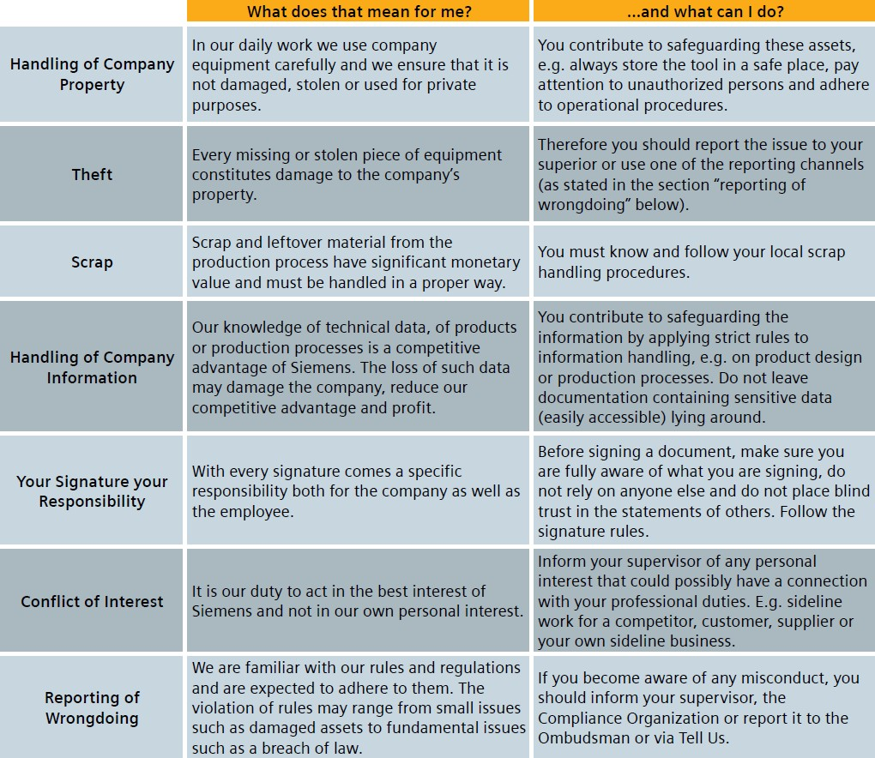

### Training and supporting documents

The **Quick guide**: Compliance@Production Facilities can be found here. [English version](https://findit.compliance.siemens.com/content/10000101/Compliance/LC_CO/LC_CO_EM/findIT_LC_CO_EM_5501.pdf)

[German version](https://findit.compliance.siemens.com/content/10000101/Compliance/CL_CO/CL_CO_AT/findIT_CL_CO_AT_5629.pdf)

###### [NL version](https://findit.compliance.siemens.com/content/10000101/Compliance/CL_CO/CL_CO_AT/findIT_CL_CO_AT_5630.PDF)

A **scribble video** explaining SIEMENS Compliance at production facilities can be found [here](https://myvideo.siemens.com/media/SIEMENS%2BCompliance%2BFactory%2BEN%2BSubtitle/1_pdob8fjt) (available also in Dutch). It explains in a smart and easy to understand way how Compliance also has an effect within production facilities. The Video uses a potential theft as an example to explain:

* + - Compliance in general
    - tasks of the compliance organization
    - actions in case of theft
    - reporting channels
    - whistleblowing
    - Compliance and ownership culture.

A **special WBT** for colleagues in production facilities will be available soon. One pager: How to tackle scrap-related issues can be found [here.](https://findit.compliance.siemens.com/content/10000101/Compliance/LC_CO/LC_CO_STR/findIT_LC_CO_STR_5132.pdf)

[**Protection Concept Factory**](https://wiki.siemens.com/display/en/Protection%2BConcept%2BFactory#space-menu-link-content) for critical IT assets also exists.

### History of changes

|  |  |  |
| --- | --- | --- |
| **Date** | **Author** | **Major changes of binding content** |
| April 1,  2020 | Yvonne Hamm- Düppe | Initial version |
| July 1,  2020 | Yvonne Hamm- Düppe  Tanja Gerecke | Minor editorial changes |
| Oct. 1,  2020 | Yvonne Hamm- Düppe  Tanja Gerecke | Minor editiorial changes |

* 1. Contacts

▌ Compliance Officer

The Compliance Officer responsible for your unit can be found through the following [link.](https://intranet.for.siemens.com/cms/059/en/about/org/Pages/compliance_organization.aspx)

▌ Corporate Governance Owner

[Tanja Gerecke](https://scd.siemens.com/luz/IdentitySearch?suchart=schnell&maxanz=50&cn=gerecke%2C%20tanja&cngenau=contains&lang=de) (LC CO DI MC)

[Yvonne Hamm-Düppe](https://scd.siemens.com/luz/IdentitySearch?cn=hamm-dueppe&suchart=schnell&utI=I&utX=X&utT=T&rtH=H&rtS=S&rtZ=Z&rtO=O&rtAktiv=A) (LC CO RFC LF)

# Compliance in Minorities

As a general rule, Siemens is not responsible for minority shareholdings, as they are considered separate legal entities.

Siemens can however be held liable for incidents in non-affiliated companies, even if Siemens does not hold a controlling interest in the company. Siemens can thus be held liable for incidents if Siemens has so called “significant control” of a minority shareholding. This requirement can be met in a number of ways, two of which are the number of shares that Siemens controls, and whether Siemens has the right to appoint a representative.

However, reputational damage from incidents that happen in a minority shareholding may occur even if Siemens has a lower amount of control.

Siemens is obliged to make at least “good faith efforts” to ensure that an appropriate Compliance system is implemented in the minority shareholding and to document such efforts. These efforts are partly taken into account during the acquisition of minority shareholdings with the Compliance Due Diligence (see [Chapter I.2.2.](https://webbooks.siemens.com/public/LC/chen/index.htm?n=Part-2-Business-Perspective%2CI.-Compliance-in-Mergers-and-Acquisitions-(M-A)%2CI.-Compliance-in-Mergers-and-Acquisitions)). Siemens is however also required to ensure Compliance in the minority shareholding **after the acquisition**.

Therefore, a necessary part of ensuring Compliance consists of the monitoring of minority shareholdings to ensure that appropriate measures can be taken if this should be necessary.

Monitoring of minority shareholdings must happen on a risk-based approach. Relevant here is the risk profile of the minority shareholding and the amount of control that Siemens has over it.

The general responsibility for monitoring Compliance in each Siemens minority shareholding lies with the relevant Siemens business / corporate function. If a Siemens representative is mandated as a board member of a minority shareholding, such Siemens representative will carry out this responsibility. Otherwise, the management of the relevant Siemens business / corporate function will be responsible.

**Monitoring of Minority Shareholdings – Overall principles**

▌ **Siemens can be held liable for criminal actions performed in a minority shareholding if Siemens has “significant control” of the company.**

▌ **The relevant Siemens business / corporate function is responsible for monitoring its minority shareholdings. If Siemens has the right to appoint a Siemens representative to a minority shareholding, this representative has to fulfill this responsibility.**

▌ **LC CO RFC LF M&A supports monitoring of minority shareholdings and alerts the BU Compliance Officer of findings from its SETIS search.**

### Roles and Responsibilities

* + 1. Tasks performed by LC CO RFC LF M&A

LC CO RFC LF M&A supports the Siemens business / corporate function by monitoring the minority shareholdings in the analytics platform “SETIS”. The monitoring of minority shareholdings in SETIS is performed using a predefined selection of keywords. This monitoring is performed regularly by LC CO RFC LF M&A, at least once a year. Monitoring results are archived in the SETIS tool. Potential Compliance red flags and other topics which may require further action are forwarded to the operational Compliance Officer. Upon request, LC CO RFC LF M&A will support by providing suggestions how to mitigate the identified risks.

* + 1. Tasks performed by the BU Compliance Officer

An inherent risk with regard to minority shareholdings is that they are not given the attention they require, as there may be unawareness of their existence and of who is responsible for Compliance. It is therefore important to always be aware of which minority shareholdings are within the responsibility of the respective Compliance Officer. The ARE Masterlist should be consulted to attain an up-to-date view on the minority shareholdings within each BU.

If a Compliance case, issue or topic within a Siemens minority shareholding comes to the attention of Siemens, appropriate Compliance mitigation measures should be assessed by the Compliance Officer responsible for the relevant Siemens minority shareholding and be addressed, i.e. recommended to the Siemens minority shareholding in question. LC CO RFC LF M&A offers assistance when required.

* + 1. Tasks performed by Siemens representative

In some minority shareholdings, Siemens has the right to appoint a representative to the minority shareholding. This can be a board member or a member of the management.

If such a representative is appointed, the representative has the obligation to monitor the Compliance situation in the minority shareholding. In the event of any substantial Compliance issues or topics within the minority shareholding, the representative must report this to the BU Compliance Officer. The representative will, in alignment with the BU Compliance Officer, communicate the required measures to the minority shareholding. LC CO RFC LC M&A offers assistance on request.

The Siemens Representatives will be trained with regard to Compliance monitoring within minority shareholdings by CF R 6 in cooperation with LC CO RFC CU.

### Training & supporting documents

###### [Circular No. 206 “Corporate Governance Rules for Siemens’ Equity Investments”](https://srs.siemens.cloud/%23/c/idd7f7)

* + - [ARE Masterlist](https://findit.compliance.siemens.com/content/10000101/Compliance/LC_CO/LC_CO_STR_SP/findIT_LC_CO_STR_SP_4272.xlsx)

### History of changes

|  |  |  |
| --- | --- | --- |
| **Date** | **Author** | **Major changes of binding content** |
| April 1,  2020 | Koen Miezenbeek (LC CO RFC LF) | First Release through the Compliance Handbook. |
| Oct. 1, 2020 | Ulrich Müller (LC CO RFC LF M&A) | New: Responsibilities clarified:   * i.e. Responsibility for monitoring Compliance in each Siemens minority shareholding lies with the relevant Siemens business / corporate function * 6.1.1.: Tasks performed by LC CO RFC LF M&A * 6.1.3. Training requirements of Siemens Representatives defined |
| Jan. 1, 2021 | Ulf Lafrenz (LC CO RFC LF M&A) | Minor formal changes. |

* 1. Contacts
     + **Compliance Officer**

The Compliance Officer responsible for your unit can be found through the following [link](https://intranet.for.siemens.com/cms/059/de/about/org/Pages/compliance_organization.aspx).

* + - **Corporate Governance Owner**

The contact person for monitoring of minority shareholdings is Ulrich Müller (LC CO RFC LF M&A)

1. Permanent Establishments (PE)

This instruction describes the handling of Permanent Establishments (PE) from a Compliance point of view and focuses on Compliance risks and their mitigation.

A PE is a legally dependent business form via which a non-resident company (parent/mother entity) establishes a presence in a country of activity. A PE arises de facto as a result of certain business activities of a parent entity (ARE) in an activity country different from its country of residence over a certain period of time.

For Compliance risks in connection with PEs, see Chapter H. 7.1.

**Permanent Establishment principles**

▌ Responsibility for PE throughout their lifecycle always lies with the legal parent entity (ARE).

▌ The CEOs of the parent entity (ARE) have the main responsibility to ensure Compliance in their area of responsibility, including PE and business and projects executed via a PE.

▌ The PE can only be closed after all (e.g. legal, Compliance, HR and tax) obligations have been fully met.

The following instruction provides the main regulatory framework for business activities rendered abroad by Siemens AG and affiliated companies:

* + [Financial Reporting Guidelines (FRG) Implementation Guidelines (Chapter 19, Permanent Establishments),](https://webbooks.siemens.com/public/FRG/IGen/)
  + [Siemens Circular No. 202 “Compliance with tax requirements in case of cross-border business activities”,](https://circulars.siemens.com/documents/circulardownload.aspx?id=sc_206.pdf) [and](https://circulars.siemens.com/documents/circulardownload.aspx?id=sc_206.pdf)
  + [Siemens Circular No. 206 “Corporate Governance Rules for Siemens' Equity Investments”](https://circulars.siemens.com/documents/circulardownload.aspx?id=sc_222.pdf)

For further details of responsibilities and governance of PE - please refer to the [FRG Implementation Guideline](https://webbooks.siemens.com/public/FRG/IGen/) Chapter 19.

Scope

This instruction applies to Siemens AG and affiliated companies executing business via PE (single-project PE, multi-project PE, branches and representation offices).

This Instruction is addressed to all Compliance Officers (COs) and PE-Managers and aims to enable an understanding of the PE-Compliance relevant risks, regulations and related responsibilities.

* 1. Purpose and risks

The aim is to ensure Compliance with Siemens Circulars as well as local and international laws and regulations.

PE are being focused separately from a Compliance point of view since they may be located in countries that have high corruption, fraud, money laundering, antitrust, export control violation risks and are cross border in respect to the legal parent entity.

In addition, **potential further risks** and challenges with regard to PEs may exist especially when setting up PEs such as:

* + - Project PEs are sometimes in (very) remote locations, which can make it difficult to carry out certain Compliance tasks.
    - PEs often lack the usual Siemens IT systems and tools.
    - Siemens processes and controls are not always in place.
    - Often, PEs are not properly supervised because of the perception that “(very) small entities pose little (or no) risk”.
    - Multi-business project PEs can require considerable coordination effort between businesses.
    - Occasionally, the organization is not aware that a PE has been set up or exists.

Examples of Compliance risks in a PE include:

* + - PEs can be used as an agent to make illicit payments or to offer improper advantages to third parties
    - Breach of local law in personnel delegations (e.g. maintenance, engineering, etc.)
    - Lack of or poor due diligence activities for relevant business third parties and employees
    - Low awareness of consequences of Compliance breaches
    - Significant developments or changes within PE which may have an impact on the Compliance set-up are not considered, e.g. significant changes in the purpose of the PE.

Thus, this instruction aims to guide PE Managers and COs to ensure Compliance in PE, detect and analyze potential Compliance risks of a PE and to implement the Siemens Compliance system.

### Roles and Responsibilities

Responsibility for PE throughout its lifecycle always lies with the legal parent entity (ARE).

CEOs of the parent entities have the main responsibility to ensure Compliance in their area of responsibility, including PE, business and projects executed via a PE.

The names of the respective COs regarding PEs’ parent entities (ARE) are clearly assigned and documented in the [ARE Masterlist.](https://findit.compliance.siemens.com/SitePages/Search%20Results.aspx?k=4272)

The responsible CO should inform his management at least once a year about the level of Compliance maintained in the assigned PE e.g. during a Compliance Review Board meeting (CRB).

Responsibility for handling of Multi-Operating Company project PEs

A multi-project PE can contain several individual projects from different operating-, strategic-, etc. companies. Due to this, it is neither practical nor operationally possible to transfer the responsibility and assurance for Compliance, including all projects, exclusively to the CO of the parent entity

Therefore, the COs of the organizational units of the individual projects are responsible to cover the Compliance risks on project level. The CO of the parent entity in this case just ensures that all the Compliance requirements for the PE "shell" itself are met.

The Compliance risks defined by the CO and the PE manager and/or the CEO of the PE must be described and the responsibility for risk mitigation must be defined.

The CO of the parent entity is also responsible for monitoring of the implementation.

### Compliance services through PE life cycle

During a PE’s life cycle, there are several tasks to be performed by the Compliance organization. The following chart presents an overview of the tasks for the different phases:

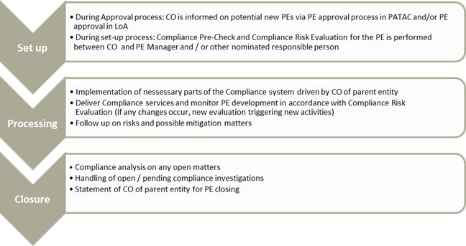

*Chart 1 “Overview of Compliance tasks in the PE life cycle”*

* + 1. Set up

When a PE will be established, this PE must be reviewed to identify the needs and scope of Compliance services. In order to enable a focused and risk-oriented analysis, a pre-selection of scope is recommended which takes into account the structure and field of activity of the PE.

Compliance risks inherent with a PE are typically linked to three criteria, which in general increase the risk at a PE:

* + - * External employees being directly employed by the PE
      * Business partner directly engaged by the PE
      * Local bank accounts under control of the PE

If one of the above criteria is fulfilled according to the pre-check chart below, then a detailed risk assessment is required.

A schematic diagram on how to proceed with such a pre-selection is shown here:

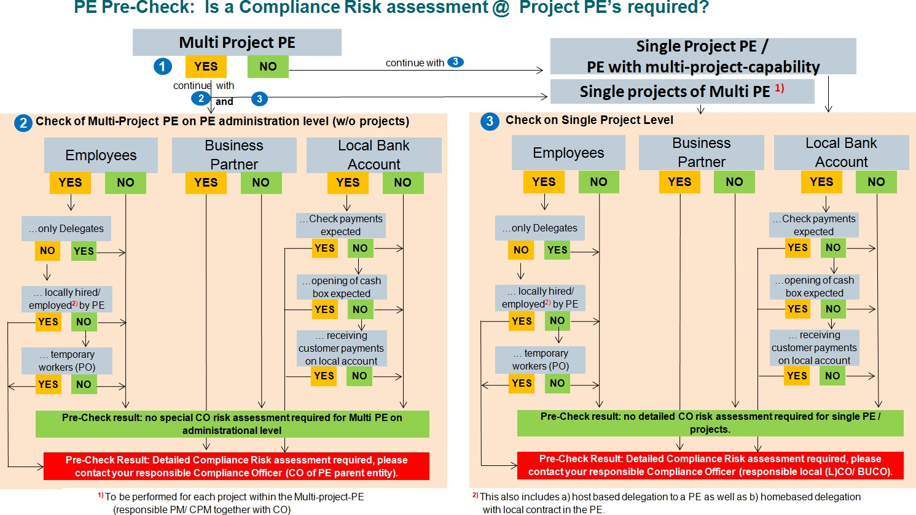

*Chart 2 “ PE Pre Check: Process to identify and mitigate Compliance Risks in a PE”*

When applicable, the PE Manager should approach the CO of the parent company in order to start this process, as the PE Manager is the first one who becomes aware of developments or changes.

In this liaison, the PE Manager and CO of the parent entity have to clarify:

* + - * The relevant Compliance topics which apply to the PE.
      * The understanding of the relevant PE employees about the applicable Compliance circulars, tools and processes.
      * Any critical, potential Compliance risks and their proper handling as per our rules and regulations.

Based on the pre-selection, the affected fields of activity are to be analyzed further with a detailed questionnaire, an example can be found here: [PE questionnaire](https://findit.compliance.siemens.com/content/10000101/Compliance/LC_CO/LC_CO_STR/findIT_LC_CO_STR_7299.docx)

Based on the results, the CO of the parent company in cooperation with the PE Manager is in charge for defining the scope of the Compliance services and describing the possible Compliance risks as well as mitigation measures. To the extent necessary, the CO of the parent entity as well as the PE Manager can nominate other person(s) to be involved in or take over the clarifying, e.g. PE Coordinator, Project Manager, Regional Compliance Officer, CO in the country of activity, etc.

* + 1. Processing

Since the PE develops during its life cycle, it is possible that an assessment for the PE may have to be repeated on a regular basis. In the event of major changes in the PE, the PE manager should contact his CO proactively to evaluate potential risks. Therefore, regular communication between the PE Manager and CO of the parent company is crucial.

It is to be ensured that the existing and newly identified risks have been described and properly mitigated and it is to be checked if the need for Compliance services has changed.

Particularities for PE personnel

Special attention lays on the training of the PE staff in the country of activity. To ensure this, the PE manager should inform the responsible CO asap if personnel recruitment is planned or carried out during the course of the project execution or the PE life cycle.

Like every Siemens employee, PE employees must be trained in Compliance relevant topics and understand the Compliance risks, relevant circulars, tools and processes. It is the responsibility of the responsible CO to assess whether risk-based training of PE employees is further necessary. In particular, the PE employees and staff should be able to identify critical Compliance topics and risks and bring them to the attention of the responsible CO for handling and / or mitigation.

* + 1. Closure

The PE Manager initiates this process upfront PE closing by contacting the responsible CO. The PE can only be closed after all (e.g. legal, Compliance, HR and tax) obligations have been fully met.

Before the closure of the PE, a review regarding all Compliance-related issues has to be conducted to ensure that there are no open or pending Compliance topics. The responsible CO has to state the PE status regarding Compliance matters and verify that there are no open Compliance tasks.

In the event that there are pending investigations concerning the PE, the CO of the parent entity will inform Case Handling (LC CO IR CF) so that case-related issues, if any, can be taken into account before PE closing. In addition, the CO of the parent entity will check with Discipline and Remediation (LC CO IR DR) that there are no open discipline and remediation tasks.

### Training and supporting material

Supporting documents:

* + - [Financial Reporting Guidelines (FRG) Implementation Guidelines](https://webbooks.siemens.com/public/FRG/IGen/)
    - [ARE Masterlist](https://findit.compliance.siemens.com/content/10000101/Compliance/LC_CO/LC_CO_STR_SP/findIT_LC_CO_STR_SP_4272.xlsx)
    - [PE questionnaire](https://findit.compliance.siemens.com/content/10000101/Compliance/LC_CO/LC_CO_STR/findIT_LC_CO_STR_7299.docx)

### History of changes

|  |  |  |
| --- | --- | --- |
| **Date** | **Author** | **Major changes of binding content** |
| January 1,  2019 | Thomas Mark | First release through the Compliance Handbook.  Changes to former “Guidance for Compliance Officers in implementing the Compliance System in Permanent Establishments” (version 1.0) are: Process simplification, abolition of “ISA-I for PE's” and Compliance Service Applicability Evaluation (SAE) and introduction of a Compliance Questionnaire. |
| January 1,  2020 | Koen Miezenbeek (LC CO RFC LF) | Update due to organizational changes |
| April 1, 2020 | Yvonne Hamm- Düppe | New structure in CO Handbook, so that PEs become a new Chapter in Part 2 H.7. |
| October 1,  2020 | Ralph Nohe  Yvonne Hamm- Düppe | Editorial changes |
| April 1, 2020 | Yvonne Hamm- Düppe | Chapt. 7.1.: Transfer of possible risks of a PE from Intranet page to Handbook |

* 1. Contacts

▌ Compliance Officer

The Compliance Officer responsible for your unit can be found through the following [link.](https://intranet.for.siemens.com/cms/059/de/about/org/Pages/compliance_organization.aspx)

▌ Corporate Governance Owner

The contact person for PE is: [Ralph Nohe](https://soc.siemens.cloud/profile/Z000FA6G) (LC CO PT CO)

## Compliance Due Diligences and Approvals

The most important aspect in all Compliance matters is to follow our principles. The focus lies on everyone’s judgement and self-responsibility. However, Compliance prevention also requires additional processes and measures; due diligences and approvals are the most frequent ones. Please also refer to [Siemens Circular No.](https://regulations.siemens.com/content/sc/226/en) [226](https://regulations.siemens.com/content/sc/226/en) for an overview of all other major Compliance related obligations.

Compliance Due Diligences

The prevention of Compliance incidents has an overall similarity throughout the different Compliance topics: the need for transparency. Only a sufficient transparency puts Siemens in the position to assess the risks connected with a third party or a transaction. Therefore, the common approach for most Compliance topics is the performance of some kind of “due diligence”.

The link between processes for Business Partner, Anti-Money-Laundering and Human Rights will be a common Due Diligence Tool in the future. But also Export Control requires inter alia checks of the end-user and the end- use of the Siemens product.

Approvals

Approvals are additional safeguards to involve a second opinion and to set a certain standard for the justification of a certain intended behavior or action. They are often integrated in due diligence processes but may also appear separately, e.g. in the area of Gifts and Hospitality.

Information only

Please not that this chapter is merely a non-binding summary of due diligence and approval content of other chapters of this handbook. In case of deviations, the regulations of the respective topic chapter prevail.

* 1. Compliance Due Diligences

Below you can find an overview of the most important Compliance due diligence processes. Please keep in mind that the binding content regarding those processes is contained in the respective chapter of the corresponding Compliance Activity Field.

▌ Business Partner

A **Business Partner Compliance Due Diligence** (Chapter [A 4.A.4.](https://webbooks.siemens.com/public/LC/chen/index.htm?n=Part-1-Activity-Fields%2CA.-Anti-Corruption%2C4.-Cooperation-with-Business-Partners%2CA.-Relevance-for-Business%2CA.4.-Compliance-Due-Diligence-(CDD))) has to be initiated in the [CDD Tool](https://compliance-tools.siemens.com/due-diligence/) by anyone intending to make business with the following types and certain **contract provisions** ([Chapter A](https://webbooks.siemens.com/public/LC/chen/index.htm?n=Part-1-Activity-Fields%2CA.-Anti-Corruption%2C4.-Cooperation-with-Business-Partners%2CB.-Relevance-only-for-Legal-and-Compliance%2CB.5.-Contract-Provisions) [4.B.5.)](https://webbooks.siemens.com/public/LC/chen/index.htm?n=Part-1-Activity-Fields%2CA.-Anti-Corruption%2C4.-Cooperation-with-Business-Partners%2CB.-Relevance-only-for-Legal-and-Compliance%2CB.5.-Contract-Provisions) need to be included in a contract with them:

* + - Intermediaries
      * **Sales-related Intermediaries**, e.g. Sales Agents, Business Consultants;
      * **Non-sales related Intermediaries**, incl. Lobbyists and Customs Agents.
    - Resellers with Red Flags
      * **Value-add Reseller**, e.g. EPC, OEM / System Integrator;
      * Distributor / other Reseller.
      * For these Resellers, a Compliance Due Diligence or the use of certain contract provisions is only mandatory in case of one of the following **Red Flags**:
        + The use of the specific Reseller is required by a third party, e.g. an end customer;
        + The Reseller receives an unusual financial benefit or business term from Siemens;
        + The Reseller places another third party between himself and his customer without plausible cause;
        + The Reseller raises integrity concerns based on information from a reliable source.
    - Cooperation/Consortium Partners

▌ **Compliance in Projects**

A Compliance Risk Assessment incl. a Compliance Due Diligence has to be conducted in [project sales](https://webbooks.siemens.com/public/LC/chen/index.htm?n=Part-2-Business-Perspective%2CH.-Compliance-in-Business-Processes-and-Projects%2C1.-Compliance-in-Project-Business) (Chapter H 1.2.1.) and [project execution](https://webbooks.siemens.com/public/LC/chen/index.htm?n=Part-2-Business-Perspective%2CH.-Compliance-in-Business-Processes-and-Projects%2C1.-Compliance-in-Project-Business%2C1.3.-Compliance-in-project-execution%2C1.3.1.-Projects-in-scope) (Chapter H 1.3.1.) if certain trigger criteria are fulfilled.

▌ Anti-Money-Laundering

In case of an indication of money laundering or terrorism financing (“**AML Red Flag**”, [Chapter C.1.)](https://webbooks.siemens.com/public/LC/chen/index.htm?n=Part-1-Activity-Fields%2CC.-Anti-Money-Laundering-(AML)%2C1.-AML-Red-Flags) in relation to a Counterpart, its Business Model, the Transaction / Financing e.g.

* Unusual or implausible business activities or
* **Indications for disguising the source of funds and/or involved persons**

or even a concrete suspicion of money laundering or terrorism financing, the responsible Compliance Officer must be informed and **an AML-specific Due Diligence (AML DD)** must be performed ([Chapter C. 2.)](https://webbooks.siemens.com/public/LC/chen/index.htm?n=Part-1-Activity-Fields%2CC.-Anti-Money-Laundering-(AML)%2C2.-AML-Due-Diligence) before entering into, or continuing with a business relationship or performing any transaction with a Counterpart.

Where required by local / sector specific AML regulations, additional or deviating measures might have to be taken (Chapter C.3.).

▌ Human Rights

A Human Rights due diligence as a module of the assessment of compliance risks within the [LoA process](https://webbooks.siemens.com/public/LC/chen/index.htm?n=Part-2-Business-Perspective%2CH.-Compliance-in-Business-Processes-and-Projects%2C1.-Compliance-in-Project-Business%2C1.2.-Compliance-in-project-sales%2C1.2.1.-Projects-in-scope-for-LoA-CRE) (Chapter H. 1.2.1.) has to be performed if certain trigger criteria are fulfilled. Please see chapter Chapter [E 5.](https://webbooks.siemens.com/public/LC/chen/index.htm?n=Part-1-Activity-Fields%2CE.-Human-Rights%2C5.-Human-Rights-Project-Due-Diligence) for more details.

▌ Procurement

The incorporated compliance check in the supplier registration of SCM STAR/PEGA SMDM on global layer level consists of the Business Partner (BP) check (Chapter [A 4.A.4.](https://webbooks.siemens.com/public/LC/chen/index.htm?n=Part-1-Activity-Fields%2CA.-Anti-Corruption%2C4.-Cooperation-with-Business-Partners%2CA.-Relevance-for-Business%2CA.4.-Compliance-Due-Diligence-(CDD))) and an assessment of an AML risk ([Chapter C. 2.).](https://webbooks.siemens.com/public/LC/chen/index.htm?n=Part-1-Activity-Fields%2CC.-Anti-Money-Laundering-(AML)%2C2.-AML-Due-Diligence)

▌ Export Control

The company application DAMEX must be used to evaluate what restrictions are applicable for a business transaction:

* + DAMEX-E (End-Use Check)

Questions about ultimate destination, end use and other warning indicators. Military and nuclear use, deliveries to certain persons, companies and organizations and certain services, such as technical support, may be subject to restrictions in the form of prohibitions and compulsory licensing.

* + DAMEX-P (Product-Specific Check)

Goods-related check at item level determining a possible license requirement fort the export of the respective item (commodity, software, technology)

* + DAMEX-SPS (Sanctioned Parties Screening)

Contains various lists of sanctions of the respective national, European and US authorities.

Please see Chapter [F. Export Control](https://webbooks.siemens.com/public/LC/chen/index.htm?n=Part-1-Activity-Fields%2CF.-Export-Control) and the [Internal Control Program Export Control (ICP EX)](https://intranet.for.siemens.com/wll/0067/en/9_apps/damex/gen/Pages/tab.aspx) for details.

**Information only**

Please not that this chapter is merely a non-binding summary of due diligence and approval content of other chapters of this handbook. In case of deviations, the regulations of the respective topic chapter prevail.

### Approvals

Below you can find an overview of the most important approvals outside of due diligence processes. Please keep in mind that the binding content regarding those processes is contained in the respective chapter of the corresponding Compliance Activity Field.

▌ Gifts & Hospitality (Chapter [A 1.](https://webbooks.siemens.com/public/LC/chen/index.htm?n=Part-1-Activity-Fields%2CA.-Anti-Corruption%2C1.-Gifts-and-Hospitality))

In addition to our general principles:

* + - A prior SpoDoM-Approval is required for offering or granting invitations to Entertainment Events, reimbursement of Lodging or Non-Local Travel Costs, or Other Contributions without Consideration
      * to Government Officials and their Related Parties, Government Entities, Healthcare Providers, members of a purchasing department or beneficiaries that are involved in important business decisions (Risk Groups),
      * if no exception applies.
    - No SpoDoM-Approval is required for offering or granting Gifts and Meals, reimbursement of Local Travel Costs, or for accepting Benefits.
    - Gifts of money are prohibited unless a prior written approval of the Compliance Officer is granted.

▌ SpoDoM (Chapter [A 2.](https://webbooks.siemens.com/public/LC/chen/index.htm?n=Part-1-Activity-Fields%2CA.-Anti-Corruption%2C2.-Sponsoring%2C-Donations%2C-Memberships))

To bundle Sponsoring Activities, Donations, Charitable Contributions and Memberships in line with the relevant strategic objectives, to create transparency, to ensure compliance with all applicable statutory regulations and to strengthen control over the associated costs, Siemens has implemented the SpoDoM tool for registering and approving the activities.

▌ Investments in third-party companies ([Chapter A.5.1.3](https://webbooks.siemens.com/public/LC/chen/index.htm?n=Part-1-Activity-Fields%2CA.-Anti-Corruption%2C4.-Conflict-of-interest%2C4.1.-Typical-constellations%2C5.1.3.-Relations-to-third-party-companies%3A-Investment))

Conflicts of interest can also arise in the case of direct or indirect investments in third-party companies or other forms of influence on a company. Such investments may require Siemens` approval.

▌ Procurement ([Chapter H.2.)](https://webbooks.siemens.com/public/LC/chen/index.htm?n=Part-2-Business-Perspective%2CH.-Compliance-in-Business-Processes-and-Projects%2C2.-Compliance-in-Procurement)

In case a supplier insists on changes/deletions to the **Corporate Responsibility contract clause/declaration or to the Code of Conduct,** exceptions can be granted according to the Escalation Process. The Compliance Officer is part of the approval process for exceptions according to the [Escalation](https://webbooks.siemens.com/public/LC/chen/index.htm?n=Part-2-Business-Perspective%2CH.-Compliance-in-Business-Processes-and-Projects%2C2.-Compliance-in-Procurement%2C2.2.-Code-of-Conduct%2C2.2.2.-Deviations-from-CoC%3A-Escalation-process) [Process (Chapter H. 2.2.2).](https://webbooks.siemens.com/public/LC/chen/index.htm?n=Part-2-Business-Perspective%2CH.-Compliance-in-Business-Processes-and-Projects%2C2.-Compliance-in-Procurement%2C2.2.-Code-of-Conduct%2C2.2.2.-Deviations-from-CoC%3A-Escalation-process)

▌ **Further approvals to be included**

**Information only**

Please not that this chapter is merely a non-binding summary of due diligence and approval content of other chapters of this Compliance Handbook. In case of deviations, the regulations of the respective topic chapter prevail.

### History of changes

|  |  |  |
| --- | --- | --- |
| **Date** | **Author** | **Major changes of binding content** |
| Oct. 1,  2020 | Yvonne Hamm- Düppe | Structural change from former Part 2 G. to Part 2, chapter H.8. |
|  |  | Chapter 8.2. Investments in third-party companies approval added |

* 1. Contacts

▌ Compliance Officer

The Compliance Officer responsible for your unit can be found through the following [link.](https://intranet.for.siemens.com/cms/059/en/about/org/Pages/compliance_organization.aspx)

▌ Corporate Governance Owner

[Yvonne Hamm-Düppe](https://scd.siemens.com/luz/IdentitySearch?cn=hamm-dueppe&suchart=schnell&utI=I&utX=X&utT=T&rtH=H&rtS=S&rtZ=Z&rtO=O&rtAktiv=A) (LC CO RFC LF)

## Compliance in Mergers and Acquisitions

Prior to the acquisition or divestment of a company, a part of a company or an interest in a company, it is necessary to evaluate the potential compliance risks for Siemens and mitigate them by taking appropriate action. This applies also to measures taken in preparation – for example, in the case of carve-outs.

**M&A principles**

▌ Regardless of the type of transaction involved – for example, a share deal, an asset deal or a merger

– a Compliance Due Diligence must be conducted prior to the I-Application.

▌ MAP DF&CLM in alignment with LC CO RFC LF M&A provides comments on the proposed transaction usually prior to the I-Application.

▌ For (1) projects of EUR 100 million or more or (2) in embargoed countries or (3) if specific compliance issues might be indicated, MAP DF&CLM and LC CO RFC LF M&A have to be involved already in preparation of the P-Proposal and have to provide comments to the P-Proposal of a proposed transaction respectively.

### Compliance Due Diligence

Prior to every investment and divestment decision, an assessment of compliance-related risks - referred to as a Compliance Due Diligence - must be conducted. In particular, the following applies:

* + 1. Time of execution

Regardless of the type of transaction involved – for example, a share deal, an asset deal or a merger – a Compliance Due Diligence must be conducted prior to the [I-Application](https://regulations-admin.siemens.com/content/SC/222/en) at the latest, in any case

* + - * before the acquisition or divestment of a company or a part of a company
      * before the acquisition or divestment of an interest in a company.

MAP DF&CLM in alignment with LC CO RFC LF M&A provides comments on the proposed transaction usually prior to the I-Application. However, in case

1. the materiality threshold of a proposed transaction of EUR 100 million is exceeded,
2. the proposed transaction takes place in a so-called embargo country or
3. other indications for potentially compliance critical topics exist,

MAP DF&CLM and LC CO RFC LF M&A have to be involved already in preparation of the P-Proposal and have to provide comments to the [P-Proposal](https://regulations-admin.siemens.com/content/SC/222/en) of a proposed transaction respectively.

* + 1. Responsibility

The execution of a Compliance Due Diligence constitutes a work stream within the M&A due diligence process. Further information and tools relating to this process are available on the MAP DF&CLM intranet site.

The M&A negotiator must involve MAP DF&CLM as early as possible in the course of the project (for example, in the case of divestments, already at the carve-out stage).

MAP DF&CLM is responsible for conducting the Compliance Due Diligence in alignment with LC CO RFC LF M&A and, if necessary, with the involvement of the compliance organization of the unit responsible for the transaction and of the compliance organization in the regions.

LC CO RFC LF M&A has the governance for the contents of the Compliance Due Diligence. In addition, LC CO RFC LF M&A has the governance for mandating and supervising of external compliance consultants which is determined together with MAP DF&CLM on a project-specific basis.

LC CO RFC LF M&A provides MAP and the unit responsible for the transaction with legal advice in compliance- related matters in connection with M&A transactions, majority investments, joint ventures and minority investments. This regulation does not affect LC M&A’s responsibility for providing advice in respect of contracts for mergers and acquisitions, majority investments, joint ventures and minority investments.

For investments by N47 a specific process without involvement of MAP applies.

* + 1. Scope

Subject of a Compliance Due Diligence is, in particular, the contracting party and the company or part of a company that is to be (partially) acquired or sold.

The Compliance Due Diligence should in particular focus on risks in the areas of corruption, antitrust law, money laundering, data privacy, export control, human rights and indications of criminal or administrative offences or criminal investigations or monetary fine proceedings against the contracting party, its shareholders, the company, its management, or against any employees with a key role in the transaction, all of the foregoing in respect of the company´s business activities, as well as on breaches of recordkeeping obligations.

* + 1. Results

MAP DF&CLM and LC CO RFC LF M&A have to document the results of a Compliance Due Diligence and report the results to the M&A negotiator. The results have to be adequately taken into consideration in the course of the negotiations, in particular, when drafting the contract.

If risks identified in the Compliance Due Diligence cannot be adequately taken into account, MAP DF&CLM and LC CO RFC LF M&A, have to document this fact and provide an assessment of the resulting compliance-related risks in the respective decision proposal. In addition, mitigation proposals with regard to the remaining compliance-related risks have to be provided.

The compliance organization of the unit responsible for the transaction must ensure the implementation of the proposed mitigation measures to reduce the remaining compliance-related risks. In this connection, the compliance organization will be supported by LC CO RFC LF M&A and, if necessary, by MAP DF&CLM.

### Compliance standards in investments

* + 1. Compliance standards in majority investments

When a company or a majority interest in a company is acquired through a M&A transaction, the Siemens unit taking over the business is obliged to set up – within 12 months from closing and in accordance with the Mandatory Items set out in the Integration Master Planner (IMP) – a compliance system that meets Siemens’ standards.

* + 1. Compliance standards in minority investments

When a minority interest is acquired, the M&A negotiator must undertake every effort to contractually agree with the relevant other parties in the transaction the implementation of an adequate Compliance System in the acquired business considering the specifics of the business and the transaction.

Depending on these specifics, an adequate compliance system for minority investments should usually comprise at least the following components:

* + - * “tone from the top” (a clear commitment by top management to combat compliance violations);
      * execution of business-related risk assessments in respect of compliance – focusing, in particular on topics relating to anti-corruption, antitrust laws and anti-money laundering;
      * nomination of compliance officers;
      * drafting and implementing of a set of compliance regulations (covering, for example, the treatment of gifts and invitations as well as dealings with business partners);
      * the implementation of communication and training measures;
      * a system for taking receipt of reports of suspected misconduct, investigating the compliance allegations and, where applicable, sanctioning such violations;
      * regular reviews of implemented compliance measures – focusing, in particular, on anti-corruption, antitrust and anti-money laundering measures;
      * establishment of a corporate culture that is committed to compliance.

Regarding the monitoring of Compliance in minority shareholdings after closing, see [Chapter H.6.](https://webbooks.siemens.com/public/LC/chen/index.htm?n=Part-2-Business-Perspective%2CH.-Compliance-in-Business-Processes-and-Projects%2C6.-Compliance-in-Minorities)

* + 1. Joint ventures

During the formation of a joint venture, the M&A negotiator must ensure – even in case of a minority interest – that the contractual partner cannot unilaterally change the compliance standards in place at the joint venture.

If this is not negotiable and cannot be agreed in the contract, this fact must be documented by LC M&A and communicated to MAP DF&CLM and LC CO RFC LF M&A so that it can be taken into account in the decision proposal and in the decision to invest / divest in an appropriate way.

### Divestments

* + 1. Contractual regulations

In case of a divestiture of a company, a part of a company or an interest in a company, the M&A negotiator and LC M&A must ensure that Siemens’ obligations vis-à-vis government authorities (for example, the SEC, the U.S. Department of Justice) and other organizations relating to the agreement of specific compliance-related regulations are fulfilled. Such requirements must be reflected in the contract with the purchaser in an appropriate way. LC CO RFC LF M&A has to inform the MAP organization and LC M&A regarding the respective compliance- related obligations.

* + 1. Carve-out/Stand-alone

LC CO RFC LC M&A manages the carve-out and stand-alone process for all Compliance related topics in divestment projects. The tasks include the management of the Workstream Compliance (“blue team”) in carve-out

/ stand-alone projects, as well as the management of the baselining and TSA (transitional service agreement) processes, the implementation of the Siemens Compliance system in the newly founded entities and the development of concepts for an independent stand-alone compliance system together with the target business and ensuring the implementation of this system.

### Training and supporting material

* [Circular No. 222 “Application for and approval of capital investments and divestments”](https://regulations-admin.siemens.com/content/SC/222/en)
* [Code of practice for compliance due diligences in M&A transactions](https://findit.compliance.siemens.com/content/10000101/Compliance/LC_CO/LC_CO_RG_M_A/findIT_LC_CO_RG_M_A_7309.pdf)
* [Circular No. 206 “Corporate Governance Rules for Siemens’ Equity Investments”](https://soc.siemens.cloud/%23/c/1ojprl)
* [Integration Master Planner (IMP)](https://intranet.siemens.com/integration)
* [ARE Masterlist](https://findit.compliance.siemens.com/content/10000101/Compliance/LC_CO/LC_CO_STR_SP/findIT_LC_CO_STR_SP_4272.xlsx)

### History of changes

|  |  |  |
| --- | --- | --- |
| **Date** | **Author** | **Major changes of binding content** |
| January 1,  2019 | Karin Bliemel LC CO RFC LF M&A) | First Release through the Compliance Handbook based on Siemens Circular SC No. 226 “Global Compliance”. |

|  |  |  |
| --- | --- | --- |
| January 1,  2020 | Frank Vormstein (LC CO RFC LF M&A) | Update due to organizational changes |
| April 1, 2020 | Koen Miezenbeek (LC CO RFC LF) | Update due to organizational changes |
|  | Yvonne Hamm- Düppe (LC CO RFC LF) | Structural restructuring of PEs and Minorities, so that Minorities becomes Chapter H.6, PEs becomes Chapter H.7 and previous Chapters I.1. and 2. become Chapter I |
| Jan 1, 2021 | Ulf Lafrenz,  Uli Müller  (LC CO RFC LF M&A) | Update due to organizational changes.  Clarification of responsibility for carve-out and stand-alone process. |

* 1. Contacts

▌ Compliance Officer

The Compliance Officer responsible for your unit can be found through the following [link.](https://intranet.for.siemens.com/cms/059/de/about/org/Pages/compliance_organization.aspx)

▌ Corporate Governance Owner

The contact person for invest- and divestments is: [Uli](https://scd.siemens.com/luz/IdentitySearch?cn=VORMSTEIN%2BFRANK%2BZ002NT5K&tcgid=Z002NT5K&c=DE&o=SIEMENS&ou=LC&l=MCH%2BM&department=LC%2BCO%2BRG%2BCL%2BM%26A&&utI=I&utX=X&utT=T&rtH=H&rtS=S&rtZ=Z&rtO=O&rtAktiv=A) Müller (LC CO RFC LF M&A)

### Introduction to Communication and Training

To ensure compliance and integrity with the law and our own internal regulations, it is of importance to communicate our internal rules and values and to train our employees worldwide.

The following section shows our [Training](https://webbooks.siemens.com/public/LC/chen/index.htm?n=Part-3-Compliance-Internal-Tasks%2CJ.-Communication-and-Training%2C1.-Training) and [Communication](https://webbooks.siemens.com/public/LC/chen/index.htm?n=Part-3-Compliance-Internal-Tasks%2CJ.-Communication-and-Training%2C2.-Communication) efforts and tools as well as how they are integrated into our organization and supported by the [Ambassadors](https://webbooks.siemens.com/public/LC/chen/index.htm?n=Part-3-Compliance-Internal-Tasks%2CJ.-Communication-and-Training%2C3.-Ambassador-program) Program @ Siemens.

# Training

This Chapter on compliance training provides employees of the Siemens compliance organization who deal with training topics with comprehensive instructions on developing and holding compliance training for the business organization.

Compliance training comprises general compliance training, as well as measures related to the activity fields, including in particular export control. It does not cover training on processes or tools. If individual training measures are defined as part of an investigation, the regulations governing them are defined in [Chapter L.5.](https://webbooks.siemens.com/public/LC/chen/index.htm?n=Part-3-Compliance-Internal-Tasks%2CL.-Case-Handling%2C-Discipline-and-Remediation%2C5.-Remediation) This Chapter contains the required guidelines for Compliance Officers, including the content, suitable methods and time of training and its target groups.

# Roles and responsibilities

* + 1. Compliance Training Circle

The Compliance Training Circle (CTCircle) is the cross-organizational cooperation network with end-to-end responsibility for providing business-related compliance training materials and the related training infrastructure. The main institutions of the CTCircle are:

* + - * Core Team:

The Core Team comprises at least three members (covering the perspectives of headquarters/governance, business and the regions/countries). It is responsible for the global training strategy and its operationalization. The Core Team defines all the stipulations and regulations in connection with internal compliance training activities centrally and in this context has global authority to issue guidelines in coordination with the Steering Committee.

* + - * Steering Committee (SteerCo):

The Steering Committee (SteerCo) consists of at least three members from the CMC and LC C GF. They decide on all requirements and regulations relating to compliance training activities on the basis of recommendations from the Core Team.

* + - * Country Compliance Officers:

The Country Compliance Officers are responsible in the local Siemens organization for giving advice and recommendations on implementing training requirements on the basis of binding global standards and identified local risks (such as CRA results). In accordance with Circular 226, Chapter 2.2, the local CEO or Head of the Company Unit is responsible for ensuring appropriate training measures are held.

* + - * Regional Training Coordinators (RTCs):

The Regional Training Coordinators (RTCs) are distributed over five regions (incl. SMO) and are based solely on regional affiliation (not AREs). They are the interface between the Core Team and Compliance Officers and facilitate local implementation of the training requirements.

They are appointed by the Core Team following agreement in their area of responsibility and administered in the [Training Contact Data Base.](https://intranet.legal-compliance.siemens.com/internal/training/compliance-contacts/)

Exception: SFS/CF F is not covered and represented by the RTCs, but is responsible on its own for all organization-related training measures.

1.1.2 Cooperation and communication

News, innovations and information are communicated promptly and comprehensively by the Core Team to the global training network.

The RTCs act as local multipliers for the regions/countries and communicate information from the Core Team to the units they represent, such as associated countries or Business Units, if such information is not communicated globally.

Information is communicated by e-mail, as well as by regular team meetings.

The Country Compliance Officers and RTCs are informed about current training projects of the CTCircle at a regular meeting (CTCircle Update).

In addition, a regular “CTCircle Update” newsletter is sent to the entire compliance organization (including antitrust law).

# Training portfolio

* + 1. Types of training

Siemens’ compliance training portfolio differentiates between three types of training:

* + - 1. Online training

**Online training** (web-based training (WBT), explainer videos, e-seminars) denotes all training activities that are to be held electronically without a trainer. Participants have flexibility in choosing when and from where to complete the training and can do so using various electronic devices.

* + - 1. Moderated training (ILT)

**Moderated training** (in-person training, virtual training, jointly termed instructor-led training (ILT)) comprises any form of guided training, in particular by a trainer. If required, this training can also be held virtually by means of suitable conferencing technology (such as Microsoft Teams).

From 01 October 2021, all globally mandatory training will take place exclusively in the form of online training.

From this date, ILTs can be offered as non-compulsory learning opportunities. In the period up to October 01, 2021, ILTs can continue to be held locally on a mandatory basis according to local requirements.

* + - 1. Awareness measures

**Awareness measures** (such as Integrity Dialog, Yammer Nuggets) denotes training and/or communication measures to publicize and raise awareness about (new) topics. They are usually short, attention-grabbing formats. The focus here is less on conveying detailed knowledge, but rather on creating and maintaining constant awareness for compliance issues and integrity. They enable managers to discuss compliance issues that arise with their employees.

The annual **Integrity Dialog** can be staged in two ways:

* **“Integrity Moments”** (binding global minimum standard with four different formats at choice, to be conducted at least once a year):
  + - * 1. In the spirit of “tone from the top/middle,” managers integrate a compliance issue lasting 2 to 5 minutes in the form of a short single-page slide presentation or
        2. explanation videos (which are provided centrally) in other presentations/talks (e.g. Team jour fixes).

1. Top management (“tone from the top”) sends out a “hot topic e-mail/post (Yammer)” to as many employees as possible so as to create awareness for specific compliance issues.
2. Yammer Nuggets (tiny posters that can be sent by e-mail/Yammer) are provided to recapitulate and dig deeper into the content that is conveyed.

* **“Integrity Dialog Classic”** (in addition to the “Integrity Moments”):

These supplementary modules tend to deal with topics of an overarching nature and are less process- related, i.e. managers do not require any special prior knowledge of the subject. In this conventional approach, managers conduct a dialog with their employees at an in-person event or virtually. Optionally, managers can be trained/informed in advance by the compliance organization in a management briefing.

The decision on how the Integrity Dialog is held (“only” Integrity Moments or in combination with a conventional module or modules) is the responsibility of the local CEOs with the support of the Country Compliance Officer and is adopted once a year in the CRB. Its focus should be on the message conveyed in the “tone from the top/middle.”

There is no obligation to document in detail the employees who take part in the Integrity Dialog; letters of invitation, minutes of meetings, etc., can be used as supporting evidence.

* + 1. Training products

A distinction is made between global mandatory, local mandatory and optional training products.

The available training products, along with the global target group definition/recommendation and whether they are mandatory, are summarized in [this overview](https://findit.compliance.siemens.com/content/10000101/Compliance/LC_CO/CTC_Circle/findIT_CTC_Circle_9570.xlsx) below.

* + - 1. Global mandatory training products

**Global mandatory training** must be rolled out worldwide to a uniformly defined target group. That applies to online training and ILT. The regulatory stipulations and obligation to furnish supporting evidence that a training topic has been dealt with are always the basis for defining whether the training is a global mandatory measure. The time of regional rollout is defined by local management following advice by the Country Compliance Officer in coordination with the Regional Training Coordinator. The period of time in which the training must be completed is stated in the individual letter of invitation.

From October 1, 2021, there will be one single target group for all globally mandatory training. This includes all employees with access to the SABA learning management system. In the period up to October 01, 2021, the target groups already defined and communicated will apply.

* + - 1. Local mandatory training products

In the case of **local mandatory training**, the country CEOs are responsible for specifying that an available training product is mandatory based on the recommendation by the Country Compliance Officer. The basis for that should be a regional risk assessment. The Compliance Officer is also given global recommendations on the target group as guidance for this training and they are documented in the learning management system My Learning (SABA) to ensure that regulatory requirements to provide supporting evidence are met.

In individual cases (such as Export Control Basic Training), a training topic may be mandatory, but its content must be adapted locally to reflect the regional regulations and risk assessment. The Country Compliance Officer (in the case of EX in coordination with the EX business partner) is responsible for defining and controlling the content .

* + - 1. Optional training products

The individual employee decides whether to take part in all other training measures, i.e. they are **optional**. Here, too, there are by and large recommendations on the target groups as guidance. Optional training can be undertaken using SABA or the integrated learning platform “My Learning World” and is documented in the respective systems.

* + 1. Target group definition

The global target group defined differs depending on the subject matter of the training measure and its definition is adapted and made available every year.

From October 1, 2021, there will be one single target group for all globally mandatory training. This includes all employees with access to the SABA learning management system. In the period up to October 01, 2021, the target groups already defined and communicated will apply. For better orientation, there will be target group recommendations for learning offerings from October 01, 2021 (“curriculum”).

* + - 1. All employees

The Siemens Business Conduct Guidelines (BCG) set forth the fundamental principles and rules governing how all employees must act within the Company Units and in relation to customers, external partners, and

the general public.

Accordingly, the web-based training **“Our BCG – Our Core”** represents basic training across all compliance fields of activity and is mandatory for all Siemens employees. If employees do not have access to SABA, the content must be conveyed by the regional compliance organization in the form of in-person training. That must likewise be documented in SABA with the aid of the Regional Training Coordinators.

Further basic trainings (“**essentials**”) available specifically for the Activity Fields are usually rolled out to the vast majority of employees who have access to SABA. That does not include employees who work in processing (e.g. in the job family “Manufacturing”).

* + - 1. Sensitive functions

There are also training measures that are designed on the basis of specific risks and rolled out for what are termed **sensitive functions**. The target group for this compliance training may vary depending on the topic and is defined for specific specialized training by the CTCircle Core Team in cooperation with the specialist department to reflect requirements. This applies to WBT and ILT.

* + - 1. Different target groups
         1. **External employees**

It is necessary to examine and define – at the country level and on the basis of statutory stipulations – the extent to which external employees (with an e-mail address …ext@siemens.com) are required to undergo training. They are currently not included in SABA and must be connected to the system in a separate process. That is done through the RTCs. If it is legally necessary at the regional level for external employees to be included in the training measures, the costs of that are borne centrally. Apart from that, the countries bear the costs of training external employees voluntarily. The CTCircle Core Team must be involved before external employees are activated in SABA.

* + - * 1. Temporary employees

If a local Siemens company is provided with temporary staff or workers by an employment agency or another business partner, the CTCircle advises treating them as internal employees as regards training. That means these temporary workers should take part in the global and (if available) local mandatory training.

If the temporary employees do not take part in the mandatory training as internal employees do, there must be appropriate supervision of the employment agency or business partner providing the temporary staff or workers.

* + - * 1. Employees at subsidiaries and acquisitions

Employees at subsidiaries and acquisitions who do not (yet) have an entry in SCD/CHCM should be connected to SABA within three months by means of a manual workaround process so as to meet their training obligations. To enable that, a specific curriculum has been created in SABA and comprises the basic WBT measures (“Our BCG- Our Core,” “Antitrust Essentials,” “Data Privacy Essentials,” and “Export Control & Customs Global Awareness”). ILT measures are held after the employees have been integrated in the HR systems (in particular SCD, CHCM). The requirements for compliance training at companies in which Siemens has a minority stake are defined in Chapter H.6.

* + - 1. Customization options

It may be necessary for various reasons (such as a CRA decision, remediation measure or local legislation) to include additional participants or participant groups individually in one or more training measures.

There may be multiple reasons for expansion of the target group; the decision to do so lies with local management following consultation with the responsible Compliance Officer and should be documented transparently.

A reduction in the minimum global target group is only possible on an individual basis (i.e. not on the basis of individual sub-job families or position types). The reasons for removal from the target group must be documented transparently (e.g. by the RTC). Such deactivations must be reviewed after a reasonable period of time and reversed if necessary.

* + - 1. Identification of participants

If SABA is used, all the relevant participants are selected automatically in accordance with global, binding minimum requirements. Manual action, such as a general query process at the operating units or through the HR organization, is not usually required and should be avoided.

The data sources are the HR systems SCD and CHCM and the entries in it. If replies are received to invitations as a result of incorrect coding in SCD/CHCM, it is the task and responsibility of the respective operating units, and not of the compliance organization, to initiate appropriate corrections in SCD/CHCM through the local HR organization.

If units are not (yet) connected to SCD/CHCM or no (sub-)job families and/or position types have been specified, the above instructions on identifying the target group must be implemented analogously. A manual transitional process for activating employees in the system is available for that (see [Chapt. J. 1.2.3.3.3](https://webbooks.siemens.com/public/LC/chen/index.htm?n=Part-3-Compliance-Internal-Tasks%2CJ.-Communication-and-Training%2C1.-Training%2C1.2.-Training-portfolio%2C1.2.3.-Target-group-definition%2C1.2.3.3.-Different-target-groups%2C1.2.3.3.3.-Employees-at-subsidiaries-and-acquisitions)). The CTCircle Core must be contacted here if necessary.

* + 1. CRB requirements

The subject of training must be discussed in the CRB once a year, no matter in which quarter.

The rolling two-year Training Roadmap must be discussed and adopted at the (lead) country level. It contains the global and local mandatory training measures (including Integrity Dialog measures) and the status of the training measures for the past 12 months.

The global training measures must be presented at the business level. If the business-related CRBs reveal training requirements, the competent Country Compliance Officers must be notified so that they can be reflected in the Training Roadmap. That requires early coordination between the business and regional managers.

Decisions on adapting the Training Roadmap during the year must be made at the next CRB meeting.

* + 1. Training Roadmap

The country units are obligated to draw up and implement a Compliance Training Roadmap covering all the regional training activities for which the respective Compliance Officer is responsible.

If necessary, subordinate assigned countries may receive instructions on region-specific training measures from their superior country units. Adaptations at the level of the respective company unit are possible, but they must be agreed with the competent Compliance Officers at the regional level.

A separate Training Roadmap does not have to be drawn up at the business level.

From October 01, 2021, the globally mandatory training measures will be rolled out centrally to all employees (see Chapt. J.1.2.3.1). Only mandatory measures going beyond this and defined on the basis of local risks are to be decided at local level. No separate training roadmap is specified for this purpose.

* + - 1. Minimum requirements for global mandatory training measures

The responsible Country Compliance Officer identifies the training measures that are defined as global mandatory measures in the Compliance Training Landscape (see Chapt. J. 1.2.2.1.).

* + - 1. Supplementation of local mandatory measures

The competent Country Compliance Officer evaluates the requirement for additional mandatory measures on the basis of local regulations and risk assessments. He/she bases that evaluation on the local risk potential, local statutory requirements, the country or company risk scores, and other factors (such as requirements pursuant to local or business-related remediation measures, ERM risks, etc.).

He/she can choose the training measures from the portfolio of local mandatory measures (see Chapt. J. 1.2.2.2.). That also includes defining the relevant Integrity Dialog measures.

There may be adjustments from local adaptation of training materials (see Chapt. J. 1.2.7.5). Additional requirements for specific local training products must be qualified together with the CTCircle Core Team before the regional Training Roadmap is agreed.

* + - 1. Structure of the Training Roadmap

The Training Roadmap has the following content:

1. Time frame (period of validity) of the Training Roadmap
2. Training plan, including a timeline, covering the global mandatory and the defined local mandatory training measures, as well as the proposed expansions and additional measures. The following details must be specified for every training measure contained in the training plan: topic, format (WBT/ILT), target group, training obligation (mandatory or optional), duration, implementation period
3. Additional documents if required, such as detailed information on training measures, reasons for adaptation or expansion, expectations from implementing the measures, procedure for handling incomplete training measures.

There is no binding template for the Training Roadmap. However, the CTCircle provides an overview of the global and local mandatory training measures for the planning period.

* + - 1. Implementation, monitoring and review of the training measures

The final Training Roadmap agreed in the CRB defines the binding framework for holding compliance training measures at the country level.

The Country Compliance Officer monitors implementation of the Training Roadmap on a regular basis (at least once a year).

* + 1. Documentation

The (Lead) Country Compliance Officers must keep documentation on the Training Roadmap and the CRB approval. All mandatory Compliance training measures must be documented in SABA. The training history is documented and stored in SABA for ten years as of when a training measure is completed by an individual employee or as of migration from the former learning management system (LMS).

* + 1. Administration and holding of training

Various structures and processes have been defined to ensure smooth processes.

* + - 1. Learning management system

All WBT and ILT measures on the subject of compliance must be administered without exception in SABA, which is operated by the Global Learning World (HR GLW). Exceptions to obligatory use of SABA are permissible only if the conditions for using it have not been fulfilled due to the fact it has been rejected by the competent body/authority or bodies/authorities. In such a case, the CTCircle Core Team must be involved immediately.

Where necessary and not already done, the local compliance organization ensures in good time that all the necessary conditions for using SABA are fulfilled and provides regional coordinators (RTCs) to organize and coordinate the training. They receive the necessary system permissions from the CTCircle Core Team in close coordination with HR GLW and are trained in using SABA.

If a rollout is needed, the responsible RTC, if applicable with the further involvement of the Global SABA Support Team ([function mailbox](mailto:saba-mylearning.legal-compliance@siemens.com)), must be contacted.

* + - 1. Local approval

All mandatory training measures have usually been presented to the Continuing Education and Training Committee of the Central Works Council and approved by the Central Works Council and in some cases by the Group Works Council.

Nevertheless, the Compliance Officer is requested – before the training measures (global and local mandatory training) are implemented – to examine whether there is an obligation to obtain approval from or notify public authorities or other bodies (such as a codetermination body) under statutory or other regulations. If so, the Country Compliance Officer must ensure that the relevant approval is obtained and/or the responsible authority/body is notified before the training measure is used.

If a training measure cannot be held due to the fact that approval for it has been not been given despite being applied for, the CTCircle Core Team must be notified immediately.

* + - 1. Training materials

All the materials/modules required for holding centrally provided training are designed by the CTCircle in coordination with the respective topic owners or the Compliance Legal unit and made available worldwide on the [Compliance Marketplace.](https://l-collaboration.siemens.com/content/10002000/workspaces/cotrma/SitePages/Home.aspx)

In general, internal training materials are not allowed to be used at external companies. This also applies in particular to companies in which Siemens has a minority stake. In the case of carve-outs, the rights to use WBT and ILT measures must be governed by license agreements with the holders of the rights. LC C GF must be contacted in this regard.

* + - 1. Languages

The materials for the ILT are provided by the CTCircle at least in English and mostly also in German, while those for the WBT are provided in further languages to differing extents (complete new version or with subtitles).

The following applies to ILT:

The local compliance organization must have the materials translated into further languages. The local compliance organization is responsible for ensuring that

* The materials are translated correctly from English/German
* The English/German templates are fully translated into the new language
* The final version is approved by a qualified person (such as a local legal counsel).

The following applies to WBT:

Further languages are defined by the training projects to reflect needs and with regard to keeping costs down, subject to the approval of the CTCircle Core Team. The translations are coordinated by the project teams and agreed with the local compliance organization.

If a mandatory training product is not available in the required language, another format may be chosen locally (e.g. recorded ILT) to meet the training requirements. This is to be documented by the RTCs via the correspondingly provided alternative products ("containers") in SABA.

If further local translations/adaptations are necessary, the local compliance organization is responsible for ensuring the training materials are correct afterwards and also bears the costs for them.

* + - 1. Adaptations to the content of ILT materials

Specific adaptation of the materials by the local compliance organization is possible subject to the following conditions:

* The adaptation focuses on local or organizational matters, such as local compliance guidelines
* The additional slides/topics are within reasonable limits
* The local compliance organization itself is responsible for creating additional slides and their content, which must be approved in advance by a qualified person (such as a local legal counsel).
* Fundamental adaptations to content must be approved by the CTCircle Core Team, if required with the involvement of the specialist departments (e.g. LC M&A CMP for antitrust)
  + - 1. Provision of trainers and their qualification

ILT measures are held by trainers from the compliance organization.

In the case of training related to data privacy, colleagues who deal with data privacy issues can also be entrusted with designing and holding the training subject to mutual agreement. In the case of training on antitrust and competition law, colleagues from LC M&A CMP (such as regional antitrust experts (RAEs), can also be integrated as trainers.

In general, it is necessary to ensure that all the nominated and used trainers are adequately qualified in terms of presentation/moderation techniques and also have sound, detailed knowledge of the compliance issues. That is the task and responsibility of the respective compliance organization and the competent RTCs.

* + - 1. Letters of invitation/reminders

The invitations/reminders are e-mailed automatically by SABA to participants as soon as one of the following conditions has been met:

* + - * 1. The employee is a member of the target group that has been bindingly defined worldwide and has not been deactivated in SABA by SCD/CHCM or the local compliance organization and has not previously taken part in the training in question;
        2. The employee has additionally been nominated by the local compliance organization or his/her manager and activated manually and has not previously taken part in the training in question.

Employees who are not (yet) connected to the HR systems (esp. SCD, CHCM) should be connected to SABA within three months via a manual workaround process in order to gain access to the essential, mandatory training (see [Chapt. J. 1.2.3.3.3](https://webbooks.siemens.com/public/LC/chen/index.htm?n=Part-3-Compliance-Internal-Tasks%2CJ.-Communication-and-Training%2C1.-Training%2C1.2.-Training-portfolio%2C1.2.3.-Target-group-definition%2C1.2.3.3.-Different-target-groups%2C1.2.3.3.3.-Employees-at-subsidiaries-and-acquisitions)).

New employees in functions with Compliance relevant risk profiles must be invited to mandatory trainings within three months or at the next possible opportunity (max. six months).

All letters of invitation and reminders are drawn up in the defined languages and have a uniform layout and text worldwide.

The standard times for the (automated) reminders for the WBT measures are:

1st reminder: 5 weeks after the invitation 2nd reminder: 7 weeks after the invitation 3rd reminder: 9 weeks after the invitation

Overdue: 10 weeks after the invitation, after which the system sets the participant to “overdue,” i.e. he/she has not successfully completed the training in the envisaged period of 10 weeks

Queries from invited participants are answered by the local compliance organization. The letters of invitation/reminders contain a reference to that effect, as well as a link to the current contact persons and participant support team at Global Learning World (HR GLW).

* + - 1. Follow-up activities for participants

In general, it is the task of the RTCs and responsibility of the competent Country Compliance Officers to identify overdue participants (if the deadline for completing the training has been exceeded) and initiate suitable measures to follow up on the training participants. Implementation of an escalation model at the local level is recommended. That can be used, for example, to define additional necessary actions (such as individual communication measures, involvement of the person’s manager).

In the case of training measures relating to data privacy or export control, the colleagues responsible for these topics might explicitly be involved; responsibility for that must be agreed on at the local level in good time.

From 01 October 2021, the manual follow-up will be replaced by an automated escalation process. Until then, the open follow-ups are to be closed as far as possible.

* + - 1. Certificates

Every participant is sent a certificate that can be downloaded from SABA after successfully completing the training. All the certificates are created with a uniform layout and text worldwide and in the defined languages. Customized texts/supplements are not permitted.

The sole signatory is the CCO (Chief Compliance Officer) of Siemens.

In addition, successful participation in all global mandatory training products that are administered in SABA is reported automatically to Workday.

* + - 1. Feedback, hosting and continuous quality assurance

Regular analyses of feedback on training is in principle essential to maintain a functioning quality assurance process. If SABA is used, a feedback questionnaire is sent out by the system together with the letter containing the certificate.

The global Compliance training products are hosted by LC C GF TR (see [Chapt. J. 1.2.2](https://webbooks.siemens.com/public/LC/chen/index.htm?n=Part-3-Compliance-Internal-Tasks%2CJ.-Communication-and-Training%2C1.-Training%2C1.2.-Training-portfolio%2C1.2.2.-Training-products)). Depending on the urgency, content feedback and necessary technical adjustments are implemented immediately or bundled. This happens in alignment with the departments responsible for the content (content owners). In addition, the content owners are asked once a year to review the global training content to ensure that it is up to date. Both activities are documented centrally. The accuracy and completeness of local training content must be ensured by the Country Compliance Officer (see [Chapt. J. 1.2.2.2](https://webbooks.siemens.com/public/LC/chen/index.htm?n=Part-3-Compliance-Internal-Tasks%2CJ.-Communication-and-Training%2C1.-Training%2C1.2.-Training-portfolio%2C1.2.2.-Training-products%2C1.2.2.2.-Local-mandatory-training-products)). This must be checked annually and documented locally in an appropriate manner.

# Training of the Compliance organization

The onboarding of new employees in the Compliance organization is supported by a variety of centrally provided web-based training courses, recorded training sessions and on-the-job training, which are summarized in the onboarding checklist. The onboarding checklist ensures that Compliance professionals are trained in the specific activity fields, including the legal framework, and are given an overview of how to use the relevant tools. In

addition, the "buddy concept" provides a contact person who is available to answer questions and support the onboarding process. This person is to be appointed by the responsible manager. Apart from the provision of self- study material, the onboarding is being supported by the two-step Compliance Education Program (CEP).

Export Control employees will also be required to update their expertise via the EX-Brush-up training on a regular basis, i.e. at least every 2 years.

* + 1. Compliance Education Program (CEP)

The two-stage program gives new compliance employees an introduction to and relevant know-how about the organization, regulations and processes of the Siemens compliance organization. The program also promotes global networking among compliance employees by means of pinpointed activities. It is mandatory for new employees in the roles of Compliance Officers and Compliance Experts at Siemens AG and affiliated companies. Participants are registered by their immediate manager with LC C GF, which organizes and implements the training.

A virtual concept for the CEP was developed in the wake of the global COVID-19 pandemic as a temporary means of enabling the training measures to be continued by means of virtual methods.

* + - 1. CEP 1

CEP 1 (in which employees participate within six months of joining the company) offers an overview of all compliance guidelines and processes, as well as the possibility of building a network with the compliance experts at Siemens’ headquarters and with other participants. It is held as in-person training in Munich-Feldafing over five days or virtually over approximately three weeks.

* + - 1. CEP 2

CEP 2 (in which employees participate 12 to 18 months after CEP 1) offers participants in-depth compliance know-how in the relevant fields of compliance and methodological knowledge (such as in agile working, communication methods), as well as the chance to share knowledge among compliance experts. For Export Control Business Partners who focus solely on export control functions, participation in CEP 2 training is optional. It is held as in-person training in Munich-Feldafing over five days or virtually over approximately three weeks.

* + 1. EX Brush-up

The EX Brush-up (for employees of the LC CO with an EX BP function, including EX BP deputies and team members with more than 2 to 3 years of experience) offers regular refresher training on export control regulations and on Siemens’ internal export control processes, procedures and systems. Participants are nominated by the Export Control Business Partner in the local compliance organization. The training is currently being held virtually with a 2-week curriculum, with the learning units condensed into three half-days.

# Training and support materials

**Compliance Intranet (training for Business Units/regions):** https://intranet.for.siemens.com/cms/059/de/processes/publications/Pages/compliance_trainings.aspx **Compliance Intranet (training for compliance employees):**

https://intranet.legal-compliance.siemens.com/internal/training_compliance.cfm

Compliance Marketplace (training materials and trainer guides):

<https://l-collaboration.siemens.com/content/10002000/workspaces/cotrma/SitePages/Home.aspx>

CTCircle:

https://[www.yammer.com/siemenscrosscollaboration/#/threads/inGroup?type=in_group&feedId=4948418560](http://www.yammer.com/siemenscrosscollaboration/%23/threads/inGroup?type=in_group&feedId=4948418560)

**CTCircle Coordinators (closed group for RTCs):** https://[www.yammer.com/siemenscrosscollaboration/#/threads/inGroup?type=in_group&feedId=9361481728](http://www.yammer.com/siemenscrosscollaboration/%23/threads/inGroup?type=in_group&feedId=9361481728) **CTCircle Trainer – Virtual water cooler (closed group for CO Trainers):** https://[www.yammer.com/siemenscrosscollaboration/#/threads/inGroup?type=in_group&feedId=23209279488](http://www.yammer.com/siemenscrosscollaboration/%23/threads/inGroup?type=in_group&feedId=23209279488) **ICP EX:** https://intranet.legal-compliance.siemens.com/compliance/icp/icpGer.cfm

**My Learning (SABA):** https://siemens-learning.sabacloud.com/

**Yammer groups (Siemens Cross Collaboration Network):**

**My Learning World LC Channel:**

Integrity Dialog:

[https://intranet.for.siemens.com/cms/059/de/career/training/Pages/compliance_integrity-dialog.aspx.](https://intranet.for.siemens.com/cms/059/de/career/training/Pages/compliance_integrity-dialog.aspx)

Business Partner Export Control:

https://intranet.legal-compliance.siemens.com/compliance/icp/icpGer.cfm#icpContacts

Compliance Academy:

https://intranet.legal-compliance.siemens.com/internal/ComplianceAcademy (access only for employees of the LC organization)

Onboarding checklist for new Compliance employees:

https://findit.compliance.siemens.com/content/10000101/Compliance/CL_CO/L_GF/findIT_L_GF_8635.pdf

# Change history

|  |  |  |
| --- | --- | --- |
| **Date** | **Author** | **Significant changes** |

|  |  |  |
| --- | --- | --- |
| Oct. 1, 2018 | Horst Hoffmann LC C GF | Transition from the Compliance Training Manual to the Web Book and update for 2019 |
| April 1, 2019 | Horst Hoffmann LC C GF | Adaptation to the new organizational structure and new processes |
| Oct. 1, 2019 | Utta Köhler  LC C GF | Adaptation to the new organizational structure, rollout of MyLearning (SABA) and transfer of OA to the CTCircle |
| Jan. 7, 2020 | Utta Köhler  LC C GF | Adaptation to the new organizational structure, rough revision of the training processes (CTCircle) |
| April 1, 2020 | Utta Köhler  LC C GF | Adaptation to the structure and processes of the CTCircle |
| Oct. 1, 2020 | [Julia Doernen](https://scd.siemens.com/luz/IdentitySearch?cn=Julia%2BDoernen&maxanz=50&suchart=schnell&tab=tabs-1)  [Dorothee Patzer](https://scd.siemens.com/luz/IdentitySearch?cn=Dorothee%2BPatzer&suchart=schnell)  [Magdalena](https://scd.siemens.com/luz/IdentitySearch?cn=Magdalena%2BKalbarczyk&suchart=schnell) [Kalbarczyk](https://scd.siemens.com/luz/IdentitySearch?cn=Magdalena%2BKalbarczyk&suchart=schnell)  [Utta Köhler](https://scd.siemens.com/luz/IdentitySearch?cn=Utta%2BKÃ¶hler&suchart=schnell)  CTCircle Core Team | Adaptation to the structure of the CTCircle and addition of new processes, streamlining of the content   * Simplification of the training obligation (global/local mandatory, optional), Chapter 1.2.2 * Reduction in CRB requirements, differentiation between Country CRB and Business CRB, section 1.2.4 * Requirements for regional training products, section 1.2.5.2 * Binding documentation in SABA, Chapter 1.2.7.1 |
| Jan 01,  2021 | Utta Köhler CTCircle Core Team | Consideration of EX Training Audit results:  - Invitation of new employees in CO-relevant functions to mandatory training within 3 months, chapt. 1.2.7.7 |

|  |  |  |
| --- | --- | --- |
|  |  | - Use of alternative training formats in case of missing language versions of mandatory trainings, recording in SABA, chapt. 1.2.7.5   * Annual review process for quality assurance, chapt. 1.2.7.10   Further concretization of training processes:   * Update of the list of training products, chapt. 1.2.2 * Connection of technically not yet fully integrated employees to SABA within 3 months, chapt. 1.2.3.3 * Inclusion of onboarding checklist and buddy concept for new CO employees, chapt. 1.3 |
| April 01,  2021 | Utta Köhler CTCircle Core Team | Announcement of structural adjustments in the training approach and process as of 01.10.2021:   * All globally mandatory trainings will be offered as online trainings, chapt. 1.2.1.2 * In the future, one global target group definition for all employees with access to SABA will apply, chapt. 1.2.2.1/1.2.3 * Globally mandatory training will be rolled out centrally in the future, omitted: specifications for (local) rolling training roadmaps, chapt. 1.2.5 * Replacement of manual follow-up by automated escalation process, chapt. 1.2.7.8 |

* 1. Contacts

The contact persons at LC C GF are on hand to answer questions at all times (in alphabetical order):

[Monika Biegner](https://scd.siemens.com/luz/IdentitySearch?cn=biegner%2C%2Bmonika&suchart=schnell) (Training management, Administration CEPs/EX Brush-up), LC C GF TR

[Julia Dörnen](https://scd.siemens.com/luz/IdentitySearch?cn=doernen%2C%2Bjulia&suchart=schnell) (CTCircle Core Team, focusing on the learning management system), LC CO RC-CN 3 [Magdalena Kalbarczyk](https://scd.siemens.com/luz/IdentitySearch?cn=kalbarczyk&maxanz=50&suchart=schnell&tab=tabs-1) (CTCircle Core team, focusing on regional training coordination), LC CO SI ET [Utta Köhler](https://scd.siemens.com/luz/IdentitySearch?cn=koehler%2C%2Butta&suchart=schnell) (CTCircle Core Team, focusing on the training portfolio and processes), LC C GF TR [Dorothee Patzer](https://scd.siemens.com/luz/IdentitySearch?cn=Dorothee%2BPatzer%2B&suchart=schnell) (CTCircle Core Team, focusing on EX and the trainer network), LC CO SMO CF

[Regional Training Coordinators](https://intranet.legal-compliance.siemens.com/training/compliance-contacts/)

# Compliance Communication

“Communications is much more complex than just saying something and expecting someone to hear you!”

The CEOs of the Siemens units must ensure that all Siemens employees are informed about all relevant legal and internal rules and processes/tools in the area of compliance and that this information is kept up to date. The CEOs are also responsible for establishing continuous and adequate communication with appropriate outreach at all organizational levels (tone from the top).

The Compliance organization provides the relevant content. As part of their Collective Action efforts, each Siemens unit must ensure that adequate information is also provided to external stakeholders.

The responsibility of Communications for relations with external media on compliance topics remains unaffected.

The Legal and Compliance Communication department is part of Global Functions (LC C GF) and strives for delivering excellent, innovative, and efficient solutions. Global Function’s goals include strengthening the organizational efficiency and achieving closer cooperation and collaboration within the global community.

Therefore, Global Functions acts as an interface between different stakeholders and works in a broad range of overarching areas by bundling, coordinating and driving Legal and Compliance topics including Legal and Compliance training and communication.

### Role of Legal and Compliance Communication

Communication is part of the tasks of Global Functions within the Legal and Compliance Organization.

Legal and Compliance Communication

* has a guidance role for all levels of communication within Legal and Compliance,
* is the communications expert for the Legal and Compliance communication strategy and communication plan, market and online communications, as well as employee and leadership communications to ensure a globally consistent Legal and Compliance wide image and messages
* creates and implements internal and external communications platforms to ensure a consistent Legal and Compliance messaging,
* executes Legal and Compliance communications measures, and
* is the communications interface to Communications.

For all communications partners, including topic owners, Businesses, Business Units, and Regions, Legal and Compliance Communication has a guidance and governance role for all levels of communications within Legal and Compliance. Furthermore, the department is the content owner and communications expert for the binding Legal and Compliance communication strategy and respective communication plan, market and online communications, as well as employee and leadership communications. The goal is to ensure a globally consistent Legal and Compliance wide image and messages.

Legal and Compliance Communication creates and implements internal and external communications platforms to ensure a consistent Legal and Compliance messaging, executes Legal and Compliance communications measures, and is the communications interface to the Communications function.

* + 1. Tasks of Legal and Compliance Communication

Legal and Compliance Communication strives to raise and increase awareness by providing positive and negative examples thus promoting responsible and ethical behavior within the company and beyond. In addition, the department supports a strong tone from the top at all organizational levels and adequate compliance communication activities and informs all employees about details of and changes to the Compliance System and internal and external rules.

Business relevance

Legal and Compliance Communication ensures that knowledge of the Compliance System is built up and maintained within the company and supports the management in performing its leadership duty.

* + 1. Compliance Communication Strategy and Plan

The [Compliance Communication Strategy](https://findit.compliance.siemens.com/content/10000101/Compliance/CL_CO/CL_CO_AT/findIT_CL_CO_AT_3367.pptx) provides information about the global Compliance Communications Strategy for each fiscal year, target groups, communication goals, and messages. It is based on strategic corporate goals, Vision 2020+, the Company’s Communications Strategy, LC’s Vision, and the Compliance Priorities.

All compliance communication activities are based on the three Siemens values “responsible – innovative – excellent” and the company’s communication premises. In order to ensure a consistent brand presence, it is crucial to follow the Siemens’ brand strategy and the company’s style guide.

Integrated communications is key to increase the impact of the activities and to be more effective and efficient.

The [Compliance Communication Plan](https://findit.compliance.siemens.com/content/10000101/Compliance/CL_CO/CL_CO_AT/findIT_CL_CO_AT_3366.xlsx) contains information about projects at corporate level, such as the publication date of a specific measure, its content owners and target groups.

The Compliance Communication Strategy and the respective Communication Plan will be updated according to relevant developments throughout the business year.

### Training and supporting material

* [Communication Download Center](https://intranet.for.siemens.com/cms/059/en/processes/publications/Pages/compliance_communication.aspx)
* [Compliance Communication Strategy](https://findit.compliance.siemens.com/content/10000101/Compliance/CL_CO/CL_CO_AT/findIT_CL_CO_AT_3367.pptx)
* [Compliance Communication Plan](https://findit.compliance.siemens.com/content/10000101/Compliance/CL_CO/CL_CO_AT/findIT_CL_CO_AT_3366.xlsx)
* LC [Communications Archive](https://intranet.for.siemens.com/cms/059/en/processes/publications/Pages/lc_webchats-newsletter-archive.aspx)
* [LC Communication Download Center](https://intranet.for.siemens.com/cms/059/en/processes/publications/Pages/compliance_communication.aspx)
* [LC CB Global Functions](https://intranet.for.siemens.com/cms/059/en/about/org/Pages/legal_cb.aspx)

### History of changes

|  |  |  |
| --- | --- | --- |
| **Date** | **Author** | **Major changes of binding content** |
| September 18, 2020 | Joerg Nullmeier (LC C GF) | Update according to new organizational terms as of October 1, 2020. |
| January 1,  2019 | Joerg Nullmeier (LC CB GF) | First release through Compliance Handbook. |

* 1. Contacts

▌ Compliance Officer

The Compliance Officer responsible for your unit can be found through the following [link.](https://intranet.for.siemens.com/cms/059/en/about/org/Pages/compliance_organization.aspx)

▌ Corporate Governance Owner LC Communications

Joerg Nullmeier (LC C GF) Ulrike Seedorf (LC C GF)

1. Ambassador Program

This guidance addresses the Compliance Officers in Regions, OpCos and Corporate units. The implementation of the Compliance Ambassador approach is on a voluntary basis. Compliance Officers may decide whether to introduce the concept in their entity by themselves.

The target of this Compliance Ambassador Guidance is to summarize, standardize and develop all the best practices in one common setup.

Globally we will only use the term „Compliance Ambassador“ (CoA).

Objectives of the Compliance Ambassador approach

The Compliance Ambassador performs a voluntary support function as „local first line contact“ between Compliance Officers as trusted business partners and local employees to facilitate a successful and sustainable business.

The Compliance Ambassador is a local point of contact for employees and the Compliance Officer. He or she answers employee's basic compliance questions (e.g. how to find information on the Compliance Intranet), supports compliance communication initiatives, and highlights potential risks or areas where Compliance training might be needed. He or she involves the Compliance Officers as necessary.

Compliance Ambassadors should be role models for Siemens values and integrity in daily business and make an important contribution to our Compliance System.

* 1. Set-up, selection and appointment

It is recommended that a Compliance Officer, who wants to introduce the Compliance Ambassador approach, takes into account the necessity, number of locations and resources etc. in close cooperation with the responsible management/business of the respective entity.

In the process of introducing the Compliance Ambassador approach, especially the selection of appropriate colleagues, it is recommended that a Compliance Officer consults the relevant management of the entity and employee´s manager (manager of the potential candidate).

Adequate platform for obtaining management´s approval for the implementation could be a Compliance Review Board meeting (CRB), if in place in the relevant entity. The selection of candidates could be agreed thereafter with the above mentioned parties bilaterally or in case of small entities as well within the CRB or another management team meeting.

* + 1. Assignment

The Compliance Ambassador is not assigned to the Compliance Organization, but represents the link between his or her organizational unit and Compliance Officer, on a voluntary basis. The Compliance Ambassador takes on additional part-time responsibilities above his or her daily tasks and responsibilities that can be added to personal PMP targets, but at sole decision by the employee´s manager and the Compliance Ambassador. Headcount and related costs will not be charged to the Compliance Organization.

Before starting, the Compliance Ambassador shall receive an official appointment letter upon nomination, and after terminating he or she shall receive a release letter. Appointment and release letters shall mandatorily be co- signed by the relevant Compliance Officer and the employee´s manager (or other management representative according to the signature regulations in the entity, e.g. CEO in smaller or Functional Head in larger entities).

Compliance Ambassador shall also sign the appointment letter to confirm his or her consent to the appointment to his or her new role.

It shall be mutually agreed by the above mentioned persons, for which period of time the Compliance Ambassador shall be appointed, whereby all parties should have the possibility of termination with an immediate effect.

A possible template of the appointment letter as well as a release letter is available on the Compliance Ambassador workspace (see point 5 of this guidance).

* + 1. Profile

The following profile elements should be taken into consideration by the Compliance Officer when evaluating potential candidates for the role of a Compliance Ambassador:

Knowledge and understanding:

* + - * adequate knowledge of the Siemens Compliance System,
      * adequate knowledge about relevant Compliance processes and policies in his or her local environment,
      * a good understanding of the processes in his or her business or functional environment,
      * sense of responsibility, well respected in the organization,
      * adequate experience in the relevant business environment,
      * access to Management of the respective organization,
      * overall understanding of the urgency of effective Compliance.

Capabilities:

* + - * integrity,
      * embraces Siemens values,
      * effective communicator,
      * takes initiative,
      * power of persuasion,
      * ability to learn,
      * sensitivity to react according the priority / relevance of the situation.

### Tasks of Ambassadors

In general, the following tasks could be performed by the Compliance Ambassador in his or her area of responsibility:

* + - answers questions about Compliance and passes on relevant questions to the Compliance Officer,
    - communicates the importance of all/relevant Compliance related topics within his or her community/function/department/work environment/project,
    - creates additional contacts between local employees and the Compliance Officers,
    - participates in team/project meetings, representing the relevant Compliance topics,
    - provides feedback and support on the updating and improving the Compliance System,
    - may participate as guest speaker during Compliance training sessions if agreed with the respective Compliance Officer and the trainer, as well as he or she may support in a co-trainer role the Compliance Officer / Management in conducting other trainings (e.g. Integrity dialog),
    - informs the Compliance Officer about Compliance related incidences and activities to prevent possible risks,
    - indicates the need for Compliance training measures within its organizational unit to the responsible Compliance Officer,
    - supports the local Compliance Organization by distributing continuously targeted information to local teams in a timely manner,
    - supports the local Compliance Organization by collecting information, data in his or her respective organization, e.g. BP completeness checks,
    - participates in information meetings with the responsible Compliance Officer,
    - in large projects he or she may support during project execution phase,
    - may discuss topics of common interest within the Ambassador community

The Compliance Officer may limit or – within the boundaries set out in the section 3.3. – extend the tasks according to the local requirements.

Therefore a Compliance Ambassador may not participate at trainings for the Compliance community like the CEP 1 or CEP 2 as above mentioned tasks are not covered by these trainings.

### Out of scope tasks of Ambassadors

The Compliance Ambassador may not perform any Compliance governance tasks, including, but not limited to the following:

* + - review, release or approve business transactions from a Compliance perspective (e.g. SpoDoM, LoA, BPC Tool),
    - control or issue directives,
    - participate in Compliance investigations and clarifications as member of the investigation team,
    - represent Compliance in audits or operational reviews,
    - act as Control Requirement Contact (CRC), Deputy CRC for Compliance related controls;
    - Compliance Ambassador might be appointed as an Independent Assessor with prior approval of the Compliance Officer.

### Responsibilities of Compliance Officers

In order to ensure the necessary engagement with the Compliance Ambassador and to keep him or her up to date regarding its necessary knowledge, it is recommended, that the Compliance Officer:

* + - evaluates the effectiveness of the Compliance Ambassador concept within his or her entity and, if necessary, take the required steps in order to change or adapt the concept to best suit its needs,
    - ensures that the Compliance Ambassador receives specialist guidance and regular information in order to stay informed about relevant Compliance related guidelines, circulars and processes,
    - motivates the Compliance Ambassadors to be engaged in his or her role, e.g. by ensuring that he or she receives first hand information, giving the possibility to network with other Ambassadors and showing off the Compliance expertise to his or her management.
    - supports the Compliance Ambassador in all questions and issues that might arise in connection to his or her role,
    - takes the initiative for regular individual meetings with the Compliance Ambassador and Compliance Ambassador community on a local level

### Communication measures

To fulfill his or her tasks the Compliance Ambassador has to receive adequate information about relevant topics. The Compliance Ambassador Program communication is supported by LC CB GF (Global Functions) and executed in close cooperation with OpCos / Countries/Corporate Compliance, especially LC CO RFC CA.

* + 1. Workspace and Information Package

As essential piece of the Compliance Ambassador communication, LC CB GF will provide a workspace at the LC Collaboration Platform named “Compliance Ambassadors”.

The workspace fulfills the following main topics:

* + - * Workspace structure:

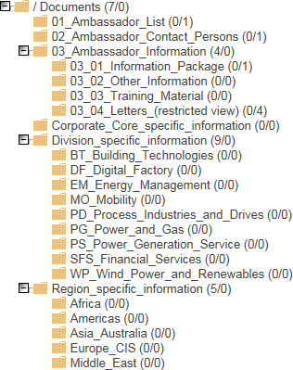

Centralized storage platform

All relevant information (information package and further communication measures, list of appointed Compliance Ambassadors, etc.) will be stored on the workspace centrally.

Additionally, OpCos/Healthcare/ Countries/Corporate Compliance have a folder of their own to share entity specific information with the Compliance Ambassadors. Each Division/Healthcare/ Countries/Corporate Compliance unit is responsible for the administration of its own folder.

Information Package for Compliance Ambassadors

The main purpose of the information package is to support the Compliance Ambassadors with the latest compliance-related news in general.

The package will be updated on a regular basis by LC CB GF based on input from LC CO RFC CA, OpCos / Countries/Corporate Compliance.

All topics are addressing all Compliance Ambassadors – irrespective of the organization they belong to.

The information package will be stored on the workspace in the folder “[03_01_Information_Package](https://l-collaboration.siemens.com/workspaces/comamb/i/Shared%20Documents/Forms/AllItems.aspx?RootFolder=%2fworkspaces%2fcomamb%2fi%2fShared%2BDocuments%2f03_Ambassador_Information%2f03_01_Information_Package)”. Compliance Ambassadors can download the news and activate the auto-alert function.

Training material on Compliance topics will be provided at the folder “[03_03_Training_Material](https://l-collaboration.siemens.com/workspaces/comamb/i/Shared%20Documents/Forms/AllItems.aspx?RootFolder=%2fworkspaces%2fcomamb%2fi%2fShared%20Documents%2f03%5fAmbassador%5fInformation%2f03%5f03%5fTraining%5fMaterial&FolderCTID=0x012000CB468985A794FB4FA24)”.

* + 1. Appointed Compliance Ambassadors and contacts

The OpCos/Healthcare/ Countries/Corporate Compliance are responsible for the administration of the Compliance Ambassadors workspace (concerning content and access rights for own Compliance Ambassadors).

LC CB GF is responsible for technical support of LC Collaboration workspace.

The OpCos/Healthcare/ Countries/Corporate Compliance introducing Compliance Ambassadors must nominate an overall contact person that acts as first line contact for the Compliance Ambassadors. An actual list has to be stored at the workspace in the folder “[02_Ambassador_Contact_Persons](https://l-collaboration.siemens.com/workspaces/comamb/i/Shared%20Documents/Forms/AllItems.aspx?RootFolder=%2fworkspaces%2fcomamb%2fi%2fShared%2BDocuments%2f02_Ambassador_Contact_Persons)”.

The OpCos/Healthcare/ Countries/Corporate Compliance are obliged to enter the names of appointed Compliance Ambassadors in the folder “[01_Ambassador_List](https://l-collaboration.siemens.com/workspaces/comamb/i/Shared%20Documents/Forms/AllItems.aspx?RootFolder=%2fworkspaces%2fcomamb%2fi%2fShared%2BDocuments%2f01_Ambassador_List)” on the workspace and update it accordingly due to personnel changes to ensure proper information flow.

### Compliance Ambassador plus

Due to the specifics of the strategic company “Siemens Mobility” its setup and environment there was a need of enriching the profile of a “Compliance Ambassador” (as described in in chapter 3 of this webbook) by additional tasks. With this enhancement of the standard concept the Ambassador is of more value add for both, business and compliance organization. It is a real “plus” for the overall organization.

* + 1. Business supporting tasks – additional tasks of an Ambassador plus

The **Ambassador plus supports business related tasks** (additionally to tasks described in chapter 3) in the following manner:

* Initial analyzing of internet findings related to business counterparts;
* Supporting bid mangers in performing the Compliance Risk Assessment;
* Supporting filling in the risk assessment of a CDD in the BPC Tool;
* Supporting the analysis whether an existing CDD may be used for a transaction;
* Supporting the execution of RIC controls (within the given boundaries – acting as Independent Assessor with prior approval of the Compliance Officer is possible);
* Information of DP responsible persons about DP related risks, incidents and other topics.
  + 1. Support for the Ambassadors plus

In order to enable the Ambassador plus to perform relevant tasks, he/she will

* receive an education program for Ambassadors plus;
* be granted viewer rights in the (compliance) tools BP Next Gen, SpoDoM and LoA Live Tool;
* be invited to supporting communication channel in Yammer.
  + 1. Appreciation

Ambassadors plus should experience that their efforts are valued and appreciated. This can be done e.g. by invitations to on-site events to strengthen the Compliance Ambassador network and encourage knowledge exchange. In addition, going the extra mile shall also be considered when performing staff reviews.

### Training and supporting material

▌ Compliance Ambassador appointment letter / release letter:

[03_04_Letters_(restricted view)](https://l-collaboration.siemens.com/workspaces/comamb/i/Shared%20Documents/Forms/AllItems.aspx?RootFolder=%2fworkspaces%2fcomamb%2fi%2fShared%2BDocuments%2f03_Ambassador_Information%2f03_04_Letters_(restricted%2Bview))

▌ Compliance Ambassador information homepage:

[Compliance Ambassador Homepage](https://intranet.siemens.com/en/compliance/topics-tools/compliance-ambassador-program.htm)

▌ Compliance Ambassador workspace:

<https://l-collaboration.siemens.com/workspaces/comamb/SitePages/Home.aspx>

▌ ComplianceOrganization:

<https://intranet.siemens.com/en/compliance/divisions.htm>

▌ Compliance Regions:

<https://intranet.siemens.com/en/compliance/regions.htm>

### History of changes

|  |  |  |
| --- | --- | --- |
| **Date** | **Author** | **Major changes of binding content** |
| January 1,  2019 | Ulrich Mueller (LC CO OC MAC),  Tobias Maiwald (LC CB GF) | First release through the Compliance Handbook based on former Compliance Ambassador Guidance V 2.0. |
| April 1, 2019 | Ines Zins (LC CO GR CAS)  Tobias Maiwald (LC CB GF) | Editorial changes due to reorganization of the company. (Vision 2020+) |

|  |  |  |
| --- | --- | --- |
| April 1, 2020 | Fran Girod (LC CO SMO RI)  Ines Zins (LC CO RFC CA) | Inclusion of the Mobility specific Compliance Ambassador plus program as Chapter 3.6. of this guidance |

* 1. Contacts

▌ Compliance Officer

The Compliance Officer responsible for your unit can be found through the following [link.](https://intranet.for.siemens.com/cms/059/en/about/org/Pages/compliance_organization.aspx)

▌ Corporate Governance Owner

Ines Zins (LC CO RFC CA)

### Introduction to risk management and reviews

Compliance risk management and Compliance reviews includes information and guidance with regard to the risk identification, the management of risk in the Compliance Processes and Tools, as well as risk mitigation and the Compliance Review Board.

The following section describes how the Compliance organization ensures the early identification of evolving risks and how these are communicated and mitigated.

# Compliance Risk Assessment

A reliable risk analysis is key for the success of planned Siemens business goals and strategies. It is also the foundation of the Compliance System. Recognizing risks at an early stage helps management to make informed decisions whether to avoid, reduce, transfer or accept certain compliance risks.

One of the prerequisites for proactively managing those risks is to create transparency in relation to the overall risk environment by evaluating the business exposure, openly and self-critically, to defined Compliance risk areas such as, but not limited, to: Anti-Corruption, Antirust, Export Control, Anti-Money Laundering and Data Privacy within the Entity.

The Compliance Risk Assessment (CRA) is one element of the Compliance Risk Management process. It targets a bottom up evaluation of local risk environment in each Siemens Entity worldwide through the CRA workshop.

During the CRA Workshop CEOs, relevant managers, and Compliance Officers meet to systematically determine and assess compliance risks on their respective companies.

CRA results are then incorporated in the group-level compliance risk analysis. The latter aims to identify systematic and globally recurring compliance risks as quickly as possible. The group-level analyses consider additional factors, such as insights from compliance controls and investigations into specific cases. The corporate compliance risks are derived from the consolidated results, which are shared with the company’s business Entities. Relevant risks are reported to the company’s Enterprise Risk Management (ERM).

Risk-reduction measures are drawn up and implemented. These measures are registered and monitored in the CRA Tracking tool. If significant or major risks arise during a year, the responsible CO reports these risks to LC CO RFC RC directly via e-mail and in the CRA Tracking tool. This Ad-hoc risk reporting does not replace Ad-hoc ERM reporting.

The progress of the derived mitigation measures must be monitored regularly, at least twice a year by the respective Entity Compliance Officer, for example, in the Compliance Review Board (CRB).

Besides the CRA Workshop (see Chapter 1.6.2), the CRA process includes an AREA - Antitrust Risk Exposure Assessment (see Chapter 1.6.1) for relevant Entities (see Chapter 1.4) to perform a top-down / bottom-up risk analysis. Both processes are combined and described in this CRA Handbook.

### Purpose

The purpose of this Handbook is to describe how to perform the CRA Workshop and AREA as well as how to define mitigation measures for the identified compliance risks. It also defines the scope and respective frequency.

|  |  |
| --- | --- |
| **CRA** | **AREA** |
| * The goal of the CRA is to evaluate compliance risks within Siemens and to define mitigation measures1 accordingly. * Moreover, the CRA creates an awareness of compliance risks, emphasizes the responsibility of the entity CEO and management in general for compliance-related topics and strengthens cooperation between the Compliance organization and the business entities. * The CRA process requires, among other things, out-of-the box thinking and input that should be collected by Compliance in an organized fashion from observations in the course of the two-year CRA period2. | * The AREA aims to identify the antitrust risk level of the various Siemens entities in a bottom-up manner and to define appropriate follow-up measures. It is carried out by management with the assistance of Legal and Compliance. * The implementation of the appropriate (i.e. risk-based) follow-up measures contributes to minimizing antitrust risks across the Siemens Group. |

### CRA Workshop Benefits

The CRA Workshop supports the CEO and the respective management in:

* + - Identifying potential compliance-related risks (resulting in direct/indirect liability, reputational harm) beyond those already mitigated by existing compliance circulars, tools and controls;
    - Incorporating company experience from investigations, audit findings and other deficiencies to identify potential sources of compliance-related risks;
    - Deciding whether to avoid, reduce, transfer or accept certain compliance risks;
    - Determining appropriate ways to limit the impact of certain risks those risks (mitigating actions);
    - Creating awareness of a compliance risk culture, supporting the CEO on his/her responsibility for risk management and compliance-related topics
    - Gaining a clear understanding of possible underlying compliance risks related to anticorruption, antitrust data privacy, anti-money laundering, human rights and export control.
    - Strengthens cooperation between the Compliance organization and the Business Entities.

1 Mitigation measures/plan and response measures/plan are used synonymously

2 Recommended by Gibson Dunn in its 360°-Compliance Review Report in November 2015

### 1.3 Stakeholders

CRA Workshop

The Entity CEO is responsible for the CRA Workshop execution as well as for the definition of the relevant mitigation measures, thus for the CRA Workshop results.

The Compliance Officer (CO) of each applicable Entity and Region is responsible for coordination and preparation of the CRA workshop (with support and input from the relevant Regional Experts on risk identified,

e.g. antitrust expert for AREA aspects). The CO also reports the workshop results to the Risk Management and Controls department (LC CO RFC RC) and is responsible for tracking and monitoring the implementation status of any defined mitigation measures.

Management’s proximity to the business renders it close to potential compliance risks, thus Management’s input is, therefore, a key source for every risk assessment process.

AREA

The CEO and the General Counsel of the entity are mandatory participants Optional participants are:

* The representatives of the Strategy and Sales department or Business Development
* Other potential stakeholders, such as (for the Lead/Assigned Country AREA meeting) the relevant Regional Antitrust Expert

### Scope

The **CRA workshop** is applicable to the following levels and therefore should be executed in accordance to this guidance:

|  |  |
| --- | --- |
| **\*“CRA Entity”** | **“CRA Region”** |
| * Operating Companies * Corporate Development Unit * Service Companies and * Strategic Companies “Mobility” | * Corporate Country * Lead Countries * *Top Risk Countries3* |

*Please refer to Annex 1 for a listing of applicable units and regions The **AREA process** applies to the following entities:

3 Note that the so-called “Top Risk Countries”, defined by the Compliance Management Team, are also required to perform a CRA Workshop (without AREA) on alternate years.

1. Business Units and Business Segments of the Operating Company Gas and Power;
2. Business Units of the Operating Company Smart Infrastructure;
3. Business Units of the Operating Company Digital Industries;
4. All Corporate Countries (incl. for China the Countries / Regions reporting and for India the Countries reporting to the respective Corporate Country);
5. Business Units and Regions of the Strategic Company Mobility;
6. All Lead Countries and Assigned Countries, irrespective of which Operating Company they report to;
7. Selected central entities, namely: Financial Services (SFS), Corporate Technology (CT), Internet of Things (IOT), Next47 (N47), Portfolio Companies (POC) and Human Resources (HR).

For the *following Regional Companies (“Top 15 AREA Countries”): Austria, Brazil, Canada, China, Denmark, France, Germany, India, Italy, Japan, Saudi Arabia, Switzerland, Spain, United Kingdom and USA, the AREA must be conducted at the Country Operating Company level (including Country Business Unit split), unless the turnover of a Country Operating Company in the respective Regional Company in the last completed financial year was less than €15 million. For all Regional Companies that are not Top 15 AREA Countries, the split by business (Country Operating Company, including Country Business Unit) is optional. The AREA must not be carried out at ARE-level. The AREA results should feed into the CRA preparation.*

List of applicable units and regions for CRA 2020 CRA Entity

Operating Companies: Gas and Power

Smart Infrastructure Digital Industries Strategic Company: Siemens Mobility

Service Companies: Financial Services

Global Business Services Real Estate Services

Corporate Development Unit: Internet of Things

Portfolio Companies

**CRA Region** Corporate Countries: China

Germany (?) India

United States

Lead Countries: Morocco Nigeria

South Africa

United Arab Emirates Australia

Canada Switzerland France Mexico Saudi Arabia Singapore Turkey

United Kingdom

Argentina Austria Brazil Spain Italy Japan

Netherlands Republic of Korea

Russian Federation Sweden

“Top Risk” Countries will be subject to CRA Workshops in FY2021

### Frequency and Timeline

The CRA Workshop must be performed by the respective Entities in scope every two years, starting from FY2020.

The Antitrust Risk Assessment (AREA) must be executed as a mandatory element of the CRA Workshop as described in Chapter 1.6.1

In odd years, the so-called Top Risk Countries are required to perform a CRA Workshop. The CRA workshop results must be documented by the end of Q1 of the Fiscal Year.

***Note that in order to support the worldwide responsibility of the Operating Companies for their business, the “Region CRA workshops” (refer to Chapter 1.4) shall be scheduled first, in October/early November and make the CRA Workshop results available in mid-November for use in the Operating Company CRA’s.***

***The “Company CRA workshops” (refer to*** ***Chapter 1.4******) shall perform their CRA’s in late November/December.***

***The progress of the derived mitigation measures must be monitored regularly, at least twice a year by the respective entity, for example, in the Compliance Review Board (CRB, refer to Chapter K. 2.).***

### CRA Workshop Process Description

The CRA process is divided into six steps. Each step is described in more detail in the following chapters:



Step 1 (Details see chapter 1.6.1 AREA, not applicable for Top Risk Countries when performing a CRA in odd fiscal years):

The AREA is the first step that must be taken. The AREA aims to identify the antitrust risk level of the various Siemens Entities and to define appropriate follow-up measures. It is carried out by management with the assistance of Legal and Compliance.

Step 2 (Details see chapter 1.6.2 Workshop Preparation):

The second step "Preparation" aims to reunite supporting information and key facts to support risk exposure discussions with management. The Entity responsible CO reviews the previous CRA results and defines the frame conditions by analyzing data from different internal and external sources (such as previous or pending cases, reviews and external audits), conducting interviews and preparing the workshop slides (with input from the relevant Regional Antitrust Experts on antitrust/AREA aspects) with key hypotheses and risks agreed with the CEO of the entity.

Step 3 (Details see chapter 1.6.3 Hold Management Workshop):

The CEO is responsible for the CRA results and emphasizes this responsibility by issuing invitations to the CRA workshop.

Step 4 (Details see chapter 1.6.4 Reporting of CRA Workshop Results):

Results are transferred to ERM, if applicable.

Step 5 (Details see chapter 1.6.5 Measures Implementation):

Focus on the response plan. A tool is provided and serves two purposes. Firstly, it serves as input for the further analysis of compliance risks on an aggregate level by LC CO RFC RC. Secondly, the CRA tracking tool can be used by the entity to implement the response plan and monitor the mitigation measures.

The results of the CRA and the mitigation measures, as well as the implementation of the latter, must be discussed and monitored regularly (at least twice a year) during Management Meetings (such as CRB).

Step 6 (Details see chapter 1.6.6 Transfer to ARE):

Finally, the CRA results are transferred to the AREs. Within the AREs, management reviews the CRA results and implements mitigation measures if applicable. In the case of newly identified risks that have not been reported by the CRA Entities and CRA regions so far, should be reported by the responsible CO of the ARE accordingly.

* + 1. Conduct an Antitrust Risk Exposure Assessment

To conduct and Antitrust Risk Exposure Assessment (AREA) is the first step that must be taken. The AREA aims to identify the antitrust risk level of the various Siemens Entities and to define appropriate follow-up measures. It is carried out by management with the assistance of Legal and Compliance.

The AREA Step 1. is not applicable for Top Risk Countries who only perform a CRA workshop, consisting of Steps 2 to 6 in odd fiscal years:

The following figure provides an overview of the process step “Conduct AREA”.



* + - 1. **Instruct sub-levels:** The relevant OpCo CO, Corporate Country CO (for China and India) and the Lead Country CO inform the relevant COs responsible for the entities listed in 1.4 above about the current AREA process and the tasks to be performed. The COs responsible for Regional Companies inform the relevant Regional Antitrust Expert accordingly.
      2. **Prepare Meeting:** The respective CO responsible for the entities listed in 1.4 above must prepare the AREA meeting together, in the case of Regional Companies, with the relevant Regional Antitrust Expert. He can optionally discuss in advance the antitrust-related questions contained in the Excel template (see [risk department](https://intranet.siemens.com/en/Compliance/topics/Compliance_risk_assessment.htm) or [LC M&A CMP](https://intranet.for.siemens.com/org/lc/en/legal/orga/cmp/Pages/cmp.aspx?tabcardname=area) [homepage](https://intranet.for.siemens.com/org/lc/en/legal/orga/cmp/Pages/cmp.aspx?tabcardname=area)) with the General/ Legal Counsel and selected Key Support Functions. As a further preparation step, the Business Unit/Regional Company CO together with the Regional Antitrust Expert must review antitrust-related cases in TRACI within his area of responsibility.
      3. **Conduct meeting:** During the AREA meeting, the antitrust-related questions must be answered, and the CEO is required to sign the results.
      4. **Define measures:** Completion of the questions in the relevant AREA template will result in an overall antitrust risk rating of low/medium/high. Based on this rating, management is required with the assistance of Legal and Compliance to determine, implement and document appropriate follow-up measures (recommended measures are provided on risk department / LC M&A CMP homepage). The defined follow-up measures can also be used for CRA mitigation measures. Please note that if a “high” antitrust risk has been identified, LC M&A CMP and LC CO IR must be consulted prior to determining the appropriate follow-up measures. In all other cases, LC M&A CMP and LC CO IR may choose to verify any entity's bottom-up risk assessment and follow-up measures in a top-down approach. The Monitoring Sheet provided on risk department / LC M&A CMP homepage can be used to monitor the implementation progress of defined follow-up measures.
      5. **Report results**: Finally, the Excel file containing the AREA results must be sent by encrypted email to LC M&A CMP using the following email address ([area-results.legal-](mailto:area-results.legal-compliance@siemens.com) [compliance@siemens.com](mailto:area-results.legal-compliance@siemens.com)) and indicating in the subject line which entity the AREA results relate to. Once the Excel file has been sent to LC M&A CMP, the original signed document should be filed locally. For further information on the AREA and the applicable AREA templates please consult the [LC M&A CMP intranet homepage](https://intranet.for.siemens.com/org/lc/en/legal/orga/cmp/Pages/cmp.aspx) or the Q&A (see risk department / LC M&A CMP homepage).
    1. Prepare CRA Workshop



The second step "Preparation" aims to reunite supporting information and key facts to support risk exposure discussions with management.

The responsible CO of the entity (with input from the relevant regional risk topics experts) reviews previous CRA results and defines the frame conditions by analyzing data from different internal and external sources (such as previous or pending cases, reviews and external audits), conducting interviews and preparing the workshop slides (with input from the relevant regional risk topics experts) with key hypotheses and risks agreed with the CEO of the entity.

The respective CO is responsible (with input from the relevant regional risk topics experts) for the preparation of the CRA workshop, whereas the CEO is responsible for the CRA results. The CEO should therefore be informed about the critical points of the analysis during the preparation phase.

1.6.2.1 Review Mandatory Inputs

In general, only the risk and mitigation measures from the previous CRA4 and the previous AREA results are mandatory input, but (for thorough preparation) other inputs are recommended in order to obtain a complete picture of the compliance risk situation. Central material has been prepared and can be used to facilitate discussions with the responsible risk owners. These materials will be part of the training sessions.

* + - 1. **Previous CRA results:** Review mitigation measures taken, especially if they are still open. The CO and the CEO decide for each open response measure from the previous assessment whether to close it or to transfer it to the new CRA risk identification.
      2. **Previous AREA results:** The last available AREA should feed into the CRA preparation phase. For further information on the AREA and the corresponding AREA templates, consult the [LC](https://intranet.w1.siemens.com/cms/legal/en/sfs/Pages/comp.aspx?tabcardname=AREA) M&A CMP intranet homepage.
      3. Review and analyze available data

The goal is to perform an analysis of the business activities and processes in order to understand the possible underlying compliance risks. It is highly recommended that the responsible CO (with

4 If applicable

input from the relevant regional risk topics experts) analyzes any information and reports he may already have on hand. This helps to refresh the awareness of the compliance topics already addressed through circulars and tools.

* + - 1. Prepare key risks for discussions

The last step before the management workshop is to concentrate the analysis on certain key statements and to focus the risk identification on certain risk areas. The risk areas provide plenty of risk examples and potential mitigation measures. Specific risk descriptions that don’t fit into predefined risk areas can be described under the risk area "Individual risks" (see CRA training slides). The COs are responsible (with input from the relevant regional risk topics experts) for summarizing this information. They are encouraged to prepare critical questions to be asked at the management workshop.

* + 1. Hold Management Workshop



The CEO is responsible for the CRA results and emphasizes this responsibility by issuing invitations to the CRA workshop.

The management workshop is the core activity in the process. During the workshop, management discusses, identifies and analyzes the compliance risks for the entity. Decisions are taken regarding the importance and priority of the risks and the corresponding mitigation measures.

* + - 1. Invitation of participant

The responsible CO consults with the CEO based on the discussion with the relevant risk regional experts, to decide who should participate in the CRA management workshop and whether one or more CRA workshops (split by Regions, Business Units or functions) need to be held. The agreed dates should be communicated to LC CO RFC RC.

A certified public accountant (such as Ernst & Young) has the right to participate in the management CRA workshop.

The meeting invitation to the management workshop is sent by the CEO, or the CEO and the responsible CO jointly.

It is highly recommended that the CRA workshop is held prior to the entity's ERM workshop.

* + - 1. Execution of Management Workshop

Consider that the time assigned for the workshop should allow enough time for deep discussions and measures description.

The already identified hypotheses and risks during the preparation phase shall be discussed and agreed with management during this workshop.

in order to identify potential new compliance risks a creative brainstorming session shall be conducted in the workshop to encourage participants to "think outside the box". Without this brainstorming session it might happen that only known risks and patterns are identified but new arising topics might be overlooked or are identified too late.

The risks identified are prioritized to obtain a rating of all risks. The rating order is from Top 1 (the most critical risks, the most important risks for the entity and the risks that most urgently require mitigation measures to be defined and implemented) to Top 5.

All risks defined in the CRA management workshop must be classified for Enterprise Risk Management (ERM) ad-hoc reporting relevancy, based on management judgment. Relevant risks must subsequently be treated according to the ERM process and assessed with the ERM methodology.

Finally, a response plan for all risks must be created with the following information:

* Risk description: “there is a risk that…, which may lead to…”
* Measure
* Risk Owner
* Relevant for ERM reporting (Y/N)
* Transferred from last CRA (Y/N)
* Priority (Level 1-5)

Note that an existing compliance case cannot be reported as a risk within the CRA process because, in logical terms, this risk has already materialized.

HR relevant risks are not to be reported in the CRA workshop, contact HR department to address them accordingly.

* + 1. Report CRA Workshop Results



The results of the CRA workshops and the local monitoring of response plans were formerly reported in Excel, without the possibility of a central evaluation in a timely manner. The use of the known CRA Input Sheets and the CRA SharePoint is discontinued. Based on the Audit Management System (AMS) of CF RIC ATC, a new Compliance Risk Tracking Tool is provided that ensures reporting and allows local tool-based monitoring of response plans implementation as well as central analysis. As an additional function, notification e-mails have been configured to alert people in charge of implementation, informing them about newly created response plans and the reaching of deadlines.

The new tool is available as of now (CRA2018) for the Top-Risk Countries 2018 and must be used starting from CRA2020 for the CRA Entities and CRA Regions.

Identified compliance risks and their corresponding mitigation measures have to be entered in the CRA tracking tool accessible here: <https://revweb.siemens.net/ams/index.cfm?go=app.welcome> PKI login. The

responsible Compliance Officers of the CRA Entities and CRA Regions are currently registered as users. For further access rights please contact [LC](mailto:CRA.legal-compliance@internal.siemens.com) CO RFC RC

The implementation of the mitigation measures must be documented promptly in the CRA tracking tool to enable local and central tracking.

The MoM of the CRA workshop should be sent via email to the Risk Management and Mitigation department (LC CO RFC RC) as evidence for CCP controls and EY.

1.6.4.1. Reporting to ERM

The responsible CO reviews the management workshop results, ensuring that the underlying risk description and mitigation measures are understandable. Then he informs the relevant risk owner of his assignment. The CO works with the risk owner to implement appropriate mitigation measures.

ERM is designed to manage risk rather than eliminate it completely, and to provide a degree of assurance covering all business objectives of Siemens. CRA complements the ERM process to broaden the identification of potential compliance risks, and thus serves as a qualified ERM input.

The following figure provides an overview of the process step "Report to ERM".

|  |  |
| --- | --- |
| **CRA** | **ERM** |
| * Internal compliance risk assessment process * Focuses purely on compliance risks, ranked by prioritization * No central status reporting of mitigation measures * Entity is responsible for timely risk mitigation * Basis for internal compliance risk analysis | * Enterprise risk management system * Broad focus on strategic, operational, compliance and financial perspective * Quarterly reporting to Corporate RIC Board * Entity is responsible for timely mitigating risks * Basis for external disclosure of risks and opportunities for SAG |

The CRA provides a structured and harmonized approach to prepare a qualified annual ERM workshop. The CRA serves as a filter to ERM. Not all compliance risks will be reported to ERM (based upon management judgment). When applying management judgment, it is recommended that the impact on the overall business objectives of an entity be considered, represented by the ERM impact dimensions.

Option 1: One compliance risk entered in the CRA equals one risk in ERM.

Option 2: Several compliance risks entered in the CRA are combined to form one risk in ERM. Option 3: The compliance risk entered in the CRA is of no relevance to ERM.

* + 1. Implement Measures



The responsible CO reviews the management workshop results (with input from the relevant Regional Antitrust Experts on antitrust/AREA aspects), ensuring that the underlying risk description and mitigation measures are understandable. Then he informs the relevant risk owner of his assignment. The CO works with the risk owner and with the Regional Antitrust Expert regarding identified antitrust risks to implement appropriate mitigation measures.

Once the defined response plan has been approved by the CEO and entered in the CRA tracking tool, the mitigation measures need to be implemented, tracked in the tool and their status to be monitored regularly. The responsible CO informs the management at least bi-annually, for example in CRB, about the risk’s status and the status of mitigation measures.

Risks reported to ERM follow the [ERM process](https://intranet.w1.siemens.com/cms/finance-controlling/en/org/dep/cfric/tm/Pages/tm.aspx) as well as the entity's internal risk mitigation process.

* + 1. Transfer to AREs



The final step is to transfer the results of the CRA to the AREs of the corresponding Entities. The following figure provides an overview of the process step "Transfer to ARE". This is only required for Audit Category 1 and Category 2 Entities (for further details, see the [Compliance ARE Master list](https://findit.compliance.siemens.com/content/10000101/Compliance/LC_CO/LC_CO_STR_SP/findIT_LC_CO_STR_SP_4272.xlsx)).

The responsible CO of the respective CRA Entity and CRA Region distributes the CRA Workshop results according to their area of responsibility or the assigned AREs respectively, by the end of Q1.

Within the ARE, the CO and ARE Management can define and implement additional mitigation measures for the relevant risks of the ARE. The risks and the response plan status of the ARE risks must be monitored within the ARE. This does not impact the reporting and monitoring defined for CRA Entity and CRA Region.

### History of changes

|  |  |  |
| --- | --- | --- |
| **Date** | **Author** | **Major changes of binding content** |
| January 1, | Thomas Mark | First release through Compliance Handbook based |

|  |  |  |
| --- | --- | --- |
| 2019 | (LC CO GR RM) | on former CRA Web-Book. |
| August9, 2019 | Thomas Mark (LC CO GR RM)  Andrew Copland-Cale (LC CO GR RM) | Adjustments to the text to reflect the new Siemens organizational structure, structure changes and editorial simplifications |
|  | Jennifer Garcia Rodriguez  (LC CO GR RM) |  |
|  | Gordon Christian  (LC M&A CMP) |  |
| January 1,  2020 | Koen Miezenbeek (LC CO RFC LF) | Update due to organizational changes |

* 1. Contacts

▌ Compliance Officer

The Compliance Officer responsible for your unit can be found through the following [link.](https://intranet.for.siemens.com/cms/059/en/about/org/Pages/compliance_organization.aspx)

▌ Corporate Governance Owner

[Jennifer Garcia Rodriguez](https://scd.siemens.com/luz/IdentitySearch?cn=Z002CDAJ&maxanz=50&suchart=schnell&utI=I&utX=X&utT=T&rtH=H&rtS=S&rtZ=Z&rtO=O&rtAktiv=A) (LC CO RFC RC) AREA: [Georg Böttcher](https://scd.siemens.com/luz/IdentitySearch?cn=BOETTCHER%2BGEORG%2BZ001PJ1T&tcgid=Z001PJ1T&c=DE&o=SIEMENS&ou=LC&l=MCH%2BP&department=LC%2BM%26A%2BCMP&&utI=I&utX=X&utT=T&rtH=H&rtS=S&rtZ=Z&rtO=O&rtAktiv=A) (LC M&A CMP)

# Compliance Review Board

Management's responsibility also includes regularly and systematically reviewing and evaluating the effectiveness of the Compliance System in conjunction with the Compliance Officer in a Review Board (see [SC 226](https://srs.siemens.cloud/%23/c/fs8o2k) [Management responsibility](https://srs.siemens.cloud/%23/c/fs8o2k)).

The “Compliance Review Board” (CRB) must be performed by COs of Businesses, Governance & Service Units and Lead Countries for each quarter of the company’s fiscal year, **covering the Company Unit performing the CRB and all Company Units assigned to it**. The CRB is also performed by the Managing Board of Siemens AG. The CRB must be established via a charter and must be held in person either separately or together with another management meeting.

This section defines mandatory requirements for the setup and performance of a CRB with the aim of

* improving compliance efficiency by using a risk-focused approach and raising awareness on the relevant topics and developments.
* further strengthening collaboration and a qualitative dialog between management and Compliance Officers in the Company Units.
* supporting the systematic and periodic management review of the implementation of the Compliance System, taking into consideration the respective (local) environment and risks and enabling related decision-making.

### Applicability

This section applies to a CRB performed by the Company Units as set out in the following. It is not applicable to a CRB with the Managing Board and the Compliance Committee of the Siemens AG Supervisory Board.

A CRB must be performed by COs of Businesses, Governance & Service Units and Lead Countries for each quarter of the company’s fiscal year.. The Chief Compliance Officer may determine exclusions, such as a lower frequency for selected Company Units.

A CRB covers the Siemens Company Unit performing the CRB, including all Company Units assigned to it. An overview of the units, covered by the CRB, shall be at least provided in the back- up presentation slides (ARE based).

The Compliance Officer of a Company Unit may determine the performance of a CRB in the units assigned to the respective Company Unit (e.g. Business Units, Assigned Country or Portfolio Company); the performance of a CRB in assigned countries with a Compliance Officer on-site is recommended. This instruction is also applicable to a CRB performed in such assigned Company Units.

### Performance of a CRB

The minimum mandatory participants of a CRB are the CEO/Head – who chairs the CRB – together with the CFO, the General Counsel and the Compliance Officer of the Company Unit performing the CRB.

A CRB should be held no later than six weeks following the end of the respective quarter.

As a general rule, a CRB is held in person either separately or in conjunction with a management meeting performed for other reasons. It is also possible to hold other compliance-related management meetings in conjunction with a CRB. If a mandatory participant is unable to attend in person and a postponement of a CRB is not feasible, remote attendance is possible via telephone conference or Circuit Meeting, for example.

The Compliance Officer prepares the compliance review (= CRB presentation).

**Each CRB is documented by separate written minutes, including the list of participants, decisions made, action items, and the compliance review.**

### Content of a CRB

Mandatory topics for the Compliance Review Board

A CRB must cover the mandatory topics stated in the table below, which must be reported by COs of Businesses, Governance & Service Units and Lead Countries either for each quarter or only for selected quarters of the company’s fiscal year. They can be presented in a qualitative and/or quantitative way. If not specifically requested by LC CO RFC, the topics may be reported in any style.

|  |  |  |  |  |
| --- | --- | --- | --- | --- |
|  | | | | |
| **Mandatory topics** | **Q1** | **Q2** | **Q3** | **Q4** |
| **Compliance cases incl. EX** | **o** | **o** | **o** | **o** |
| **Business partners** | **o** | **o** | **o** | **o** |

|  |  |  |  |  |
| --- | --- | --- | --- | --- |
| **Compliance Risks** | **o** | **o** | **o** | **o** |
| **Export Control** | At least once a year,  if relevant more frequently/quarterly | | | |
| **Data Privacy** | At least once a year,  if relevant more frequently/quarterly | | | |
| **Compliance Communication strategy and plan** | At least once a year,  if relevant more frequently/quarterly | | | |
| **Compliance Training** | At least once a year,  if relevant more frequently/quarterly | | | |

* + 1. Compliance cases

|  |  |  |
| --- | --- | --- |
| **Topic** | **Compliance cases**  Development of central and local cases, trends and mitigation measures, disciplinary sanctions | |
| **Frequency** | Quarterly | |
| **Content** | **Topics** | **Description** |
| Case development | Cases open at the end of the previous quarter, additional cases in the present quarter, closed cases in the present quarter, open cases by the end of the present quarter; cases  >9 months old |
| Progress phase | Pre-evaluation, clarification, remediation |
| Key issues and significant trends | Please give information corresponding to the key compliance issues that have been detected in the cases, such as issues concerning a specific sales channel or department. |

|  |  |  |
| --- | --- | --- |
|  | Mitigation measures | Please list the significant mitigation measures that have been implemented to mitigate risks detected during the clarification of cases, such as activities concerning an entire department, several units (AREs) or the Regional Companies (RC); measures concerning a sales channel or a certain business type; activities that require an analysis or review of local policies, systems or tools, and so on. |
| Disciplinary sanctions | Sanctions for non-compliant behavior |

* + 1. **Export Control**

|  |  |  |
| --- | --- | --- |
| **Topic** | **Export Control** | |
| **Frequency** | Once per year | |
| **Content** | **Topics** | **Description** |
| Monitoring ICP Compliance | * Status of MONA self-assessments (Spot Checks) * Detected violations of export control and sanctions regulations * Results of external and internal audit * Status of issued remediation actions |
| Processes | * Relevant changes in national export control legislation * Regulatory changes with significant Impact on Siemens business * Status of implementation of Siemens global Internal Control Program (ICP IST), including country-specific Export Control regulations * Initiated measures to ensure sustainable correct partner screening process |
| Focus Risk Topics | * Relevant business with critical countries and with critical end-use (as per the ICP EX) * EX measures for e-business (e.g. online shops), software and technology transfer |

* + 1. Business partners

|  |  |  |
| --- | --- | --- |
| **Topic** | **Business partners** | |
| **Frequency** | Quarterly | |
| **Content** | **Topics** | **Description** |
| Management awareness regarding responsibility | * reporting of significant changes in the BP portfolio (e.g. new high-risk BPs) * reporting of significant allegations of specific BPs (e.g. cases, press releases) * Audit findings regarding BPs |
| Business Partner landscape and environment | - e.g. review of need for the relationship/performance of BP, planned on-site visits (Compliance on site check), |
| Focal points/ red flags | * BPs from other units * Highest-risk BP relationships |

* + 1. **Compliance Communication strategy and plan**

|  |  |  |
| --- | --- | --- |
| **Topic** | **Compliance Communication strategy and plan** | |
| **Frequency** | Once per year | |
| **Content** | **Topics** | **Description** |
| Prozesse | * Implementation and localization of global Communication strategy and plan including:   + internal and external target group communication   + Tone from the Top * Reporting on implementation status previously aligned communication activities |

* + 1. Data Privacy

|  |  |  |
| --- | --- | --- |
| **Topic** | **Data Privacy** | |
| **Frequency** | Once per year | |
| **Content** | **Topics** | **Description** |

|  |  |  |
| --- | --- | --- |
|  | Cases and legal development.  Business impact | * Cases within Siemens or other data breaches * New data privacy requirements * Results from internal audits * Business relevant questions of customers in regard to data privacy |

* + 1. **Compliance Training**

|  |  |  |
| --- | --- | --- |
| **Topic** | **Compliance Training** | |
| **Frequency** | Once per year | |
| **Content** | **Topics** | **Description** |
|  | For Lead Country COs:  2-year training roadmap | - 2-Year training roadmap incl. regional training landscape (global and local mandatory activities) and status of training activities. Approval needs to be documented in CRB minutes. |
|  |  | - After one year: Interim review after one year: Implementation status and identified need for adaptations necessary for the following FY and approval of adaptations |
|  |  | - After 2 years: Evaluation of complete implementation of the training roadmap and introduction of new training roadmap |
|  | For: Siemens Businesses (SI, DI, SMO), Service & Governance CO: CO training landscape | - Presentation of CO training landscape, incl. global mandatory activities and specific training needs according to current business risks |

* + 1. Compliance Risks

|  |  |
| --- | --- |
| **Topic** | **Relevant Compliance Risks, Mitigation and Remediation Measures** |
| **Frequency** | Quarterly |

|  |  |  |
| --- | --- | --- |
| **Content** | **Topic** | **Description** |
| Compliance Risks | Compliance Risks should be reported on a quarterly basis.  There are generally no restrictions regarding the selection of the risk topic(s) (overview of all risks or focus on one specific risk). (Re)emerging Risks1 should be considered as well. |
| **Apart from reporting specific risks, following topics can be considered:** | |
| Status of risk mitigation (CRA and ERM) | Report on the implementation status of the measures planned to mitigate identified risks resulting from continuous monitoring, CRA and ERM. |
| Feedback Awareness Topics | Statement on the applicability of the awareness topics (risk) based on the evaluation in the area of responsibility, including specific identified risks and planned mitigation measures. [Find the link here](https://compliance.siemens.cloud/c_risk.html) |
| CCP | Status of remediation of deficiencies. |

1 Please consider a (re)emerging risk as a change or increase of known (familiar) risks or risks that become apparent in new or changed conditions e.g. new technologies, regulatory changes, economic pressure. E.g., local corruption cases might increase due to competitive business environment post corona crisis.

As a general guidance you might consider to evaluate the following areas to facilitate discussions over potential

(re) emerging risks.

* **Business strategy**: Internal changes as entering in unfamiliar business fields by acquiring new business (M&A) or developing new products (R&D); developing new sales objectives (entering in **new** markets, getting critical customers, doing business with new critical/risky countries, developing new business models, associating with new third parties); Organizational changes (decentralized structures operating in many locations and delegated decision-making authority).
* **Business external environment:** External influences beyond the control of the organization, e.g., changes in the economic environment, new global technologies and highly competitive environments.
* **Regulatory environment**: An external influence and more relevant to compliance risks, all applicable statutory, regulatory, contractual and professional obligations and duties. E.g., the amount of government oversight and law enforcements, fines imposed and cases prosecuted.
* **Compliance and Risk Management Culture:** Management and employees commitment to risk management process, bonus culture that might reward excessive risk taking, clean business decission making, messages and attitudes towards risk identification activities and mitigation strategies of risks, changes in mechanism for internal risk assessments and compliance incidents records and treatment.
* **People awareness and skills**: Deficiencies in employee training, skills and knowledge, available assigned resources and management oversight over compliance topics.
  + 1. Optional topics

Optional topics are important topics that can and should be reported in a CRB when applicable and if necessary, at the discretion of the Compliance Officer. The Compliance Officer decides whether to include a topic, taking into consideration his or her own observations or inputs from relevant internal sources – such as the results of a CRA workshop, case-related or audit findings – and external developments. The CEO/Head of the Company Unit may also decide to include further topics. It is recommended that such decisions be documented in writing together with the key considerations.

The following table contains a non-exhaustive list of optional topics and a proposed frequency for the CRB. The topics can be presented in a qualitative and/or quantitative way, and any reporting style may be chosen.

|  |  |  |  |  |
| --- | --- | --- | --- | --- |
|  | **Proposed frequency** | | | |
| **Optional topics** | **Q1** | **Q2** | **Q3** | **Q4** |
| Anti-money laundering | o | o | o | o |
| Collective Action | o |  | o |  |
| Competition and compliance (Antitrust) | o | o | o | o |
| Compliance communications |  | o |  | o |
| Compliance Control Program |  |  | o |  |
| Compliance in minority investments | o |  | o |  |
| Gifts and hospitality | o | o | o | o |
| Human Rights | o |  | o |  |
| Mergers and acquisitions |  | o |  | o |
| Permanent establishments | o |  | o |  |
| Procurement, purchasing and payments | o | o | o | o |
| Project management (sales and execution phases) |  | o |  | o |
| Rules, regulation and circulars | o | o | o | o |
| Results of the Siemens Global Engagement Survey for the Integrity & Compliance category |  |  | o |  |
| SpoDoM (compliance-related topics) | o |  |  |  |
| Significant developments in the regulatory environment (OpCos/: market segment; Regions/Countries: local regulations; Corporate: area/function, e.g. labor law) |  | o |  |  |

If you have any questions regarding the optional topics, please contact the corresponding governance owner directly.

### CRB charter

The Compliance Officer, in consultation with the CEO/Head of the respective Company Unit, may further specify or extend the requirements of this section for the performance of a CRB (such as further mandatory participants beyond those determined in section 3 of this section, preparation or frequency, mandatory stand-alone performance).

Such determinations must be included in the CRB charter of the respective Company Unit.

The CEOs/Heads of the Operating Companies, Service Companies, Corporate Development departments, Governance departments, Corporate Countries and Lead Countries must establish a CRB charter either with unlimited validity or for a specific fiscal year.

At the very least, the CRB charter must define

* the purpose of the CRB,
* the mandatory participants and their roles,
* the general coverage of the CRB as stated in section 2 of this section,
* the mode and frequency of performance,
* the documentation of a CRB,
* and the requirement to document decisions made and action items defined in a CRB.

### Submission of CRB documents

Information will be updated soon. In case of questions please contact [ines.zins@siemens.com.](mailto:ines.zins@siemens.com)

### Exceptions

The Chief Compliance Officer may approve deviations to the requirements contained in SC 226, Chapter 4.6 or this section if requested by a Compliance Officer. The deviations should be included in the CRB of the following quarter and the information of approval should be provided. (Information will be updated soon. In case of questions please contact [ines.zins@siemens.com](mailto:ines.zins@siemens.com).)

In case of shifting mandatory topics from CRB Q3 to the following FY, a status report of the mandatory topics should be provided.

### Training and supporting material

* 1. History of changes

|  |  |  |
| --- | --- | --- |
| **Date** | **Author** | **Major changes of binding content** |
| January 1,  2019 | Ines Zins, (LC CO GR CAS) | First release through Compliance Handbook based on Siemens Circular SC No.226 “Global Compliance”, Appendix 8. |
| April 1, 2019 | Ines Zins (LC CO | Editorial changes concerning the reorganization of the |
|  | GR CAS) | company. |
| March 31, | Ines Zins (LC CO | Deletion of mandatory topic 'High risk payments' |
| 2020 | RFC CA) |  |
| October 1,  2020 | Ines Zins (LC CO RFC CA) | Implementation of new mandatory topics and frequency as defined in the Fresh Eyes Project. |

### Contacts

▌ Compliance Officer

The Compliance Officer responsible for your unit can be found through the following [link.](https://intranet.for.siemens.com/cms/059/en/about/org/Pages/compliance_organization.aspx)

▌ Corporate Governance Owner

The contact person for Compliance Review Boards is: [Ines Zins](https://scd.siemens.com/luz/IdentitySearch?tcgid=Z003A3VJ&output=print&lookUp=yes) (LC CO RFC CA)

# Compliance Control Program

The Compliance Control program (CCP) is one of the core elements of the Compliance system at Siemens and is implemented in Siemens entities and its affiliated companies on a global scale. It is an integral part of the [Policy &](https://apex2.cit.siemens.de/pls/apex/f?p=101%3A10%3A33676766247531%3A%3ANO%3A) [Control Masterbook (PCMB),](https://apex2.cit.siemens.de/pls/apex/f?p=101%3A10%3A33676766247531%3A%3ANO%3A) which covers all compliance-related areas, such as Business Partners, SpoDoM Compliance activities,Export Control ICP etc.. They are assessed through the Risk and Internal Control (R/IC/) System to identify Compliance risk areas.

### Overview

All Siemens entities are required to implement an effective and efficient Risk and Internal Control (R/IC/) System within their area of responsibility. The LC CO Organization is in place to provide the guidance, support and expertise needed to successfully implement, monitor and maintain an effective Compliance Control Program.

R/IC/ supports the Managing Board in its responsibility to manage risks effectively and provide reasonable assurance that the organization’s assets are safeguarded, financial reporting is reliable, and laws and regulations are complied with.

* Are basically controls within R/IC/ to ensure that the established Compliance process is working properly
* Forms part of the Policy and Control Master Book (PCMB) of CF A IC
* Consists of 3 Compliance Controls Requirements from LC CO RFC RC
* Fosters compliance throughout all three compliance dimensions (Prevent – Detect – Respond) in the activity fields of Anti-Corruption, Antitrust, Anti-Money Laundering, Data Privacy, Export Controls and Human Rights
* Promotes continues improvement of the Siemens Compliance System

**Compliance Control Program (CCP) – Overview**

*Chart 1: “CCP -Overview”*

### Goal and scope

The Compliance Control Program aims at ensuring the adherence and implementation of the globally applied Compliance System and Processes. The CCP is being continually refined and customized in order to comply with the current Siemens Guidelines. Changes within the Siemens Group and suggestions for improvement from operative units are incorporated into the revision on a regular basis.

Current priorities

The PCMB contains control requirements from LC CO to foster Compliance throughout all Compliance dimensions in the fields of Anticorruption, Antitrust, Anti-Money Laundering, Data privacy, Export Control and Human Rights.

### Training and supporting material

* [R/IC/ Methodology and Manual](https://intranet.for.siemens.com/cms/054/en/processes/publications/Documents/RICManual.pdf)
* [CCP Homepage](https://intranet.for.siemens.com/cms/059/en/processes/publications/Pages/compliance_control-framework.aspx)

### History of changes

|  |  |  |
| --- | --- | --- |
| **Date** | **Author** | **Major changes of binding content** |
| January 1,  2019 | Laszlo Nagy | First release through the Compliance Handbook based on Siemens Circular SC No. 226 “Global Compliance”. |
| January 1,  2020 | Koen Miezenbeek  LC CO RFC LF | Update due to organizational changes and for the new edition of the PCMB |
| September 16,  2020 | Axel Frey  LC CO RFC RC C | Update due to new Compliance Control Program (CCP) |

* 1. Contacts

▌ Compliance Officer

The Compliance Officer responsible for your unit can be found through the following [link.](https://intranet.for.siemens.com/cms/059/de/about/org/Pages/compliance_organization.aspx)

▌ Corporate Governance Owner

The contact person for CCP is:

[Andrew Copland-Cale](https://scd.siemens.com/luz/IdentitySearch?cn=COPLAND-CALE%2BANDREW%2BZZZZZ9CK&tcgid=ZZZZZ9CK&c=DE&o=SIEMENS&ou=LC&l=MCH%2BP&department=LC%2BCO%2BRFC%2BRC&&utI=I&utX=X&utT=T&rtH=H&rtS=S&rtZ=Z&rtO=O&rtAktiv=A) (LC CO RFC RC)

1. Introduction to Case Handling, Discipline and Remediation

The overall governance for the handling of compliance cases at Siemens is with Compliance Regulatory:

* + Compliance Regulatory is responsible for investigating compliance cases where required and for taking actions including disciplinary and remediation measures when chargeable violations by Siemens employees are identified.
  + There is no differentiation between “local” and “central” cases.
  + All cases are being classified following a risk based approach as “low”, “medium”, and “high” risk cases; this classification is being done from a corporate view in the meaning that “high” risk cases can have a big impact on the global Siemens company, “medium” risk cases usually have an impact on the involved business unit and / or the country only, and “low” risk cases have no immediate risk for the company (but still could turn out to be “medium” or “high” risk cases in course of the case development).

Compliance cases concern in particular violations of criminal or administrative law and related internal regulations as well as criminal or administrative proceedings against the company or its employees.

Therefore, each compliance case handled at Compliance Investigation & Regulatory has a designated lawyer from Compliance Investigation & Regulatory Central Function assigned to the case for its whole lifecycle. The lawyer is handling the case from the receipt of allegations, the plausibility check, the preparation of the mandate to be issued, the investigation together with the investigator, the remediation together with the remediation manager and labor lawyer, to the final legal aspects before closing the case. The lawyer is giving legal advice on all compliance related matters caused by the case.

The legal advice from the team members of Investigation & Regulatory Central Function together with the fact finding activities from the Investigation & Regulatory Case Handling team as well as the specialized input from the Remediation & Discipline team safeguards company interests worldwide in major investigations by public prosecutors and other law enforcement authorities against Siemens AG, Siemens Regional Companies, affiliates and/or employees. In this context, the lawyers at Compliance Legal also handle information requests from authorities (in Germany and worldwide).

The Compliance Investigation & Regulatory Remediation & Discipline team ensures proper response to the findings form investigations. It supports the business and tracks the implementation of recommendations included in the investigation reports in order to ensure that identified deficiencies are eliminated and has governance responsibility for the disciplinary process resulting from non-compliant behavior, including steering the (regular and accelerated) Central Disciplinary Process,

**Principles**

▌ If you become aware of a plausible allegation of a compliance case, e.g. of

* a violation of criminal or administrative law or
* a violation of a Siemens-internal regulation relating to criminal or administrative law (for example, the Business Conduct Guidelines)

▌ use for reporting one of the following contacts

* the [Chief Compliance Officer,](https://intranet.siemens.com/cco)
* the Compliance Officer responsible for the [Division, Business Unit or country,](https://intranet.siemens.com/compliance-divisions)
* the [Tell Us](https://intranet.siemens.com/tellus) reporting channel or
* the [Siemens Ombudsman](https://intranet.siemens.com/ombudsman)
* [or the colleagues from Compliance Investigation & Regulatory Central Function](https://scd.siemens.com/luz/IdentitySearch?sn&sngenau&gn&gngenau&tcgid&psn&psngenau&nn&nngenau&c&cgenau&o&ogenau&l&lgenau&dep=LC%2BCO%2BIR%2BCF&depgenau&bau&bauUml&baugenau&room&roomUml&roomgenau&tn&tns=all&tngenau=contains&fax&faxgenau=contains&mail&mailgenau&are&aregenau&cost&costgenau&orgid&orgidgenau&sponsor&gidMan1&utI=I&utX=X&utT=T&rtH=H&rtS=S&rtZ=Z&rtAktiv=A&rtO=O&maxanz=50&suchart=detail&utG=G)

**History of changes**

|  |  |  |
| --- | --- | --- |
| **Date** | **Author** | **Major changes of binding content** |
| April 1, 2019 | Bernd Plagemann | Discontinuation of the differentiation between central and local cases. |

## Process Principles

These three sub-chapters provide summaries in connection with compliance cases. The summaries are designed to reflect the different aspects: the process, main messages for the conduct and to answer the most obvious practical questions.

## Process Overview

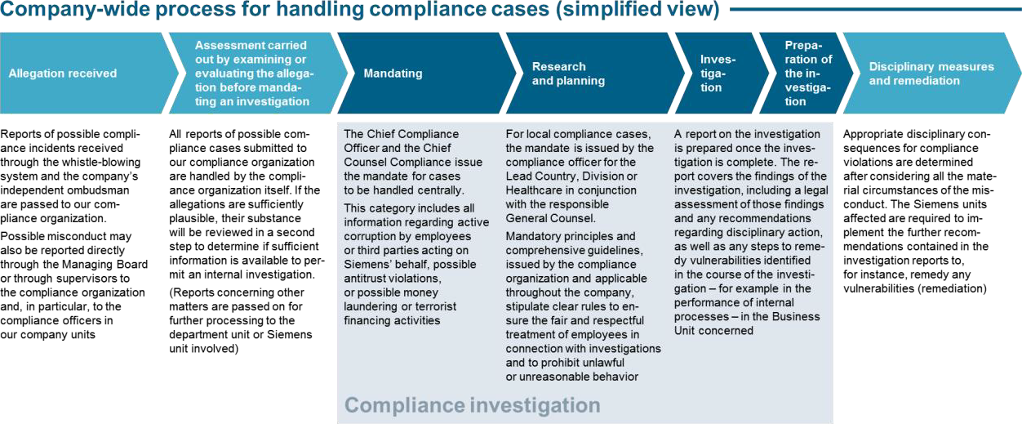

*Chart 1: "Process Overview"*

## Do’s and Don’t’s

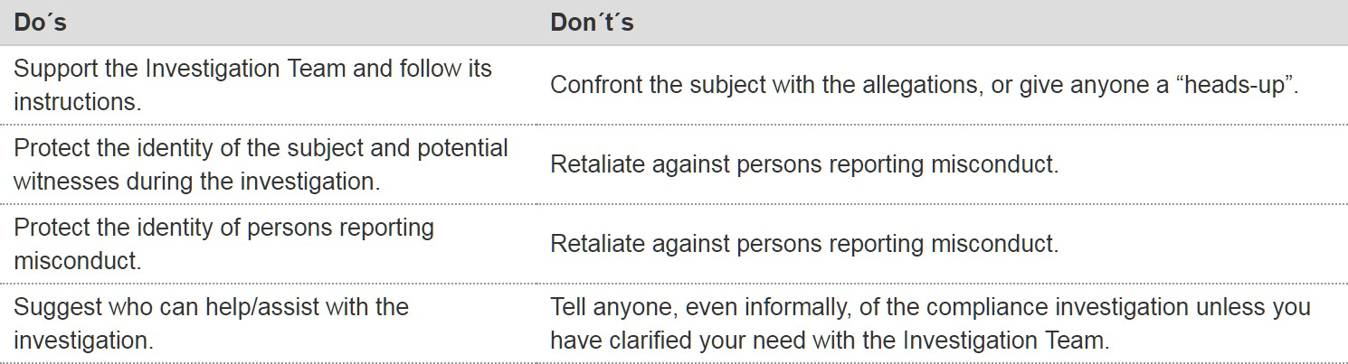

*Chart 2: “Do’s and Don’t’s*

## Questions & Answers

* + What is the difference between a Compliance Investigation and an audit?

Investigation is the process of inquiring into a matter of possible individual misconduct through research, follow-up, study, or formal procedure of discovery, in order to establish the facts of this matter. Investigating means to examine a misconduct, crime, problem, statement, etc. in an objective and independent manner with either exculpatory or incriminatory results.

**Internal auditing is** an independent, objective assurance and consulting activity with focus on an organization’s operations. It helps an organization accomplish its objectives by offering a systematic, disciplined approach to evaluate and improve the effectiveness of risk management, control, and governance processes.

* + When is a Compliance Investigation conducted at Siemens?

All Compliance Investigations at Siemens will be conducted following the receipt of allegations, which, after a thorough plausibility check by Compliance Regulatory and Investigation, will result in the authorization of a mandate, either by the Chief Counsel Compliance and the Chief Compliance Officer for high risk cases, or by the responsible Compliance Officer together with the responsible lawyer from Compliance Regulatory and Investigation for all other cases.

* + What is the objective of a Compliance Investigation?

The objective of a Compliance Investigation is to establish the facts pertaining to an allegation of wrongdoing.

* + How can Siemens employees be assured that they will be treated fairly?

On basis of Siemens Circular No. 226, all Compliance Investigations will be carried out according to an established process and free of any interference. Once the facts have been established a legal evaluation will be carried out and both are recorded in a report. Employees may also rely on the principles enumerated in the following question.

* + What are the four most important principles in Compliance Investigations?
    - The Investigation Team shall respect the principle of confidentiality in an investigation.
    - The Investigation Team shall respect both the spirit and the letter of the law within each jurisdiction where Siemens conducts business.
    - The Investigation Team shall respect all rights accorded to the individual by custom and law in upholding the presumption of innocence.
    - The Investigation Team shall protect the identity of persons reporting misconduct to the best extent possible.
  + Who will receive the investigation report?

According to the given process, Compliance Investigations reports are addressed in “high” risk cases to the Chief Compliance Officer, in other cases to the respective Compliance Officer. Furthermore, a distribution list is recommended in the report following the “need-to-know principle”.

* + Will the subject of a Compliance Investigation be informed about the investigation results?

Yes - if the investigation did not substantiate the allegation, the subject will receive an official clearance letter issued by Regulatory Compliance Legal. If the allegation is substantiated by the investigation, the subject will receive notice of a pending disciplinary hearing. However, the subject will not be provided with the investigation report.

## History of changes

|  |  |  |
| --- | --- | --- |
| **Date** | **Author** | **Major changes of binding content** |
| April 1, 2019 | Bernd Plagemann | Discontinuation of the differentiation between central and local cases. |

1. Contacts

▌ Please [contact](https://intranet.for.siemens.com/cms/059/en/about/org/Pages/compliance_organization.aspx) Compliance Regulatory and Investigation or the Case Handling hub in your region for further questions.

▌ Corporate Governance Owner

[Anette Kraus (LC CO IR)](https://soc.siemens.cloud/profile/Z002K99S)

## Case Handling - Investigations

Siemens expects its employees to comply with the law and Siemens’ internal regulations, to behave in a law- abiding and exemplary manner in order to prevent compliance cases from arising and to immediately report all information they may have regarding impending or existing compliance cases.

Siemens also expects its employees when affected to cooperate in internal compliance investigations in a transparent and open manner in order to enable Siemens to detect and to stop any potential misconduct.

Siemens will react adequately to determined Compliance violations by asserting claims for damages and the implementation of disciplinary measures. However, considering all circumstances of the individual case, it may be in the best interests of the company to refrain from these actions against an employee who has committed a Compliance offense or who is suspected of such (“Granting of Leniency”).

This is particularly the case if,

* + the company is dependent on the active participation of suspicious employees for the clarification of Compliance-relevant facts with serious material or immaterial effects, and if such participation can only be obtained in this way, and
  + the employee shows understanding and convincingly communicates that he will abstain from future misconduct and act as a role model for integrity.

Details can be provided by LC CO IR RD

### Compliance Cases

The matters listed below are “compliance cases” if they involve actions that are performed by Siemens employees in the course of their business activities or by third parties acting on Siemens’ behalf and/or that may damage the overall reputation of Siemens:

* + - all plausible allegations
      * of a violation of criminal or administrative law or
      * of a violation of a Siemens-internal regulation relating to criminal or administrative law (for example, the [Business Conduct Guidelines](https://intranet.legal-compliance.siemens.com/docs/2019_SAG_BCG_English_FINAL.pdf));
    - all impending or current criminal or administrative proceedings against Siemens AG, one of its Affiliated Companies or one of its employees as well as any related requests for information;
    - all impending or current proceedings by a multilateral development bank (for example, the World Bank) or a credit insurer (for example, Euler Hermes, KfW) as well as any related requests for information;
    - all information1 regarding intentional violations of accounting regulations – that is, regulations regarding accounting and financial reporting, independent audits of financial statements, bookkeeping and bookkeeping controls;
    - all intentional damages (no lost assets) that occur to the detriment of Siemens AG or its Affiliated Companies and/or occur on the company’s properties or projects (in this case also private property) (“security incidents”, formerly “TreuInfo cases”) as described in chapter 6 “Security incident management, formerly “TreuInfo””;
    - all information regarding intentionally false reports of compliance cases;
    - all information regarding possible breaches of data privacy law;
    - all information regarding possible money laundering or terrorist financing activities;
    - all information regarding possible human rights violations
    - all information regarding a violation of export control or embargo regulations
    - all plausible HR cases, if LC CO IR, at its discretion and in alignment with HR, considers the handling by itself necessary.

In contrast to the above items, for matters mentioned under 6) to 9) this is irrespective of whether such activities are performed by Siemens employees or by related or unrelated third parties when Siemens can be held liable for the misconduct.

### Responsibilities

There is no differentiation between local and central compliance cases – there is only one “Compliance Case”. However, a Compliance Case is to be classified following a risk based approach as “high”, “medium”, or “low” risk The risk level is determined by the risk the case may have: cases which expose Siemens globally are classified as “high” risk cases; cases with exposure to the relevant business unit and / or to the specific regional company only are classified as “medium” risk cases; and cases which do not have any immediate risk exposure at the time they have been reported, are classified as “low” risk cases.

All Compliance Cases will be handled by Compliance Investigation and Regulatory – the bundling of the responsibility in one department ensures that all cases are being handled by experts and in the same way; hereby, the high-quality level is guaranteed throughout the handling of all Compliance Cases.

Impending or current criminal or administrative proceedings against Siemens AG, one of its Affiliated Companies or one of its employees as well as any related requests for information or any searches must be reported immediately to the local Legal or Compliance department. These units must immediately notify Compliance Investigation and Regulatory (LC CO IR).

* + 1. ”High” risk cases

The following matters are generally classified handled as “high” risk compliance cases due to their potential risk exposure to Siemens globally:

1. “Information” in this context includes reports provided by employees or third parties, findings by Compliance Officers, requests for information by public authorities, criminal or administrative proceedings by law enforcement agencies or other public authorities, and searches.
   * all impending or current criminal or administrative proceedings by law enforcement agencies or other public authorities in Germany against Siemens AG, one of its Affiliated Companies or one of its employees;
   * requests for information by law enforcement agencies or other public authorities in Germany;
   * all information regarding active corruption or the providing of unfair advantage by employees or third parties acting on Siemens’ behalf;
   * all information regarding possible antitrust violations;
   * all information regarding intentional violations of accounting regulations – in particular, regulations regarding accounting and financial reporting, independent audits of financial statements, bookkeeping and bookkeeping controls;
   * all impending or current proceedings by a multilateral development bank (for example, the World Bank) or a credit insurer (for example, Euler Hermes, KfW) as well as any related requests for information;
   * all information regarding intentional wrongdoing that has led or can lead to damages of over € 50,000 to tangible or intangible assets;
   * all information regarding intentional wrongdoing on the part of an employee who is an ICFR and Supporting Certifier or belongs to the Top Management;
   * all information regarding a violation of export control or embargo regulations;
   * compliance cases that cannot be handled locally due to potential conflicts of interest as far as the conflict of interest cannot be resolved locally;
   * all information regarding intentional false reporting of compliance cases;
   * all information regarding possible money laundering or terrorist financing activities and
   * all information regarding possible human rights violations if not under the responsibility of another department.2
     1. ”Medium and Low Risk” cases

All compliance cases that do not meet the criteria set out in point 2.2.1. of this chapter will be classified with “medium” or “low” risk. In general, the cases will be handled by LC CO IR in the same way as the “high” risk” cases. However, the Mandating and Reporting process differs: “Medium” risk cases will be mandated by the Compliance Legal together with the Compliance Officer responsible for the region / the business; these are also the ones responsible for issuing the final report.

“Low” risk cases do not require a mandate but will be monitored by Compliance Investigation and Regulatory together with the Compliance Officer responsible.

* + 1. Other cases

There are also other cases that – although involving violations of Siemens’ internal regulations – will not be handled by the Compliance Organization. These cases include, for example, matters in which specialist expertise is required or matters in which no intentional violation of Siemens’ internal regulations is alleged. Unless these cases are central compliance cases, they will be forwarded to the relevant specialist department for action.

1. E.g. regarding employment practices or health and safety

This applies in particular to the following HR-specific matters for which the HR organization is responsible:

1. HR standard processes such as hiring, dismissal, issuance of work permits etc.
2. workplace environment, pay, incentives, calculation of bonuses, workloads, overtime, and all other organizational or procedural HR topics
3. improper favoritism, workplace intimidation, all forms of discrimination, harassment or other inappropriate behavior on the part of coworkers, managers or other company employees
4. irregularities related to travel or organizational expenses
5. improper use or damage of company property
6. matters related to workers councils and unions
7. matters related to pensions

The following cases may be taken over by LC CO IR at its discretion and I alignment with HR. Allegations in connection with:

* ongoing/imminent governmental or criminal investigations
* material damage to the company (more than 50.000 €)
* asserted retaliation against a whistleblower
* intentional false reporting of compliance cases
* allegations against top executives, Country Heads, Heads of Corporate Units, ICFR Certifiers, and senior managers
* harassment or discrimination (including, but not limited to, based on race, gender, national origin, sexual orientation) that could result in material financial risk or impact the company’s reputation in public opinion or the press.
* improper use of social media that could result in material financial risk or impact the company’s reputation in public opinion or the press.
* allegations of substantial systemic misconduct with significant financial or reputational impact

In addition, the GM SEC organization is responsible for the following GM SEC-specific and similar cases with no apparent relation to compliance matters:

* 1. Sabotage (i.e. to products, machines, production lines, vehicles, etc.)
  2. Politically motivated crime (i.e. arson to cars, etc.)
  3. Organized crime, gang crime
  4. IT and cyber-related crime
  5. Theft
  6. Terrorism (i.e. supporting authorities)
  7. Espionage
  8. Extortion

GM SEC will immediately inform LC CO if they become aware of a matter that is relevant to the compliance organization.

LC CO will immediately inform GM SEC if they become aware of a matter that is relevant to GM SEC.

In appropriate cases, and within the limits of availability, GM SEC resources are accessible to the compliance organization for investigation assistance and can be mandated accordingly.

In matters that are the responsibility of GM SEC and require law enforcement interaction, GM SEC shall consult with LG CO IR if the matter is material, has the potential for civil, administrative or criminal legal risk to the company, or has potential public relations implications.

Furthermore, specifics apply for the recording of DP and EX Cases in TRACI. The handling of pure work errors at LC CO DP and LC CO EX should be recorded according to the following criteria in a case-by-case analysis in TRACI:

* + - Indications of systematically determined misconduct by the same person or group of people.
    - Indications of intentional or grossly negligent misconduct by the same person or group of people.
    - repeat cases.
    - recurrent process weaknesses and organizational deficits.
    - If, in relation to the relevant work error and a hypothetical overall view, it can be assumed that an authority / an examiner would initiate an official measure / procedure against Siemens.

If LC CO DP or LC CO EX intends to disclose internally identified misconduct by employees and misconduct / process weaknesses through voluntary disclosure and / or other approaches to authorities, this must be reported to the clearing committee via LC CO IR CF. On this basis, LC CO IR CF decides whether a TRACI registration should be carried out (regardless of whether a case has already been initiated by the authorities or not). For further details please see [here.](https://findit.compliance.siemens.com/content/10000101/Compliance/LC_CO/LC_CO_RG_CH/findIT_LC_CO_RG_CH_9193.pptx)

### Case tracking tool – TRACI

In order to provide a uniform system for recording compliance cases (as defined in point 1 of this chapter) within the Compliance Organization, the compliance case tracking tool (TRACI: Tracking Compliance Cases Internationally) was implemented from October 1, 20093.

Governance responsibility for TRACI lies with Compliance Risk Management and Mitigation department (LC CO RFC RC) in conjunction with the head of Compliance Investigation and Regulatory (LC CO IR).

* + 1. Registration of compliance cases in TRACI

The employees of the Compliance Organization worldwide must ensure that all compliance cases known to them are registered immediately in TRACI.

* + 1. Reporting and certification

1. For Germany only: The agreement announced in [CHR Circular No. 65/09](https://wse04.siemens.com/content/P0006195/Shared%20Documents/dir2010_2019/2009/CHRRS6509_8.pdf) (including the relevant supplements) applies to the TRACI application. The data privacy regulations included in that agreement must be complied with.

The uniform TRACI procedure standardizes and simplifies compliance review reporting. It ensures that all compliance cases that are to be reported to management are known at Compliance Investigation and Regulatory and that Siemens meets its internal and external reporting obligations and can take appropriate measures to investigate potential wrongdoing.

Compliance Officers must confirm on a quarterly basis that – to the best of their knowledge and belief – the new cases within their respective areas of responsibility have been accurately and completely entered in TRACI (“certification”). The tool also enables other Compliance Officers assigned to the previously mentioned Compliance Officers to implement certification. Certification at the end of a quarter is possible up to the tenth business day of the subsequent quarter (U+10).

At the end of every quarter, Compliance Investigation and Regulatory analyzes the compliance cases registered in the TRACI system and reports key data to the Chief Compliance Officer, who – jointly with the Chief Counsel Compliance – informs the Managing Board of Siemens AG, the Audit Committee of the Supervisory Board and the independent auditors.

* + 1. Handling of compliance cases

The responsibilities for handling compliance cases are set out in section 1 of this chapter.

TRACI supports the work processes in the Compliance Organization and reflects the responsibilities for handling a Compliance case.

Compliance Investigation and Regulatory will keep the respective Compliance Officers updated on ongoing cases.

* + 1. Registration of security incident cases

Effective January 1, 2020, the TreuInfo compliance process will be superseded by [IncidentReporting@Siemens](https://incidentreporting.siemens.com/) (IR@S) in the responsibility of GM SEC.

For damages that arise outside GM SEC’s area of responsibility (for example, in areas for which LC, SFS CO or HR are responsible), a template for recording key data will be provided. Such cases that also constitute Compliance cases and are reported directly to GM SEC will be forwarded by GM SEC to the Compliance organization for further handling.

Further information can be found in chapter 6 “Security incident management (formerly “TreuInfo”)”.

* + 1. Technical details

The TRACI application can be accessed from the intranet via https://traci.Compliance.siemens.com/traci. Questions regarding the tool and related topics may be directed to [traci-treuinfo.Compliance@siemens.com.](mailto:traci-treuinfo.Compliance@siemens.com)

Details on the tool are provided by the intranet-based training programs and by information in the tool itself.

* + 1. Access authorization

Due to the sensitivity of the data in the TRACI system and to avoid conflicts of interest and apply a strict need-to- know principle, only those employees of the Compliance Organization who are fully authorized to perform the

tasks of the Compliance and Legal organization will have access to TRACI cases. Applications for exceptions must be submitted to Compliance Investigation and Regulatory and accompanied in every case by a written justification. Rights of use and access authorizations for TRACI will be handled via the Finance Portal. Therefore, all entries in the Finance Portal for access authorization must be accurate and complete, and must be updated to take account of any changes. The relevant Compliance Organization will review the accuracy of the entries of all authorized users in the Finance Portal at least once a quarter and correct those entries immediately, if necessary.

### Investigation process for allegations

All compliance cases reported to the Compliance Organization will either be handled by Compliance Investigation and Regulatory or forwarded to the relevant specialist department or Siemens unit for further action.

* + 1. Main principles

The following main principles of a compliance investigation must be complied with:

* + - * The responsible investigative unit must conduct an objective and impartial investigation into all reported compliance allegations. Any internal investigation requires a formal mandate4 .
      * All Siemens personnel and units engaged in internal investigations and fact-finding activities must perform their duties in a manner that is consistent with applicable laws and Siemens’ values.
      * Inquiries must be conducted on the basis of a presumption of innocence.
      * The identities of the complainant, witnesses or the subject of the investigation will not be disclosed to third parties unless this is required by law. Internal inquiries regarding ongoing investigations must be handled according to the "need-to-know principle”. These principles ensure that all investigations are conducted in accordance with the confidentiality requirements and the law within each jurisdiction.
      * Investigative measures must be suitable, necessary and appropriate for fulfilling the aims of the investigation.
      * The code of conduct for internal compliance investigations as laid down in chapter 3 “Code of conduct for compliance investigations and fact-finding” outlines the requirements that must be observed during such activities.
    1. Steps in the evaluation of a cases

The process for evaluating compliance cases comprises the following steps:

* + - * The first step is to determine whether a reported case is a compliance case (as defined above). If it is not a compliance case, the matter will be forwarded to the relevant specialist department (HR, GM SEC, EHS etc.) for further action.
      * If a reported case is a compliance case, the plausibility of the related allegations will be reviewed. If these allegations are not plausible, the case will be closed in the compliance case tracking tool TRACI and will not be pursued further

1. For details, please refer to section 2.4.3. of this chapter “Mandate contents”.
   * If the allegations are sufficiently plausible, their substance will be reviewed in a second step to determine if sufficient information is available to permit an internal investigation (a so-called initial suspicion).
   * If the allegations are sufficiently substantial and the case is a “medium” risk compliance case, the Compliance Officer together with Compliance Investigation and Regulatory – Compliance Legal will issue an investigation mandate.
   * If the case is a ”high” risk compliance case, the relevant counsel (case lawyer) at Compliance Investigation and Regulatory will issue an investigation mandate, which will be reviewed by the Head of Compliance Investigation and Regulatory and approved by the Chief Compliance Officer.
   * Compliance Investigation and Regulatory (LC CO IR), Legal Competition (LC M&A CMP) – particularly in the case of antitrust violations – and third parties may be mandated to conduct investigations of central compliance cases. Compliance Investigation and Regulatory will provide legal support for all investigations of central compliance cases. The local Compliance Office or another local specialist department (for example, HR, Taxes, Export Control or EHS) may be mandated to clarify ”medium” risk compliance cases or individual aspects of compliance cases.
   * Outside counsel will be mandated by Compliance Investigation and Regulatory if necessary. In order to avoid labour law related deadlines, the responsible local HR and/or legal department should be informed at the earliest possible stage.
     1. Mandate contents

All mandates will contain

* + - * an identifying TRACI number
      * the name of the unit mandated to conduct the investigation/clarification, and
      * a statement of the allegations and the Siemens unit involved.

In “high” risk compliance cases, investigations mandates will contain the signatures of the Chief Compliance Officer and the Chief Counsel Compliance.

In “medium” risk compliance cases, investigation mandates will contain the signatures of the relevant lawyer at LC CO IR CF and the relevant Compliance Officer.

Mandates may be shown to interviewees for the purpose of authorizing investigative activities. Therefore, in order to protect reporters and ensure the integrity and effectiveness of investigations, they will not contain any information or personal data in addition to the information listed.

* + 1. Need-to-know principle / procedure of an investigation

The Chief Compliance Officer (in “high” risk compliance cases) or the relevant Lead Country Compliance Officer (in “medium” risk compliance cases) will inform – on a need-to-know basis – the CEO, CFO, General Counsel and Compliance Officer of the relevant Siemens unit (OPCP, or Business Unit) and of the relevant local unit and/or Lead Country and OPCO that the mandate has been issued. The Chief Compliance Officer will inform other individuals of the mandate as required.

In connection with their investigations, investigating units must be provided – to the extent permitted by law – with access to all relevant information available to Siemens AG and its Affiliated Companies. This applies in particular to

* + - * interviews conducted with relevant employees and witnesses,
      * the collection and securing of documents and other written information, and
      * the collection and evaluation of electronic data.

In connection with their investigation, investigation units must be provided – to the extent permitted by law – with access to all relevant information available to the units for which they are responsible.

In its investigation, the investigating unit must comply with the Code of Conduct for Compliance Investigations and Fact-Finding (chapter 3) and all applicable local laws. Its activities must be suitable, necessary and appropriate for fulfilling the aims of its investigation. In the course of its investigation, the investigating unit must accordingly inform the Compliance Officer or Compliance Investigation and Regulatory (in central compliance cases) of all findings on a regular basis so that they may review the appropriateness of the investigative measures to be implemented. In ”high” risk compliance cases, the Chief Counsel Compliance must be directly informed of all findings on a regular basis so that he or she may review the appropriateness of the investigative measures to be implemented.

Violations by fact-finding units of the Code of Conduct for Compliance Investigations and Fact-Finding may be deemed compliance cases and sanctioned accordingly.

Employees must be notified of any investigations – and in particular of any collection of data – relating to them to the extent that such notification does not endanger the purpose of the investigation.

* + 1. Data collection

Data may be collected only to the extent permitted under applicable local law.

An agreement regarding the aspects of compliance investigations governed by labor law and data privacy law has been concluded with the Central Works Council of Siemens AG5.

The investigating units will submit and sign an application for data mirroring and collection (Data Collection Request – DCR). The DCR will be forwarded to Compliance Investigation and Regulatory for review. Compliance Investigation and Regulatory will consult the Data Privacy Organization to ensure that the DCR complies with data privacy laws. DCRs will be approved and signed by the relevant counsel at Compliance Investigation and Regulatory and the Chief Counsel Compliance.

* + 1. Conclusion / results

After concluding their investigations, investigating units will issue investigation reports. These reports, which must be approved by Compliance Investigation and Regulatory will include a description of the investigation/clarification

1. For Germany only: The contents of this agreement were announced in [CHR Circular No. 44/15](https://wse04.siemens.com/content/P0006195/Shared%20Documents/dir2010_2019/2015/HRRS4415_1.pdf) and its supplements.

framework, the findings of the investigation, the legal assessment of those findings and any related recommendations for action.

In cases where the investigating/clarifying units did not substantiate a wrongdoing by an employee, the employee concerned should receive a Clearance Letter, if legally permissible under local law.

In ”high” risk compliance cases, the Chief Compliance Officer will provide the reports to all relevant individuals on a need-to-know basis and to Compliance Investigation and Regulatory Discipline and Remediation (LC CO IR RD). If disciplinary measures are required, the reports will also be forwarded to the relevant HR department.

In ”medium” risk compliance cases, the responsible Compliance Officer will provide the reports to the relevant individuals on a need-to-know basis. Investigation reports must always be treated confidentially and may not be distributed further without the prior consent of the Chief Compliance Officer (in ”high” risk compliance cases) or the responsible lawyer from Compliance Investigation and Regulatory (in “medium” risk compliance cases),

### Prohibition of retaliation

Retaliation of any kind against individuals who have reported complaints or compliance cases in good faith will not be tolerated. This prohibition applies to any action that may directly or indirectly harm the employment relationship, earning potential, bonus payments, career development or other work-related interests of the reporter.

Disciplinary sanctions imposed in a due process in response to a reporter’s involvement in any reported wrongdoing are not regarded as retaliation under this policy.

Reporting of retaliatory actions

Employees who notice or learn of a current or impending retaliatory action should immediately inform Compliance Case Handling (LC CO IR) either directly or via a member of the Siemens Compliance Organization. Compliance Case Handling will immediately take all steps necessary to protect the interests of the relevant employees. There may also be an internal investigation into the allegations. If such an investigation finds that this policy has been violated, appropriate measures will be taken. These measures may include disciplinary measures against the individuals who are responsible for and/or have taken part in the impermissible retaliatory actions.

Documentation of disciplinary measures

If disciplinary measures or other measures under labor law are taken against an employee who has reported a compliance case, Compliance Case Handling must be informed immediately.

If such measures are not connected with the reporting of a compliance case, the facts, the chronology and the basis for the measures must be documented by the relevant manager prior to their implementation.

### Training and supporting material

[Compliance Academy](https://intranet.legal-compliance.siemens.com/internal/ComplianceAcademy/) (see Learning Landscape for Investigations Training and Case Library)

[Siemens Compliance Brochure](https://www.siemens.com/content/dam/internet/siemens-com/global/company/sustainability/downloads/responsible-business-behavior-compliance-at-siemens.pdf) [Business Conduct Guidelines](https://findit.compliance.siemens.com/content/10000101/Compliance/CL_CO/CL_CO_AT/findIT_CL_CO_AT_128.pdf)

### History of changes

|  |  |  |
| --- | --- | --- |
| **Date** | **Author** | **Major changes of binding content** |
| January 1,  2019 | Bernd Plagemann | First release through the Compliance Handbook based on Siemens Circular SC No. 226 “Global Compliance”, Appendix 5. |
| April 1, 2019 | Bernd Plagemann | Discontinuation of the differentiation between central and local cases. |
| January 1, 2020 | Julia Wirth | Update regarding responsibilities of recording of fiduciary cases (former TreuInfo cases). |
| July 1, 2020 | Julia Wirth | Update on handling of DP and EX cases and HR cases in TRACI. |
| October 1, 2020 | Julia Wirth | Update on HR cases and the definition of CO cases. |

* 1. Contacts

▌ Compliance Officer

The Compliance Officer responsible for your unit can be found through the following [link.](https://intranet.for.siemens.com/cms/059/de/about/org/Pages/compliance_organization.aspx)

▌ Corporate Governance Owner

The contact person for case handling is:

[Annette Kraus (LC CO IR)](https://soc.siemens.cloud/profile/Z002K99S)

The contact person for "medium" and "low" risk cases is: [Michael Rackow (LC CO IR EG E)](https://scd.siemens.com/luz/IdentitySearch?cn=RACKOW%2BMICHAEL%2BZ0028PWK&tcgid=Z0028PWK&c=DE&o=SIEMENS&ou=LC&l=MCH%2BP&department=LC%2BCO%2BRG%2BCH%2BEA%2BEU&&utI=I&utX=X&utT=T&rtH=H&rtS=S&rtZ=Z&rtO=O&rtAktiv=A)

The contact persons for the Case tracking tool – TRACI are [Marco Liese (LC CO PT CO)](https://soc.siemens.cloud/profile/Z000E4MF)

[Manja Ehnert (LC CO IR CF](https://soc.siemens.cloud/profile/Z002HX8A))

## Code of conduct for investigations and fact- finding

It is crucial that all Siemens personnel engaged in investigation-related activity perform their duties in a manner that is consistent with applicable laws and the Siemens values.

This code of conduct for Compliance investigations and fact finding (“Code”) supplements the [Business Conduct](https://intranet.legal-compliance.siemens.com/docs/2019_SAG_BCG_English_FINAL.pdf) [Guidelines](https://intranet.legal-compliance.siemens.com/docs/2019_SAG_BCG_English_FINAL.pdf) and applies to all internal inquiries and investigations performed by authorized Siemens personnel relating to alleged, potential or actual violations of company policies, internal regulations or applicable law (hereinafter referred to as “fact-finding”).

Governance responsibility for the Code rests with the Chief Compliance Officer of Siemens AG.

### Applicability

The Code is particularly applicable to the following Siemens units (alphabetical order):

* + - CF Audit
    - Compliance Organization worldwide
    - Compliance Investigation and Regulatory
    - Computer Emergency Response Team ∂ Data Privacy
    - HR / OPCO HR / Local HR
    - Litigation
    - Operational Review / RIC Organization
    - Security Office
    - Works Council / GSpA

### Code requirements

Siemens personnel engaged in fact-finding will:

* + - conduct their activities consistent with applicable legal and professional standards in an objective and diligent manner,
    - demonstrate fairness and respect toward parties involved in investigations, including, but not limited to, interviews and other direct contacts,
    - avoid the presumption of guilt or fault on the part of the parties involved,
    - grant the parties involved the right to be heard,
    - allow, where company policy and applicable laws permit or direct, the presence of a lawyer and/or a member of the works council / spokespersons’ committee at an interview. Employees will be responsible for the

organization and costs involved unless otherwise determined by Compliance Investigation and Regulatory (LC CO IR); costs for lawyers will generally not be reimbursed,

* + - consult Compliance Investigation and Regulatory (LC CO IR) in advance when an interview has the potential to elicit self-incriminating statements by employees in order to ensure that local legal protocol is followed and that, where required by local law, employees are provided with appropriate legal advice,
    - allow employees to make corrections to the interview minutes,
    - draw conclusions with respect to the guilt or fault of the parties involved only after information sufficient to validate such conclusions has been obtained,
    - disseminate information gathered during fact-finding activity solely on a need-to-know basis,
    - maintain the confidentiality of information obtained during fact-finding activity consistent with company policy, internal regulations and applicable laws, and otherwise to the extent reasonably practicable under the circumstances,
    - protect the identity of reporters of potential violations of company policies, internal regulations and applicable laws to the extent reasonably practicable under the circumstances.
    - abide by company policies and applicable laws related to the protection of privacy rights and the collection of electronic and other data.

Siemens personnel tasked with fact-finding will not apply the following techniques:

* + - Make or obtain secret tape recordings of interviews or other communications
    - Utilize private investigators1
    - Assume a false identity or present a false pretext for fact-finding
    - Make false statements of material fact
    - Induce a violation of law or policy
    - Make promises premised upon the outcome of the inquiry
    - Trespass onto private property
    - Circumvent the rights granted to the employees involved under company policies or applicable laws, or the employees’ representation by legal counsel.

Engage in any attempt to determine the identity of an anonymous reporter without the pre-approval of the Chief Counsel Compliance of Siemens AG.

### Conflicts of interest

1. Siemens personnel engaged in fact-finding will avoid actual or potential conflicts of interest or the appearance of actual or potential conflicts of interest. Actual or potential conflicts of interest may result, among other things, from:
   * a personal or professional relationship with any party involved in an investigation,

1 Exceptions: With explicit approval: 1) by the CHR Head for HR matters; 2) by the GM SEC Head for GM SEC matters; 3) by the LC C LIT Head for Litigation matters and (4) by the Chief Counsel Compliance for other matters.

* any connection to or involvement in activities related to the subject matter of the investigation.

1. Siemens personnel engaged in fact-finding who become aware of an actual or potential conflict of interest or the appearance of an actual or potential conflict of interest will:
   * promptly inform their supervisors,
   * directly or through their supervisors notify the Chief Compliance Officer of Siemens AG or the General Counsel of Siemens AG.
2. The supervisor of an employee who reports an actual or potential conflict of interest or the appearance of an actual or potential conflict of interest must promptly evaluate whether a conflict situation exists and, if so, take appropriate action to ensure that the fact-finding activity continues without any appearance of bias or partiality. Such action will include:
   * the exclusion of the fact-finder and, if appropriate, the unit or function from further fact finding or any other role in the case.
   * the outsourcing of the fact-finding or specified tasks to another internal unit or function
   * or to an external service provider.
3. If a conflict of interest is subsequently determined not to exist or is resolved, the fact-finder may resume his or her role in the investigation at the discretion of his or her supervisor.

### Code violations

Reported violations of this Code will be deemed Compliance Cases and handled accordingly. Violations of this Code may result in disciplinary measures.

### Training and supporting material

[Siemens Compliance Brochure](https://www.siemens.com/content/dam/internet/siemens-com/global/company/sustainability/downloads/responsible-business-behavior-compliance-at-siemens.pdf)

### History of changes

|  |  |  |
| --- | --- | --- |
| **Date** | **Author** | **Major changes of binding content** |
| January 1,  2019 | Jens Burgard | First release through the Compliance Handbook based on Siemens Circular SC No. 226 “Global Compliance”, Appendix 7. |

* 1. Contacts

▌ Compliance Officer

The Compliance Officer responsible for your unit can be found through the following [link.](https://intranet.for.siemens.com/cms/059/de/about/org/Pages/compliance_organization.aspx)

▌ Corporate Governance Owner

The contact person for this code is: [Jens Burgard (LC CO IR CF)](https://scd.siemens.com/luz/IdentitySearch?cn=burgard%2Bj&utI=I&utX=X&utT=T&rtH=H&rtS=S&rtZ=Z&rtO=O&rtAktiv=A)

## Disciplinary Measures

This chapter sets out the basic principles, rules and decision criteria to ensure due process and transparency in the disciplinary processes and the imposition of a reasonable, adequate, consistent and impartial response to non-compliant behavior.

### General rules

Siemens personnel who violate the laws and regulations and/or applicable Siemens policies including the Siemens [Business Conduct Guidelines,](https://intranet.legal-compliance.siemens.com/docs/2019_SAG_BCG_English_FINAL.pdf) while acting within the scope of their employment (“non-compliant behavior”) shall be subject to appropriate disciplinary consequences1. Non-compliant behavior can result from action or the willful failure of action.

Non-compliant behavior can also exist when a manager tolerates non-compliant behavior by a supervised employee or when a manager fails to promptly report and stop non-compliant behavior. Generally, a manager’s failure to exercise proper supervision and organizational duties can amount to non-compliant behavior2.

Disciplinary consequences shall be evaluated and decided in disciplinary processes at central or local level3.

Co-determination rights4 of the employee representatives (if and where applicable) shall be respected throughout the applicable processes.

Personal employee data shall be processed and transferred in accordance with applicable data privacy laws.

Changes to the rules set out in this chapter are only permissible to the extent they are required by local law. LC CO IR RD5 must be notified in advance of any such changes.

### Disciplinary processes

The appropriate response to non-compliant behavior is evaluated and decided either:

* + - In a global disciplinary process at central level by the “Central Disciplinary Committee” (CDC), comprised of members of global top management, whose actions are based on rules set out in this chapter and in the CDC Charter in which significant parts of the CDC process are referred to LC CO IR RD (“Regular CDC Process”, see also section 4.2.1.1).

1. Please refer also to Chapter A of the [Business Conduct Guidelines](https://intranet.legal-compliance.siemens.com/docs/2019_SAG_BCG_English_FINAL.pdf) (hereafter also “BCG”).
2. Please refer also to Chapter E of the BCG.
3. The applicable disciplinary process depends upon the nature and severity of the non-compliant behavior and the workforce categorization (Top Management, Senior Management and Non-Senior Management) of the affected employees.
4. Co-determination means the employees’ participation and involvement in the management’s decision-making process related to employees’

status and rights. In legal systems with co-determination, employees usually form special bodies exercising the employees’ rights.

1. Department Compliance Investigations and Regulatory, Discipline and Remediation.
   * In an accelerated CDC Process by the responsible management6 along with the governing Human Resources Organization (“HR Organization”), whose actions are based on rules set out in this chapter and in the CDC Charter (“Accelerated CDC Process”, see also section 4.2.1.2). Disciplinary decisions that are made via the Accelerated CDC Process must be approved by LC CO IR RD. The CDC will be informed accordingly.
   * In general processes by the responsible management along with the governing HR Organization whose actions are based on the rules as set out in this chapter (see also section 4.2.2).
     1. CDC processes
        1. **Jurisdiction of the CDC**

The CDC jurisdiction applies as follows:

* For employees of the Top Management (TM) group and ICFR Certifiers, the CDC shall have jurisdiction in all cases regardless of the nature and severity of the non-compliant behaviour.
* For employees of the Senior Management (SM) group, CDC jurisdiction depends on the nature and severity of the non-compliant behaviour. The CDC will likely exercise jurisdiction where there are substantial violations of the BCG, particularly when the violations are related to anti-corruption or antitrust regulations or when they involve financial integrity rules,7 are systemic or have significant financial or reputational impact. For Supporting Certifiers, CDC jurisdiction is likely when the non-compliant behaviour impacts the supporting certifier’s reliability.
* For employees of the Non-Senior Management (NSM) group, the CDC will exercise jurisdiction only in excep- tional cases that present the potential for severe risks for the company (especially financial or reputational impact)8.
* Where CDC jurisdiction only applies to certain employees of a case, the CDC may exercise jurisdiction over all employees involved in the underlying case regardless of their categorization to ensure consistency and equal treatment of all involved parties.
* To the extent permissible under local law, CDC members may direct certain cases to the CDC regardless of the involved employee’s workforce categorization, if, in their discretion, the case implicates an important company interest.
  + - 1. Regular or Accelerated CDC Process

Non-compliant behavior within the jurisdiction of the CDC can be handled through the Regular CDC Process or the Accelerated CDC Process:

1. The Accelerated CDC Process is conducted by the management team on the respective Siemens entity level, Business Unit or Country level.
2. Particularly intentional violations of accounting and financial reporting regulations, independent audits of the annual financial statements and internal accounting controls.
3. Particularly cases where there are anti-corruption or antitrust violations, or where the violations involve concerns related to accounting rules and financial integrity.
   * For employees of the Top Management (TM) group and ICFR Certifiers, the Accelerated CDC Process is generally not available.
   * For employees of the Senior Management (SM) group and Supporting Certifiers, the Accelerated CDC Process may apply, if the nature and severity of the non-compliant behaviour does not warrant CDC consideration in the Regular CDC Process.
   * For employees of the Non-Senior Management (NSM) group, the Accelerated CDC Process is generally appropriate.

Determination of CDC jurisdiction

LC CO IR RD is responsible for determining whether CDC jurisdiction applies in a particular case and whether the Regular CDC Process or the Accelerated CDC Process will be followed. This determination is generally only made after the fact-finding activities9 have been completed and a final written report has been submitted to LC CO IR RD.

4.2.1.3 Further rules and governance

**Execution of disciplinary measures10**

Disciplinary measures may not be executed until the fact-finding process has been finalized and the CDC’s decision or recommendation has been issued, or after the required steps of the Accelerated CDC Process have been performed.

Suspension or other measures during fact-finding

In exceptional cases, while fact-finding activities are ongoing, the execution of disciplinary measures (such as immediate suspension) could be warranted due to mandatory local labor law deadlines, to protect the ongoing investigation or for other reasons in the best interest of the company. Such exceptions require adherence to the rules and procedures of this chapter and may not be taken without the prior approval of LC CO IR RD. At its discretion, LC CO IR RD may direct the decision to the CDC.

Role of LC CO IR RD

The composition of the CDC and additional rules related to the CDC Processes are provided for in the CDC Charter. LC CO IR RD is the governance owner for the Regular CDC Process and the Accelerated CDC Process. In this role, LC CO IR RD may perform monitoring activities to ensure that the requirements of this chapter are carried out. The latter also applies in cases that have been investigated by LC CO IR CF / LC CO RFC LF11 and were assigned for disciplinary evaluation and decision in the General Disciplinary Processes.

* + 1. General disciplinary processes

In cases where CDC jurisdiction does not apply, General Disciplinary Processes shall be followed by the responsible management along with the governing HR Organization, in accordance with the rules set out below.

1. Formal investigations or other fact-finding activities.
2. As stated before, disciplinary measures shall be executed with due regard to co-determination rights of the employee representatives.
3. Department Compliance Investigations and Regulatory Central Function / Compliance Risk, Framework and Controls Legal Frame.
   * + 1. Jurisdiction

As a rule, the disciplinary evaluation and decision upon the appropriate response to non-compliant behavior shall be undertaken by the affected employee’s manager/department head and the responsible local HR Organization.

Cases with a potential wider impact shall be dealt with by the responsible higher-level management and the respective Head of HR. This especially concerns cases that present the potential for conflicts of interest.

* + - 1. Establishment of local disciplinary committees

Upon notice to LC CO IR RD, the responsible management may establish disciplinary committees or other committees as evaluation and/or decision bodies (“Local DC”)12 with the CDC as benchmark.

Local DC processes and procedures must be set out in a written charter that shall be guided by the CDC Charter and, at minimum, set out the following:

* + - * + Members of the Local DC by title
        + Rules governing the role and involvement of the affected employee’s manager/higher-level management
        + Jurisdiction of the Local DC
        + Meeting rules
        + Process to conclude on decisions/recommendations
        + Mechanisms for resolving (potential) conflicts of interest
      1. Involvement of stakeholders Management and HR organization

Where the Local DC or higher-level management determines a disciplinary measure, the affected employee’s manager and the appropriate local HR Organization must be sufficiently informed/consulted and shall implement the decision and consider how and to what extent the non-compliant behavior shall be reflected in the Performance Management Process (“PMP”) according to section 4.2.5.

Involvement of the Compliance Officer

If an investigation has been conducted by the Compliance Organization, the responsible Compliance Officer shall be promptly informed about the timeline for the decision and the execution of the disciplinary measures.

* + 1. Basic principles and decision criteria

All individuals evaluating and taking decisions in the Disciplinary Processes (collectively “Decision Body”) must thereby comply with the following basic principles13 and decision criteria:

* + - 1. Basic principles

1. So called “Local Disciplinary Committees”.
2. The CDC has implemented comprehensive principles (beyond these basic principles) as applicable in the CDC Processes in its CDC Charter.
   * The disciplinary evaluation and decision shall be reasonable, adequate, consistent and rendered without bias, partiality or personal interest.
   * All circumstances of the particular case, including the local legal framework, shall be considered.
   * A hearing of the employee conducted by individuals taking the disciplinary decision within a General Disciplinary Process and in the presence of the employee’s manager or higher-level management shall be considered, particularly before any disciplinary measure in the form of a termination is imposed14. The criteria for the hearing in the CDC Processes are provided in the CDC Charter.
   * The decision criteria as provided under section 4.2.3.2. of this chapter shall be considered to ensure consistency.
   * The disciplinary evaluation and decision need to be based on appropriately conducted and documented fact- finding. This fact-finding needs to comply with chapter 3 “Code of conduct for compliance investigations and fact-finding” and all other company policies and local legal requirements. Any indication of improper fact- finding shall be immediately and adequately followed up.
   * Employees who are in charge of and personally engaged in the fact-finding shall have no vote in the subsequent evaluation and decision on the disciplinary measure. An exception may be made in cases that are investigated by the relevant HR Organization if such cases do not require comprehensive fact-finding and no conflict of interest exists.
   * Actual or potential conflicts of interest or the appearance of conflicts of interest in the disciplinary process are not permitted and need to be resolved immediately. Actual or potential conflicts of interest may result, inter alia, from a personal or professional relationship between a member of the Decision Body and the subject employee and/or previous or current personal involvement by a member of the Decision Body in the facts/circumstances relating or leading to the non-compliant behaviour.
   * Employees who believe there is an actual or potential conflict of interest or the appearance of an actual or potential conflict of interest shall promptly inform appropriate personnel. If no local rules are established to address conflicts of interest, appropriate personnel would include their manager, the next management level or the governing HR Organization. As soon as such notification has been provided, the person/department addressed, in conjunction with the respective HR Organization, must promptly determine or seek advice with respect to whether a (potential) conflict situation exists and, if so, take appropriate action to ensure that the disciplinary process continues without any appearance of bias or partiality. Such action shall include the exclusion of the individual(s) from the disciplinary process and the nomination of an appropriate substitute.

Disregarding the outlined principles and criteria may itself constitute non-compliant behavior and, if so, shall be handled accordingly.

* + - 1. Decision criteria

When deciding the appropriate response to non-compliant behavior, inter alia the following criteria shall be considered in the evaluation, if applicable:

* + - * + Nature and severity of the non-compliant behaviour
        + Degree of participation

1. For Germany, it should be noted that a hearing shall also particularly be considered prior to a formal warning.
   * Duration and frequency of misconduct
   * Whether the employee was acting on instruction or through his/her own will
   * Intent or negligence
   * Self-enrichment or intention of self-enrichment
   * Extent of damage to the company
   * Period and course of employment
   * Relevant past non-compliant behaviour (labour law perspective)
   * Internal company factors and conditions that might have facilitated the non-compliant behavior
   * Time of the non-compliant behaviour and behaviour thereafter
   * Position level and role and responsibilities of the individual at the time of the misconduct
   * ICFR certification function at the time of the misconduct and at present15
   * Candidate for and extent of amnesty16
   * Cooperation and attitude during the fact-finding/disciplinary process
   * Self-indictment in whistle-blowing situations
   * Recognition of improper conduct by the individual
   * Standards set/measures taken in comparable cases
     1. Disciplinary or other measures

The assessment of appropriate measure(s) in response to non-compliant behavior shall be made by the Decision Body. This discretionary decision shall be exercised in accordance with the basic principles as provided under section 4.2.3.1. above and respecting the rules as provided below in this section 4.2.417.

Depending on the nature and severity of the non-compliant behavior, the following measures as laid down in section 4.2.4.1. - 4.2.4.6) are generally available to the extent they are permissible under local law.

It is the responsibility of the affected employee’s manager and the Head of the relevant HR Organization to ensure that an adequate record of executed disciplinary measures is maintained. Such record shall be maintained in the employee’s personnel file, to the extent18 permissible under local law.

* + - 1. Compliance training

If the Compliance Organization was responsible for the investigation of the non-compliant behavior, the Decision Body needs to decide whether or not the employee will have to participate in tailored online or in-person Compliance training or Finance training. Tailored in-person Compliance training or Finance training requires the involvement of the responsible Compliance or Controlling and Finance function. The employee’s manager is responsible for ensuring that the Compliance or Finance training course is completed.

* + - 1. Warnings

1. This criterion is of particular relevance in Compliance cases.
2. This criterion is only relevant in a limited amount of Compliance cases.
3. As stated before, the disciplinary decision and implementation shall be executed in accordance with co-determination rights of the employee representatives.
4. Such record shall be deleted as required by relevant local laws.

Informal Warning

An informal warning or other comparable measure under local law, which can be written or oral, is appropriate in cases of less serious non-compliant behavior that require some disciplinary response but less than a severe sanction.

An informal warning consists of: (1) a description of the employee’s non-compliant behavior, and (2) a clear direction with regard to the expected change in behavior for the future.

As a rule, the informal warning shall be delivered in person by the employee’s manager. Verbal warnings can be made in the presence of an HR representative, particularly where he/she took part in the disciplinary process.

Formal warning19

A formal warning or other comparable measure under local law is appropriate in cases of non-compliant behavior that require a serious disciplinary response, but where it is reasonable to continue the employment relationship with the employee.

A formal warning should consist of at least: (1) a description of the employee’s non-compliant behavior and (2) a clear direction with regard to the expected change in behavior for the future, and (3) the announcement of further measures up to and including the termination of employment, if the employee does not change his/her behavior

As a rule, the formal warning shall be delivered in person by the employee’s manager in the presence of the HR representative who took part in the disciplinary evaluation process. The formal warning should be documented in writing.

4.2.4.3 Consequences for remuneration

In cases of non-compliant behavior that require response measures in addition to a formal warning, potential appropriate disciplinary measures include the forfeiture or revocation of entitlements to variable pay (e.g. Senior Management Short Term Incentive) and/or voluntary remuneration elements (particularly the Siemens Stock Awards) 20 for a defined period of time.

The forfeiture of Siemens stock awards can only affect awards that have not vested at the time the disciplinary decision is taken. It shall also be decided whether new stock awards should be granted in the period following the execution of the disciplinary measure.

The rules of this section shall also apply to other voluntary remuneration elements if they exist.

* + - 1. Transfer to another function

It shall be determined whether non-compliant behavior warrants a transfer to another function as a side step or demotion. If such action is taken, adequate steps should be taken to ensure that such a transfer is not perceived as a promotion. In no case shall an employee be transferred to a function with a higher workforce categorization and/or a function with greater overall remuneration.

1. This includes a final written warning.
2. Such measures can only be imposed to the extent they are permissible under local law and/or the relevant regulations governing the conditions of employment.
   * + 1. Further measures

Other measures in addition to or as an alternative to the measures provided under Nos. 1 through 4 above may include, but are not limited to, the following measures, which shall be limited to a reasonable period of time:

* + - * + Suspension (with or without remuneration)
        + Exclusion from promotion
        + Exclusion from an ICFR certification function

Additional measures can be official monitoring by a suitable senior manager or tailored training.

* + - 1. Termination

If termination of the employee for non-compliant behavior is warranted, such termination may be “ordinary termination” or “extraordinary termination.”

Ordinary termination

Ordinary termination is appropriate in cases of non-compliant behavior that warrants termination because it is no longer reasonable to continue the employment relationship, but it is not necessary to terminate the employment utilizing extraordinary termination. An ordinary termination may provide for a statutory notice period or for a statutory severance payment under local law.

Extraordinary termination

Extraordinary termination (e.g. termination for cause, termination for gross misconduct or termination without notice period) can be appropriate in the most severe or repeated cases of non-compliant behavior.

* + 1. Consideration within the Performance Management Process (PMP)

Non-compliant behavior requires sound management judgment from the employee’s manager regarding whether or not, to what extent and for which time period the non-compliant behavior should be considered in the PMP. All cases of non-compliant behavior that warrant a formal warning or even more severe measures generally qualify for such consideration. Specific consideration should (if applicable) be placed on the employee’s HOW evaluation, variable pay (target achievement) and development actions. These considerations and management decision need to be discussed with the relevant HR Organization prior to the Round Table discussion.

Where the non-compliant behavior has an impact on the PMP, appropriate documentation of the behavior (not the disciplinary measure imposed) shall be added to the PMP feedback dialogue form21.

The employee’s consideration in future PMP round table discussions and the possibility for the employee to be subject to remuneration increases and/or to a different potential statement in future PMP round tables depend on the severity of the non-compliant behavior and conduct shown by the employee thereafter.

* + 1. Reporting

1. If local law does not allow documentation of the behavior and measure imposed in the employee’s personal file/PMP feedback dialogue form, such documentation may not occur.

The responsible Compliance department requests from the relevant HR Organization anonymized data to allow the Compliance Organization an anonymized systematic internal reporting of non-compliant behavior and corresponding disciplinary measures22 . Selected data will also be used for external reporting. LC CO is responsible for defining the respective reporting categories and the details of the reporting process.

### Training and supporting material

[Siemens Compliance Brochure](https://www.siemens.com/content/dam/internet/siemens-com/global/company/sustainability/downloads/responsible-business-behavior-compliance-at-siemens.pdf)

### History of changes

|  |  |  |
| --- | --- | --- |
| **Date** | **Author** | **Major changes of binding content** |
| January 1,  2019 | Bernd Plagemann | First release through the Compliance Handbook based on Siemens Circular SC No. 226 “Global Compliance”, Appendix 11. |
| April 1, 2019 | Bernd Plagemann | Discontinuation of Position Level assignment. |

4.5 Contacts

▌ Compliance Officer

The Compliance Officer responsible for your unit can be found through the following [link.](https://intranet.for.siemens.com/cms/059/de/about/org/Pages/compliance_organization.aspx)

▌ Corporate Governance Owner

The contact person for disciplinary measures is: [Bernd Plagemann (LC CO IR RD)](https://scd.siemens.com/luz/IdentitySearch?cn=plagemann%2Bb&utI=I&utX=X&utT=T&rtH=H&rtS=S&rtZ=Z&rtO=O&rtAktiv=A)

1. HR (Compliance) cases are not included in the reporting activities.

## Remediation

This chapter describes the Case-based Remediation Process, i.e. basically the roles, process steps and activities put in place for compliance remediation when compliance violations have been established during compliance investigations or forensic audits.

The main objective is to share among the stakeholders involved in a remediation case a common understanding of the different roles involved, their rights and duties and the activities necessary to remediate the compliance violation.

Please note:

This document only covers remediation activities resulting from “central” investigations, i.e. investigations mandated by the CCO and conducted either by the central investigation team (LC CO IR), or an external law firm. Remediation measures resulting from local investigations or regular CF A audit mandates, for example, do not fall within the scope of this document.

### Structure and usage

Structure of this chapter

The document first describes the case-based remediation project organization and the roles involved in the remediation process. This includes the roles at corporate level, in the OPCOs or the entity where the remediation measures have to be implemented (chapter 0).

The document then goes on to describe the overall process steps to be conducted during a compliance remediation (chapter 0). If you would just like to obtain a general overview of the process, you may only read this chapter.

Standard activities or sub-activities are then explained in more detail (chapter 0).

A table which rephrases or amends the textual process description has been added for each sub-activity. It details the activity and lists the standard inputs and outputs. Comments have been provided which can help the reader to better understand and implement the activity.

The table shall be used when the detailed information contained is required, for example to clarify which steps should typically be taken or which output is expected.

Finally, an annex is provided which contains, among other things, a glossary defining names, concepts and abbreviations used in the document and templates and guidelines supporting the process implementation and performance (chapter 0).

How to use

The document is intended for persons involved during the case-based remediation process. This includes members of the Compliance Organization as well as other functions involved in the process (e.g. legal, tax, human resources, finance & accounting, audit, etc.).

Depending on the individual's familiarity with the remediation process, the document can be:

* either read through from beginning to end in order to understand, for example, the roles, tasks, outcomes, and interfaces in the remediation process,
* or used occasionally as the specification and reference of the standard remediation process, e.g., in order to solve any differences in understanding between:
  + the remediation process between different stakeholders
  + or the responsibilities, rights and duties of these stakeholders.

As the document has been approved and released, it is both a reference and a binding document for any case-based remediation.

Nevertheless, the process must be tailored to each remediation case as appropriate. The specific case-based remediation process must be shared, documented and agreed upon among those involved in the remediation case; ultimately, the objective is to share a common understanding on how to remediate a specific compliance violation effectively and efficiently.

Case-based remediation is commonly carried out in the form of a project, meaning project management methods and techniques are used in the project as appropriate.

### Project Organization and Roles

This section describes the major roles involved in the remediation process, i.e. the functions that individuals, groups or parts of the Siemens organization have to perform in order to participate in remediation of a compliance violation.

The description of the roles has been structured in accordance with their involvement in the remediation project:

* + - Regular project team members
    - Additional team members involved in the project “as required”
    - Interface functions, who are for the most part only kept informed of project progress or which are required to escalate issues which cannot be solved within the respective remediation project.

The Remediation Team consists of both regular project team members and additional team members.

Some role assignments are implicit within the Siemens or compliance organization (e.g., “OPCO Management”, “OPCO Compliance Officer”). Others have to be determined with regard to the specific remediation case, i.e. individuals have to be assigned to the role explicitly.

In general, one dedicated person is assigned to a role. If required, several persons may be assigned to a role. On the other hand, one person can own one or more roles at the same time. Some roles may be mutually exclusive (e.g., “Remediation Manager” and “Case Lawyer”).

Criteria for the role assignment shall be the competence required to fulfill the task but also, for example, availability, commitment of the role owner and empowerment through the organization. Role assignment fit is one of the keys for a successful compliance remediation.

The following role descriptions help to illustrate not just the functions and responsibilities (“duties”) persons assigned to a role will have within the remediation case, but also the expectations they may have concerning other roles and the compliance organization in general (“rights”).

Thus, besides the task description, the specification of rights and duties are a fundamental part of the role description to help empower the role owner in performing his role.

Additional roles which are not described below may be necessary in particular cases. Similarly they have to be specified as part of the process tailoring activities.

The roles and specific role assignments shall be communicated within the specific remediation case project organization.



**The Project Organization consists of regular and additional Members and interface functions**

Compliance Remediation Project Organization

Compliance Remediation Project

Tax Expert

Investigator

Case Lawyer

Compliance Officer

Remediation Manager

Regular Team Members

Compliance Discipline Lawyer

Experts

Entity Management

Head of HR

General Counsel

Additional Team Members

Division/Lead

Country Key Contact

Corporate

Compliance Officer

Head of Discipline and Remediation

Lead Country Compliance Officer

Remediation Team Lead

Division Compliance Officer

Division / Lead

Country Management

Chief Compliance

Officer

Interface Functions

**Restricted © Siemens AG 2013. All rights reserved**

Page 3 July 2013 Corporate Technology

*Chart 1: “Compliance Remediation Project Organization”*

* + 1. Regular Team Members
       1. **Remediation Manager**

|  |  |  |  |  |  |
| --- | --- | --- | --- | --- | --- |
| **Remediation Manager** | | | |  | |
| Description | * Drives and monitors the remediation process for the respective remediation case * Sets up the Remediation Team1 * Coordinates all central and local remediation measures * Provides the involved stakeholders with access to required information, applying the “need-to-know” principle * Checks and archives the submitted evidence for each remediation measure * Writes and distributes the remediation report * Closes the remediation for a compliance case * Reports on the progress of the remediation measures to the Remediation Team Lead and the head of the Corporate Compliance Risk and Remediation department | | |  | |
| Rights | | | Duties | | |
| * Has access to all information required to implement the recommended remediation measures * May delegate tasks required for the implementation of recommended measures to the responsible Compliance Officer or other members of the Remediation Team * Has the final say in the finalization of the remediation activities for a compliance case; in the case of diverging opinions, this decision should be aligned with the Remediation Team Lead and the head of the Compliance Discipline and Remediation department. | | [1] | * Drives the implementation of recommended measures resulting from compliance investigations * Informs all involved stakeholders of the progress of the remediation activities on a regular basis * Generates and distributes excerpts from the investigation report (if required and in accordance with the need-to-know principle) in alignment with the case lawyer * Escalates conflicts to the Remediation Team Lead and the head of the Compliance Discipline and Remediation department * Writes the Remediation Report * Ensures proper documentation and   archiving of all required information related to the remediation activities | |  |

1 Project Team consisting of regular team members and additional team members.

|  |  |  |  |  |  |
| --- | --- | --- | --- | --- | --- |
| **Remediation Manager** | | | |  | |
|  | |  | of a compliance case | |  |
| Comments | [1] subject to data privacy and confidentiality rules | | | | |

* + - 1. Compliance Officer

This role acts as the local Remediation Manager.

|  |  |  |  |  |  |
| --- | --- | --- | --- | --- | --- |
| **Compliance Officer** | | | |  | |
| Description | * Drives the remediation activities in his area of responsibility (e.g. OPCO, Regional Company) * Is the main contact for the Remediation Manager in relation to the implementation of remediation measures in the relevant entity * Coordinates expert functions in the entity required for the implementation of remediation measures (e.g. HR, accounting, legal, procurement, etc.) * Provides evidence concerning remediation measures to the Remediation Manager * Informs the Entity Management * Support Local Compliance Officer, as appropriate * Initiates escalation to the next reporting level (e.g. Corporate or Lead Country CO or OPCO CO) or to the Entity Management in alignment with the remediation manager | | | [1] | |
| Rights | | | Duties | | |
| * Has access to all information required to implement the recommended remediation measures * May delegate tasks required for the implementation of recommended measures to functional experts | | [2] | * Drives the implementation of recommended measures within his area of responsibility (e.g. Regional Company, OPCO, Corporate Unit) * Informs Entity Management of the progress of the relevant remediation activities * Documents remediation results * Forwards evidence to the Remediation Manager | |  |
| Comments | 1. e.g. CEO and CFO of the respective Siemens unit) 2. subject to data privacy and confidentiality rules | | | | |

* + - 1. Case Lawyer

|  |  |  |  |  |  |
| --- | --- | --- | --- | --- | --- |
| **Case Lawyer** | | | |  | |
| Description | * Advises the Case Remediation Team in legal matters * Advises the Remediation Team on the formulation of concrete measures from the recommendations2 in the investigation report | | |  | |
| Rights | | | Duties | | |
| * Decides jointly with the Remediation Manager on the granting of access to the investigation report or excerpts thereof and other documents regarding the investigation, e.g. interview minutes etc. * Monitors legal proceedings and other legal actions in relation with a compliance investigation, in alignment with the General Counsel of the entity * Is involved during the initial phase (“Plan”) of the remediation process * Has access to all information collected during the remediation phase * May participate in all remediation team meetings * Receives the remediation report for the case lawyer’s file | |  | * Drafts and issues clearance letters to relevant employees * Closes the compliance case in TRACI after completion of the remediation phase | |  |
| Comments |  | | | | |

* + - 1. **Investigator**

|  |  |  |
| --- | --- | --- |
| **Investigator** | |  |
| Description | * Clarifies open issues resulting from the investigation during the initial phase (“Plan”) of the remediation process * Advises the Remediation Team on the formulation of concrete measures from the recommendations in the investigation report |  |

2 Recommended measure or set of measures defined to remedy a deficiency identified during a compliance investigation. The recommendations are defined during the investigation phase and are described in the investigation report. A recommendation may result in one or more remediation measures.

|  |  |  |  |  |  |
| --- | --- | --- | --- | --- | --- |
| **Investigator** | | | |  | |
| Rights | | | Duties | | |
| * Is involved during the initial phase (“Plan”) of the remediation process * Has access to all information collected during the remediation phase * May participate in remediation team meetings * Receives the remediation report | |  | * Provides access to all relevant information from the investigation phase to the members of the Remediation Team; in particular uploads all attachments to the investigation report to the central archiving platform * If required, explains the rationale of recommendations in the investigation report to the Remediation Team | |  |
| Comments | There may be more than one investigator conducting an investigation. In this case, a Lead investigator is the main contact towards the remediation team.  He is responsible for ensuring that the above duties are rendered to the remediation team. | | | | |

* + - 1. Tax Expert

|  |  |  |  |  |  |
| --- | --- | --- | --- | --- | --- |
| **Tax Expert** | | | |  | |
| Description | * Advises the Remediation Team in tax-related matters. * Follows up on tax issues throughout the lifetime of a case | | |  | |
| Rights | | | Duties | | |
| * Has access to the investigation report and requires attachments in accordance with the ‘need to know’ principle * Participates in remediation team meetings (if required) * Is kept informed of the outcome of remediation measures, in particular those with financial impact | |  | * Analyses tax impacts of compliance cases * Initiates corrections to the tax statements of the affected entities if required * Provides a final tax statements to the Remediation Manager | |  |
| Comments | The involvement of a tax expert is not required for Clearance3 and Closure4 Cases, provided the investigation report makes no reference to potential financial impacts. | | | | |

3 Investigation resulting in allegations against individuals not being able to be substantiated.

* + 1. Additional Team Members

Additional team members may join the Remediation Team as required.

The requirement is established by the Remediation Manager, where necessary in alignment with the Case Lawyer, the Investigator, and the Compliance Officer.

The desired criteria include, e.g.:

* Functional expertise.
* Organizational empowerment for the implementation of remediation measures.
* Requirements from the entity concerned.
  + - 1. General Counsel

|  |  |  |  |  |  |
| --- | --- | --- | --- | --- | --- |
| **General Counsel** | | | |  | |
| Description | * Implements all sorts of legal actions from the investigation report,   e.g. provides a legal opinion on potential criminal or civil actions/claims or other legal matters in the relevant country   * Monitors legal proceedings in relation with a compliance investigation in alignment with the Case Lawyer * Monitors the remediation process from a legal perspective in the entity | | |  | |
| Rights | | | Duties | | |
| * Is kept informed of the progress and outcome of the remediation process * Has access to the investigation results and to all information collected during the remediation phase | | [1] | * Provides local legal advice during the remediation phase * Prepares decision proposals on legal matters for Entity Management or other participants of the Remediation Process | |  |
| Comments | [1] subject to data privacy and confidentiality rules | | | | |

* + - 1. **Head of HR**

|  |  |  |
| --- | --- | --- |
| **Head of HR** | |  |
| Description | * Supports the Remediation Team in the implementation of HR- related measures (e.g. disciplinary measures, training activities, HR process-related measures) |  |

4 Investigation resulting in the investigated allegations not being able to be substantiated. In contrast to a clearance case, there is no involvement of individual employees.

|  |  |  |  |  |  |
| --- | --- | --- | --- | --- | --- |
| **Head of HR** | | | |  | |
| Rights | | | Duties | | |
| * Has access to all information required to implement the HR-related measures, in particular for the implementation of disciplinary measures | | [1] | * Organizes and drives the process for the decision on and implementation of local disciplinary measures outside of the scope of the CDC in accordance with Siemens circular no. 286, Appendix 11. Informs the Remediation Manager about the completion of the disciplinary process | |  |
| Comments | [1] subject to data privacy and confidentiality rules | | | | |

* + - 1. Entity Management

|  |  |  |  |  |  |
| --- | --- | --- | --- | --- | --- |
| **Entity management** | | | | [1] | |
| Description | * Supports the Remediation Manager and the Compliance Officer during the remediation phase * Implements recommended measures addressed to the management of the relevant entity * Ensures a sustainable implementation of mitigation measures in his area of responsibility | | |  | |
| Rights | | | Duties | | |
| * Has access to all relevant information from compliance investigations and from the respective remediation process in accordance with the ‘need to know’ principle * Is kept informed of the progress of remediation activities in his area of responsibility by the Compliance Officer on a regular basis | | [2] | * Is involved in decision process about local disciplinary measures taken against employees in his area of responsibility * Sets the required tone from the top concerning compliance-related issues * Drives and supports the implementation of remediation actions assigned to the entity management | |  |
| Comments | [1] The term “entity management” stands for the responsible manager(s) of a Siemens entity, e.g. a regional company, a OPCO, business unit or business segment, a corporate unit or department or sub-entity thereof. Usually, the entity management comprises CEO and  CFO of the respective unit. Additional persons/functions may also be included, dependent of | | | | |

|  |  |  |
| --- | --- | --- |
| **Entity management** | | [1] |
|  | the details of the respective case.  [2] subject to data privacy and confidentiality rules | |

* + - 1. **Expert**

Experts are nominated as required by the Remediation Team. They come from organizational functions such as the accounting departments, supply chain management or Corporate Units.

|  |  |  |  |  |  |
| --- | --- | --- | --- | --- | --- |
| **Expert** | | | |  | |
| Description | * Supports the Remediation Team in the implementation of measures in his area of responsibility | | |  | |
| Rights | | | Duties | | |
| * Has access to information required for the implementation of the measures in his area of responsibility | | [1] | * Ensures proper and fast implementation of the required measures * Provides advice upon request from the Remediation Team * Provides evidence concerning the implementation to the Compliance Officer and/or Remediation Manager | |  |
| Comments | May be selected to implement a single measure only or a larger part of the defined remediation measures.  Not usually kept informed of the overall results of the investigation. Does not usually receive the remediation report.  [1] subject to data privacy and confidentiality rules | | | | |

* + - 1. Compliance Discipline Lawyer

|  |  |  |
| --- | --- | --- |
| **Compliance Discipline Lawyer** | |  |
| Description | * Governance for disciplinary processes in accordance with Circular No. 226, Appendix 11. Prepares and coordinates meetings of the Central Disciplinary Committee (CDC) * Advises local HR and Entity Management concerning local |  |

|  |  |  |  |  |  |
| --- | --- | --- | --- | --- | --- |
| **Compliance Discipline Lawyer** | | | |  | |
|  | disciplinary processes (in alignment with the Remediation Manager) | | |  | |
| Rights | | | Duties | | |
| * Has access to information from the remediation phase required for the disciplinary process and the implementation of the relevant disciplinary measures (in cases where CDC process is applied) * Needs to be involved in the decisions on local disciplinary measures (if required by the investigation report or requested by the Compliance Officer or the Remediation Manager) | |  | * Informs the Remediation Manager about the applicable disciplinary process after assessment (if required by investigation report) * Informs the Remediation Manager about the completion of the disciplinary process in cases where CDC process is applied | |  |
| Comments | Details of disciplinary measures are treated confidential and are not shared with the participants of the remediation process. | | | | |

* + 1. **Interface Functions**

5.2.3.1 Chief Compliance Officer

|  |  |  |  |  |  |
| --- | --- | --- | --- | --- | --- |
| **Chief Compliance Officer** | | | |  | |
| Description | * Has overall governance for all compliance processes process * Issues the investigation mandate and the investigation report * Reports to the managing board | | |  | |
| Rights | | | Duties | | |
| * Has access to all information related to compliance cases worldwide * Is kept informed of the progress of remediation activities * Receives all remediation reports * May overrule decisions taken during the investigation or remediation process | |  | * Informs the managing board of compliance issues (if required) | |  |
| Comments |  | | | | |

* + - 1. **Chief Counsel Compliance**

|  |  |  |  |  |  |
| --- | --- | --- | --- | --- | --- |
| **Chief Counsel Compliance** | | | |  | |
| Description | * Leads the Compliance Regulatory function * Has overall governance of the compliance investigation and remediation process * Decides in cases of escalations/conflicts during the investigation or remediation process * Issues the investigation mandate together with the Chief Compliance Officer * Reports to the Chief Compliance Officer | | |  | |
| Rights | | | Duties | | |
| * Has access to all information related to compliance cases worldwide * Is kept informed of the progress of remediation activities * Receives all remediation reports * May overrule decisions taken during the investigation or remediation process | |  |  | |  |
| Comments |  | | | | |

* + - 1. OPCO/Healthineers Compliance Officer

|  |  |  |
| --- | --- | --- |
| **OPCO Compliance Officer** | |  |
| Description | * Is the Compliance Officer for the OPCO or **Healthineers**   (separately managed) involved in the remediation case   * Is the escalation instance for issues arising during the remediation in a business unit or any other entity assigned to the OPCO or the Healthineers business * Monitors remediation progress in his OPCO or the Healthineers business; this includes also cases from local entities where the OPCO is “additionally informed” * Informs the OPCO or the Healthineers management of the status of the remediation activities * Analyses systematic risks arising from investigated compliance cases * Provides input on systematic risks to the relevant Compliance |  |

|  |  |  |  |  |  |
| --- | --- | --- | --- | --- | --- |
| **OPCO Compliance Officer** | | | |  | |
|  | Review Board | | |  | |
| Rights | | | Duties | | |
| * Has access to all information related to compliance cases and the resulting remediation measures in the OPCO or the Healthineers business in accordance with the ‘need to know’ principle and in his area of responsibility * Obtains regular reports on the progress of the remediation activities related to his OPCO or the Healthineers business (quarterly) | |  | * Informs the OPCO or the Healthineers management of compliance issues (if required) * Provides input for the relevant compliance review boards | |  |
| Comments |  | | | | |

* + - 1. **Lead Country Compliance Officer**

|  |  |  |  |  |  |
| --- | --- | --- | --- | --- | --- |
| **Corporate or Lead Country Compliance Officer** | | | |  | |
| Description | * Is the Compliance Officer of the Corporate or Lead Country to which the (regional) entities affected by the remediation case belong * Is the escalation instance for issues arising during the remediation in a Regional Company or any other entity assigned to the lead country * Monitors remediation progress in his Corporate or Lead Country and the assigned countries * Informs Corporate or Lead Country management about the status of the remediation activities * Analyses systematic risks arising from investigated compliance cases * Provides input on systematic risks to the relevant Compliance Review Board | | |  | |
| Rights | | | Duties | | |
| * Has access to all information related to compliance cases and the resulting remediation measures in the   Corporate or Lead Country in | |  | * Informs the Corporate or Lead Country management of compliance issues (if required) * Provides input for the relevant | |  |

|  |  |  |  |  |  |
| --- | --- | --- | --- | --- | --- |
| **Corporate or Lead Country Compliance Officer** | | | |  | |
| accordance with the ‘need to know’ principle and in his area of responsibility   * Obtains regular reports on the progress of the remediation activities in his area of responsibility – if there is a substantial number of cases | |  | compliance review boards | |  |
| Comments |  | | | | |

* + - 1. Corporate Compliance Officer

|  |  |  |  |  |  |
| --- | --- | --- | --- | --- | --- |
| **Corporate Compliance Officer** | | | |  | |
| Description | * Is the Compliance Officer responsible for the Corporate Core, for the Corporate Services and Financial Services (SFS), [1] * Is involved if a Corporate Unit is impacted by a remediation case * Monitors remediation progress in his area of responsibility * Informs the management of the Corporate Units of the status of the remediation activities * Analyses systematic risks arising from investigated compliance cases * Provides systematic risks as a input to the relevant Compliance Review Board | | |  | |
| Rights | | | Duties | | |
| * Has access to all information related to compliance cases and the resulting remediation measures in the Corporate Units in accordance with   the ‘need to know’ principle and in his area of responsibility   * Obtains regular reports on the progress of the remediation activities related to the Corporate Units (quarterly) | |  | * Informs management of the Corporate Units about compliance issues (if required) * Provides input for the relevant compliance review boards | |  |
| Comments | [1] Entities/departments belonging to the Corporate Core, Corporate Services, or Financial Services are referred to as “Corporate Units” within this document | | | | |

* + - 1. **OPCO / Corporate Country / Lead Country/Corporate Unit Management**

|  |  |  |  |  |  |
| --- | --- | --- | --- | --- | --- |
| **OPCO/ Corporate/Lead country Management** | | | |  | |
| Description | * Is responsible for the proper and sustainable implementation of remediation measures in the OPCO / Corporate or Lead Country/Corporate Unit | | |  | |
| Rights | | | Duties | | |
| * Has access to all information related to compliance investigations and remediation measures in the respective OPCO / Corporate or Lead Country/Corporate Unit (with the exception of “restricted” cases) * Is kept informed of the progress of remediation activities by the OPCO / Corporate or Lead Country/Corporate Unit Compliance Officer | |  | * Decides on issues escalated to OPCO / Corporate or Lead Country/Corporate Unit management during the implementation phase | |  |
| Comments |  | | | | |

* + - 1. Remediation Team Lead

|  |  |  |  |  |  |
| --- | --- | --- | --- | --- | --- |
| **Remediation Team Lead** | | | |  | |
| Description | * Manages the Central Compliance Remediation Team5 * Assigns Remediation Manager * Assures reporting to Head of the Compliance Discipline and Remediation team * Establishes Remediation Case Class (see section 0) | | |  | |
| Rights | | | Duties | | |
| * Has access to all information related to remediation activities * May overrule decisions of the Remediation Manager in relation to the status of remediation measures | |  | * Advises the Remediation Manager during the remediation phase (if required) * Monitors adherence to the defined remediation process; in particular   performs regular spot checks on the | |  |

5 Project Team consisting of regular team members and additional team members.

|  |  |  |  |  |  |
| --- | --- | --- | --- | --- | --- |
| **Remediation Team Lead** | | | |  | |
|  | |  | completeness and quality of the remediation results (e.g. report, evidence)   * Ensures regular reporting of the progress of the remediation activities to the Head of the Compliance Remediation and Discipline department, the Chief Counsel Compliance, the Chief Compliance Officer, and the OPCO and Lead or Corporate Country Compliance Officers (if applicable) * Maintains the central database of remediation cases | |  |
| Comments |  | | | | |

* + - 1. Head of Remediation and Discipline department

|  |  |  |  |  |  |
| --- | --- | --- | --- | --- | --- |
| **Compliance Remediation and Risk Prevention** | | | |  | |
| Description | * Manages the Remediation and Discipline department * Owns the process for Compliance case-based remediation | | |  | |
| Rights | | | Duties | | |
| * Has access to all information related to remediation activities * May overrule decisions of the Remediation Manager and of the Remediation Team Lead in relation to the status of remediation measures | |  | * Informs Chief Counsel Compliance and Chief Compliance Officer (if required) | |  |
| Comments |  | | | | |

* + - 1. **OPCO/Corporate or Lead Country Key Contact**

|  |  |  |
| --- | --- | --- |
| **OPCO/Corporate or Lead country Key Contact** | |  |
| Description | * Is the main Remediation Team contact to the respective OPCO or Corporate or Lead Country Compliance Officer * Provides regular updates on the progress of the remediation   activities in the respective OPCO/Healthineers business/ Corporate |  |

|  |  |  |  |  |  |
| --- | --- | --- | --- | --- | --- |
|  | or Lead Country (and assigned countries)   * Supports reporting preparation for the CRB * Provides input for risk analysis * Is member of the Remediation Team | | |  | |
| Rights | | | Duties | | |
| * Obtains information from all remediation managers handling cases from the OPCO/ Corporate or Lead Country (and assigned countries) | |  | * Prepares overviews of the progress of remediation cases for a regular review meeting with the Corporate or Lead Country Compliance Officer * Provides information about the remediation process to its stakeholders in the Corporate/Lead Country * Delivers training on the process | | [1]  [2] |
| Comments | 1. Usually on a quarterly basis 2. If required | | | | |

* + 1. Process Overview

This section provides an overview of the case-based remediation process (see Chart 2: “Remediation Process

*Overview* below)

The process consists basically of five steps and step-independent activities which can be summarized as follows:

* + - 1. Step 1: Receive & Assign.

The Remediation Team Lead analyzes the investigation report in order to understand the findings related to the case and to identify the activities required to remediate the compliance violation. He determines the remediation case class (major, medium, low, as defined in Section 5.3.3.) and he assigns the Remediation Manager (RM) to the case.

* + - 1. Step 2: Plan.

The Remediation Manager analyzes the investigation report in more detail to establish the remediation plan. Besides doing this, he identifies and sets up the team which will be in charge of the remediation case.

* + - 1. Step 3: Execute.

The Remediation Manager organizes and kicks off the Remediation Team. The remediation measures are planned in detail. Responsibilities and deadlines are agreed upon. The measures are implemented by the stakeholders involved as planned. The Remediation Manager monitors and controls the progress of the implementation and intermediate results. He identifies and initiates corrective actions as appropriate.

* + - 1. Step 4: Document.

The Remediation Manager gathers and analyzes the evidence relating to the remediation. When all material is available and complete, he writes up the remediation report. On a case-by-case basis, the remediation report will be validated by the Remediation Team Lead and/or the Head of Remediation and Risk Department.

* + - 1. Step 5: Finalize.

The Remediation Manager distributes the remediation report to a standard distribution list as defined in section

5.3.5. and archives the relevant documents (remediation reports, evidence) as appropriate. He also updates the respective tracking tools (e.g. TRACI). When completed, the remediation case can be closed.

* + - 1. Report & Analyze Risks.

The section describes case-independent activities.

Reporting for OPCO, Corporate or Lead Country and Corporate CRB is done periodically for all projects within the Compliance and Risk Organization. Data for further risk analysis is prepared. Lessons Learned are performed.

The degree of implementation (DI) is monitored and updated individually for each remediation measure through each of the process steps in order to reflect their level of completion.

As remediation measures have been identified in the investigation report, the remediation process usually starts with DI2 (See 5.3. , Table 1 Degree of Implementation).



**Case-based Remediation Process**

**Steps**

**1. Receive & Assign**

**2. Plan**

**3. Execute**

**4. Document**

**5. Finalize**

**Main Activities**

* Receive Investigation Report
* Identify Remediation Needs
* Analyze Investigation Report
* Establish Remediation Plan
* Conduct Remediation Kick-off
* Define Remediation Measures
  + Gather Remediation Evidences
  + Validate Remediation Evidences
  + Archive Remediation Report
  + Archive Remediation Evidences
    - Establish Remediation
  + Set-up Remediation
    - Implement Remediation • Write Remediation
    - Distribute Remediation

Class

* + - * Register Remediation Case
      * Assign Corporate Compliance Remediation Manager

Team

Measures

* Monitor & control Implementation
* Initiate corrective Actions

Report

* Review Remediation Report [optional]

Report

* + Close Remediation Case

**DI**

DI1

DI3

DI4

DI5

DI2

**Report & Analyze Risks**

* Perform Overall Governance Tasks
* Report to Division and • Report to Corporate

Lead Country

CRB

* Perform Lessons Learned
* Prepare Data for further Risk Analysis

DI - Degree of Implementation

LC CO RG DR **© Siemens AG, internal**

*Chart 2: “Remediation Process Overview”*

* + 1. Process Description

Basically, this section describes the activities within the five process steps and the step-independent activities. Inputs and preconditions for the activities, and the work and outputs of the activities are specified.

The goal of a process is to establish the collaboration between the stakeholders and to generate outcomes as efficiently as possible and at low risk to the project objectives. Therefore, it may be necessary to adapt the process and procedures to the project objectives in order to generate the outcomes appropriately.

* + - 1. Step 1: Receive & Assign

In this step, the Remediation Team Lead analyzes the investigation report in order to understand the findings related to the case and to identify the activities required to remediate the compliance violation. He determines the remediation case class (major, medium, low, as defined in Section 5.3.3.) and he assigns the Remediation Manager (RM) to the case.

* + - * 1. Receive Investigation Report

The Remediation Team Lead receives the investigation/audit report. Information relating to the issue of an investigation report is distributed by the Chief Compliance Officer via email to a distribution list defined in accordance with the “need-to-know-principle”.

|  |  |  |  |
| --- | --- | --- | --- |
| **Receive Investigation Report** | | | |
| Objective | Receive the investigation report from the Chief Compliance Officer.  Organize additional document distribution if required | | |
| Role | R | Remediation Team Lead |  |
| A |  |  |
| C | Chief Compliance Officer |  |
| I | Remediation Team |  |
| Input | Investigation documents. These include:   * Investigation Report * Attachments | |  |
| Precondition | All investigation documents available in the report distribution tool (SharePoint) and on the central document management system (Livelink) | |  |
| Activities | * Receive the investigation report | | [1] |
|  | * Identify need for further report distribution | | [2] |
| Output | Updated case database | |  |

|  |  |
| --- | --- |
| **Receive Investigation Report** | |
| Comments | Full access to the investigation documents for the Corporate Compliance Remediation Team. (Otherwise) restricted access as appropriate.   1. Further distribution in accordance with the “need to know”-principle 2. In agreement with Case Lawyer |

R: Responsible A: AcknowledgeC: Contribute I: Informed

* + - * 1. Identify Remediation Needs

The Remediation Team Lead assesses the investigation documents. He identifies the remediation needs and stakeholders to be involved.

|  |  |  |  |
| --- | --- | --- | --- |
| **Identify Remediation Needs** | | | |
| Objective | Analyze the investigation documents  Identify remediation needs | | |
| Role | R | Remediation Team Lead |  |
| A |  |  |
| C |  |  |
| I |  |  |
| Input | Investigation documents | |  |
| Precondition | - | |  |
| Activities | * Analyze investigation documents * Identify remediation needs (tasks, efforts, etc.) * Identify stakeholders as appropriate | |  |
| Output | List of remediation needs (optional) | |  |
| Comments | This step is a prerequisite for the following steps.  A formal documentation is not required. | | |

R: Responsible A: AcknowledgeC: Contribute I: Informed

* + - * 1. Establish Remediation Case Class

Based on the severity of the findings in the investigation report and on the remediation needs, the Remediation Team Lead establishes the remediation case class as defined in section 5.3.

Remediation Case class impacts, e.g. remediation project set-up, effort for the activities and level of formality needed.

|  |  |  |  |
| --- | --- | --- | --- |
| **Establish Remediation Case Class** | | | |
| Objective | Establish remediation class of the investigation report | | |
| Role | R | Remediation Team Lead |  |
| A |  |  |
| C |  |  |
| I |  |  |
| Input | Investigation -Report | |  |
| Precondition | - | |  |
| Activities | * Evaluate investigation report with respect to, e.g.:   + Impact and complexity   + Remediation needs (e.g. number of recommendations and expected implementation effort) * Assign remediation case class | | [1] |
| Output | Remediation case classification | |  |
| Comments | [1] Classification, see 0 5.3.3. Remediation Case Classification | | |

R: Responsible A: AcknowledgeC: Contribute I: Informed

* + - * 1. Register the Remediation Case

The key data of the case is registered in the central remediation case tracking data base. This includes, e.g.:

case identifiers,

entities involved,

nature and title of the investigation report,

summary of remediation measures,

statistical information.

|  |  |  |  |
| --- | --- | --- | --- |
| **Register the Remediation Case** | | | |
| Objective | Identify and register the remediation case key data | | |
| Role | R | Remediation Team Lead |  |
| A |  |  |

|  |  |  |  |
| --- | --- | --- | --- |
| **Register the Remediation Case** | | | |
|  | C |  |  |
| I | Members of the Remediation Team |  |
| Input | Investigation Report | |  |
| Precondition | - | |  |
| Activities | * Identify the remediation key data * Register the key data in the tracking data base | | [1] |
| Output | Remediation Case Tracking Data Base (updated) | |  |
| Comments | [1] Actually implemented in the form of an Excel file | | |

R: Responsible A: AcknowledgeC: Contribute I: Informed

* + - * 1. Assign Remediation Manager

The Remediation Team Lead appoints the Remediation Manager (RM) of the Corporate Compliance Remediation team, taking into account the person's workload and competencies, and other criteria (e.g. defined key contacts for OPCOs or Lead Countries).

In the event of more than one Remediation Manager being assigned to the remediation case, the role split between them has to be established. This would be the case, for instance, when the workload is shared between several Corporate Compliance Remediation team members.

To finalize the assignment, the following activities are performed by the Remediation Team Lead:

assign the case to the Remediation Manager in the central case tracking database (TRACI tool),

update the central remediation case tracking database with the name of the Remediation Manager,

inform the RM of the assignment

if required, align with the head of the Compliance Discipline and Remediation department

|  |  |  |  |
| --- | --- | --- | --- |
| **Assign Remediation Manager** | | | |
| Objective | Establish and assign Remediation Manager to the remediation case | | |
| Role | R | Remediation Team Lead |  |
| A |  |  |
| C | Remediation Manager |  |
| I |  |  |

|  |  |  |
| --- | --- | --- |
| **Assign Remediation Manager** | | |
| Input | Investigation Report |  |
| Precondition | - |  |
| Activities | * Identify requirements for Remediation Manager tasks |  |
|  | * Appoint the Remediation Manager * Define roles and responsibility of each Remediation Manager | [1] |
|  | * Record information in the relevant tools, as appropriate: | [2] |
|  | o RM assigned in the central case tracking data |  |
|  | base |  |
|  | o RM named in central remediation case tracking | [3] |
|  | data base |  |
|  | * Inform the Remediation Manager of his assignment |  |
|  |  | [4] |
| Output | Information about the RM assignment |  |
| Comments | 1. Depending on workload, more than one Remediation Manager may be necessary and appointed. 2. If more than one Remediation Manager appointed 3. TRACI tool 4. Medium as appropriate, usually e-mail. | |

R: Responsible A: AcknowledgeC: Contribute I: Informed

* + - 1. Step 2: Plan

In this step, The Remediation Manager analyzes the investigation report in more detail to establish the remediation plan. Besides doing this, he identifies and sets up the team which will be in charge of the remediation case.

He updates the Degree of Implementation (DI) as appropriate.

* + - * 1. Analyze Investigation Report

The Remediation Manager analyzes the investigation documents thoroughly, identifying any immediate actions required and initiating any corrective actions as appropriate. Further he identifies the next steps to be taken.

|  |  |
| --- | --- |
| **Analyze Investigation Report** | |
| Objective | Analyze investigation report and attachment in order to:   * understand the remediation needed |

|  |  |  |  |
| --- | --- | --- | --- |
| **Analyze Investigation Report** | | | |
|  | * identify how to proceed further | | |
| Role | R | Remediation Manager |  |
| A |  |  |
| C | Investigator  Case Lawyer | [1] |
| I |  |  |
| Input | Investigation Report/F A FOR Report  Attachments | |  |
| Precondition | - | |  |
| Activities | * Analyze investigation report and attachments * Identify challenges or concerns * Involve stakeholder address concerns or issues raised * Identify and address urgent topics immediately (e.g. decision on disciplinary measures) * Identify next steps | |  |
| Output | Documentation of the report analysis (optional) | |  |
| Comments | [1] Further information required if additional challenges or issues have been raised | | |

R: Responsible A: AcknowledgeC: Contribute I: Informed

* + - * 1. Establish Remediation Plan

The Remediation Manager establishes a detailed remediation plan. The plan includes the tasks, the object of the remediation measure, the remediation organization and the resources needed. For that purpose he identifies and involves all relevant stakeholders.

The object of the remediation measure largely depends on the specific remediation case. It includes, e.g. disciplinary measures, legal actions, financial actions, administrative actions (e.g. process updates) or audit actions, as needed.

|  |  |  |  |
| --- | --- | --- | --- |
| **Establish Remediation Plan** | | | |
| Objective | Identify and establish remediation plan based on the analysis of the investigation report | | |
| Role | R | Remediation Manager |  |
| A |  |  |

|  |  |  |  |
| --- | --- | --- | --- |
| **Establish Remediation Plan** | | | |
|  | C | Investigator Case Lawyer  Other stakeholders, as appropriate |  |
| I |  |  |
| Input | Documentation of the report analysis | |  |
| Precondition | - | |  |
| Activities | * Identify and involve stakeholders, as appropriate * Identify remediation measures needed in accordance with the recommendations in the investigation report * Identify Remediation Team needed * Update the Degree of Implementation as appropriate * Plan the remediation kick-off with Remediation Team | |  |
|  | [1] |
|  | [2], [3] |
|  | [4] |
| Output | Remediation plan  Remediation Team/Remediation Task Force6 | |  |
| Comments | 1. Remediation measure includes, e.g.:    * Revision of guidelines, policies, processes    * Establishment of (new) controls    * Definition of evidence to be provided    * Disciplinary measures 2. Remediation Team is either the:    * Case Remediation Team or    * Remediation Task Force, mainly for high-impact cases    * None, mainly for low-impact cases 3. Based on the case classification or number/impact of measures, the Remediation Manager and Investigator may decide to set up a Remediation Task Force 4. Usually, depending on the Investigation Class:    * Class A (Major): Kick-off meeting or call | | |

6 Specialist sub-set of the Case Remediation Team, consisting of management representatives from, for instance, the local organization, the OPCO or the OPCO and technical experts. It is formed when confidential or critical measures have to be implemented.

|  |  |
| --- | --- |
| **Establish Remediation Plan** | |
|  | * Class B (Medium): Kick-off call * Class C (Low): Kick-off call or trigger e-mail to stakeholders |
|  |  |

R: Responsible A: AcknowledgeC: Contribute I: Informed

* + - * 1. Set-up Remediation Team

The Remediation Manager sets up the Remediation Team. He ensures amongst other things that each individual is committed to the remediation case and will have the expected empowerment and resources to contribute to the remediation case. He organizes the remediation kick-off meeting, evaluates whether further document distribution is required and initiates the further distribution of the investigation report if required.

|  |  |  |  |
| --- | --- | --- | --- |
| **Set-up Remediation Team** | | | |
| Objective | Ensure the commitment of the Remediation Team.  Ensure availability of the Remediation Team | | |
| Role | R | Remediation Manager |  |
| A |  |  |
| C | Remediation Team/Remediation Task Force |  |
| I |  |  |
| Input | Remediation Plan | |  |
| Precondition |  | |  |
| Activities | * Confirm relevant stakeholders of their membership in the case Remediation Team/Remediation Task Force   + Ensure their commitment   + Ensure their availability   + Organize remediation kick-off meeting | | [1] |
| Output | Commitment and availability obtained | |  |
| Comments | [1] Meeting or call as planned | | |

R: Responsible A: AcknowledgeC: Contribute I: Informed

* + - 1. Step 3: Execute

In this step, the Remediation Manager organizes and kicks off the Remediation Team. The remediation measures are planned in detail. Responsibilities and deadlines are agreed upon. The measures are implemented by the stakeholders involved as planned. The Remediation Manager monitors and controls the progress of the implementation and intermediate results. He identifies and initiates corrective actions as appropriate. the Degree of Implementation (DI) accordingly.

* + - * 1. Conduct Remediation Kick-off

The Compliance Remediation Manager organizes and conducts a Remediation Kick-off meeting which marks the start of the joint remediation activities for the Remediation Team. A major objective is to gain the complete commitment of the people involved and to share a common understanding on the measures necessary to mitigate the detected violations. Open questions related to the facts and conclusions described in the investigation report can be clarified during the kickoff.

The kickoff meeting is organized either as a LiveMeeting/telephone conference or – in particular in cases with high impact for the affected entities – a face-to-face meeting.

In cases with low impact (e.g. Clearance Cases, Closure Cases, or cases with a small number of recommendations), the kickoff meeting may also take the form of an e-mail from the Remediation Manager to the respective stakeholders (Compliance Officer and others).

|  |  |  |  |
| --- | --- | --- | --- |
| **Conduct Remediation Kick-off** | | | |
| Objective | Start remediation activities with the Remediation Team  Establish a common understanding of the remediation measures | | |
| Role | R | Remediation Manager |  |
| A |  |  |
| C | Remediation Team |  |
| I | Other stakeholders | [1] |
| Input | Remediation plan | |  |
| Precondition | Remediation kick-off meeting organized | | [2] |
| Activities | * Clarify remaining questions/issues with the Investigator and Case Lawyer * Identify urgent topics to be addressed immediately * Review remediation measures * Confirm remediation measures * Define implementation steps for the remediation measures (see also next chapter) | |  |
| Output | Remediation plan (updated) | |  |

|  |  |  |
| --- | --- | --- |
| **Conduct Remediation Kick-off** | | |
|  | Other outcomes documenting the results of the kickoff | [3] |
| Comments | 1. Other members of the Remediation Team such as, for example, Head of HR,   General Counsel, Tax Expert   1. Meeting or call, as planned 2. This includes, e.g.:    * Minutes of meeting    * Status list    * Summary | |

R: Responsible A: AcknowledgeC: Contribute I: Informed

* + - * 1. Define Remediation Measures

The Remediation Team defines the remediation measures in detail. This is usually done during the kickoff meeting or bilaterally between the Remediation Manager and the stakeholder concerned. The remediation measures are based on the Recommendations from the respective Investigation Report. A recommendation may result in one or multiple remediation measures depending how best to address the underlying deficiency. In cases where a recommendation is deemed to be fulfilled or no longer necessary, appropriate documentation is retained.

The measures shall be defined in such a to facilitate an easy understanding of the necessary steps to implement the recommendation.

This includes, e.g.:

Statement of objectives

Evidence required

Roles and responsibilities involved

Main tasks

Deadline for the implementation

|  |  |  |  |
| --- | --- | --- | --- |
| **Define Remediation Measures** | | | |
| Objective | Define remediation measures [1]  Approve remediation measures | | |
| Role | R | Remediation Manager |  |
| A |  |  |
| C | Remediation Team | [2] |
| I |  |  |

|  |  |  |
| --- | --- | --- |
| **Define Remediation Measures** | | |
| Input | Remediation measures |  |
| Precondition | - |  |
| Activities | Define/refine remediation measures. This includes, e.g.: |  |
|  | * Define objectives * Define evidence required * Assign responsibility * Define timeline * Define approach for monitoring and control-activities * Validate remediation measures * Approved remediation measures | [3]  [4] |
| Output | Remediation measures (approved) |  |
| Comments | 1. Activity has usually started during the remediation kick-off 2. Case Remediation Team/Remediation Task Force 3. Depending on the case, evidence includes, for example,    * (Copy of) clearance letter    * (Notification of) disciplinary measures    * Minutes    * Phone call or e-mail to confirm completion of measure    * Screen shot    * Booking voucher 4. Depending on the remediation class, this includes, for example,    * Monitoring method, e.g.:    * On-site visit    * (Regular) status meeting, also by phone    * Provision of status information via, e.g.:      + E-mail      + Report      + Tracking of action items    * Schedule | |

R: Responsible A: AcknowledgeC: Contribute I: Informed

* + - * 1. Implement Remediation Measures

Each stakeholder involved shall contribute to the implementation of the measure in relation to the plan, including, for example,

the individual role and responsibility,

the results to be delivered and

the schedule.

|  |  |  |  |
| --- | --- | --- | --- |
| **Implement Remediation Measures** | | | |
| Objective | Implement the remediation measures, as planned | | |
| Role | R | Persons responsible for the remediation measures |  |
| A |  |  |
| C | Remediation Manager  Compliance Officer |  |
| I |  |  |
| Input | Remediation measures | |  |
| Precondition | - | |  |
| Activities | * Implement remediation measures, as defined * Produce and make available remediation evidence, as defined | |  |
| Output | Remediation measures (implemented)  Evidence | |  |
| Comments |  | | |

R: Responsible A: AcknowledgeC: Contribute I: Informed

Monitor & control Implementation

Since the remediation measures can take some time to complete, deviations from the plan can occur. The Remediation Manager therefore has to regularly monitor and control the implementation. He involves stakeholders as appropriate and identifies corrective actions if deviations to the plan have occurred. If required, the Remediation Manager may organize follow-up calls during the implementation phase.

|  |  |  |  |
| --- | --- | --- | --- |
| **Monitor & control Implementation** | | | |
| Objective | Monitor implementation of the remediation measures Make sure that implementation is on track  Identify need for correction | | |
| Role | R | Remediation Manager |  |
| A |  |  |

|  |  |  |  |
| --- | --- | --- | --- |
| **Monitor & control Implementation** | | | |
|  | C | Persons responsible for the Remediation Measures  Local Compliance Officer |  |
| I |  |  |
| Input | Remediation plan  Remediation evidence | |  |
| Precondition | Monitoring and control approach defined | |  |
| Activities | * Collect remediation implementation status information, as defined   •   * Evaluate information * Involve Local Compliance Officer, as appropriate * Identify need for corrective action * Actualizes the Degree of Implementation as appropriate | | [1] |
| Output | Evaluation of remediation implementation  List of corrective actions | |  |
| Comments | 1. This includes, e.g.:    * Additional remediation measures    * Additional activities within remediation measures | | |

R: Responsible A: AcknowledgeC: Contribute I: Informed

5.2.5.3.5. Initiate corrective Actions

The Remediation Manager initiates any corrective actions identified, i.e. he may redefine the measures in alignment with the affected stakeholders (see “**Define Remediation Measures**”) and ensures they are suitably implemented by the assigned stakeholders.

|  |  |  |  |
| --- | --- | --- | --- |
| **Initiate corrective Actions** | | | |
| Objective | Initiate corrective actions, if necessary  Get plan back on track | | |
| Role | R | Remediation Manager |  |
| A |  |  |
| C | Persons responsible for the remediation measures |  |

|  |  |  |  |
| --- | --- | --- | --- |
| **Initiate corrective Actions** | | | |
|  |  | Local Compliance Officer  Other stakeholders |  |
| I |  |  |
| Input | List of corrective actions | |  |
| Precondition | - | |  |
| Activities | * Define corrective actions * Align corrective actions with stakeholders | | [1][2] |
| Output | List of corrective actions (released) | |  |
| Comments | 1. See “Define Remediation Measures” 2. After alignment, corrective actions have to be implemented, monitored and controlled. | | |

R: Responsible A: AcknowledgeC: Contribute I: Informed

* + - 1. Step 4: Document

In this step, the Remediation Manager gathers and analyzes the evidence relating to the remediation. When all material is available and complete, he writes up the remediation report. On a case-by-case basis, the remediation report will be validated by the Remediation Team Lead and/or the Head of Remediation and Risk Department.

* + - * 1. Gather Remediation Evidence

The Remediation Manager collects the remediation evidence relating to the remediation and ensures that it is complete. He identifies and initiates corrective actions if necessary. This activity may have already started in practical terms in the previous process step.

|  |  |  |  |
| --- | --- | --- | --- |
| **Gather Remediation Evidence** | | | |
| Objective | Collect a complete set of remediation evidence | | |
| Role | R | Remediation Manager |  |
| A |  |  |
| C | Persons responsible for the remediation measures  Local Compliance Officer |  |
| I |  |  |
| Input | Remediation evidence | |  |

|  |  |  |
| --- | --- | --- |
| **Gather Remediation Evidence** | | |
| Precondition | - |  |
| Activities | * Collect remediation evidence | [1] |
|  | * Check for completeness * Initiate corrective actions if necessary | [2] |
|  |  | [3] |
| Output | Remediation evidence |  |
| Comments | 1. Activity mostly started in “5.2.5.3. Step 3: Execute” 2. Criteria for the scope, content and range of material to be provided can be found in Section **Error! Reference source not found. Error! Reference source not found.** 3. This includes, e.g.:    * Involvement of the Local Compliance Officer to support procurement of the material | |

R: Responsible A: AcknowledgeC: Contribute I: Informed

* + - * 1. Validate Remediation

The Remediation Manager validates the remediation evidence. He ensures that they meet expectations, i.e. they are appropriate to close the remediation case. If not, he initiates corrective actions, e.g. by requesting updates from the relevant stakeholders.

When all remediation evidence has been validated, the task of the Remediation Team is completed. The Remediation Team can be released. In practice, this happens informally.

|  |  |  |  |
| --- | --- | --- | --- |
| **Validate Remediation evidence** | | | |
| Objective | Assess remediation evidence for completeness and appropriateness | | |
| Role | R | Remediation Manager |  |
| A |  |  |
| C | Persons responsible for the remediation measures  Local Compliance Officer |  |
| I |  |  |
| Input | Remediation evidence | |  |
| Precondition | - | |  |
| Activities | * Analyze remediation evidence * Evaluate remediation evidence for, e.g.:   o Completeness | |  |

|  |  |  |
| --- | --- | --- |
| **Validate Remediation evidence** | | |
|  | o Appropriateness   * Initiate and validate corrective actions if necessary * Release the Remediation Team | [1]  [2] |
| Output | Remediation evidence (validated) |  |
| Comments | 1. This includes, e.g.:    * Involvement of the Local Compliance Officer 2. When all remediation evidence has been validated, the task of the Remediation Team is completed. The Remediation Team can be released. In practice, this happens informally. | |

R: Responsible A: AcknowledgeC: Contribute I: Informed

* + - * 1. Write Remediation Report

The Remediation Manager writes the Remediation Report. The report is based on a standardized template and contains:

Key data of the relevant investigation report

Distribution list of the recipients of the remediation report

List of recommendations and their implementation status including a summary of the implementation results

Final remark summarizing the status of the remediation activities

|  |  |  |  |
| --- | --- | --- | --- |
| **Write Remediation Report** | | | |
| Objective | Write up Remediation Report | | |
| Role | R | Remediation Manager |  |
| A |  |  |
| C |  |  |
| I |  |  |
| Input | Template remediation report  Remediation evidence | | [1] |
| Precondition | Conditions for remediation case closure are met | |  |
| Activities | * Write up remediation report * Provide adequate level of anonymity | |  |

|  |  |  |
| --- | --- | --- |
| **Write Remediation Report** | | |
|  | * Classify the remediation report | [2] |
| Output | Remediation report (Draft) |  |
| Comments | 1. See 0 5.3.4. Templates 2. Usually “Confidential” | |

R: Responsible A: AcknowledgeC: Contribute I: Informed

* + - * 1. Review Remediation Report

*This activity is optional. It is performed for high complexity cases, cases with specific constraints in relation to the distribution list, or in cases where the Remediation Manager is still inexperienced.*

The Remediation Team Lead and assigned stakeholders review the remediation report. The Remediation Manager reworks the remediation report in line with any comments made during the review.

|  |  |  |  |
| --- | --- | --- | --- |
| **Review Remediation Report (optional)** | | | |
| **Objective** | Validate and finalize remediation report | | |
| **Role** | **R** | Remediation Manager |  |
| **A** |  |  |
| **C** | Remediation Team Lead  Assigned stakeholders |  |
| **I** |  |  |
| **Input** | * Remediation report (Draft) | |  |
| **Preconditio n** | • | |  |
| **Activities** | * Check remediation report, for e.g.:   + Completeness   + Plausibility * Rework the remediation report according to the findings | |  |
| **Output** | * Remediation report (reworked) * Review minutes * Remediation report (distributed) | | [1] |

|  |  |
| --- | --- |
| **Review Remediation Report (optional)** | |
| **Comments** | [1] The review minutes include the review comments.  The review minutes may be informal if appropriate. |

R: Responsible A: AcknowledgeC: Contribute I: Informed

* + - 1. Step 5: Finalize

In this step, the Remediation Manager distributes the remediation report to a standard distribution list as defined in section 5.3.5. and archives the relevant documents (remediation reports, evidence) as appropriate. He also updates the respective tracking tools (e.g. TRACI). When completed, the remediation case can be closed. He updates the Degree of Implementation (DI) accordingly.

* + - * 1. Archive Remediation Report

The Remediation Manager archives the Remediation Report and other supporting documents on the appropriate infrastructure.

|  |  |  |  |
| --- | --- | --- | --- |
| **Archive Remediation Report** | | | |
| Objective | Archive remediation report  Archive further documents related to the remediation case | | |
| Role | R | Remediation Manager |  |
| A |  |  |
| C |  |  |
| I |  |  |
| Input | Remediation report  Supporting documents | |  |
| Precondition |  | |  |
| Activities | * Archive the remediation report and other supporting documents in the dedicated archive system | | [1] |
| Output | Remediation report (archived)  Supporting documents (archived) | |  |
| Comments | [1] Note: remediation evidence is archived separately. | | |

R: Responsible A: AcknowledgeC: Contribute I: Informed

* + - * 1. Archive Remediation Evidence

The Remediation Manager stores the remediation evidence relating to the remediation on the appropriate infrastructure. He assigns access rights to the report to the persons named in the distribution list in the remediation report.

|  |  |  |  |
| --- | --- | --- | --- |
| **Archive Remediation Evidence** | | | |
| Objective | Archive remediation evidence  Ensure individual access is restricted as appropriate | | |
| Role | R | Remediation Manager |  |
| A |  |  |
| C | Remediation Team Lead |  |
| I |  |  |
| Input | Remediation evidence | |  |
| Precondition |  | |  |
| Activities | * Archive the remediation evidence in the dedicated archive system | |  |
| Output | Remediation evidence (archived) | |  |
| Comments |  | | |

R: Responsible A: AcknowledgeC: Contribute I: Informed

* + - * 1. Distribute Remediation Report

The Remediation Manager identifies the distribution list (from the list already defined in the Remediation Report) and distributes the Remediation Report accordingly. He sends a standardized e-mail to the defined addressees containing a brief note on the finalization of the remediation activities and providing a link to the Remediation Report stored in the central database. The report itself is not distributed but can be downloaded by persons with the appropriate access rights.

|  |  |  |  |
| --- | --- | --- | --- |
| **Distribute Remediation Report** | | | |
| Objective | Inform those involved of the finalization of the remediation case  Make remediation report available for addressees | | |
| Role | R | Remediation Manager |  |
| A |  |  |
| C |  |  |

|  |  |  |  |
| --- | --- | --- | --- |
| **Distribute Remediation Report** | | | |
|  | I | <Contributing stakeholder>  <Informed stakeholders> | [1]  [1] |
| Input | Remediation Report | |  |
| Precondition |  | |  |
| Activities | * Identify the distribution list for the remediation report. * Set up the proper access rights * Inform those involved of the finalization of the remediation case * Inform the addressees on the remediation report availability | | [2] |
| Output | Remediation Report (distributed) | |  |
| Comments | 1. See **Error! Reference source not found. Error! Reference source not found.** 2. Format: -pdf   Report can be downloaded via link provided | | |

R: Responsible A: AcknowledgeC: Contribute I: Informed

* + - * 1. Close

The Remediation Manager ensures that all relevant stakeholders have received the required information concerning the finalization of the remediation activities. He closes the remediation case in the required tools and databases (central case tracking tool TRACI, remediation case tracking database).

|  |  |  |  |
| --- | --- | --- | --- |
| **Close Remediation** | | | |
| Objective | Route the compliance case back to the Case Lawyer  Formally close the remediation phase. | | |
| Role | R | Remediation Manager |  |
| A |  |  |
| C | Case Lawyer  Remediation Team Lead |  |
| I |  |  |
| Input | Remediation report | |  |
| Precondition | - | |  |

|  |  |  |
| --- | --- | --- |
| **Close Remediation** | | |
| Activities | * Update the case information * Route the compliance case back to the Case Lawyer in the central compliance case tracking tool * Update the central remediation case tracking database * Finalize the remediation case * Release the Remediation Manager | [1], [2]  [3]  [4] |
| Output | Remediation Case (routed) | [1] |
| Comments | 1. TRACI Tool 2. Done by the Remediation Team Lead   The remediation is completed and can be considered finalized A formal notification can be generated if necessary.   1. After the remediation activities are completed, the Case Lawyer is responsible for finally closing the case in TRACI. This is not part of the remediation process. 2. The task of the Remediation Manager is then completed. The Remediation Team Lead can release the Remediation Manager. In practice, this happens informally. | |

R: Responsible A: AcknowledgeC: Contribute I: Informed

* + - 1. Report & Analyze Risks

The section describes case-independent activities.

Reporting for OPCO, Corporate or Lead Country and Corporate CRB is done periodically for all projects within the Compliance and Risk Organization. Data for further risk analysis is prepared. Lessons Learned are performed.

* + - * 1. Perform Overall Governance Tasks

The Remediation Team Lead handles various governance topics in order to ensure a proper environment for conducting case-based remediation activities. This includes but is not limited to:

Regular reporting to the Head of the Corporate Compliance Risk and Remediation department

Gathering and providing feedback to Investigators, Case Lawyers, Tax Experts and other stakeholders on potential areas for improvement identified during the remediation phase (e.g. in relation to the information provided in the investigation report or the quality of the recommendations)

Identification of potential process improvements and driving resulting changes

Efficient allocation of resources within the Corporate Compliance Remediation Team

**Perform Overall Governance Tasks**

|  |  |  |  |
| --- | --- | --- | --- |
| **Perform Overall Governance Tasks** | | | |
| Objective | Ensure an efficient process and allocation of resources to perform remediation activities with the highest quality, diligence and speed. | | |
| Role | R | Remediation Team Lead |  |
| A |  |  |
| C | Remediation Managers |  |
| I | Head of the Corporate Compliance Risk and Remediation department |  |
| Input | Information gathered while the case-based remediation was being carried out | |  |
| Precondition |  | |  |
| Activities | * Address identified weaknesses to the relevant stakeholders. * In case of resource weaknesses, try to solve these in alignment with the Head of the Corporate Compliance Risk and Remediation department, e.g. through reallocation of resources or hiring of new personnel. | |  |
| Output | An efficient process and suitable allocation of resources to perform remediation activities | |  |
| Comments |  | | |

R: Responsible A: AcknowledgeC: Contribute I: Informed

* + - * 1. Report to OPCO and Lead Country

On a quarterly basis, the defined OPCO/Corporate or Lead Country Key Contact prepares a report on the remediation activities in the OPCO/Healthineers/Corporate Units/Corporate or Lead Country (and assigned countries) for the responsible compliance officer. This report is also used as an input for the OPCO/Healthineers/Corporate Unit/Corporate or Lead Country Compliance Review Board.

|  |  |  |  |
| --- | --- | --- | --- |
| **Report to OPCO and Corporate or Lead Country** | | | |
| Objective | Quarterly report on compliance activities | | |
| Role | R | OPCO/Healthineers/Corporate/Lead Country Key Contact |  |
| A |  |  |
| C | Remediation Team Lead |  |

|  |  |  |  |
| --- | --- | --- | --- |
| **Report to OPCO and Corporate or Lead Country** | | | |
|  |  | Members of the remediation teams |  |
| I | OPCO/Healthineers CO Corporate CO  Corporate Country or Lead Country CO |  |
| Input |  | |  |
| Precondition | Remediation case database is up-to-date | |  |
| Activities | * Generate report on compliance activities in the OPCOs/Corporate or Lead Countries * Provide the reports to the OPCO/Healthineers/Corporate / Corporate Country or Lead Country Compliance Officers | | [1], [2], [3] |
| Output |  | |  |
| Comments | 1. Frequency: at least quarterly, more often if required 2. Standard content includes:    * General statistical overview    * Detailed analysis of ongoing activities 3. Reporting for the lead countries is only prepared and distributed if a substantial number of open remediation cases (e.g. 3 or more) exist for the lead country and the assigned countries. | | |

R: Responsible A: AcknowledgeC: Contribute I: Informed

* + - * 1. Report to Corporate CRB

On a quarterly basis, a summary report related to the handling of compliance cases is prepared for the Chief Compliance Officer. This report is also used as an input for the Corporate Compliance Review Board.

|  |  |  |  |
| --- | --- | --- | --- |
| **Report to Corporate CRB** | | | |
| Objective | Report on compliance activities | | |
| Role | R | Remediation Team Lead |  |
| A |  |  |
| C | Members of the Remediation Team  Members of the Compliance Strategy, Planning, and |  |

|  |  |  |  |
| --- | --- | --- | --- |
| **Report to Corporate CRB** | | | |
|  |  | Reporting team |  |
| I | Chief Compliance Officer  Corporate Compliance Review Board |  |
| Input |  | |  |
| Precondition |  | |  |
| Activities | * Produce an overview of the remediation activities * Report on the status of the remediation activities to the Chief Compliance Officer and the Corporate Compliance Review Board * Collect information and produce the final Compliance Activity Report | | [1], [2], [3]  [4], [5] |
| Output |  | |  |
| Comments | 1. Frequency: quarterly 2. Used as input for the Compliance Activity Report for Chief Compliance Officer 3. Standard template used 4. Upon request 5. Also input for the OPCO/Lead country Compliance Review Board   [5] By Compliance Strategy, Planning, and Reporting | | |

R: Responsible A: Acknowledge C: Contribute I: Informed

* + - * 1. Perform Lessons Learned

On a regular basis, lessons learned are organized and conducted in order to evaluate the experiences gained in the recent remediation projects, define corrective measures if necessary and identify compliance-related risks.

|  |  |  |  |
| --- | --- | --- | --- |
| **Perform Lessons Learned** | | | |
| Objective | Learn from recent compliance remediation projects | | |
| Role | R | Remediation Team Lead |  |
| A |  |  |
| C | Members of the Remediation Team |  |
| I |  |  |

|  |  |  |
| --- | --- | --- |
| **Perform Lessons Learned** | | |
| Input | Data from recent remediation cases |  |
| Precondition |  |  |
| Activities | * Prepare and perform lessons learned workshop * Evaluation data from recent remediation projects * Identify lessons learned. This includes:   + Typical compliance violations   + Typical root causes   + Compliance-related risks   + Strengths and weaknesses of the compliance process * Define corrective measures, as appropriate | [1] |
| Output | Lessons learned |  |
| Comments | [1] Frequency: as required | |

R: Responsible A: AcknowledgeC: Contribute I: Informed

5.2.5.6.6. Prepare Data for further Risk Analysis

Lessons learned from recent compliance cases are brought to the attention of the Corporate Compliance Risk team. This may happen throughout the fiscal year as applicable.

On a regular basis, input from various sources is collected in order to update the corporate risk landscape and to define potential mitigation measures. The Remediation Team Lead prepares and provides input from the Remediation team for this workshop.

|  |  |  |  |
| --- | --- | --- | --- |
| **Prepare Data for further Risk Analysis** | | | |
| Objective | Provide information on compliance risks identified during lessons learned to Corporate Compliance Risk Team | | |
| Role | R | Remediation Team Lead |  |
| A |  |  |
| C | Corporate Compliance Remediation Team |  |
| I | Compliance Risk Team |  |
| Input | Lessons Learned from Compliance Cases | |  |
| Precondition |  | |  |
| Activities | * Collect information on compliance risk from the compliance case lessons learned data | | [1] |

|  |  |  |
| --- | --- | --- |
| **Prepare Data for further Risk Analysis** | | |
|  | * Provide the information | [2] |
| Output | Data on compliance- related risks | [3] |
| Comments | 1. Frequency: annually (may be adjusted as required) 2. Information will be used during corporate risk workshop 3. For further use in compliance risk workshop | |

R: Responsible A: AcknowledgeC: Contribute I: Informed

### Training and supporting material

* + 1. Degree of Implementation

|  |  |
| --- | --- |
|  | Definition |
| DI1 | Audit Measures identified:  Measures identified in general in order to close (remedy) a compliance violation |
| DI2 | Recommendation defined:  Measures identified for content and evaluated |
| DI3 | Detailed Measures defined: Measure defined. This includes:   * responsibility assigned * time frame * action plan |
| DI4 | Intermediate work result delivered: Implementation of measures into work.  Intermediate work results (e.g. remediation evidence) delivered |
| DI5 | Measure implemented:  Measures fully implemented. Documentation (report, remediation evidence, etc.) archived |

*Table 1 Degree of Implementation*

* + 1. Remediation Case Classification

|  |  |  |  |
| --- | --- | --- | --- |
|  | Major (Class A) | Medium (Class B) | Low (Class C) |
| Criteria | Major impact on Siemens | Medium impact on Siemens | Lower impact on Siemens |
| Impact | * Legal topics, e.g. ongoing or threatening proceedings or inquiries by a government agency or a multilateral   development bank | * Legal topics, e.g. ongoing proceedings or inquiries by a government agency or a multilateral development bank | * Clearance or closure report with allegation not substantiated * Minor process weaknesses |

|  |  |  |  |
| --- | --- | --- | --- |
|  | * Substantial financial impact * Disciplinary sanctions in the scope of the CDC process with impact on high- ranking managers (GPL 4 and above, SOA certifiers) * High number of   recommendations | * Financial impact * Disciplinary sanctions expected * Lower number of recommendations * Process weaknesses |  |
| Comment | Task Force installed |  |  |

*Table 2 Remediation Classification*

* + 1. Templates
    - [Remediation report](https://findit.compliance.siemens.com/content/10000101/Compliance/LC_CO/LC_CO_RG_DR/findIT_LC_CO_RG_DR_7522.docx) (status as of November 2014)
    - [Distribution list for the remediation report](https://findit.compliance.siemens.com/content/10000101/Compliance/LC_CO/LC_CO_RG_DR/findIT_LC_CO_RG_DR_7523.docx) (status as of November 2014)
    - [Minimum requirements for evidence to be provided in order to close a recommendation](https://findit.compliance.siemens.com/content/10000101/Compliance/LC_CO/LC_CO_RG_DR/findIT_LC_CO_RG_DR_7524.pptx) (status as of November 2014)

### History of changes

|  |  |  |
| --- | --- | --- |
| **Date** | **Author** | **Major changes of binding content** |
| January 1,  2019 | Bernd Plagemann | First release through the Compliance Handbook. |

5.6. Contacts

▌ Compliance Officer

The Compliance Officer responsible for your unit can be found through the following [link.](https://intranet.for.siemens.com/cms/059/de/about/org/Pages/compliance_organization.aspx)

▌ Corporate Governance Owner

The contact person for remediation is:

[Bernd Plagemann (LC CO IR RD)](https://scd.siemens.com/luz/IdentitySearch?cn=plagemann%2Bb&utI=I&utX=X&utT=T&rtH=H&rtS=S&rtZ=Z&rtO=O&rtAktiv=A)

## Security incident management (formerly “TreuInfo”)

Security incidents are caused by activities intended to damage Siemens and can be categorized as follows:

* criminal acts (for example, theft, property damage, threats)
* missing persons / extortion / kidnapping
* civil unrest / armed attacks / terrorism
* economic espionage
* violations of travel security regulations.

All employees are required to immediately report security incidents to the relevant security officers and/or in the tool [IncidentReporting@Siemens](https://incidentreporting.siemens.com/) (IR@S). GM SEC will support the relevant managers as needed.

Effective January 1, 2020, all reporting to the CFO and CEO will be conducted by GM SEC. The suppliers contributing to the dataset will also receive access to the reports.

The roles and responsibilities for incident processing and the related procedures are set out on the [Incident](https://intranet.for.siemens.com/cms/056/en/processes/security/Pages/security.aspx) [Management homepage.](https://intranet.for.siemens.com/cms/056/en/processes/security/Pages/security.aspx)

### [IncidentReporting@Siemens](https://incidentreporting.siemens.com/) (IR@S)

Effective January 1, 2020, the TreuInfo compliance process will be superseded by [IncidentReporting@Siemens](https://incidentreporting.siemens.com/) (IR@S). Damages will be recorded in the Criminal Act template, which is accessible in the tool.

In contrast to the previous definition of TreuInfo damages, there is a reporting obligation for all intentional damages (no lost assets) that occur to the detriment of Siemens AG or its Affiliated Companies and/or occur on the company’s properties or projects (in this case also private property). This constitutes a fiduciary case.

▌ **For IR@S Cases the following criteria must be fulfilled:**

* an intentional act involving Siemens employees and/or third parties, and
* an economic loss or material damage to the company´s property (no lost assets) or projects and/or
* an economic loss or material damage that occurred on the company’s properties or project

sites.

There is, in general, no threshold level for reports.[1] As a rule, the value of a damage is equal to the replacement value in euros (where applicable, at the current exchange rate).

For damages that arise outside GM SEC’s area of responsibility (for example, in areas for which LC, SFS CO or HR are responsible), a template for recording key data will be provided by GM SEC. The incidents and damage amounts recorded in this template will be included in the overall report. For this reason, the department responsible for a particular case must have entered all relevant incidents in the template, at the very latest, by the time case processing is completed. Any changes in the individuals with authorized access must be reported to GM SEC.

The change with respect to TreuInfo does not affect the registering procedure for Compliance cases as defined in the [Compliance Handbook L. 2.1.](https://webbooks.siemens.com/public/LC/chen/index.htm?n=Part-3-Compliance-Internal-Tasks%2CL.-Case-Handling%2C-Discipline-and-Remediation%2C2.-Case-Handling%2C2.1.-Compliance-Cases) These will still be registered in TRACI. Cases that are reported directly to GM SEC but also constitute Compliance cases will be forwarded by GM SEC to the Compliance organization for further handling.

Which damages must I report as an employee?

Any incident with damage which is

1. intentional

The damage must have been caused deliberately. If an item is simply only lost (i.e. on a train, etc.) and there is no indication that a theft has occurred, no report is necessary, but other processes might apply (i.e. wipe device, report loss at lost and found, report lost information on device, etc.).

and is

1. damage to Siemens assets

Siemens property was affected by the incident. This can be the result of theft, but other damages are possible (i.e. through sabotage, vandalism, etc.)

and/or

1. happens on a Siemens site or project

Not only damage to Siemens is important to us. We want to know when an incident happens on a Siemens site or project even when private property is affected. The circumstance that there is crime on the site or project is relevant to us.

There is no damage-threshold for reporting except for office material (e.g. printer-paper, toner, pens, etc.) which lies at 200.-EUR. Any damage must be converted into EUR according to the current exchange rate in order to maintain comparability. The damage value should reflect the replacement value or costs to restore the desired state of the damaged item. For items which cannot be replaced with an identical item (maybe due to only newer

[1] Except for office supplies (for example, printer paper, writing implements and toner). A reporting threshold of €200 applies in this case.

versions being available), the value of a comparable replacement or - if still available - the original purchasing price can be reported.

Which damage must I report as Compliance, HR, SFS CO?

Any damages which are not already reported as a Security Incident (e.g. resulting from a TRACI case, a HR investigation or Fraud investigation by SFS CO) must be reported using the template which was created for this use case. The template is only for damages resulting from cases which are handled by the above-mentioned entities and can be found in IR@S under “Report Incident” -> “other templates” -> “Compliance, SFS CO and HR- Compliance Damage Report”. Any damages reported here will be part of the global reporting to the CFOs. Damages must be entered after conclusion of the case at the latest. Contributors to the reports will have access to their own reported cases and to a dashboard with numbers relevant to their area of responsibility. Any changes to access rights can be requested at [GM SEC.](mailto:samuel.roberts@siemens.com)

### Training and supporting material

Training and supporting material can be found on the [Security Incident Management Homepage.](https://intranet.for.siemens.com/cms/056/en/processes/security/Pages/security.aspx)

### History of changes

|  |  |  |
| --- | --- | --- |
| **Date** | **Author** | **Major changes of binding content** |
| January 1,  2019 | Uwe Breitenstein | First release through the Compliance Handbook based on Siemens Circular SC No. 226 “Global Compliance”, Appendix 6. |
| January 1,  2020 | Julia Wirth | Update regarding responsibilities of recording of fiduciary cases (former TreuInfo cases). |

* 1. Contacts

▌ Compliance Officer

The Compliance Officer responsible for your unit can be found through the following [link.](https://intranet.for.siemens.com/cms/059/de/about/org/Pages/compliance_organization.aspx)

▌ Corporate Governance Owner

The contact person for IR@S is: [Samuel Roberts (GM SEC ICM CPI)](https://soc.siemens.cloud/profile/Z000RFFP)

## Dealing with public authorities and other third parties

### Information requests

Due to their particularly high level of potential risk and their importance for Siemens’ reputation, any impending or current criminal or administrative proceedings against Siemens or one of its employees as well as any related requests for information must be reported immediately to Compliance Investigation and Regulatory Central Function (LC CO IR CF).

Any response to such a request must be coordinated in advance with LC CO IR CF

### Dawn raids

*(This chapter about dawn raids can be printed out or separately filed as Pdf* [*here*](https://findit.compliance.siemens.com/content/10000101/Compliance/LC_CO/LC_CO_RG_PL/findIT_LC_CO_RG_PL_7480.pdf) *in order to have the content close to hand1)*

In the event of an unannounced entry request by public authorities (“dawn raid”), the principles set out below must be observed to the extent permitted by local law2.

The principles must be adjusted in accordance with local law requirements and may be amended appropriately to provide local dawn raid guidance. Supporting documents (such as a standard notification form for security and reception staff or information on the local intranet) may be added if appropriate and in consultation with Siemens AG Legal and Compliance (Compliance Investigation and Regulatory and Legal Competition). Security and reception staff especially must be made aware of these principles and of the difference between an announced visit by the authorities and a dawn raid.

The following public authorities in particular might conduct a dawn raid:

* + - Public prosecutor’s office
    - Investigative judge’s office and Antitrust agencies
    - Police/federal/state investigative bureaus
    - Tax fraud investigators
    - Customs inspectors

1. Status of the Pdf is as of January 1st, 2020.
2. The measures described in this appendix must be enacted or ensured by different categories of employees. Measures 1 through 5 will generally fall within the area of responsibility of security and reception staff. Measures 6 through 13 fall within the area of responsibility of employees who are subsequently involved in the dawn raid.
   * Secret service units
   * Other public investigating agencies

**In case of a dawn raid, please**

▌ first of all, communicate front desk to immediately inform local Compliance and Legal,

▌ stay calm, polite and cooperate with the authority,

▌ do not obstruct the inspection and do not conceal, alter, remove or destroy any documents or electronic data and

▌ do not conduct informal conversations. Be factual.

* + 1. Notification

The security or reception staff where the public officials request entrance must immediately inform the assigned representative(s) of the local Legal and Compliance team (“local Legal and Compliance”). Their telephone contact details must be published appropriately, for example in the local dawn raid guidance. If available and appropriate, a central dawn raid hotline or information system can be set up to direct the information to the assigned team members.

In addition, Siemens AG Compliance Investigation and Regulatory Central Function (LC CO IR CF) must be informed immediately. In the event of an antitrust raid, Siemens AG Legal Competition (LC M&A CMP) must also be informed.

* + 1. Cooperation

The public official in charge of the dawn raid (“lead official”) must be informed that it is Siemens’ general policy to cooperate with public authorities and that the notification of Legal and Compliance is intended to facilitate such cooperation.

* + 1. Communication

A “communication ban” occurs when the lead official forbids all communication for a brief period of time in order to prevent the loss of evidence, in particular when conducting simultaneous searches at multiple locations. In this case, the lead official must be asked for permission to contact (1) a representative of local Legal and Compliance or, if this request is denied, (2) an external lawyer representing the company.

* + 1. Identification

The lead official must be asked to identify himself/herself and his/her colleagues in order to ensure that only authorized public officials are involved in the dawn raid. The authority’s address, the name of at least the lead

official and, if provided, their telephone contact details must be copied or written down and be forwarded to local Legal and Compliance.

* + 1. Search warrant

The lead official must be asked to produce the search warrant. This document must then be sent by fax or e-mail to local Legal and Compliance and to [Compliance Investigation and Regulatory Central Function.](https://intranet.for.siemens.com/cms/059/en/about/org/Pages/compliance_regulatory.aspx?tab=1) If the public officials do not provide a search warrant or other type of court order, they should be asked (1) which authority is conducting the investigation, and (2) what the subject of the search is, in particular, what allegations are being made.

It is important to note whether the search warrant contains restrictions as to the places to be searched, specific documents or items to be seized, limitations on the dates of the documents or the timing of the dawn raid, or other restrictions.

Local Legal and Compliance should then be consulted to clarify whether or not entry should be denied. In all cases, employees must refrain from physically obstructing the public officials.

* + 1. Attendance by a lawyer

The lead official must be asked to wait until the arrival of the lawyer from or sent by local Legal and Compliance before commencing the search and seizure. Employees should not obstruct the search if the lead official declines to wait.

The public officials should be accompanied by Siemens’ security or reception staff and/or a senior employee into a meeting room to wait there together until the assigned internal or external lawyer arrives.

To the extent possible and permissible, a Siemens representative should be made available to the public officials as an exclusive contact person, preferably from senior management.

Furthermore, to the extent possible and permissible, the public officials should be accompanied throughout their search by a sufficient number of representatives from local Legal and Compliance and/or external lawyers.

* + 1. Communication with affected employees on site

The affected employees on site must be informed that Siemens is in the process of cooperating with a search by an authority. Any instructions given by the lead official or by Legal and Compliance must be given immediate attention. Employees must cooperate and may not obstruct the public officials. It is forbidden to conceal, alter, remove, or destroy any documents or electronic data in the affected areas. Employees must not inform anyone not affected by the dawn raid.

* + 1. IT equipment

If the dawn raid encompasses electronic data, the relevant IT department must be called in for support. Local Legal and Compliance must prepare a concept with the relevant IT department detailing how to retrieve electronic data and equipment and which stakeholders to involve.

Local Legal and Compliance must verify the exact extent of the authorities’ search and seizure powers. Some authorities may have the power to require blocking of e-mail accounts, to connect their search tools to the IT infrastructure, and to be accorded the rights of an administrator (for example under EU antitrust law). Some public

officials may only have the power to seize the equipment while the review of the electronic data must be conducted by other public officials.

* + 1. Communication with public officials

Any Siemens employee who is asked questions by the public officials shall indicate that he or she wishes to speak to a lawyer before answering them. This applies whether the employee is questioned as a witness or as the subject of the investigation. Local Legal and Compliance shall arrange for external lawyers to represent employees during interviews if the employee is questioned as a subject.

To the extent permissible, conversations with the public officials must be limited to organizational matters (such as the location of individual documents). Employees may be obliged to answer questions that refer to the topic of the search as set out in the search warrant (for example in the case of a search under EU antitrust law). Answers must be factual, correct and never speculative

* + 1. Documentation

To the extent permitted by the public officials, copies must be made of the documents seized. In addition, all documents (whether in electronic or hardcopy form) and other items seized must be registered in an internal itemized list.

* + - 1. When public officials are inspecting or copying documents and electronic data, especially e-mails, they must be monitored and asked the following question:

Does the electronic data/document/item being searched and/or seized meet the authorized scope of the search as described in the search warrant?

If in doubt, employees must ask the public officials to allow local Legal and Compliance to check each copy or electronic file with them.

* + - 1. On conclusion of the search and seizure, the public officials must be asked for their written inventory, including a receipt, itemizing all documents and items seized (by name/description and location prior to seizure).

Moreover, the public officials shall be asked for a copy of the list of items the public officials were ordered to seize (seizure list), if available and permitted. If so provided for under local law, steps must be taken to ensure that only items on that seizure list are seized. Any items taken by the public officials but not

mentioned on the seizure list might be considered to have been “surrendered voluntarily”, which could have negative implications for a subsequent legal defense. Local Legal and Compliance and Siemens AG Compliance Investigation and Regulatory Central Function must be consulted before documents are handed over to determine whether Siemens has an obligation to hand them over and whether Siemens should insist on the formal seizure of the documents or produce them voluntarily. If appropriate under applicable law, steps must be taken to ensure that all items seized are listed in the authority’s inventory as having been seized and not, for example, as having been “surrendered voluntarily”.

Prior to the voluntary submission of documents, the Siemens AG Clearing Committee must be involved via Compliance Investigation and Regulatory Central Function (for details please refer to chapter “Clearing Committee Guidance”).

* + 1. Differences of opinion

If there are any differences of opinion during the search and seizure, the lead official must be asked to identify the legal basis of the action. The response must be recorded in writing.

* + 1. Final report

After the public officials have left the company premises, a final report on the dawn raid must be prepared and sent to the assigned representatives of local Legal and Compliance and to Siemens AG Compliance Investigation and Regulatory Central Function. In the case of an antitrust raid, the report must also be sent to Siemens AG Legal Competition.

### Clearing Committee

In order to assess the risks resulting from the disclosure of information and documents by Siemens to law enforcement or other governmental agencies in compliance-related matters, the “Clearing Committee” (Committee) has been established.

The Committee decides on the following matters:

* + - requests for disclosures of information and documents from public enforcement and similar authorities/criminal courts3;
    - voluntary self-disclosures by Siemens.

The Committee must also be informed about mandatory self-disclosures by Siemens.

Structure and procedure

The Committee comprises

* + - the Chief Counsel Compliance and
    - the Lead Counsel Litigation.

Once a disclosure of documents is requested or a mandatory or voluntary self-disclosure is considered, the request or consideration (case) must be submitted to the Committee.

Each case is driven by a case owner who prepares a “request for resolution” for the Committee. Such a request should contain a recommendation and an executive summary of the background to the request and should comprehensively address all relevant legal aspects and risks (see the sample e-mail at the end of this document). The request should be sent to the lawyer who is administering the Clearing Committee tracking list4 before submitting the request to the Committee.

1. The Clearing Committee process applies only to requests from public authorities with law enforcement capacity, not to requests by civil courts, embassies and similar.
2. Currently [Mrs. Nada Sramek](https://scd.siemens.com/luz/IdentitySearch?cn=sramek%2Bn&utI=I&utX=X&utT=T&rtH=H&rtS=S&rtZ=Z&rtO=O&rtAktiv=A)

For mandatory self-disclosures, the case must be submitted to the Committee for information purposes only.

* + The Committee evaluates the request and the attached documents.
  + The Committee takes a unanimous decision whether or not to authorize the proposed disclosure (except for mandatory self-disclosures, where the Committee is only informed).
  + All relevant information is collected in a Clearing Committee case tracking list.

Further information on the legal aspects (legal privilege, advantages and disadvantages of self-disclosures) can be found [here.](https://intranet.legal-compliance.siemens.com/docs/Guidance_Clearing_Committee_additional_information.doc)

A sample e-mail for the request for resolution can be found [here.](https://intranet.legal-compliance.siemens.com/docs/Guidance_Clearing_Committee_Sample_email_Request.doc)

### History of changes

|  |  |  |
| --- | --- | --- |
| **Date** | **Author** | **Major changes of binding content** |
| January 1,  2019 | Martin Petrasch, Ines Keller (Dawn Raids)  Nada Sramek (Clearing Committee) | First release through the Compliance Handbook based on Siemens Circular SC No. 226 “Global Compliance”. |
| January 1,  2020 | Koen Miezenbeek | Update due to organizational changes |

* 1. Contacts

▌ Compliance Officer

The Compliance Officer responsible for your unit can be found through the following [link.](https://intranet.for.siemens.com/cms/059/de/about/org/Pages/compliance_organization.aspx)

▌ Corporate Governance Owner

The contact person for dawn raids is: [Martin Petrasch (LC CO IR CF)](https://scd.siemens.com/luz/IdentitySearch?cn=petrasch%2Bm&utI=I&utX=X&utT=T&rtH=H&rtS=S&rtZ=Z&rtO=O&rtAktiv=A)

[Ines Kellner (LC CO RG IR CF)](https://scd.siemens.com/luz/IdentitySearch?cn=KELLNER%2BINES%2BZ002FK3T&tcgid=Z002FK3T&c=DE&o=SIEMENS&ou=LC&l=ERL%2BM%2BWVS50&department=LC%2BCO%2BRG%2BCL%2BCHL&&utI=I&utX=X&utT=T&rtH=H&rtS=S&rtZ=Z&rtO=O&rtAktiv=A)

The contact person for the Clearing Committee is:

[Nada Sramek (LC CO IR CF)](https://scd.siemens.com/luz/IdentitySearch?cn=sramek%2Bn&utI=I&utX=X&utT=T&rtH=H&rtS=S&rtZ=Z&rtO=O&rtAktiv=A)

# Data deletion and retention

The basic principles on data protection to be observed by **all Siemens employees** are listed in the Chapter "Data Privacy: Responsibility" ([Chapter Part 1 D.1](https://webbooks.siemens.com/public/LC/chen/index.htm?n=Part-1-Activity-Fields%2CD.-Data-Privacy%2C1.-Responsibility).).

This Chapter compiles the special obligations for data deletion and retention that must be observed by

**Compliance employees** in the context of Compliance Case Handling1, as well as Discipline and Remediation.

In this context, it is important to take into account the particular tension between obligations regarding retention periods imposed by authorities or by law on the one hand, and the obligation for data economy and, above all, deletion on the other.

**What every Compliance employee must know:**

▌ Personal data must be deleted2 (Chapter Part 3 L.8.2.) when the purpose for processing the data no longer exists, unless retention obligations or rights (Chapter Part 3 L.8.1.) exist (Art. 17 GDPR).

▌ The purpose of processing personal data in Compliance Case Handling is to ensure a functioning Compliance system, depending on the date in the form of

* the Case Handling, i.e., the investigation of allegations of possible Compliance violations ([Chapter Part 3 L.2](https://webbooks.siemens.com/public/LC/chen/index.htm?n=Part-3-Compliance-Internal-Tasks%2CL.-Case-Handling%2C-Discipline-and-Remediation%2C2.-Case-Handling))
* responding to such violations, including appropriate Disciplinary Measures ([Chapter Part 3](https://webbooks.siemens.com/public/LC/chen/index.htm?n=Part-3-Compliance-Internal-Tasks%2CL.-Case-Handling%2C-Discipline-and-Remediation%2C4.-Disciplinary-Measures) [L.4](https://webbooks.siemens.com/public/LC/chen/index.htm?n=Part-3-Compliance-Internal-Tasks%2CL.-Case-Handling%2C-Discipline-and-Remediation%2C4.-Disciplinary-Measures)),
* the Remediation of weaknesses in processes ([Chapter Part 3 L.5](https://webbooks.siemens.com/public/LC/chen/index.htm?n=Part-3-Compliance-Internal-Tasks%2CL.-Case-Handling%2C-Discipline-and-Remediation%2C5.-Remediation)),
* the handling of information requests from authorities ([Chapter Part 3 L.7.1](https://webbooks.siemens.com/public/LC/chen/index.htm?n=Part-3-Compliance-Internal-Tasks%2CL.-Case-Handling%2C-Discipline-and-Remediation%2C7.-Dealing-with-public-authorities-and-other-third-parties%2C7.1.-Information-requests).),
* the fulfillment of legal requirements (e.g. disclosure obligations, searches) ([Chapter Part 3](https://webbooks.siemens.com/public/LC/chen/index.htm?n=Part-3-Compliance-Internal-Tasks%2CL.-Case-Handling%2C-Discipline-and-Remediation%2C7.-Dealing-with-public-authorities-and-other-third-parties%2C7.1.-Information-requests) [L.7.1](https://webbooks.siemens.com/public/LC/chen/index.htm?n=Part-3-Compliance-Internal-Tasks%2CL.-Case-Handling%2C-Discipline-and-Remediation%2C7.-Dealing-with-public-authorities-and-other-third-parties%2C7.1.-Information-requests).) or
* the pursuit of damage claims or other consequential issues (e.g. financial or tax implications).

### Data retention obligations and rights

Insofar as no deviating regulations on data retention for Compliance Case Handling apply, the Siemens Guideline on retention obligations and periods ([Leitfaden zu Aufbewahrungspflichten und -fristen](https://lkb.siemens.com/content/00000008/LegalKnowledgeBase/y1t6v041dbqp/LKB002358.pdf) - only available in German)

1 For the purposes of this Chapter, Compliance Case Handling means all processes with which Investigation Regulatory (LC CO IR) deals in terms of content.

2 For Germany please also see [No. 3.8. Annex 2 & no. 6.2. Annex 3 to CHR Circular No. 44/15 1st Amendment of](https://wse04.siemens.com/content/P0006195/Shared%20Documents/dir2010_2019/2015/HRRS201544_03_KBV_Compliance_System.pdf) [21 September 2016 („Konzernbetriebsvereinbarung über das ‚Siemens-Compliance-System‘).](https://wse04.siemens.com/content/P0006195/Shared%20Documents/dir2010_2019/2015/HRRS201544_03_KBV_Compliance_System.pdf)

apply. In particular, in the context of Compliance Case Handling, the statutory retention **obligations** (Chapter L.8.1.1.) and the retention **rights** in Siemens' own interest (Chapter L.8.1.2.) must be observed.

* + 1. Legal retention obligations

Of particular interest in Compliance Case Handling are the retention obligations for lawyers` files (Chapter L.8.1.1.1.), individual German statutory retention obligations (Chapter L.8.1.1.2.) and the applicable national statutory retention obligations (Chapter L.8.1.1.3.).

* + - 1. Lawyers` files

According to German law3, a lawyer shall retain files for **6 years** after the end of the calendar year, in which he/she has brought a case to a conclusion, in order to be able to give an orderly account of his professional work.

Files include

* + - * + originals or copies of documents received for or on behalf of the client on grounds of lawyers’ professional practice,
        + correspondence between the lawyer and the client and/or
        + any other document necessary to comprehend the case.

This applies accordingly in as far as the lawyer uses electronic data processing in order to keep files, such as LIA4, but it does not apply to data stored in other LC CO IR tools, such as FCMS5/Recommind6 data. However, evidence extracted from FCMS/Recommind data becomes part of the file stored in LIA and thus of the lawyers’ file, as far as such evidence is necessary to comprehend the case.

* + - 1. **Individual German statutory retention obligations**

According to the **German Money Laundering Act** (Geldwäschegesetz), there is a **5-year** retention obligation for all data collected and information obtained in the course of fulfilling due diligence obligations7.

Under **German Securities Trading Law** (Wertpapierhandelsgesetz), there is a retention obligation of **5 years8**. According to the **German Fiscal Code** (Abgabenordnung) and the **German Commercial Code**

(Handelsgesetzbuch), original invoices and underlying contractual and tax-related documents, i.e. in particular

contracts with external lawyers, must be retained for **10 years9**.

3 (Sec. 50 BRAO)

4 Siemens Legal & Compliance Document Management System / matter archive

5 Siemens Compliance Forensic Case Management System

6 Siemens Legal & Compliance data analytics tool

7 (Sec. 8 GWG)

8 (Sec. 83 WpHG)

* + - 1. Further national statutory retention obligations

If the national law applicable in the specific case prescribes further retention periods, these must be observed separately. For details, please refer to the applicable national regulations and case law.

* + 1. Retention rights in Siemens' own interest

A data retention **right** results from how long it is justified under data protection law, i.e. necessary for Siemens in the respective individual case, to take into account collected personal data in the context of a Compliance investigation (Chapter L.8.1.2.1:`Legal Hold`) or also with regard to imminent or pending damage claims, criminal or administrative fines proceedings (Chapter L.8.1.2.2.: Statutory Limitation Periods).

* + - 1. Legal Hold

A right of retention may arise in the course of a Compliance investigation. After a Compliance investigation has been initiated, LC CO IR may issue a **Legal Hold**10 (see [Siemens Circular 226 Chapter 5.2](https://srs.siemens.cloud/%23/c/fs8o2k).). This is an instruction to employees in the course of a Compliance investigation not to delete specified data (retention obligation).

* + - 1. Statutory Limitation Periods

A further right to data retention in Compliance Case Handling arises due to imminent or pending damage claims and criminal or administrative fines proceedings. In this context, the applicable statutory periods of limitation must be taken into account, which justify further retention prior to their expiry.

German Administrative and Criminal Law

Depending on the exact allegations, the relevant statutory limitation period under German Administrative and Criminal Law is generally 6 months to 3 years and 3 to 5 years respectively after the offence has been completed. For practicability reasons, we assume that the beginning of the limitation period in our Compliance cases is near to case closing. However, if a result constituting an element of the offence occurs later, the limitation period shall commence to run from that time11. Such a result could occur several years following case closing (e.g. ongoing payment under long-term contracts obtained by fraudulent or corruptive means).

9 (Sec. 147 AO, Sec. 257 HGB)

10 The obligation to retain all possible documents within the scope of an "Investigation/Litigation Hold" issued by LC C LIT is detailed in the Guideline on Retention Obligations and Periods in section 2.4.1. ([Leitfaden zu](https://lkb.siemens.com/content/00000008/LegalKnowledgeBase/y1t6v041dbqp/LKB002358.pdf) [Aufbewahrungspflichten und -fristen](https://lkb.siemens.com/content/00000008/LegalKnowledgeBase/y1t6v041dbqp/LKB002358.pdf)). Siemens Circular 207 (“Obligation to retain documents after the conclusion of the independent compliance investigation”) related to the “Debevoise Investigation” end of 2006 has been archived and substituted by a “Legal Hold”.

11 See sec. 78(3),(4), 78a StGB and sec. 31 (2),(3) OWiG; for details please refer to the StGB or any applicable special statues and case law.

German Tax Laws

Limitation period under relevant German Tax Laws is 4 to 10 years12.

German Civil Law

For civil damage claims under German Civil Law relevant limitation period is 3 years starting at the end of the year in which the claim arose up to 30 years in case of excusable lack of claimant’s knowledge of the circumstances giving rise to the claim and the identity of the obligor13.

FCPA/UK Bribery Act

Similar applies under FCPA provisions, especially in case of conspiracy14, while under the U.K. Bribery Act there is no formal statute of limitations at all15.

German Stock Corporation Law

Additionally, Siemens management can be held liable for damage caused by not having duly organized the Compliance procedures for a period of 10 years, with the burden of proof for having applied the necessary diligence lying upon them16.

### Data deletion

Once the Compliance case or process is closed, the data is generally no longer required for the purpose for which it was collected or otherwise processed and must be deleted subject to the retention obligations and rights mentioned above (see Chapter L.8.1.), as well as other national regulations applicable in the specific case.17

12 See sec.169 (2) no. 2, 170, 370 AO¸ for details please refer to the relevant tax laws or any applicable special statues and case law.

13 See sec. 195, 199 (1) BGB; for details please refer to the BGB or any applicable special statues and case law.

14 A 5-years limitation period generally applies under FCPA, whereas conspiracy is deemed to be a “continuing offence” extending limitation period (see 18 U.S.C. §3282); the limitations period may also be extended by a tolling agreement, or the government may apply for an extension of up to 3 years in order to obtain evidence from foreign countries (18 U.S.C. § 3292); for civil actions see 28 U.S.C. §2462.

15 When deciding whether to prosecute an allegation, the competent U.K. authorities will decide on the basis of (i) the evidence and (ii) the public interest (see bribery Act 2010: Joint Prosecution Guidance of the Director of the Serious Fraud Office and the Director of Public Prosecutions, p. 4 et seq.).

16 Sec. 93 para. 6 AktG – in combination with sec. 93 para. 2, sec. 91 para. 2 AktG.

17 For Germany please also see [No. 3.8. Annex 2 & no. 6.2. Annex 3 to CHR Circular No. 44/15 1st Amendment](https://wse04.siemens.com/content/P0006195/Shared%20Documents/dir2010_2019/2015/HRRS201544_03_KBV_Compliance_System.pdf) [of 21 September 2016 („Konzernbetriebsvereinbarung über das ‚Siemens-Compliance-System‘)](https://wse04.siemens.com/content/P0006195/Shared%20Documents/dir2010_2019/2015/HRRS201544_03_KBV_Compliance_System.pdf)

Data deletion shall be observed at each and every step of the [Compliance Case Handling process](https://webbooks.siemens.com/public/LC/chen/index.htm?n=Part-3-Compliance-Internal-Tasks%2CL.-Case-Handling%2C-Discipline-and-Remediation%2C1.-Process-Principles%2C1.-Process-Overview) up to and including disciplinary measures and remediation.

The deletion of all personal data takes place:

* **Immediately** in the case of obviously abusive or unsubstantiated information as well as in the case of information which already after a rough examination turns out to be obviously unsubstantiated and are not based on sufficient grounds for suspicion.
* After **4 months** in the case of data collection requests ([Part 3 Chapter L.2.4.5](https://webbooks.siemens.com/public/LC/chen/index.htm?n=Part-3-Compliance-Internal-Tasks%2CL.-Case-Handling%2C-Discipline-and-Remediation%2C2.-Case-Handling%2C2.4.-Investigation-process-for-allegations%2C2.4.5.-Data-collection).).
* After **5 years** of all data in the case of Compliance with the retention obligations under the German Securities Trading Act18.
* After **6 years** in the case of Clearance, Closure Reports and all other Compliance cases that were closed without Findings or Compliance cases that were closed as implausible or duplicate.19
* After **10 years** in the case of Investigation Reports and all other compliance cases closed with Findings20, and in the case of original invoices and underlying contractually and fiscally relevant documents (e.g. attorney compensation agreements, time sheets)21,
* After **15 years** in the case of disciplinary proceedings and actions following Compliance investigations22.

The deletion period begins

* for data collection orders, immediately after the lawyer closes the case,
* otherwise, after the end of the calendar year in which the lawyer closed the case, or
* for original invoices and underlying contractual and tax-related documents, after the end of the calendar year in which the document was created, or
* after the end of the year in which the disciplinary measure was imposed.

For deletion periods of the reports of all Compliance Case Handling Tools, please refer to the deletion periods in the respective report of the CDP Center.

18 (Sec. 83 Abs. 8 WpHG)

19 The closure of the case is usually documented by the closure of the case in TRACI by the respective case lawyer (regulated by [Konzernbetriebsvereinbarung on the IT procedure "TRACI" CHR Circular no. 065/09 dated](https://wse04.siemens.com/content/P0006195/Shared%20Documents/dir2010_2019/2009/CHRRS6509_8.pdf) [31.07.2009, 8th addendum dated 19.01.2017](https://wse04.siemens.com/content/P0006195/Shared%20Documents/dir2010_2019/2009/CHRRS6509_8.pdf)).

20 The purpose of retention here is, on the one hand, that Siemens requires the data for the establishment, exercise or defense of legal claims. This applies during the statutory limitation period in which proceedings may be initiated or claims may be asserted by or against Siemens. On the other hand, retention is necessary to protect Siemens' legitimate interests; in particular, information on convictions for certain criminal offenses is usually required for participation in public tenders. See also obligation to delete pursuant to Section 8 (4) GWG.

21 See in detail Guideline on Retention Obligations and Periods ([Leitfaden zu Aufbewahrungspflichten und -](https://lkb.siemens.com/content/00000008/LegalKnowledgeBase/y1t6v041dbqp/LKB002358.pdf) [fristen](https://lkb.siemens.com/content/00000008/LegalKnowledgeBase/y1t6v041dbqp/LKB002358.pdf))

22 The purpose of retention here is to conduct the so-called `Compliance Check` as a basis for recruitment/promotion decisions for important key positions at Siemens. The Siemens AG interest includes the company-wide interest, see Art. 6 (1) f) GDPR.

### Training and supporting material

For support and guidance on relevant retention and deletion periods, see the Siemens Guideline on retention obligations and periods ([Leitfaden zu Aufbewahrungspflichten und -fristen](https://lkb.siemens.com/content/00000008/LegalKnowledgeBase/y1t6v041dbqp/LKB002358.pdf) - only available in German).

### History of changes

|  |  |  |
| --- | --- | --- |
| **Date** | **Author** | **Major changes of binding content** |
| April, 1, 2021 | Yvonne Hamm- Düppe | New Chapter L.8: Transition and consolidation of key Compliance Case Handling regulations from the "LC CO Data deletion and retention policy" (dated Oct. 1, 2014, last amended Aug. 3, 2019); concurrently: repeal of the "LC CO Data deletion and retention policy." |

* 1. Contacts

▌ Compliance Officer

The Compliance Officer responsible for your unit can be found through the following [link.](https://intranet.for.siemens.com/cms/059/en/about/org/Pages/compliance_organization.aspx)

▌ Corporate Governance Owner

[Annette Kraus (LC CO IR)](https://soc.siemens.cloud/profile/Z002K99S)

# Mobility

This chapter contains the deviations from and/or additions to the corporate compliance regulations as described in Part 1 to 3 of the Compliance Handbook applicable to the Business Mobility. .

### Cooperation with Business Partners

For Mobility the **Management** Approval of CDDs is required as follows:

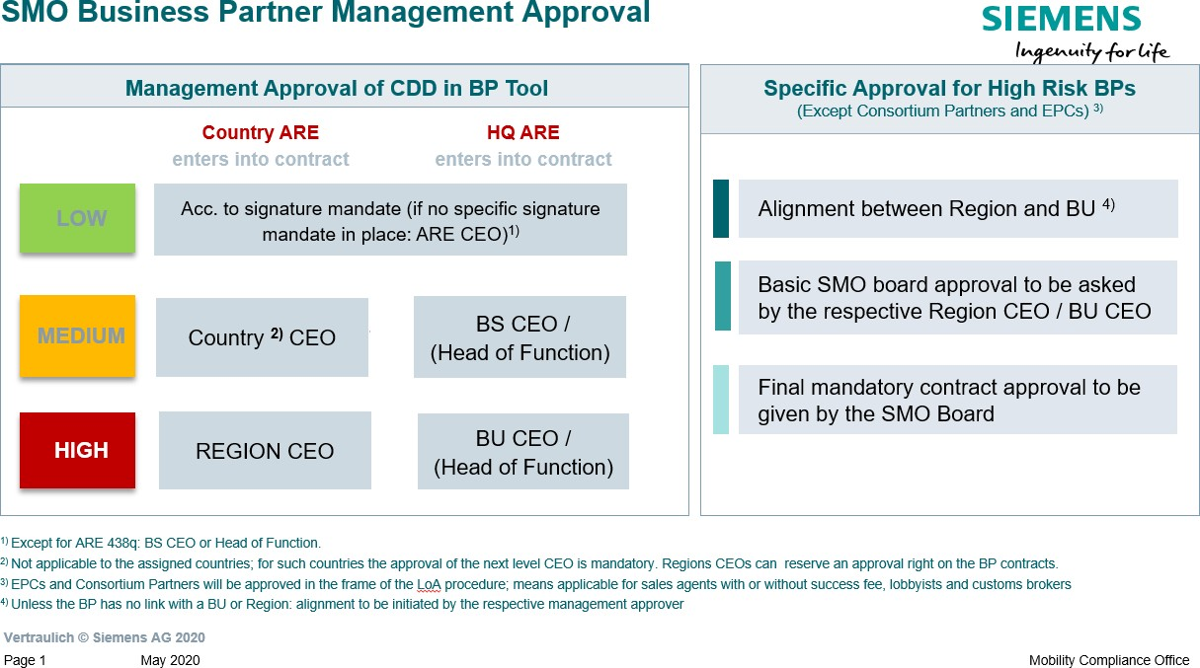

For Mobility the **Compliance** Review and Approval is required as follows:

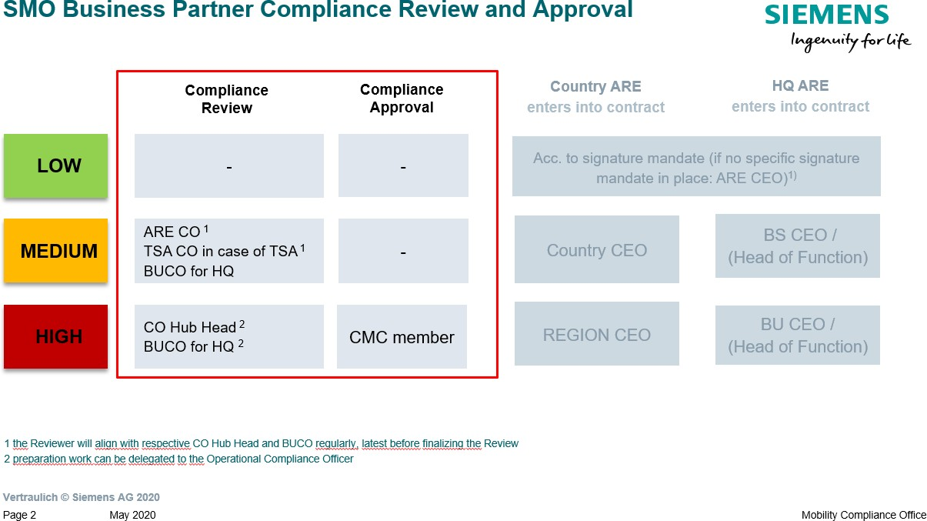

### Export Control

As an own legal entity, Mobility has its own Export Control Officer (ECO) and Export Control Commissioner (ECC), in addition to the Siemens ECO and ECC. The Siemens ICP is fully applicable for Mobility.

### History of changes

|  |  |  |
| --- | --- | --- |
| **Datum** | **Autor** | **Wesentliche Änderungen des verbindlichen Inhalts** |
| April 1, 2019 | Corinna Lange | Chapter 1.1.: EX deviations at SMO introduced |

|  |  |  |
| --- | --- | --- |
| April 1, 2020 | Corinna Lange | Chapter 1.1.: EX` deviations at SMO deleted |
| July 1, 2020 | Nina Miller | Chapter 1.1.: Cooperation with Business Partners: Deviations for CDD Review und Approval introduced |
| October 1,  2020 | Andrea Schmid | Chapter 1.2.: Export Control: Information on export control responsibilities added. |

* 1. Contacts

▌ Compliance Officer

The Compliance Officer responsible for your unit can be found through the following [link.](https://intranet.for.siemens.com/cms/059/en/about/org/Pages/compliance_organization.aspx)

▌ SMO Governance Owner

Andrea Schmid (LC CO SMO RG)

# Siemens Real Estate (SRE)

SRE's business is related to compliance at various points. First and foremost, there is the risk of money laundering, which is frequently encountered in the real estate sector. In addition, there is a theoretical risk of bribery of authorities, for example, in the issuance of building permits. Finally, conflicts of interest among employees with regard to the selection of suppliers are also conceivable due to the high purchasing volume.

▌ **SRE projects / Compliance Questionnaire**

Specific information on compliance in PASDIS and on the Compliance Questionnaire can be found in chapter M.2.1. Compliance Handbook.

▌ **Money laundering prevention**

General information on money laundering prevention can be found in [chapter C. Compliance](https://webbooks.siemens.com/public/LC/chen/index.htm?n=Part-1-Activity-Fields%2CC.-Anti-Money-Laundering-(AML)) [Handbook](https://webbooks.siemens.com/public/LC/chen/index.htm?n=Part-1-Activity-Fields%2CC.-Anti-Money-Laundering-(AML)).

Specific aspects for real estate transactions are covered in the Compliance Questionnaire (see chapter M.2.1. Compliance Handbook) as well as chapter chapter M.2.2. Compliance Handbook.

▌ **Anti-corruption: Business Partner**

General information on the topic of business partners can be found in [chapter A.4. Compliance](https://webbooks.siemens.com/public/LC/chen/index.htm?n=Part-1-Activity-Fields%2CA.-Anti-Corruption%2C4.-Cooperation-with-Business-Partners) [Handbook](https://webbooks.siemens.com/public/LC/chen/index.htm?n=Part-1-Activity-Fields%2CA.-Anti-Corruption%2C4.-Cooperation-with-Business-Partners). Here, particularly relevant for SRE are:

* Business partners with contact to approval authorities who can influence a non-sales-related decision or action in favor of Siemens ([non-sales-related intermediaries](https://webbooks.siemens.com/public/LC/chen/index.htm?n=Part-1-Activity-Fields%2CA.-Anti-Corruption%2C4.-Cooperation-with-Business-Partners%2CA.-Relevance-for-Business%2CA.1.-Business-Partner-Types%2CA.1.2.-Non-sales-related-Intermediary)).
* Business partners who assist in the sale of Siemens properties ([Sales-related intermediaries](https://webbooks.siemens.com/public/LC/chen/index.htm?n=Part-1-Activity-Fields%2CA.-Anti-Corruption%2C4.-Cooperation-with-Business-Partners%2CA.-Relevance-for-Business%2CA.1.-Business-Partner-Types%2CA.1.1.-Sales-related-Intermediary)).

▌ **Anti-corruption: Gifts & Hospitality**

General information on gifts and hospitality can be found in [chapter A.1. Compliance Handbook](https://webbooks.siemens.com/public/LC/chen/index.htm?n=Part-1-Activity-Fields%2CA.-Anti-Corruption%2C1.-Gifts-and-Hospitality).

▌ **Anti-corruption: Conflict of interest**

General information on conflict of interest can be found in chapter [A.5. Compliance Handbook](https://webbooks.siemens.com/public/LC/chen/index.htm?n=Part-1-Activity-Fields%2CA.-Anti-Corruption%2C5.-Conflict-of-interest).

General information on compliance in purchasing can be found in chapter [H.2. Compliance](https://webbooks.siemens.com/public/LC/chen/index.htm?n=Part-2-Business-Perspective%2CH.-Compliance-in-Business-Processes-and-Projects%2C2.-Compliance-in-Procurement) [Handbook](https://webbooks.siemens.com/public/LC/chen/index.htm?n=Part-2-Business-Perspective%2CH.-Compliance-in-Business-Processes-and-Projects%2C2.-Compliance-in-Procurement).

▌ **Data Privacy**

General information on data privacy can be found in [chapter D. Compliance Handbook](https://webbooks.siemens.com/public/LC/chen/index.htm?n=Part-1-Activity-Fields%2CD.-Data-Privacy).

In Germany, Location Management is the responsible entity for the proper and compliant operation of video surveillance systems in Germany for public grounds (and possibly company sites) in accordance with Section 6 b BDSG. For relevant checklists and background information, please contact the SRE Contact for Data Privacy, see chapter M.2.5 Compliance Handbook.

▌ **Security incident management (formerly "TreuInfo")**

If, for example, intentional damage occurs at the expense of Siemens AG and its affiliated companies, or on the company's properties and projects, information on how to proceed can be found in [chapter L.6 Compliance Handbook](https://webbooks.siemens.com/public/LC/chen/index.htm?n=Part-3-Compliance-Internal-Tasks%2CL.-Case-Handling%2C-Discipline-and-Remediation%2C6.-Security-incident-management-(formerly-%E2%80%9CTreuInfo%E2%80%9D)).

* 1. PASDIS CRE / Compliance Questionnaire
     1. SRE business outside of PASDIS

For all activities in relation to external parties below the below mentioned PASDIS thresholds, the [SRE](https://findit.compliance.siemens.com/content/10000101/Compliance/LC_CO/LC_CO_RG_PL/findIT_LC_CO_RG_PL_9733.docx) [Compliance Questionnaire](https://findit.compliance.siemens.com/content/10000101/Compliance/LC_CO/LC_CO_RG_PL/findIT_LC_CO_RG_PL_9733.docx) should be used as a checklist by SRE to assess possible Compliance related aspects. Your responsible [Compliance Officer](https://intranet.for.siemens.com/cms/059/de/about/org/Pages/compliance_organization.aspx) does not need to be involved unless there are any concerns or questions. Signature or documentation of the questionnaire is not required.

* + 1. PASDIS

The [SRE Compliance Questionnaire](https://findit.compliance.siemens.com/content/10000101/Compliance/LC_CO/LC_CO_RG_PL/findIT_LC_CO_RG_PL_9733.docx) is mandatory for all PASDIS-Projects requiring a Compliance-Quality- Gate according to the [Global Threshold Matrix](https://application.gms.siemens.com/content/10000087/Reg/Shared%20Documents/ST022_Annex%201.1%20-%20Threshold%20Matrix%20real%20estate%20transactions.pdf) (Annex 1.1 to SRE Standards Nr. 022).

The questions are to be answered by the Project Manger as far as not indicated otherwise and to be aligned with responsible Compliance Officer. The final version needs to be documented as PDF digitally signed by Project Manager and responsible [Compliance Officer.](https://intranet.for.siemens.com/cms/059/de/about/org/Pages/compliance_organization.aspx)

* + - * Question 1 (**Anti-Corruption / Conflict of Interest / General Integrity**) is relevant for any external SRE activity.
      * Question 2 (**Export Control**) is only applicable if our (planned) contractual partner has not yet been registered as creditor or debtor in SRE`s ERP-System (MP1) or any activity takes place in an Export Control Country of Risk.
      * Question 3 (**Anti-Money-Laundering**) is only applicable for transactions.
      * Question 4 (**Human Rights**) is only applicable in case of construction works in countries with extreme Human Rights risk.

The signed PDF must then be uploaded to [PASDIS](https://application-secure.it.siemens.com/content/10000007/SitePages/Home.aspx) before the project starts. If the contract partner(s) has/have not yet been determined, e.g. because a construction project has not yet been awarded, the SRE Compliance Questionnaire must be coordinated in accordance with the above specifications and documented as soon as the selection of the contract partner(s) has been made. In this case, the following text can be uploaded to PASDIS as a "dummy" prior to project start to bridge the gap:

"*At this time, the major contractor(s) have not yet been determined. The compliance questionnaire has been pre-discussed with the Compliance Officer for the items where the person of the contract partner is not important. It is currently anticipated that the key contractor(s) will be determined no later than [ . .20 ]. The Project Manager will coordinate the final compliance questionnaire with the Compliance Officer in a timely manner and document it in PASDIS."*

* + 1. PASDIS Tool-Workflow for Compliance Officers

1. To perform an approval, open link in Workflow-E-Mail:

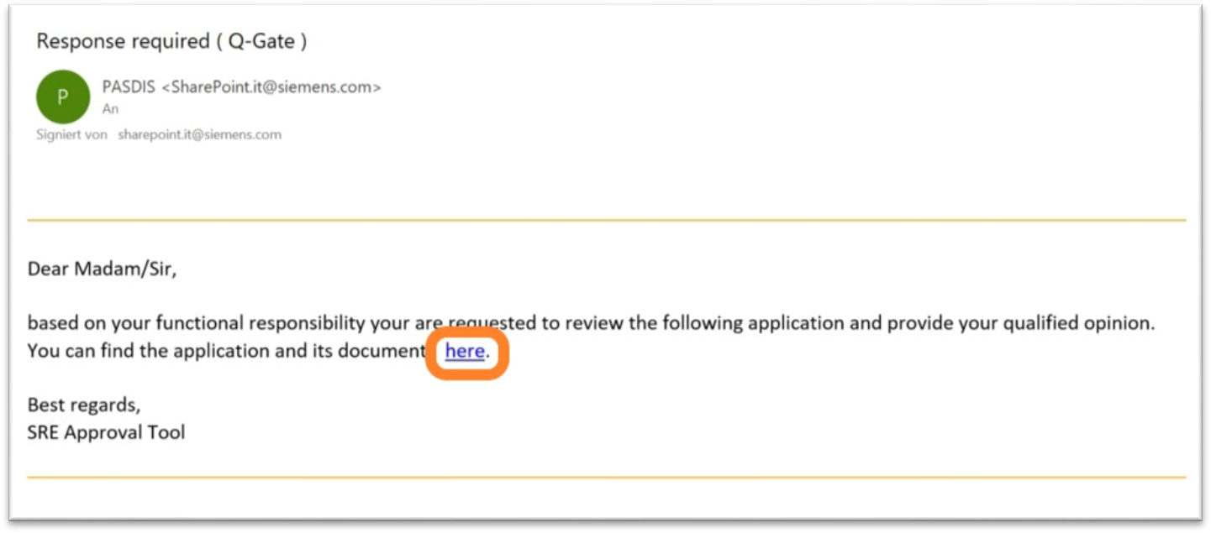

1. **To view documents, go to “Project Repository” on main page you are led to by using the E-Mail link.**

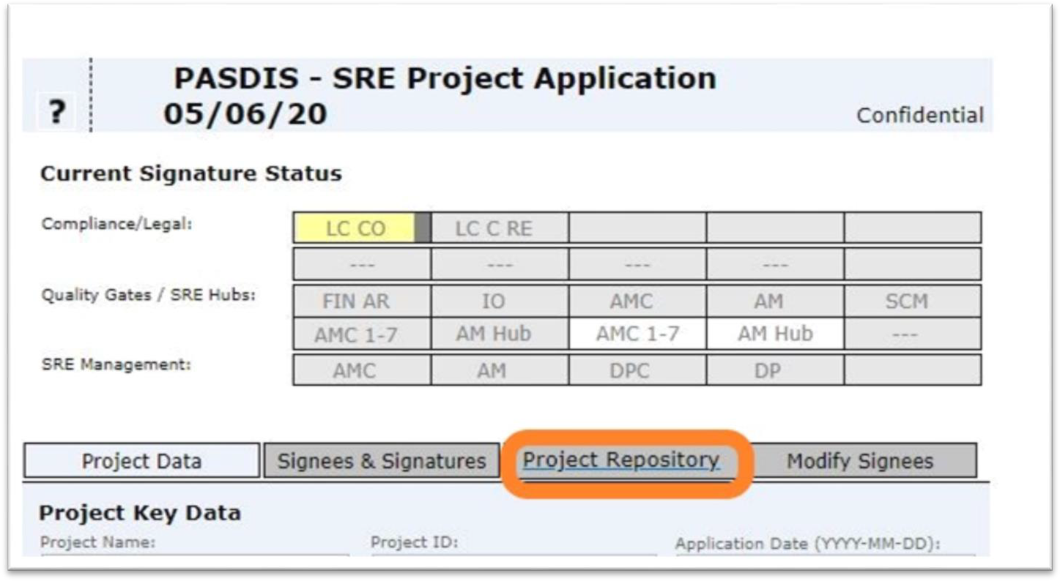

1. In “Project Repository”, go to “Attachment Library” to access all relevant documents.

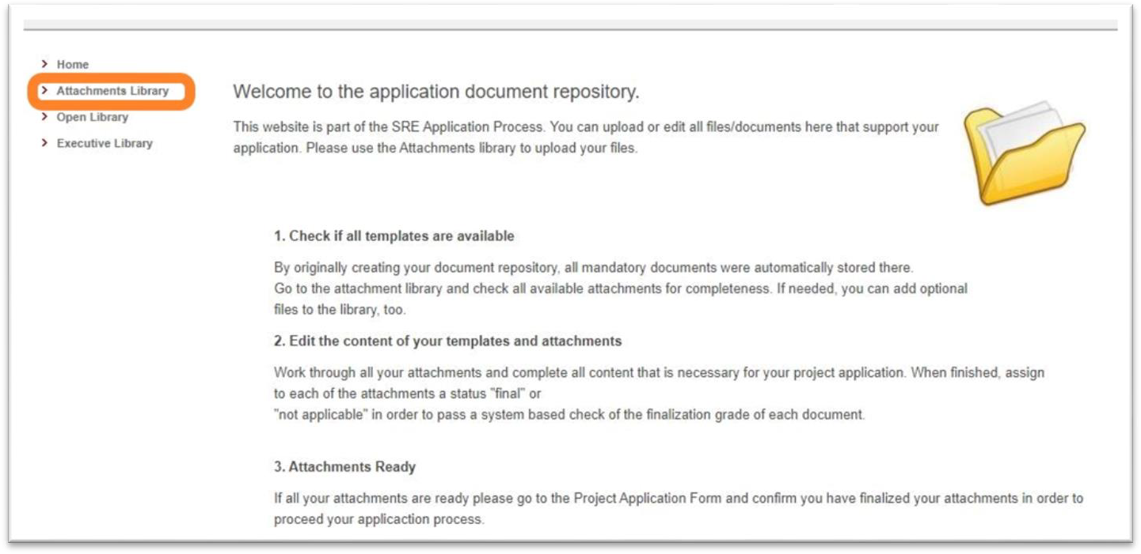

1. **After checking the documentation, got to main page you are led to by using the E-Mail link and look for the yellow area at the bottom of the page “Q-Gate appraisal”.**

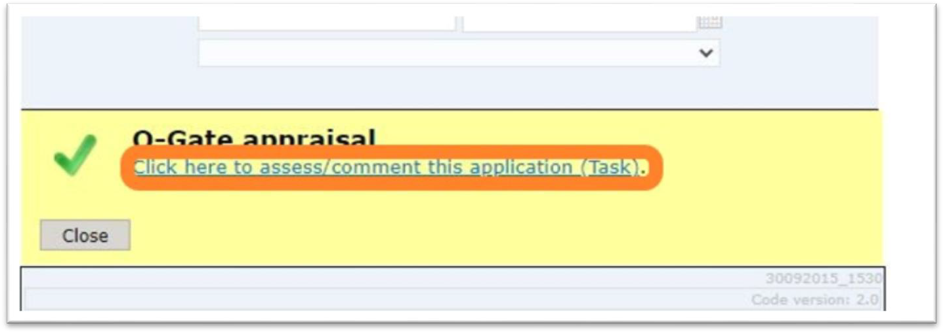

1. **Select applicable outcome, comment, and click “OK”.**

### Anti-Money Laundering

General information on money laundering can be found in [chapter C. Compliance Manual.](https://webbooks.siemens.com/public/LC/chen/index.htm?n=Part-1-Activity-Fields%2CC.-Anti-Money-Laundering-(AML))

Siemens Real Estate Consulting is subject to special provisions of the German Anti-Money Laundering Act when acting as a real estate broker. Corresponding special requirements are summarized in the document "AML Risk Analysis and Measures Concept of Siemens Real Estate Consulting Management GmbH (ARE 447k)", which is on file with the Company's management and the responsible Compliance Officer.

### Training and supporting material

Training and support material can be found at the end of each chapter A. to I. of the Compliance Handbook.

### History of changes

|  |  |  |
| --- | --- | --- |
| **Date** | **Author** | **Major changes of binding content** |
| Oct. 1,  2020 | Henning Tabbert | Integration of text from [https://application.gms.siemens.com/content/10000091/en-](https://application.gms.siemens.com/content/10000091/en-us/compliance/Pages/compliance-immobilien.aspx) [us/compliance/Pages/compliance-immobilien.aspx](https://application.gms.siemens.com/content/10000091/en-us/compliance/Pages/compliance-immobilien.aspx) |
| 01.01.2021 | Henning Tabbert | * Revision of the texts and adaptation of the CRE description * Particularities for the prevention of money laundering (AML) in SRE |

* 1. Contact**s**

▌ Compliance Officer:

Isadora Burgard-Torres ([SCD](https://scd.siemens.com/luz/IdentitySearch?cn=Isadora%2BBurgard-Torres&suchart=schnell)) (LC CO RFC CU)

▌ Export Control:

Sebastian Johna ([SCD](https://scd.siemens.com/luz/IdentitySearch?cn=Sebastian%2BJohna&maxanz=50&suchart=schnell)) (LC CO RFC CU EX)

▌ Data Privacy:

Robert Maibaum ([SCD](https://scd.siemens.com/luz/IdentitySearch?cn=Robert%2BMaibaum%2B&suchart=schnell)) (SRE EHS&SEC)

1. Siemens Logistics (SL)

This chapter contains the deviations from and/or additions to the corporate compliance regulations as described in Part 1 to 3 of the Compliance Handbook applicable to Siemens Logistics (SL).

### Export Control

In Siemens Logistics (SL) the governance responsibility for export control lies not within LC CO but with [SL Export](https://confluence.ppal.directory/pages/viewpage.action?pageId=179060602) [Control and Customs (ECC).](https://confluence.ppal.directory/pages/viewpage.action?pageId=179060602)

### Data Privacy

Any processing of personal information in an application or system on SL level must be documented within the [SL](https://confluence.ppal.directory/display/RPAR/Register%2Bnew%2BProcessing%2Bactivities) [Processing Register](https://confluence.ppal.directory/display/RPAR/Register%2Bnew%2BProcessing%2Bactivities) by the respective process manager with the support of SL IT.

### Compliance in Project Business

According to [SL LoA Guideline](https://confluence.ppal.directory/display/BPM/Limits%2Bof%2BAuthority%2B%28LoA%29%2BWW#LimitsofAuthority(LoA)WW-LoADocuments) for all projects >= 1 Mio EUR an Compliance Statement (CS) must be prepared and is an mandatory document for the PM40 LoA call. For all projects < 1 Mio EUR an Compliance Checklist voluntary can be filled by the project manager and send to the [responsible Compliance Officer](https://intranet.for.siemens.com/cms/059/de/about/org/Pages/compliance_sppal.aspx) for risk evaluation.

### 3.4 Contacts

▌ Export Control

Winkler Paul (SL RE&CT)

▌ Data Privacy

Katharina von Köding ([LC CD POC SL CO](https://scd.siemens.com/luz/IdentitySearch?dep=LC%2BCD%2BPOC%2BSL%2BCO&utI&utX&utT&rtH&rtS&rtZ&rtO&rtAktiv))

▌ Compliance in Project Business

Katharina von Köding ([LC CD POC SL CO](https://scd.siemens.com/luz/IdentitySearch?dep=LC%2BCD%2BPOC%2BSL%2BCO&utI&utX&utT&rtH&rtS&rtZ&rtO&rtAktiv))